  Component One: Student Journal (learning log) 796 words  Contribution to Overall Module Assessment: 25% | Student No: | Augusta-Roxana Toth (2226559)
 | Module Title: | Hotel Placement - Hotel Administration & Front Office Operations
 | Module Code: | (BMIH4004)
 | Lecturer: | Natalie Brailsford
Description: What happened?
In this journal, I would like to talk about the importance of the reception staff, the skills needed by that person who greets people at the entrance, and the personal experience I had at the hotel.
Receptionists at hotels typically have good communication skills, which enables them to engage with customers in person or through the phone. People who are traveling again will want to feel safe and secure when staying at a hotel.
A recent analysis of job listings on Hcareers revealed that many companies are looking for front desk workers with 12 skills. While the lobby is the first thing visitors see when entering a hotel, the front desk agent plays a vital role in the establishment's success. An employer is looking for individuals who are dedicated to making their job look great (Hcareers, 2021).
My experience at the reception was a special one because you need a quick mind to find solutions to some unforeseen problems. It happened 2 weeks ago when there was a horse competition and reporters came from all over the world. The hotel was fully booked, all 166 rooms full, and people were still coming into the hotel saying they had rooms booked online. We went, notified the manager and manager of the hotel, and together we found the solution to transfer them to another nearby hotel. But for me this experience was a little stressful because I was putting myself in the position of the client, how he feels at that moment.

Reception staff are responsible for understanding the hotel's supply and demand situation, ensuring that the rooms are being operated properly, and keeping track of the hotel's secrecy policies. Through this experience I will acquire the skills to be more communicative with people, to quickly find a solution in unforeseen situations, all with patience and calm. The skills I have now for this job would be I am understanding, and I like to help people around me in any situation.

The front office is a vital part of any hotel, as it is responsible for providing the best possible experience for guests and handling important data such as room statuses and guest information. Proper staffing, training, and organization are crucial for a smooth operation. Receptionists are the first point of contact that businesses and their clients have with each other. They represent the importance of good first impressions.
Feelings: What were your feelings?
My feelings about this experience were deep, because you must step out of your comfort zone many times, and behave politely, and respectfully regardless of your state at that moment. The hotel customer must feel as if he is stepping into his second home and wish him to always return with a smile on his face.
The impeccable outfit you must have been to be appreciated and from my point of view, the first impression is the hotel's business card.
An excellent front desk person should be able to multitask. There will be times when multiple clients require attention, and at that moment you must know how to manage the situation in order not to lose their patience.
The front desk staff is typically the silent conductor of a train. While it's assumed that the manager is leading the way, this individual can also make a valuable contribution to the hotel’s success. Collaboration with your colleagues is also an important point, since teamwork is the key to success, especially in the hotel field. If each employee understands his duties and does it with dedication, the customer will certainly be satisfied and will repeat his experience (Expertly, 2016).
Evaluation: What was good and bad about the experience?
The first impression that a hotel gives its customers is very important, and the way that its front desk staff interacts with them can make or break its reputation. Having a good front office manager is very important to ensure that your staff is trained and that they can excel in their work (LinkedIn, 2022).
Working towards customer delight, focusing on the details, being extremely organized, mingling with staff and guests, being result-oriented, being a team player, and being proactive, these are the main qualities you acquire thanks to your job, which leads to a great plus and shapes you as a person.
The negative experience you find in this job would be the ability of some customers not to understand the importance of respecting some rules, which could even affect the safety of all of us in the hotel. The language that many of them use, when they have a certain request and they cannot fulfill it immediately, often patience is lacking and then the customers become dissatisfied. I could say that all positive or negative experiences are part of a receptionist's life and can define us as a person, who we are, and who we want to be in the future related to the professional side.
Conclusion: What could you have done differently or in addition? Action plan: if it happens again what would you do?
In conclusion, being a receptionist is like an engine without which a hotel could not function, it is the visiting card and the first impression of the client.
The improvement I would recommend would be for the employees themselves to be able to make some decisions without consulting superiors, especially when it comes to improving the operation of the hotel.
They should not wait for superior management to instruct them on how to improve the front office. The success of the establishment depends on how well its staff can handle guests' concerns and queries. If they can make the guests feel valued and satisfied, they will be highly effective front-office staff. The negative experience I had as a receptionist was when the tone was raised with us, but it was an agitated moment because they ran out of rooms. Morally, we understood the situation they were in. But from the previous experiences I heard them tell, they were related to people who had consumed more alcohol or were under the influence of other substances. I would probably be more drastic with such people. I would immediately call the police if they didn't understand and became agitated.
“A satisfied customer is the best business strategy of all.” (LeBoeuf, 2022).

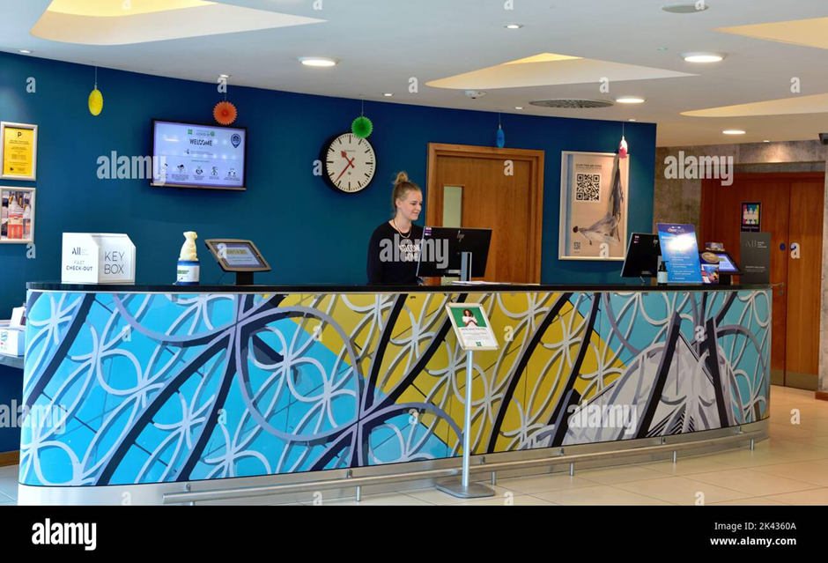

(Ibis Hotel, 2023).

Component Two
Contribution to Overall Module Assessment: 25%
Trip Advisor Review Response 150 words +/-10%
Hello Sjessie77,

Thank you for your great review of our hotel. We really appreciate you taking the time to leave us your 5-star review. It means a lot to the whole team, and we’d love to have you back very soon. We've forwarded your kind words to our team, and we hope that we can provide the same level of service in the future. We appreciate your feedback so that we can continue to improve our checking experience. We want to express our gratitude for taking the time to write a review about our hotel at the Ibis Styles Birmingham Airport & NEC. We are so glad that you enjoyed staying with us and that you found our beds comfortable. Your feedback helps us improve the services that we provide and lets us know that you are satisfied with the experience that you have had. We hope that you will return to our hotel in the future. Thanks for choosing to stay with us!

Screenshot of referenced Trip Advisor review used: 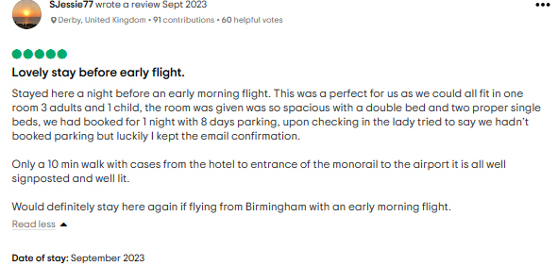
Letter of complaint response 500 words +/- 1-%
To, Mr Ronald Federick,
17 Trinity Court,
Swansea
SA1 2AR
September 2nd, 2023
Dear Sir Federick,
I am the General Manager of Ibis Hotel Birmingham. I was informed that your recent stay did not meet our standards. We take pride in offering the best possible service, and hearing that we have fallen short is something we will address immediately.
We would like to extend an apology for the inconvenience caused by your experience at the hotel. We are dedicated to providing our guests with the best possible service and would like to take this opportunity to thank you for raising this matter.
Your first complaint was about cold and tasteless breakfasts. We're sorry you didn't have a good experience with this. We told the chef to personally take care of the taste of the food, and about the fact that you found your food cold, we strive to maintain a high temperature in the special breakfast dishes, but sometimes it happens that they do not cope or are defect so that they keep the food warm between 7 a.m. -10 a.m. I will notify the maintenance staff to check the special vessels if they are working at full capacity.

The second complaint was about the noise produced by a baby in the next room, there was a mistake made on the booking in relation to the allocation of rooms. We are sincerely sorry for having trouble sleeping.

We would like to apologize for the inconvenience caused by our services on August 26th. We realize that our standards weren't up to the mark. We are sorry to hear that you didn't find the room to be clean. After receiving notice of your complaint, our staff members were immediately dispatched to do the cleaning. Due to the fact that we are dealing with a small number of employees, and they have a large volume of rooms in a short period of time, this problem has come to this. Negligence towards hotel hygiene, which is very important for our customers, will have consequences for housekeeping employees. We don't want to make excuses for this situation, we just let you know the situation we are in.
We would like to apologize for the inconvenience caused by these issues. We will do our best to make sure that this doesn't happen again during your stay. Reach out to me if you have any further inquiries.
We are committed to addressing this issue and are hoping that you will trust us with another opportunity.
We want to make it right. To do so, we will give you a 40% discount on future bookings at our hotel. You must present this letter with the code DB326559 while making a reservation.
We would like to extend an apology to you for the inconvenience that you encountered during your stay at our establishment. We are committed to providing our guests with the best possible experience, and we regret that we fell short of that objective. We hope that you will consider us for future visits.

Thank you for your understanding!

Sincerely,
Augusta Toth
Ibis Hotel Birmingham
General Manager

Component Three:
Contribution to Overall Module Assessment: 50% (1000 words +/- 10%)
Writing in essay format
The Guest Cycle
The various phases of interaction between a hotel and its guests are referred to as the guest cycle. These stages are based on the type of activities that are involved in the interaction. The four main stages are arrival, departure, stay, and pre-arrival.
In order to effectively serve their customers, front office staff members must be knowledgeable about the various activities involved in the guest stay. Having a good understanding of the hotel's business flow can help them provide the best possible service. The guest cycle concept also helps to improve the efficiency of the front office (Aleman, 2022).
Element 1 – Pre-Arrival

Before a guest arrives, they have to make a decision regarding a hotel. There are many factors that can affect a guest's choice. Some of these include the type of hotel they prefer, the distance from their work or school, the advertisement, the corporate and travel agent, and the loyalty program of the hotel (Kumar, 2023).
The reservation process itself can also affect a guest's decision to make a reservation. The way the reservation agent interacts with the client and describes the hotel's various features can influence their choice. Reservation agents can create a reservation on the hotel's management software if a request has been accepted. This process starts the hotel's guest cycle (Graham, 2022). The reservation record contains information about the guest's specific request to help the hotel provide them with the best possible service.
The collected information helps the hotel complete the various pre-registration activities for the upcoming stay. For instance, it allows the reservation agent to assign a room based on the guest's request and the room rate to the guest folio.
While the details of the reservation can help the hotel provide guests with an anticipatory service, the main goal of the reservation process is to ensure that the room they are looking for will be available when they arrive (Tam, 2019).
The hotel and the guest communicate before the arrival of the travelers. This stage of the guest's journey is known as the pre-arrival phase.
The reservation is the most crucial activity preceding the arrival of the travelers. During this phase, the guest chooses the type of hotel they wish to stay in.
Factors that influence a guest's choice include the services offered by the hotel, the location, and the recommendations of friends and family. After choosing a hotel, the guest can contact the establishment through various means, such as e-mail, fax, or telephone.

Element 2 – Arrival

The arrival stage of a guest involves registering and arranging a room assignment. Following this, the guest establishes a connection with the hotel through its front office. The front office staff is responsible for clarifying any inquiries about the room rate or other details of the reservation (Romo, 2022).
Before starting the registration or check-in process, the front office personnel should first determine the reservation status of the guest. Guests with a reservation or those who do not have one can still provide business opportunities to the hotel's front desk personnel.
A registration card or Reg. card, which is printed and signed at the time of the check-in process, is a vital part of the hotel's operations. It contains information about the guest such as the reservation number, address, credit card details, and passport. Since the hotel and its guests enjoy various legal benefits, it is obligatory for the guest to provide a signature on the card.
Upon completing the registration process, the guest's departure date and payment have been confirmed and signed. They can be escorted by a staff member or given a room key.
The occupancy stage of the stay starts after the guest has checked in.

Element 3 – Duration of stay

The front office staff's demeanor during the occupancy stage can influence the guests' perception of the establishment.

The hotel's front office acts as the primary contact point for the guests, coordinating their requests and providing them with supplies and information.
The front desk staff must take special care to respond promptly to queries from the guests. They aim to provide the best possible service, exceeding their guests' expectations and encouraging them to return.
One of the hotel's most important concerns during the occupancy stage is security. This includes the protection of valuables and funds. The front desk must follow proper procedures when it comes to handling guests' keys, deposit boxes, emergencies, and property surveillance (Lacalle, 2021).
During the occupancy stage, various charges can affect the hotel account of its guests. Most of these are posted to the guests' accounts according to the procedures set by the front office. The room charges are the most common among the charges that the hotel collects.
Checking the balances of the guest accounts and verifying the charges posted to their account are other tasks that the front office staff members perform during the occupancy stage.

Element 4 – Departure

The various aspects of the guest cycle, such as guest accounting and services, are completed in the fourth and final phase, which is departure.
When a guest departs, they receive the correct statement of their accounts, return the keys, and leave the hotel. The front office then updates the status of the room and informs the housekeeping staff.
Feedback forms are then handed over to the front office to gather feedback about the experience of the guests.
By understanding the various stages of a guest's journey, you can develop a marketing strategy that will attract them at the right time. This will allow you to connect with them at a deeper level and increase your sales (Deepan, 2020).

References
Component One
- Experity (2016). 5 Essential Characteristics of a Good Front Desk Officer. Available at: https://www.experityhealth.com/blog/characteristics-of-a-good-front-desk-officer/ (Accessed 01 October 2023).
- Hcareers (2021). 12 Necessary And Essential Skills Of Front Desk Professionals. Available at: https://www.hcareers.com/article/career-advice/12-necessary-and-essential-skills-of-front-desk-professionals/ (Accessed 27 September 2023).
- LinkedIn (2022). 8 Ways to Become the Best Hotel Front Office Manager. Available at: https://www.linkedin.com/pulse/8-ways-become-best-hotel-front-office-manager-illangakoon/ (Accessed 01 October 2023).
- Vishak (2022). 25+ Popular Quotes on Customer Satisfaction. Available at: https://surveysparrow.com/blog/quotes-on-customer-satisfaction/ (Accessed 20 October 2023).
- Ibis Hotel (2023). Hotel reception desk UK Stock Photos and Images. Available at: https://www.alamy.com/stock-photo/hotel-reception-desk-uk.html?sortBy=relevant/ (Accessed 20 October 2023).
Component Two
- Bradley A. (2023). Strong Hotel Complaint Letter: How To Write It Right! Available at: https://requestletters.com/home/how-to-write-a-hotel-complaint-letter-with-sample/ (Accessed 13 October 2023).
- Chinn A. (2023). How to Write an Apology Letter to Customers [12 Templates & Examples] Available at: https://blog.hubspot.com/service/apology-letter-to-customers/ (Accessed 17 October 2023).
- Editorial Team (2023). How to Write a Hotel Complaint Letter. Available at: https://www.allgetaways.com/hotel-booking/write-hotel-complaint-letter.html/ (Accessed 16 October 2023).
- Kisielewska M. (2022). 6 Apology Letters to Customers [Examples + Writing Tips. Available at: https://www.tidio.com/blog/apology-letter-to-customers/ (Accessed 16 October 2023).
- Panchal R. (2020). Hotel Complaint Letter: 6+ Free Templates. Available at: https://writolay.com/complaint-letter-bad-service-hotel// (Accessed 13 October 2023).
Component Three
- Alemar S. (2022). The Hotel Guest Cycle & Why It Matters. Available at: https://www.canarytechnologies.com/post/the-hotel-guest-cycle-why-it-matters/ (Accessed 20 October 2023).
- Deepan (2020). The Guest Cycle.Available at: https://www.easyhotelmanagement.com/2020/06/guest%20cycle%20in%20hotel%20.html/ (Accessed 20 October 2023).
- DPMI (2022). Guest Cycle in a Hotel. Available at: https://dpmiindia.com/blog/2022/12/23/guest-cycle-in-a-hotel/ (Accessed 14 October 2023).
- Graham K.(2022). Wow, Your Guests From Pre-Arrival to Departure! Available at: https://www.linkedin.com/pulse/wow-your-guests-from-pre-arrival-departure-karen-graham/?trk=articles_directory/ (Accessed 15 October 2023).
- Hotelogix (2018). How to enhance pre-arrival guest experience in easy ways using hotel technology. Available at: https://www.hospitalitynet.org/news/4087748.html/ (Accessed 20 October 2023).
- Kumar P.(2023) Introduction to guest cycle. Available at: https://hmhub.in/introduction-to-guest-cycle/ (Accessed 20 October 2023).
- Lacalle E.(2021). How can hotels generate more revenue from the pre-arrival stage? Available at: https://www.mews.com/en/blog/hotel-pre-arrival-stage/ (Accessed 20 October 2023).
- Romo F. (2022). Automation and The Hotel Guests Cycle: Departure. Available at: https://www.linkedin.com/pulse/automation-hotel-guests-cycle-departure-francisco-javier-martin-romo/ / (Accessed 20 October 2023).
- Travel Pedia (2023). What are pre-arrival and arrival? Available at: https://lovethemaldives.com/faq/what-is-pre-arrival-and-arrival/ (Accessed 14 October 2023).
- Tam W. (2019). 5 Key Technologies to Enhance the Guest Life Cycle. Available at: https://roomkeypms.com/blog/5-key-technologies-to-enhance-the-guest-life-cycle/ (Accessed 20 October 2023).

