

Comparison of IPV4 and IPV6 routing protocols
by
Christopher Morris

Supervisor: Dr. Kapilan Radhakrishnan
Second marker:?

Project submitted as part of the requirements for the award of BSc (Hons) Computer Networks and Cybersecurity
May 2019
DECLARATION

I, Christopher Morris, declare that I am the sole author of this Project; that all references cited have been consulted; that I have conducted all work of which this is a record, and that the finished work lies within the prescribed word limits.

This work has not previously been accepted as part of any other degree submission.

Signed : c.morris
Date : 01/05/2019

FORM OF CONSENT
I, Christopher Morris, hereby consent that my Project, submitted in candidature for the BSC Computer Networks and Cybersecurity degree, if successful, may be made available for inter-library loan or photocopying (subject to the law of copyright), and that the title and abstract may be made available to outside organisations.

Signed : c.morris
Date : 01/05/2019

Abstract
There are several factors which can impact a network’s security, including bandwidth and encryption. Internet Protocol version 6 has been slow in deployment compared to its predecessor, version 4, and the objective is to figure out whether it has remained the more secure of the two. After completing a literature review, experimentation in GNS3, and analysis, version 6 is deemed to be secure, but the drawbacks means it remains in the shadow of version 4, despite version 4 addresses’ depleting. The opinion is that more focus needs to be given to version 6 to help it grow and overcome its barriers.

CONTENTS PAGE
Table of Contents
Chapter 1 – INTRODUCTION 5
CHAPTER 2 - RESEARCH & REVIEW OF LITERATURE 7
CHAPTER 3 - RESEARCH AND/OR DEVELOPMENT METHODOLOGY 17
CHAPTER 4 - DESIGN & IMPLEMENTATION 20
CHAPTER 5 – EVALUATION 22
CHAPTER 6 - CONCLUSIONS AND RECOMMENDATIONS 24
CHAPTER 7 – REFLECTION 25
CHAPTER 8 – REFERENCES 28
APPENDICES 30

Chapter 1 – INTRODUCTION

This project will analyse Internet Protocol (IP) Versions 4 and 6. Both versions have several protocols that assist in their functionality, and this task will involve testing these protocols in to determine which one is more secure. With version 6 expected to replace version 4 in the imminent future due to version 4 running out of IP addresses, the aim is to determine whether its security is more consistent to that of its predecessor.

Four protocols (two from each IP version) have been selected: RIP (Routing Information Protocol) version 2/Enhanced Gateway Interior Gateway Routing Protocol (EIGRP) for IPv4, and RIP next generation and the IPv6 version of EIGRP for IPv6. These two were chosen due to the lack of research material comparing them.
The focus of the task will be determining what security measures the four protocols have in place via experimentation in GNS3, but focus will also be given to performance. Any important data will be recorded in tables and graphs before being analysed and measured against research literature.
This project is necessary because while there is a wide variety of research that helps compare the two IPs, there is a limited comparison in terms of security. This project aims to extend understanding for those unaware or wanting to learn about the different protocol versions. The reason why this topic was chosen was that interest was taken into why Version 6 is not more commonly used, and whether security is a factor in it’s delayed deployment.
The main audience for this project will be people working in the field of networking, specifically engineers who are tasked with areas such as IP addressing who would benefit from increased knowledge of the differences between the two protocols. What will make this project stand out is the fact that a wide variety of knowledge will be considered, both from experimentation and a literature review.

1.1 Aim
The aim of the project is to evidence whether the chosen IPv6 protocols are more secure than those of IPv4.
The prediction is that the version 6 protocols will be more secure, the reasoning being that while, from literature previously researched along with the author’s intuition, version 4 is identified as the more popular protocol due to version 6 having less time to develop, version 6 brings more benefits.

1.2 Objectives
To accomplish the goal of identifying which IP version is more secure, there are three main objectives within the project:
• A literature review to develop understanding of current research.
• Experimentation to determine which protocol performs best in terms of security.
• Analysis of the findings against the literature review findings
These objectives will answer the project question.
“Are the routing protocols of IPv6 more secure than those of IPv4?”
These objectives will be met through primary research in the form of experimentation and secondary via a literature review and analysis after the experimentation. These objectives are relevant because they link with each other and will ensure a measurable outcome is reached.
The project will be managed through meetings with a supervisor and updating a Gantt chart which details target dates for tasks. A test run of experimentation will ensure that the experiments are achievable. Several stages will need to be completed within specified timeframes (e.g. the literature review before the interim viva).
1.3 Project layout

The project will be laid out in the following manner: an introduction detailing the task and any background information, literature review discussing which criteria the results should be analysed against, a justification of the methods employed, data results of the experimentation, an overall analysis, a conclusion, any recommendations and further research followed by references and appendixes.

CHAPTER 2 - RESEARCH & REVIEW OF LITERATURE

2.1 Research
IPv4 and IPv6 backstory
An IP address gives each device a unique identifier that enables communication and access to web sources. The Internet required a standard protocol to control increasing demand, hence the creation of IPv4 in 1978. However, in the 1990’s, it was determined that IPv4 needed a successor for when it became overloaded, with the consequence that addresses could no longer be allocated. IPv6 was created in 1995 as a replacement internet protocol. While estimates as to when IPv4 addresses will run out completely vary, most agree that it will be before 2020 (though with version 4 still serving a role to users in some capacity). [1]
The below diagram lists some of the key differences between version 4 and 6.
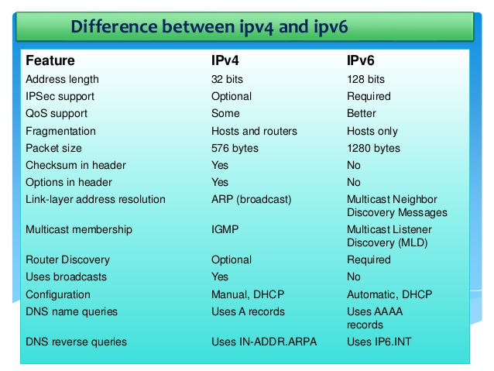 [2]
Main features
IP addresses are split into one of five groups, ranging from “class” A-E. The lowest value IP address is 1.0.0.1. This, up until the address 126.255.255.254, forms class A. Class B encompasses the values from 128.1.0.1 – 191.255.255.254, followed by Class C ranging from 192.0.0.1 – 223.255.255.254 and Class D including 224.0.0.0 until 239.255.255.255. Lastly, any value from 240.0.0.0 to the highest IP address possible (255.255.255.255) is listed in Group E.
Classes A-C are the most common, with Class D only generally used for multicast addresses and Group E only used as backup addresses in future. There are two main bases of addresses; private or public. Private addresses are reserved for local networks and non-Internet tasks. The most common private addresses begin with either 10.0.0.0, 172.168.0.0, or 192.168.0.0. Meanwhile, Public lists the available addresses the provider has available from a pool.
The addresses are applied in one of two ways, dynamically or statically. Dynamically means they are automatically assigned by the device itself based on a pool of addresses, while static addresses are formed by the user on each device. In terms of dynamic addresses, automatic addresses via Network Address Translation (NAT) save time on part of the user and keep costs lower, but the provider may change the address later, causing confusion and less reliability. Meanwhile, static ensures more security as the control lies with an assigned user but having one address makes a device easier to track and attack.
There are two main forms; classful and classless. Classful splits IP addresses into two main sections (network address and host address), while classless instead applies a process known as Variable Length Subnet Masking (VLSM), a process that splits the network and host addresses into two sections each to make potential changes easier. Both have their benefits and drawbacks; classful addresses having two segments allows for simple implementation, but its resulting predictability can be viewed as a security risk. Classless includes all information regarding subnets, but in the process requires more storage.
Messages can travel through a network in one of five ways; anycast (one device sending data to one of the several involved), broadcast (one sending data to all devices involved), geocast (used when sending data to a different geographical region), multicast (one sending data to several but not all), or unicast (strictly between two devices). Each type has factors to bear in mind; for example, unicast is simple and common among networks such as peer-to-peer, but therefore lacks the scaliblity of others (especially when being required to send multiple messages.) A key difference between IPv4 and v6 is that v4 does not support Anycast communication.
There are several varieties of IP addresses. The first is loopback, an address that allows for users to simulate their addressing scheme and have one address that sends signals. This makes the overall accuracy higher but uses more storage, with each address needing to be unique. The next is link-local, which assigns an address to an interface which differs from the MAC address to allow for communication between devices. These addresses do not require a unique address (making them less likely to be hacked over a remote network), but this makes pinging the network (making sure it is reachable) more difficult.
IPv6 expands on version 4 and includes other types of addresses, including site network and global network. [3] These are addresses that tailor their flexibility based on the geographical region of the area (e.g. for a Wide Area Network that requires a global network to obtain multiple addresses). This makes reaching services such as a finance department easier across a network, but resultantly requires more security measures due to encompassing a larger scope.
Similarities and differences
Two of the most common routing protocols are Routing Information Protocol (RIP) and Enhanced Interior Gateway Routing Protocol (EIGRP). Both are distance-vector protocols, meaning they choose how to deliver data based on the distance of its target. RIP was quickly established as a leading protocol in 1988 due to its simplicity, followed by EIGRP via Cisco in 1993. Both are classless protocols and therefore include the subnet mask (range of available IP addresses) anytime changes are applied. [4]
There are several things that RIP and RIPng have in common, such as both using the amount of hops to calculate its path and applying it as a cap of 15, and having mutual features such as poison reverse (a method that ensures that packets are not delivered to points have been discontinued). This increases efficiency as time is saved, but can have an effect on storage as it continually sends out updates. However, the main ways RIPng improves on its predecessor include sending its subnet information after every update, supporting both classful and classless addresses, and allowing authentication to improve security.
EIGRP v4 and v6 were designed with few improvements in mind. Most aspects remain the same, such as both applying the Diffuse Update Algorithm (DUAL) to keep convergence and efficiency consistent, but an example of a difference is v6 requiring a router ID to help distinguish it.
The primary difference between version 4 and version 6 is that version 6 addresses are longer at 128-bits, compared to 32 bits in version 4. Version 6 provides a larger quantity of addresses available for use; 4.3 billion addresses were formed by Version 4, however, approximately double the amount was required. [5]
Version 6 supports approximately 340 undecillion addresses. [5] This is due to version 6 working in hexadecimal format. In this format, letters are used to replace numbers above nine, creating a higher quantity of addresses. Hexadecimal uses a base of sixteen, expanding on the ten used in the binary base of IPv4.
A further advantage of Version 6 is that the routing tables have been simplified (e.g. with sections such as the type of service and the total length being merged into one section named “flow label”), making them easier to use. However, due to several issues, IPv4 retains the aspect of familiarity. Other factors such as simplicity help IPv4 remain the more popular of the two.

2.2 Related work
A reason why people are hesitant to accept Version 6 and remain using Version 4 are because of the slow speed Version 6 has been in deploying its IP addresses, as explained by P. Wu, Cui, J. Wu, Liu, and Metz. [6] Despite being created in 1998, IPv6 struggles in a variety of factors such as Quality of Control (the set of rules which help a network to function), this has had the effect that only popular websites such as YouTube having the capacity to apply it in an effective manner. Wu et al claim that these issues will soon be fixed provided enough focus is given to IPv6.
A further reason, as stated by Babatunde and Al-Debagy, is due to the lack of compatibly between Versions 4 and 6. [7] They suggest there are significant differences between the two that prevent Version 6 from being more widely used, for example it has more complex IP addressing. The paper attempts to counter this by pointing out how the two IPs can operate together, such as both using techniques for example dual-stacking (using devices that accept IP addressing schemes of both versions).
The next paper is by Ali [1], who works at Philadelphia University in Jordan for the CIS (Computer and Information Science) department. The paper is again published in a journal; the International Journal of Computer Science in 2012. Ali investigates when IPv6 should be used, the differences between it and its predecessor, and the benefits and drawbacks of both. The main objective is to highlight the differences between versions 4 and 6.
According to Ali, there are many differences between the two versions that must be considered when deciding whether to switch from 4 to 6. These include services (such as Anycast communication, which gives an IP addresses several paths to a destination and is only available on version 6). Another factor is compatibly; version 4 hosts can easily be upgraded to 6 via the use of a DNS (Domain Name System), which controls IP addresses and their data.
Ali concludes that is impossible to determine when Version 6 will fully replace Version 4 because there is no hurry to fully implement Version 6. Unlike papers 1 and 2, no experiments were conducted. The data is entirely listed in text except for one diagram. This is likely due to it being a comparison between versions 4 and 6 and having less need to document experiment results of protocols.
There are only seven references, indicating the work is mostly Ali’s own knowledge and can be a drawback in terms of obtaining a variety of sources. Another thing to consider is the bias; the paper mostly talks about the benefits of version 6 and the drawbacks of version 4 despite being titled as a comparative study between the two. This is likely due to version 6 being the less experienced protocol and requiring more knowledge but is something that must be considered.
The next paper is written by Chandra, Kathing, and Kumar [8]. All three work in computing departments encompassing three cities in India and created the paper for an International Computing Conference in 2013. The aim of the paper was to evaluate what role version 6 will play in future society. The trio pinpoint 2019 as the time when version 6 will fully surpass its predecessor.
They primarily discuss the methods that would allow IPv4 and IPv6 to work together, along with the positives and drawbacks of both versions. All comparative data is presented in tables to easily differentiate between versions 4 and 6. As well as highlighting differences, such as version 6 not requiring manual or automatic assignation of IP addresses, what is also described is how the two versions can work together. This includes the use of dual stacking (which permits the use of both version 4 and 6).
The trio are in agreement with Ali and claim that Internet Protocols have sufficient strategies to deal with issues. Despite version 6’s imminent replacement of version 4, the IP structure will remain largely unchanged until the 2030’s provided enough preparation is made. This is due to investments made by stakeholder companies in countries such as the U.S., China, and Australia.
One advantage this paper has is that, unlike Ali’s paper, there is limited bias and it does not focus on one version more than the other, making the reasoning hold significant weight for when the results of this task will be analysed. However, it has a short length and no experiments are conducted.
The next paper is written by Golkar, Dreibholz, and Kvalbein [9]. The three are researchers who work at the Simula Research Labatory in Norway, and are created a paper in 2014 to be published an International Networking Conference.
The paper is published on the 20th birthday of IPv6, measuring how it performs against version 4 in terms of Internet path stability. It is primarily composed of text with a few graphs to back up its reasoning. A topology was created of the NORNET network (the network architecture of the authors).
The experiments that were carried out included; how each version distributes its Internet path, and how often that path changes with and without load balancing (splitting functions across the network to prevent storage issues), as well as how often it changes based on events such as configuration changes.
The results show that version 6 applies load balancing more than version 4, and its transport paths change more often. The trio conclude that while version 6 has clear advantages over version 4 (such as simpler topologies which make network access easier), there are also clear reasons why it is not ready to fully replace version 4 (such as it changing paths more often), and more experiments and research needs to be completed first for safety.
An advantage of the paper is the high amount of references at 18. However, what must be considered is that not every branch of the trio’s network model includes IPv6, which could have an impact on the results.
The last related paper to consider is by Parra, Rios, and Rubio. [10] Rios and Rubio work at universities in Colombia and Spain respectively, while Parra is associated with an organisation called the Intelligent Internet Research group. This document was used at a conference (the International Conference for Wireless Communications) in 2011. The work was completed with the software OPNET.
The main objective is to measure both version’s quality of service. The paper analyses the overall quality of service between the two IP versions. The objective is to complete experiments based on the factors that form a quality of service in a network, such as packet delivery and jitter.
The results demonstrate the way in which version 6 can match version 4 in terms of quality of service. The end-to-delay and jitter was almost identical for both, despite the values increasing over time. The main differences between versions 4 and 6 lie in how they transfer data (their data routes), which version 6 has been programmed to improve on the elements of its predecessor. This paper is useful because it includes categories that can be applied to this task but can held back by its short length.

2.3 Literature review
Several papers have been selected for analysis in this project, based on the research question.
The first paper is by Chauhan and Sharman [11]. Both authors are associated with universities in India; for Chauhan, the Symbosis University of Applied Sciences in India. For Sharman, it is the Shri Mata Vaishno Devi University. The paper was published for use at a conference. The overall aim is to see how well IP version 6 fares before its eventual replacement of version 4.
The pair discuss RIP and RIP next generation along with OSPF (Open Shortest Path First), a protocol that is compatible with both versions 4 and 6 (named OSPF4 and 6, respectively). These four protocols were tested in a series of experiments that involved testing the following factors: throughput, end-to-end delay, jitter, and the overall delivery of packets.
Each experiment was carried out four times. Each time, the size of packets travelling across the network increased from; 256, to 512, to 1,024, to 2,048. The software used for the tests was Exata Cyber, a simulator program capable of carrying out network experiments. The data was exported into and presented as bar graphs to show all the data all at once and keep it measurable.
RIP next generation was identified as the best performing-protocol it had the highest throughput, and the lowest end-to-end delay, the lowest jitter along with RIP, and the highest packet delivery ratio. Meanwhile, OSPF version 4 was concluded as the worst-performing protocol.
The paper includes twelve references, ranging from the years 1998-2014. It must be considered that only papers published within the last five years will prove useful for this project, and the number of references for this paper will be a lot higher. This paper is useful because it gives an early indication of performance results, which will be referenced her as a guidance for which protocol is more secure. A major difference is that a different simulation platform will be used for experimentation and EIGRP will be tested instead of OSPF.
The Al-Ani’s [12] meanwhile, have published a paper that looks at EIGRP alongside RIP and OSPF. D. Al-Ani is associated with the University of Kirkuk in Iraq, while A Al.-Ani is affiliated to the University Institute of Engineering and Technology in India while still serving as D Al-Ani’s co-author. This paper underwent publication in the Procedia Computer Science Journal in January 2018. Like Paper 1, the aim is to evaluate version 6’s performance in certain categories before its full-fledged deployment.
The two examine latency and end-to-end delay. Like Chauhan and Sharman, they tested version 4 and 6 of each protocol and increased the packet size to ensure variety in terms of results. The experiments were conducted in the software GNS3, a program that specialises in scaling down complex networks. Exactly like Paper 1, the protocols were measured at four sizes; 256, 512, 1,024, and 2,048.
The overall conclusion is that IPv6 performs better, suffering from less delays and lower latency. A pattern throughout the paper is that RIP and EIGRP require large packet sizes to reach their destinations quicker (compared to OSPF, which is the opposite). OSPF is the protocol with the highest-total results, which indicate that results between protocols for this task will be close. As developments are made, the authors claim that compatibly between wired and wireless networks will increase.
This paper is useful because it looks at both versions of RIP and EIGRP and includes a wide variety of references. The results for it indicate that IPv6 performs better in the category of latency (a response time between two networks), giving it less delay and an advantage in terms of security. However, a criticism is that the paper appears one-sided and lacks variety of categories compared to the other selected papers.
Paper 3 is by Mohammad, Hanif, Abusukon and Al-Otoum [13], who all work at the Al-Zaytoonah University in Amman, Jordan. The main objective of the paper is to discover which protocol performs best at distributing its routing in the simulation program of OPNet, which EIGRP being among them. The paper was published in the International Computer Networking journal in March 2017.
The overall aim of the paper is to measure RIPv2, EIGRP, OSPF, and IS-IS (Intermediate System) together, namely in the context of VoIP (Voice over Internet Protocol) and how fast data travels with it. The protocols were measured concurrently with one at a time taking precedence. The results show that the best combination of protocols to use, namely in regards to VOiP technology, is RIPv2-EIGRP-ISIS.
This paper is useful in looking at how EIGRP performs against a protocol that is not RIP, which helps give it context for this project.
Paper 4 is by Syed and Ambore [14], who all work at the Minnesota State University in Mankato, Minnesota, USA. This paper looks at whether RIP or OSPF has a higher quality standard for versions 4 and 6. It was published in the International Computer Networking journal in November 2016.
The main objective is to compare RIP and RIPng against OSPF and OSPFv3 in terms of networking, namely jitter and the delivery. The results show that RIPng performs better than OSPF in terms of drop of traffic, end-to-end delay and jitter, though its delay variation is worse.
This paper is useful because it looks at how RIP performs against a protocol that is not EIGRP (which helps give it context for this project), and includes the most references out of all the chosen material at 37.
Paper 5 is constructed by A. Buldu, set in Marmara University in Istanbul, Turkey. [15] This is a task that was published in a Science Journal in 2010 and analyses the types of security threats encountered by both protocol versions, including fragmentation (diving a packet of data accordingly).
The results demonstrate that IPv6 is continuing to grow as v4 becomes outdated, but is not fully ready yet due to issues in transition and inexperience in matters such as rogue devices. Despite this though, v6 has a higher security standard due to features such as improve detection of intrusions.
This paper is useful because it may heavily influence the result of this task, though it being the oldest considered paper at a release date of 2010 is a drawback.
Lastly, Paper 6 was created by Henten and Tadayoni of Aalborg University in Copenhagen, Denmark, and listed at the European Regional Conference in 2012. [16] This paper again analyses how ready IPv6 is to fully replace its predecessor, such as the barriers it must overcome and how to resolve them.
The results demonstrate that despite IPv4 beginning to run out in 2011, IPv6 has not been quick to replace it due to an inability to create stable paths. However, they concur with Buldu [15] that v6 is quickly replacing v4 and trends such as Internet of Things (IoT) and dual-stacking will utilise and promote it.
This paper is useful because it gives more weight to the author’s prediction and concurs with Buldu [15], though the fact that falls out of the ideal timeframe of the last five years can help benefit this project and see if this conclusion should change.
Overall, these six papers will serve as useful sources to compare the results of this task. This is due to how similar their layouts are and how recently they have been published. While there are drawbacks to consider, such as their small overall scale and lack of secondary references, their goals are similar enough to this task that they can easily be analysed against.

CHAPTER 3 - RESEARCH AND/OR DEVELOPMENT METHODOLOGY

3.1 Methodology
This project will use multi-methods of research, encompassing a literature review and an experiment. [17] The primary method for this project of data collection will be through experimentation, as this was considered the most appropriate method for the scope of the task. Other methods such as a case study and survey were ruled out, based on them not being able to produce quantitative data. These methods produce qualitative data, which is not suitable for this investigation.
The advantages of choosing an experiment include having greater control via the use of variables, allowing users to complete specific objectives. Also, once they are created, they can be repeated potentially with the variables being adjusted to achieve a wider range of results. However, consideration must be given to tampering with the variables too much, which will result in unreliable data. Meetings with the supervisor will help avoid this and ensure the task remains on track and achieves its desired objectives.
The topics of IPv4 and v6 have gained considerable research material in the form of published articles. Therefore, it would be beneficial to use existing data as reference points and for comparison. Also, the experiments being measured against literature review will allow for the data, which will be quantitative, to be measured and recorded in tables and charts.
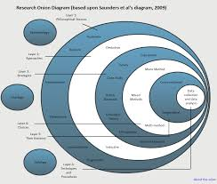 [18]
Figure 1: Onion Research-model
According to the Saunders Research Onion model, the data generated from this task will be deductive and positive. The literature review also involves the collection of inductive data. Deductive means that a theory will be posed and then tested out to see whether it is true, while positivism is where the data will be based on facts and logic rather than using qualitative data via a pragmatist approach. This is also backed up by the fact that the data will be composed of statistics rather than theories. Inductive data, meanwhile, is data that involves creating a theory after collecting data. This task is the other way around; a theory is posed, and an attempt is made to ascertain whether it is true.
There are two main methods that are used to analyse quantitative data; descriptive or inferential. Descriptive means discovering the basic averages of the data, such as it’s mean (most common factor), while inferential requires more depth, looking at any correlations and any differences. This task will apply mostly inferential data, looking for any patterns in both its results and those of the research material, while also including aspects of descriptive such as frequencies and how often experiments are repeated.
The project’s reliability will come from the experiments being repeated at least three times to ensure results are accurate and repeated across the four protocols. Validity will be provided by the control of variables and comparing the result against existing material. The nature of the experiment set up will allow further researchers to replicate the experiment as conducted. The use of GNS3 and the availability of several additional areas that could be investigated lends itself to generalizability.

3.2 Ethics
The overall guidelines for this task will be relatively lower due to being an experiment that does not require outside opinions and less approval. However, the university guidelines are still required to be adhered to. Any equipment on campus that is used must be used responsibly and must have prior notice. Any work based on the research of others must be referenced.
The experiments will be conducted in a software simulator called GNS3, which can run network tasks. The hardware and software provided at the university will serve as backup material. A topology model will be created which will require the approval of the supervisor to allow to run the desired testing. Results will then be collated and presented as graphs and tables.
To help answer the main research question of whether the protocols of IPv6 are more secure than those of IPv4; one core sub-question will be posed:
- Which protection measures have put in place for both protocols?”
As many network factors as possible will be tested which are considered to have an impact on network security. Chapters 1, 4, 6 and 7 of this task were formed of primary research, while 2, 3 and 5 combined primary and secondary. [19]

CHAPTER 4 - DESIGN & IMPLEMENTATION

4.1 Task predictions and outline
The overall prediction is that IPv6 will prove to be the more secure protocol, though IPv4 will have moments where it proves more secure.
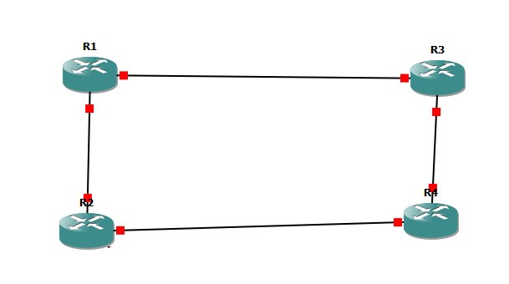
Figure 2: GNS3 topology
The idea is to have one protocol per router; R1 and R2 for RIP and EIGRP of IPv4, and R3 and R4 represent RIPng and EIGRP of IPv6. The reason why GNS3 was chosen to complete the project is that it is popular among research material and was judged to be easily adaptable to use without prior experience. It also allowed for simple creation of the network topology, which encompassed four routers (one for each protocol) being connected.
The reason for this was that it would allow for clear separation between protocol and achieve clear results, while also being able to share data if necessary and not increasing potential risks such as network flooding by adding too many routers and appliances. Another reason for the design was inspiration from the research material, namely the Al-Ani’s, who used GNS3 in their task. [12]

4.2 Implementation barriers
Examples of difficulties that were encountered during the implementation include having to download specific sets of routers to build the network topology. There was a wide variety of routers to choose from, so consideration was given.
Also, time had to be given to understanding GNS3, which had not been used prior to the task. This cut into time allocated for other tasks such as evaluation, but the program remained similar enough that the delay was not prolonged.
Consideration had to be given to using the software in several locations, as it links to a local server and can be therefore be rendered usable if the location is changed. To overcome this, the experiments will aim to use the same server throughout, and preferences will have to be updated if locations change.

4.3 Design choices
The IP addresses (192.168.1.1, 192.168.2.1, and 2001:DB8:ACAD:B::1/64) were chosen due to experience with past lab work and easy integration with the protocols. From the available list, the Cisco 7200 router was judged to be the one that would perform most efficiently due to experience and familiarity.
Each router will be opened via a command prompt and carry out configuration (written commands) chosen by the author to test how well each protocol performs in a suitable category. The chosen categories will result in an odd number so a definitive conclusion can be reached, and the results will then be listed and a conclusion will be established. An example model was created for the interim viva and inspired the final creation of this task by being able to fulfil the experimentation objective.

CHAPTER 5 – EVALUATION

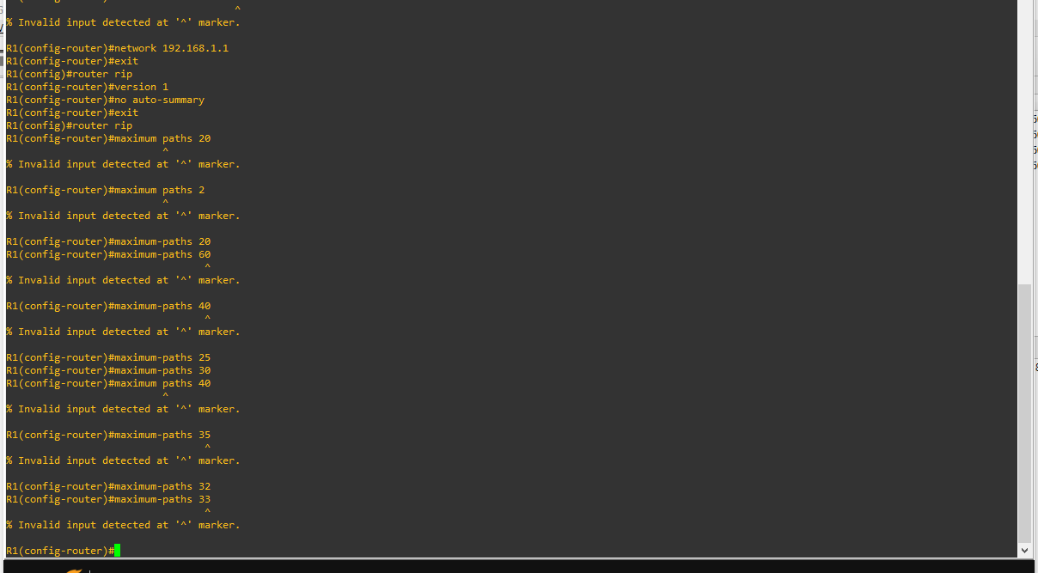
Figure 3: Experimental sample

5.1 Research material main points
The following are the main points to take away from the six selected research papers:
Chauhan and Sharman/Mohammad, Abusukhon, and Al-Maitah/Syed and Ambore – RIPng is best-performing protocol, so should be most secure
Al-Ani’s – IPv6 performs better
Buldu/Tadayoni and Henten – IPV6 is more secure

5.2 Experiment results

5.2.1 Route summarization
Route summarization is the process of merging network addresses together into a single group. [20] This can simplify a network, but there is an increased change of forming paths that the user finds insufficient. This task will be about how easy it is to disable the process with the command “no auto-summary” and increase security by giving the user the option of whether to do so.
Can the four protocols disable route summarization?
RIP | No
EIGRP for IPv4 | Yes
RIPng | Yes
EIGRP for IPv6 | No

The results for this are unusual, with two protocols out of four (one from each version) being successful. RIP cannot auto-summarize as it is a classful protocol (which cannot merge addresses). RIPng can arguably auto-summarise the easiest, sharing the praise it has received from Chauhan and Sharman [11], Mohammad, Abusukhon, and Al-Maitah [13], and Syed and Ambore. [14] However, it is disabled by default on EIGRP for IPv6. In this regard, the author would give the advantage to IPv4.

5.2.2 Bandwidth
Bandwidth is how much storage a network is capable of handling. This is an important network measure that can have an impact on security if not consistent. RIP does not allow the ability to adjust bandwidth, while EIGRP can be configured with the “ip bandwidth eigrp percent.” The author would give the advantage to IPv6 in this category due to it being more recent and having more potential to grow, in this case concurring with the Al-Ani’s [12] and Tadayoni/Henten. [16]

5.2.3 Encryption
Encryption is how much storage a network is capable of handling. This is arguably the most important factor in determining security, as it can control measures such as passwords. While no methods are present on RIP version 1, EIGRP allows users to both encrypt standard-text characters or apply a process named MD5 (which can protect values up to 128-bits.) RIPng, meanwhile, depends on IPSec, the built-in framework which outlines its operation. [21] For this category, the author would argue that version 6 is more secure, since IPsec can help balance out the risk of MD5 becoming outdated, landing it three main methods to version 4’s two.
Overall, while version 4 is deemed to have the edge in auto-summarization, version 6 is judged to be more secure with bandwidth and encryption.

CHAPTER 6 - CONCLUSIONS AND RECOMMENDATIONS

6.1 Conclusion
Overall, the hypothesis was answered; Internet Protocol version 6 was deemed to be more secure than version 4 and the author believes that it would benefit from more worldwide promotion to help it deploy more often and in a safer manner. However, the author now has a firmer understanding as to why version 4 has remained the superior protocol, mainly due to its simplicity and the remaining issues that version 6 has such as fragmentation.
The objectives were met as best as possible, and the pre-task predictions turned out to be true, though the specific details such as auto-summary being deemed better for version 4 remained a surprise. There is room for improvement in future tasks, such as more planning before starting to ensure less delays, but areas such as intuition and presentation skills have been improved.

6.2 Recommendations
For a future project, areas that can be explored can include the original project idea of performing a detailed analysis between network categories such as jitter (the overall network delay time) and throughput (the overall storage amount). This idea was scrapped due to time restraints. Other protocols such as OSPF can also be applied, due to the lack of data that RIP version 1 produced. This way, it can be discovered if the results would have turned out differently and/or strengthen understanding of these areas. Also, using a software that was new prior to the task means that there is area for further improvement and usage.
While networking tasks are normally experiment-based, as knowledge continues to grow, other types such as case studies can be considered (or at least an inclusion of more inductive data). Lastly, experimentation could be performed as a draft first to ensure at least a blueprint can be worked off from. This will save time for other tasks and improve planning skills.

CHAPTER 7 – REFLECTION

7.1 Project plan
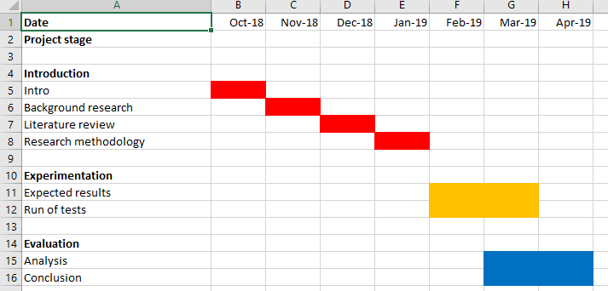
Figure 4: Original Gantt chart
The original chart was divided by month. The original intentions were to complete every introductory section by January, conduct experimentation in February and March, and complete analysis throughout March and April. After the interim viva, this plan was expanded to include a more through view of the plan.
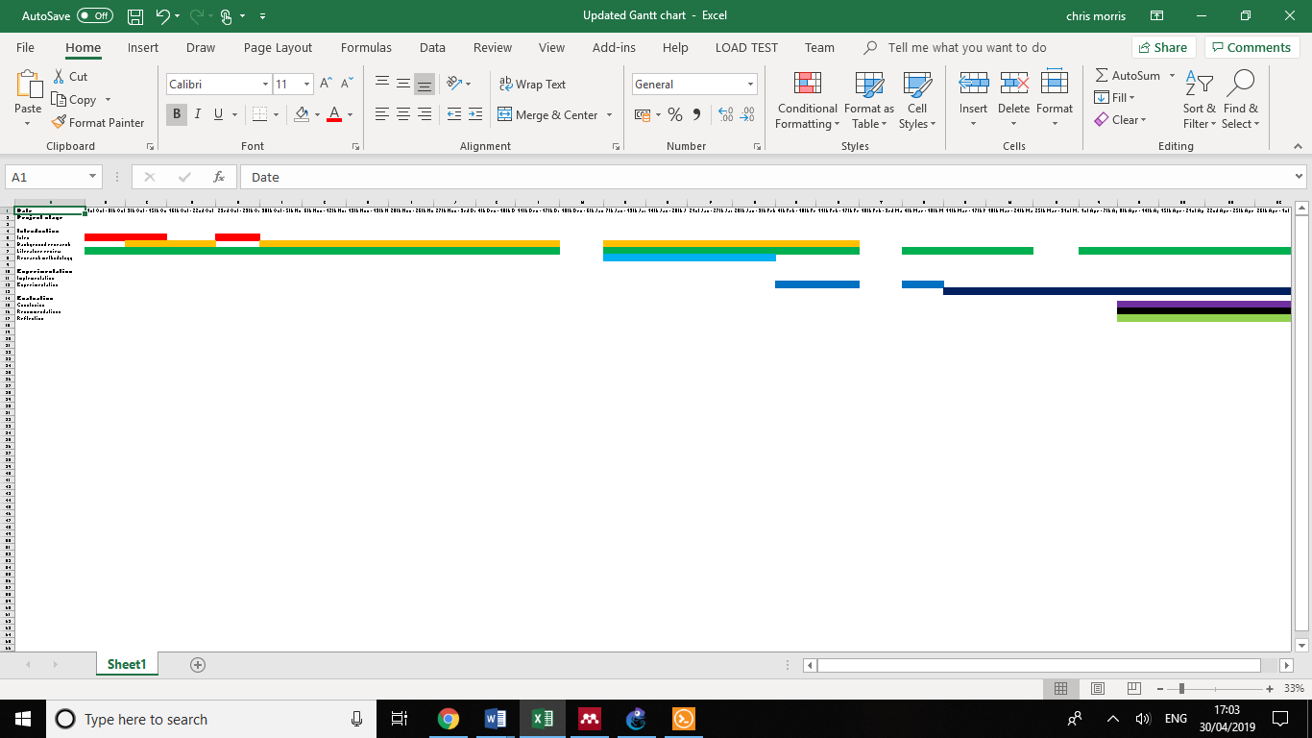
Figure 5: Updated Gantt chart
As the project developed, the plan was adjusted to reflect weekly progress instead of monthly. The introduction was still completed as quickly as possible, but the literature review was expanded to occur across the entire duration of the project and complete the analysis.
After a break period for Christmas, methodology took place throughout January. After beginning implementation in February, it served as a rest period to re-evaluate the task. After tidying up the project in March, the author decided to cut down the task due to time restraints and variety to answer one main question instead of testing several categories. Experimentation and the conclusion then took place throughout April.
In future, having more research papers, as well as having them at an earlier point, will allow more time to comprehend their results. Other factors that cut into time include choosing a new software, though having this in mind early as a back-up shortened this delay. Overall, following a plan requires improvement in future (e.g. sticking to deadlines more strictly to avoid falling behind on other tasks).

7.2 Personal reflection
In terms of personal development, the project has benefitted in terms of setting realistic expectations. In future, fewer and more specific targets could be made to ensure that they are all completed, and then added to if extra time was left. Also, when splitting the objectives into sub-objectives, they could next time be divided into area of importance. This way, the most vital tasks are performed first and worked on the most followed by extra tasks, increasing efficiency.
However, one area of the task that went well was considering what to as a back-up strategy if the original measures put in place did not suffice. These include what software to choose if the first choice, Cisco Packet Tracer, could not perform the experiments. This is an aspect that will aim to remain consistent in future.
Another positive aspect of the task was the interim viva, where knowledge of the subject had to be demonstrated via a presentation and questions. The presentation was scored positively due to self-confidence, and then went on to be built on with meetings with the supervisor, which were held as often as possible.
Also, as GNS3 was software that the author had not known about prior to the task, flexibility was crucial to succeed. The author adapted quickly due to prior knowledge and intuition and benefitted from being out of their comfort zone. Though, in future and as stated, experience should be gained before choosing the required programs.
Leading on from intuition, the original inspiration of the task was to perform an analysis between a variety of network categories such as bandwidth and jitter to discover which protocol performs better. However, this was changed due to time restraints and belief that it would not make the project stand out enough. Some of the categories instead formed sub-questions to answer the main question. This can be considered both an advantage and a disadvantage; more decisiveness and prior planning will be required in future, but adapting on the spot to make the task achievable is a positive.
If another experimental task is undergone, it would be more beneficial in future to ensure that enough experience has been achieved with the chosen hardware/software. In this case, GNS3 was chosen and had to be tested during scheduled time on other areas of the task. Prior planning beforehand will prevent this in future and ensure both that the task can be achieved and that the overall plan is stuck to in a better manner.

CHAPTER 8 – REFERENCES

[1] A. Ali, “Comparison study between IPV4 & IPV6,” 2012.
[2] Slideshare, “Ipv6^ new.”
[3] Network Innovations, “Broadband Global Area Network,” no. 403.
[4] I. Fiţigău and G.Toderean, “Network Performance Evaluation for RIP, OSPF and EIGRP Routing Protocols,” no. 26, 2013.
[5] S. L. Levin and S. Schmidt, “IPv4 to IPv6 : Challenges, solutions, and lessons,” Telecommunications Policy, vol. 38, no. 11, pp. 1059–1068, 2014.
[6] A. S. Survey, P. Wu, Y. Cui, J. Wu, J. Liu, and C. Metz, “Transition from IPv4 to IPv6 :,” vol. 15, no. 3, pp. 1407–1424, 2013.
[7] O. Babatunde and O. Al-debagy, “A Comparative Review Of Internet Protocol Version 4 (IPv4) and Internet Protocol Version 6 (IPv6 ),” vol. 13, no. 1, pp. 10–13, 2014.
[8] D. G. Chandra, M. Kathing, and D. P. Kumar, “A comparative study on IPv4 and IPv6,” Proceedings - 2013 International Conference on Communication Systems and Network Technologies, CSNT 2013, pp. 286–289, 2013.
[9] F. Golkar, T. Dreibholz, and A. Kvalbein, “Measuring and comparing Internet path stability in IPv4 and IPv6,” 2014 International Conference on the Network of the Future, NOF 2014, 2014.
[10] O. J. S. Parra, A. P. Rios, and G. L. Rubio, “Quality of service over IPV6 and IPV4,” in 7th International Conference on Wireless Communications, Networking and Mobile Computing, WiCOM 2011, 2011.
[11] D. Chauhan and S. Sharma, “Performance evaluation of different routing protocols in IPv4 and IPv6 networks on the basis of packet sizes,” Procedia Computer Science, vol. 46, no. Icict 2014, pp. 1072–1078, 2015.
[12] D. R. Al-Ani and A. R. Al-Ani, “The Performance of IPv4 and IPv6 in Terms of Routing Protocols using GNS 3 Simulator,” Procedia Computer Science, vol. 130, pp. 1051–1056, 2018.
[13] Z. Mohammad, A. Abusukhon, and M. A. Al-Maitah, “A Comparative Performance Analysis of Route Redistribution among Three Different Routing Protocols Based on OPNET,” International journal of Computer Networks & Communications, vol. 9, no. 2, pp. 39–55, 2017.
[14] M. Syed and I. Y. Ambore, “Performance Evaluation of OSPF and RIP on IPV4 &amp; IPV6 Technology Using G.711 Codec,” International journal of Computer Networks & Communications, vol. 8, no. 6, pp. 01-15, 2016.
[15] A. Buldu, “IPV4 / IPV6 security and threat comparisons,” no. December 2010, 2014.
[16] R. Tadayoni and A. Henten, “Transition from IPv4 to IPv6,” no. July 2012, pp. 1–19.
[17] Onion Derby, “Outside of the Onion.”
[18] P. D. Schwaferts, “Applying Saunders Research Onion,” pp. 1–15.
[19] J. W. Creswell, Educational Research: Planning, Conducting, and Evaluating Quantitative and Qualitative Research. 2012.
[20] Cisco, “Configuring RIP - Chapter 22,” pp. 1–10.
[21] Ciscopress, “Configuring the Enhanced Interior Gateway Routing Protocol.”

APPENDICES
Logbook
31st October 2018
- Prioritize Introduction, work on that for next few weeks
- 2nd chapter is lit review, need section on related work
- By next week, complete aims (one clear statement about project) and objectives, and any background work (why the project is necessary, what is it, how, expectations)
- Up until Christmas literature review is the focus.
8th November 2018
- Split intro into sub-headings
- Outline aims and objectives
- Come with one hypothesis to form research question
22nd November 2018
- Cut down sections
- More background information (advantages, disadvantages etc.)
- Find related work
- Focus on comparison for lit review (4,000 words including related work)
- Look at past projects in IEEE library
13th December 2018
- Finish lit review
- Prepare for interim viva
21st January 2019
- Add more sub-headings
- Substantially add to research section
- Change lit papers to be more specific
14th February 2019
- Create network topology
- Need more research
- Need more methodology
7th March 2019
- Experiment with GNS3
- Finish research
21st^{th} March 2019
- Evaluate availability of Cisco Lab during Easter as backup
- Finish implementation section

