Turbo Charger Analysis
M5X02200
BSc Motorsport Engineering
UWTSD
Daniel Salathiel
P149609

Contents Page:
- Introduction.
- Background Literature.
  - Design of Turbocharger systems.
  - Intercooler Design.
- Turbocharger Methodology.
- Turbocharger application methodology
  - Turbonetics 62-1 compressor.
  - Turbonetics T3 ‘’Super 60’’ Turbocharger
  - Turbonetics T04B Turbocharger
  - Turbocharger map number 4 (No name).
  - Intercooler Calculations and Design.
- Analysis.
- Conclusion.
- Bibliography.

- Introduction:
The focus of this report will investigate in detail how the application of forced induction using a Turbo charger can increase the efficiency, and volumetric flow of a vehicles engine. The report will investigate a specific engine application, using calculations to determine the correct compressor. Through these calculations an informed decision on what compressor is suitable for the application can be decided. This decision will be determined by the limitations and efficiency on the different compressor maps, and how it compares to the naturally aspirated volumetric flow.
The goals of this report are to calculate and utilise the needed data to concisely determine the correct Turbonetics compressor for the engine being analysed. I will be carrying out an analysis of a V8 spark ignition, four stroke engine. An informed decision will be made on the data produced to give a clear understanding of what type of turbo should be used to get the best efficiency and drivability out of the engine selected. From this data a suitable intercooler will be chosen for the application using further calculations. Once the turbocharger and intercooler is selected, a conclusion based on the findings can be drawn.
- Back ground Literature:
On a turbocharged engine the air intake is already compressed before entering the engine. Increasing the volume of air that can be drawn into the combustion chamber compared to naturally aspirated engines. Naturally aspirated engines rely on the ambient pressure to intake the air needed for the combustion process.
This is stated by bwauto:
‘’The engine aspirates the same volume of air, but due to the higher pressure, more air mass is supplied into the combustion chamber’’.
This means that the engine can utilise more fuel due to the increase in air available, thus more fuel can be burnt increasing the power output of the engine.
(bwauto, 2002, p1)
Put simply, a turbocharger is an air pump like the engine itself. But takes ambient pressure and compresses it to a higher than atmospheric pressure and delivers this to the inlet of the engine. A turbocharger uses the waste gases expelled from the engine, which are directed over the turbine of the turbocharger instead of escaping through the exhaust. This in turn drives the impeller that compresses the intake air.
(Turbodynamics, 2018, p1)
The internal cross-section and components for a twin scroll can be seen in the figure below:
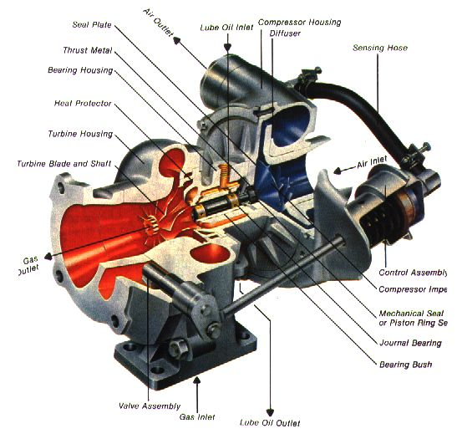
Figure 1: Internal diagram of a Turbocharger (turbokit101, 2018)

2.1 Design of Turbocharger systems:
The combustion process of an engine can cause adverse effects on turbocharges due to the nature of the cycles, which is discussed by turbodynamics.com, 2018 below:
‘’ The cylinders inside an internal combustion engine fire in sequence (not all at once), so exhaust exits the combustion chamber in irregular pulses’’.
Conventional twin scroll turbo chargers which will be used for this report, route these irregular pulses in a path over the turbos turbine in manner that causes them to collide with each other. Gathering the energy from pairs of cylinders to smooth out the pulses produced.
Once the exhaust gases have passed through the turbine side of the turbo charger the gases then flow through the outlet into the exhaust system of the vehicle. Passing through the catalytic converter, before exiting through the tail pipe to atmosphere.
On the compression side of the turbocharger, the turbine powers the air compressor, which gathers the air at ambient pressure from atmosphere. It then passes through the compressor, being compressed up to 30% above atmospheric pressure. This means more air can be forced into the engine. The heat from the process of compression can have a detrimental affect and reduce the efficiency of the burn. Due to this process generating heat, the air must be cooled down before entering the engine. This is achieved using heat exchange in an intercooler system.
(Turbodynamics, 2018, p1)

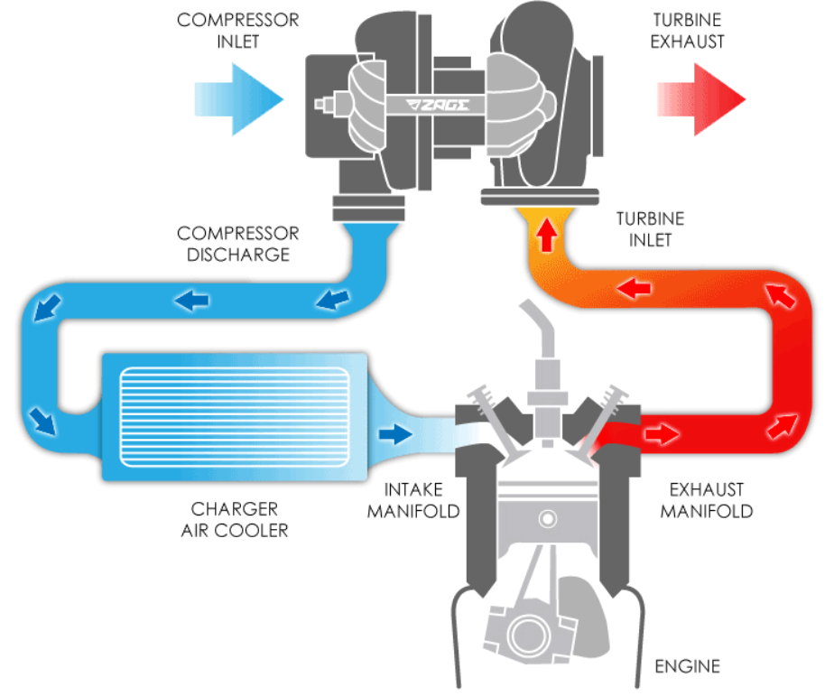
Figure 2: Turbo cross-sectional diagram (Turbodynamics, 2018).
The figure above shows the path of flow into the two parts of the turbo charger and where they travel.
The blue indicates the air flow from atmosphere, into the compressor, and then through the intercooler. Once it passes through the intercooler, the temperature of the air is reduced. This is due to heat exchange occurring, due to the external cold air passing through the intercooler fins and channels. The cooled internal compressed air then travels to the intake manifold of the engine.
The red indicates the exhaust gas flow. It shows how it travels out of the combustion chamber via the exhaust manifold, into the turbine, spinning the turbocharger up to speed. Then the gases exit via the exhaust via a down pipe and out the tail pipe to atmosphere after pollutant treatments.
2.2 Intercooler design:
There are two main types of intercooler design; air to air and air to water. Both using bodies of liquid to exchange heat. An intercooler is a component with in a forced induction system that acts as a heat exchanger. It is used to cool the air due to the relationship between pressure increase, and temperature increase being proportional. The hot air is less dense, meaning the less volume can be taken into the combustion chamber, thus reducing the amount of oxygen per unit volume. This means that there can be less fuel burnt, meaning a reduction in efficiency and power produced. The increase in temperature can also lead to predestination as supported by enginebasics.com online article.
‘’ Hot air also causes a higher cylinder temperature and therefore can aid in pre-detonation of the combustion cycle causing what we call, detonation.
(Enginebasics, 2018, p1).
Intercooler design has an important role on the efficiency of the heat being transferred. If the intercooler is too small or thin, it will become heat soaked. This is the process where the intercooler has too much hot air passing through it, with not enough surface area or clean flow to expel it. Therefore, it becomes inefficient and the air temperature is that of the turbocharger. On the other hand, too large an intercooler with a poor flow design can lead to pressure drops decreasing the efficiency of compression.

- Turbocharger methodology:
To gather a greater understanding of the workings of a turbocharger, a tear down of a turbocharger used on the Ford Eco boost twin scroll application was carried out. The process is as followed:
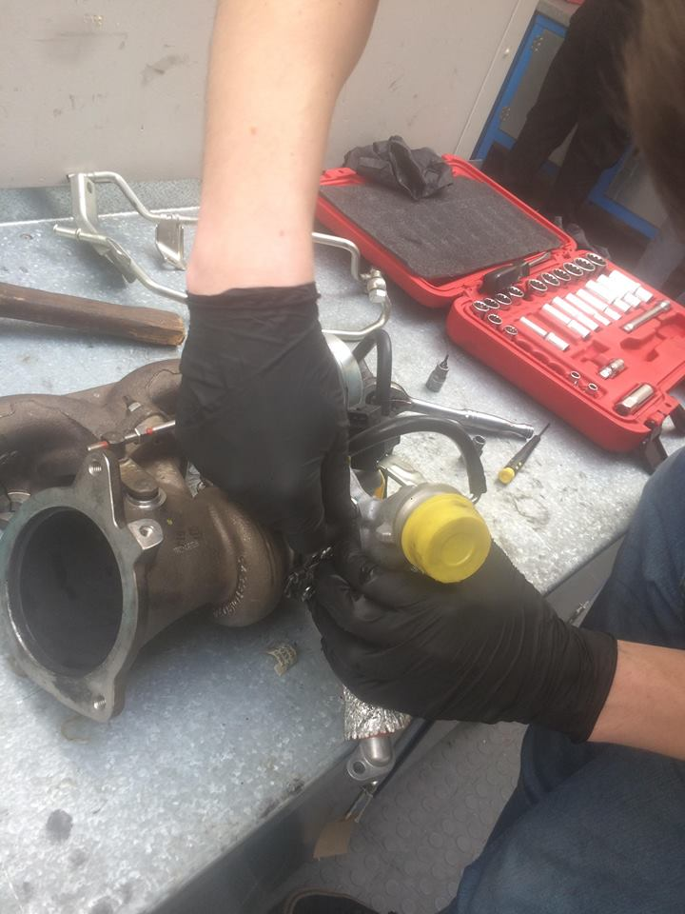
The oil feed lines need to be removed first to gain access to the relevant bolts and fixtures to dismantle the turbocharger. The removal of the waste gate control arm is essential to allow for the free movement of the intake casing of the turbocharger. Shown to the right in figure 2, highlighted by the red circle.
Once the waste gate control arm retaining nut is removed, the casing 10mm bolts can be removed to allow the casing to be released. The is done while the centre clamp is still tight to allow the whole unit to act as leverage to remove the housing.
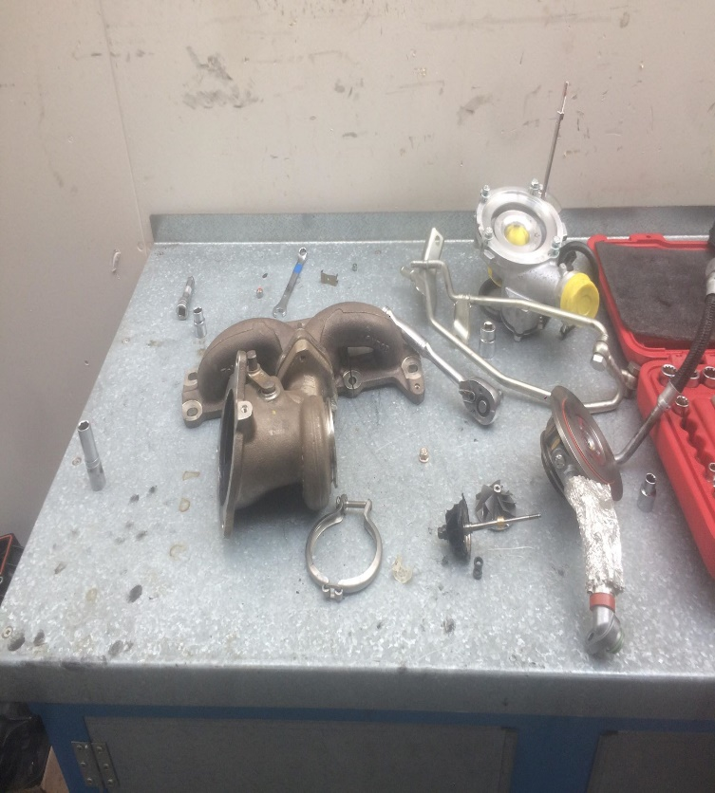
Figure 3: Turbocharger wastegate and intake casing removal.
Now the casing is removed from the intake compressor backing plate, the centre nut on the shaft is assessable for removal. The centre shaft must be removed before the centre clamp can allow the two housing plates to become separate. When removing the centre nut holding the impeller to the shaft, special care must be taken to ensure no damage is caused. This is due to the thread being an opposite thread, for self-tightening due to it tightening in the same direction as rotation. The nut should be turned clockwise (right) to loosen.
The shaft can now be removed once the impeller has been taken off. This is achieved by replacing the nut to protect the fine thread from damage, and lightly tapping the shaft, not to cause it to bend or disform. Once loose enough to pull out by hand, remove the nut and the shaft alike. The bearings from inside the centre casing will come out with the shaft. Be sure to note the order for re assembly
Figure 4: Right to left step-by- step of removal.
Now the inner tensioning clamp needs to be removed as seen in figure 3. This holds the right-hand side inner bearing and oil feed for the turbine shaft. As well as the heat shielding and backing plate for the compressor.
For the reassembly of the turbocharger, this process is reversed. Ensuring free movement of the shaft and bearings are placed correctly. Torque to spec where possible. Torque specs can be found in the service manual for the specific application.

- Turbocharger application methodology:
Based on the configuration and the specification. Calculations can be used to assess what would be the best turbocharger to use for the application. The Pressure ratio and cubic feet per minute can be calculated from the given specification of the engine. They are as followed;
The engine is a v8 spark ignition, with a redline of 9500rpm. The desired boost pressure of the turbocharger is 12 psi.
14.7 psi can be taken as the ambient pressure.

$$PR= \frac{14.7+Boost}{14.7}$$
$$PR=\frac{14.7+12}{14.7}=1.82$$
Calculation volumetric flow for the N/A Application:
$$V=\frac{v×nv×N}{2×60}$$

V = volumetric flow rate (m³/s)
v = total engine displacement (m³) = ?
η = volumetric efficiency = 0.85
N = engine speed (rpm) = 9500 rpm

First the Total engine displacement must be calculated:
$$v=πr^{2}×L$$
Bore= 95mm = 0.095m
Stroke= 80mm = 0.08m
So,
$$v=π{×0.0457}^{2}×0.08$$
$$v=5.67×{10}^{-4}×8$$

$$v=4.54×{10}^{-3}$$

Now that the displacement has been calculated, it can be inputted into the volumetric flow formula,
$$V=\frac{4.54×{10}^{-3}×0.85×9500}{2X60}$$
$$V=0.229 m/s^{2}$$

The value above gives the volumetric flow for the engine under N/A conditions. To calculate the volumetric flow for the Turbocharged setup in this report, the following equation must be used:
$$Vt=PR×\frac{v×n_{v}×N}{2×60}$$
PR=1.82
$$Vt=1.82×\frac{4.54×{10}^{-3}×0.85×9500}{2×60}$$
$$Vt=0.545 m/s^{2}$$

Converting to lb/min for the compressor maps:
1CFM= 0.07 lb/min
1 m/$s^{2}$= 2119 CFM
So,
$$0.0545×2119=1154.86 CFM$$
Converting to lb/min:
$$1154.86 ×0.07=80.84 lb/min$$
4.1 Graph Analysis:
@ 100% PR= 1.82 Vt= 80.84 lb/min Key:
@ 50% PR= 1.82 Vt= 40.42 lb/min Key:
@ 20% PR= 1.00 Vt= 20.21 lb/min Key:
Now that the volumetric flow for the engine has been calculated for the 12psi of boost pressure, the different compressor Turbonetics maps can be analysed. This will give a clear understanding of what is the most suitable turbocharger to use.

4.1 Turbonetics 62-1 Compressor:
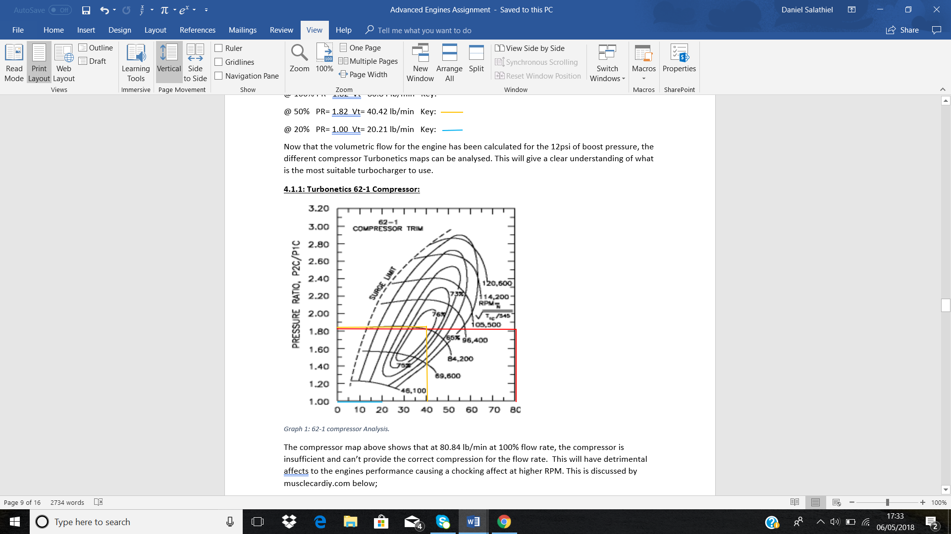
Graph 1: 62-1 compressor Analysis.
The compressor map above shows that at 80.84 lb/min at 100% flow rate, the compressor is insufficient and can’t provide the correct compression for the flow rate. This will have detrimental effects to the engines performance causing a chocking affect at higher RPM. This is discussed by musclecardiy.com below;
‘’The pressure ratio at a constant turbine speed will begin to drop off as mass flow rises to the point of choke flow, or where the compressor ceases to efficiently compress the air to a useable degree of adiabatic efficiency’’.
The efficiency at 40.42 lb/min at 50% is that of 76%, meaning at half the rpm rev range the compressor would be producing efficient flow rate to the engine. On the other hand, at 20.21 at a PR of 1.00 the compressor fails to provide the correct efficiency. This point on the graph is the idle of the engine, meaning the flow rate would cause the turbocharger to get confused and not operate affectively. Making the turbocharger not suitable.

4.2 Turbonetics T3 ‘’super 60’’ Turbocharger:
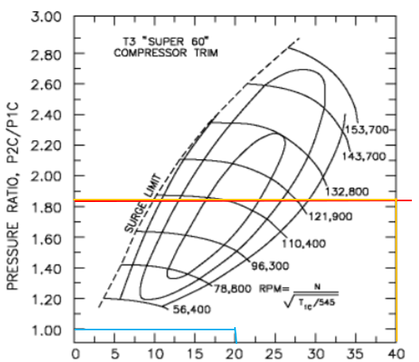
Graph 2: Turbonetics T3 turbocharger map.
As seen in the previous graph, the T3 turbocharger map graph shows that the turbocharger doesn’t provide efficient enough flow rate at full rpm as shown by the red line. The efficiency can’t be read. Neither can the 50% rpm range (yellow line) and the 20% at 1.00 PR which is displayed by the blue line. This means this turbo charger isn’t correct for this engine application due to its limitations in flow range and efficiencies.

4.3 Turbonetics T04B Turbocharger:
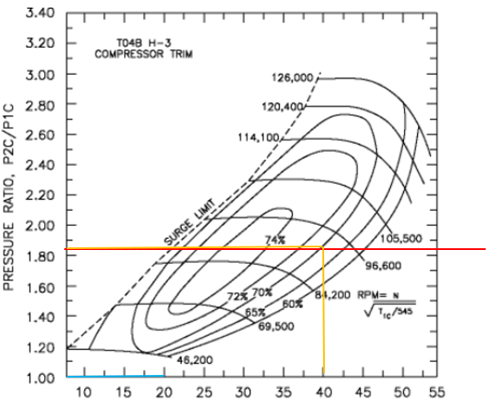
Graph 3: Turbonetics T04B Turbocharger.
The peak flow at 100% flow rate shown by the red line on the graph above shows that this turbo charger can’t provide enough volumetric flow for the engine application, which requires 80.84 lb/min. Due to the design limitations this would mean the engine would lose efficiency at higher rpm range. The map does display an acceptable efficiency of 70% for the 50% flow rate of 40.42 lb/min. At the 20% around the idle value, the turbo charger also doesn’t impede the surge limit meaning the turbo will run smoothly. But it would cause a high threshold waiting for the turbocharger to spool up enough for compression. This is described by the online article by roadandtrack.com.
‘’ the RPM at which a turbocharged engine can begin to push enough exhaust to start spooling up the turbo’’.
The turbocharger isn’t correct for this application.

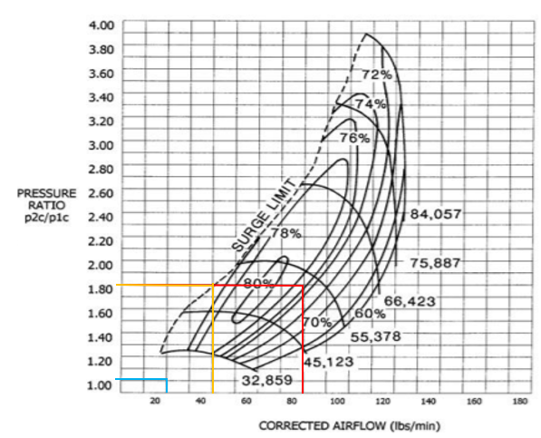
4.4 Turbonetics map number 4 (no name):

Graph 4: Turbonetics turbocharger map 4.
The map shown above unlike the previous graphs displays a high enough volumetric flow for the engine. This is shown by the red line on ‘graph 4’. The red line shows that at the 100% flow rate of 80.84 lb/min, the compressor at the 1.80 PR shows an 76% efficiency. This is more than enough to provide the correct flow at the higher Rpm ranges. At the 50% flow rate, which would be normal driving conditions for a road car, the turbocharger provides 74% efficiency, although very close to the surge limit, it doesn’t fall outside of the specified limit. This means there will be no negative affects caused to the turbocharger at 50% flowrate that would cause a negative performance characteristic. At the 20% flow rate at 1.00 PR, the turbocharger also doesn’t fall outside the surge limit. The compromise with this Turbocharger application, would be the threshold. But this wouldn’t affect the drivability of the car. This turbocharger is suitable for the engine specification.

4.5 Intercooler calculations and selection:
To give an understanding of the requirements for the design of the intercooler system, the compressor outlet temperature must be calculated.
$$T_{out}= {1.82}^{0.28}×27$$
$$T_{out}= 31.93 degrees celcius$$
Now that the Turbine outlet temperature has been calculated, the actual temperature rise needs to be calculated:
$$Actual Temperature Rise= \frac{({PR}^{0.28}×T_{in }}{n_{C}}$$
$$Actual Temperature Rise= \frac{\left({1.82}^{0.28}×27\right)-27}{0.76}$$
$$=6.49 degrees celcius$$
So, the actual increase in temperature is as followed;
$$=27+6.49 \\ =33.49 degrees celcius$$
4.2.1 Calculating the Intercooler Efficiency:
The equation for the intercooler efficiency is as followed;
$$ni=\frac{T_{co}-T_{io}}{T_{co}-T_{a}}$$

T_{co} = compressor outlet temp
T_{io} = intercooler outlet temp
T_{a} = ambient (inlet) temp
This equation can be rearranged to give the T_{io} (intercooler outlet temperature), this can be achieved due to the efficiency of the intercooler being given in the briefing.
$$T_{io}=\frac{T_{co}-n_{i}}{T_{co}-T_{a}}$$
$$T_{io}=\frac{31.93-0.60}{31.93-27}$$
$$T_{io}=6.35 degrees celcius$$

The sizing of the can be calculated by extending the following graph and extrapolating the size;
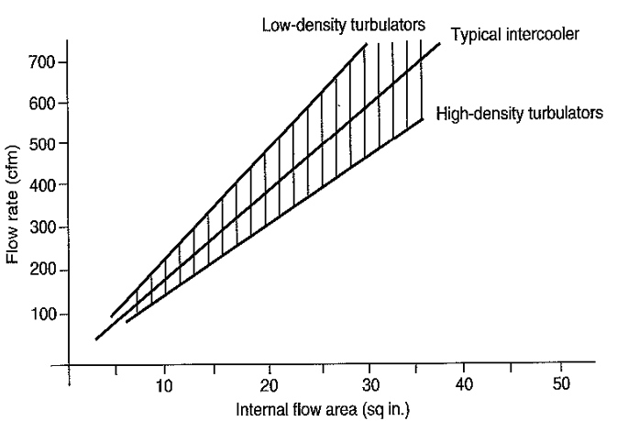
Graph 5: Intercooler cfm to square inch correlation.
The internal flow for the 1154.86 CFM was that of 56 square inches. From this the charge face can be found.
$$charge face= \frac{Internal flow area (sq.in)}{area available for air entry}$$
$$Charge face= \frac{56}{0.45}$$
$$Charge face=124.4 Sq.in$$
From this information the data shows that an intercooler at 60% efficiency can reduce the flow temperature from the turbine by 25.58 degrees Celsius. For this to be achieved the internal area must be 56 square inches in area, with an overall external area of 124.40 square inches if only 45% air flow coverage is available.

5.0 Analysis:
The turbocharger that was selected was the fourth map of the Turbonetics compressors. It was chosen for its efficiency at both the 100% flowrate of 80.84 lb/min, the efficiency at 50% flowrate of 40.42 lb/min and the efficiency of the turbocharger at the 20% flowrate of the engine at 20.21 lb/min.
For the 100% flow rate the turbocharger showed the best efficiency for the engine flow rate that was calculated. This was due to it being the only turbocharger that could provide enough compression to allow the engine to achieve its peak flow at 80.84 lb/min with a suitable efficiency of 76%. The other maps only provided enough corrected flow for the 50% flow which was 40.42 lb/min at 74% efficient. This allowed me to make an informed decision on the suitable turbocharger for this engine design. The flow rate falls inside the surge line, meaning the turbocharger will run efficiently at lower rpm, and will have preferred characteristics on idle rpm. This is at the 20% flow rate at 1.00 PR, which is clear of the surge line displayed. This will pre-long the life of the turbocharger and reduce the pulses from the combustion process. Meaning the turbo wont stall or surge. This application would be more suited to a motorsport environment due to the efficiency being greater at higher flow rates. A more suitable turbocharger for a road car would be lower and mid-range, with it starting to drop off towards the redline. This would make the car more drivable.
The intercooler design had to reduce the turbine outlet temperature to an acceptable temperature to maximise the density of the air being compressed into the inlet manifold. The intercooler has an efficiency of 60%, with a total exposed surface area of 40%. At this efficiency the intercooler reduces the temperature of the air from 31.98 degrees Celsius, to 6.49 decrees Celsius. This means the intercooler at 60% reduces the temperature by 33.49 degrees Celsius through heat exchange. The size of intercooler was chosen from the calculated flow rate of the boosted engine at 12psi. The graph below was extenuated to extrapolate the size of the intercooler.
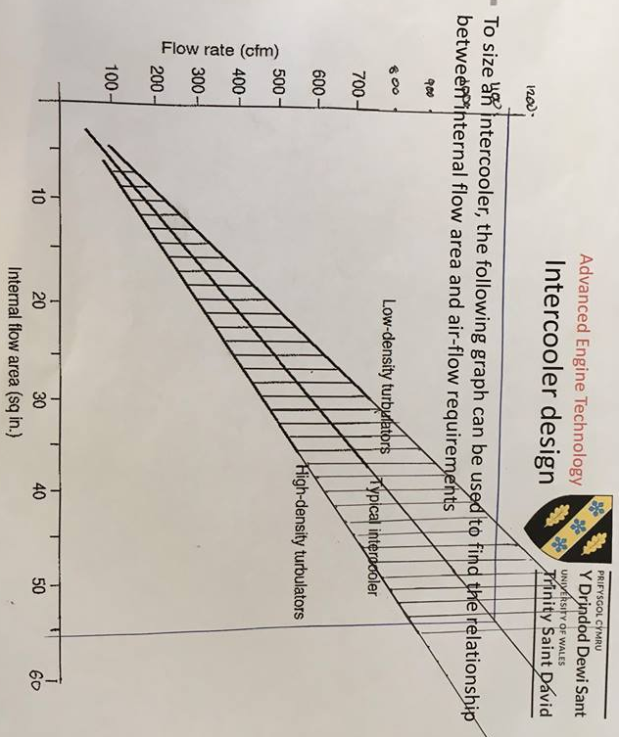
Graph 6: Intercooler sizing from CFM data.
For the percentage and the flow rate, the calculated internal sizing for the intercooler was 56 square increase. This is the internal surface area needed to cool the compressor outlet charge.
The charge face for the external surface area is that of 124.4 square inches, calculated from the percentage exposed and the internal surface area.
The intercooler plays a crucial role in creating a denser charge of air entering the engine, meaning the sizing calculations above are crucial, as supported by (car-techie.com) below;
‘’The rate of air flowing through the engine is only dependent on engine speed. As a result, the mass flow rate of air flowing through the engine is mainly dependent on the temperature of the air. At higher temperatures, the air is less dense and for the same volume, there is a smaller mass of air. The reverse is true for cold air’’.
Modifications to the current naturally aspirated design would have to be carried out to accommodate the turbocharger discussed. These modifications would include the use of a flange plate on the exhaust manifolds once they connect into one exhaust pipe. This means the turbo charger can be mounted in the exhaust stream powering the turbine, connecting to a down pipe to the exhaust system. Another altercation would be an intake pipe system connecting the outlet of the turbocharger to the intercooler, and then to the throttle body.

6.0 Conclusion:
The limitations of natural aspirated being restricted to ambient pressure draw can be overcome with the addition of a turbocharger forced induction. The increase in pressure means more efficiency and power can be produced
The findings of this report have help identify a suitable turbocharger for the V8 spark ignition four stroke engines. The conclusion was made from the calculated data for pressure ratio and charged flow rate at the ideal 12 PSI of boost pressure. The fourth turbocharger from Turbonetics has the ideal characteristics for the engine in this report. This is when compared to the other turbochargers that couldn’t produce enough flow for the 100% flow rate. The key characteristic of the Turbocharger is the 100% flow rate, 50% flow rate and 20% flow rate efficiencies are within tolerance. The efficiencies on the fourth flow map were acceptable for a motorsport application. It would allow for acceptable running of the engine at all throttle positions under load, or at idle. The higher efficiencies are higher up the rpm range, making the Turbocharger most suited to a motorsport environment. Coupled with the suitable intercooler and modifications discussed in the report, the intake temperature of the charge can be dramatically decreased. Improving the density of air being compressed into the engine increasing its efficiency and power outputs.
It has been made apparent by the findings in this report, that the efficiency of a Turbocharger will never be a hundred percent due to the nature of the design. This is due to energy loss due to friction, heat exchange and mechanical loss. A greater depth of analysis for these factors can only be realised with increased data on the turbocharger chosen. Once this data is analysed can a full picture of what the turbocharger would behave like in the real world can be seen. Although there is efficiency draw backs, the advantages of turbocharges outweigh the limitations of naturally aspirated intake flow. This is due to it being able to overcome the limitations of ambient air pressure, compressing the air to higher values. creating a platform for great improvements of power and efficiency of the engine overall. Concluding the process of selecting a suitable turbocharger and intercooler for the engine given.

7.0 Bibliography:
Car Techie (2018), Intercooler benefits, Available at: http://www.car-techie.com/engine.php?025 [Accessed on: 28/04/2018]
Engine Basics (2018) What is an Intercooler? Available at: http://www.enginebasics.com/Advanced%20Engine%20Tuning/Intercooler.html [Accessed on: 02/05/2018]
Jay, K, Miller. (2018) How to Match a Turbocharger to Your Engine: Step-by-Step Guide, available at;
https://www.musclecardiy.com/performance/match-turbocharger-engine-step-step-guide/ [Accessed on: 02/05/2018]
Bob Sorokanich, (2017), ‘’Turbo lag’’, Available at: https://www.roadandtrack.com/new-cars/car-technology/a14242489/you-might-not-actually-know-what-turbo-lag-really-means/ [Accessed on: 28/04/2018]
Borgwargner, (2002), Principles of Turbocharging, Available at: http://www.turbos.bwauto.com/products/turbochargerPrinciples.aspx [Accessed on: 04/05/2018]
Turbodynamics, (2018) How Does A Turbocharger Work, Available at: https://www.turbodynamics.co.uk/technical/understanding-turbochargers/ [Accessed on: 04/05/2018]
John, Hun. Turbocharger basics, Available at: http://my.prostreetonline.com/2016/04/22/turbo-kit-tech-101-turbocharger-basics/ [Accessed on: 04/05/2018]

