


Network Security (NS)

Case Study 1 with Solutions

Faculty of Applied Design and Engineering
School of Applied Computing
Mount Pleasant Campus
Swansea
SA1 6ED

- INTRODUCTION AND OBJECTIVES OF THE Exercises
In the lectures, you learnt about Port Scanning which is an essential factor in successfully protecting the network environment. Apply your understanding and knowledge from what you have learnt in the lecture and as well as conduct research using text books, library databases, and/or the Internet to do the following questions:

You are the Security professional for a company, you have used Nmap to scan the company network and obtain the scan result shown in figure 1.
Analyse the output and describe what services are running and what security implications these may have for this particular network.

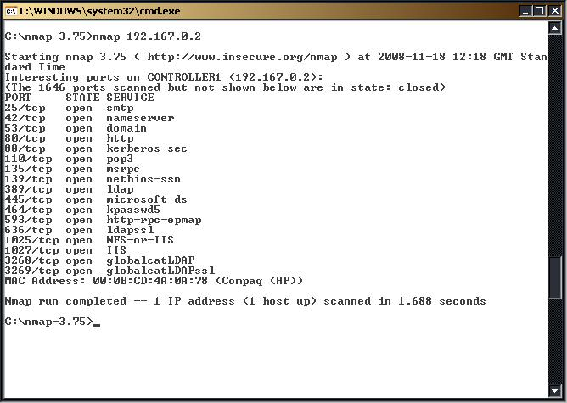
Figure 1: Output of Scanning Tool

Work in groups of two or three, Present your findings & understanding to the class.

Solution:
From the output of the scanning tool (nmap), it is clear that there are a number of ports open on this end system. The security implications vary depending on the service that is enabled.
The ports that are open are:
25 smtp
42 nameserver
53 dns
80 http
88 kerberos
110 pop3
135 msrpc
139 netbios-ssn
389 ldap
445 microsoft-ds
464 kpasswd5
593 http-rpc-epmap
636 ldapssl
1025 NFS-or-IIS
1027 IIS
3268 globalcatLDAP
3269 globalcatLDAPssl.

There are 17 ports open on the target system. This system is running SMTP (mail) through to a global naming service on port 3269. With this number of ports open a hacker will have seventeen ports to banner grab from. The weakest ports are likely to be the ones with the oldest versions of services (as they are more likely to be vulnerable). For example, the services running on ports 593 and 1027 are likely to be vulnerable. Both Microsoft's RPC systems and IIS services have been compromised and if appropriate versions they may be susceptible to vulnerabilities.

[Students may focus on other ports and vulnerabilities, which in general will be awarded mark for salient point.
However, marks are awarded for indicating that there are 17 ports open and this represents a significant range for an attacker to target.]

