An Evaluation on the Evolution of Web Design
universtiy of wales trinity st david
Research methods and professional development
Shamuel Hashan 1803153
2022

ABSTRACT
This masters research project will investigate the evolution of websites, which web design methods are most popular and emerging design methods. The purpose of this report is to provide insight on the plans for this project. Websites are very popular with almost every organisation requiring one. They have been around for a few decades and are used by more and more people. Since websites have been around since the 1990s, it is clear that the design of those websites would have gone through some changes. This report looks at what those changes are and how the websites then compare to the websites now. There is also an aim to find which design methods are the best to use so this various design methods will also be looked at as well as emerging design trends. The research gathered from looking at these will be used to create a website to further indicate how websites have evolved. This project will follow a phenomenological and a positivist research philosophy. The strategy being taken will be a deductive strategy. Several websites will also have a caste study done on them to evaluate the design methods used. This project will come with various limitations such as the time constraints, but they can be managed. To ensure the project is kept as ethical as possible only relevant information will be taken from participants in surveys and interviews. Surveys and interviews are to methods of collecting data for the project. There will also be a lot of documents hosting the relevant information being reviewed. The data being collected will be qualitative data. The software methodology that is being followed is the Agile development methodology. A few resources will also be required for the project. There will be a laptop being used, university computers could potentially be used and small screen devices such as phones to test the web pages responsiveness. Several software will be used throughout the project including VS code, Discord, Teams, Google Forms, Adobe Photoshop, OBS and Office applications such as Microsoft Word, PowerPoint, Excel and Project. The results from the survey should provide insight on which web design methods the participants prefer and their thoughts on web design. The interview participants will also provide their insight on how they view web design has developed. Various other participants will also give feedback on the development of the project and give their opinion on the final website being developed. Tests on the website will also be done. The project will end with an idea on which web design tools are the best to use, which emerging web design tools are going to be the most popular and how much has websites evolved.

INTRODUCTION
Accessing websites are almost essential for people live. Websites are used by everyone who can access the internet to help them with various tasks. They can be used to help contact people, do their banking, research information, play games or just browse various other forms of media as well as other things. It is very difficult to through life without using web pages. Since there is a big demand for websites, web developers will have to make their website stand out using different techniques to make their website look better than their competitors and that is done through web design which is what this project will be looking at in detail.
Web design has evolved a lot over the years. It has gone from a basic page that displays information to a well-designed page that displays information in a lot more presentable manner to the user as more and more design trends come up as time goes. One-page websites, mobile first websites, chatbots, voice activated interface and VR are a few examples of modern web design trends. Design trends have evolved a great deal over the years and that is what this study will be looking at. This also includes how web design software has also changed as well as the evolution of web design.
It is important to look at the evolution of web design as it will show how design trends have changed over the years and how it contrasts to the design of websites made now to the websites made before and it can help identify emerging trends in web design.
This can help organisations get ideas of which design methods they should use for their websites. This research will look at how different websites were in the 20th century and compare the quality pf those websites to the quality of the ones now. Some of the oldest websites will be looked at and then some modern websites that has used recent design trends. Research on the evolution of web design was done before by Dale Bonsor for Quibble in the 17th of April 2020. This was two years ago, and more design trends have emerged since then as the trends in web design are constantly changing. The study that will be conducted will enhance the knowledge of web design for patients as it will require research onto the various design methods in web development. Organisations policy on web designs as this research will include a lot of information on what good web design methods are.
There are many issues in web design such as finding which method would be the best one for users to follow. There are many websites out there that haven’t been designed well and don’t follow any trends. The research being done here will help them see more design methods that they can then implicate on to the websites they create. There are many issues found in current websites and that will also be looked at in this project. Examples of these are that websites might use outdated designs, stock images might be overused, some websites are not responsive for mobile devices or even designed too much resulting in the web pages being cluttered and messy. The research here would look at how these can also be avoided. There are various variables during the project. The independent variable would be the various methods used by many websites when it comes to designing web pages and the quality of websites from the past. An independent variable would the opinions on the various participants that would have had a questionnaire sent to them where they would review the various web pages and web design methods and provide their opinions on them. This will help identify which web design methods are their favourite and what attracts them to websites as the purpose of this project is to study how websites have evolved and what methods of web design are the best.
It is highly likely if not certain that websites would have evolved a great deal since they first came around and that they are continuing to evolve. There is a big chance that there will be many more emerging web design trends that are being used by web developers. The author believes that the best web design method will include Memphis design and that web sites would have evolved a great deal and will continue to do so.
During this project there will be various research that will be needed to be conducted to help come to a conclusion. One of the first things to be researched will be the first websites and how they looked. The date of their creation and the design will be looked at. The various website design methods will also be researched to look at what is being used by the best websites today. Surveys will be sent out asking users about their thoughts on how websites evolved and also which web design methods the prefer the most. The research used there would be used to then design a website using the design methods that were looked at. Software commonly used to design websites will also be looked at to see the evolution of that as well. This research should conclude with an idea of how much web design have evolved, the best methods used for web design, the various software used for web design and a website made using the methods researched.
This project could include a software development methodology as it will include the development of a website and a document review methodology as many documents and information will be looked at during the research.

LITERATURE REVIEW
Today there are over millions of websites however, the very first website that was created by Tim Berners-Lee. The creator of the first web browser and world wide web ma de a website called CERN in august 6, 1991. It also had the very first address for a webpage which was http://info.cern.ch/hypertext/WWW/TheProject.html. This European Organization for Nuclear Research used a NeXT Computer to run the website. This website presented information on how web pages can be created as well as providing more information on hypertext. [1]
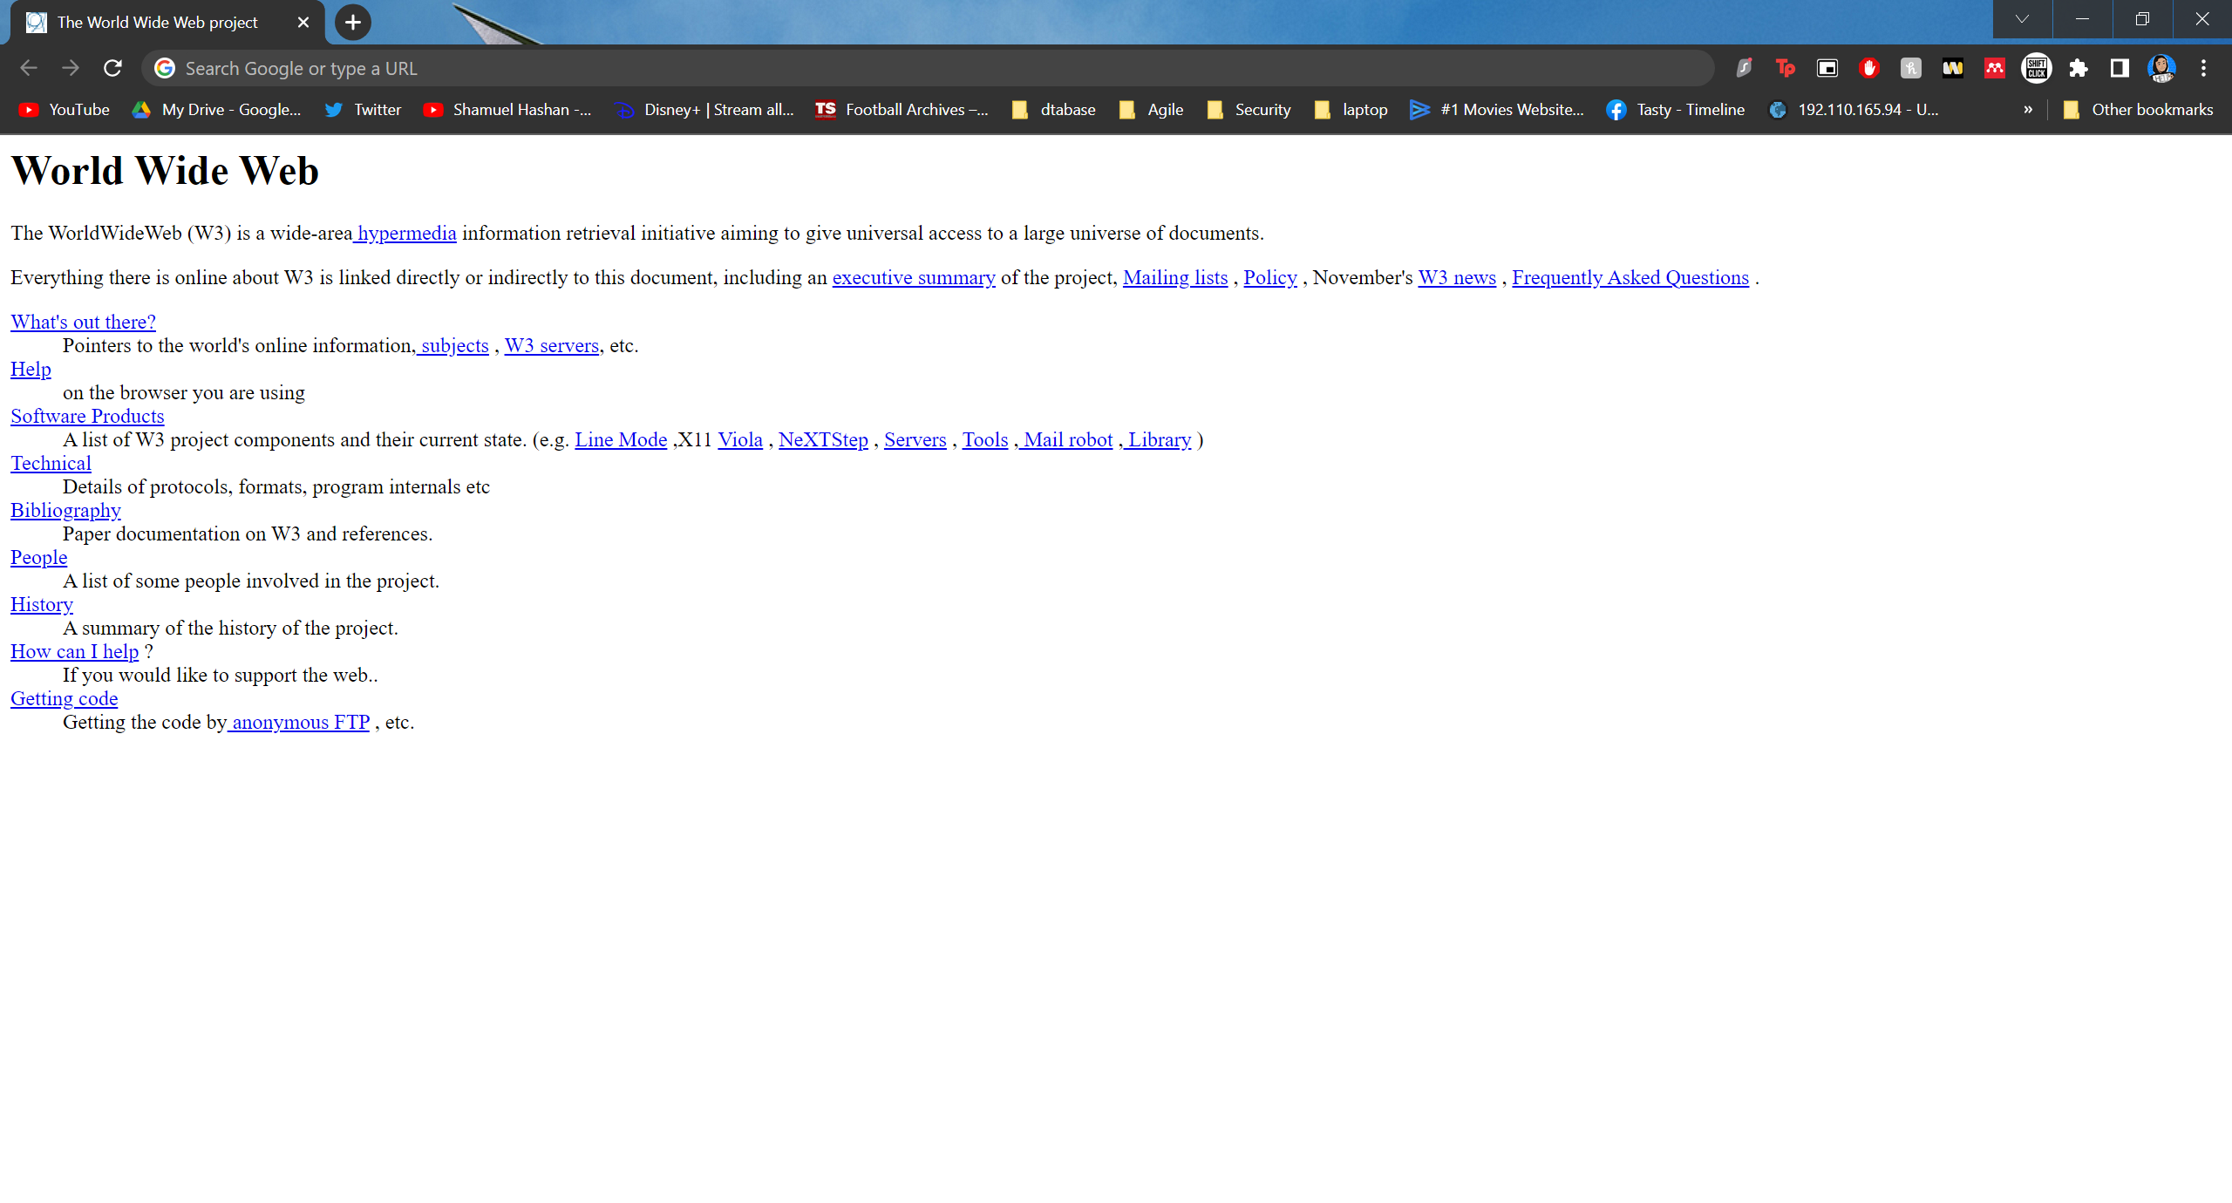
Figure 1: The very first website [2].
Figure 1 what the very first website looks like. It is very basic and doesn’t really have any styling or design. It is mostly just text. Styling was used for the heading to make the text big and bold and for links to underline the text and change the text colour to blue.
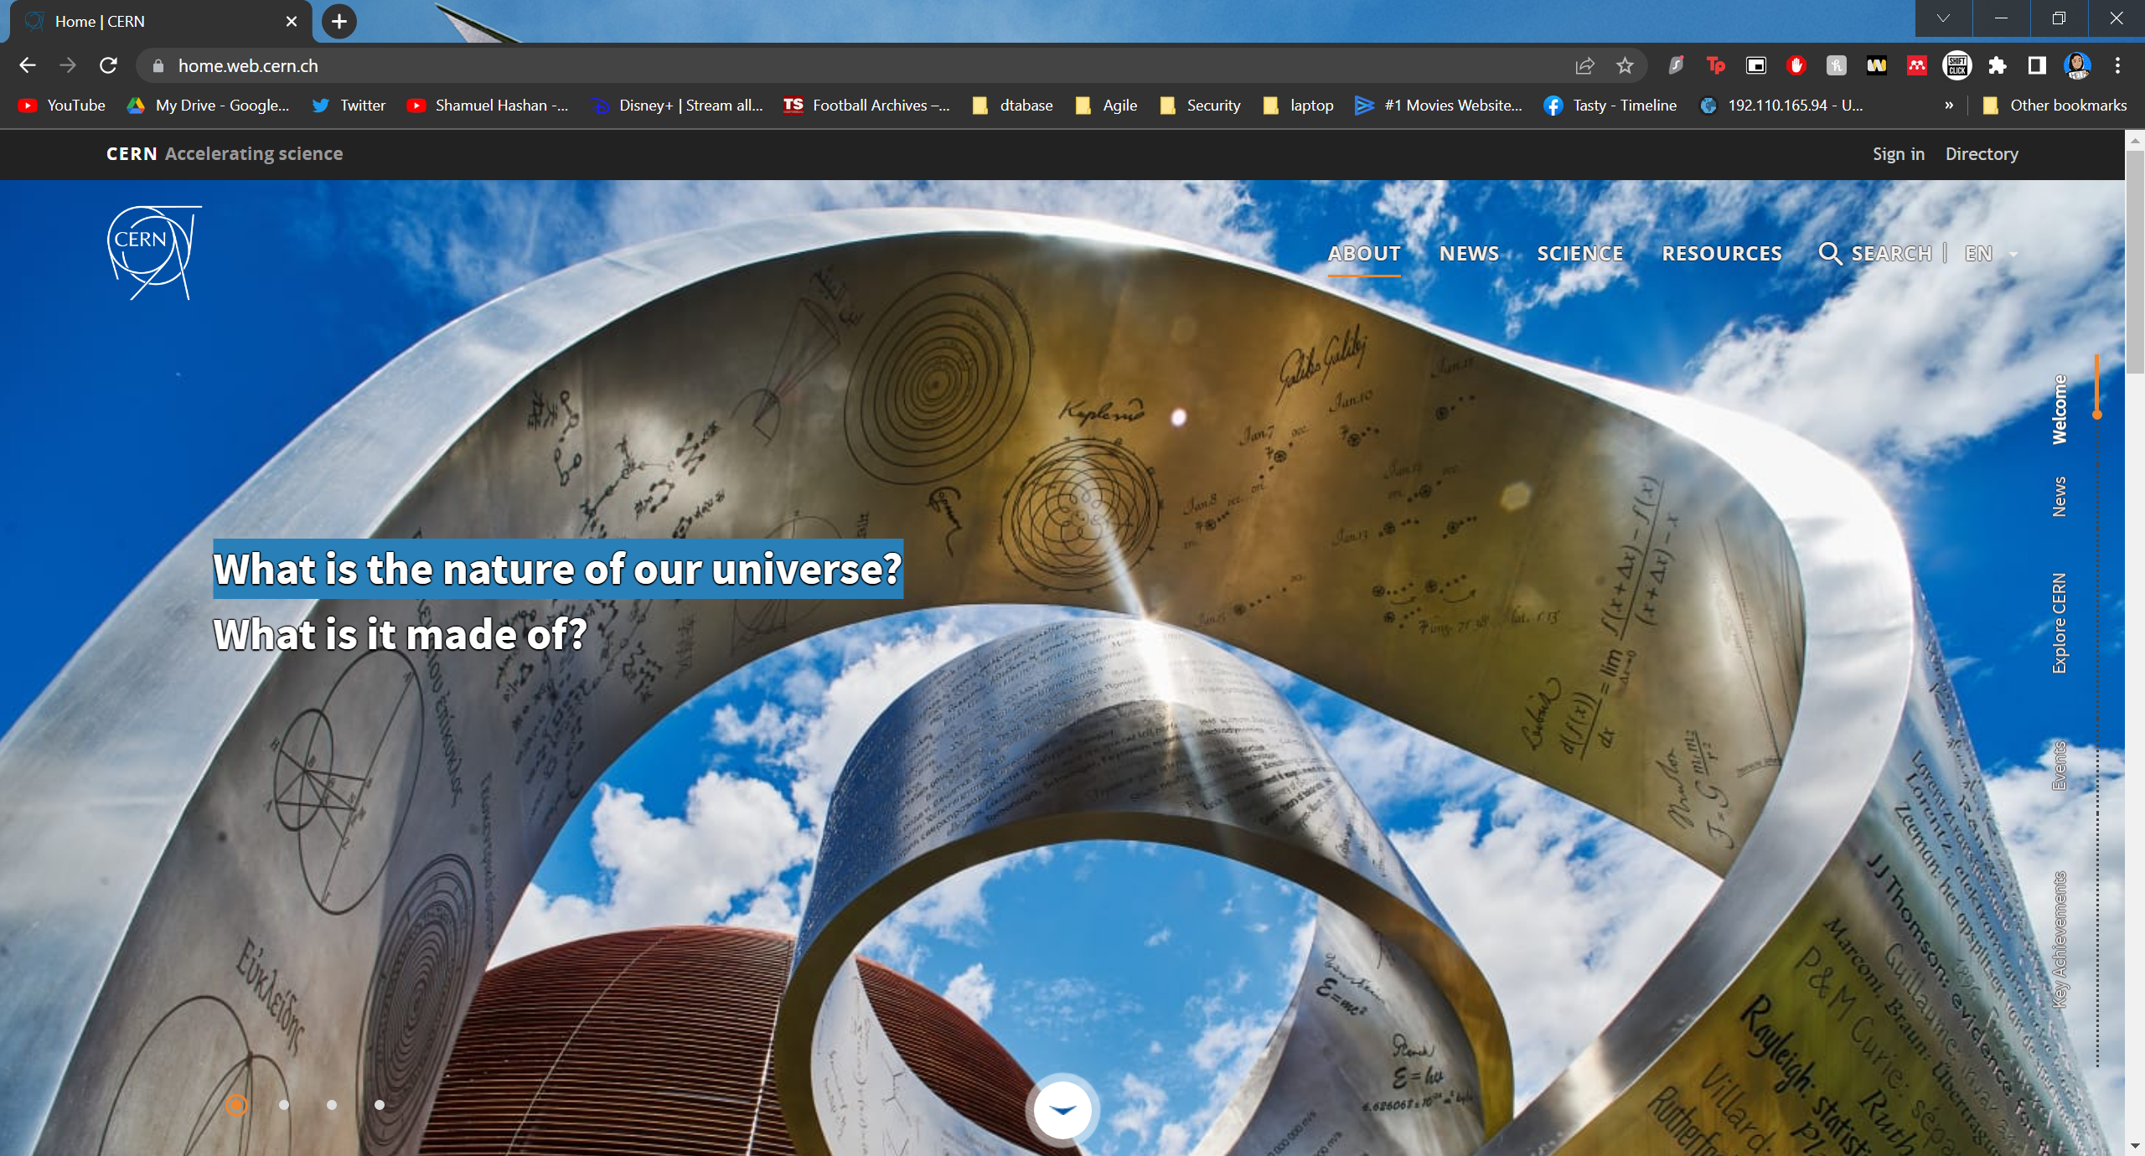
Figure 2: Modern CERN webpage [3]
The image shown in Figure 2 is a web page created by CERN using design methods used today. This website has much more features than the original page such as an image, navigation bar, a header and search bar.
Yahoo is a web service provider that has been around since 1996. This web services website has gone through various updates over the years.
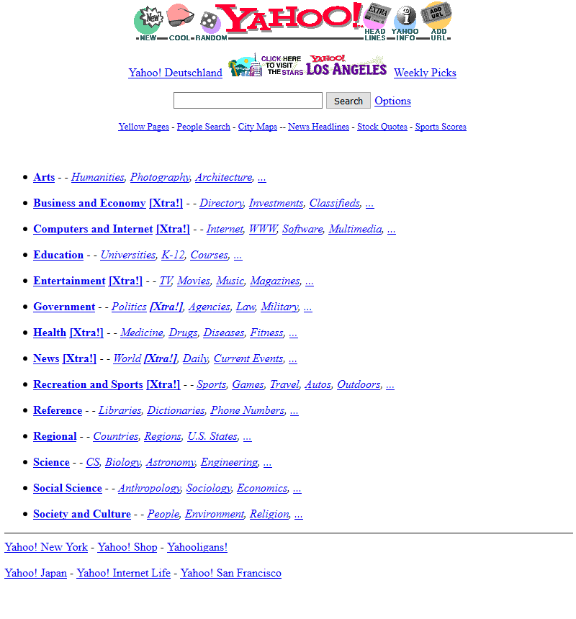
Figure 3: Yahoo 1996 [4]
Figure 3 shows that the Yahoo website in 1996 was very much text based but it did include a search bar and a logo.
Websites did introduce the use of tables in 1997 when the HTML 3.2 standard was introduced which allowed the numbers of options for web designers creating websites to increase and add structure to the websites as they used more features such as multi-column layouts to the web pages. The use of tables however did come with a risk of impacting the accessibility of websites while tabular data and the layout of a website could have used a table. [5]
The Yahoo website did go through some changes when it came to 2002 as shown in Figure 4.
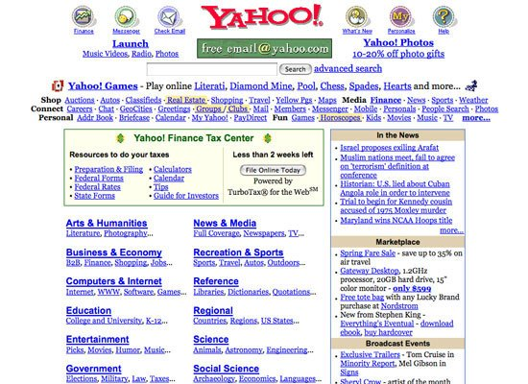
Figure 4: Yahoo 2002 [4]
The website here has included the use of tables and borders and more text colours. The layout of the website has improved drastically.
Macromedia shockwave was used by developers so menus could be made for the websites as well as various multimedia content for CD-ROMS. The shockwave files were large, but it was possible to play the shockwave files online due to broadband internet, but it was impractical for most as the dial up was the standard internet connection method.
Flash based web designs were developed in 1996. In the early stages of Flash, the tools used were basic, but it did grow to have more powerful tools that allowed web developers to use it to make an whole website. Web developers had a lot more possible options presented with Flash than what would have been possible with HTML as they were quite limited with the options in their design. Developers would use various table structures or spacer images before the introduction of flash. Flash has made it possible for websites to be interactive and use feature animation.[6]
Dynamic HTTML (DHTML) techniques became popular in between the late 1990s and the early 2000s. Various web technologies were found in DHTML. Examples of these would be JavaScript and server-side scripting. Making page elements more interactive or animated were popular and DHTML helped with that. This began the concept of users being able to view content that isn’t just static but allow then to view interactive content.[7] [8]
3DML was invented by Michael powers in 1996. This is a web design language that is used to create three dimensional websites. The files are written in a form of non-valid XML. One 3DML browser is Flatland Rover that has been developed independently. Internet explorer also did come with plugins that were available to use as well as plugins for AOL browser, Opera Netscape Navigator but the development stopped in 2005 which means there isn’t a plugin available for Firefox.[9]
CSS-based designs became popular in the early 2000s. It was available before, but the support provided by the major browsers were limited and a lot of web designers were not familiar with it. However, there a lot more advantages to CSS based designs over that of table-based or flash-based designs. The design elements and the content are kept separate in CSS which results in the web layouts visual aspect and the content being more distinct from each other. This is a better practice than table-based layouts for providing a layout for a web page. The markup clutter will also be reduced resulting in the layout of the web pages looking cleaner. The maintenance of the websites is also made easier with CSS due to the separation of the design and content elements. The websites look can be changed without the content being altered. The page response time of CSS based websites are faster than the response time of table-based designs due to the size of the files in CSS designs are normally smaller than that of table-based designs. There could be a bandwidth hit as users visit websites that they have not visited before as the stylesheets are downloaded for the first time. The user’s browser will cache the CSS by default which will allow the following pages viewings to be faster.[10]
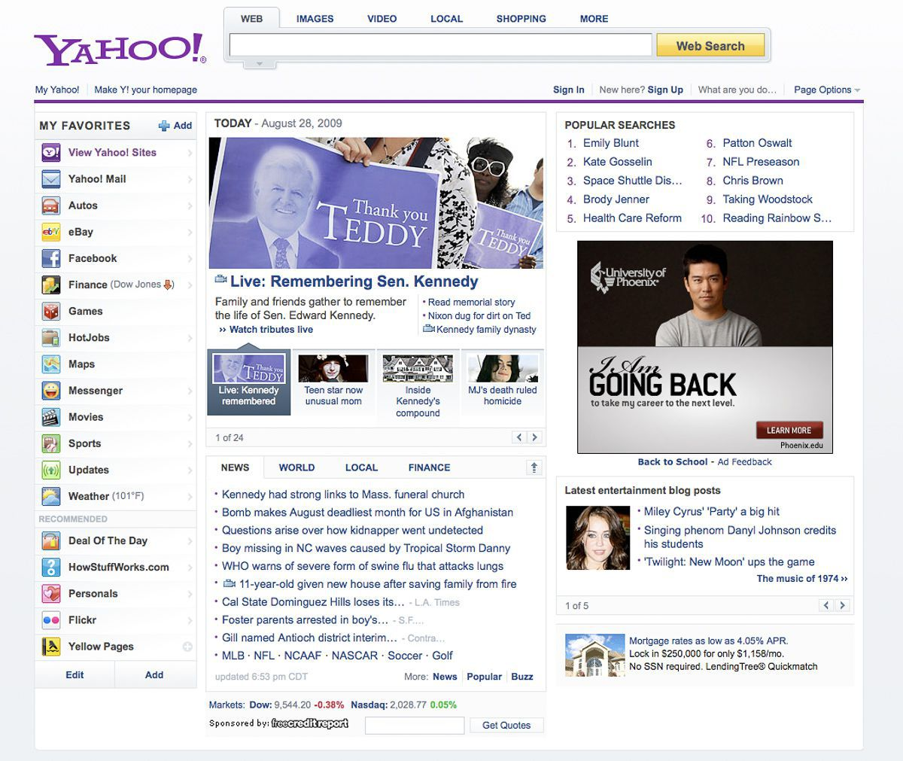
Figure 5: Yahoo 2009 [11]
Figure 5 shows that yahoo looks a lot better with the use of CSS. The overall layout is a lot neater and easier to read. The is a menu on the side, a search bar at the top and other links on the right with the main content in the middle. This is a layout followed by many social media pages today as shown in Figure 6.
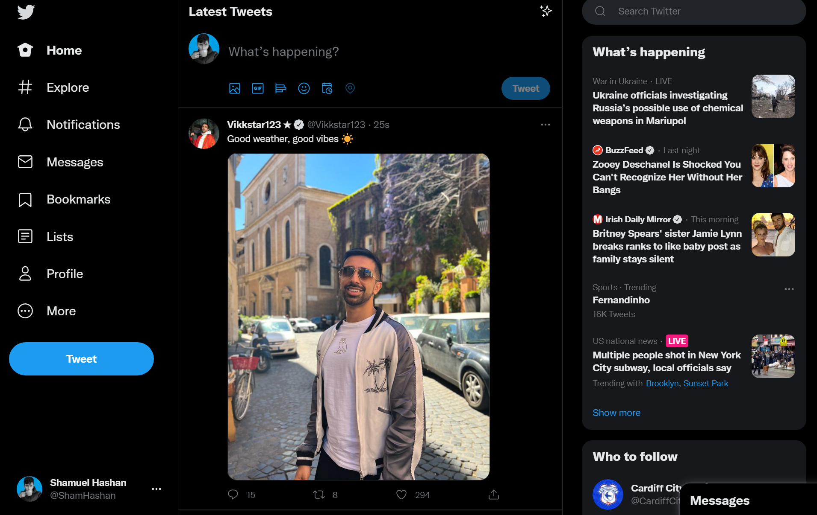
Figure 6: Twitter
Due to the rise in users using their mobile phones in 2010, web designers started to play with websites that would have responsive designs so the websites can be viewed more functionally on mobile devices. 2013 was labelled as the year of responsive design by Mashable and it was almost a necessity for majority of the websites to have a responsive design as opposed to having it as an extra addition as the number of users accessing websites from mobile devices are rising. It was recorded in 2020 that 50.88% of users accessing on webpages through mobile phones according to Telemedia online [12]. Websites have been designing the web pages to suit the needs of mobile users more. Examples of this would be the rise of vertical scrolling and centralised content. There are also more minimalist designs being made to fit the needs of the small screens of mobile devices. Responsive design is resulting in designers giving a web pages structure more thought. Large background images are also being put in websites with the text in front which can also lead to parallax scrolling[13]. Many websites now are also looking at creating mobile first design which is where the web pages are designed with the mobile devices in mind first as mobile devices might have a few restrictions that designers will need to overcome such as considering touch screen technology as most small screens are touch screen rather than a mouse where users would be using their hands to navigate through the website. These websites will then be expanded into desktop versions once the small screen web pages have been designed [14][15].
Another way web design has evolved is using frameworks. Developers have use sets of tools and resources to aid them in building and managing websites. Examples of what frameworks can do are that they can provide a template for websites that the web developers can follow to present information. Frameworks can also provide a script that can be used for a flow of information or use APIs to have data resources accessed.[16] There various types of frameworks. One of them are user interface frameworks. These frameworks would help websites to look more stylish and professional. They normally consist of having a type of grid system that aligns elements, they might also handle colour schemes. User Interface frameworks normally handle the front-end side of web development. Examples of what user interfaces would include are Bootstrap, Materialize, Foundation and Semantic UI.[16]
JavaScript is the language most front-end frameworks are written in. Frontend frameworks mostly used to organise the websites functionality and the interactivity. Examples of frontend frameworks are Angular JS, Vue and React.[17]
Backend frameworks vary a lot more as various of programming languages are used to write them and they include several different features. Examples of backend frameworks would be Django, Gin Gonic, Express, Laravel, Ruby on Rails and Flask. The programming language the code is written in normally determines the backend framework as well as the features needed for the website. [18]

METHODS

Research methodology
This project will be following a research methodology as this project will consist of a lot of research. This includes research on web design methods, history of web design, emerging web design trends, frameworks, and various websites. The history of web development will be researched so it can be compared to how much it has evolved in the present. The web design methods and the emerging web design methods will be researched to also compare to the past and see the difference in the websites. The information gained from researching this will also be used when it comes to developing a website for the project. Frameworks apart of the evolution in websites so they will be researched as there are many frameworks that provide various services, and they will each be looked at. This research will also help decide which framework to use for the website being made. Research will be done through looking through the web and reading articles and books on the topics. More research will also be done when sending questionnaires to the public to gather their thoughts on the evolution in web design as well as to gather information on their experiences with web design to help make a quality website.

Philosophy
This project’s philosophy is a bit of both phenomenological and positivist. It is a positivist approach in the sense that it is looking at the evolution of web development as it is very clear that web design has evolved a great deal as web design is constantly improving. However, this project will also look at the best web design trends and that is however is subjective which is where the phenomenological approach comes in. There are many web design method trends that users might prefer. Some qualitative research will be performed in this project too.

Strategy
This project also follows a deductive approach to this project. It follows a deductive research approach as this projects aim is to test the theory that websites have evolved a great deal over the years. It also will also follow a deductive approach as to finding out which web design method is the best to use for when it comes to developing websites. For both theories, research will be performed through looking at research and then performing tests with the information gained through the research. This project will use the research to make a website and share it with users to gather their opinion on the website and web design methods. There is a risk that the deductive reasoning doesn’t work if the premise is incorrect to start with.

Approaches
These approaches were chosen as they fit the needs of the project best. A case study will be done on various websites where the design methods used will be looked at as well as the overall quality of the websites design. Websites from various years will be looked at and compared to evaluate the evolution of web design. The data on good web design trends gathered from the research will then be used to make well designed website.

Limitations
There will be various limitations when it comes to completing this project. One of these limitations would be the time constraints as there are deadlines that will need to be met. Maintaining good time management and following schedules should help in not missing the deadlines. An external factor that would disrupt the project could be the pandemic. This pandemic has been very unpredictable, and COVID-19 is still being passed around meaning there is still a risk of catching it which could result in the author becoming too ill to do work for some time which would slow down the completion of the project. To reduce the risks of catching the virus measures will be made to remain safe. Another limitation would be the risk of losing internet access.
Most of the research is done online and not having access to good internet will slow down the research side of the project a great deal. The author is doing a lot of the work in the university campuses to ensure that the author has a good stable internet connection.
Another limitation would be that when it comes to completing certain tasks, it can be found to be too difficult. If this is the case, then the task would be researched and the author will look for help on forums or go to people who have a better understanding of the current task.
There is always a risk that the work that is done will be lost due to various reasons. This can bed due to human error such as forgetting to save or losing the drive in which the data is stored. The devices used for the project can also be stolen or the USB could get corrupted. The work will be backed up in three different locations to ensure the work is kept safe and will be backed up regularly.
There will also be legal limitations with the project. Numerous sources will be looked at for research phase of the project and there would be a risk of plagiarism if those sources were used and passed off as the author’s own work. The author will make sure to reference any sources used to ensure that no one’s work is plagiarised. All the work done will be done in accordance with the laws. One example law that the author will follow would be the copyright designs and patent act to ensure there are no legal issues as well as the author making sure they do a lot of their own work.

Ethics
There will be a few procedures in place to ensure this project is as ethical as possible. The ethical and legal polices will be followed. The participants on the surveys and interviews will be asked for consent and will be told everything they need to know. Only relevant information will be taken for the project from them. The only information about them they will provide is their age so the demographic can be captured. They will be informed that they can leave at any time for any reason before they start too. This project will also follow the British computer society code of conduct.

Validity, Reliability and Generalisability

Validity
The best way to investigate the hypothesis that websites have evolved a great deal is to look at various websites and versions of those websites from different dates. That way it can be shown how organisations improve their websites over time and what they add. Researching documents will also help. Documents will be researched on various web design methods, emerging web design trends and frameworks to help develop a website using the information gathered from the research.

Reliability
If there was a different investigator for this project, they might get a similar result for how websites have evolved but the question of the best web design method could be subjective so they might come up with a different conclusion to that question.

Generalisability
This project can be used for various organisations to look at to show the importance of keeping their websites up to date as this project should show that web design methods are constantly evolving. It could also help other web designers decide on which web design methods they might want to use for their website. A similar investigation on this can be done with software or games development. How much has software or games evolved and which is the best method to develop them?

Data Evaluation methods

Data Collection
The data collected during this project will be qualitive data. This project will collect data that mostly describes design methods for websites. The data collected should answer how much web sign has evolved and which web design methods are best. The data will be collected through the research of various documents and answers from participants in surveys and interviews. At least 10 answers will be need for the survey. The people answering the survey will be contacted through social media or through texts. If enough data is not collected, then more links to the survey will be shared.

Data Evaluation
The data will be evaluated through collecting data from users’ surveys and interviews. Users will be given a survey asking them about their opinions on certain web design methods and how much they think web design has changed. Interviewers will be taken to g et their opinions on the website that will be created in the project and see what they think about it and if they would like to improve it. The data will be presented in graphs and tables to portray the users’ thoughts on the topics. The web design method is preferred by the most users could then be used when designing a website.

Development Methodology

Software Development Methodology
The software development methodology that will be followed will be an Agile development methodology for various reasons. One of those reasons would be that the author has written an assignment on Agile, so the author does have a good understanding of this. Agile has various advantages such as that it is very flexible when it comes to making changes. The software will require a lot of testing and testing is a big part of the Agile methodology. Customers will be involved a lot during the decision-making process in Agile and it would be the same in this project. Participants will be kept in the loop about the website and will be allowed to provide feedback during various development phases and changes would be made according to their requirements. The data from the first survey will provide information on what kind of website should be developed. A prototype would be designed and shown to various participants. The feedback gained from that would be used when developing a website and when that is done it will be shown to participants for review. Another reason for why the agile methodology is being followed is because it has less risks as the work is done on small sprints. This means that if there are any errors in the code it can be resolved there and then.

Resources

Hardware Resources
Throughout the course of this project, various hardware would have been used to help carry out the completion of this project. Probably the most important hardware would be the authors laptop as that would be where they do majority if the work on the project. The laptop mentioned is a HP Omen. This is a very powerful Laptop that was worth £1200. It has an AMD Ryzen 7 processor and a Nvidia GeForce RTX 3060. The report will be written there, the code will be written on there, surveys will be written on there and it will also be used to carry out the research for the project. The university computers could be used if the laptop was not available. Small screen devices such as mobile phones or tablets could also potentially be used when it comes to testing the website. The hardware of the participants answering the surveys and taking part in interviews will be needed as well.

Software Resources
Various software will be used through the course of the project. VS code is likely to be used when it comes to developing the website. The choice for this development software is due to it being very easy to use for the author as they have used it very often over the past three years. Microsoft work will be required to write up the findings from the research and present the findings from the experiments and testing. Google forms will be used to write up a survey and send them to various participants and to collect their data and present them in graphs. Microsoft project will be required throughout the start of the project to develop a Gantt chart and to ensure that the project is on track. Discord will also be required while performing interviews with various participants as it allows users to easily stream their screen. Teams will also be used when it comes to contacting the supervisor and having meetings with them. OBS is a recording software that will be used to record interviews with participants. The software shouldn’t cost much as once again, the author has all the required software installed. Adobe Photoshop will also most likely be used to create various graphics.

Information Resources
Various resources will be looked at to gather information for the project. Information will be obtained on through articles, books, journals and web pages. Most of this will be gathered in the research phase of the project to gather information on web design and other relevant information. Could also be used during the development phase if there are any issues to be looked up. For example, some features might be too hard to code and would require research.

Human Resources
Information will also be obtained from other people during this project. The project supervisor will provide insight and advice as to how to go about completing the project. The supervisor will be contacted through email and online calls. This will most likely be on outlook and teams. There will also be participants answering questions on a survey for the project. At least 10 people will be needed, and they will be contacted by either social media or texts. Some might even be contacted when seen face to face.

Results

Surveys
Surveys will be conducted before the development of the website starts to gather information on the users’ thoughts on web design. They will be asked which features on websites do they like and which features do they dislike if any. There will also be questions asking how often they browse websites, which type of websites they browse the most and which device do they browse them on. The answers from the survey will be recorded using a spreadsheet on google as google forms can convert the data from there ant put it on google spreadsheets. Once that is done the data will be put into graphs. The answers from the questionnaire will mostly be qualitative data as most of it is since majority of the answers will be subjective. The information gathered here would be used when it comes to developing a website. At least 10 people will be looked at for the surveys. This survey should help answer which design method is best and which features on websites people like the most.

Interviews
Another way results will be collected will be through interviews. Some participants will be asked to chat through calls on discord. The interview process here would be rather structured. At first, they will be shown old websites from the beginning and slowly be shown other websites getting more and more modern. They will be asked if they have seen any changes in the websites and what changes they do see. The participants will be asked to rate each website out of 10. After they have seen the most recent website, they will be asked how much they think web development has evolved and to provide a rating out of 10 for the overall evolution of web design. The participants inputs will be used when it comes to developing the website. The interview will be recorded, and the author will then look back at the recordings and make notes as well as making the notes during the interview. Around 5 participants will be needed for the interviews. Once a prototype for the website has been made it will be shown to various participants to get their feedback on the prototype to then use when it comes to developing the website. This will also be shown to the participants in an interview. Through various stages of the website’s development, it will be shown to the participants, and they will again provide feedback. This will be done after shot periods of developments so the websites will be more flexible for change. Once the website ahs been completed it will show to 5 participants where they will offer their final thoughts on the website. Most the data from these interviews will be qualitative. The information gathered from these interviews should help provide more insight as to what people think about the evolution of web design and it should show how much people think it has evolved. It should also show their opinions on the website that was just developed. Most the information gathered here would yet again be qualitative.

Testing
Testing will be required throughout the development process to ensure that the website is working correctly. All the functions on the website will be tested and this shall provide results on if certain features are working or not. The information gathered through these tests are essential as it shows if the website is working correctly. The type of data that is collected is quantitative as the tests either pass or fail. It isn’t subjective.

Evaluation
The research gain from this project can have various benefits to web designers. Web design is essential in today’s world and almost every organization will have a website. That is why organisations cannot get away with average websites. To really stand out they got to use the best web design methods and that is shown in this project. The research done will allow web designers to see which web design methods the users prefer. This will also provide an evaluation of the evolution of web design. This project can be used to demonstrate how quickly web design has progressed and how quickly it will continue to progress. The project will also include insight as to which emerging web design trends are popular and this will also help web designers have an idea on developing websites. The website that is created will provide visible evidence of how web design has evolved over the years. There will be various risk and limitations such as time constraints. However as spoken before, they can be managed. The project could be done before October, and it shouldn’t cost too much as the author has all the equipment needed.

7. BIBLIOGRAPHY
[1] “FLASHBACK: This Is What the First-Ever Website Looked Like.” https://www.businessinsider.com/flashback-this-is-what-the-first-website-ever-looked-like-2011-6?r=US&IR=T (accessed Apr. 08, 2022).
[2] “The World Wide Web project.” http://info.cern.ch/hypertext/WWW/TheProject.html (accessed Apr. 08, 2022).
[3] “Home | CERN.” https://home.web.cern.ch/ (accessed Apr. 08, 2022).
[4] “Yahoo Visual Timeline 1996-2006.” https://www.searchenginejournal.com/yahoo-visual-timeline-1996-2006/3306/ (accessed Apr. 10, 2022).
[5] W. Craig, “The Evolution of Web Design - WebFX.” https://www.webfx.com/blog/web-design/the-evolution-of-web-design/ (accessed Apr. 12, 2022).
[6] J. Hoffnan, “Flash And Its History On The Web - The History of the Web,” Aug. 07, 2017. https://thehistoryoftheweb.com/the-story-of-flash/ (accessed Apr. 12, 2022).
[7] ricmac, “1997: The Year of DHTML – Web Development History,” Jun. 02, 2021. https://webdevelopmenthistory.com/1997-the-year-of-dhtml/ (accessed Apr. 12, 2022).
[8] “DHTML - 1997 | Web Design Museum.” https://www.webdesignmuseum.org/web-design-history/dhtml-1997 (accessed Apr. 12, 2022).
[9] “An Introduction to 3DML.” https://www.xml.com/pub/1999/01/3dml/3dml-plain.html (accessed Apr. 12, 2022).
[10] AGEEK, “The Evolution of CSS in 3 Decades | AGEEK,” Aug. 17, 2021. https://ageek.dev/css-evolution (accessed Apr. 12, 2022).
[11] “The changing face of the Yahoo! homepage, 1996-2006.” https://mashable.com/feature/yahoo-history (accessed Apr. 12, 2022).
[12] “Market Snapshot: Desktop and mobile internet usage in 2020 | Platforms & Technology.” https://www.telemediaonline.co.uk/market-snapshot-desktop-and-mobile-internet-usage-in-2020/ (accessed Apr. 14, 2022).
[13] “History of Responsive Web Design - exSite Communications | exSite Communications.” https://exsite.ie/history-of-responsive-web-design/ (accessed Apr. 14, 2022).
[14] J. Unadkat, “Mobile First Design: What it is & How to implement it | BrowserStack,” Mar. 11, 2021. https://www.browserstack.com/guide/how-to-implement-mobile-first-design (accessed Apr. 16, 2022).
[15] A. Gupta, G. Alexander Vasquez Rodriguez, W. Au, and E.---------------------------------------- Resea, “White Paper on Mobile Web Design & Development Approach for Feature Phones Related papers RESPONSIVE-WEB-DESIGN-Et han-Marcot t e Mobile Web Design Feature Ph”, Accessed: Apr. 16, 2022. [Online]. Available: http://www.opensourcetechnologies.co
[16] “What is web development framework (WDF)? - Definition from WhatIs.com.” https://www.techtarget.com/searchcontentmanagement/definition/web-development-framework-WDF (accessed Apr. 17, 2022).
[17] M. Kaluža, K. Troskot, and B. Vukelić, “COMPARISON OF FRONT-END FRAMEWORKS FOR WEB APPLICATIONS DEVELOPMENT,” Zbornik Veleučilišta u Rijeci, vol. 6, no. 1, pp. 261–282, May 2018, doi: 10.31784/ZVR.6.1.19.
[18] R. Patel, “6 Most Popular Backend Frameworks for Web App Development,” Jan. 10, 2022. https://www.mindinventory.com/blog/best-backend-frameworks/ (accessed Apr. 17, 2022).

