Group work Presentation Speaker Note
Effective Teamwork
Lecturer: Malani Gunaratnam

Norbert Nemes Student ID:1909124

Effective Teamwork and Communication BMSW4002
University of Wales Trinity Saint David
Introduction
In the following short report, I will cover the team roles part of effective teamwork according to Meredith Belbin theory.

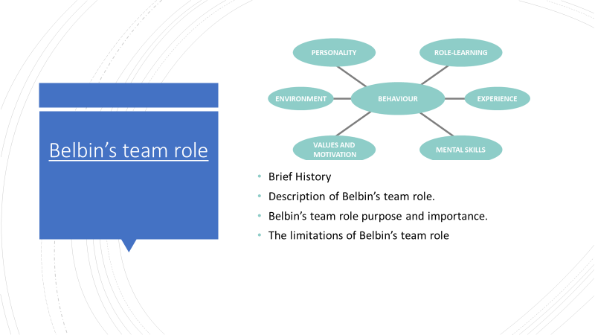
Raymond Meredith Belbin was a researcher and studied in the management team subject for years. He worked out a theory related to human behaviour and reaction to maximise the success, performance, and effectiveness within an organisation. Belbin described a team role as “a propensity to act, contribute and relate in particular to others” (Belbin, 2010). Belbin’s system helps to select the appropriate person for a specific position within an organisation. His theory aims to identify workplace-related behavioural strengths and weaknesses, moreover, improving people skills and increasing their efficiency for higher performance. The importance of this method, additionally, provide a language system in communication between individuals and teams for greater understanding and better collaboration (Belbin.com, 2018). Belbin suggested nine team roles that ideal foundation for team success. However, it does not mean that each team require nine members (Belbin, 2009). Belbin’s team role theory has two main limitations. There is no suggestion or manner which provides a solution for hierarchical imbalance within people. Moreover, it does not focus on the interpersonal relationship between team members. In other words, human behaviour likely changes more often than the personality itself (AbleSim, 2018).
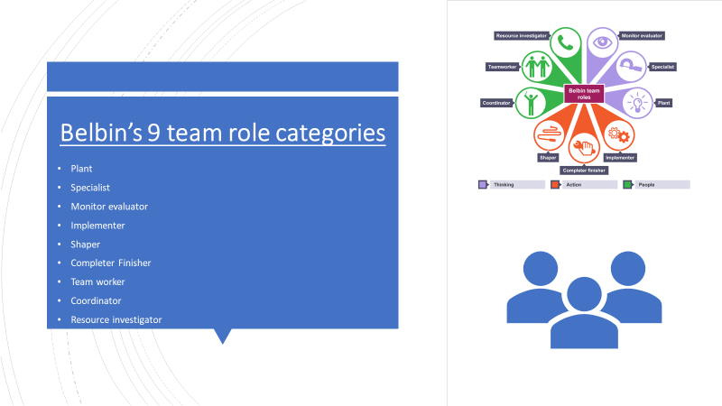
Belbin’s 9 team role categories
The Plant creates new creative ideas, support team when it suffers or lost in complex tasks. Characterised by an excellent problem-solving ability. Possible weakness: lack of effective communication with others in a team (Belbin, 2009).
The Monitor evaluator is extensively analysing the ideas, thinks critically to take the best conceivably logical decision. They are the so-called all-seeing eye. The possible weakness is the over scepticism in diverse tasks. (Belbin, 2009).
The Coordinator recognises talents inside a team, and leading team members to goals. The possible weakness, often overloaded with responsibilities, and it reduces the quality of their efficiency (Belbin, 2009).
The Implementer is a disciplined, hardworking, and reliable individual who loves to work by an organised and structured plan. Implementers are the so-called pulling power of the team. Possible weakness: difficulty to deviate from their well-established plan (Belbin, 2009).
The Shaper is a very energetic and dynamic person, described as achievers. They are delivering results in time. The characteristic usually extroverts and takes pressures easily. Possible weakness: They often seem aggressive, and emotionally offends others (Belbin, 2009).
The Completer finishers are accurate and perfectionist. They are the controllers at the end of the project, ensuring the quality of the highest requirements. Possible weakness: They are likely to fall victim of stress because they often driven by anxiety as the pressure of perfectionism (Belbin, 2009).
Team workers are diplomatic and sensitive individuals with uplifting personality. Keeps team mechanism turning. Possible weakness: unlikely deliver bad news. (Belbin, 2009).
Resource investigators are keen and energetic individuals. Characterised with the ability to attract new businesses and spot out opportunities. Possible weakness: They are free minded and often not follow rules (Belbin, 2009).
Specialists are single-minded and experts in their specific field. Characterized by technical and academical knowledge moreover a continuous thirst for learning. Possible weakness: losing interest in the whole project (Belbin, 2009).
References
1. AbleSim.com 2018. “Belbin Team Inventory Explained Looking at Drawbacks, Common Mistakes”. [online] Available at: <https://ablesim.com/belbin-team-inventory/> [Accessed 27 April 2020].
2. Belbin.com. (2018) What’s Belbin all about? [online] Available at: <https://www.belbin.com/> [Accessed 1 May 2020].
3. R. Meredith Belbin (2010) “Team Roles at Work Second edition”. Great Britain (2010) Published by Elsevier Ltd. ISBN: 978-1-85617-800-6
4. R. Meredith Belbin (2009) “The Belbin Guide to Succeeding at Work”. London (2009) Published by A & C Black Publishers Ltd. ISBN: 9-781-4081-1501-5

