Knowledge and Information Management

BMSW5106

Elena Gabriela Snopu 2019133
Md Kalam

Executive Summary
The report aims to highlight the relevant knowledge management theories and principles in an organization. A case of a highly successful organization has been taken. In this digital age, the ability to manage knowledge and information is a core skill necessary for success. It is important to understand the principles of knowledge creation, sharing, and application. Amazon provides an excellent example of how a company has successfully implemented these principles. Various elements of knowledge management, like application, creation and sharing have also been touched upon. Only academic publications served as the basis for all the study.

Table of Contents
Executive Summary 2
Introduction 4
Knowledge Management Theories 6
Principles of Knowledge Creation 6
Knowledge creation, sharing, and application 8
Background of Amazon 9
Importance of Knowledge Management in Organization 9
How KM helps organizations in satisfying customers and achieve competitive advantage 10
Evaluation of Knowledge and Information Management Models 11
Management Information system 11
Knowledge and Amazon’s Standard Operating Procedures 14
Recommendations for Amazon 15
Conclusion 16
References 17
Amazon Poster 19
Poster Speaker Notes 20

Figure 1 Business Information Value Chain (Source- KC Laudon, 2015) 12

Introduction
A customer-focused organization's basis must be built on the fundamental leadership value. Customer obsession, which means concentrating on consumers and working from their requirements and wishes funnel led through to the business, is one of Amazon's guiding principles. The leaders and staff of Amazon work diligently to earn the confidence of its consumers. While they are still aware of their rivals, their preoccupation and major goal is the client. Among other features of its diversification of the market services that it gives its consumers, Amazon has numerous categories, including digitalization, internet services, retail services, mobile devices, and Amazon Prime. The American multinational technology corporation Amazon.com specializes in cloud computing, digital streaming, artificial intelligence, and e-commerce. Jeff Bezos started Amazon in his Bellevue, Washington, garage. It has been called "one of the world's most powerful economic and cultural forces." It began as an online book marketplace but has now grown to include a wide range of goods, earning it the nickname "The Everything Store." Through technological innovation and broad distribution, Amazon has established a reputation for upending well-established industries. Through its Amazon Prime Video, Amazon Music, Twitch, and Audible divisions, Amazon also disseminates a range of digital and streaming material (Baboolal-Frank, 2021).
Over the years, KM as a discipline has been a hot topic of debate. In recent years, as the underpinnings of industrialized economies switched from natural resources to intellectual assets, the significance of KM has become increasingly acknowledged. Due to its capacity to provide organizations with strategic results related to profitability, knowledge management has attracted a great deal of interest in business and management circles. capacity expansion and increased competition. The fact that we live in a globalized society with quick information is no longer debatable. transmission through the Internet over vast geographic distances Organizations no longer only compete financially these days. Knowledge is the new competitive advantage in business, not cash and strength. Many businesses have come to the realization that technology-based competitive advantages are ephemeral and that their employees are the only source of sustainable competitive advantages. As a result, in order to stay ahead of the competition, businesses must have the ability to effectively recruit, develop, organize, and use the skills of their workforce. People's insights, comprehensions, and practical knowledge are collectively referred to as knowledge. It is an essential tool that enables individuals to behave wisely. Thus, knowledge may be considered an unseen or intangible asset, the development of which necessitates sophisticated cognitive processes including perception, learning, communication, association, and reasoning (Omotayo, F.O., 2015).

Knowledge Management Theories
A rapidly developing field of practical intelligence for management is known as knowledge management. It just became a managerial "buzzword" in the last ten years. The main focus of organizational KM theory is on organizational structures and how a hierarchy and culture are incorporated into an organization to manage knowledge and knowledge processes. Ecological knowledge management (KM) theory places a strong emphasis on people, connections, and learning communities. This includes interactions between people and organizations as well as the internal and external forces that motivate people to share their knowledge. Technological and the process of building technology enablers to aid in the transfer of knowledge and the preservation of information are the main topics of techno-centric theory. No matter whether the theory of practice is used, knowledge management considers how people, processes, and technology affect sharing of information (Al Saifi, 2015)

Principles of Knowledge Creation
Such a foundation would produce objective and advantageous knowledge generation. However, defending absolute objectivity in the social sciences is particularly challenging. There is nothing "absolute" about the empirical foundation of objective science. Science is not a firm foundation. There is no "invisible hand" that distributes resources in an economy, but the system functions as if there were one, therefore a theory's assumptions about reality are always erroneous if it is supposed to be an accurate reflection of reality (Gustavsson, 2007).
Amazon evaluated the Company's accounting for its tax contingencies using expertise and experience from the appropriate income tax authorities regarding international, transfer pricing, and other income tax rules. To examine potential impacts on the Company's positions, they evaluated changes in the relevant regulatory environments, including recent court rulings in pertinent instances. The accuracy of the company's calculations and data used to estimate the number of tax advantages to recognize were also examined, along with the suitability of the company's valuation methodology and assumptions, including the derivation of forecasts of income or loss.
A component of intangible assets is knowledge. This helps to structure and gauge the types of information that are accessible in organizations by integrating knowledge management into the current logic of managing physical and financial resources. The company's knowledge of and about its clients, as well as personnel understanding of consumers, procedures, technologies, etc., are all included in the intellectual capital. The influence over employees and consumers is limited; they do not belong to the corporation in the same sense that tangible assets do. The value of workers is not included in the balance sheet for this reason.
The value of the company's relationship with the client is represented by customer capital. Client capital is the breadth (coverage), depth (penetration), and loyalty (attachment) of the customer base. Patients of a doctor, the customer base of a mail-order business, branch networks of a bank, and their client connections are examples of customer capital. Relationships with distributors and suppliers must also fall under this type of capital. Organizational or structural capital is the third type of intellectual capital. Innovation capital, process capital, and cultural capital are three categories of organizational capital. Process capital is the total value of the value-generating processes.

Knowledge creation, sharing, and application
Instead of being a process of tacit or explicit knowledge alone, knowledge generation is an organizational, social, and collaborative dynamic process of interactions between the two types of knowledge. The process of creating new understanding is thought to be what constitutes knowledge production. Three distinct types of knowledge-creation processes are as follows: First, existing knowledge must be encoded in transmission-friendly formats to streamline complex cause-and-effect knowledge. Next, existing knowledge must be combined.
The act of making knowledge available to others within an organization is referred to as knowledge sharing. It may also be noted that sharing knowledge is giving people access to one's knowledge and receiving it from others. It is the social interaction culture, which refers to the sharing of information, experiences, and abilities across the board in an organization. People who are eager to share information with others to interact with coworkers successfully are examples of knowledge sharers, as are those who effectively consult others to learn from others (knowledge receivers) (Geisler, and Wickramasinghe, 2015).
Knowledge application may be described as the business procedures that enable a corporation to easily access knowledge through efficient storage and retrieval systems. Even so, knowing does not ensure that it is used. does not generate organizational value by itself. However, its use to produce efficient action does. Effective knowledge utilization requires the representation and dissemination of knowledge. The chance to employ widely accessible and disseminated knowledge grows, even while representation and distribution still do not guarantee the application of information. To make choices, solve problems, construct competence maps to put people in teams and tasks that will maximize productivity, and provide job aids and training, knowledge application requires accessing and applying information (North, and Kumta, 2020).

Background of Amazon
Few predicted the epidemic would be this widespread or persistent when it first began in early 2020. Whatever influence Amazon had had in the world up until that point was amplified by the fact that most physical locations closed for extended periods and people stayed at home. As a result, hundreds of millions of people relied on Amazon for PPE, food, clothes, and a variety of other necessities to get by during this historic period. Businesses and governments also had to transition, essentially overnight, from on-site collaboration with coworkers and technology to remote work. AWS significantly contributed to the success of this business continuity. Millions of businesses were able to adapt to these challenging conditions thanks to the cloud's elasticity to scale capacity up and down quickly as well as AWS's unusually broad functionality, whether companies experienced extraordinary demand spikes or demand diminished quickly with reduced external consumption. This was caused by a combination of factors, including our assistance in helping businesses reduce costs by optimizing their AWS footprint, including the uncertainty and sluggish demand that so many firms experienced. Companies were simultaneously taking a step back and deciding what they wanted to alter as a result of the outbreak. AWS revenue continued to increase quickly in the first year of the epidemic, increasing by 30% year over year.

Importance of Knowledge Management in Organization
The rivalry is growing fiercer in the present dynamic corporate climate, and sustainability has become a problem. Implementing policies to guarantee sustainability and competitiveness has placed a major emphasis on organizational performance. Performance is the cornerstone of all organizational operations since it decides whether or not an organization will survive. To maximize the return on investment, companies must manage resources such as time, money, and energy effectively. The company's performance must be considered while developing corporate plans if the organization is to continue to exist. Organizational performance consists of both financial and non-financial performances. The former relates to concrete or monetary advantages like return on investment, revenue, and profit margins, whilst the latter refers to customer happiness, growth, and other intangible benefits. Organizational performance, which reflects how an organization makes use of its tangible and intangible resources to fulfil its objectives, is at the center of all operations since it determines the survival of the organization.
An organization should concentrate on strategies to achieve sustained growth and financial performance, the capacity to adapt quickly to changes and spend a lot of effort on developing its workforce if it wants to create a high-performing organization with strong financial results, satisfied customers, and high employee morale. Product leadership, focused on product-based competitiveness, service innovation, and customer intimacy are three value disciplines that may be used to categories strategic performance skills that give a road to competitive advantage (Muthuveloo, Shanmugam, and Teoh, 2017)

How KM helps organizations in satisfying customers and achieve competitive advantage
Knowledge is an economic resource that may provide you with a competitive edge. This collective knowledge dwells in the minds of the company's suppliers, workers, customers, etc., and it is more valuable than the conventional elements of production (land, money, and labor) in ensuring a firm's steady growth. Identifying and assessing the necessary and accessible knowledge, as well as planning and directing activities to further develop knowledge assets to achieve business goals, are all parts of knowledge management. The significance of effective knowledge usage as a key driver of core competency development, performance improvement, value creation, and competitive advantage has long been understood and accepted by studies, both past and present. the belief that the innovation process is the most information-intensive business activity, a firm's capacity for innovation strongly depends on its intellectual assets and knowledge management capabilities. KM not only fosters high levels of innovation but also grows a company's competitive edge. Being competitive requires a company to continuously increase the capabilities of the goods and services it provides. It is not enough. A company has to have strong KM capability to create and support work practices and routines to remain competitive, even with assets and resources alone (Lee, et.al 2016).

Evaluation of Knowledge and Information Management Models
Special, Tacit knowledge rooted in personal experience and about one's acceptance, viewpoints, and standards are referred to as tacit knowledge. Tactic knowledge is occasionally seen as the real key to getting things done and developing new value in conventional assessments of the role of knowledge in corporate organizations. People can only ever record the results of their skills; they can never record the skill itself. They are unable to justify their actions in the paper. This could only be discovered by direct experience and observation. The owner of tacit information is unaware of their possession of it, and even when they realize it, they are unable to convey it since tacit knowledge cannot be separated from performance (Huie, Cassaberry, and Rivera, 2020)
Markets in the twenty-first century are unstable because technology advances quickly, there are many rivals, and goods and services quickly become outdated. Knowledge may aid firms in maintaining their competitiveness. The early stages of Amazon's evolution make clear the importance of social contact in the process of knowledge acquisition. A clear sign that Bezos grasped the need for fresh knowledge development is the focus he placed on culture. Two aspects of Bezos' plan to promote creativity can be seen: first, the promotion of alternative thinking within a team atmosphere; and second, the deliberate hiring of individuals with a variety of backgrounds. One valid explanation for its early success was the diverse skill sets of the individuals Bezos brought together. Bezos searched out talented individuals with relevant expertise who could add to the team's overall competence. Nonaka had a propensity to embrace a philosophical viewpoint, and so did Jeff. What mattered is management's commitment to knowledge management procedures and assessment of the amount of time spent on certain knowledge development activities. Several knowledge management methods are then used to examine each's presence or absence. To test a model that connected knowledge management enablers to the SECI modes and, ultimately, organizational performance, there is a scale available (Farnese, et.al, 2019).

Management Information system
Technically speaking, an information system is a collection of interconnected parts that gather (or retrieve), process, store and disseminate information to enable decision-making and control inside an organization. Information systems may assist managers and employees with problem-solving, coordination, and control, as well as problem analysis, visualization, and new product development. Information systems hold data about relevant individuals, locations, and objects either inside the firm or in its immediate surroundings. By "information," we mean data that has been transformed into something that can be understood and used by people. In contrast, data are streams of unorganized facts that reflect happenings in organizations or the physical world before they have been arranged in a way that is understandable to humans.
It would be helpful to give a small example that contrasts information with data. Millions of bits of information from bar codes, which characterize each product, are scanned at supermarket checkout counters. The cumulative number of bottles of dishwashing liquid sold at a specific store, the brands of dish detergent that were selling the fastest at that store or in those total sales, or the overall amount spent on that brand of dishwashing liquid at that store or in that sales region are just a few examples of the kinds of data that can be totaled and analyzed to provide meaningful information (Laudon, and Laudon, 2015).
The most well-known conceptual framework for comprehending knowledge-generating processes in businesses is the SECI model (Nonaka 1994). The approach sees knowledge generation as a dynamic process, just as Amazon does in its information management system, both in the early phases of the process and later. spans all ontological levels, the ongoing conversation between tacit and explicit knowledge creates new knowledge and amplifies it (individual, organizational, inter-organizational). The model stands out because it provides a useful instrument for evaluating knowledge generation in organizational contexts in addition to formalizing a theory of knowledge formation centered on the epistemological dichotomy between tacit and explicit knowledge.
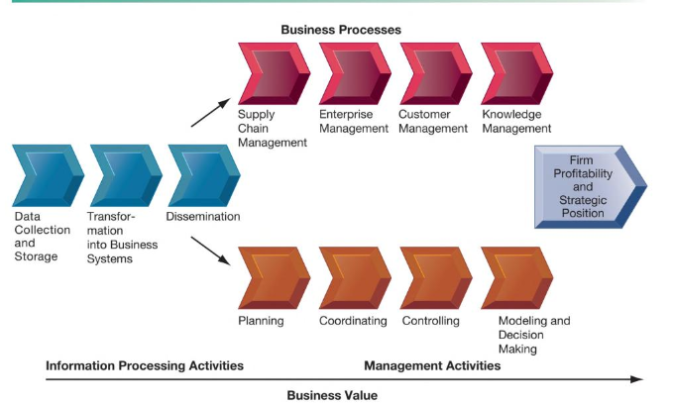
Figure 1 Business Information Value Chain (Source- KC Laudon, 2015)

Knowledge and Amazon’s Standard Operating Procedures
Every piece of information, from reviews to product specs, should be presented uniformly and in the same sequence wherever feasible. This results from excellent content management, where they create the knowledge and then consistently broadcast it to users. The capability to track and record every single information "nugget" is a bonus. Because material appears differently on multiple devices, employees shouldn't have to learn how to read or comprehend it. Although metaphors, flowcharts, and other organizational structures have value, that value is dramatically reduced, and users may become confused if each site has its unique presenting technique. The same interface is used for all transactions with Amazon, including purchases (Moore, and Tambini, 2018).
The SECI model may be used to illustrate the strategies the business employs in the market for knowledge management within the organization. Exploring the model's breadth and determining how conceptual it is for managing knowledge inside an organization is essential. The model consists of four typical knowledge management methods used by enterprises. The initial phase is socialization, which is the exchange of tacit knowledge through experience, observation, imitation, and involvement in both informal and formal organizational procedures. Amazon has competition from well-known businesses like Overstock VIP Shop Holdings. To encourage healthy commerce, the organization has done well to keep positive relationships with its rivals. The business's use of the cloud computing model has made it easier to keep track of customer and supplier data. Designing strategies to improve efficiency and convenience over the competition may benefit from such knowledge.
It is crucial to emphasis that the company's management complies with the Payment Card Industry Data Security Standard, which is beneficial when processing credit card information. Loss of credit card information can harm a company's efforts to build credibility and keep its competitive advantage. In connection with the collection, storage, and disclosure of user personal information, Amazon maintains physical, procedural, and electronic security measures. Devices purchased from Amazon are secured to prevent data loss and unwanted access. In essence, Amazon employs strict procedures that have demonstrated to be effective in protecting information privacy, a key issue for many customers throughout the world.

Recommendations for Amazon
Digital methods for acquiring and sharing information shouldn't be disregarded because they can progress business operations. Correct information management strategies aid in developing abilities and techniques to boost profitability inside a sector. Amazon has recently started using digital methods for managing commerce. The second piece of advice for the business is to enhance people management strategies since they affect information flow. Even if it is a multi-billion-dollar corporation, one can always pick things up and change unmotivated personnel.
Customer reviews have served as a cornerstone and a vital source of data for future decision-making. Many global corporations can forecast market trends and make wise judgments by using this knowledge. Customers' input is typically utilized to plan future actions and comprehend certain facets of consumer behavior. It would be wise to gather this data to evaluate and comprehend trends that affect knowledge management practices (Abualoush, Bataineh, and Alrowwad, 2018)

Conclusion
The aforementioned study is a knowledge management report that focuses on creating fresh concepts and examining established models and frameworks. The ability to harness the potential of creativity and innovation is essential for knowledge management in the twenty-first century. Understanding the essential knowledge management procedures necessary for organizational development, Evaluating the notion and significance of knowledge management in terms of an organization's knowledge assets and their management creating a foundation for a culture of knowledge management, all has been done in this document. All of the content has been properly researched utilizing scholarly articles and well-cited literature for the essay's objectivity and reader understanding.

References
Abualoush, S., Bataineh, K. and Alrowwad, A.A., 2018. The role of knowledge management process and intellectual capital as intermediary variables between knowledge management infrastructure and organization performance. Interdisciplinary Journal of Information, Knowledge, and Management, 13, p.279.
Al Saifi, S.A., 2015. Positioning organisational culture in knowledge management research. Journal of Knowledge Management.
Baboolal-Frank, R., 2021. Analysis of amazon: Customer centric approach. Academy of Strategic Management Journal, 20, pp.1-16.
Farnese, M.L., Barbieri, B., Chirumbolo, A. and Patriotta, G., 2019. Managing knowledge in organizations: A Nonaka’s SECI model operationalization. Frontiers in Psychology, 10, p.2730.
Geisler, E. and Wickramasinghe, N., 2015. Principles of knowledge management: theory, practice, and cases: theory, practice, and cases. Routledge.
Gustavsson, B. ed., 2007. The principles of knowledge creation: research methods in the social sciences. Edward Elgar Publishing.
Huie, C.P., Cassaberry, T. and Rivera, A.K., 2020. The impact of tacit knowledge sharing on job performance. International Journal on Social and Education Sciences, 2(1), pp.34-40.
Laudon, K.C. and Laudon, J.P., 2015. Management information system. Pearson Education India.
Lee, V.H., Foo, A.T.L., Leong, L.Y. and Ooi, K.B., 2016. Can competitive advantage be achieved through knowledge management? A case study on SMEs. Expert Systems with Applications, 65, pp.136-151.
Moore, M. and Tambini, D. eds., 2018. Digital dominance: the power of Google, Amazon, Facebook, and Apple. Oxford University Press.
Muthuveloo, R., Shanmugam, N. and Teoh, A.P., 2017. The impact of tacit knowledge management on organizational performance: Evidence from Malaysia. Asia Pacific Management Review, 22(4), pp.192-201.
North, K. and Kumta, G., 2020. Knowledge management: Value creation through organizational learning.
Omotayo, F.O., 2015. Knowledge Management as an important tool in Organisational Management: A Review of Literature. Library Philosophy and Practice, 1(2015), pp.1-23.

Amazon Poster

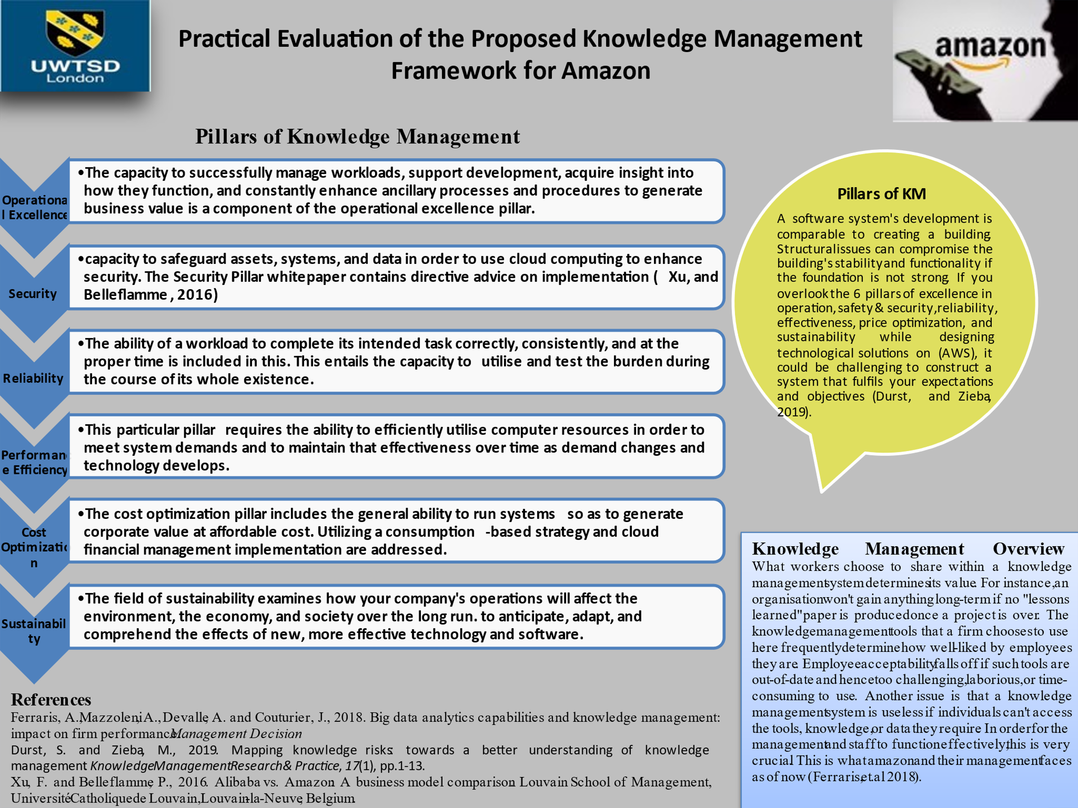

Poster Speaker Notes
- Jeffrey Bezos, a graduate of Princeton University, chose to launch an online business in the summer of 1994 after deciding to quit his position as senior vice-president of Wall Street investment firm D. E. Shaw to take advantage of the potential given by the quick growth of Internet usage.
- The online book retailer, which was initially incorporated under the name "Cadabra," later changed its name to "Amazon" for practical reasons (so that it would appear first in directories' alphabetical list) and symbolic reasons (to suggest that the company could expand to the size of the Amazon River). Bezos purposefully chose to sell books because brick-and-mortar businesses had a finite amount of storage space. Amazon became the first business of its sort to go online in this fashion.
- By providing customers with tools and features that ease the conditions of purchase, Amazon, which is fueled by (ICT) and of-course the Internet, was able to minimize the overall transaction costs experienced by customers information asymmetry, uncertainty. They have been successful in getting their users involved in their own online communities, and among themselves, sharing knowledge and experience. Additionally, they succeeded initialize the user-generated data (such as transactions, customer profiles, and purchasing trends) as part of the services they provide to retailers, to their benefit, the quantity, and product kinds and unrelated parties.
- The value generation component, which is crucial to the analysis of business models, is considered in this framework. Amazon has adopted a more active strategy, established its own logistical network and sold products under its own private label. Amazon has kept a cooperative connection with the vendors selling on its site by using a strategy that is more like to that of a conventional store. Several platforms are available on Amazon for user interaction. Customers can discuss issues they have before, during, or after a transaction on the Amazon Daily forum, for instance.
- The knowledge management framework that has been suggested stands on the shoulders of the pillars. A brief illustration contrasting information with data would be beneficial. At supermarket checkout counters, bar codes that identify each product are scanned for millions of pieces of data. Wherever possible, all information, from product specifications to reviews, should be presented similarly. This happens as a result of excellent content management, which allows for the creation of information and its ongoing dissemination to users. In order to process credit card information, it is important to emphasize that the management of the business conforms with the Payment Card Industry Data Security Standard. Digital information gathering and sharing techniques may advance corporate operations, thus they shouldn't be ignored. Information management helps with the development of skills that increase profitability within a sector.

