DS 1 Assignment

My Screenshots/Photos
- Please add 4–6 screenshots or photos of your digital life.
- You can use your phone or laptop.
- For each screenshot, write one or two sentences explaining what it shows.

Screenshot/Photo 1
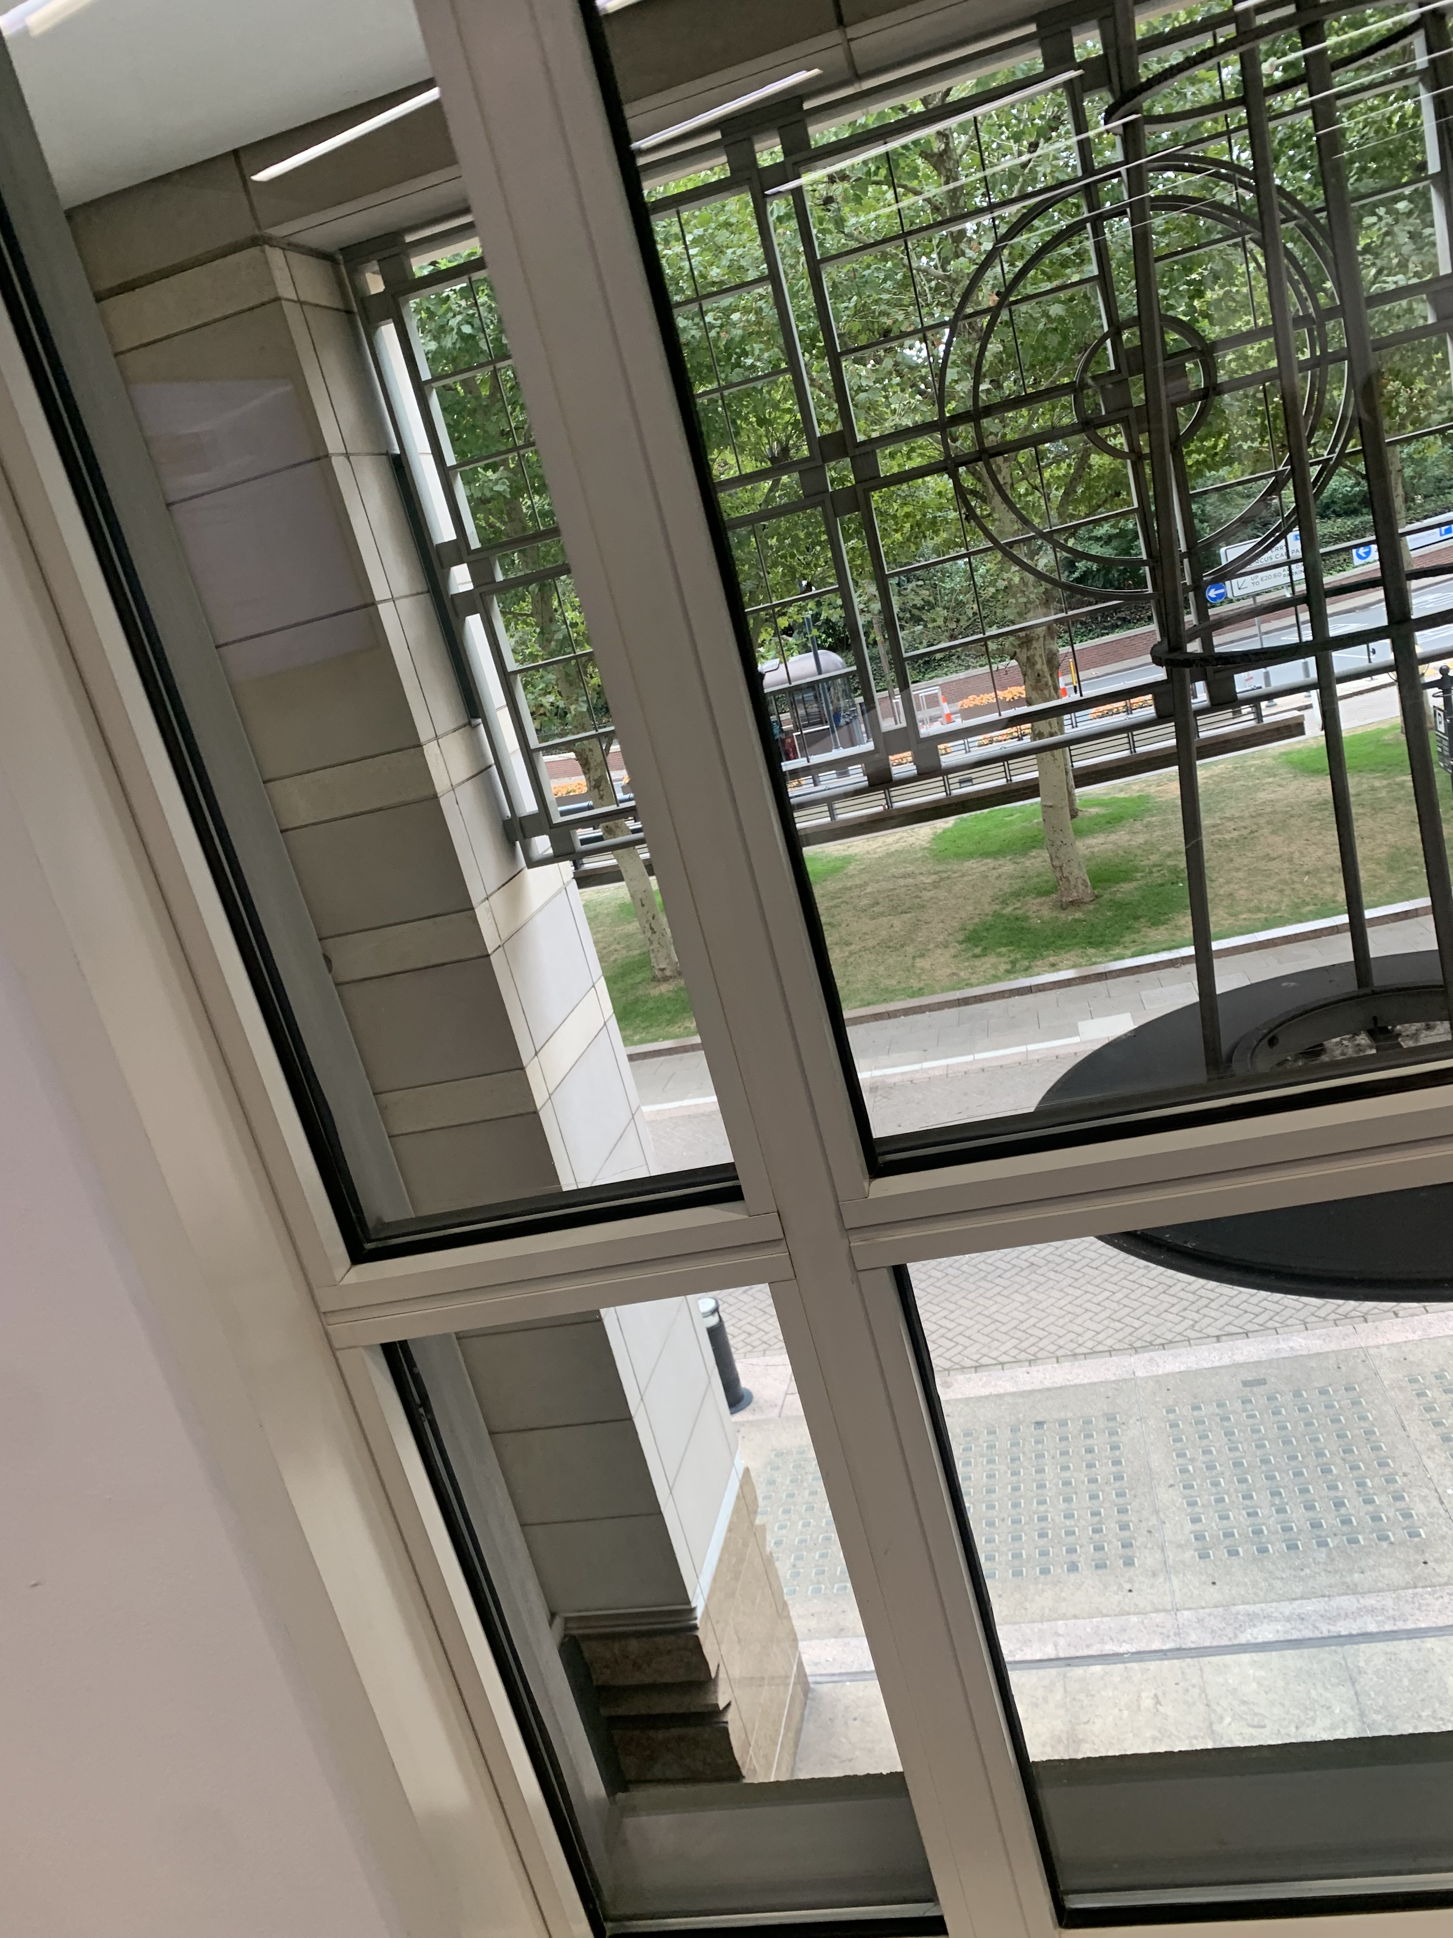
Using my digital life skills I have took, emailed and uploaded a picture to this template. This is picture of the view I have in my lecture when I’m thinking about my work…

Screenshot/Photo 2
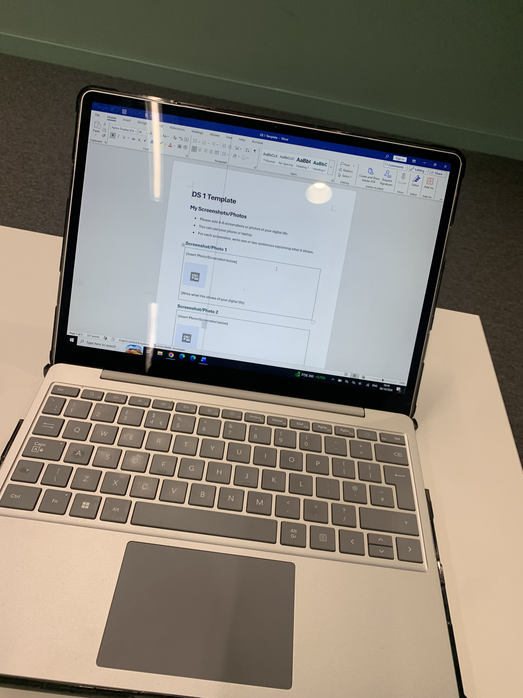
Using my digital life skills I’ve took, emailed and uploaded this picture to this template. It is of the laptop I’m currently using in my lecture for my work, and also the one I used to upload these images.

Screenshot/Photo 3
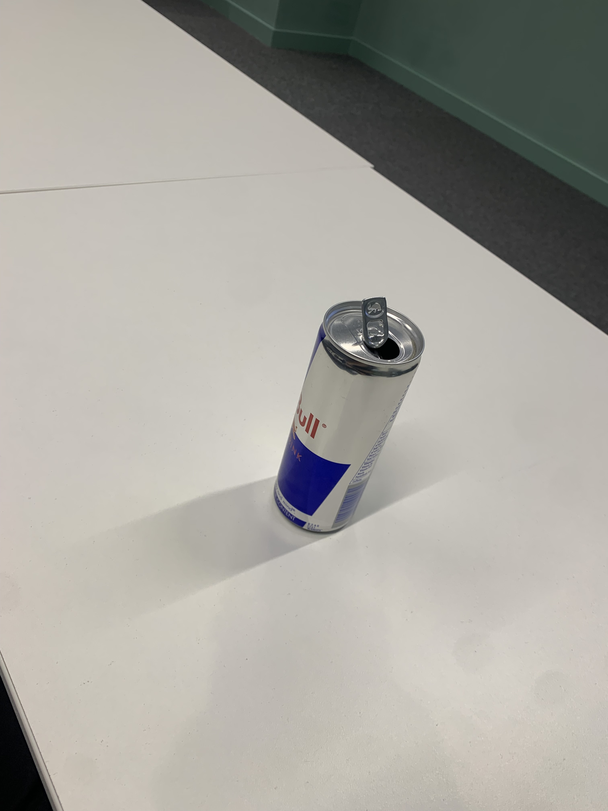
Using my digital life skills I’ve took, emailed and uploaded a picture to this template. The picture is of my energy drink that I drink to wake me up for the day.

Screenshot/Photo 4
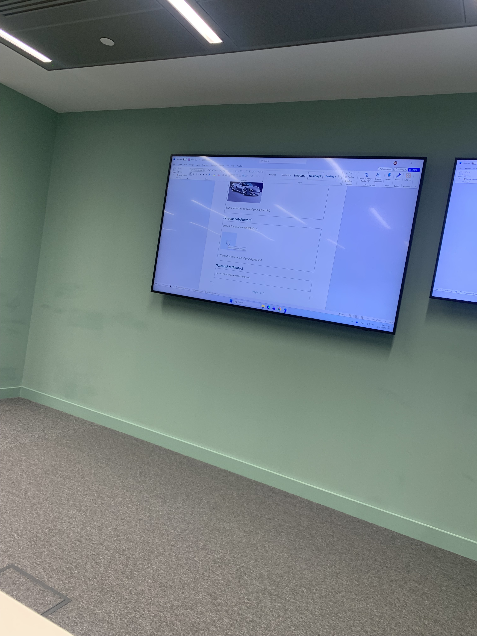
Using my digital life skills I have took, emailed and uploaded a picture to this template. this picture is of my lecturer’s instructions that I’m currently using to complete this work.

Screenshot/Photo 5
[Insert Photo/Screenshot below]

[Write what this shows of your digital life]

Screenshot/Photo 6
[Insert Photo/Screenshot below]
[Write what this shows of your digital life]

My Short Reflection
- Write 5–8 simple sentences about your digital life.
- You can use the sentence starters below if helpful.
I feel I’m experienced in most skill involving my digital life. I am confident uploading screenshots and pictures from my phone to my computer. I familiar with most technology used in all digital lives. I was not confident sending emails but have discovered it’s easier than I thought. I hope this module will teach me other digital skills I’m not confident with.

Sentence starters
- I use digital tools to …
- I feel confident when I …
- I want to improve …
- I often use these tools: …
- I sometimes feel nervous about …
- I hope this module will help me …
- Digital skills are important for me because …
You can write more if you want.

Submission Checklist
Before you submit, please check:
​​​ ☐ I added 4–6 screenshots
☐ I wrote short sentences for each screenshot
☐ I wrote my short reflection
☐ My work is my own
☐ My file opens correctly
​​☐ My file opens correctly

