Chloe-Louise Stevens.

p146612

Photojournalism and documentary photography.

“Propaganda and its effects on the media and the public by using Photographs and campaign posters to make their statement.”
Final Word Count: 5170

Paul Duerinckx

Content

List of Illustrations.
Introduction.
Chapter 1 – UKIP/Leave Campaign Propaganda.
Chapter 2 – Nazi Germany Propaganda.
Chapter 3 – Media and the use of propaganda.
Conclusion.
Bibliography.

List of Illustrations

- UKIP, Breaking point campaign poster, Mark Thomas (photographer), 16th June 2016.
- UKIP, No border, No control campaign poster, Artist Unknown, 29th October 2017.
- 1964 Tory Campaign poster, Chris York, 16th March 2013.
- DER EWIGE JUDE film clip, United States holocaust memorial museum, 29th October 2017.
- DER JUDE Nazi propaganda poster, Artist Unknown 2nd December 2017.
- “Get out van”, Patrick Wintour, 22nd October 2013.
- The sun front page cover “COR-BIN”, The Sun, 7th June 2017.
- The sun front page cover “save our bacon”, The Sun, 5th may 2015.
- The sun front page cover “DISMAY”, the Sun, 1st October 2017.
- Migrant attack Victims, Britain First, 1st December 2017.
- Brexit Mutineers, Steven Swinford, 14th November 2017.

Introduction
In this essay, I want to investigate the use of propaganda in the British journalism industry during the 2016 EU referendum and also how it has garnered a role in politics to help politicians with their manifestos, but not only in the British journalism industry but how propaganda has been used in the last century and what negative effects it has brought. To do this I have researched some of the most famous propaganda posters and texts from the last century so that I could develop a clearer idea of what makes propaganda successful and why it is such an important tool in the political world. There are many of instances where propaganda has been used successfully and sometimes not successfully; Adolf Hitler and his Propaganda minister, Josef Goebbels, used some of the most successful propaganda pieces in the Twentieth century.
From my extensive research, I have developed an understanding of the political propaganda technique of dehumanization – which in essence is demeaning a person or group (religious or not) so extremely that they are no longer viewed as human beings and equals but something far less; and in the case of the Nazi’s to the point of being nothing more than a disease that needed to be eradicated from the world. The author, Eunice Choi writes that “The point of propaganda is to dehumanize your enemy in such a way as to make it okay to kill them”.
Not only is dehumanization a widely used propaganda tool for far-right wing political groups, like the British group, Britain First, but it has also been used by White Supremacists and Neo-Nazi groups alike in many First World countries, especially in America in the last few years, since the second presidency of Barack Obama, who is widely known to have stood against anything that was negative towards those who needed help within the more developed countries.
Not only that but the reason political organisations are using propaganda is to gain support and encouragement from the general populous and to convince the voting public to vote for them by targeting certain fears and insecurities of the working class people, especially in terms of immigration and especially in terms of the EU Referendum, the openness of the British borders to those who are seeking asylum from war-torn, Middle-Eastern countries.

Chapter 1

UKIP/Leave Campaign Propaganda
In 1993, there was the formation of the UK Independence Party, or UKIP as they like to be known as; and according to their website they formed to campaign for the withdrawal from the EU, something that didn’t happen for another thirteen years. On UKIP’s official website, they claim that they do not hate Europe, foreigners or anyone else, yet their entire rhetoric during the 2010s what they print on their website is completely different to propaganda and any other type of media portrayals of them as a political party – they have been openly accused of being explicitly aggressive in terms of foreign policy and also in terms of what the, then current leader, Nigel Farage, was publicly saying about immigration and how it was corrupting the country. During my research I had begun to notice a reoccurring theme between both the UKIP of the 2010s and the German’s during the reign of Adolf Hitler; both used racism/religion as a scapegoat for the countries problems, especially in terms of Immigration and the European Union (especially in Britain as right-wing groups believe that this is the case), although for Germany it was the problems that the Jews were “causing” Germany, according to Hitler.
Firstly, as the leader of UKIP during the noughties, to which he later resigned from, however in the 2010s he became the leader of the party again, this time however his rhetoric had become focused upon the “damage” that the immigrants were doing to the economics of the country. In 2016, Farage became a prominent figure head in the EU Referendum, his stance being that he wanted the UK to leave the EU – originally it could be presumed that he did this due to what his party was formed for, as it states on the UKIP website, that the reason that the party wanted to leave the EU was because the democracy of the Union had forced Britain’s own democracy to be undermined by those who forget what their actual purpose was. With this change in rhetoric, came a dramatic change in their propaganda use, and with Farage being a figure head for the Leave campaign in the run up to the Referendum, the rhetoric was very much the same as UKIPs, although was increasingly more aggressive in terms of closing the borders of the country and also in vetting any person attempting to enter the country through Europe, after escaping the Middle-Eastern war-torn countries.

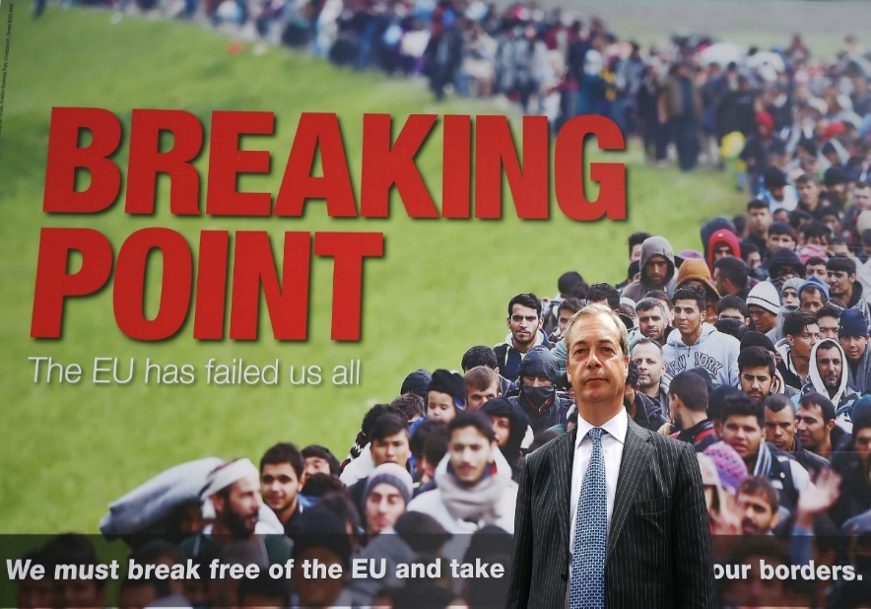

The above image is a very aggressive poster used by Farage and the Leave campaign as to why it would be better for Britain if the isle dissolve its union with the continent, this links closely with UKIP’s original policy of wanting Britain to leave the EU due to the isles democracy was being ruled by the ‘elite’ of Europe who had no idea what they were doing. This particular poster was rolled out the day before the referendum which indicates how important timing is when it comes to successfully using propaganda – it can only be speculated that if this poster was released too early in the Leave campaign, it is possible that it would not have had the desired effect of riling peoples motives to vote against the campaign that would have in Farage’s eyes, kept the borders open and allowing the ‘elite’ democrats of Europe to keep control over the country. Another aspect that makes this image more successful is the use of the phrase “breaking point”, which is bold and bright red to ensure it stands out against the image used in the photograph, it also catches your eye and is the first thing you read in the poster you then go on to read “The EU has Failed us all” which indicates that UKIP’s main vices in the Leave campaign was targeting working classes people insecurity about immigration as they are scared about becoming over populated and that immigrants are coming over to the UK for the benefit system as that Is what the British newspapers print on an almost daily basis, by blaming the EU because of the Freedom of movement act, to confirm this idea of using propaganda in a racist method the bottom line of the poster states “ we must break free of the EU and take back control of our borders” this statement further reaffirms UKIP’s need to push through negative propaganda about immigration.
While the above image is that of explicit aggression on behalf of UKIP and the Leave campaign, there is one image that draws on even greater fear of the working class demographic in Britain, and that is the way that immigrants view Britain, as a way to climb higher up, while abusing the countries generosity. In the following image it mentions the borders and how Britain, as a country, has no control over its borders.
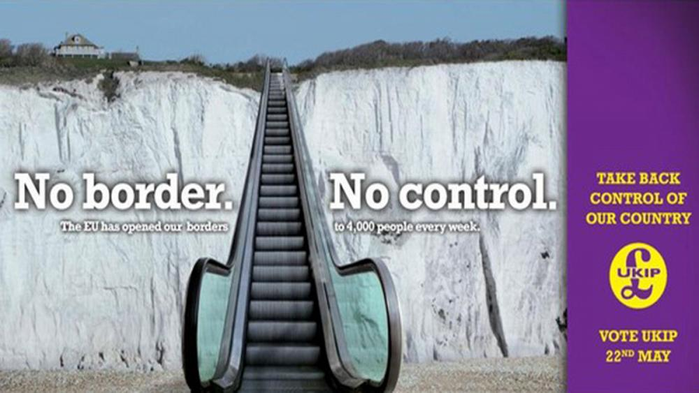

This image was used by UKIP and later resurfaced during the Referendum campaigns for the Leave camp. This image enforces UKIPs stance on border control as they realised it was one of the main concerns of their targeted audience, UKIP use text with their posters efficiently, they are able to create strong forms of propaganda by cleverly wording phrases that attracts the older generation of working class people by targeting their ignorance and insecurities to fit in with their political agenda, the poster above exaggerates the number of immigrants that come into the UK every week. The use of an escalator on the white cliffs of Dover is quite a weird image to look at, it is a surreal image but the use of text strengthens their image and makes the poster makes sense.
However, it was not only UKIP that were the main runners for Britain to leave the EU – the Conservative party were also a major factor in this need that Britons had to take back control of their borders, however much of the demographic for the Conservative party are the older generation or the middle classes; possibly more so for the older generation as they would have seen Britain without the control and confines of the European Union. The Conservatives propaganda proposal for Britain back in the 1960s was quite similar to what Farage had started to speak out about publically in the 2010s.
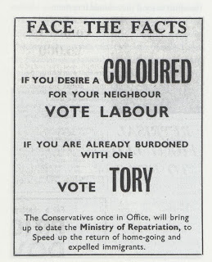

The difference between the UKIP and 1960s Tory propaganda was the use of diverse imagery and the style of rhetoric that they both employ. During the period that this campaign poster was published it was during a very difficult time in British culture; the white people and people of colour in the confines of the British Isles were seen as two completely different races, the whites being the supreme race, and the people of colour nothing more than vagabonds and criminals.
Not only that but the text shows that is from a different era and society to which we live in now, the use of wording like “coloured” which has been made into a bold font explicitly dehumanizes those of a specific skin colour indicates that the problems the Tory’s felt they faced were the people of colour. By using font like this the MP clearly knew his targeted audience and played into the fact the white British public felt threatened and worried about immigrants coming over and over running the UK, by using this form of political propaganda he was able to get white supporters to back his campaign, the text its self is not as graphic or abusive as modern posters, that are been shown above.
Before the notion of the EU Referendum there had already been a steady increase in the rise of hate crimes being reported to the police in England and Wales each year, especially since the 2011/12 reports were published. Between the years 2015 and 2017, the police have seen a 27% increase in racial hate crimes, whereas there was a 35% increase of religion-based hate crime reported to the police during the exact same time – these however were not the only hate related crimes reported to the police, but it these hate crimes that are the most significant as they are what UKIP and the Leave campaign were unintendedly aiming for when they openly persecuted those who fit their agenda.
These statistics indicate that much of the public was influenced by the strategically released image from the Leave campaign, and also how influential propaganda can be to those who feel threatened by the immigrants who have come to Britain to work, causing feelings of unease amongst the working class, as it is ultimately those who have come to Britain from foreign, European countries that are willing to do the jobs that most British citizens refuse to do, as they believe that they are in some dignified sense more superior to the roles that they are willingly allowing the foreigners to take. However, this aspect to what those who migrate to the isle do is never publically announced, for fear of repercussions by not only the working class but also the elite.
There has been much discussion about the first poster of Nigel Farage and the links it has to a Nazi Germany propaganda image that they used to promote their racial campaign. The links between these propaganda pieces are uncanny in their ability to influence people who are only able to think as part of the society and not individually. Unlike the Germans, the British people were much more separated in their opinions, as for the outcome of the Referendum there was only a 2% difference between the Leave and Remain campaigns; the major importance for this referendum was the turn-out for those in the demographic age group of 18-24 years olds, there was a reported 71% turn-out for this demographic unlike many of the normal general elections where there has been an average of 58% turn out for those between the ages of 18-24. These results have been the biggest turn-out for this demographic in a long time, which means that students and others in this age range, who are by the older generation to want everything handed to them on a platter, are actually taking an interest in the future of their country. The interests shown by the 18-24 year olds is similar to the interest that the Hitler Youth took in the future of Germany, and the thousand year Reich.

Chapter 2
Nazi Germany Propaganda.

Propaganda used during the Third Reich was established at the beginning of 1930s when Hitler rose to power. When looking at Nazi propaganda the use of racial hatred isn’t hidden like in the UKIP poster, it is very much in the fore-front of the clip, dehumanization has been used very well in both of these examples, after a while of looking at the actual photograph you stop noticing these are people fleeing something terrible and just look at them as a mass of people. Unlike UKIP, the Nazis called their ‘enemies’ parasites, like in the above poster, which dehumanizes them beyond even a different species to human, they are something that Hitler felt needed to be eradicated from the world, like a disease when the right cure is found for it. , it also states that they had no respect for other places or people by saying “undermining their host countries” this could easily stir up anger and lead to far right supporters in becoming increasingly angry which leads to this idea of a mandate to hate. See the image below.
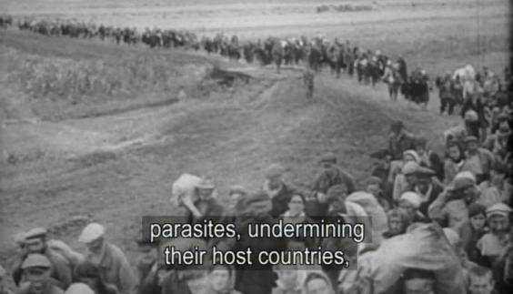

This scene is from a Nazi propaganda film called The Eternal Jew. The UKIP leave campaign poster has been linked with this image, both posters have people queuing and walking in a semblance of a line, carrying their belongings; both of these posters use text in an aggressive way and promotes the use of dehumanization, as it is easier to hate if you don’t think of the people in the posters as humans, by using a photograph or a film clip which shows people of a different race queuing up like cattle it takes away their identity and changes their beliefs by the use of text that is used over the poster.
The similarities between both UKIP and Nazi propaganda is unparalleled, they both use the same rhetoric to scare the populous into believe what they want, giving the populous and sheep-like mentality. The Nazi propaganda campaign was really well organised and created a lot of support however UKIP used it as their main campaign tool.
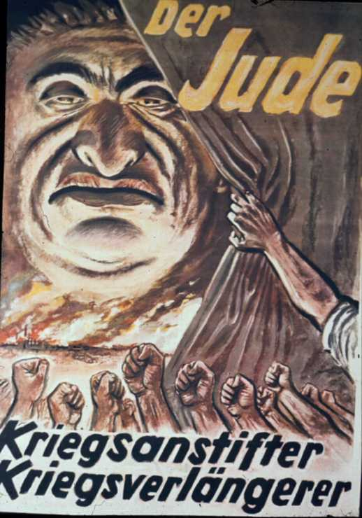
The Nazi propaganda campaign was incredibly cruel but clever; they used many different outlets to promote their agenda, they used the usual posters and newspapers but also used TV channels and the radio to push their message, Hitler and Gobbles knew how to use propaganda to their advantage but, they also knew how to use it well, there was one poster in particular that the Nazis used in their propaganda campaign and that was of the Jew- depicting him as a warmonger and someone who wanted to prolong war in the country.

This poster was published in 1943 just before the end of the Second World War, this poster would have affected the outcome of the war because it would have kept the general public riled up and angry. It features the Jew drawn in a very unattractive and in an evil manner, with the quote “warmonger” and “war prolonger” indicates that it was not just Hitler, his propaganda was so effective that most Nazi’s believed it was the Jews fault. Hitler used propaganda to make sure the German peoples loyalty wasn’t starting to fray, the language on poster is explicitly abusive and in your face and pushes a clear message of hate, the representation of the Jewish person in this poster characterises him as evil, and eventually portrays all Jews this way. This is another classic case of using dehumanization, Hitler and gobbles had mastered the skill of propaganda successfully and used it to their advantage they caused a great frenzy with the people and ran a rather successful racist and hate-filled campaign against anyone they saw as inferior to their Aryan race; this ultimately brought about the beginning of the second world war.
The use of propaganda began during the Woodrow Wilson administration where the ideology of “more intelligent members of the community” came from. Woodrow Wilson set up the creel commission to encourage the population to encourage America to get involved in the first world war, the creel commission was successful as it turned the nation from being pacifist and uninterested in the war to wanting to fight the Germans and save the world. As Noam Chomsky goes on to explain “state propaganda when supported by the educated classes and when no deviation is permitted from it can have a big effect. It was a lesson learned by Hitler and many others and it has been pursued to this day” indicates to us that when the state publishes propaganda it is usually capable of causing great distress and a political party that shares the same ideals will gain the most support.

Chapter 3
Media and its use of propaganda

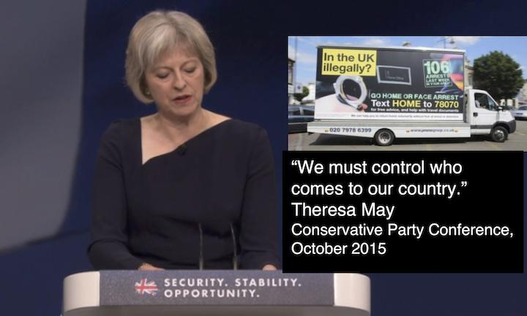
Another form of propaganda that I would like to discuss is that of the use of it in Media and how it is much more accepted. For example, Theresa May in 2015, as the Home Secretary for then Prime Minister, David Cameron, willingly allowed the commission of a vehicle that had a poster printed on the side that boldly stated “Go Home” and this was aimed exclusively towards those immigrants that were either in Britain illegally or the British public felt that they were there illegally, whether they have documentation to prove otherwise.

The use of vehicles has become the new form of Political propaganda, because people will see them when they are walking the streets or driving past them. these vans made a very strong statement on the behalf of the government due to their wording, the first thing you see when you look at the van is in block yellow “ In the UK illegally” which indicates that it is directed to illegal immigrants which isn’t the issue it’s the blunt way in which the text is used for instance “ Go HOME or FACE ARREST” is extremely blunt and in your face, as Julian Huppert whom was the liberal democrat home affairs committee member at the time stated “ the vans had demonised people who were in the country legitimately”. This proves the use of dehumanization being used as a running theme in propaganda especially in British political propaganda, although British propaganda isn’t the only propaganda that uses the technique of propaganda which leads me into my research on propaganda and how it’s been used successfully over time.
Theresa May placed herself in a position to be seen as taking a rather prominent stand with the Leave campaign during 2016 and then in 2017 when she ran to become Prime Minister after David Cameron resigned from the post shortly after the results of the EU Referendum. For her campaign, Theresa May told the voting public that she wanted to build a strong and stable Britain by having a strong and stable leadership. Through extensive research I discovered that there is a link between Theresa May saying she wanted a “strong and stable” leadership with Adolf Hitler, who wrote in his autobiography, Mein Kampf, “Today, in November, 1926, it stands again before us, free through the whole Reich, stronger and internally more stable than ever before.’ Which indicates that the Tory party use lessons learnt from Hitler’s war propaganda and uses the same ideals as the propaganda that was published during Hitler’s campaign. For a political party to use a slogan that is so close to a text used by a radical racist that caused the Second World War on racial hatred by using propaganda indicates that propaganda is used and recycled.
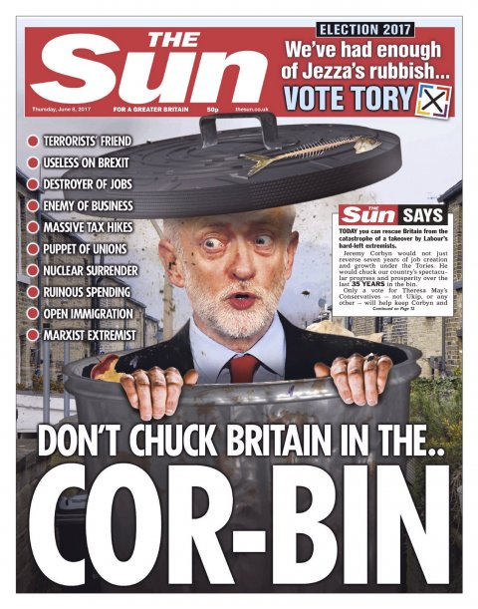
The British journalism industry usually backs one party, particularly, and prints political propaganda in support of their chosen party in the recent 2017 elections we saw a lot of political propaganda fleeting to support the conservatives and released a lot of Anti-Labour/Corbyn propaganda campaigns, for example the Sun released an article during the election campaign which features a drawing of Jeremy Corybn (leader of the Labour party) in a rubbish bin.
On June the 8th the Sun newspaper published this front page, the sun has been renowned for publishing propaganda about Jeremy Corbyn since he became leader of the Labour party, this front page features text saying “open immigration” which preys on the older generation working class’s insecurity about immigration, this tells us that the Sun newspaper released this front page in the hopes of convincing the British public that under a Labour government that immigration would rise this newspaper also claims “ massive tax hikes” which if someone was to read the labour manifesto it states that the people earning over £123,00 a year would see a rise in tax, the way the Sun newspaper has reported this pledge in a way that reads all persons would be hit by rising tax which would catch the eye of the reader and help swing the opinion towards the Tory party, the use of the cartoon with the pun “ don’t chuck Britain in the Cor-bin” demonstrates that the Sun newspaper is very anti-labour. The cartoon drawing of Jeremy Corbyn is very joke like, as if the paper is trying to make him out to be a joke, another piece of text I want to analyse is “rumour spreading” this terminology is straight forward, short and sweet but it indicates that Jeremy Corbyn is untrustworthy, this piece of text is particularly dangerous to Jeremy Corbyn reputation as it is not something you want written about you in the British media especially on the day of voting in an election.
Another newspaper front cover I want to talk about is the sun front page for the 2015 Election, the Sun newspaper backed the Tory prime minster at the time David Camron and launched an anti-labour campaign against the party leader at the time Ed Miliband, the released a front page featuring a unattractive photograph of Ed Miliband,
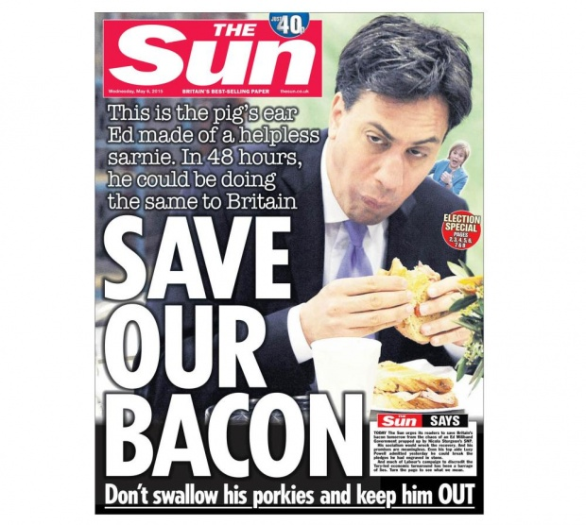

The photograph features Ed Miliband eating a bacon sandwich, the way the Sun newspaper uses text and the choice of wording against a photograph indicates that by using puns in their propaganda they are trying to make a joke out of Ed Miliband and his campaign, with these sort of newspaper articles and front page covers timing is everything, if this particular article was printed early in the election campaign it would have been forgotten about and not caused such a stir with the general public, the use of “ save our bacon don’t swallow his porkies and keep him out” paired with the photograph makes for a good pun, the Sun use puns as a main part of their propaganda they use puns to make the person featured in the article a laughing stock which in theory would make them unelectable and would make the Sun’s propaganda successful. Although the British journalism industry usually backs one party and prints bias propaganda it has turned on the favoured political party from time during the 2017 election we saw newspapers like The Sun and the Daily Mail turn their anti-party propaganda from Jeremy Corbyn and the Labour party towards Theresa May and the Tory party because she lost seats to labour, the sun calls “ Her gamble is disaster” after she called a General election to strengthen her mandate for the Brexit negotiations.
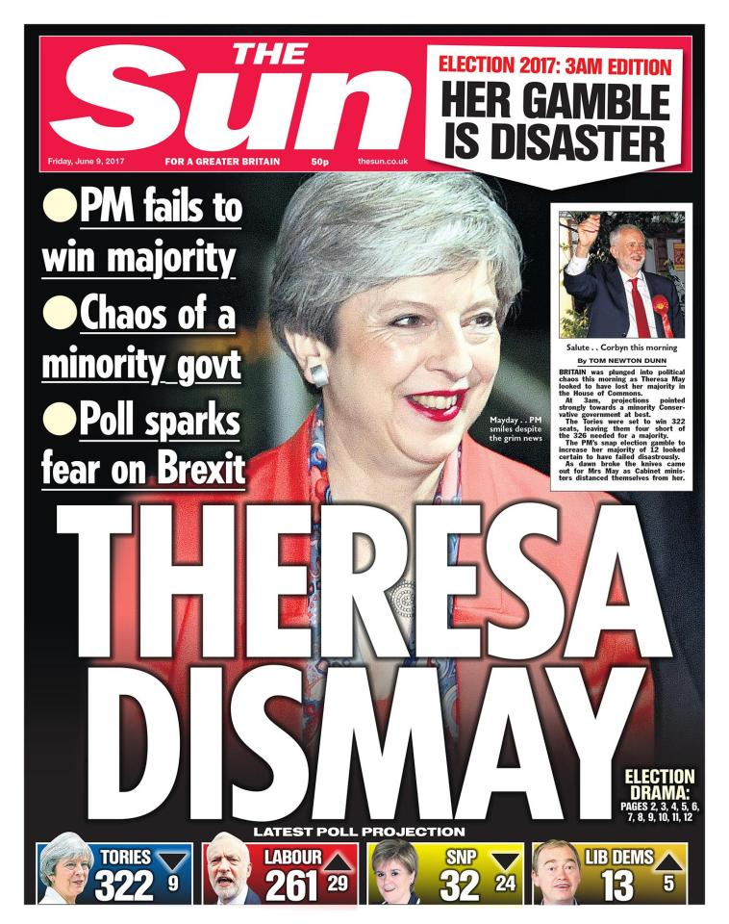

They say she “fails to win majority” which indicates that they are calling her a failure which confirms that they have turned against the woman they claimed was “strong and stable” through the run up to the election Theresa may and the British newspapers claimed that a Jeremy Corbyn government would lead to a “coalition of chaos” which when they used “chaos of a minority Govt” just backs up my previous point on that they have turned on her, although they put so much effort into their propaganda campaign they are quick to change their angle and turn on the person and party they have been producing positive propaganda about.
Through extensive research I have gathered that The Sun newspaper is owned by Rupert Murdock who is a millionaire and backs the Conservatives, which is why the Sun produces so much propaganda against any other party that is competing against the Conservatives, the Sun uses social media as a way to connect with more people alongside every other form of journalism, as I said above, social media has become a new platform for propaganda as it is a quick and reliable way to release new forms of propaganda, the reason social media has become a hot spot for political propaganda is because most people have a form of social media and its free to post on social media which leads me into talking about Donald trump ( the current American president) and his use of twitter in which he tweets his own propaganda and he is usually involved in scandals to do with twitter, his most recent scandal was when he retweeted a Britain First tweet on 29th of November 2017, which caused out raw amongst the British public which led to the British prime minster Theresa may saying “ it was the wrong thing to do”, this indicates that social media is a danger when it comes to political propaganda as the President of the United states is able to retweet far right racist propaganda which is dangerous as it encourages far right wing supporters that racist propaganda is acceptable in today’s society.
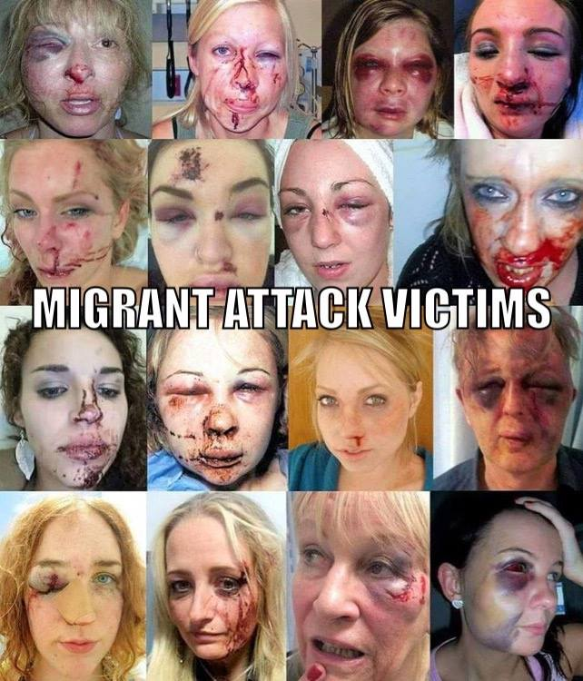
I have also learnt that propaganda surrounds us constantly; Owen Jones who is a journalist for the broadsheet paper, The Guardian, and an active socialist activist uses social media to get his message across, he releases video’s on Facebook almost daily and is constantly talking about the socialism movement and how it would fix the British politics in the age of social media propaganda is easier to share and push on to the people, extreme right fascist groups like “ Britain first” are very prominent on Facebook pages and constantly post images like the one below.

This photograph was taken off they’re active Facebook pages. This aggressive form of propaganda isn’t a publication by the state it is a publication by a private extreme right political group, it shows sixteen women that are severely beaten which is obviously distressing with the text “ migrant attack victims” blaming migrants for attacking these women, there is no evidence to support these claims and these claims have caused a frenzy with far right voters and is getting circulated by the far right voters even though there is no evidence to back these claims up. This sort of propaganda is extreme and causes a lot of hate for the voters that are connected to these pages, with it being on social media there is no real investigation in to these types of posters and they are left to promote their idea of a better Britain. To coincide with the above image, I want to talk about the role that the British journalism industry has to play in the use of political propaganda and I want to investigate if the British journalism industry to understand if it has just become a political campaigning tool. The British journalism industry is full of newspaper articles pushing political propaganda messages, the first newspaper I want to talk about is the Daily telegraph which printed an article calling conservatives MP’s “the Brexit Mutineers” mutineer means “someone who takes part in a mutiny”.
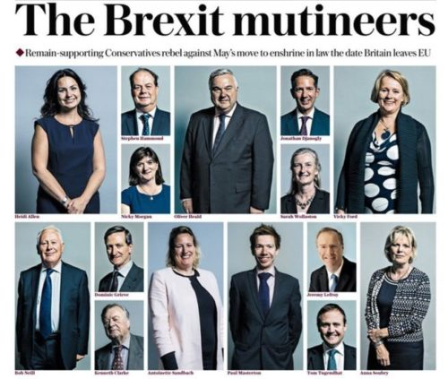

This article used Tory MP photographs and lined them up as criminals; the use of mutineers as a descriptive word makes out they are rebelling against the government by apparently trying to block the Leave date for the Withdrawal Bill. The way the Daily Telegraph has used the photographs of the MP’s which voted against May is a clever way of targeting a group of people and to dehumanize them by calling them “mutineers”. To make such a public stance about MP’s causes the readers anger to think they are voting against them, which leads me on to the Daily mail which realised an article titled “supreme court judges are enemies of the people” after the supreme court ruled that the MP’s must vote on leaving the EU as it is policy for MP’s to vote on new laws and legislations, by calling the supreme court judges enemies to the people it insinuates a sense of betrayal to the British people and people that are uneducated when it comes to politics, this sense of propaganda surrounds us daily and we are buying in to it.

Conclusion
In conclusion to my points in my introduction through intensive research I have gained the understanding about how the use of propaganda in the British journalism industry helped swing the vote during the 2016 EU referendum by promoting false facts and promoting far right ideals, the propaganda used in the Leave campaign for the EU referendum was heavy based on immigration and was UKIP’s main vice during the leave campaign, political propaganda uses a lot of technique’s but the main one that has been used throughout history is the use of dehumanization as history proves it results in a successful form of propaganda; recently right-wing propaganda has been recycled and used in the last few years, first by the UKIP party with the campaign poster that links in with the Nazi Germany propaganda film and then secondly by Theresa may and the conservative party with the “ strong and stable” slogan, when propaganda is used successfully it can achieve life changing results, I also looked in to the role of the British journalism industry and its role when it comes to publishing political propaganda, I have learnt from my research that particular newspapers like the Sun and the daily mail has become a political propaganda tool by the propaganda they release during critical times in political campaigns, I have also developed an understanding that social media has become a marketing tool for political propaganda due to ease of sharing things on social media. Propaganda and newspapers have a big part to play when it comes to political campaigns and it helps the “working class people” decide who to vote for.

Bibliography
Books:
- Chomskym,N.(2003). Media Control. Dehradun [India]:published by Upendra Arror for the Etch, an imprint of Natraj publishers.
Internet references:
- http://www.ukip.org/ukip_reveals_new_billboard_design
- https://www.ushmm.org/wlc/en/article.php?ModuleId=10008228#
- https://herb.ashp.cuny.edu/items/show/1200
- https://www.thesun.co.uk/news/3748893/the-sun-says-vote-conservative-dont-chuck-britain-corbyn/
- https://www.thesun.co.uk/archives/politics/184228/save-our-bacon/
- http://www.pressgazette.co.uk/from-mayhem-to-theresa-dismay-how-front-pages-changed-through-the-night-to-reflect-uks-surprise-election-result/
- http://theconversation.com/strong-and-stable-leadership-inside-the-conservatives-election-slogan-77121
- https://dictionary.cambridge.org/dictionary/english/mutineer
- https://www.ft.com/content/8c41b7d2-663f-11e7-9a66-93fb352ba1fe
- https://prezi.com/hbmxpayduzw8/dehumanize-nazi-propaganda/
- https://www.facebook.com/OfficialBritainFirst/
- http://www.ukip.org/
- http://www.history.com/this-day-in-history/hitler-publishes-mein-kampf
- http://www.mondopolitico.com/library/meinkampf/v2c11.htm
- http://www.telegraph.co.uk/news/general-election-2015/11449546/Nigel-Farages-turnaround-on-immigrants-is-too-little-too-late.html
- https://www.theguardian.com/politics/2013/oct/22/go-home-billboards-pulled
- https://www.theguardian.com/uk-news/2013/oct/22/go-home-vans-scrapped-failure
- http://www.huffingtonpost.co.uk/2015/03/16/britains-racist-election-channel-4-ukip_n_6876394.html
- https://www.theguardian.com/politics/2016/jun/16/nigel-farage-defends-ukip-breaking-point-poster-queue-of-migrants
- http://www.telegraph.co.uk/news/2017/11/14/nearly-20-tory-mps-threaten-rebel-against-brexit-date-brutal/

Choi, E. (2013) Dehumanize/Nazi Propaganda.
UKIP, for the Nation, UKIP.org.
Dan Hodges, The Telegraph, 2015.
UKIP, for the Nation, UKIP.org.
UKIP, for the Nation, UKIP.org.
UKIP, for the Nation, UKIP.org.
UKIP, for the Nation, UKIP.org.
York, 16/03/2015
Hate crimes in England and Wales between 2016 and 2017 – Gov.uk, (Oct. 2017)
YouGov.com
http://www.ushmm.org October 29th 2017
Unknown, 1st December 2017
Chomsky, 2003
Wintour, 22nd October 2013
Wintour,
Taylor, may 4th 2017
Hitler, 18th July 1925
The sun, 7th June 2017
The sun, 5th May 2015
Ponsford, 1st October 2017
May, 22nd April 2017
Britain first, 1st December 2017
Dictionary, 10th December 2017
Suinford, 14th November 2017

