Changemakers – Building your brand for sustainable employment
my career, my future
Olivia Hurlow (2103531)

Contents page

Reflection

My Current CV

References

Reflection –
The probation service is an executive agency within the Ministry Of Justice, that manage people within custody and ensure public protection, and rehabilitation, and helps reduce re-offending which consists of management and delivery of sentence plans (Home Office, 2021). During the talk, I learned that the probation service is an excellent organization that ensures offenders are better people in the future, I think that a lot of people believe that the probation service and officers are too soft when they are involved in public perceptions more than what people think (Smith, 2022). During the talk, I felt that the information that was being provided to me was useful and knowledgeable as to what the probation service is and the avenues which I can go down in my future career. During the talk, I learned that the probation service looks for determined, team-orientated, and strong-minded people to be part of the team that works tirelessly day to day to ensure that offenders are well looked after while in prison and out of prison. However, although I feel that the session was knowledgeable and useful and it could be a potential avenue for a career in the future, I don’t feel that it is a career path for me right now.
Working for Swansea: opportunities in local government are an organization that has departments in both adult and child services that work closely with people to improve their well-being and work closely to assist people if they have worries about themselves or another person that they wish to share (Swansea Council, 2021). From attending the talk I was made aware of the services and jobs that Swansea council provides from teaching assistances to business support officers that work closely with vulnerable and complex people to ensure their quality of life is just like everyone else’s. During the talk, I felt curious as to what the service offered to members of the public and intrigued to know more about the help that they provide and the responsibility they must undertake to ensure people’s safety. The good thing about this talk was that it provided a great deal of detail and information about the services that they provide and the number of different roles I could undertake either as a volunteer or as a full-time team member, I found this interesting and intriguing and could possibly see myself enquiring for a volunteer position while still attending university to see whether it is something that I could see myself taking on within my future career.
South Wales Police aim to bring thousands of people together to ensure that South Wales is safe. The police work 24 hours around the clock covering the two largest cities and are offering a variety of exciting career opportunities (South Wales Police, 2023). Whilst attending the talk I gained a bigger intelligence about the different jobs available to me starting with a digital forensics investigator, during the talk I felt delighted to be sat in the same room as authority figures and excited about what I was about to learn about. During the experience, it was good to gain a bigger understanding of the pivotal role that a digital forensics investigator plays within a criminal investigation and the key technology that is involved in such investigations. As I have always had an interest in a career path within the police this talk was of great use and interest as it has helped me gain a better understanding of what the job can intel and I have great knowledge of the possible career path that I can take and I going to consider as a future opportunity that I will undertake.
There was also the role of a cybercrime investigator that works at the intersection of cybersecurity and criminal justice, they work on gathering evidence from digital systems that prosecution can use on internet-based criminal activity (Bowcut, 2023). During the talk, I was thinking that this could be a possible career path for me as I am interested in any role within the police, and I felt relaxed and satisfied that I was gaining knowledge and intelligence and was thankful for the chance to be able to learn of the professionals and the love that they have about their jobs. During the talk, it was good to be able to learn about their experiences and regardless of whether they win or lose the experiences that they have in the force will change lives and perspectives. This is a definite career path that will ensure all avenues are investigated to be able to help solve crimes on a different level and is a great chance to gain experience and learn more and more. The role of a detective inspector is also of great interest to me so being able to attend a talk with a detective inspector was a great opportunity, a detective inspector has the role of managing a team of sergeants, constables, and all other police staff, and they manage and monitor policing activities and have the power to deploy the correct resources to incidents like road traffic accidents (College of Policing, 2023). After the talk, I felt intrigued and interested in what I had learned about and was confident that it had given me the best possible way of deciding what career path I would like to take after university, and I was thankful for the opportunity to learn. The good thing about the experience was that it was a hands-on real-life situation in which I gained information, and it gave me a raw insight into what life as a detective inspector holds. From this talk, I am considering a career in this pathway, and the intelligence, experience, and adrenaline you get from such a job are what sold it for me, the skills and experiences I can gain from this job can prepare me for a better future and future life challenges.

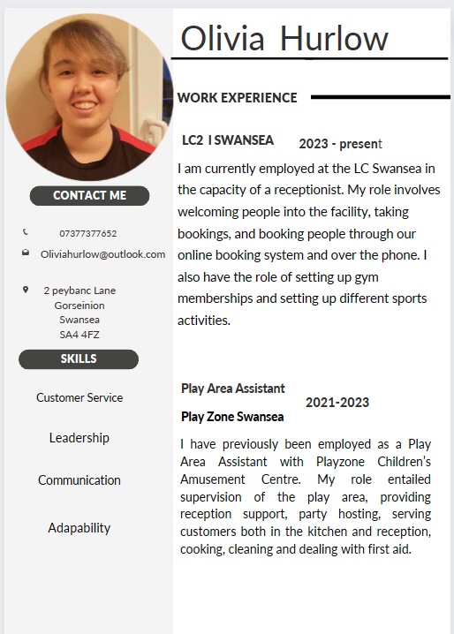
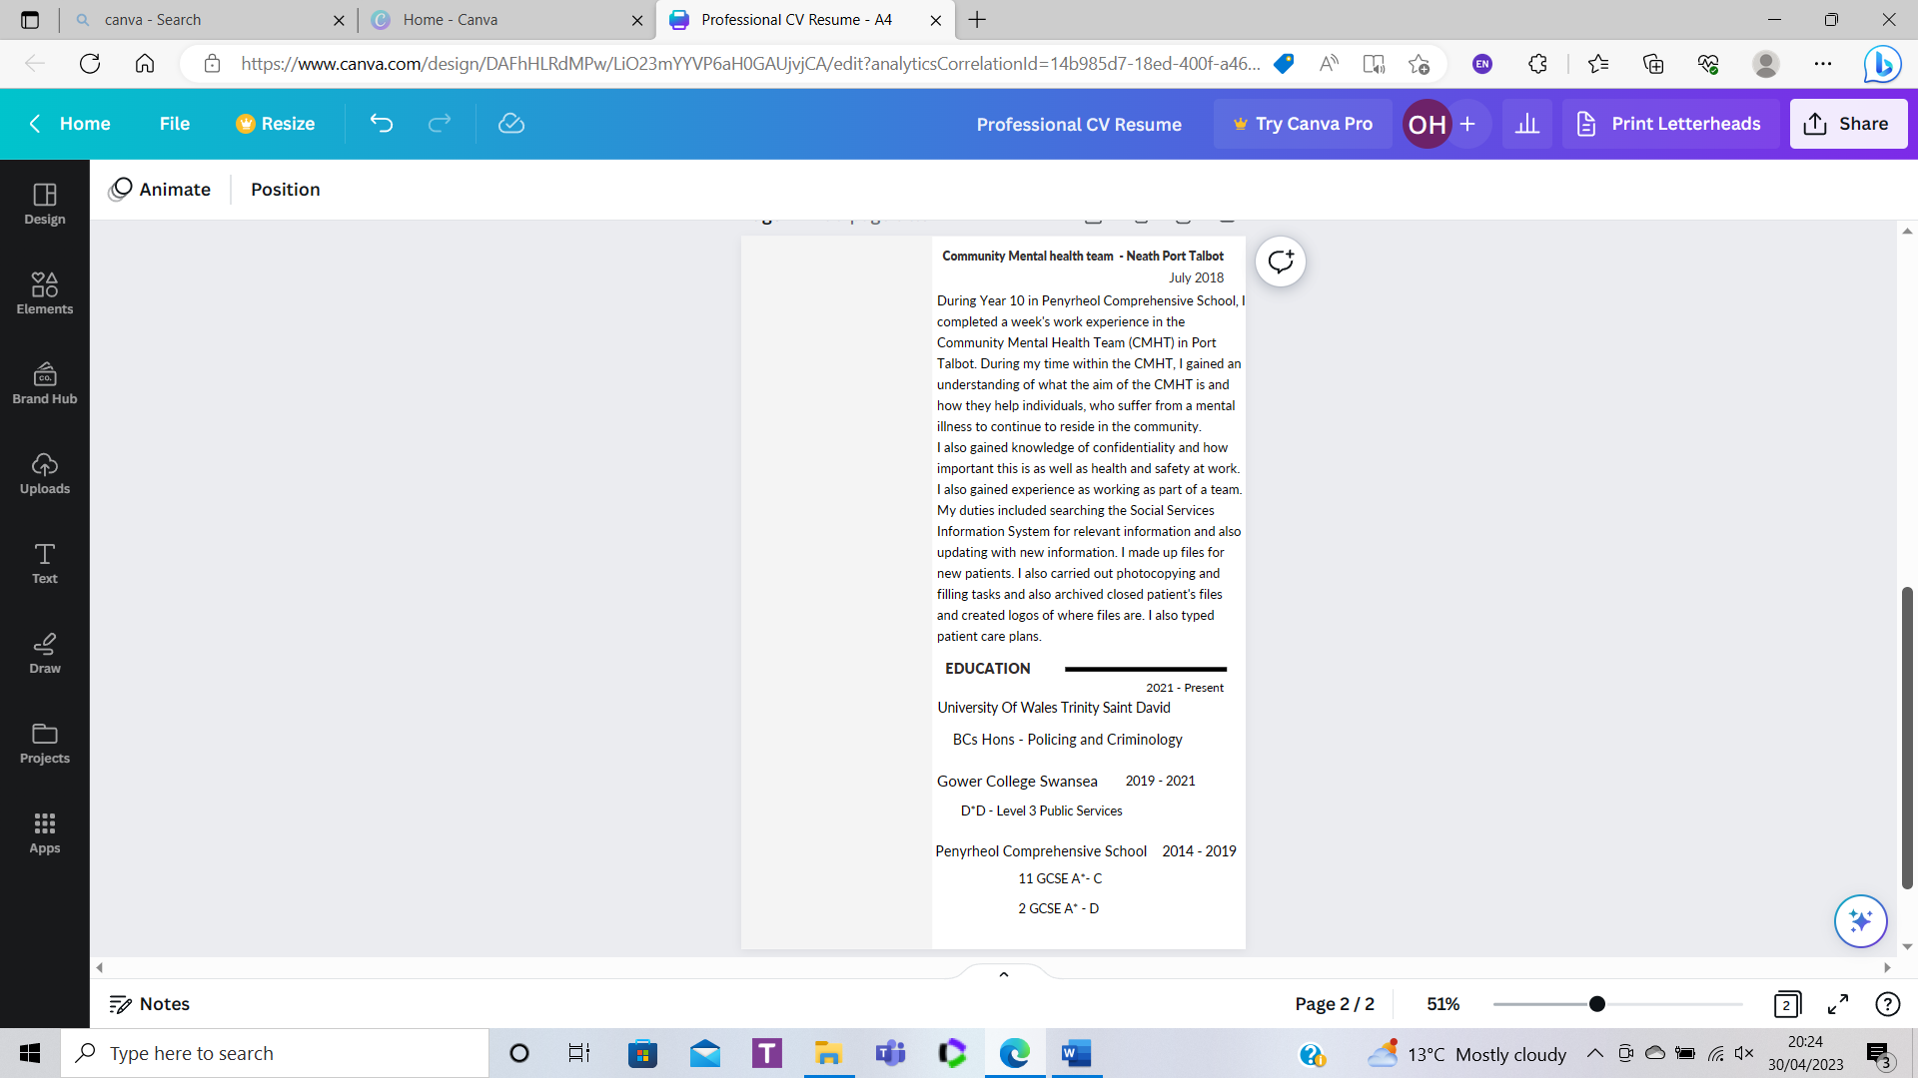

References
Bowcut, S., 2023. How to become a cybercrime investigator: A complete career guide. [Online]
Available at: https://cybersecurityguide.org/careers/cyber-crime-investigator/
[Accessed 3 April 2023].
Coucil, S., 2021. How Adult services can help with information, advice and assistance. [Online]
Available at: https://www.swansea.gov.uk/howsocialservicescanhelp
[Accessed 3 April 2023].
Office, H., 2021. Probation Service - About us. [Online]
Available at: https://www.gov.uk/government/organisations/probation-service/about
[Accessed 1 April 2023].
Police, S. W., 2023. Careers. [Online]
Available at: https://www.south-wales.police.uk/police-forces/south-wales-police/areas/careers/careers/
[Accessed 3 April 2023].
policing, C. O., 2023. Inspector. [Online]
Available at: https://profdev.college.police.uk/professional-profile/police-inspector/
[Accessed 3 April 2023].
Smith, J., 2022. Life as a probation officer , England : University of Portsmouth .

