
DIEGO GUAZZAROTTI
1816567
M5X01923
CULTURE AWARENESS
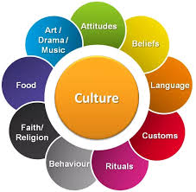

Lecture: Dale Clarke

PAGE CONTENTS

- INTRODUCTION 3

- HOW TO ACT AT THE TABLE AROUND THE WORLD 4

- HOW WAS YOUR MEALTIME? 5

- MAY I HAVE A BIT MORE? 6

- DIFFERENT MANNERS DIFFERENT COUNTRY 7

- IN CONCLUSION 8

- REFERENCES 9

INTRODUCTION
The Aide Memoire or Memorandum of a Hotel, or Hotel Information Memorandum is an article organized by professional’s expert in social communication planned intended for the diverse gatherings involved within the quality, from customers to personnel. It characterizes an official article that consents to know a sequence of statistics suitable in connecting with individuals, and consequently individuals, of diverse philosophies. To know the countless customs and traditions of the several principles permits you to express a positive competence since the personnel and a fine instruction from the clients. To show admiration aimed at the diverse populations within the hotel is one of the maximum grades of admiration that may be needed. The Aide Memoire is done of a few characteristic fragments, which recapitulate in aspect the physiognomies of the several individuals. The characteristic parts that structure the Aide Memoire are dissimilar, contingent on the category of structure, the market, the subject, and the part in which we discover ourselves. Complications that frequently appear from diverse values are very intricate for example a multidimensional perception. A part of information, traditions, habits, and uses that distinguish several individuals and several zones of origin. Nevertheless, a correct and operative organization of diverse philosophies within a hotel building would be a fantasy if there is no compact understanding and facts of the principles. “Having information about other people’s folkways can improve human relations” (Norine Dresser, 2005). Variety administration should pay attention on a plan that distinguishes the personality of personnel and have confidence in the profits of variety within administrations.” Unfortunately for the world of work, culture changes very slowly, and good management is needed today” (Samuel A. Culbert,2017).
Hotel possessors and hotel supervisors have known that great excellence provision is gradually becoming a significant achievement aspect, high service ideals consent the plan to be show in the market and energetically. Class in the service segment is problematic to assess because of three different phases of the service: heterogeneity, imperceptibility, and inseparability of consumption and productions. In 1988, Parasuraman et al established a dimension framework to ratio the value of service. SERVQUAL is the framework name. Parasuraman et al, with SERVQUAL, has separated the value of service hooked on 5 precise proportions. Security, consistency, empathy, and awareness are concrete. These 5 recognized proportions are utilized in the report and dimension of the class of service in the guesthouse segment. The trustworthiness dimension worries the providing of services created principally on the conference or greater than opportunities. Awareness mentions the aptitude of personnel to reply effectively and promptly to client’s' needs. The concrete mention the overall functionality and attendance of the guesthouse. The assurance suggests the information and courteousness of the personnel and their aptitude to encourage trust and security. Understanding is articulated in the wisdom that administration and its workers be concerned about the requests of the customers. The value of guesthouse service seeming by clients descends from an evaluation of what they have confidence in. Hotels must propose their expectations and their observations of the act of the guesthouses that offer their services. Conferring to numerous experiential educations in the hospitality segment in attendance are intercultural variances in the behavior and attitudes of guests. No-one ought constantly imply traditional practices and principals, particularly persons that are still essential to the principles. In the situation of the structural support of the service, decent corporation wisdom and cultural compassion are decisive for achievements. Conserving and savings resources are extremely treasured.

HOW TO ACT AT THE TABLE AROUND THE WORLD

“There is maybe a no better way to understand a culture, its values, preoccupations, and fears, than by investigating its attitudes toward food” (Julia Luisa Abramson, 2007).
In Japan and China, spoons or forks are forbidden, only chopsticks are used. In Thailand, spoons and forks are used, but only the latter is carried to the mouth. “In Thailand, you're expected to use a spoon (and not a fork) to put food in your mouth” (Sarah Schmalbruch, 2015). The individual use of the forks is to accompany the nutriment. Recall, nevertheless, do not lick them, cross the forks or leave the forks in a perpendicular spot on the rice vessel, because the gesture could recall the incense fire wood positioned straight up in the plate once the dead soul are grieved and the burial is celebrated. In Indonesia, Ethiopia, India, and in few zones of the Middle East, fingers are crucial. You dine by your right hand because the left-hand hand is a representation of filths, it is set aside for the greatest modest actions and used for the purging of the body, completely by using a single big platter in the middle of the dine table. With clear explanations they not once lick their fingers hand. In France, knives and forks are used, obviously, but you do not cut vegetables leaves by a knife. That custom age back to the ancient times when silvery cutlery oxidized on interaction with wine vinegar. Nowadays silvery cutlery is no more used, but the tradition has persisted.

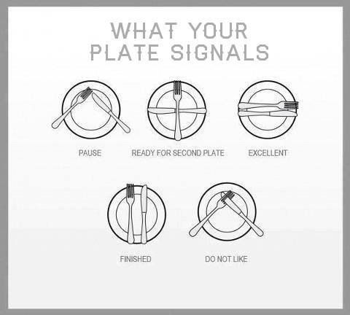

HOW WAS YOUR MEALTIME?
In China, a pleasant burp is the finest method to express thanks to the Cooker for the exceptional plates and to demonstrate high gratitude for the dish eaten. Meanwhile in Japan to ensure respect to the chefs working in the kitchen it is significant to do stuff serenely, the proportions, showing gratitude at the table, the meal, the composition and the aspect of the meals. “the graciousness of service and attention to guests that characterizes the fine art of Japanese omotenashi (hosting a meal)” (Michael Ashkenazi, 2003). While you are consuming a bowl of noodles or a vegetable soup, nevertheless, it is alike significant to be blatant. Only in this method would you prove that you truly appreciate the meal you are having. In Thailand, to demonstrate that you have appreciated dining, you may take a dish as numerous times as you like, nevertheless, since every person has to appreciate it, before pleasing the last dish, it is decent to make certain that all the other diners approve.

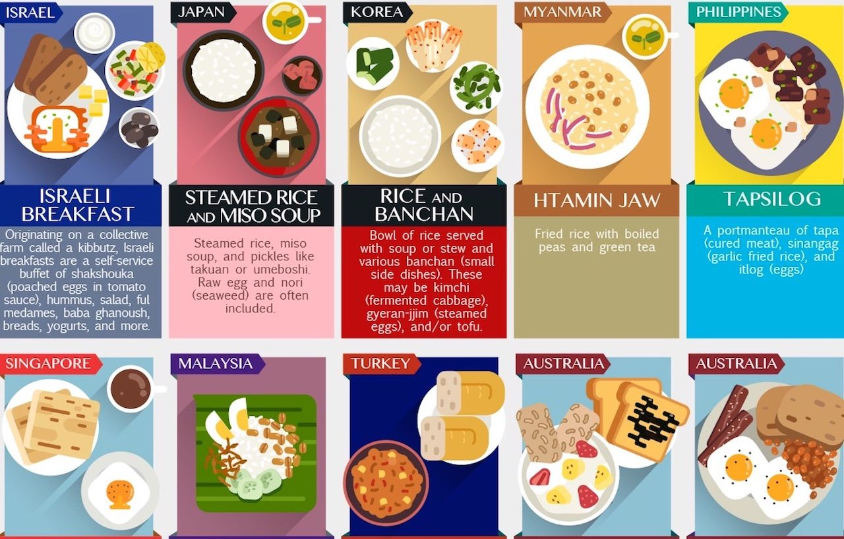

MAY I HAVE A BIT MORE?
In Spain, it is categorically prohibited to request for an extra dish, where it is an act of excessive impoliteness. In Georgia instead is very pleasant to accept one extra plate is almost an obligation. The instruction, consequently, is for eating tiny food portions therefore that you may enthusiastically take another additional dish. In the Arabic states, where meals are constantly served in great portions, requesting for an extra portion is a praise for the persons who have prepared the meals. Be cautious to end the whole dish you have been served in India because not finishing a portion of the meal in the plate for the Indians imply squander it and consequently insulting the chefs. “For many centuries Indian people have sought a healthy outlook and balance with the natural world” (Lois Ellen Frank, 2013). In China, on the other hand, cleaning the entire plate imply not having eaten sufficiently, which is a method to express to the chefs that he has not prepared plenty to provender you. At all times keep some food on the serving dish. Do not soak bread after the mealtime into the serving dish in France because that is the Italian way to compliment the Chef.

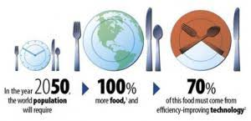

DIFFERENT MANNERS DIFFERENT COUNTRY
Not every request for pepper and salt in Portugal. Consider it tremendously impolite since it implies that the dish provided with the absence of taste. Not ever divided the bill in Georgia, since one and an only person must pay. Never puff your nose while sitting in table in Japan, it is known as sort of disgraceful. Not every request for the components of a meal in Zambia, you would give the impress that you are frightened of being food diseased. While you are in South Korea, not ever begin the meal earlier than the elder individual sitting at the table has begun to eat the food, it is inappropriate and tremendously discourteous. You would have to pause for the elder male sitting at the table before starting to eat your meal in Egypt. In Germany and Austria, it is tremendously disrespectful to show up late for your dinner, and you should warn it in advance to the restaurant’s host. While in Greece and Mexico, nevertheless, it is usual to reach the mealtime around 30 minutes later than the settled time, in Argentina it is up to 30 minutes later than the arranged time. In Italy and South Africa showing the thumps up is an act of endorsement, while in Bahrain and Nigeria it is a grave offense. In Nigeria, it is prohibited to keep eye watching contact while speaking to somebody as well, even though doing a burp after the mealtime means that you enjoy it. Not ever leave a meal on an Afghanistan table if you are pleased, you will need an extra. You should dine with your left-hand and not be seated earlier than your seat is assigned, as well. While in Egypt, you should agree al the times to have black coffee or tea and you should not ever put extra some salt in the plates, those persons who prepared your meal will be insulted. While in Russia, it is well-mannered to assist those persons who invited you to cook and clean, even though it is illicit or in slightly occasion extremely dispirited to converse about politics arguments. While in Belgium having your fingers cracked, is bad education, meanwhile in China is whistling. It is forbidden to talk of death in Taiwan because the residents are influenced that the arguments spoken would after come reality. While in Thailand, consider an adulterated sign to utilize the left-hand to give or pass something. While in Brazil, wedded females should be kissed in their cheeks 2 times and single ladies should have one more kiss. While in Japan, you must remove your shoes before incoming the habitation and the reactions and feelings must not be exposed excessively.

IN CONCLUSION
As a conclusion, this report would summarise all the manners and habits about what you may do and what you may not do in all the different countries.
China: you may be on time, using a chopstick, to burp at the conclusion of the mealtime, you may not shake or touch hand, whistling and be loud.
Egypt: you may always accept coffees and teas and you must pause for the eldest individual to start the mealtime. You may not request for pepper and salt for your dish.
India: you may use “Namaste” to meet, to shake hand are adequate between two men, eating with righthand, you may not waste food is very unpolite, “I can’t stand persons who do not take food seriously” (Oscar Wilde, 1893), the left-hand is viewed impure, use constantly the right-hand to dine and giving belongings and effects.
Malaysia: you may use Malaysians’ handshake as a greeting, you may not touch the head of any individual.
Japan: you must take off your shoes before going into a habitation.
Russia: you may not talk about politics at the table during mealtime.
Portugal: you may not request for pepper and salt for your food.
Philippines: you may raise your eyebrows to communicate “affirmative” and being very friendly and warm with people.
Germany: you may be meticulous and exact and firm handshakes are favored, you may not be an outward person, to be loud and dialog to somebody with your fist in your pocket.
South Korea: you may be tremendously good-mannered and lay down the spoon or chopsticks over the table to specify that you have done eating, you may not kid about costs and to touch people.
French: you must be punctual; the handshake is a swift shake with a bit of heaviness in the grasp and waits for a lady to offer her hand at first, you must not use a firm and pumping handshake.

“Culture that has withstood change over centuries, and may still provide a portal into ancient traditions, are truly becoming a global anomaly” (Justin Guariglia, 2008).

REFERENCES
J. Guariglia, (2008), Planet Shanghai, Chronicle Books, San Francisco, P.10.
J. L. Abramson, (2007), Food culture in France, Greenwood Press, Westport, P.8.
L. E. Frank, (2013), Foods of the Southwest Indian Nations, Ten Speed Press, New York, P.18.
M. Ashkenazi, (2005), Food culture in Japan, Greenwood, Westport, P.11.
N. Dresser, (2005), Multicultural manners: essential rules of etiquette for the 21st century, John Wiley & Sons, Hoboken, P.22.
O. Wilde, (1893), Finedininglovers.com, Available at: https://www.finedininglovers.com/article/best-food-quotes-oscar-wilde, (Accessed 31/04/2020).
S. A. Culbert, (2017), Good people, bad managers, Oxford University Press, New York, P.135.
Sarah Schmalbruch, (2015), Business Insider, Available at: https://www.businessinsider.com/table-manners-around-the-world-2015-9?r=US&IR=T, (Accessed 29/04/2020).

