

Module:
Knowledge and Information Management Skills for the Workplace
Lecturer: MOHAMED KALAM
Module Code: BMSW5106

Assignment Title:

Knowledge and Information Management of Amazon

Report

By: Zlatina Tyulyusheva
Student ID 1919008

Abstract
The tacit knowledge of the individual and explicit knowledge of the organisation are related to decision making activities and are important for the quality of the decisions made and the future of any company (Mosconi and Roy, 2013). The aim of Knowledge Management is to make those decision efficient and effective. According to Demarest (1997) the ultimate goal of KM is to find out if the existing knowledge works for achieving the company goals and its influence on performance and efficiency. Knowledge exists withing the company even if it is not being acknowledged, captured, and distributed. However, managing it will facilitate understanding knowledge, systematizing it would help avoid chaos and dissemination of knowledge increases its power by involving more people and including their experience and point of view.
The report reviews the Knowledge Management techniques used by Amazon and how the “Earth’s most customer centric company” (Amazon Sustainability Report, 2020, p.3) acquires, retains, and shares knowledge, and proposes a framework that could help the company when facing future challenges.

Table of Contents
Abstract 2
Introduction 4
1. Amazon and The Importance of Knowledge Management for Organisational Success 5
1.1. Company Background 5
1.2. Knowledge Management - Definition 5
2. Knowledge and Information Management Models/ Theories 6
2.1. Embedding Knowledge in Products and Services 6
2.2. Management Information Systems and their influence on Knowledge Management in the organisation 8
3. Knowledge Management practices used by Amazon 10
3.1. Amazon’s SOP and The Importance of Knowledge 10
3.2. How KM Techniques and Practices add value to Amazon’s products and services 11
3.3. Future Challenges 12
4. Conclusion 12
5. Recommendations 13
Reference List: 14
Appendices 17
Appendix A 17
Appendix B 18
TASK 2 Proposed Knowledge Management Framework for Amazon 19

Introduction
Knowledge has always played significant role for the progress and evolution of the civilisation, however in the recent years it has been also acknowledged as an asset of an outstanding value to an organisation incomparable to other economic assets because it impacts the way it is managed (Mosconi and Roy, 2013). As any other organisational asset knowledge needs to be maintained and managed throughout the main stages of acquiring, retention, and dissemination. The way a company is embedding the knowledge in its products and services determines its success with its customers.
The main purpose of writing the report is to investigate the Knowledge Management (KM) practices adopted by Amazon and to recommend and suggest a framework that can be helpful for the company in handling future challenges and reinforce their knowledge management practices.
Amazon started as an online business for selling second-hand books, that used to take up to 30 days for delivery, form the garage of its founder Jeff Bezos in 1994, and within its first month of operation it has already been selling book to people in every single state of the US and in 45 countries around the world (Hartmans, 2021). Today Amazon is the biggest online seller globally, selling vast variety of products, with its own streaming platform Amazon Prime Video and also providing variety of B2B services- logistics, storage, loans, it is the biggest online platform to third-party vendors as well as established its cloud computing platform Amazon Web Services (AWS) as a global leader in the cloud-based computer services (Amazon, 2020).
In order to identify and analyse how Amazon is managing knowledge this report is underpinned by different models and principles, including Wiig KM Model (1993) that defines the three stipulations necessary for the management of a business organisation and the importance of the organisational memory for the future success of the company (Mohapatra et al., 2016); SECI KM Model (1995) by Nonaka and Takeuchi focusing on creation of tacit knowledge, its transformation to explicit knowledge and its use (Nonaka and Ichijo, 2007); Bukowitz and Williams KM Cycle with focus on organisational strategy, and Meyer and Zack KM Model (1996) referring to using knowledge management as a tool increasing value with the existing knowledge (Mohapatra et al., 2016).
Based on the findings the report recommends a framework based on the findings supported by critical evaluation of various theoretical models and principles applicable with the Amazon organisational culture, leadership principles, goals, and objectives, considering the volatile nature of the business environment, identifying future threats and challenges as well the market trends and forces.

Amazon and The Importance of Knowledge Management for Organisational Success
According to Fernanda and De Toledo (2004) knowledge is simultaneously an input in the organisational processes and an output as a result of those processes, and as a source of competitive advantage it should be managed rightly to obtain the maximum of its value. Any company entering and operating in the business environment needs to consider the 7P’s of the marketing Mix- Price, Product, Place, Promotion, People, Process and Physical evidence. A qualitative and quantitative knowledge about customers results in designing and offering of better products suitable for their needs, or even, in the case of Amazon, to predicting future customer needs.

Company Background
The unique vision for the market domination of a company as “an everything store” belongs to the founder of Amazon-Jeff Bezos, until very recently the richest man in the world, who started the business from his garage, and by prioritising market growth instead of profit, by investing vast amounts in warehouses, supply networks and data systems almost three decades later he evolved his company from selling online books to an empire valued at $683.9 bn leaving behind companies like Apple, Microsoft and Google, (BBC, 2019). Amazon headquarter, based in Seattle, Washington is also known as Day 1, and Amazon websites are available in 13 countries, with shipping destinations to over 100 countries, selling everything, including electronic devices (Alexa, Kindle, Echo, Fire tablet) and home security cameras (Ring, Amazon Cloud Cam), all developed by the company; groceries; own entertainment network (Amazon Prime Video) and even aerospace company, called Blue Origin (Amazon, 2020). The most profitable Amazon product however is Amazon Web Services (AWS), and to illustrate its scale of operation is sufficient to name just few of the biggest companies, using AWS- Facebook, Twitter, Netflix (direct competitors in online streaming), BBC, NHS in the UK, even government structures in the US as well as MI5 and MI6 in UK (Cave, 2020; Syal, 2021).
The surge in online sales as a result of the pandemic created 400 000 additional jobs at Amazon in 2020 and the company is currently employing more than 1.3 million people (Amazon, 2020).

Knowledge Management - Definition
According to North and Kumta (2018) KM facilitates the collective and systematic creation, sharing and applying of knowledge by individuals, teams and business organisations and thus helping them achieve their strategic and operative goals and objectives, and they define three driving forces that determine importance of knowledge for organisational performance and success, illustrated in Appendix A.
According to Ichijo and Nonaka (2007) knowledge is the main source for creating a competitive advantage of any company in the 21st century, therefore KM is essential for sustaining this advantage by applying different practices for acquiring, retaining, sharing, and managing company knowledge. They emphasise on the importance of knowledge and its management globally considering the changes in the macro-environment that are happening at a great speed and believe that the future success of a company is defined by the abilities of its leaders and managers to obtain intellectual capital by creating and sharing knowledge.
KM has significant importance for satisfying customer needs because it helps the organisation to know more about the customer by collecting relevant data and information. For example, Sainsbury’s is using club card called Nectar to collect information about the purchasing and buying habits of customers and thus they can differentiate services, offer discounts, promotions and special offers tailor made to the customers. Without having the KM and Customer Relation Management (CRM) tools collecting all this information would not be possible. Managing the knowledge is helping the company to know more about the customers, understanding the customer needs, customising the products and services offered according to the demand and expectations of the customers, to meet customer expectations and enhance customer services. By keeping customers pleased with the products and services that helps companies generate more revenues and create more valuable products and be more competitive.

2. Knowledge and Information Management Models/ Theories

2.1. Embedding Knowledge in Products and Services
According to Ichijo and Nonaka (2007) capturing intellectual capital and keeping record of past experiences, including mistakes and failures, is a valuable source for creating core competency and steers the organisation to future success. In 1994 they proposed a KM model called SECI, comprising of 4 steps- Socialisation, Externalisation, Combination, and Internalisation, illustrated in Figure. 2, with focus on creation and use of the knowledge. According to the model tacit knowledge, created by individual experience, standards, and values, once shared, receives validation, improves by blending with other people knowledge, and this is how it keeps developing. Central for the model is the human empathy and the continuous process of knowledge conception throughout flowing the organisation, following the 4 stages, also discussed in Appendix B.

Figure 2. SECI Model
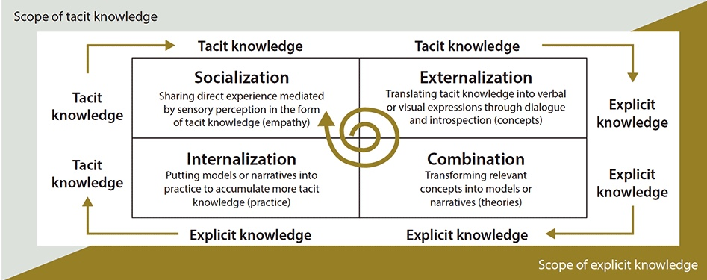
Source: Hitachi, 2020
It might seem that a model that put the human relationships at its core is a step back considering the global digitalization and the dramatic impact Artificial Intelligence has on the processes in the successful companies, including Amazon. In addition, scholars like Mohapatra (2016) argue that it is difficult for a big organisation to follow individual KM cycle, even though they have the resources to do so. However, Nonaka himself gives sound examples with two very successful companies like Microsoft and Hitachi, that implemented knowledge creation process with empathy for people, aiming at developing AI as an extension of human capabilities and not to replace humans (Nonaka, 2020).
On the other hand, Bukowitz and Williams KM Cycle proposes a framework, as displayed in Figure.3, which also takes into consideration tacit and explicit knowledge, however it analyses the content and how valuable it is for the organisation and thus supports the strategical decisions of the company. The model does include the contribution of the employees but unlike the SECI model sees them as a mean to acquire, retain and disseminate the knowledge suitable to achieve the company objectives. It also suggests that not all of the acquired knowledge is worth keeping and that some of it actually should be divested (Mohapatra, 2016).
Figure 3. Bukowitz and Williams KM Cycle
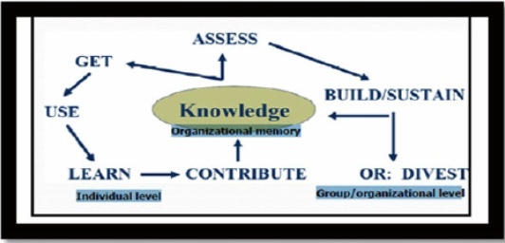
Source: Mohapatra (2016, p.24)
The findings of this report in the light of the review of both SECI and Bukowitz and Williams KM Cycles indicate that both models have characteristics beneficial for embedding knowledge in the products and services. According to SECI model the newly created tacit knowledge ignites a new cycle of knowledge formation. The continuous process of converting tacit and explicit knowledge leads to transforming subjective values into objective, socially distributed knowledge and to creating a policy that meets the customers’ expectations and demand (Ichijo and Nonaka, 2007). However, knowledge also drives strategy and strategy drives KM hence its significant impact on the formulation of organisational strategy related to all the components of the marketing mix- people, product, price, place, promotion, process, and physical evidence and this is where Bukowitz and Williams KM Cycle can be beneficial (Moscony and Roy, 2013).

2.2. Management Information Systems and their influence on Knowledge Management in the organisation
Laudon and Laudon (2013) define a Management Information Systems (MIS) as a group of interdependent elements that accumulate (or recover), administer, save, and disseminate information to reinforce organisational decision making and management. MIS also support managers and employees in analysing situations, understanding better customer needs and expectations, and in creating new products in services. MIS and organisations affect each other- usually managers are implementing MIS to achieve the business objective of the company and to enable more efficient and high-performance working process. On the other hand, the MIS influences the organisational structure, business processes, even culture and management decisions (Laudon and Laudon, 2013).
According to a 4- dimensional framework proposed in 2013 by Mosconi and Roy, consisting of structure, culture, process and activities, and technology and tools, individuals/ employees play central role hence the importance of their understanding for their contribution to the overall organisational processes and MIS. This idea is leading in the SECI model, along with the strong belief that knowledge is a significant source of competitive advantage for the company and successful will be those organisations who create and manage knowledge into innovation (Mullins and McLean, 2019). According to Natek and Zwilling (2016) when related to the MIS the Socialisation element of the SECI model can be interpreted as intended to provide support for employees, where tacit knowledge is shared through communication. The externalisation refers to the need MIS to codify knowledge so it can be available, accessible, easily comprehended by the employees. In the Combination stage MIS uses all the data and information available to allow better understanding of the customer needs, for example Amazon is using deep learning AI where algorithms make assumptions to extract valuable information from vast amount of data about the habit of its customers (Tech Vision, 2020). in the internalisation stage the organisation is benefitting from the new knowledge and the employees are learning from the MIS which leads to creating new tacit knowledge and re-ignites the KM cycle.
In addition to MIS the operation of many companies, including Amazon, involves different Operation Information Systems (OIS), including Transaction processing System (TPS), Process Control Systems and the advanced cloud computing platform of Amazon, for example, enables the advanced use of Production Planning, Enterprise Resource Planning (ERP), Product Lifecycle Management (PLM), High-Performance Computing (HPC) and Computer-Aided Design (CAD) (Amazon, 2020). OIS, combined with the MIS and Knowledge Management are pillars of the Information Architecture (Jamil et al., 2015).
A model with focus on information architecture belongs to Meyer and Zack, release in 1996. It consists of five stages- acquisition, refinement, storage, distribution, and presentation, as seen in Figure 4., and its focus is on creating products and services with higher value based on the already existing knowledge within the organisation (Mohapatra et al., 2016).
Figure 4. Meyer and Zack KM Cycle
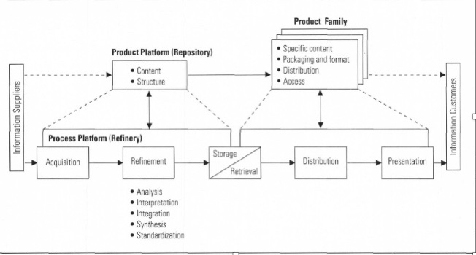
Source: Meyer and Zack (1996, p. 47)
Main elements of their model are Repository for the information of products and services, consisting of information structure and content; and Refinery- as platform for the information processes, comprising 5 stages. The acquisition stage measures different aspects of the data, with only high-quality, related to the specific processes, data kept; in the refinement stage the information is stored in easily accessible formats, value is added and unnecessary data removed; next stage stores the data to use it when required, the distribution stage navigates data to the relevant recipient, and finally becomes knowledge in the final -presentation- stage, which also allows the company to measure the success of the KM cycle by evaluating the added value (Meyer and Zack, 1996; Mohapatra et al, 2016). Meyer and Zack (1996) also believe that repository and refinery support the organisations in creating products and services by extracting knowledge of the needs of the customers and companies, can actually create demand by introducing new, exciting products and services by predicting customer needs, something Amazon mastered as leverage.
Having critically evaluated both KM cycles it can be concluded that organisations dealing with colossal amount of data could have serious leverage my applying the Zack and Meyer KM Cycle and thus be more successful in sharing and exchanging knowledge across the organisation and add value to its products and services.

Knowledge Management practices used by Amazon
Main source for inspiration to achieve the global Amazon success can be found within the 14 Leadership principles proclaimed and practiced by the company and its founder Jeff Bezos. The main ideas the company is based on – or “the Amazon cocktail” as he calls them- are “Long-term Thinking, Passion for Invention, Commitment to Operational Excellence and Customer Obsession” (Amazon, 2020, p. 3) , and the company vison is to set an example and inspire exceptional customer service among other businesses and organisations by creating the world’s most customer centric company that listens to its customers and provide personalised experience, that invents for customers and put them at the centre of everything Amazon does (Croitor, 2017). KM techniques allow Amazon to execute all the above and more.

3.1. Amazon’s SOP and The Importance of Knowledge
Gough and Hamrell (2009) define Standard Operation Procedures (SOPs) as official documents describing the way organisations act upon a task and records this action according to the industry regulations and local laws, outlining the anticipated procedures where quality standards are concerned. They observe that even though many companies create SOPs, only for the purpose of audits and regulatory bodies checks, SOPs should be seen as a detailed manual showing what, how and when to perform a task and how to record it. In essence, SOPs are knowledge- if seen through the principles of SECI model, tacit knowledge from employees, managers and customers that became explicit organisational knowledge, organised and accessible for new members that further enrich the knowledge and is always handy for the existing employees to ensure they provide high quality services to the highest standards. Currently Amazon have over 250 SOPs, divided in seven main sections: Product Listing, Promotions, Inventory Management, Reports and performance, Customer service, Account Maintenance, Financials, which are constantly being reviewed and updated (SellerMap, 2021).
One of the most successful B2B products that Amazon offers is the Fulfilment by Amazon (FBA) which gives the sellers access to the logistic system of Amazon. This provides a brilliant opportunity for any seller to grow their business, reach more consumers and achieve higher customer satisfaction. The seller simply sends the product to a fulfilment centre and Amazon handles the whole journey from the purchase to the customer service, including packaging, delivery, and return. However, sellers have many other responsibilities and tasks to fulfil to grow their brand and having the right SOPs at hand relives the workload by automating tasks and provides the brand the tools to really improve quality (Wong, 2020).
Implementing and using SOPs at Amazon can be seen as competitive advantage, decision making tools and at the core of providing exceptional customer service for the biggest online seller in the world. Charan (2019) believes that behind the immense success of Amazon in treating each of its hundreds of millions of customers individually stays not only the undeniable power of digitalisation but also highly- organised knowledge and consistency in standards enabled through SOPs.

3.2. How KM Techniques and Practices add value to Amazon’s products and services
In his annual letter to the shareholders in 2020, his last as CEO, Jeff Bezos reminds that Amazon vision includes not only value creation for its customers, but also for the shareholders, employees and sellers (Amazon, 2020), and the company mission has been successfully achieved so far by using the full potential of the power of KM.
Amazon’s leading principle of customer obsession and continuous development of the customer relationships results in inimitable customer loyalty without offering any reward programme or incentive- for example, one of Amazon’s paid services Amazon Prime, offering unlimited delivery on over 100 million products within 24 hours for monthly fee, sees 85% of the subscribers visiting the online retailer weekly and 45% making purchase at least once a week (Buglewizc, 2021).
The most profitable service Amazon offers up to date however is a B2B service called Amazon Web Services (AWS), which in 2020 generated 63% of the profit of the whole company and recorded 30% increase, having achieved 32-34% market share- more than any other cloud computing company in the world (Bishop, 2021). AWS is a computing platform, operates in 245 countries and provides variety of products and services, including servers, cloud storage and security (Page, 2021). Unlike other providers, Amazon charges only for what the customer is using, which makes it affordable for company of any size and needs.
Different KM techniques allow Amazon to realise their vision to be the leading customer centric company in the world well ahead of the competition by creating demand using accumulated data that deep learning AI transforms in valuable information that predicts customer behaviour and adds unique value to its services by applying KM principles and strategies (Rosenberg, 2014).

3.3. Future Challenges
Even though Amazon is the most successful e-commerce company in the world, there are several challenges that need to be considered, also acknowledged in the latest Annual Report of the company (2020), including competition, Intellectual Property protection, data protection, staff retention and as of recently COVID-19.
AWS has been accused of being involved in anticompetitive practices and has been subject to claims that it copies and implementing unlawfully software developed by other companies (Page, 2021). Along with that there is a growing concern about the unstoppable growth of Amazon and its knowledge database which means power. Some believe that owning such a big market share creates monopolism and jeopardises fair competition and even free speech and claim that controlling 80% of the e-book marketplace and more than 30% of the cloud services allows Amazon to even erase materials and documentation (Cotton, 2021).
As discussed in the report, 1/3rd of the world is using AWS for their cloud storage, including US government structures and recently it was revealed that the UK secret services agencies MI5 and MI5 will be storing information on the Amazon’s cloud (Syal, 2021). Thus raised a lot of questions and concern about UK government secrets being saved on a software developed and owned by an US based company, and whether there is a risk of for such sensitive information by providing potentially huge power to.
Considering the above examples as presumption of Amazon using the data stored at AWS unlawfully transparency and accountability are vital, and according to the Data Privacy Section regarding AWS Amazon would not access any of the data stored without the agreement of the customer (Amazon, 2020). However, currently what Amazon actually access can be controlled only by the company, and this can be a challenge in the future in relation to earning and keeping customers’ trust (Amazon, 2020).

Conclusion
Knowledge Management practices are essential for achieving Amazon’s vision of the world’s most customer-centric company in the world, giving the organisation undeniable competitive advantage as the most successful and profitable e-commerce company. A qualitative and quantitative knowledge about customers results in designing and offering of better products suitable for their needs, or even, and even predicting the customer needs. This improves the marketing position of the company and increases the efficiency and profitability.
Knowledge plays vital role for the business success is in creating successful organisational strategy. Understanding how customers receive, read, and interpret any communication coming from the company, helps Amazon and any other company to reach more customer and communicate effectively with them, and even predict their needs.
The effective acquisition, storage and sharing of knowledge is a vital for the successful implementation and management of knowledge in organisations. KM and enhanced organisational performance are undeniably linked by innovation, and nowadays companies should constantly reinvent and innovate in order to be competitive, led by KM principles and practices.

Recommendations
Employees play vital role in the sharing tacit knowledge and in creating new organisational knowledge hence employee motivation is important for successful knowledge management processes. Even though Amazon increased its starting wage to $15 per hour and impacted other companies in the US to do so (Amazon, 2020), often there are reports for poor working conditions, inhumane expectations from the workers in the Fulfilment centres, injuries, and unsafe working conditions. Such reports can drive consumers away and could be a reason for low retention rate which will have negative effect on creating and retaining knowledge, therefore is recommended that Amazon reviews working conditions often, put more efforts towards safer working environment and satisfied employees.
According to whistle blowers, Amazon is not handling its customer information- personal data, credit card information- with the expected level of protection and thus can become a potential target to security violations, with some even claiming that Amazon cannot really establish all the data it has, where it is stored and who has access to it (Manancourt, 2021). Even though Amazon dismissed such claims, they can affect customer loyalty, a potential breach in the security of AWS where Amazon retains most of its information, along with 1/3 of the world, can cost the company huge financial loss, therefore is recommended to ensure data protection to the highest standards and constant review and upgrade of its security policies, procedures, and practices.
AWS is considered one of the most reliable cloud services, using remote locations for its data centres that are closely supervised and maintained to the highest standards (Page, 2021). In December 2021 some of the company’s servers experienced temporary outage which led to difficulty accessing Neflix, Alexa, Kindle, Ring and created chaos during the busiest time of the year for the retailer affecting fulfilment centres and deliveries (Soper, 2021). The problem was resolved within 24 hours, however the possibility to reoccur exists. Such incidents jeopardise how and when the company shares knowledge and affects the communication and knowledge flow between the stakeholders hence this is an area where Amazon could focus attention and efforts to limit such outages or when they occur to fix them faster. That would improve and add more value to the service and prevent financial losses due to delays and preserve the company image.

Reference List:
Amazon (2020) Annual Report 2020. Available at: https://s2.q4cdn.com/299287126/files/doc_financials/2021/ar/Amazon-2020-Annual-Report.pdf (Accessed: 09th of December 2021)
Amazon (2020) Amazon Sustainability Report 2020: Further and Faster, Together. Available at: https://sustainability.aboutamazon.com/pdfBuilderDownload?name=amazon-sustainability-2020-report (Accessed: 21st of December)
Amazon (2021) What is Fulfilment by Amazon? [online] Available at: https://sell.amazon.com/fulfillment-by-amazon (Accessed: 08th of December 2021)
BBC (2019) Amazon becomes world’s most valuable public company. [Online] Available at: https://www.bbc.co.uk/news/business-46793466 (Accessed: 23rd of November 2021)
Buglewizc, S. (2021) “Amazon customer loyalty: Winning without rewards program” CCG Retail Marketing [blog]. 17 March. Available at: https://www.customer.com/blog/retail-marketing/amazon-customer-loyalty-winning-without-rewards-program/ (Accessed: 06th of December 2021)
Bishop, T. (2021) Amazon Web Services posts record $13.5B in *profits* for 2020 in Andy Jassy’s AWS swan song [Online] Available at: https://www.geekwire.com/2021/amazon-web-services-posts-record-13-5b-profits-2020-andy-jassys-aws-swan-song/ (Accessed: 09th of December 2021)
Cave, J. (2020) Who's Using Amazon Web Services? [2020 Update] [Online] Available at: https://www.contino.io/insights/whos-using-aws (Accessed: 10th of December 2021)
Charan, R (2019) How Amazon Does It: Decision Making Inside The World’s Most Daring Digital Company. Available at: https://chiefexecutive.net/how-amazon-does-it-decision-making-inside-the-worlds-most-daring-digital-company/ (Accessed: 08th of December 2021)
Cotton, T. (2021) “Big Tech reboot – time to stop further consolidations, revive competition and promote free speech”, Fox News, 16th of November. Available at: https://www.foxnews.com/opinion/big-tech-revive-competition-promote-free-speech-sen-tom-cotton (Accessed: 10th of December 2021)
Croitor, D. (2017) Amazon’s 14 Leadership principles via Jeff Bezos [video] Avaialble at: https://www.youtube.com/watch?v=B-xdfQv3I1k (Accessed:09th of December 2021)
Demarest, M. (1997) Understanding knowledge management. Long range planning. [Online] 30 (3), 321,374–322,384.
Fernanda, M.F. And De Toledo, J.C., (2004) “Analysing the knowledge management through the product development process”. Journal of Knowledge Management, 8(1), pp. 117-129. DOI: 10.1108/13673270410523952

Gough, J. & Hamrell, M. (2009) “Standard Operating Procedures (SOPs): Why Companies Must Have Them, and Why They Need Them. Therapeutic innovation & regulatory science. [Online] 43 (1), pp.69–74 DOI: 10.1177/009286150904300112
Hartmans, A. (2021) “14 other little-known facts about the early days of the e-commerce giant”, Business Insider, 2nd of July. Available at: https://www.businessinsider.com/jeff-bezos-amazon-history-facts-2017-4?r=US&IR=T (Accessed: 23rd of November 2021)
Ichijō, k. And Nonaka, I. (2007) Knowledge creation and management new challenges for managers. Oxford: Oxford University Press.
Jamil, G. L. et al. (2015) ‘Architecture of Information’, in Handbook of Research on Information Architecture and Management in Modern Organizations. [Online]. IGI Global. pp. 24–60.
Laudon, K. & Laudon, J. P. (2013) Management Information Systems, Global Edition. 13th ed. Place of publication not identified: Pearson Education Limited.
Manancourt, V. (2021) “Millions of people’s data is at risk’ — Amazon insiders sound alarm over security” Politico, 24th of February. Available at: https://www.politico.eu/article/data-at-risk-amazon-security-threat/ (Accessed: 21st of December)
Meyer, M.H. and Zack, M.H., (1996) “The Design and Development of Information Products”. Sloan management review, 37(3), pp. 43-59. DOI: 10.1016/S0737-6782(97)81448-8
Mohapatra, S, Agrawal, A, & Satpathy, A (2016) Designing Knowledge Management-Enabled Business Strategies: A Top-Down Approach, Springer International Publishing AG, Cham.
Mosconi, E. and Roy, M.C., 2013. “Linking knowledge management and organizational performance”. International Business Research, 6(9), p.68. DOI: 10.5539/ibr.v6n9p68
Mullins, L. J. & McLean, J. E. (2019) Organisational behaviour in the workplace. 12th ed. Harlow: Pearson.
Nonaka. I. (2020) Management Based on Human Empathy For Building a Future of Better Living in a Dynamic World. Available at: https://www.hitachi.com/rev/column/ei/vol15/index.html (Accessed: 06th of December 2021)
North K., Kumta G. (2018) Knowledge Management, 2nd edn. New York : Springer
SellerMaps (2021) Full list of Amazon SOPs. [online] Available at: https://sellermaps.com/full-amazonusa-sop-list/# (Accessed: 08th of December 2021)
Soper, S. (2021) „AWS resolves its outage. What happens now?“ Bloomberg, 8th of December Available at: https://www.bloomberg.com/news/newsletters/2021-12-08/aws-resolved-its-outage-what-happens-now (Accessed: 09th of December 2021)
Syal, R. (2021) „Priti Patel pressed to explain award of spy agencies cloud contract to Amazon“, The Guardian, 27th of October. Available at: https://www.theguardian.com/uk-news/2021/oct/26/amazon-web-services-aws-contract-data-mi5-mi6-gchq (Accessed: 10th of December 2021)
Page, V. (2021) What is Amazon Web Services and Why Is It So Successful? Available at: https://www.investopedia.com/articles/investing/011316/what-amazon-web-services-and-why-it-so-successful.asp (Accessed: 8th of December 2021)
Rosenberg, M. (2014) The Knowledge Management Genius of Amazon.com [Online] Availabe at: https://learningsolutionsmag.com/articles/1480/the-knowledge-management-genius-of-amazoncom (Accessed: 09th of December 2021)
Sreko, N. and Zwilling, M. (2016) “Knowledge Management Systems Support SECI Model Of Knowledge-Creating Process”, Management, Knowledge and Learning Joint International Conference, Timisoara, Romania, 25-27 May. Available at: http://www.toknowpress.net/ISBN/978-961-6914-16-1/papers/ML16-251.pdf (Accessed: 07th of December 2021)
Tech Vision (2020) Inside Amazon’s smart warehouse [video]. Available at: https://www.youtube.com/watch?v=IMPbKVb8y8s (Accessed: 29th of November 2021)
Wong, V. (2020) How Standard Operating Procedures Create a $1,000,000 Amazon FBA Business [blog]. 6th of May. Available at: https://empireflippers.com/sop-creates-1m-fba-business/ (Accessed: 08th of December 2021)

Appendices

Appendix A
According to North and Kumta (2018) there are three main mutually dependent forces that determine the increasing significance of knowledge as competitive advantage and the importance of its management:
- The shift from capital to knowledge-based society means that companies predominantly deal with information and the related products and services, which leads to the transition of the traditional organisational structure and transformation of the different roles of management and employees
- Globalisation has heavily influenced how labour is being distributed globally, and until recently industrial societies are becoming knowledge-based societies. Products and services are being delivered globally faster than ever as a result of digitalisation
- The development of Information and Communication Technologies (ICT) facilitates handling of large amounts of data, easy connectivity, co-operation and communication at lower cost.

The three driving forces enhancing importance of knowledge as competitive advantage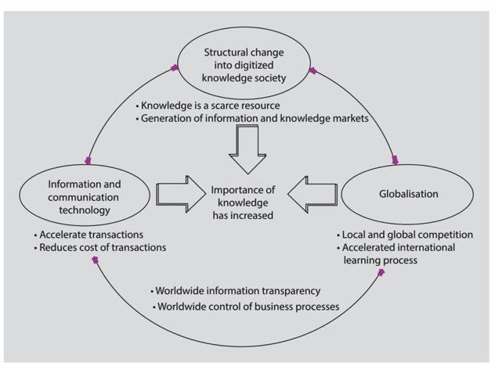
Source: North and Kumta (2018, p.3)

Appendix B

SECI Model
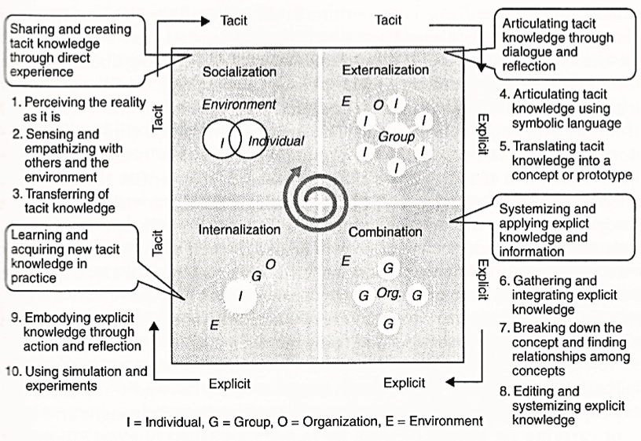
Source: Nonaka and Toyama (2008) (cited in Sreko and Zwilling, 2016)

- Socialisation, where tacit knowledge collected and shared.
- The accumulated knowledge is expressed through Externalisation
- The new concept is structured and finalized Combination where explicit knowledge, accumulated from inside and/ or outside of the organisation becomes more compound and organised through selection, combination, and processing
- At the Internalization stage the explicit knowledge is then transformed by accumulating tacit knowledge by putting it into practice

TASK 2 Proposed Knowledge Management Framework for Amazon

