BA Business Management

Module: Entrepreneurship

Module code: LCBB5001
Student Name: Peter Gottschling
Student ID:2030897
Lecturer: Riaz Bhatti

Table of contents

Introduction 3
Business description / market opportunity 3
Industry analysis 5
Operations and management team 7
Marketing mix 9
Financials 10
Market research 11
Conclusion 12
References 13

INTRODUCTION
This assignment will produce a business plan for Lecture Travel which will be operating its business in the United Kingdom. In this business plan, industry analysis will be done with the help of porter's five forces to understand how successful the business can be in the tourism industry. The assignment will discuss various sources of funding for the business along with how much revenue the business will generate in the first six months.

BUSINESS DESCRIPTION / MARKET OPPORTUNITY
Lexture Travel is a tourism company that will operate its business in the United Kingdom. The company's mission and vision are to provide high-quality services at low-cost. There are many opportunities in the United Kingdom's tourism industry. The goal of this company is to provide better service than the existing travel companies. This company is looking to operate their business on a partnership model. As three people will operate the company together, the business operation of the company is likely to be much smoother as each person has different knowledge and expertise (Usai et al., 2018). The company has decided to initially set up a few branches in some popular locations in the United Kingdom. In the future, the company will expand its business across the globe through the franchise model, when its popularity and customer base will increase significantly through these branches. After the devastating impact of covid 19, the tourism industry has become active again. People are showing more interest in tourism than ever before. The company wants to use this opportunity to offer different types of exciting travel and adventure packages to customers. As people want to spend less money on luxury due to the recession, the company is thinking of offering tour packages through EMI. Very few companies offer tour packages through the EMI system, so doing this will give the company a competitive advantage. The company will add services such as package holidays, winter holidays, SKI holidays, cruise holidays etc. to their product category. The company also decided to tie up with various hotels and airlines in the future and provide all those services to their consumers (MacKenzie and Gannon, 2019). The company is thinking of having a special package which will be a very affordable package. The itinerary will include the best travel destinations in the world. Since the company will have three owners, their shareholding patterns will be equal.

INDUSTRY ANALYSIS
Porter's five forces model is very appropriate for analysing the external environment of a country. This business plan will analyse the UK tourism industry using Porter's Five Model.
- The threat of new entry
Starting a business in the UK tourism industry requires a lot of investment. Although the threat to new entry is very high, the barrier in the tourism market has reduced a lot because of the Internet. Marketing costs are greatly reduced due to the presence of various efficient marketing channels that enable new entrepreneurs to find suppliers and resources. Competition is high in this industry so differentiation is a vital barrier (Mayntz, R. and Schneider, 2019). Lexture Travel can make a good place in this industry only when they provide innovative services to the customers.
- The threat of substitutes
The threat of substitute goods is not very high in the UK tourism industry. There are many competitors in this industry so companies are always facing challenges. In order to run a successful business in this industry, companies have to offer unique services to consumers so that they use their services again and again.
- Bargaining power of customers
Bargaining power of buyers in the tourism industry is very high because there are many companies in the market and they get more opportunities. Buyers always try to purchase the best service at very low prices. In the beginning, the company has to provide the best quality service at a very low price to the customers (Adelakun, 2020). As a result of which they will be able to increase the number of customers. So, in the future, they will not be affected by the bargaining power of the buyers.
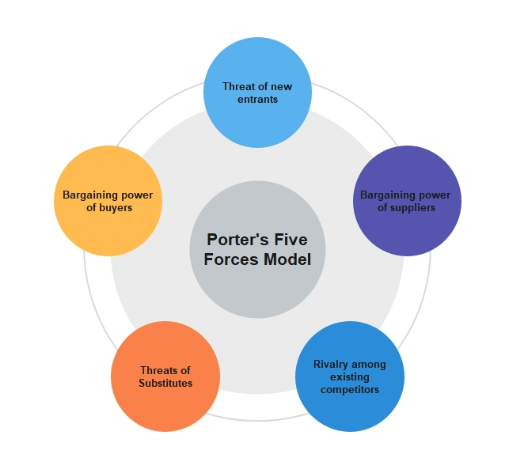
Figure 1: Porter's five forces model
(Source: Adelakun, 2020)

- Bargaining power of suppliers
The bargaining power of suppliers in the UK tourism industry is high, which has a negative impact on companies. Lexture Travel requires an efficient supply chain with multiple suppliers to avoid the bargaining power of suppliers. Buying raw materials with few suppliers will increase their bargaining power day by day which will affect the profit margin of the company.
Competitive Rivalry
Name of competitor | Differentiation
Hays travels | In order to compete with Hays Travel, the company has to provide services at affordable prices.
Barrhead Travel Services Ltd | Barrhead Travel is also a well-reputed company and to compete with them, the company needs to build a Sustainable Differentiation.
Travel Counsellors, | Instead of doing business in a small market by competing with competitors, doing business by collaborating with them will increase the market size and increase the profit margin.

OPERATIONS AND MANAGEMENT TEAM
OPERATIONS
The tourism industry has played an important role in the economic development of the United Kingdom over the past few years. Since the tourism industry is a service-based industry, the business operation process of this industry is vital and if this process is not run properly then companies will lose their customer base. Creating a tourism product is a complex process. First of all, one has to get a good idea about the tour destination, then the tour has to be planned, all kinds of travel arrangements have to be made and accommodation has to be provided. A robust marketing plan is very important to attract tourists to travel (Ferdinand and Tresyanto, 2020). Tourism companies have to monitor the entire process well so that tourists do not face any problems while travelling. Lexture Travel has got a good understanding of various popular tourist destinations with the help of various experts and made proper planning to travel the place. The main suppliers of the tourism business are hotels and transportation services. The company has tied up with hotels and transportation services located in various tourist destinations so that tourists can be easily accommodated there without any hassle. Lexture Solutions has interacted with hotels and transport chains of various countries through the internet for business purposes. The company takes the help of airlines and private cars to transport tourists to different places. This is a simple business operations process that all tourism companies follow but not everyone can execute this process well. Lexture Travel will follow all kinds of legal structures while planning its business operations so that it will not face any legal problems.
How would the company generate revenue?
There are many ways to generate revenue in the tourism industry that are followed by various tourism companies. Lexture Travel will initially follow two ways to generate revenue, the first one is earning commission and the second one is service fees. Various tourism companies earn commissions from booking flights, hotels etc. Also, the company will earn service fees from providing various tourism packages. It is possible to earn more profit by reducing operational costs in the tourism business (Elliott, 2020). The company will always try to provide good service to the consumers without leaving any errors as a result of which their consumer base will continue to increase and there will be no chance of losing revenue.
MANAGEMENT TEAM
Name | Skills | What do they bring to the firm
Mr X | Organised skill, Leadership skill | Mr X is one of the key members of this company who is very passionate about travel. He can create very unique travel plans. Also, having leadership skills, he will be able to steer the company in the right direction.
Mr Y | Leadership skill, Communication skill | Having good communication skills, he will be able to interact with customers very well and sell them company packages.
Mr Z | Management and administration skills | He will be able to run the organization very well due to his good management and administration skills.
Ms A | Negotiation and creative skills | Due to her good negotiation and creative skills, she will be able to create very exciting travel plans and negotiate well with suppliers which will increase the company's profit margin.

MARKETING MIX
- Product
Lecture Travel is generally interested in starting its business with various types of tourism products and packages. They plan to include Winter holidays, summer holidays, Ski holidays, Adventure, Office excursions, College excursions etc. packages in their product categories. They will provide different types of services to consumers in the future which will increase their company's revenue a lot. In order to compete well with competitors, the company have to offer unique and innovative products, otherwise, it will not be able to grow its customer base (Buhalis, 2019).
- Price
The company will operate the business within a highly competitive price range. Their lowest tour package will be 100 Pounds. Most of their tour packages will be between 100 and 500 Pounds. It is a very competitive price because very few companies operate their business in this price range. They will also have a yearly subscription plan that will offer a twenty per cent discount on every tour package for those who purchase it.
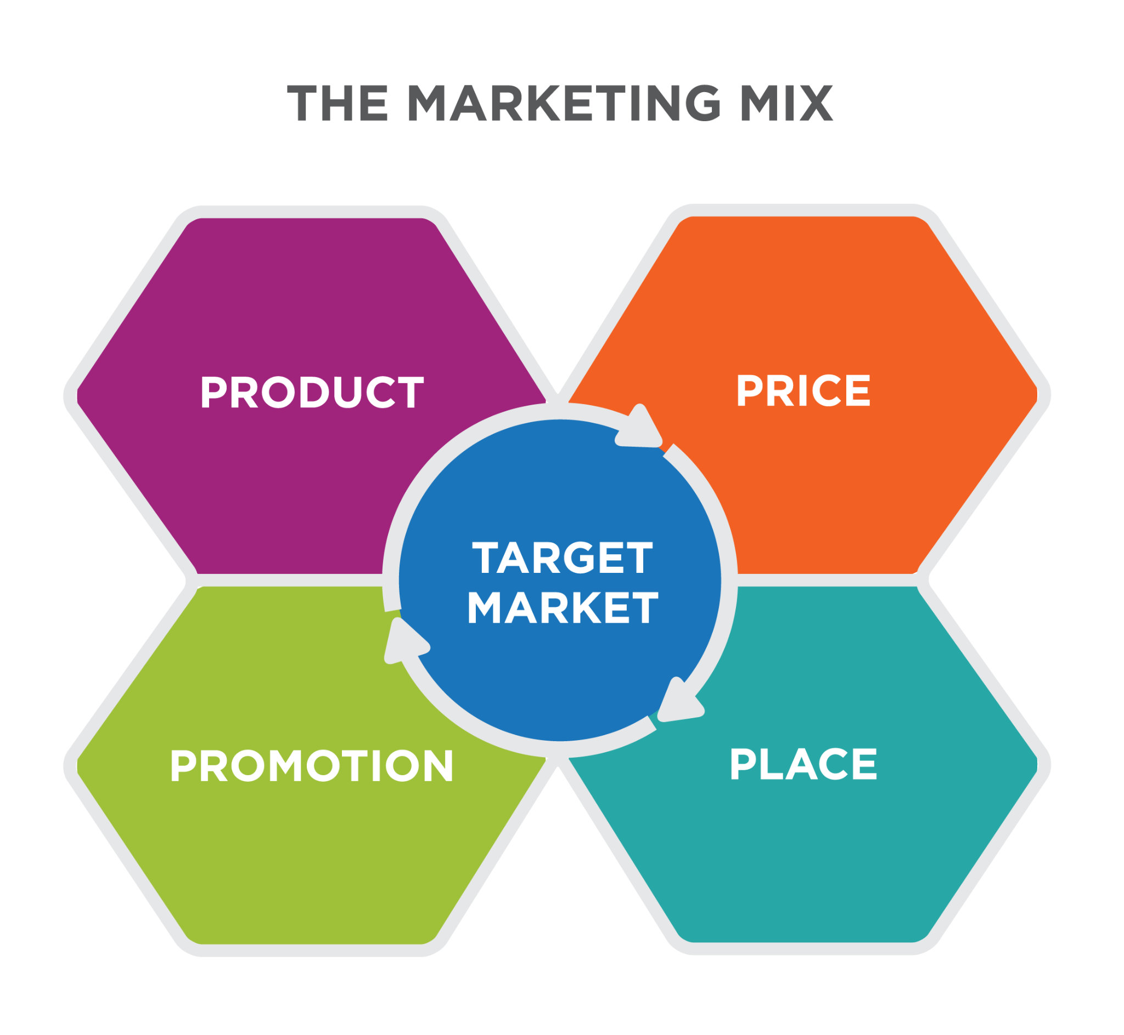
Figure 2: Marketing mix
(Source: Buhalis, 2019)
- Promotional Mix
The company will adopt a very unique marketing strategy to reach their product to potential customers. They will implement marketing strategies like social media marketing and email marketing to promote their products. Through paid advertisement on various social media sites, the information about their products can reach consumers. As consumers use social media more than before, it is a very cost-effective and unique marketing technique (Sofronov, 2018). They will also use referral marketing techniques whereby their existing consumers will promote their products to new consumers.
- Place
Choosing a place is very important for the tourism business. Initially, they decided to set up their branches in various popular places in the UK. If branches can be set up in populated areas, then they will get a much bigger market to sell the products. Various big companies have set up their branches in popular places, so if the company sets up branches in those places, consumers can compare and see who provides the best quality service at a low price (Petrova et al., 2018).

FINANCIALS
Sources of funds
It is a partnership business so three partners of this business will fund some money and family and friends will take some funding to start the business. Once the business is started, then the business will be expanded with funding from angel investors and bank loans. Angel investors and venture capitalists are very popular sources of funding who fund various startups if they like the business idea. It becomes really difficult to expand a business without a proper finding (Thabit and Raewf, 2018). Since Lexture Travel will enter the market with a very unique product category, they have a high chance of getting funding from angel investors or venture capital.
Use of funds
 | Month 1 | Month 2 | Month 3 | Month 4 | Month 5 | Month 6
Revenue (from operations and marketing section) | 5000 £ | 8000£ | 11000£ | 15000£ | 19000£ | 25000£
Fixed Costs  (List out fixed costs) | Equipment= 500£  Wages= 1000£ | Equipment= 500£  Wages= 2000£ | Equipment= 1000£  Wages= 2500£ | Equipment= 1500 £  Wages= 3500£ | Equipment= 2500£  Wages= 5000£ | Equipment= 3500£  Wages= 6000£
Variable Costs  (List out variable costs) | Meterials= 500£ | Meterials= 400£ | Meterials= 500£ | Meterials= 500£ | Meterials= 1000£ | Meterials= 1000 £
Profit | 3000£ | 5100 £ | 7000£ | 9500£ | 10500£ | 14500£

MARKET RESEARCH
Market research is very important to start a business. The business environment in the United Kingdom is quite positive. The tourism industry is a major contributor to the United Kingdom's economy. Political stability plays a very important role in the development of a country. The political stability of the United Kingdom is very good, so starting a business here will make lexture travel quite successful (Font and Lynes, 2018). The economic condition of the United Kingdom is quite good because of various types of business as well as many tourists visiting the United Kingdom every year which has a positive impact on the country's economy. Social factors in the United Kingdom greatly affect the tourism industry. The technological factor has affected the United Kingdom's tourism industry positively because tourism companies are using various technological tools to make their business profitable. The legal system in the United Kingdom is very strong, so Lexture Travel has to comply with all the rules and regulations, otherwise, it will have a detrimental effect on their business (Ritchie and Jiang, 2019). The company must do business keeping in mind all the environmental factors of the United Kingdom.
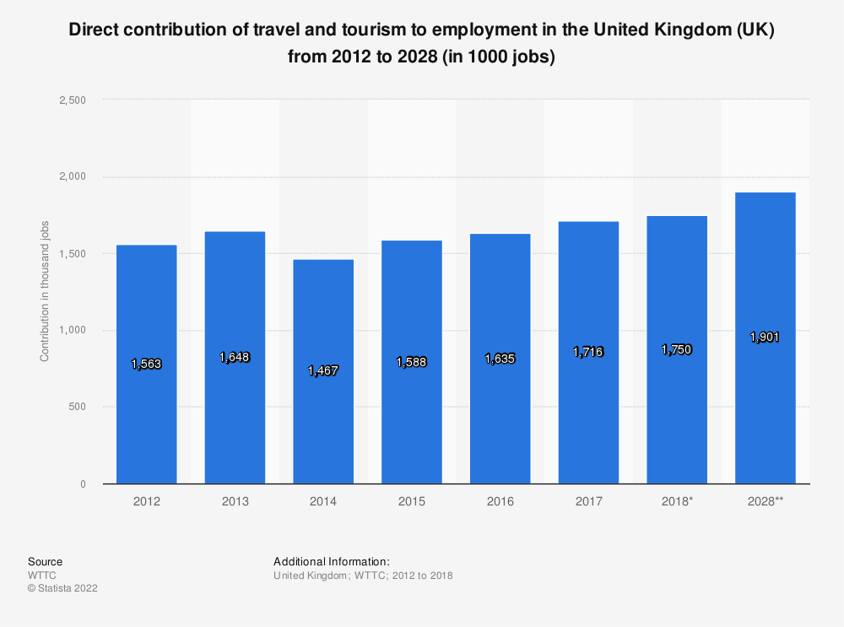
Figure 3: Contribution of travel and tourism to employment in the UK
(Source: Statista, 2022)

CONCLUSION
The tourism industry of the United Kingdom is quite successful. In this assignment, the operations and marketing teams of the company are discussed. The study also analysed the 4p marketing strategy of lecture travel. The company is going to launch their business with a very innovative product category that will make the company quite popular.

REFERENCES
Adelakun, A., (2020). Should Porters Five Forces have value in Businesses today. Computing for Business (BSC) Aston University Birmingham.
Buhalis, D., (2019). Technology in tourism-from information communication technologies to eTourism and smart tourism towards ambient intelligence tourism: a perspective article. Tourism Review.
https://eprints.bournemouth.ac.uk/33026/1/75%20Tourism%20Review%20Technology%20in%20tourism%20Buhalis%20Perspective%20article.pdf
Elliott, J., (2020). Tourism: Politics and public sector management. Routledge.
Ferdinand, D.Y.Y. and Tresyanto, C.A., (2020). Marketing strategy using porters five force model approach: A case study at the culinary center in Sidoarjo Regency. International Journal of Business and Management Invention (IJBMI), 9(11), pp.44-48.
https://www.ijbmi.org/papers/Vol(9)11/Ser-1/F0911014448.pdf
Font, X. and Lynes, J., (2018). Corporate social responsibility in tourism and hospitality. Journal of Sustainable Tourism, 26(7), pp.1027-1042.
MacKenzie, N. and Gannon, M.J., (2019). Exploring the antecedents of sustainable tourism development. International Journal of Contemporary Hospitality Management.
Mayntz, R. and Schneider, V., (2019). The dynamics of system development in a comparative perspective: Interactive videotex in Germany, France and Britain. In The development of large technical systems (pp. 263-298). Routledge.
Petrova, M., Dekhtyar, N., Klok, O. and Loseva, O., (2018). Regional tourism infrastructure development in the state strategies. Problems and Perspectives in Management, (16, Iss. 4), pp.259-274.
Ritchie, B.W. and Jiang, Y., (2019). A review of research on tourism risk, crisis and disaster management: Launching the annals of tourism research curated collection on tourism risk, crisis and disaster management. Annals of Tourism Research, 79, p.102812. https://reader.elsevier.com/reader/sd/pii/S0160738319301690?token=42654C4A135F51EFA7E1C7C445F47F2BDC3F52170BD97803B8783D62A3BB37CFF24644EC6152E64D9C2FDEBBCE4F8D2A&originRegion=eu-west-1&originCreation=20230110120244#
Sofronov, B., (2018). The development of the travel and tourism industry in the world. Annals of Spiru Haret University. Economic Series, 18(4), pp.123-137.

Statista, (2022) Topic: Travel and tourism in the United Kingdom (UK), Statista. Available at: https://www.statista.com/topics/3269/travel-and-tourism-in-the-united-kingdom-uk/ (Accessed: November 24, 2022).
Thabit, T. and Raewf, M., (2018). The evaluation of marketing mix elements: A case study. International Journal of Social Sciences & Educational Studies, 4(4).
Usai, A., Scuotto, V., Murray, A., Fiano, F. and Dezi, L., (2018). Do entrepreneurial knowledge and innovative attitude overcome “imperfections” in the innovation process? Insights from SMEs in the UK and Italy. Journal of Knowledge Management.
https://iris.unito.it/bitstream/2318/1681651/2/Post-print_JKM_2018_Usai%20et%20al.pdf

