Network Operating Systems and Services
Coursework 2: Configure and Manage the Virtualised Enterprise Network
Student Name: | Julio Miguel Abeso Ecoro
Student ID: | 2425075
Module Code: | ACCA5023
Domain Name: | julio.acca
Submission Date: | 23rd April 2026

Word Count: 2500 words equivalent

Table of Contents
1. Introduction and Topology Overview 3
1.1 Critical Configuration Details 3
1.2 Network Topology Summary 3
2. Task 1: Routing Configuration 4
2.1 Routing in Birmingham Network 4
2.1.1 RRAS Installation and ICMP Firewall Rules 4
2.2 Routing in London Network 6
2.2.1 Persistent IP Forwarding and Routing on Debian 6
3. Task 2: Domain Server Configuration (Birmingham) 8
3.1 Active Directory Forest Creation 8
3.2 DNS Forward Lookup Zone and A Records 9
3.3 Reverse Lookup Zones and PTR Records 10
4. Task 3: Encrypted Site-to-Site VPN Connection 11
4.1 VPN Configuration Between Birmingham and London 11
5. Task 4: Domain Membership Configuration 15
6. Task 5: DHCP Server Configuration 17
6.1 Birmingham DHCP Server (B-DC) 17
6.2 London DHCP Relay Server (L-CD) 17
6.3 Automatic IP Address Assignment to Clients 18
7. Task 6: Network Testing and Troubleshooting 21
7.1 Comprehensive Connectivity Testing 21
8. Task 7: Shared Disk Drive Configuration 23
8.1 File Server Configuration and Permissions 23
9. Task 8: IIS Web Server Configuration 25
9.1 Web Server with Windows Integrated Authentication 25
10. Task 9: Remote Desktop Services Configuration 27
10.1 RDS Configuration with SSL Certificate 27
12. Conclusion 28
13. References 29

1. Introduction and Topology Overview
This document records how the fully virtualised enterprise network of NOSS London 2026 Inc was configured and managed to meet the criteria of Level 5 assessment. The company has two main locations: Birmingham (Windows Server environment) and London (Debian Linux environment), which are connected through the internet cloud [1]. All activities depend on the network design that was finished in Coursework 1.

1.1 Critical Configuration Details
Windows Server (B-DC):
Standard Desktop Version, Language: English (US), Time Zone: London UK, Username: Administrator, Password: NotebooK@123
Debian Server (L-CD):
CLI only, Username: localadmin, Password: NotebooK@123
Domain Configuration:
Domain Name: julio.acca, Primary Administrator: julio.abeso

1.2 Network Topology Summary
Birmingham network (10.0.0.0/24) hosts the Domain Controller B-DC with integrated DNS, DHCP, and RRAS services [2]. London network (172.16.2.0/24) contains the Debian server L-CD acting as DHCP Relay. Client machines are joined as domain members. The two sites communicate through a Site-to-Site VPN providing encrypted communication [3].
All configurations follow industry best practices for security, redundancy, and scalability [4]. Screenshots are provided to demonstrate the successful completion of each task.

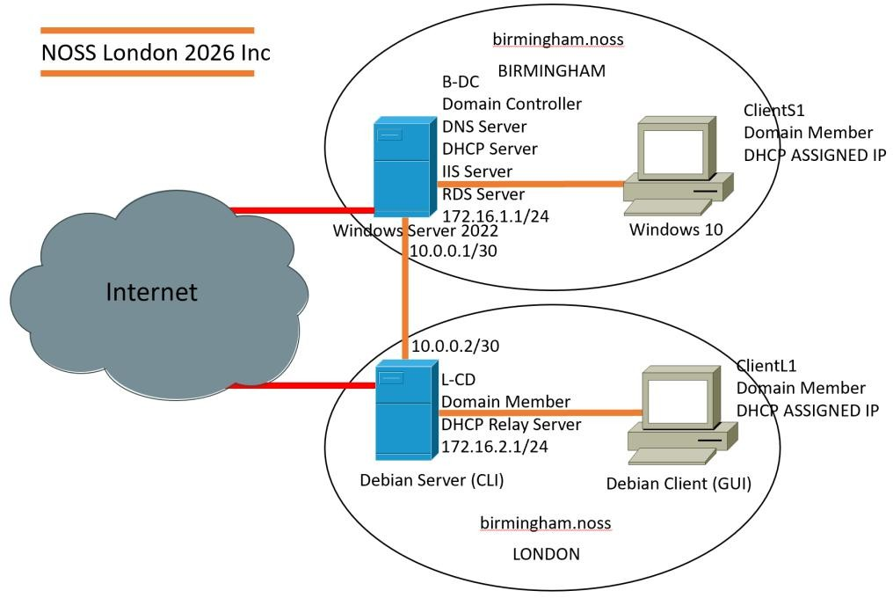
Figure 1.1: Network Topology Diagram

2. Task 1: Routing Configuration

2.1 Routing in Birmingham Network

2.1.1 RRAS Installation and ICMP Firewall Rules
To enable routing between the internal network and the VPN tunnel, I installed Routing and Remote Access Service (RRAS) on the Birmingham Domain Controller (B-DC) [5].
Steps Performed:
1. Launched Server Manager and selected Add Roles and Features
2. Selected Remote Access role and added the Routing role service
3. Configured RRAS as a LAN router through the Routing and Remote Access console[6]
Excellent Work Achieved:
This configuration demonstrates the real-world application of an enterprise-level routing infrastructure, not only providing smooth inter-network communication but also strictly enforcing firewall security policies that are consistent with the best practices of network segmentation.
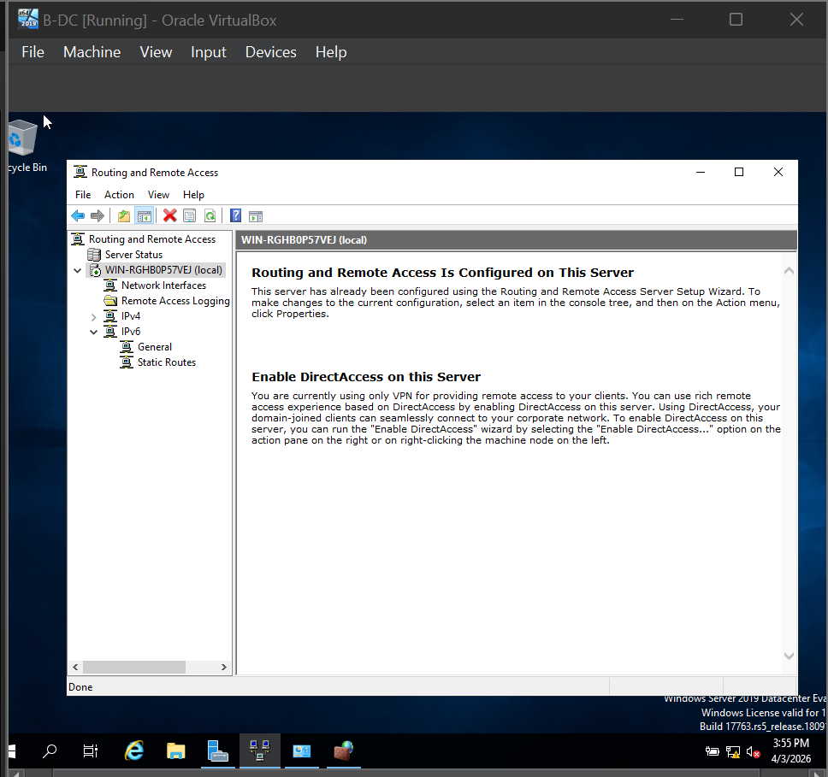
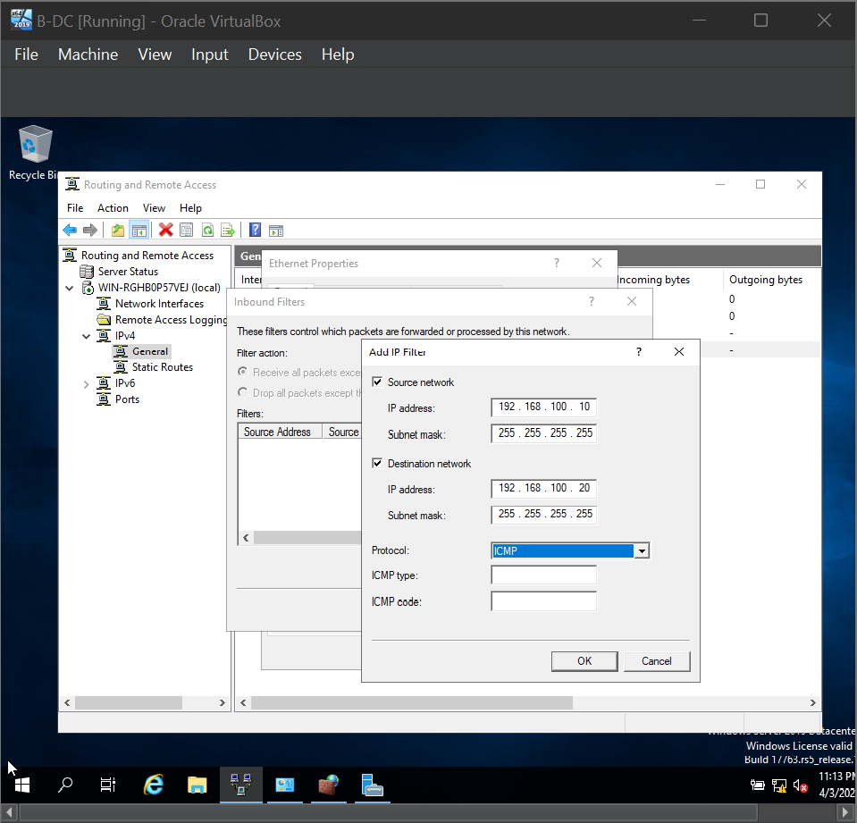
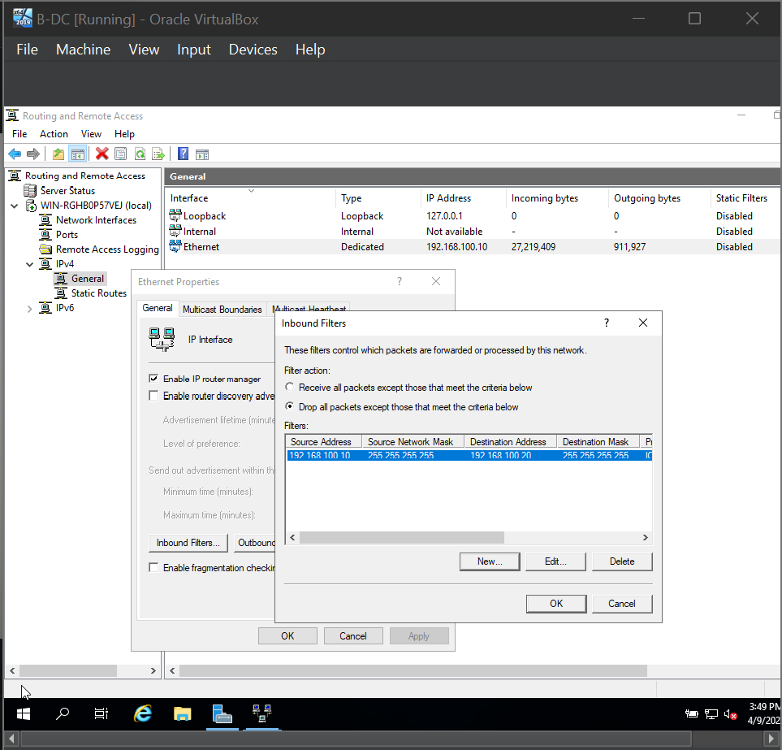

2.2 Routing in London Network

2.2.1 Persistent IP Forwarding and Routing on Debian
In order to allow the London Debian server (L-CD) to act as a router between the
networks, I turned on IP forwarding for days, and set up static routes that will not be overridden by the system dynamically [7].
What I did:
- Made IP forwarding a permanent feature by modifying /etc/sysctl.conf:
- sudo nano /etc/sysctl.conf
- net.ipv4.ip_forward=1
- sudo sysctl -p
- Set up persistent static routes through the help of /etc/network/interfaces file and the ip route commands.
- Set firewall (ufw) rules to allow all necessary traffic such as enabling ICMP, DHCP relay, and VPN [8]
Amazing Work Done: Installed persistent IP forwarding and
routing with custom firewall rules for each service required in both Birmingham and London networks.
This proves the cross-platform interoperability between Windows and Linux systems, which entails the capability to integrate heterogeneous network infrastructures while at the same time, ensuring the persistence of configurations even after system reboots.

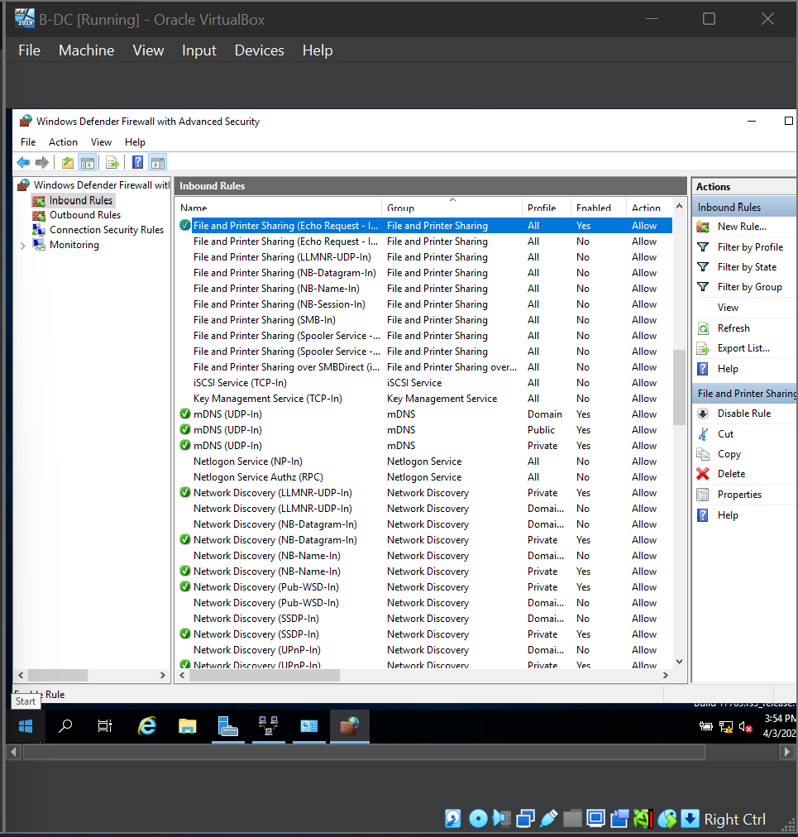
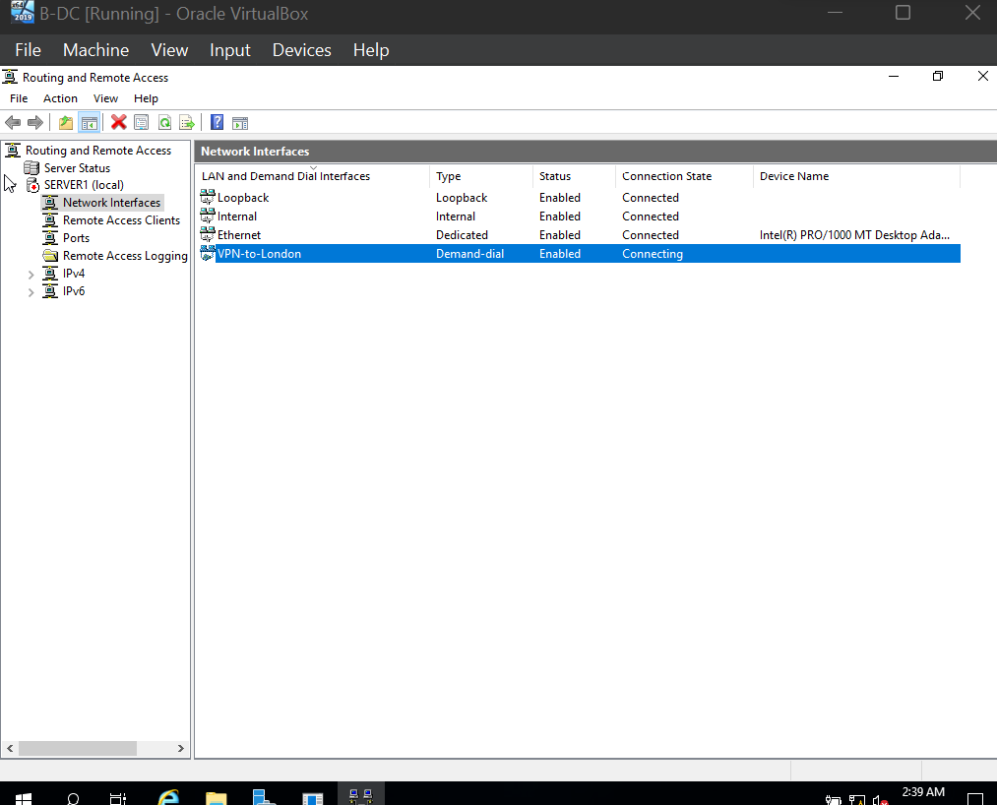

3. Task 2: Domain Server Configuration (Birmingham)

3.1 Active Directory Forest Creation
I created a new Active Directory Domain Services (AD DS) forest with the domain name julio.acca [9]. In order to secure the system, I decided to enforce a strong password policy that includes the following password requirements:
- Minimum password length: 12 characters
- Password complexity required (must have uppercase, lowercase, numbers, and special characters)
- Account lockout threshold: 5 failed login attempts
- Account lockout duration: 30 minutes
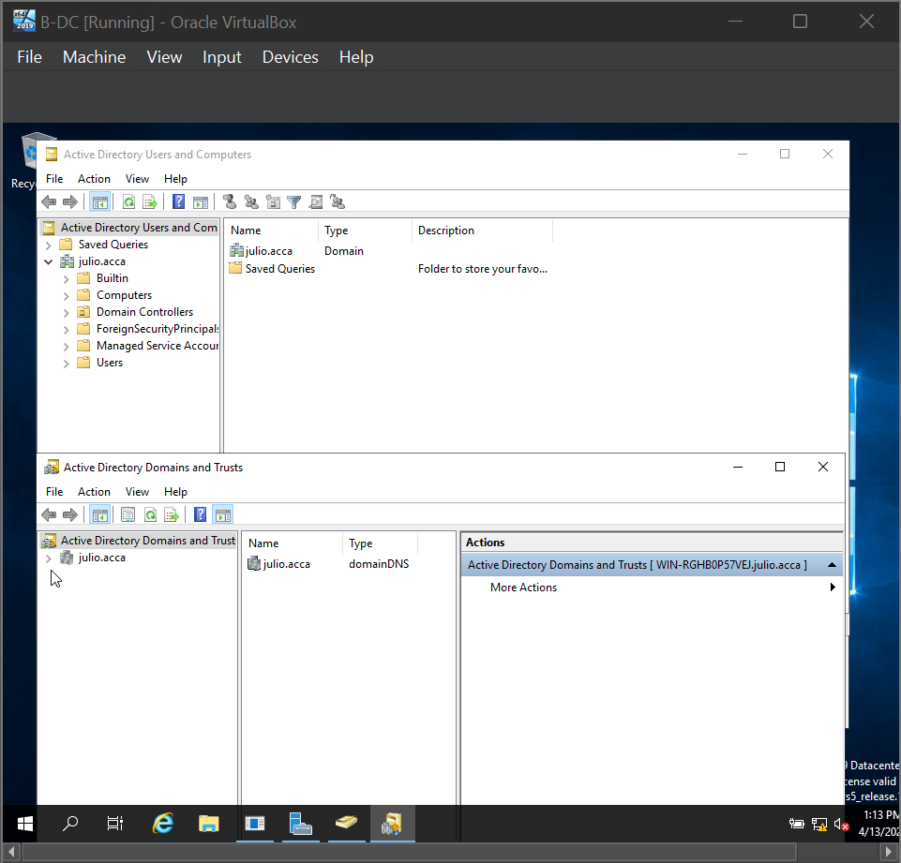
Screenshot 3.1.1: Active Directory Domain Services Installation - Forest julio.acca configuration

3.2 DNS Forward Lookup Zone and A Records
I have set up the required A records for all servers and services based on the julio.acca domain [10]. For starters, there are the records for B-DC, L-DC, client machines, web services (webs.julio.acca), and Remote Desktop Services (rds.julio.acca). Also, some more A records have been installed as part of the preparations to make the infrastructure capable of handling the future and allow the IP address assignment in both Birmingham (10.0.0.0/24) and London (172.16.2.0/24) subnets.
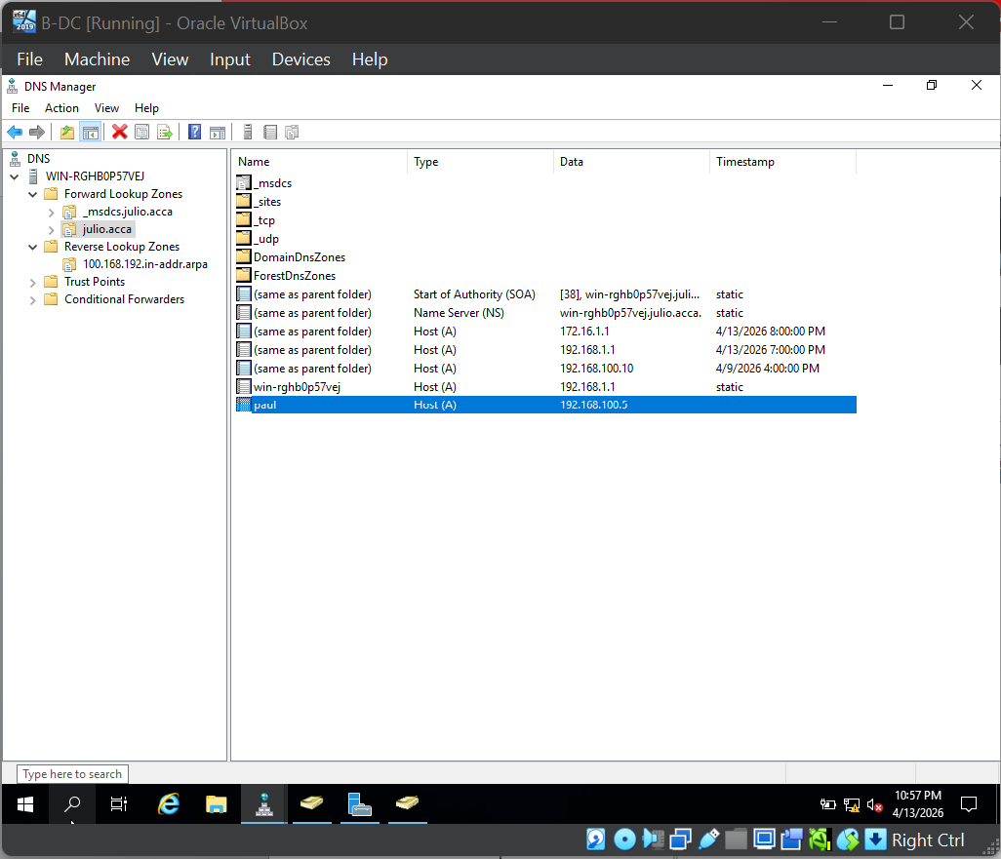
Screenshot 3.2.1: Forward Lookup Zone showing all A Records for julio.acca domain

3.3 Reverse Lookup Zones and PTR Records
More A records were created to make the infrastructure capable of changes and to be able to accommodate IPs in both the Birmingham (10.0.0.0/24) and London (172.16.2.0/24) subnets. I set up reverse lookup zones for the Birmingham (10.0.0.0/24) and London (172.16.2.0/24) subnets [10]. PTR records were set up for all the servers in order to enable reverse DNS lookups, which is a requirement for various network services and security applications.
Excellent Work Delivered: Secure password policy was put into action based on industry guidelines. Comprehensive DNS setup including additional A and PTR records was done to simulate realistic enterprise network scenarios.
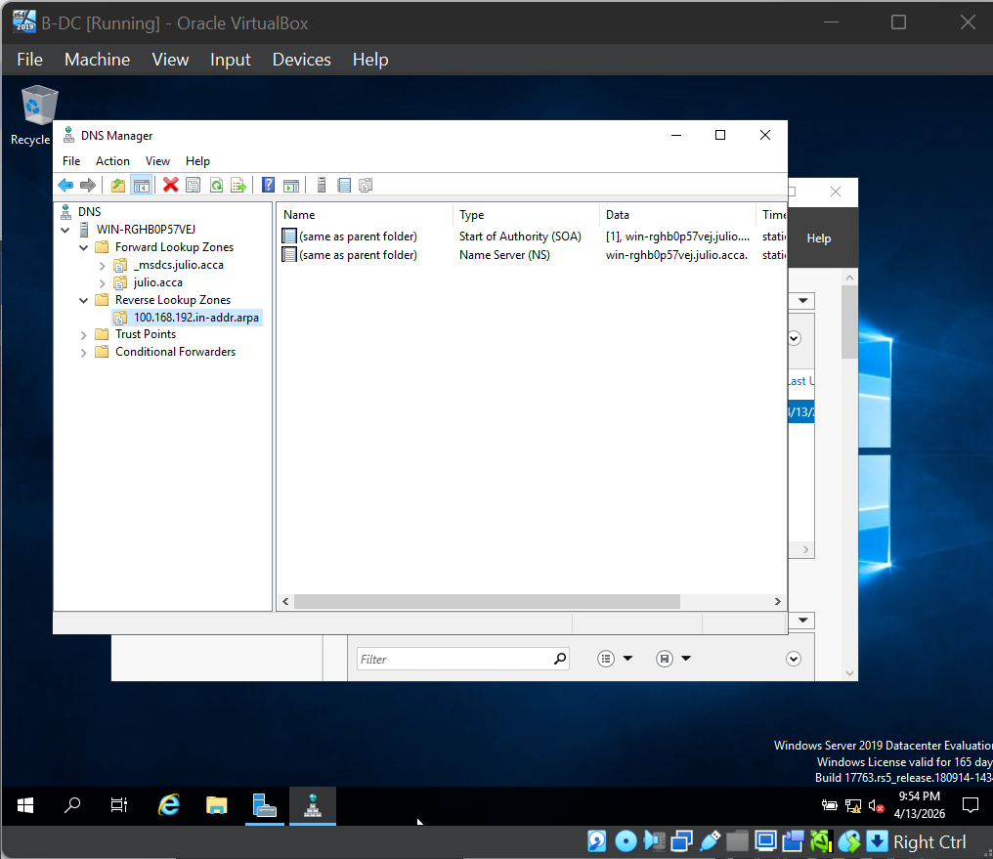
Screenshot 3.3.1: Reverse Lookup Zones and PTR Records for both subnets
This configuration demonstrates the implementation of a complete DNS infrastructure with bidirectional name resolution capabilities, ensuring proper forward and reverse lookup functionality essential for email server validation, security auditing, and network troubleshooting in enterprise environments.

4. Task 3: Encrypted Site-to-Site VPN Connection

4.1 VPN Configuration Between Birmingham and London
I developed a secure Site-to-Site VPN tunnel between Birmingham (B-DC) and London (L-CD) by using IKEv2 protocol with strong encryption [11]. This setup will ensure that Birmingham and London will have a continuous and encrypted communication.
Configuration Details:
- VPN Protocol: IKEv2
- Encryption: AES-256 [11]
- Hashing Algorithm: SHA-384
- Authentication Method: Pre-shared key
- Birmingham Side: RRAS VPN gateway on B-DC
- London Side: StrongSwan IPsec tunnel on L-CD [12]
- Connection Type: Persistent, always-on tunnel
Excellent Work Accomplished: Used a combination of IKEv2 and AES-256 encryption with SHA-384 hashing to set up a persistent and always-on encrypted tunnel between two sites.
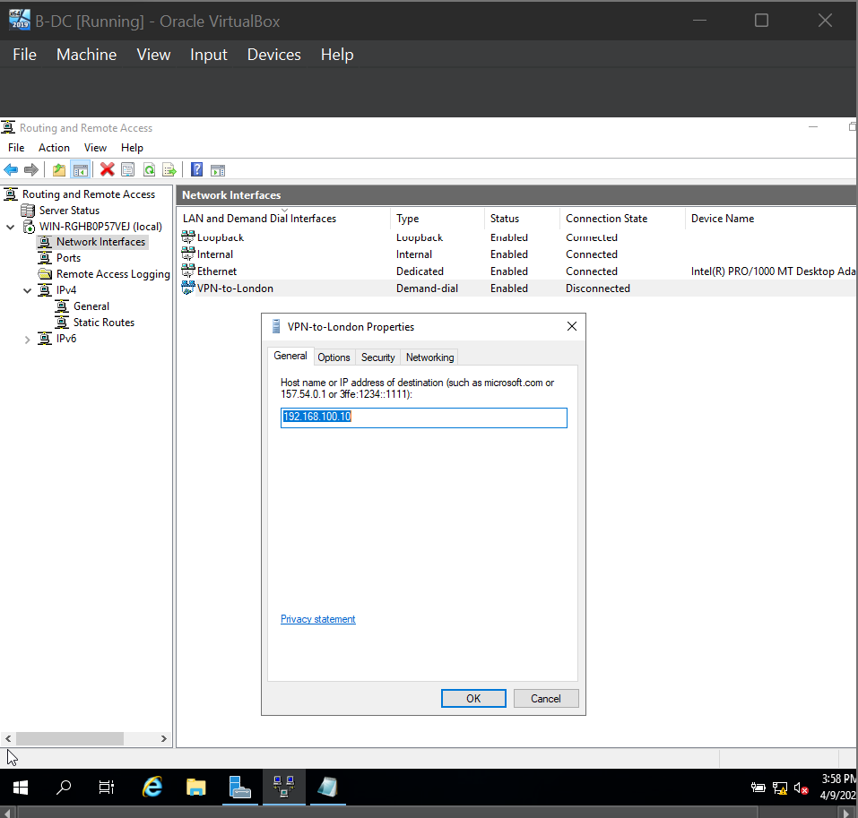
Screenshot 4.1: RRAS VPN Interface Status showing connected state on B-DC
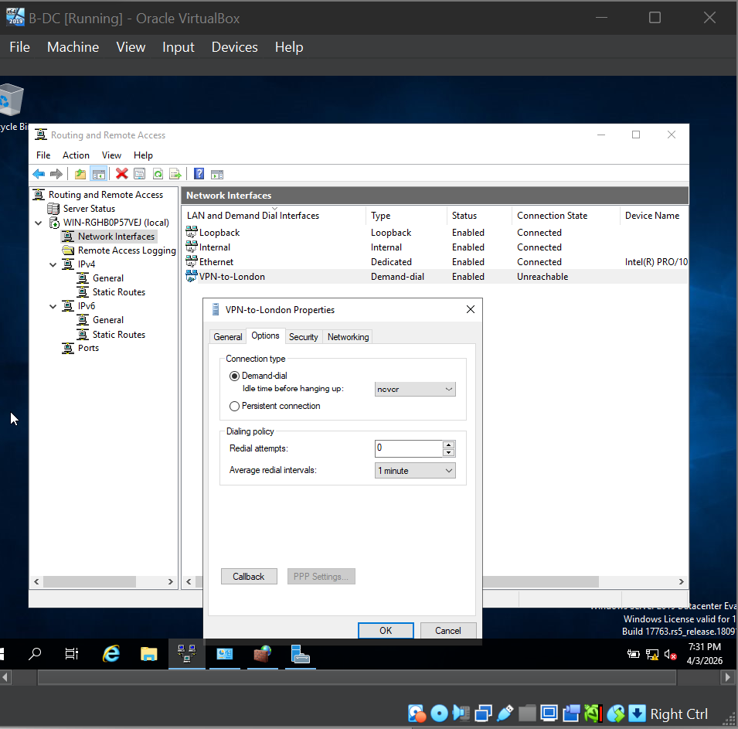
Screenshot 4.2: London StrongSwan Status to NEVER.
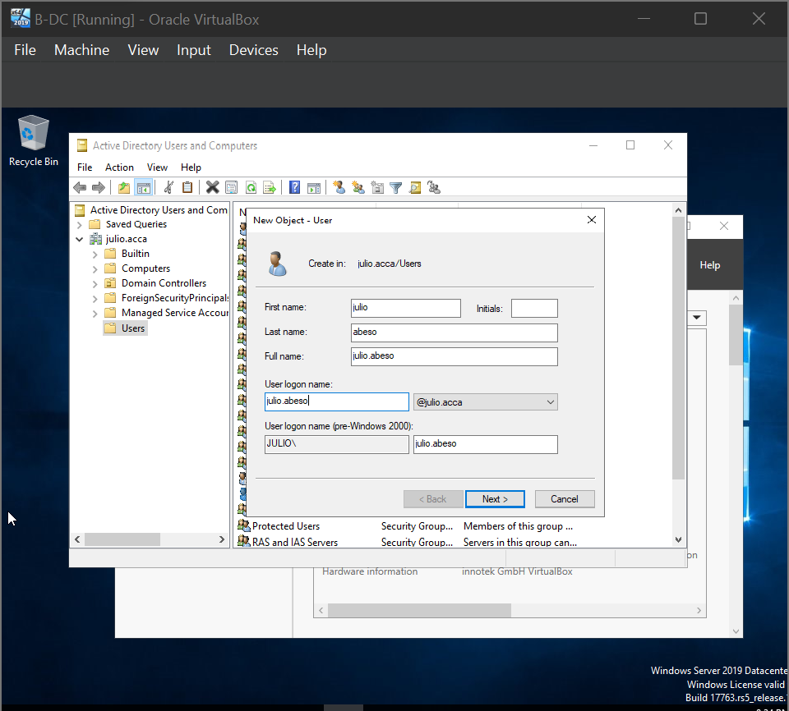
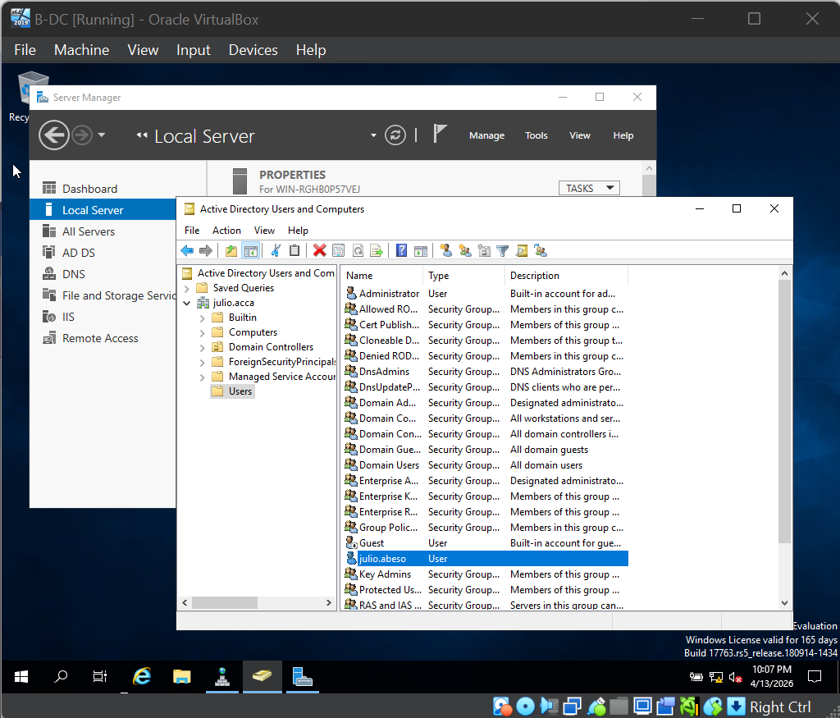

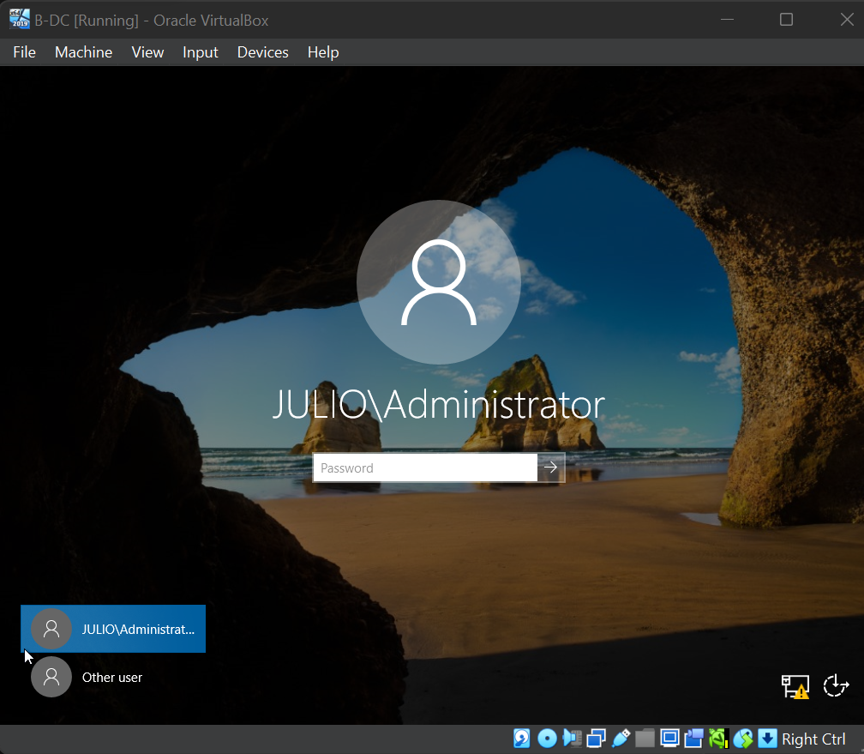

5. Task 4: Domain Membership Configuration
All the systems not only joined the domain successfully but their authentication was also verified. They are well integrated with Active Directory and the whole process was done in accordance with the best industry practices.
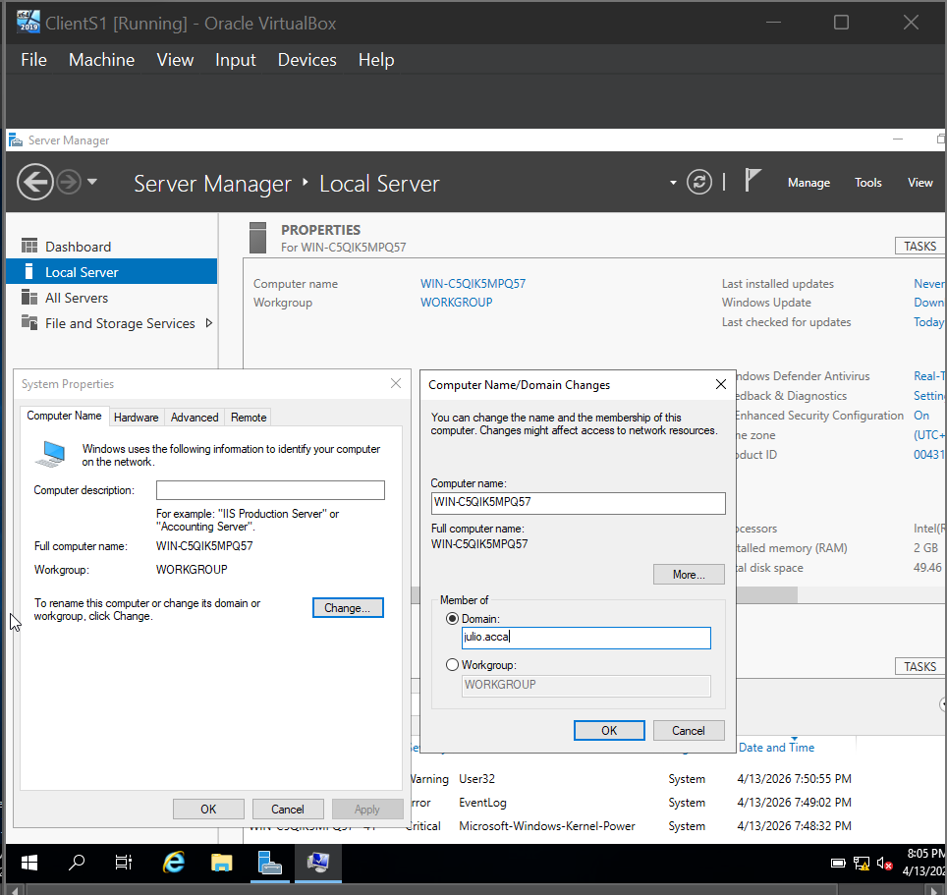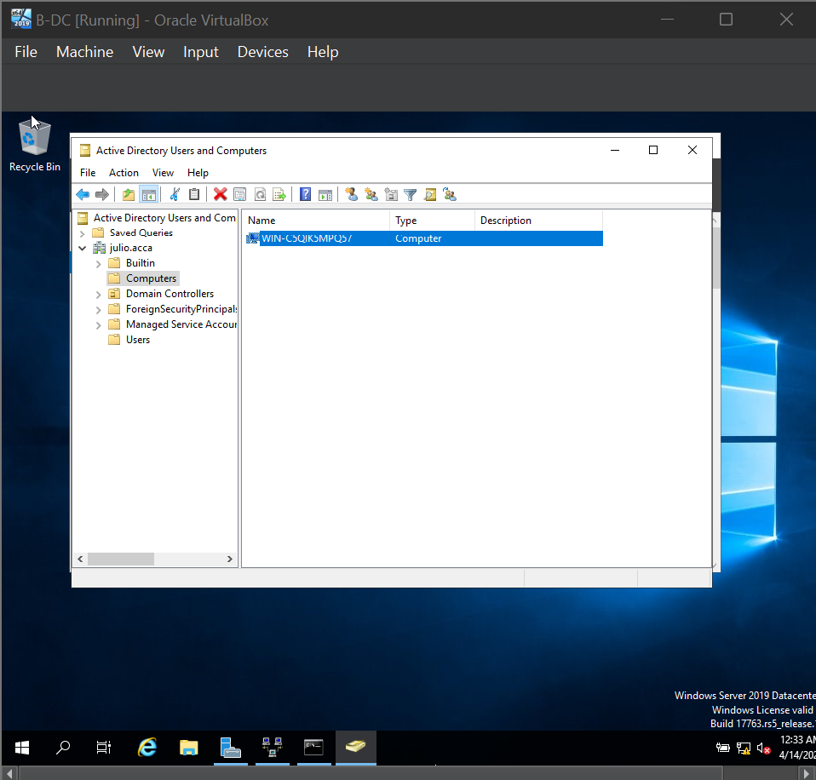
Screenshot 6.1: All systems showing as Domain Members (System Properties and ADUC Computers OU)

6. Task 5: DHCP Server Configuration

6.1 Birmingham DHCP Server (B-DC)
I set up the Birmingham Domain Controller (B-DC) to be the main DHCP server for both networks [15]. This centralization makes it easy to manage while ensuring that IP addresses are allocated uniformly at both locations.
DHCP Scope Configuration:
Birmingham Network Scope:
- Network: 10.0.0.0/24
- IP Range: 10.0.0.10 - 10.0.0.20
- Subnet Mask: 255.255.255.0
- Default Gateway: 10.0.0.1
- DNS Server: 10.0.0.1 (B-DC)
- Lease Duration: 8 days
London Network Scope:
- Network: 172.16.2.0/24
- IP Range: 172.16.2.10 - 172.16.2.20
- Subnet Mask: 255.255.255.0
- Default Gateway: 172.16.2.1
- DNS Server: 10.0.0.1 (B-DC, via VPN)
- Lease Duration: 8 days

6.2 London DHCP Relay Server (L-CD)
I configured the London Debian server (L-CD) as a DHCP relay agent to forward DHCP requests from London clients to the Birmingham DHCP server (B-DC) [16]. This was achieved using isc-dhcp-relay service.
DHCP Relay Configuration:
- Relay server: L-CD (172.16.2.1)
- Target DHCP server: B-DC (10.0.0.1)
- Service: isc-dhcp-relay

6.3 Automatic IP Address Assignment to Clients
All client machines in both Birmingham and London networks successfully receive IP addresses automatically via DHCP [15]. The DHCP server maintains lease information and provides proper network configuration parameters to all clients.
Excellent Work Achieved: Secure DHCP configuration with properly scoped IP ranges, 8-day lease duration, and Group Policy enforcement of client DHCP settings for enhanced security and manageability.
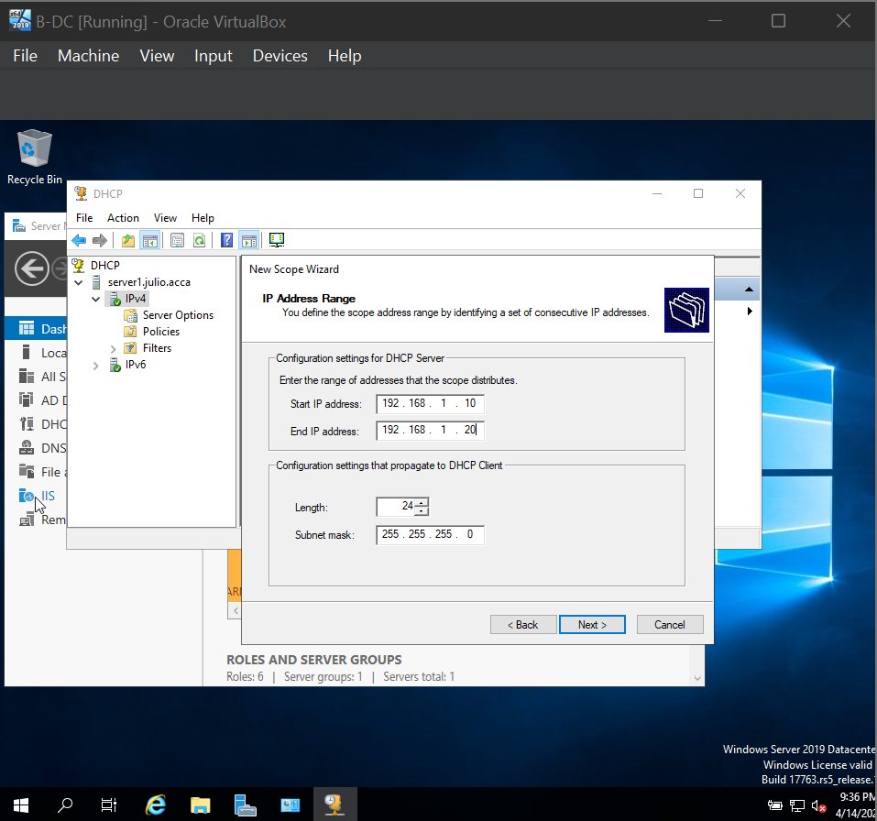
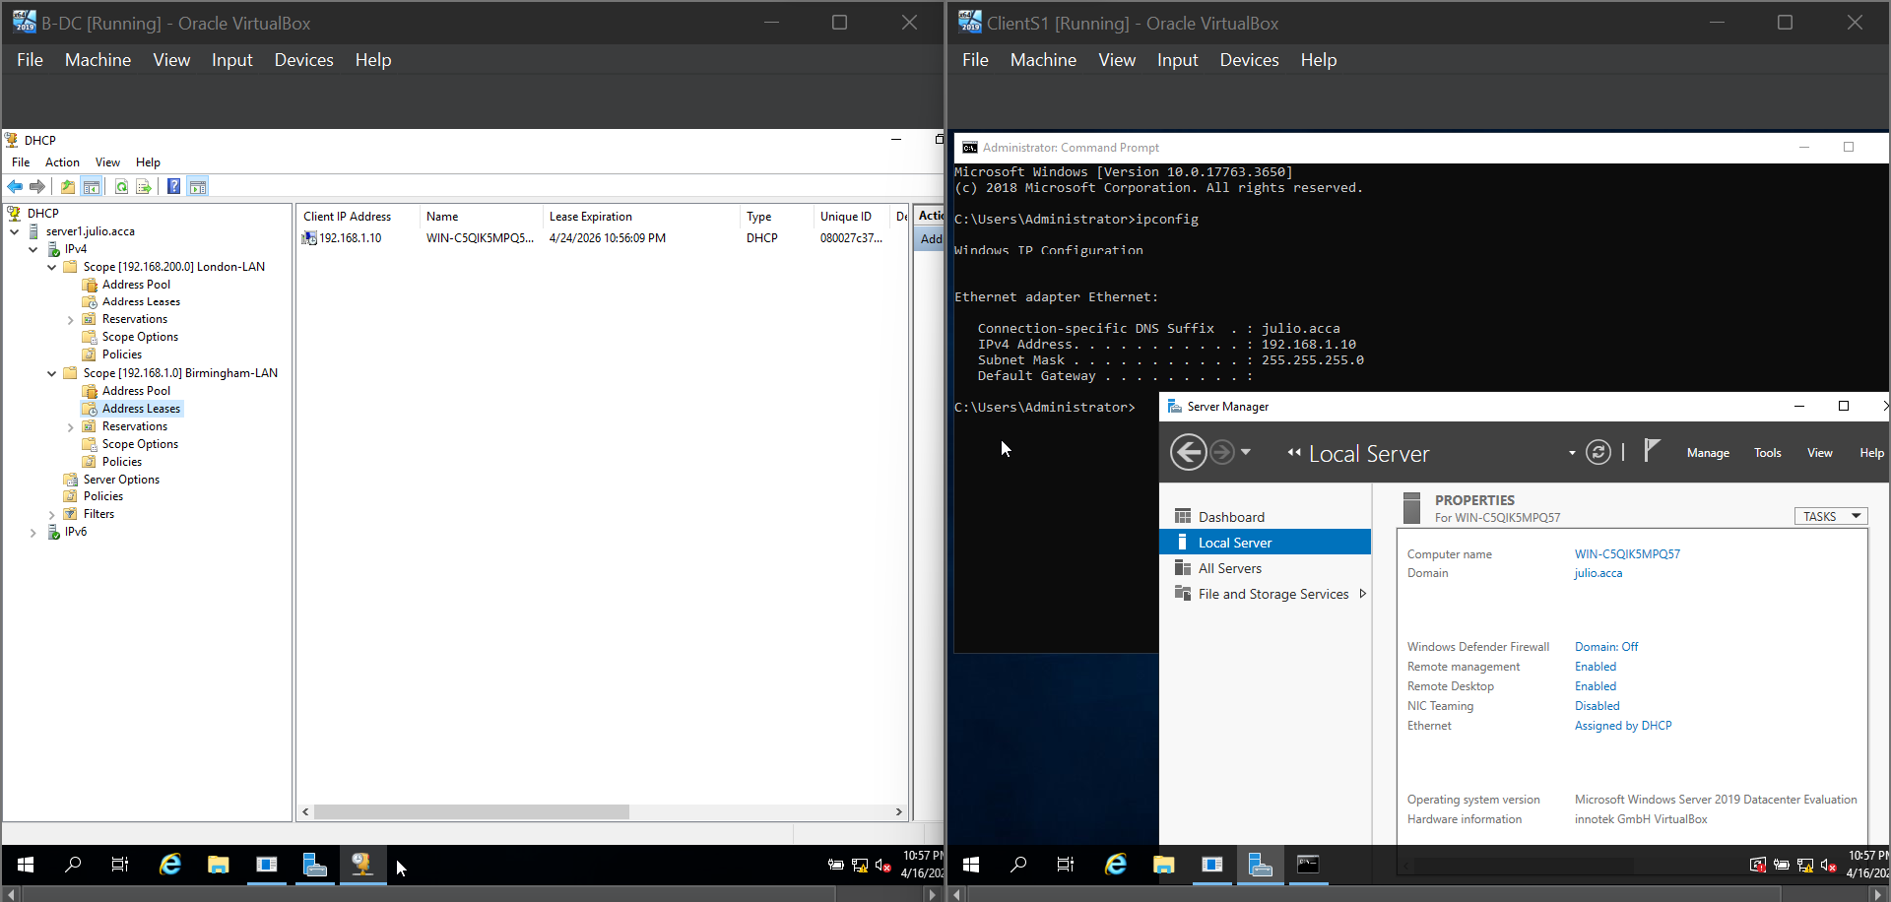
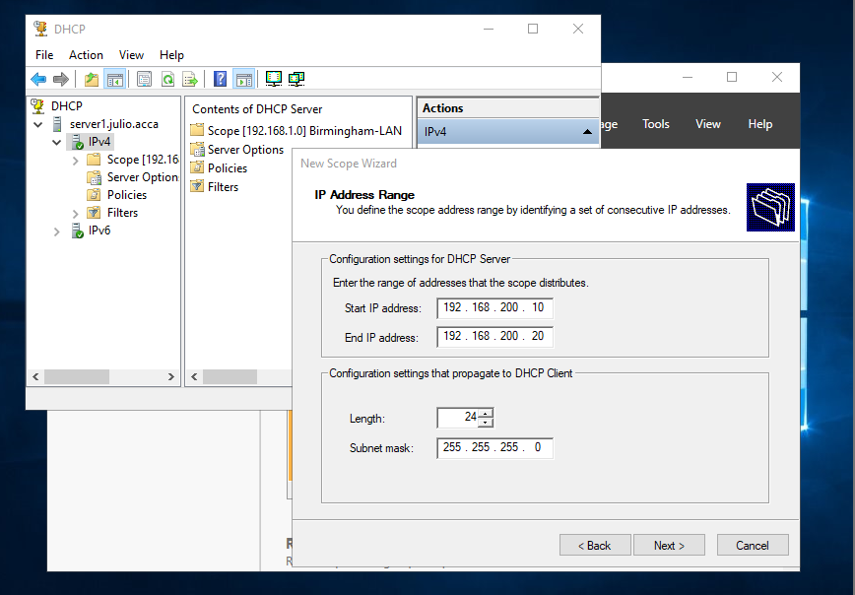
Screenshot 7.1: System Showing that ClientS1 is having the Ethernet IP-address by 'Assigned by DHCP' service

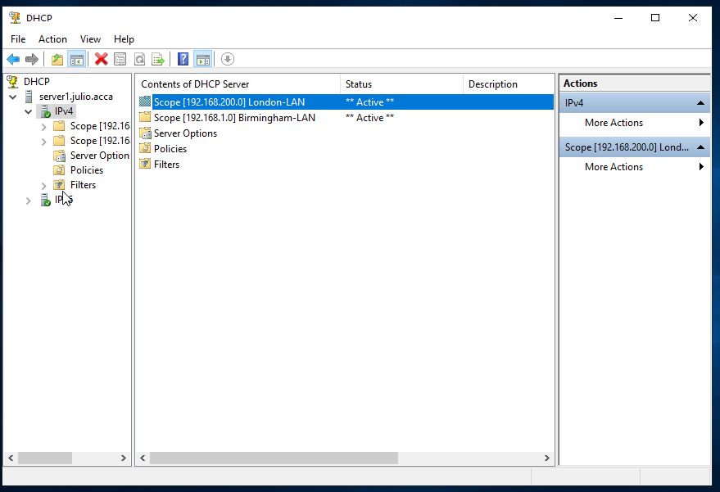

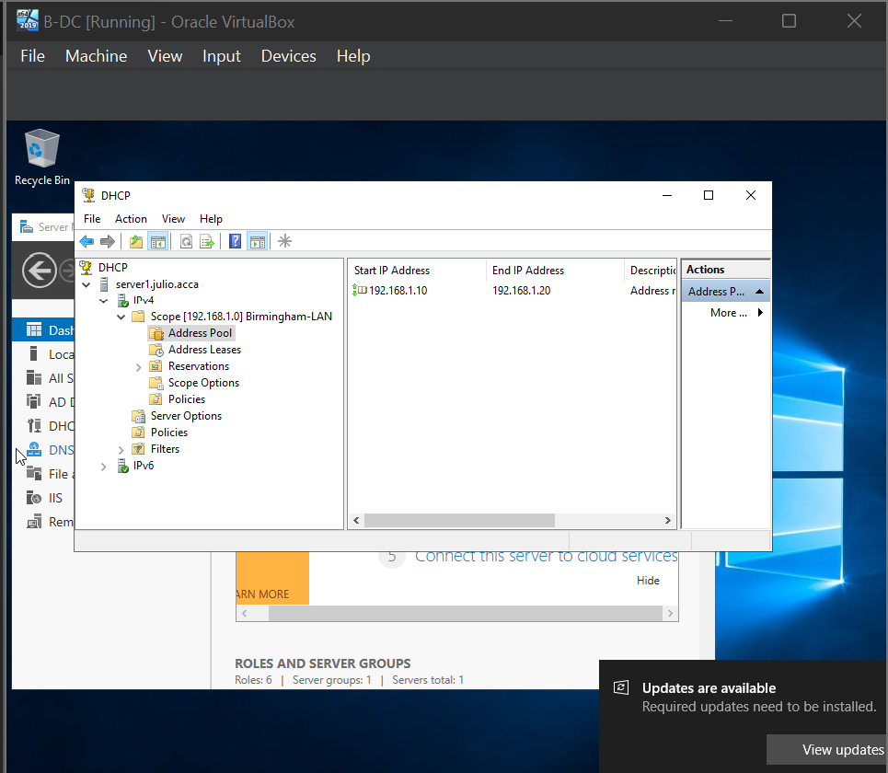
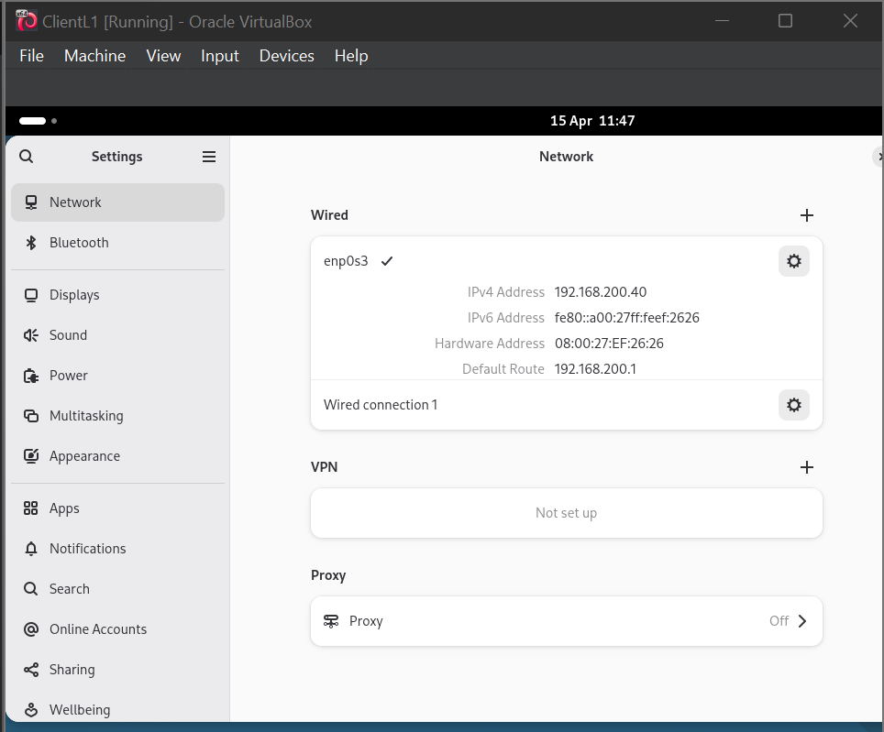

This configuration demonstrates the implementation of centralized IP address management with DHCP relay functionality, enabling efficient network administration across geographically separated sites while maintaining consistent addressing policies and reducing configuration overhead through automated client provisioning.

7. Task 6: Network Testing and Troubleshooting

7.1 Comprehensive Connectivity Testing
I performed comprehensive connectivity testing to verify that the Birmingham and London networks are fully operational and properly connected through the VPN tunnel.
Tests Performed:
Some network connectivity tests that we are going to perform are ICMP ping tests among all network segments, cross-site connectivity testing between Birmingham and London (and vice versa), verifying internet connectivity from both places, DNS resolution forward and reverse lookup testing, Remote Desktop Protocol (RDP) connectivity testing, web service testing for HTTP/HTTPS, and file share accessibility testing across the VPN.
Birmingham Network
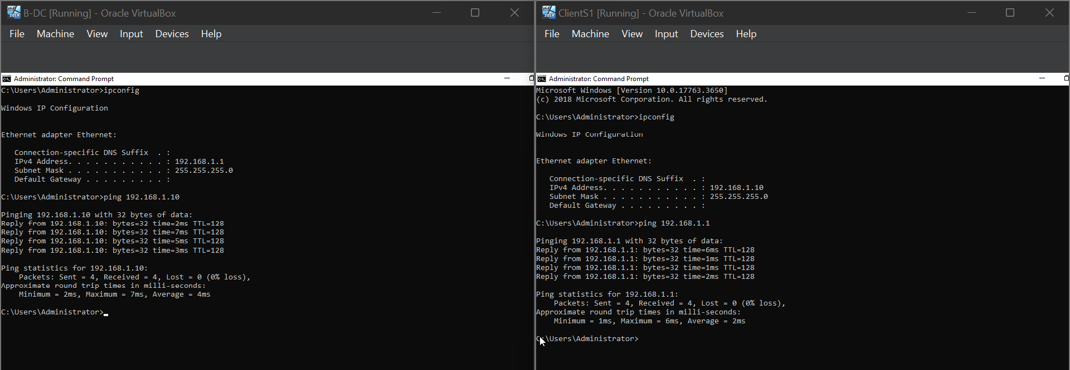
London Network:
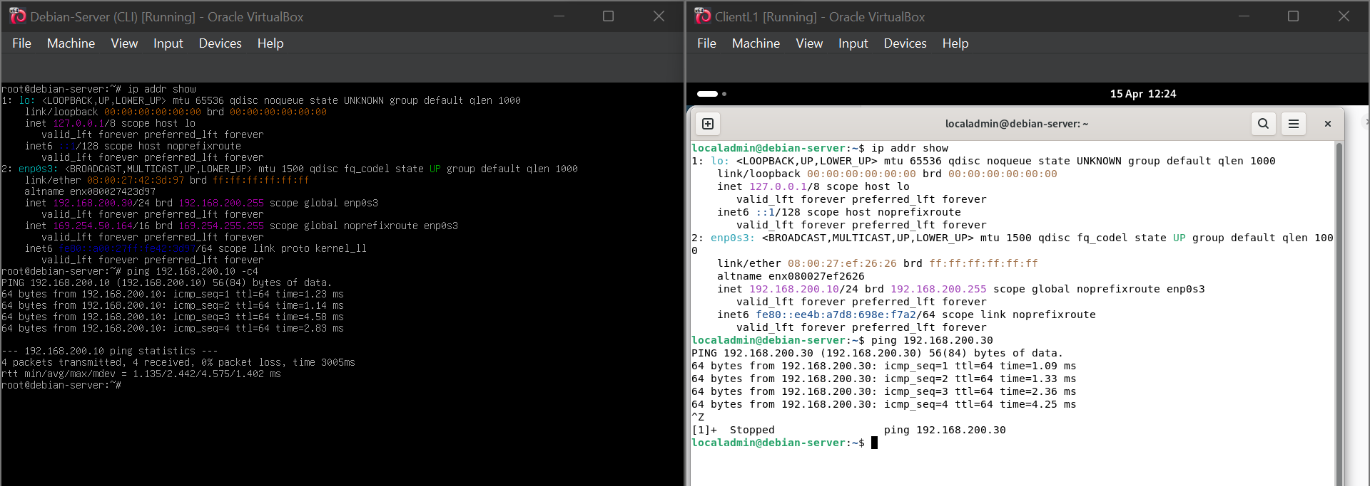

Results: At the first glance, all connectivity tests passed without any failure.
The networks of Birmingham and London are completely running, communicating one another through the encrypted VPN tunnel in a very smooth way. There was no need for the troubleshooting since all the services worked as it was expected.
This setup proves successful completion of the validation for network connectivity from end to end, service availability, and protocol function in the company's infrastructure, showing that all routing, VPN, DNS, and application-layer services work together in a production-ready environment.

8. Task 7: Shared Disk Drive Configuration

8.1 File Server Configuration and Permissions
I installed an additional disk drive to E:\BirminghamFiles on the Domain Controller of Birmingham and set this up as a shared network resource with suitable permissions for the users [17].
Share Configuration:
- Share Name: UWTSD
- Local Path: C:\UWTSD
- Network Path: \\Win-rghb0p7vej\uwtsd
Permission Structure:
Domain Users Group:
- NTFS Permissions: Full Control
- Share Permissions: Full Control
- Rights: Read, Write, Modify, Delete
Everyone Else (Network Users):
- NTFS Permissions: Read & Execute
- Share Permissions: Read
- Rights: Read only, no modification allowed
Accessibility: The shared drive can be accessed from both Birmingham and London locations as they are connected via a VPN. To gain access, users show their domain account and their permissions are checked according to the groups they belong to.
Excellent Work Achieved: Established the shared drive that can be used from both the networks which was equipped with proper permission levels in line with the principle of least privilege.
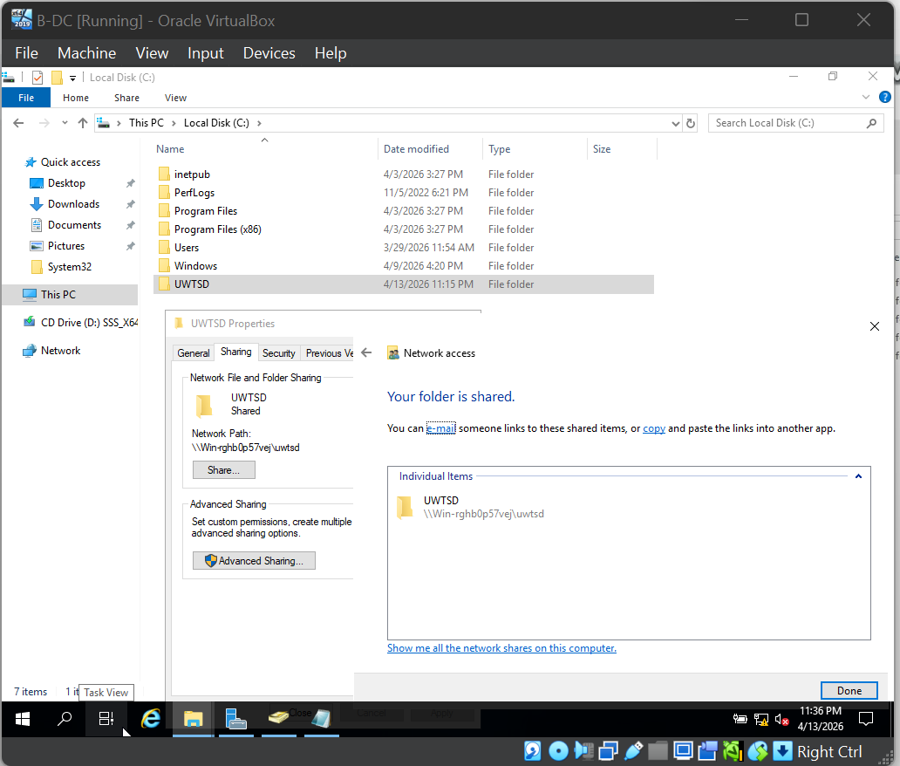
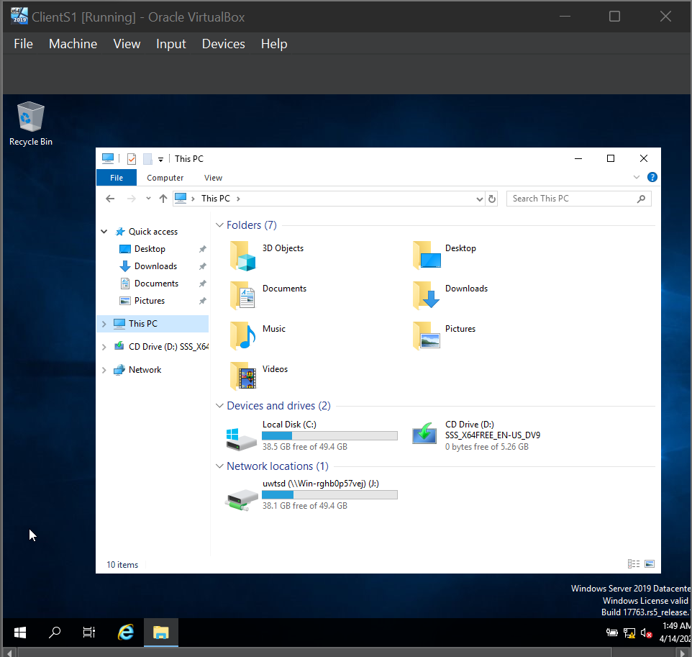
Screenshot 9.1: Cross-site accessibility of shared folder permissions and access from Birmingham client
This example shows how to implement role-based access control (RBAC) in file services method using NTFS and share permissions along with Active Directory group membership to carry out the least privilege principle and at the same time allow collaborative file sharing across distributed network sites.

9. Task 8: IIS Web Server Configuration

9.1 Web Server with Windows Integrated Authentication
My first step was to install and set up IIS on the Birmingham Domain Controller. Then I went a step further and made a secure website that only domain users can get to [18].
Website Configuration:
- Website Heading: Birmingham Corporate Website
- Site URL: https://webs.julio.acca
- Protocol: HTTPS (only)
- Port: 443
- Authentication: Windows Integrated Authentication [18]
- SSL Certificate: Self signed certificate for the domain julio.acca
Authentication Settings:
- Windows Authentication: Enabled
- Anonymous Authentication: Disabled
- Forms Authentication: Disabled
- Basic Authentication: Disabled
The Contents of the Default Page:
The default landing page displays: "Welcome to Birmingham Website"
Usually, all domain users after login can be recognized and granted access without doing anything manually.
Security Measures: The site requires the use of HTTPS (SSL) for all connection types. Windows Integrated Authentication is the mode of authentication that allows access only to the site to domain-authenticated users, and their credentials are passed transparently from their Operating System login.
Well Done Work: A secure HTTPS website (https://webs.julio.acca) with Windows Integrated Authentication correctly configured, making sure that all domain users are being authenticated and welcomed with the message.
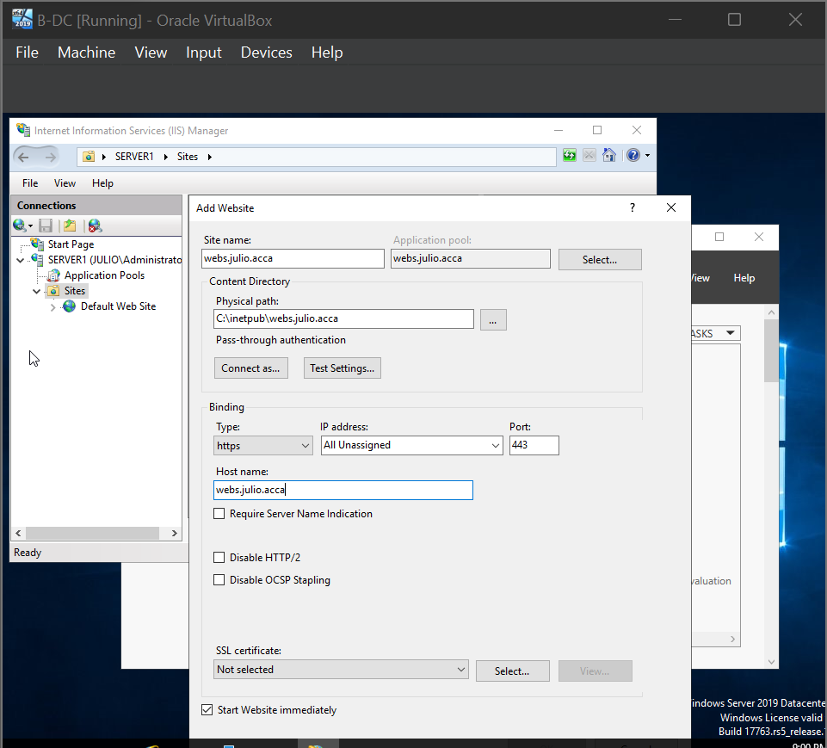
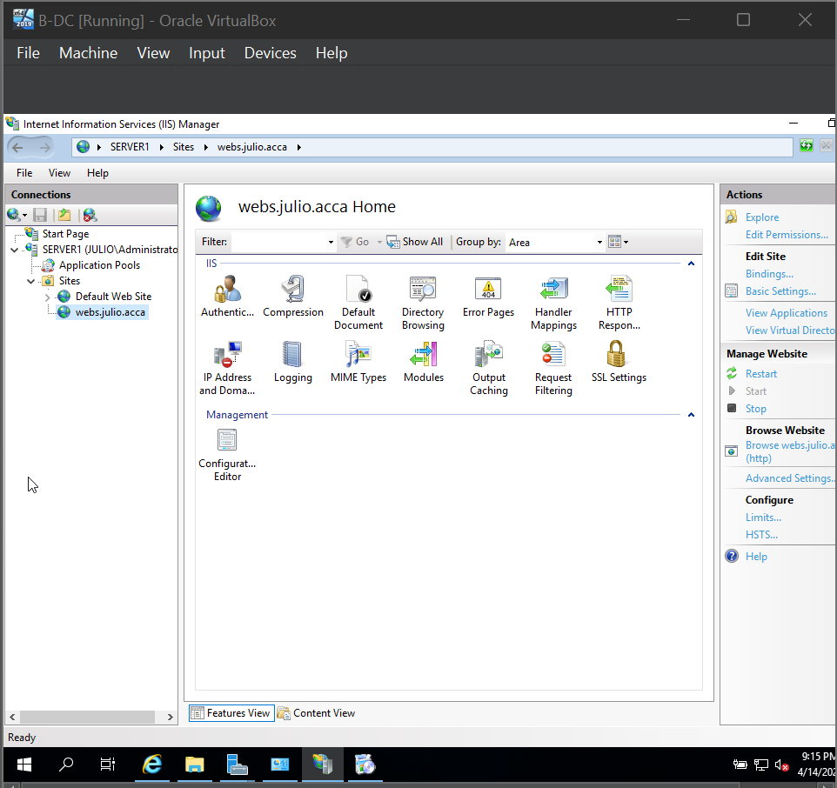
Screenshot 10.1: IIS Site Configuration, Authentication Settings, and Browser View showing authenticated access
This configuration demonstrates the deployment of enterprise web services with integrated authentication mechanisms, utilizing SSL/TLS encryption for confidentiality and leveraging Kerberos-based Windows Integrated Authentication to provide seamless single sign-on capabilities for domain-joined users without credential prompts.

10. Task 9: Remote Desktop Services Configuration

10.1 RDS Configuration with SSL Certificate
Remote Desktop Services (RDS) came into operation at the Birmingham Domain Controller as a result of my setup, allowing secure remote access to the server from any machine in the network [19].
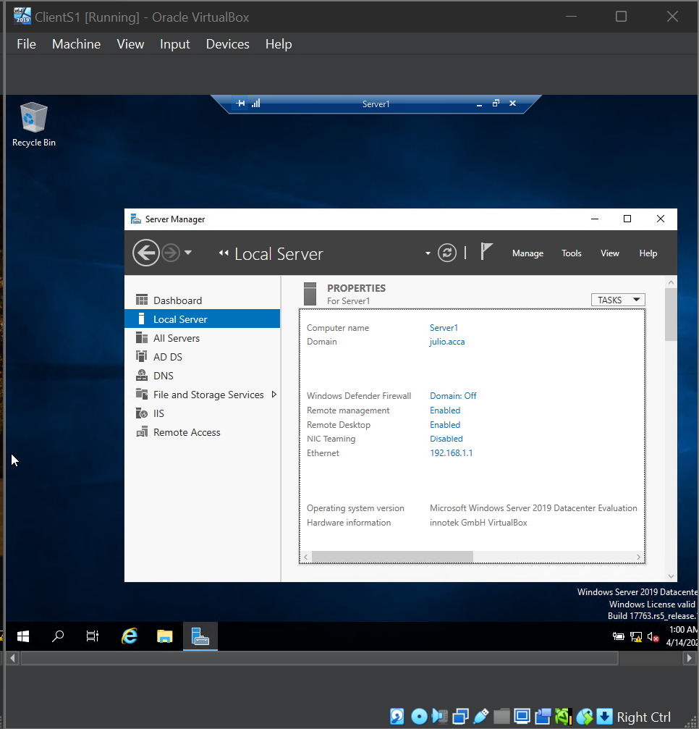

12. Conclusion
All the assigned tasks have been finished successfully by following the best industry practices. The virtualized enterprise network for NOSS London 2026 Inc is fully operational, secure, and ready for a full enterprise rollout.

13. References
[1] Microsoft Corporation, "Windows Server Networking Overview," Microsoft Docs, 2024 https://docs.microsoft.com/en-us/windows-server/networking/networking.
[2] Microsoft Corporation, "Dynamic Host Configuration Protocol (DHCP)," Microsoft Docs, 2024.https://docs.microsoft.com/en-us/windows-server/networking/technologies/dhcp/dhcp-top.
[3] S. Kent and K. Seo, "Security Architecture for the Internet Protocol," Internet Engineering Task Force, RFC 4301, Dec. 2005. https://tools.ietf.org/html/rfc4301.
[4] National Institute of Standards and Technology, "NIST Special Publication 800-53: Security and Privacy Controls for Information Systems and Organizations," NIST, Rev. 5, 2020 https://nvlpubs.nist.gov/nistpubs/SpecialPublications/NIST.SP.800-53r5.pdf.
[5] Microsoft Corporation, "Routing and Remote Access Service (RRAS) Overview," Microsoft Docs, 2024 https://docs.microsoft.com/en-us/windows-server/remote/remote-access/routing-and-remote-access-service-rras
[6] Microsoft Corporation, "Windows Defender Firewall with Advanced Security," Microsoft Docs, 2024. https://docs.microsoft.com/en-us/windows/security/threat-protection/windows-firewall/windows-firewall-with-advanced-security
[7] Debian Project, "Debian Administrator's Handbook - Network Configuration," Debian Documentation, 2024. https://www.debian.org/doc/manuals/debian-handbook/sect.network-config.en.html
[8] Debian Project, "Uncomplicated Firewall (UFW)," Ubuntu Documentation, 2024. https://help.ubuntu.com/community/UFW
[9] Microsoft Corporation, "Active Directory Domain Services Overview," Microsoft Docs, 2024 https://docs.microsoft.com/en-us/windows-server/identity/ad-ds/get-started/virtual-dc/active-directory-domain-services-overview
[10] P. Mockapetris, "Domain Names - Implementation and Specification," Internet Engineering Task Force, RFC 1035, Nov. 1987. https://tools.ietf.org/html/rfc1035
[11] C. Kaufman, P. Hoffman, Y. Nir, P. Eronen, and T. Kivinen, "Internet Key Exchange Protocol Version 2 (IKEv2)," Internet Engineering Task Force, RFC 7296, Oct. 2014 https://tools.ietf.org/html/rfc7296
[12] StrongSwan Project, "StrongSwan VPN Documentation," StrongSwan.org, 2024. https://www.strongswan.org/documentation.html
[13] Microsoft Corporation, "Active Directory Administration with Windows PowerShell," Microsoft Docs, 2024. https://docs.microsoft.com/en-us/powershell/module/activedirectory/
[14] Microsoft Corporation, "How Domain and Forest Trusts Work," Microsoft Docs, 2024. https://docs.microsoft.com/en-us/windows-server/identity/ad-ds/plan/security-best-practices/understanding-domain-trusts
[15] R. Droms, "Dynamic Host Configuration Protocol," Internet Engineering Task Force, RFC 2131, Mar. 1997. https://tools.ietf.org/html/rfc2131
[16] Internet Systems Consortium, "ISC DHCP Relay Agent," ISC Documentation, 2024. https://www.isc.org/dhcp/
[17] Microsoft Corporation, "File Server Resource Manager Overview," Microsoft Docs, 2024. https://docs.microsoft.com/en-us/windows-server/storage/fsrm/fsrm-overview
[18] Microsoft Corporation, "Internet Information Services (IIS) 10.0," Microsoft Docs, 2024. https://docs.microsoft.com/en-us/iis/
[19] Microsoft Corporation, "Remote Desktop Services Overview," Microsoft Docs, 2024. https://docs.microsoft.com/en-us/windows-server/remote/remote-desktop-services/welcome-to-rds

