Programs in C and Documentation

Assignment - Part C

Sarah Rule
1810755

Task - Part C
Pairs – Develop a C program to allow the user to play a version of a popular card matching game, such as that shown below:
- Identify specific problems in completing the exercise.
- Write a clear analysis of the solutions (the thought process behind them) – what logical stages are required. You could use a flowchart or pseudocode.
- Show a code listing with annotations.
- Show testing (screenshots) that clearly demonstrate that the solutions work under all circumstances.
Aim of the game is to turn over the largest number of matching pairs in the lowest number of moves.
NOTE – Remember, there are many marks available for design etc. It is better to have a version of the game that is partially functional, even if it does not incorporate the more complex requirements.

Identify the problem:

- How many pairs are going to be in the array?
- Ask user if they want to play.
- If users answer is yes, shuffle the cards.
- Ask user to enter choice 1 position.
- Ask user to enter choice 2 position.
- If card matches, let user know and allow user to carry on playing until all pairs are matched.
- If user chooses a card that has already been matched let them know they need to pick another number.
- Once all pairs are matched, let user know they have matched all the pairs.
- Once all pairs are matched. End game.
- If cards do not match, let user know and allow them to keep trying until they matched all the pairs.
- Have a score at the end to let the user know how many turns they took.
- Create a high score file to keep track of the users scores.

Annotated Code

#include <stdio.h>
#include <stdlib.h>
#include <time.h>

void cardlayout(int pairs[12]); //prototype for function
void shufflecards(int pairs[12]);

void main()
{
int pairs[12] = { 1 ,4 ,3 ,6 ,5 ,2 ,2 ,1 ,6 ,4 ,5 ,3 }; // set up an array
int card1, card2; //declaring a variable
char choice = (char)'y'; //declaring a variable
int i;//declaring a variable
char cont = 'n';//declaring a variable

printf("Would you like to play the game Matching Pairs - y/n?");//Ask the user if they would like to play the game
scanf(" %c", &choice);//user to enter answer to the question
shufflecards(pairs); //calling a function
cardlayout(pairs); //calling a function

while (choice == 'y') //Whilst the user's answer is y, the game will play and go into asking the user the position of their first guess
{
while (cont == 'n')
{
printf("Enter the position of the first card(0-11):\n");//ask user to enter guess position of first card
scanf("%d", &card1);

if (pairs[card1] != -1) //if the choice is not equal to -1 then continue with the game
{
cont = 'y';
}

else if (pairs[card1] == -1) //if the choice is equal to -1, let the user know they have already picked this card
{
printf("You've already chosen this card! "); //statement to let user know they have already picked this card
}
}

cont = 'n';

while (cont == 'n')
{
printf("Enter the postion of your second card(0-11):\n");//ask user to enter guess for the second card
scanf("%d", &card2);

if (pairs[card2] != -1) //if the card is not equal to -1, continue with game
{
cont = 'y';
}
else if (pairs[card2] == -1)
{
printf("You've already chosen this card! "); //let user know they have already picked this card
}
}

cont = 'n';

if (pairs[card1] == pairs[card2]) //if card 1 and 2 match then revert the cards to -1
{
pairs[card1] = -1;
pairs[card2] = -1;

printf("It's a match, Well Done!\n"); //Message to print to user if their cards match
cardlayout(pairs);//calling a function to reprint the cards after the user has matched them
}

else
{
printf("Sorry that was not a match. "); //Message to print to user if cards do not match
}
}
}

void cardlayout(int pairs[12])//function to call the layout of the cards for the user to pick
{
int i = 0, j = 0;

for (i = 0;i < 12;i++) //how many numbers are avilable to pick from
{
for (j = 0;j < 4;j++) //getting the numbers to go down a line after the 4th number, allowing it to be shown in a table format
{
if (pairs[i] == -1) //if pairs are the same then set the number to -1 so they are unable to pick those numbers again
{
printf(" ");//if they have been matched then only show a space within the table
}
else
{
printf("%d ", i); //if they haven't been matched then print the numbers as they follow (in order)
}
i++;
}
printf("\n");
i--;
}
}

void shufflecards(int pairs[12]) //function to call at the start of each programme to shuffle the cards before the user plays the game.
//This is called after the user has entered their option on whether they would like to play or not.
{
int myrand1, myrand2;
int low = 0; //lowest number to pick
int high = 11; //highest number to pick
int i;
int temp;//allows the numbers to be stored while switching/shuffling

srand(time(NULL)); //seed randomness
for (i = 0;i < 40;i++)//shuffles the card 40 times
{
myrand1 = rand() % (high - low + 1) + low;
myrand2 = rand() % (high - low + 1) + low;

temp = pairs[myrand1];
pairs[myrand1] = pairs[myrand2];
pairs[myrand2] = temp;
//the above code allows one card to be stored in a 'temp' area while two other cards are being shuffled into different places.
}
}

Testing
Normal Values
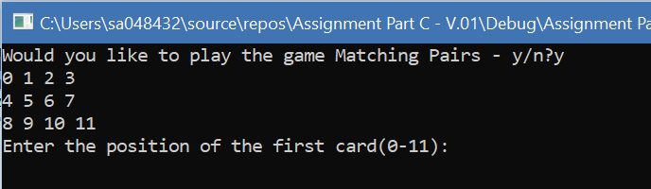
Result: The programme ran as expected. The programme asked the user if they would like to play, the user has entered the answer and then asked the user for their choice of position given the first card. The programme has also told the user the choice of numbers e.g. 0-11.

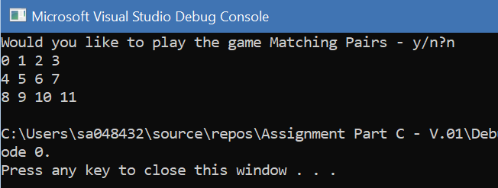
Result: Programme ran as expected. The programme has asked the user if they would like to play the game, the user has answered ‘n’ which is a no, therefore the game has automatically ended. The user is unable to enter any choices because of this.
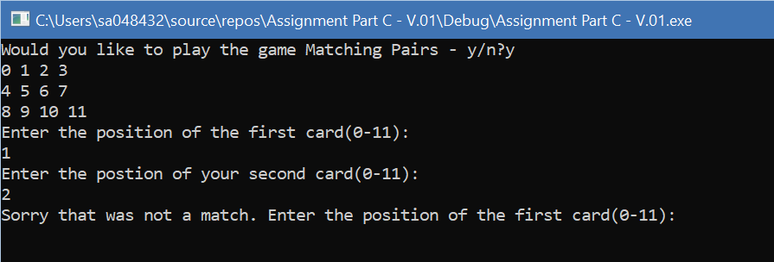
Result: The programme ran as expected. The question has been asked and answered. The user has entered their first and second choice of cards, however, these were not a matching pair which is what the programme has explained to the user.

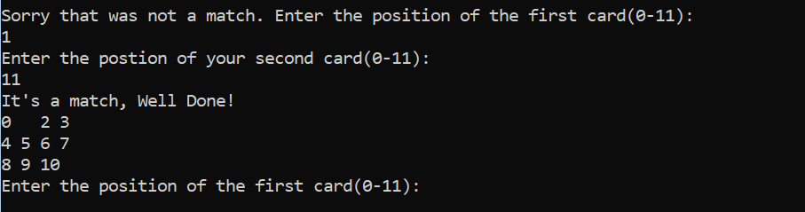
Result: The programme ran as expected. The user has managed to match a pair, this is position ‘one’ and ‘eleven’. As you can see the programme has run correctly and produced the card layout again for the user to pick their next choice while eliminating the cards that have just been matched.

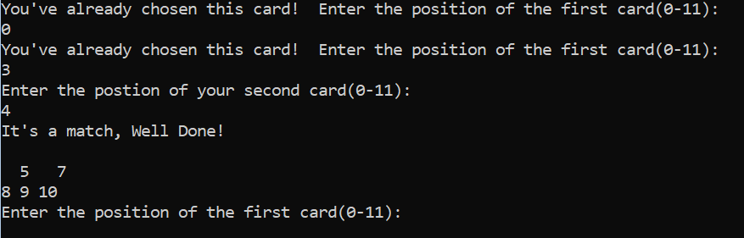
Result: The programme ran as expected and produced an output to let the user know they have already picked the card in question and that they will need to pick another one. This is to prevent the user from picking the same card twice, which could – if there was one in place – affect the high score system etc.

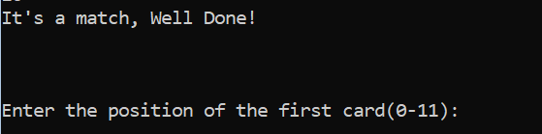
Result: The programme ran as expected in one part, but also failed in another. The image here shows that once all cards have been matched then there are no cards left to pick, this lets the user know that they have therefore matched all the cards. However, the game then goes back to ask the user the position for their first choice as opposed to printing a message to let the user know that they have managed to match all the cards. This means the game carries on and makes the ending impossible.

Testing
Boundary Values
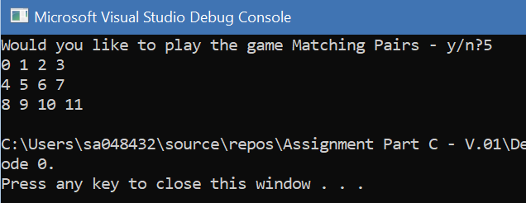
Result: Programme failed. The programme has failed as the user has entered number instead of the required ‘y’ or ‘n’. The programme has ended without allowing the user to play.

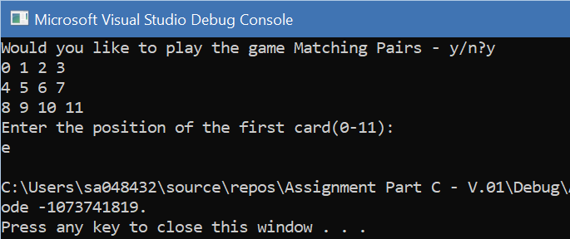
Result: Programme failed. The programme has failed on the second part as the user has entered a letter as opposed to a number when asked which their first choice of position is. This has caused the game to end without allowing the user to play.

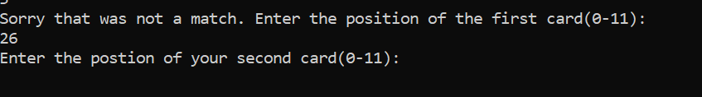
Result: Programme failed. The programme has failed because the user has entered a number outside of the choice. The programme hasn’t identified that this is outside of the choices as it hasn’t been coded in that way so there is no way to stop the user from inputting any number. The code will still continue on as if the user has inputted a correct value. This means the game will continue to play but the outcome will not be produced correctly.

Testing
Problems & Faults

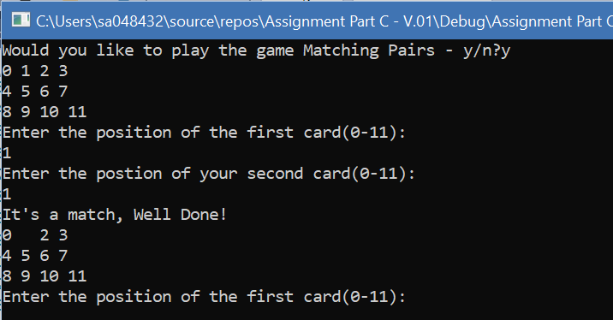
Result: Programme failed. The user has entered ‘y’ stating that they would like to play the game. This has worked fine and the code has then gone on to ask the user to enter their first choice, which they have chosen ‘1’. This has worked fine, in which the code has then gone on to request the user’s second choice. The user has inputted the same number as the first which is ‘1’, this has come up as a match, when it shouldn’t have. The first choice of card should not be available as a choice for the second card.
The second fault within this part is that the 1 has now been taken away from the table as it has been ‘matched’ but this leaves an odd amount of cards on the table which means the game cannot be completed as the pairs are now odd so therefore it will always leave 1 card left on the table.

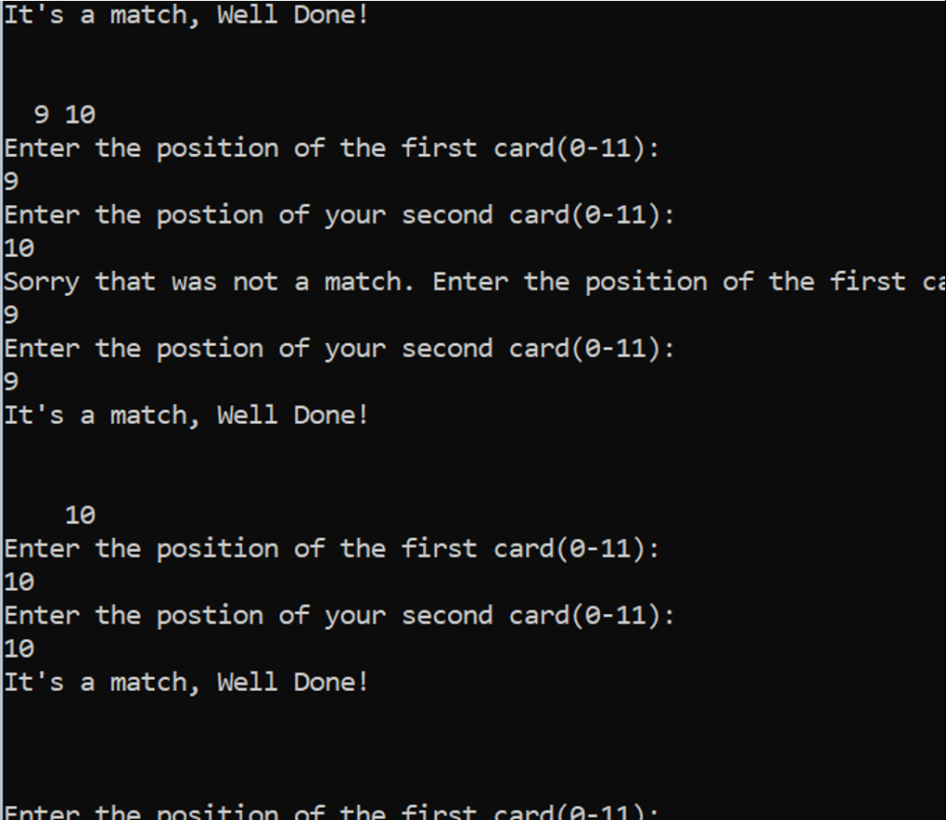
Result: Programme failed. The programme has failed, this is because there are two cards left but as you can see they have entered the two remaining cards which do no match. This means there is no possibility to complete the game unless entering the same number which is the fault as explained above. Allowing the code to let the user enter the same number for choice one and two means that the user can match the card each time singularly as opposed to the intention of the game, which is ‘pairs’.

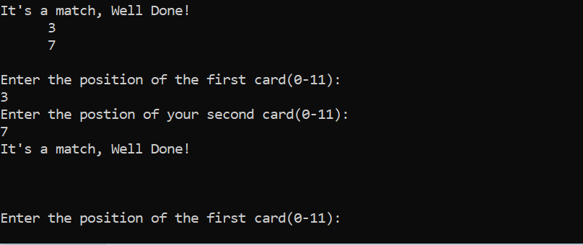
Result: Programme failed. The programme has failed because the game has not ended even though the user has matched all the cards (none showing in the table).

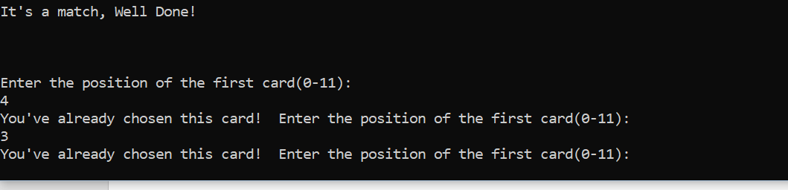
Result: Programme failed. The user has matched all the pairs which is showing the table as now empty, so therefore the game should end. However, the game has allowed the user to continue to keep playing so that they can enter more choices of positions. The user has now entered two choices of positions both coming up as already chosen meaning there are no cards left to pick. The game needs to stop looping and end but there is nothing in the code leaving the game to continue to play.

