.
Applied Leadership and Management in the Workplace
Module Assignment Submission
Student Name: | Jean Ellis
Student Number: | 2309700
Module No: | BMSK4014
Module Title: | Problem solving and decision making

Statement of Confirmation of Authenticity
By the act of making this submission, the student declares that this is the work of the student named above. The work has not, in whole or in part, been knowingly presented elsewhere for assessment, or where assessment has been built on a previous assessment, this has been identified. Where materials have been used from other sources it has been properly acknowledged. If this statement is untrue, the student acknowledges that an assessment offence has been committed.
Attention is drawn to the plagiarism and unfair practice policies of both the University and of ILM.

Contents
Table of Contents
Introduction 4
Define a complex problem in the workplace including scope and impact 4
Analyse information of the problem 5
8
Alternative solutions to the problem 8
Decision making techniques 9
Detailed plan for the solution 11
Communicate the plan to stakeholders 12
Monitoring and review techniques 13
Conclusion 13
Appendices 14
References 14

Introduction
This report will be looking at a complex problem in the workplace and exploring how the problem can be resolved using a variety of critical thinking techniques to come to possible solutions. It will define a complex problem including scope and impact and use a few techniques to find the root causes contributing to the problem. It will then use strategies to try and resolve the problem and implement them into the workplace.

Define a complex problem in the workplace including scope and impact
Tulgan (2014) explains that a complex problem is one that does not have an easy solution. It must be approached in all different perspectives, and it may lead to multiple solutions or little solutions. A complex problem requires careful planning and communication across all levels of the company. When trying to solve this problem there are number of techniques that should be used before coming to the final solution. this is to make the decision-making process fair and thorough. And to cover all outcomes
The complex problem in this report is high staff turnover in a care home. The care home is experiencing high staff turnover rates, and this is leading to disruptions in the care of the residents, low staff morale and added costs for recruitment and training. This is affecting the resident’s overall wellbeing and raising doubts amongst their families. The care home must first try to understand the possible reasons for high staff turnover. This is crucial in order to deal with this complex problem accordingly. Ahmed (2015) explains what the possible reasons could be for high staff turnover,
Reasons for high staff turnover
- Workload- care work is a physically and mentally demanding job. When the staff to resident ratio is low it can become extremely overwhelming and difficult for staff to cope. This could lead to injuries and decline in mental or physical health.
- Low wages- when staff feel they are not being compensated for their hard work they may look for a better well-paid job.
- Lack of career growth- A lack of opportunities to progress in their professional development could spur them to leave and pursue growth elsewhere
- Poor management- Lack of support from management and poor leadership skills can contribute significantly to high turnover rates.
- Negative work environment- Bullying, lack of teamwork and poor morale will certainly drive employees away.
All these areas will need to be explored and worked on to decrease high staff turnover and create a more stable and supportive work environment for its staff. High staff turnover in this type of workplace can significantly impact the quality of care provided to its residents and cause unnecessary stress to remaining staff.
The objective is to develop a strategic plan aimed at reducing staff turnover by addressing the root causes and implementing sustainable solutions to enhance job satisfaction and retention. First, we must look at the scope and impact of the problem. Reed (2016) explains that the scope is looking at who is affected and how wide does the problem reach and the impact is looking at who is affected.
Scope
- Inconsistencies with the quality of care to residents.
- Remaining staff over worked and stressed
- Increased costs on training and recruitment
- Damage to the care homes reputation
- Residents' wellbeing and quality of life may decline
Impact
- Residents' health may decline due to the inconsistent care and routine.
- Constant changes may impact residents' mental wellbeing.
- Families may lose trust in the care home.
- Company could build a reputation for high turnover and put off potential job searchers.
- It could lead to lower occupancy rates and impact the home financially.
Upon looking at the scope and impact the care home can now try and find a solution to improve all these areas and get their home back to a fully functioning and safe environment. For their residents and staff.

Analyse information of the problem
IIBA (2009) explains that one to way to evaluate the information of a complex problem is to use the fishbone analysis. It a tool used to find the root causes of a problem. It can help to pinpoint the exact areas causing the issue by breaking down the complex problem into more manageable segments. By using a fishbone analysis, the care home can identify:
- Root causes
- Address the most significant causes
- Develop solutions
- Implement and monitor
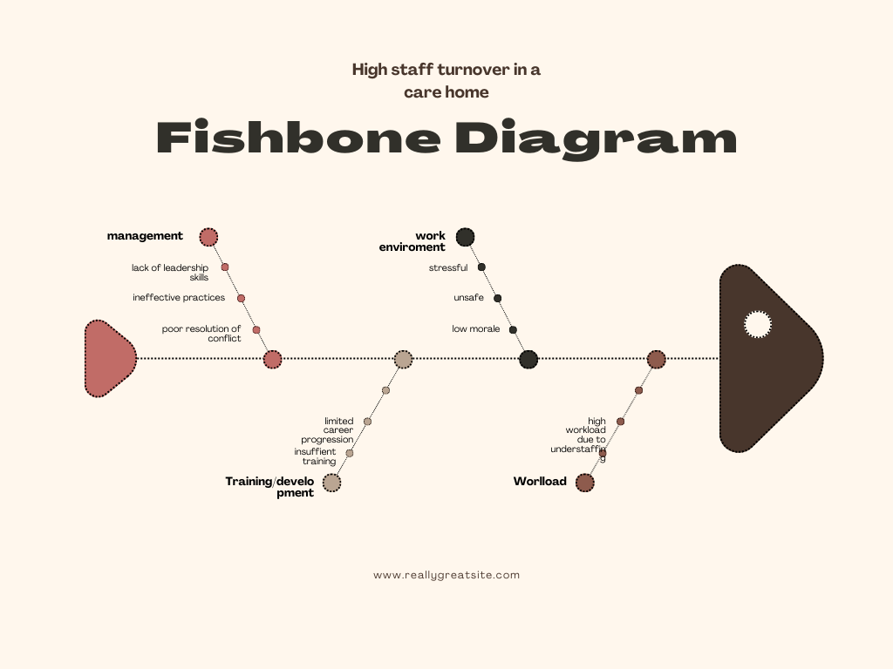
The fishbone analysis above has been used to identify the root causes contributing to the high staff turn in the care home.
- Management – lack of leadership skills, ineffective practices, and poor resolution of conflict.
- Work environment – Stressful, unsafe, low morale.
- Training/development – Limited career progression, insufficient training.
- Workload – High workload due to staff shortages.

Brainstorming
According to Rawlinson (2017) Brainstorming is a creative problem-solving technique that involves thinking of ideas freely, no matter how feasible or impossible they may sound. The care home carried out their own brainstorming session and their ideas are as follows;
Management and Leadership
- Offer regular training to improve conflict skills and team management.
- Schedule regular meetings to discuss issues.
- Establish open communication between staff and management for regular feedback.
Training and Development
- Develop a detailed training plan so new employees to feel well prepared.
- Provide ongoing training opportunities to enhance skills.
- Establish clear career progression paths.
Compensation and Benefits
- Competitive salaries
- Enhanced benefits- health insurance, pension plan etc
- Performance bonuses
Workload/schedule
- Offer a decent work/life balance
- Adequate staffing
- Efficient workflow
Work Environment
- Ensure the home is well maintained and a safe working environment
- Create designated areas for staff to take breaks and destress during shifts

Employee engagement
- Recognition program
- Employee feedback
- Team building
Residents and families
- Person centred care
- Encourage staff and resident's connections
- Involve families in care decisions
- Ask for feedback
Operations
- Make sure resources are easily available for staff to access
- Regularly review and improve the care home
- Implement processes to reduce stressors
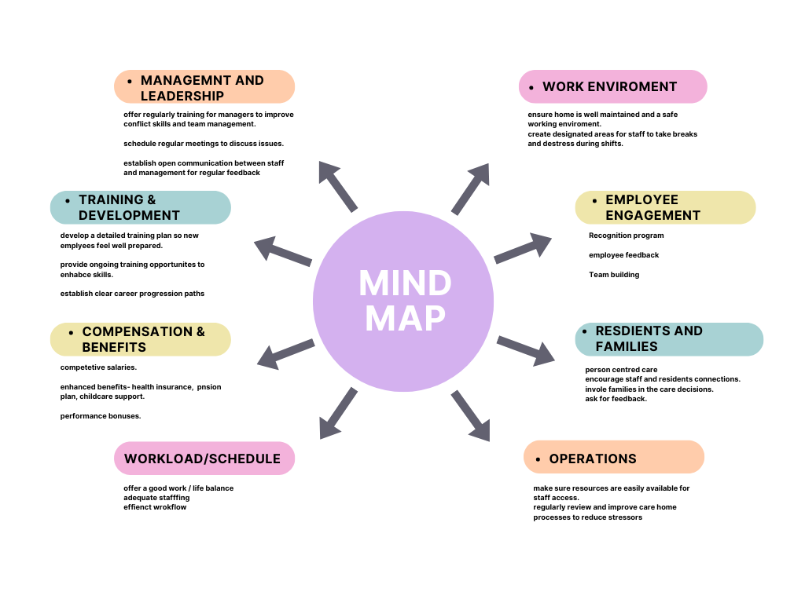

Alternative solutions to the problem
Allen (2012) states that when addressing high staff turnover in the workplace it is essential to explore a variety of alternative solutions to find the most effective approaches. It is important to have alternative solutions to a problem so that the problem can be addressed in multiple ways. It allows flexibility in decision making and implementation. So, if one solution fails by having alternatives it can ensure that the problem can still be addressed.
Employee wellbeing programs – offer mental health resources and access to counselling to all staff and stress management workshops.
Wellness/Selfcare programs – offer gym memberships, relaxation techniques, a work-based mentor.
Flexible work options – create part time positions to attract people who may not be able or want to work fulltime.
Strengthen team dynamics – establish peer support groups where staff can share their worries and challenges. Implement coping strategies.
Universal training – think about training all staff in all areas so in the event of absences staff can cover for each other and ease the burden.
Support networks – join support groups who are in the same industry so experiences can be shared and can be learned.
Improve recruitment strategies – implement staff referral programs and bonuses for each successful recruitment. Explore all different platforms for recruitment such as job fairs and social media.
Once all these possible solutions are in place and in progress it is important to keep track of how they are working or not working. Taylor (1994) suggests how to implement these alternatives
Implementation of alternative solutions
- Test these solutions on a small and gradual basis before full implementation. This will make it easier to assess their effectiveness.
- Establish a feedback loop with staff so you can keep in the loop about their experiences and suggestions.
- Ensure the appropriate resources are put in place to support the implementation.
- Review the effectiveness of these solutions regularly and adjust as and when.
By implementing these alternative solutions, the care home can create a more supportive and appealing environment to both residents and staff. And it will reduce staff turnover and enhance the quality of care provided to its residents.

Decision making techniques
(Mindtools.com) explains that a Grid Analysis is a structured decision-making tool used to evaluate and compare multiple options based on specific criteria. It helps in prioritizing alternatives by systematically scoring and weighing each option against established criteria.
It works by scoring each option out of 0 to 5 with 0 being poor and 5 being good. Once you have scored each option you must then multiple each score by the value of its importance. The option/options that scored the highest wins! And you have a clearer understanding of which areas to work on the most.
Factors: | Cost | Staff satisfaction | Feasibility | Time | Sustainability | Total
Weights: | 3 | 5 | 4 | 3 | 4
Wellbeing programs | 4 | 5 | 3 | 3 | 3 | 70
Flexible working options | 4 | 4 | 3 | 3 | 3 | 65
Strengthen team dynamics | 3 | 5 | 4 | 2 | 4 | 78
Recruitment strategies | 5 | 5 | 3 | 4 | 4 | 80

The solutions that scored the highest are
- Wellbeing programs
- Strengthen team dynamics
- Recruitment strategies
With these being the highest scored it is likely that these will need to be worked on the most to reduce high staff turnover in the care home. Implementing these solutions can provide significant improvements on high staff turnover and the overall performance in the care home.

Rus (2021) explains that a Cost-Benefit Analysis is a systematic approach to evaluating the financial implications of different strategies or solutions. It involves comparing the costs and benefits of each option to determine which provides the best value. For addressing high staff turnover in a care home, a Cost benefit analysis can help identify the most cost-effective solution by quantifying both the anticipated costs and benefits.
The care home has decided they need to ramp up their recruitment and advertising method, so they have purchased an advertisement program with an agency. The agency has charged the care home £2000 for a bespoke advertising package and £300 for the software needed to create the package. The care home has also taken out a contract with the agency at £100 per year which will be for the regular updating and refreshing of their advertising package. And a further £150 will be paid in year 3 for the updating of the software.
In the cost benefit analysis, below it shows how much the home must contribute to their advertising solution.
Cost benefit analysis for recruitment

Costs | Year 1 | Year 2 | Year 3 | Year 4 | Year 5 | Total
Purchase of advertising program | £2000 | - | - | - | - | £2000
Net cost | £2000 | - | - | - | - | £2000
Program contract | - | £100 | £100 | £100 | £100 | £400
Software | £300 | - | - | £150 | - | £450
 |  |  |  |  |  | £4850

With the care home improving their advertising program and retaining staff for longer they can work out their cost benefit's. Below is an example of some of the areas they can save on revenue. Throughout year 1 to year 5 they have saved a sum of £50,000 from staff savings- this being the result of retaining staff for longer periods of time. And throughout year 1 to year 5 they have also saved £9000 on staff training- this being the result of not having to keep training fresh staff because the previous are remaining.
Benefits
 | Year 1 | Year 2 | Year 3 | Year 4 | Year 5 | Total
Staff savings | £10,000 | £10,000 | £10,000 | £10,000 | £10,000 | £50,000
Training cost savings | £1000 | £2000 | £2000 | £2000 | £2000 | £9000
 |  |  |  |  |  | £59,000

By combining the cost analysis and cost benefits the care home can work out how much revenue they will save annually.
Total benefits £59,000 = 5.6:1 (for every £1 spent the home are getting a £5.60 return.
Total costs spent £4850
Net benefit £11,000 - Annual benefit £2300 = £8700
Total annual benefit £59,000- £4850/5 (number of years) = £10.830
Based on this cost benefit analysis, the care home will initially have to invest a large amount of money into implementing these solutions but as each year goes by, they will have to spend less. This will be down to the success of each solution and the monitoring of their progress.
And the benefit of implementing this solution shows that the care home will make a significant saving of £59,000 by year 5.

Detailed plan for the solution
According to Clark (2013) A Gantt Chart is a project management tool that can be used to plan and track the progress of tasks and activities over time. It highlights the tasks that need to be done for the project, with the schedule showing the start and end dates of each task. Creating a Gantt Chart for addressing high staff turnover in a care home involves outlining the tasks required to implement selected solutions and organizing them in a timeline.
The care home has created the Gantt chart below to implement a recruitment program over an 8-week period. They have given themselves 4 weeks to plan and implement each area that they believe need to be worked on and by week 8 onwards these tasks will be an ongoing process.

Task | Week 1 | Week 2 | Week 3 | Week 4 | Week 5 | Week 6 | Week 7 | Week 8 | Ongoing
Planning
Training program
Develop recruitment process
Implement referral programs
Team building activities
Engage with mental health support systems

Communicate the plan to stakeholders

Maani (2015) advises that once the plan has been created it must be shared with the care home stakeholders. And to use certain modes of communication for each stakeholder.
- Care home directors, management, HR
- Staff
- Residents and their families
- Training providers/recruitment agencies
Mode of communication for each stakeholder
- Directors/management – formal face to face meeting, PowerPoint presentation
- Staff – informal meeting, email updates, notice boards
- Residents and families- send detailed letters explaining the changes, host family meetings
- Training providers/recruitment agencies- send detailed letters, emails, and meetings.
It is important to choose the right method of communication with each stakeholder to make sure the message is conveyed effectively whilst encouraging engagement and understanding.

Monitoring and review techniques
Now the plan is in motion it will need to be closely monitored to ensure it is going smoothly and to deal with any disruptions promptly.
The Gantt chart can be used to keep on track of schedule and set realistic milestones.
Proctor (2002) suggests to also monitor and track other areas regularly these include;
Employee satisfaction- this can be done via regular surveys to track morale, satisfaction, and engagement.
Turnover rate- Compare against baseline data to keep track of an increase or decrease in staff levels.
Retention rate- Monitor how long fresh staff remain during employment at the workplace.
Absences – Monitor and track the frequency of absences. A decrease in rate may indicate improved job satisfaction.
Training and development- Track the number of staff participating in training. An increase may indicate commitment to their career.
One to one meeting’s- Offering one to one catch ups with employees is a way to gain feedback and for them to air any concerns they may have.
Resident and families feedback- Carry out regular surveys and regular family meetings.
Performance reviews- Track employee performance- are they meeting expectations? Will they benefit from more training?
Adapt and improve – Be prepared to adapt the plan should new challenges arise.

Conclusion
To conclude this report has explored what a complex problem in the workplace is. It has discovered that a complex problem in a care home is high staff turnover. The high staff turnover was causing considerable damage to the care home, its staff, and its residents. So, techniques were explored to find solutions to the problem. This report also worked out how the care home could save money on high staff turnover by investing in an appealing advertising program. The takeaway of this report is that to run a successful care home it is crucial that management are up to date on their skills and training and that employers offer consistent support and reassurance to their employees. High staff turnover can be extremely stressful for remaining staff and damaging to the company's reputation, so it is especially important that solutions are implemented to address the issue promptly.

Appendices



References

Ahmed, E. E.-H. (2015). Antecedents of Turnover Intentions Among Critical Care Nurses: Quality of Work Life as Perceived by Staff Nurses and Its Relation to Their Turnover Intention at Critical Care Units. Germany : Lambert Aca.
Allen, D. (2012). Managing Employee Turnover: Dispelling Myths and Fostering Evidence-Based Retention Strategies. . United States: Business Expert Press.
Clark, W. (2013). The Gantt Chart, a Working Tool of Management. United States: HardPress Publishing.
https://www.mbatools.co.uk/Toolbox/DecisionMaking/gridanalysis.htm#:~:text=Grid%20Analysis%20is%20a%20useful,important%20for%20making%20the%20decision. (n.d.).
https://www.mindtools.com/aaadlna/grid-analysis-technique. (n.d.). https://www.mindtools.com/aaadlna/grid-analysis-technique.
IIBA . (2009). A Guide to the Business Analysis Body of Knowledger. Canada:: International Institute of Business Analysis.
Maani, K. (2015). Multi-stakeholder Decision Making For Complex Problems: A Systems Thinking Approach With Cases. Singapore:: World Scientific Publishing Company.
Proctor, T. (2002). Creative Problem Solving for Managers. . Taylor & Francis.
Rawlinson, J. (2017). Creative Thinking and Brainstorming. United Kingdom: Taylor & Francis.
Reed, A. (2016). Be a Great Problem Solver – Now! The 2-In-1 Manager: Speed Read - Instant Tips ; Big Picture - Lasting Results. . United Kingdom: Pearson Education.
Rus, G. (2021). Introduction to Cost–Benefit Analysis: Looking for Reasonable Shortcuts. United Kingdom: Edward Elgar Publishing.
Solutions. (2017). Belgium: 50Minutes.com., T. P. (n.d.).
Taylor, J. ( 1994). Practical Problem-Solving Skills in the Workplace: EBook Edition. . United State: AMACOM.
Tulgan, B. (2014). The 27 Challenges Managers Face: Step-by-Step Solutions to (Nearly) All of Your Management Problems. United Kingdom: Wiley.

