DS 1 Template
My Screenshots/Photos
- Please add 4–6 screenshots or photos of your digital life.
- You can use your phone or laptop.
- For each screenshot, write one or two sentences explaining what it shows.
Screenshot/Photo 1 — WhatsApp

I use WhatsApp to communicate with my family and friends through messages, voice calls and video calls. It helps me stay connected with people who are important to me, even when we are apart.

Screenshot/Photo 2 — Snapchat
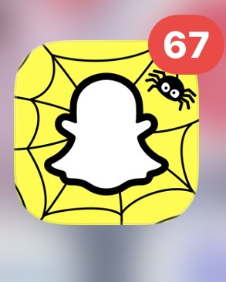
I use Snapchat to share photos, videos and messages with friends. It is a fun way to share everyday moments and keep in touch.

Screenshot/Photo 3 — Google Maps
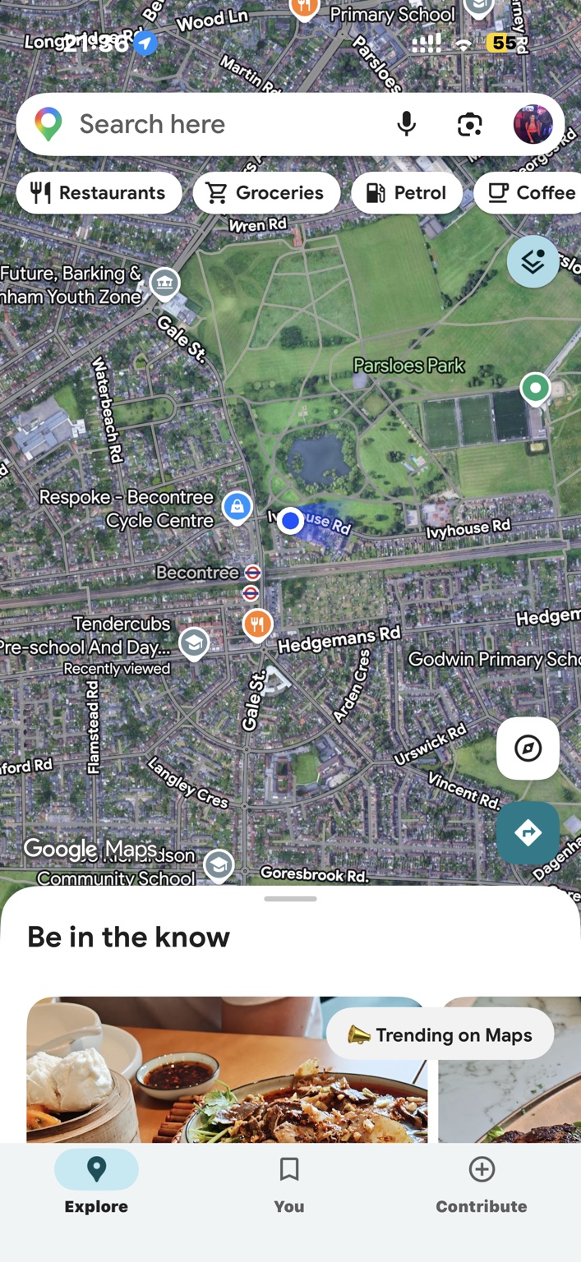
I use Google Maps to find locations, plan journeys and get directions. It helps me travel more easily and discover places nearby.

Screenshot/Photo 4 — Notes
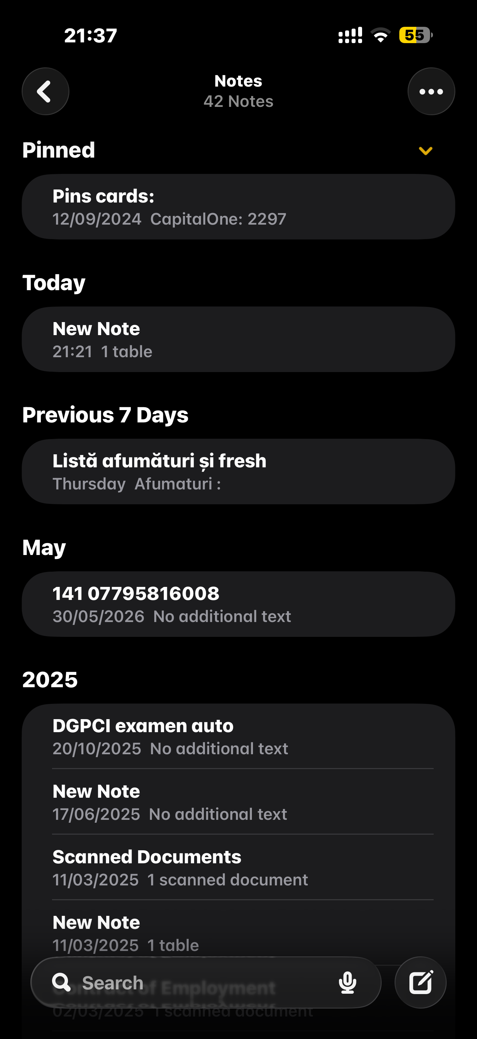
I use the Notes app to write down important information, make lists and keep track of ideas. It helps me stay organised and find information when I need it.

Screenshot/Photo 5 — Barclays
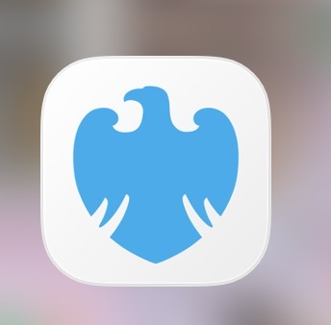
I use the Barclays mobile banking app to check my balance, review transactions and manage my money. It helps me monitor my spending and make payments without visiting a branch.

My Short Reflection
- Write 5–8 simple sentences about your digital life.
- You can use the sentence starters below if helpful.
I use digital tools every day to communicate, find information and organise my life.
I feel confident when I use apps such as WhatsApp, Snapchat and Google Maps because they are easy to access on my phone.
I often use these tools to keep in touch with people, plan journeys, save notes and manage my money.
Digital tools save me time because I can complete many tasks without needing to go somewhere in person.
I understand that I need to protect my personal information, especially when using banking apps or saving private notes.
I want to keep improving my digital skills so I can use apps and online services safely and effectively.
Digital skills are important for me because they help me in my everyday life, at work and when learning new things.

