5/2/2019
Nicholas Evans
1704662
Software Development Part C
ACCA4017

Contents
Implementation – Function Based 2
Pairs – The Rules 2
Logic Breakdown 2
Testing 3
The code 6

Implementation – Function Based

Pairs – The Rules

The work displayed below is a code which was designed using C programming to resemble a fully functioning game of Pairs. The rules of the game is simple, select a card, then select another. If the cards are different, put them back face down and try again. If the two cards are the same, the matched cards are removed from play. Repeat this process until all cards are matched.
The code below allows the user to see how many cards are left in the form of numbers. If the selected numbers do not much, the program will inform the user to try again. If the user selects a matching pair, the program with ‘star’ out the numbers so the user is unable to select them again. This is the programs way of removing the matched numbers from the game.

Logic Breakdown

Here is the breakdown on how the program is designed to work in a step by step format.

- Input numbers in the array – To prevent getting 3 or more of the same number.
- Shuffle – The numbers are shuffled each time a new game starts resulting in a new game each time.
- Print Numbers – Displays the available numbers and the starred out options.
  - For Loop for 12 times
  - IF array element = 0
    - Print * if it’s a match
  - Else
    - Print array element number
- Card 1 – select a number between 0-11. If the user selects an unspecified number, a warning will show to try again using the displayed options. The same thing will occur if the selected number has already been matched. If this happens, the code will start this step again.
- Card 2 – Same as card 1, accept the program will check if you have selected the same number as card 1. If this happens, the code will start this step again.
- If ‘Matched’ – The program will convert the matched numbers to ‘0’ in game, preventing them to be selected again. This is shown in the form or a star (*).
- If ‘Not matched’ – The program will notify the user to select again.

If either step 6 or 7 occurs, the program will notify the user to select two new numbers. Essentially repeating the process from step 3.

Testing

Test No | 1
Test description | Arrays
Expected Results | Displays the array
Screenshots | 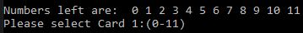
Actual Results | Displays the array
Pass/Fail | Pass

Test No | 2
Test description | Shuffle
Expected Results | Each new game changes the paired numbers
Screenshots | 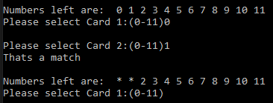  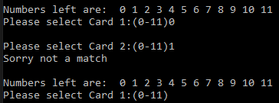
Actual Results | Each new game changes the paired numbers
Pass/Fail | Pass

Test No | 3
Test description | Print Numbers
Expected Results | The program displays the required numbers and instructions
Screenshots | 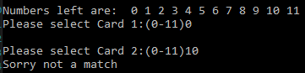  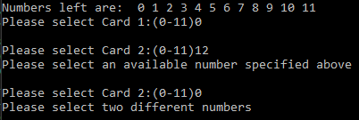  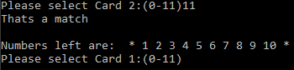  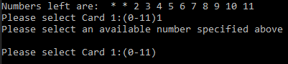
Actual Results | The program displays the required numbers and instructions
Pass/Fail | Pass

Test No | 4
Test description | Card 1
Expected Results | Only allows the user to select the specified numbers
Screenshots | 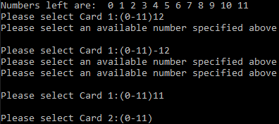
Actual Results | Only allows the user to select the specified numbers
Pass/Fail | Pass

Test No | 5
Test description | Card 2
Expected Results | Only allows the user to select the specified numbers
Screenshots | 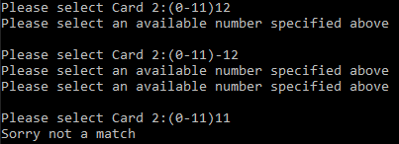
Actual Results | Only allows the user to select the specified numbers
Pass/Fail | Pass

Test No | 6
Test description | Matching
Expected Results | The program recognise a match and no match
Screenshots | 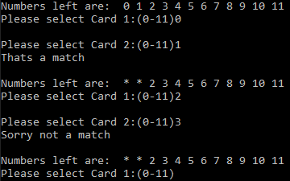
Actual Results | The program to recognise a match and no match
Pass/Fail | Pass

Test No | 7
Test description | Game End when all matching are found
Expected Results | Congratulate the user for winning
Screenshots
Actual Results | Game ends when all matching are found
Pass/Fail | Pass

The code

Below is the full code written using Visual Studio 2017 using C.

#include <stdio.h>
#include <stdlib.h>
#include <time.h>

void printNumbers(int pairs[]);

void main()
{
int pairs[12] = { 1,1,2,2,3,3,4,4,5,5,6,6 };
int card1, i, temp, count = 0;
int card2;
int rand1, rand2;
int low = 0; //lowest of range
int high = 11; //highest of range
srand(time(NULL)); //seed randomness

//shuffle
for (i = 0; i < 100; i++)
{
rand1 = rand() % (high - low + 1) + low;
rand2 = rand() % (high - low + 1) + low;
temp = pairs[rand1];
pairs[rand1] = pairs[rand2];
pairs[rand2] = temp;
}

printNumbers(pairs);

while (count < 6)
{
card1 = -1; // Goes into the while loop
while (card1 < 0 || card1 > 11) // If numbers are outside 0-11
{
printf("\nPlease select Card 1:(0-11)");
scanf("%d", &card1);

if (card1 < 0 || card1 > 11) // If numbers are outside 0-11
{
printf("Please select an available number specified above\n");
}
if (pairs[card1] == 0) // Check the number hasn't been matched
{
printf("Please select an available number specified above\n");
card1 = -1; // To stay in th while loop
}
}

card2 = -1; // Goes into the while loop
while (card2 < 0 || card2 > 11) // If numbers are outside 0-11
{
printf("\nPlease select Card 2:(0-11)");
scanf("%d", &card2);

if (card2 < 0 || card2 > 11) // If numbers are outside 0-11
{
printf("Please select an available number specified above\n");
}
if (card2 == card1)
{
printf("Please select two different numbers\n");
card2 = -1; // To stay in th while loop
}
if (pairs[card2] == 0) // Check the number hasn't been matched
{
printf("Please select an available number specified above\n");
card2 = -1; // To stay in th while loop
}
}

if (pairs[card1] == pairs[card2])
{
printf("Thats a match\n");
pairs[card1] = 0;//take out of the game
pairs[card2] = 0;//take out of the game
count++;
}
else
{
printf("Sorry not a match\n");
}
printNumbers(pairs);
}

printf("Congrats! Thanks for playing :)\n\n");

}

void printNumbers(int pairs[])
{
int i;
printf("\nNumbers left are: ");
for (i = 0; i < 12; i++)
{
if (pairs[i] != 0)
{
printf(" %d", i); // Prints off number in pairs
}
else
{
printf(" *"); // Prints off if numbers equal 0
}
}
}

