Name – Tarun Kathpal
Student Id-2516282
Module Name -Computer Architecture and Operating Systems
Group-3
Lecturer Name – Anum Paracha

Introduction
Operating systems are essential software that manage computer hardware and software resources while providing a platform for users and applications to interact efficiently. They perform important functions such as memory management, process management, file management, device management, user management, and system security, ensuring that computer systems operate reliably and effectively.
This report explores the key functions of general-purpose operating systems, with a particular focus on Microsoft Windows and Linux. It demonstrates the practical use of command-line interface (CLI) tools by examining a range of Windows Batch/PowerShell and Linux Bash commands used for process management, file and directory management, network testing, user management, and task scheduling. The report also includes examples of Batch and Bash scripting to illustrate how command-line automation can simplify routine administrative tasks and improve system efficiency.
The report combines theoretical knowledge with practical demonstrations, supported by screenshots, examples, and relevant academic references. The aim is to develop a clear understanding of operating system concepts while demonstrating practical command-line and scripting skills that are valuable in modern computing and IT environments.

Task 1. Key Functions of General Operating Systems
An operating system (OS) is the core software that manages a computer's hardware and software resources. It acts as an interface between the user and the computer, allowing applications to run efficiently while ensuring that system resources are allocated correctly. Popular general-purpose operating systems include Microsoft Windows, Linux, and macOS. Each operating system provides similar core functions, although they may implement them differently.

1.1 Process Management
Process management controls the execution of programs running on a computer. The operating system creates, schedules, and terminates processes while ensuring that multiple applications can run at the same time without interfering with one another. Windows uses the Task Manager to display running processes, CPU usage, memory consumption, and background applications. Effective process management improves system performance and prevents conflicts between programs.

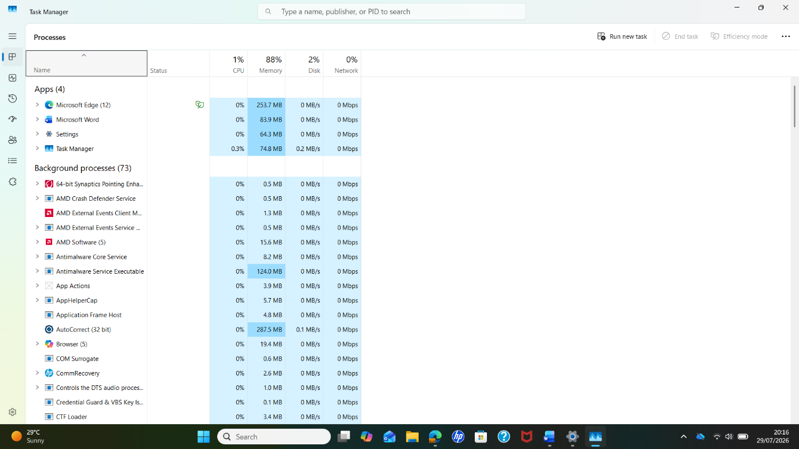

1.2 Memory Management
Memory management is responsible for allocating and releasing RAM to programs when they are executed. The operating system ensures that each process has when they are executed. The operating system ensures that each process has sufficient memory while preventing one application from accessing another application's memory. When physical memory becomes limited, the operating system uses virtual memo maintain
system performance. and allows multiple applications to operate 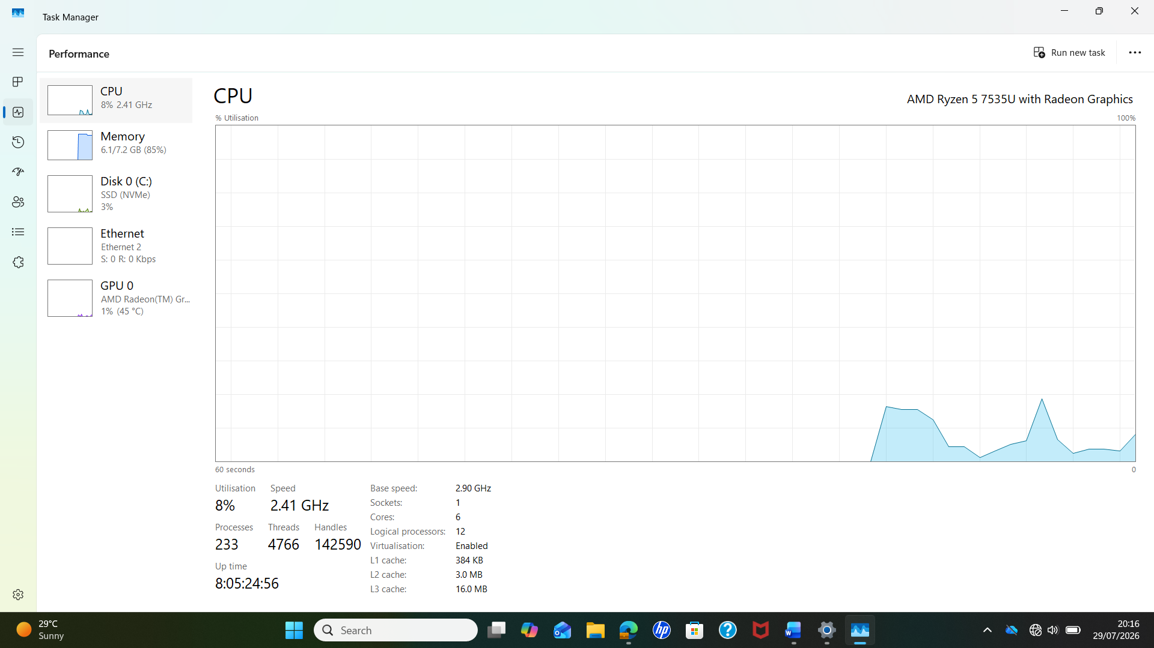

1.3 File System Management
The operating system organises and manages files and folders stored on storage devices. It enables users to create, rename, copy, move, and delete files while controlling file permissions and access rights. Windows primarily uses the NTFS file system, while Linux commonly uses ext4. Efficient file management ensures that information is stored securely and can be retrieved quickly.

1.4 Device Management
Device management allows the operating system to communicate with hardware components such as printers, keyboards, monitors, USB devices, storage drives, and network adapters. Device drivers act as translators between the operating system and hardware. If a driver is missing or outdated, the hardware may not function correctly.
Screenshot 4: Windows Device Manager displayed installed hardware.

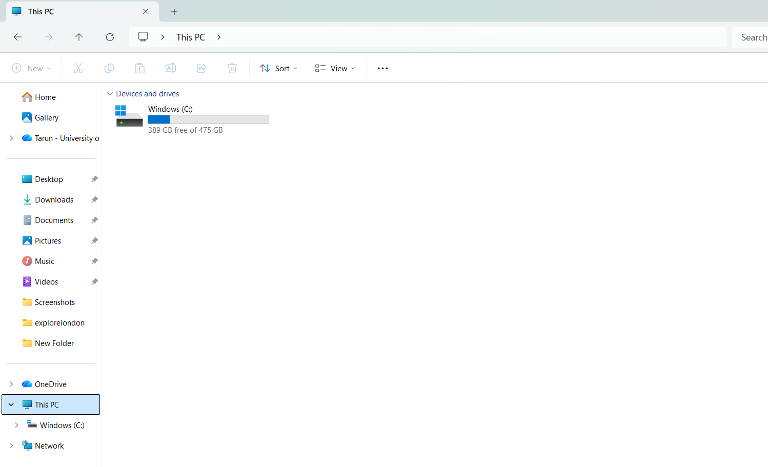

1.5 User Management and Security
Operating systems provide user accounts with different permission levels to protect data and system resources. Administrators can install software and change system settings, while standard users have restricted permissions. Security features such as passwords, user authentication, Windows Defender, and firewalls help protect the system from malware, viruses, and unauthorised access.

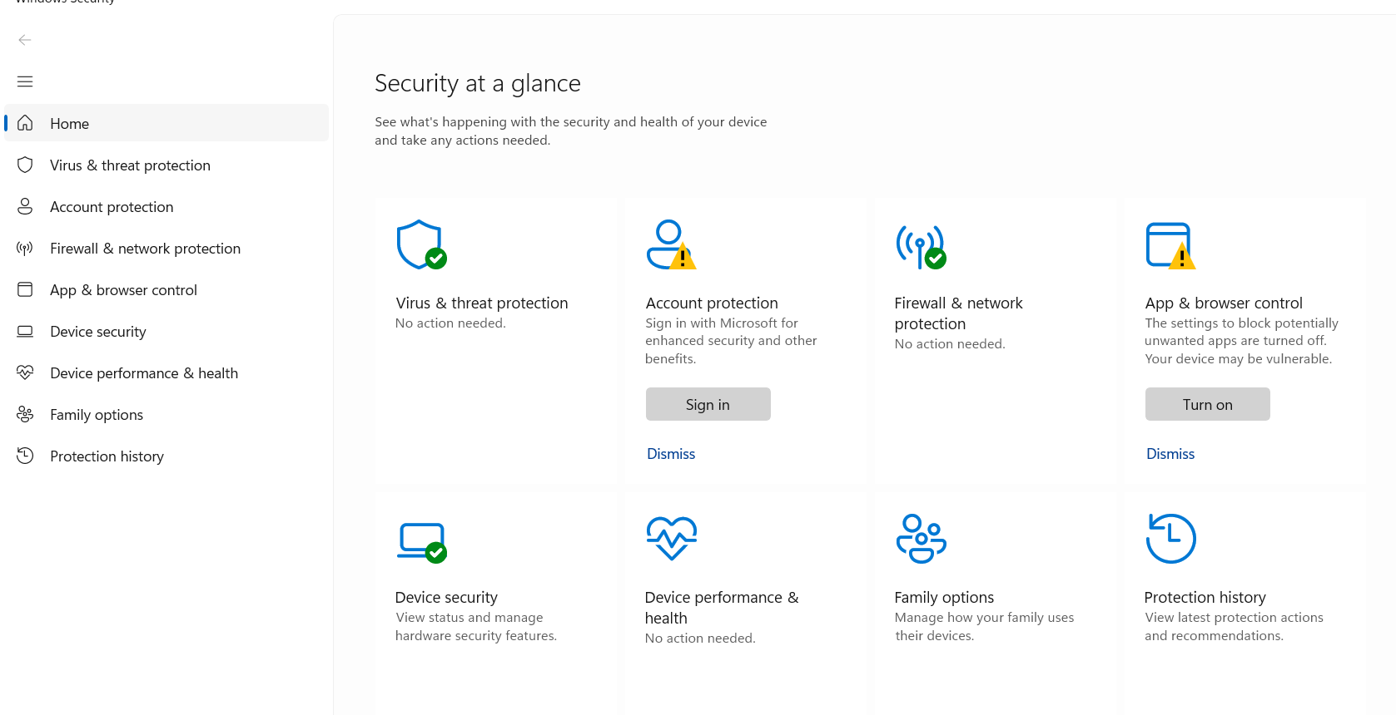
1.6 Resource and Network Management
The operating system manages system resources such as CPU time, memory, storage space, and network connections. It allocates these resources efficiently to maintain smooth performance even when several applications are running simultaneously. Modern operating systems also manage internet connectivity, wireless networks, file sharing, and network security to ensure reliable communication between devices.
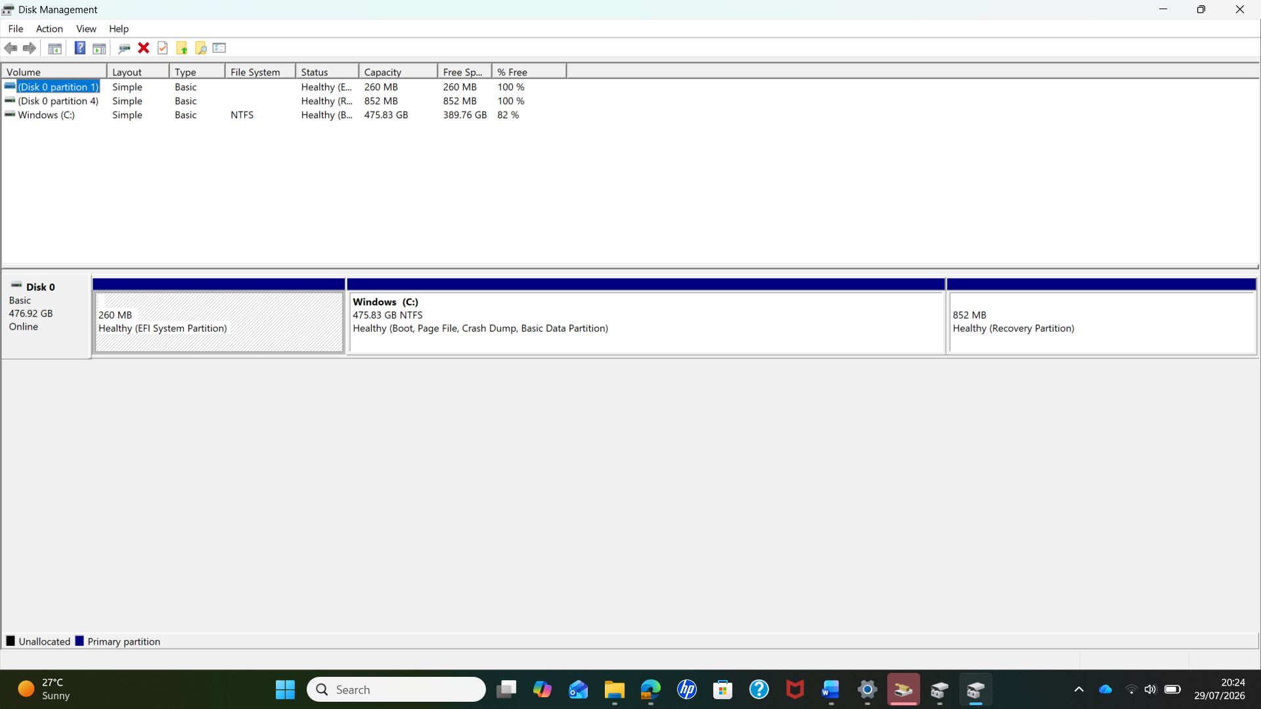

Task 2
Use of Windows OS CLI Commands
The Windows Command-Line Interface (CLI) provides a text-based method for interacting with and managing the operating system. Command Prompt (CMD) allows users to perform various administrative and troubleshooting tasks by entering commands directly into the terminal. In this section, a range of Windows CLI commands is demonstrated to show practical skills in process management, file and directory management, network testing and monitoring, user management, and task scheduling. Each command is executed in Command Prompt and supported with a screenshot showing the command and its output. Options and switches are also used where appropriate to demonstrate how commands can provide additional information or perform specific functions. These practical examples demonstrate how CLI tools can be used to manage and monitor a Windows operating system efficiently.

1.Command: Dir
File and directory management
The dir command displays the files and folders in the current working directory. It helps users view and manage directory contents through the Windows Command Prompt.

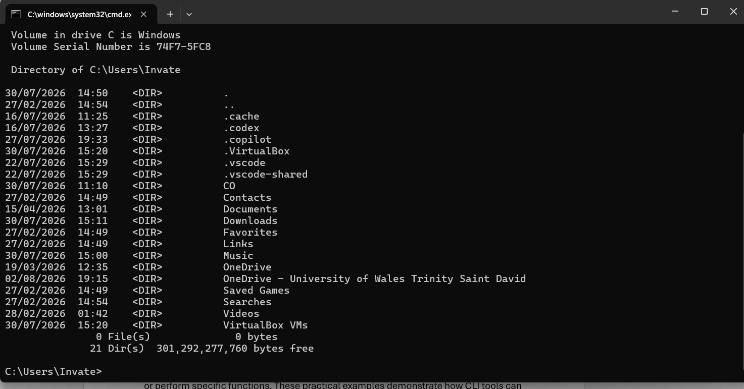

Figure: Output of the dir command in Windows Command prompt

Explanation: The dir command was used to display the contents of the current working directory. The screenshot shows the folders available in the C:\Users\Invate directory, including Documents, Downloads, Music and Videos. The command also displays information such as the date and time of the directories and the available free space.
This demonstrates how the Windows CLI can be used to inspect directory contents without using the graphical File Explorer

2. Command: Task list
Process Management – task list
The task list command is used to view the processes currently running on a Windows computer. It provides information about active applications and background processes, including their process ID (PID) and memory usage. This command is useful for monitoring system activity and identifying processes that may be affecting system performance.

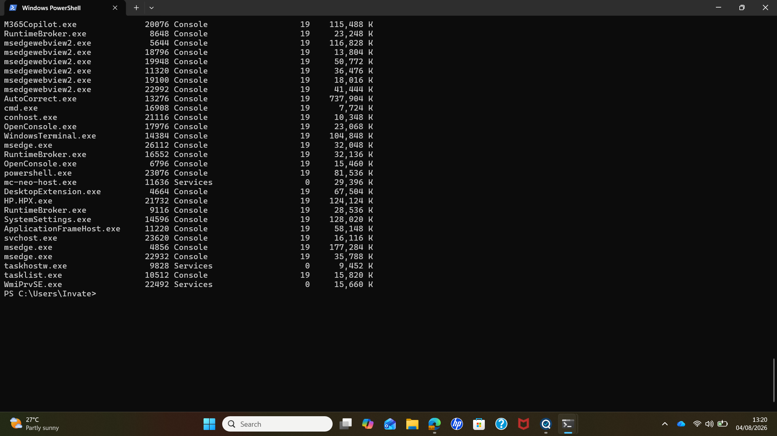

Figure: Output of the task list command in window power shell.

Explanation: The output shows the processes currently running on the Windows system. It includes information such as the process name, process ID (PID), session, and memory usage. This information can help a user or administrator monitor active processes and identify applications that may be using significant system resources.

3 Command: ping
Network Testing – ping
The ping command is used to test whether a computer can communicate with another device or server over a network. It sends test packets to the specified destination and displays the response time and whether the destination is reachable.

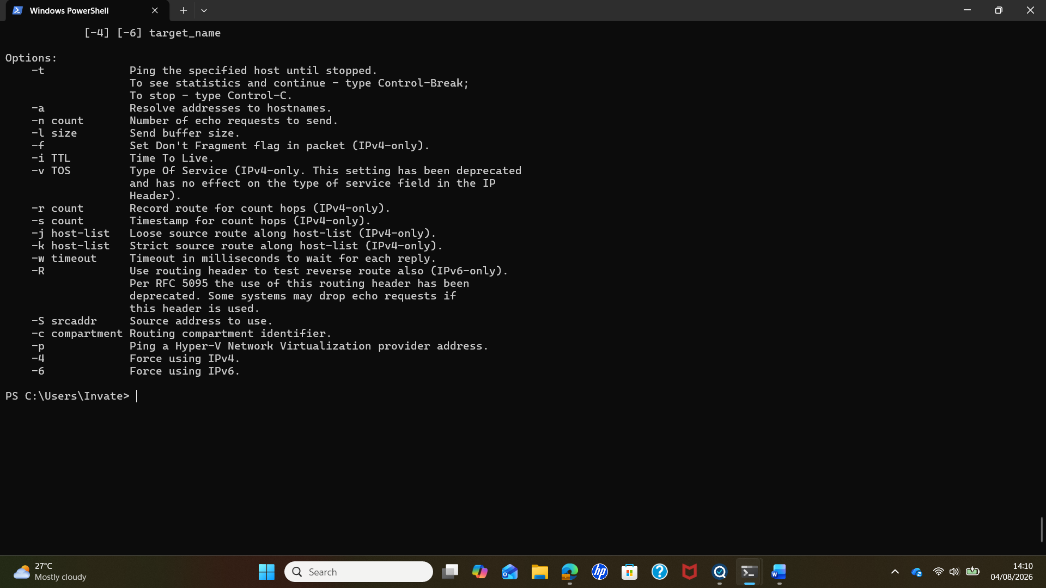
Figure : Output of the ping command window power shell.

Explanation
The ping command was used to test the network connection between the computer and the selected destination. The command sends test packets to the destination and displays the responses received, including the response time. A successful response indicates that the destination is reachable over the network.

4 Command: Net user
User Management – net user
The net user command is used to display the local user accounts available on a Windows computer. It is useful for viewing and managing user accounts through the command-line interface.
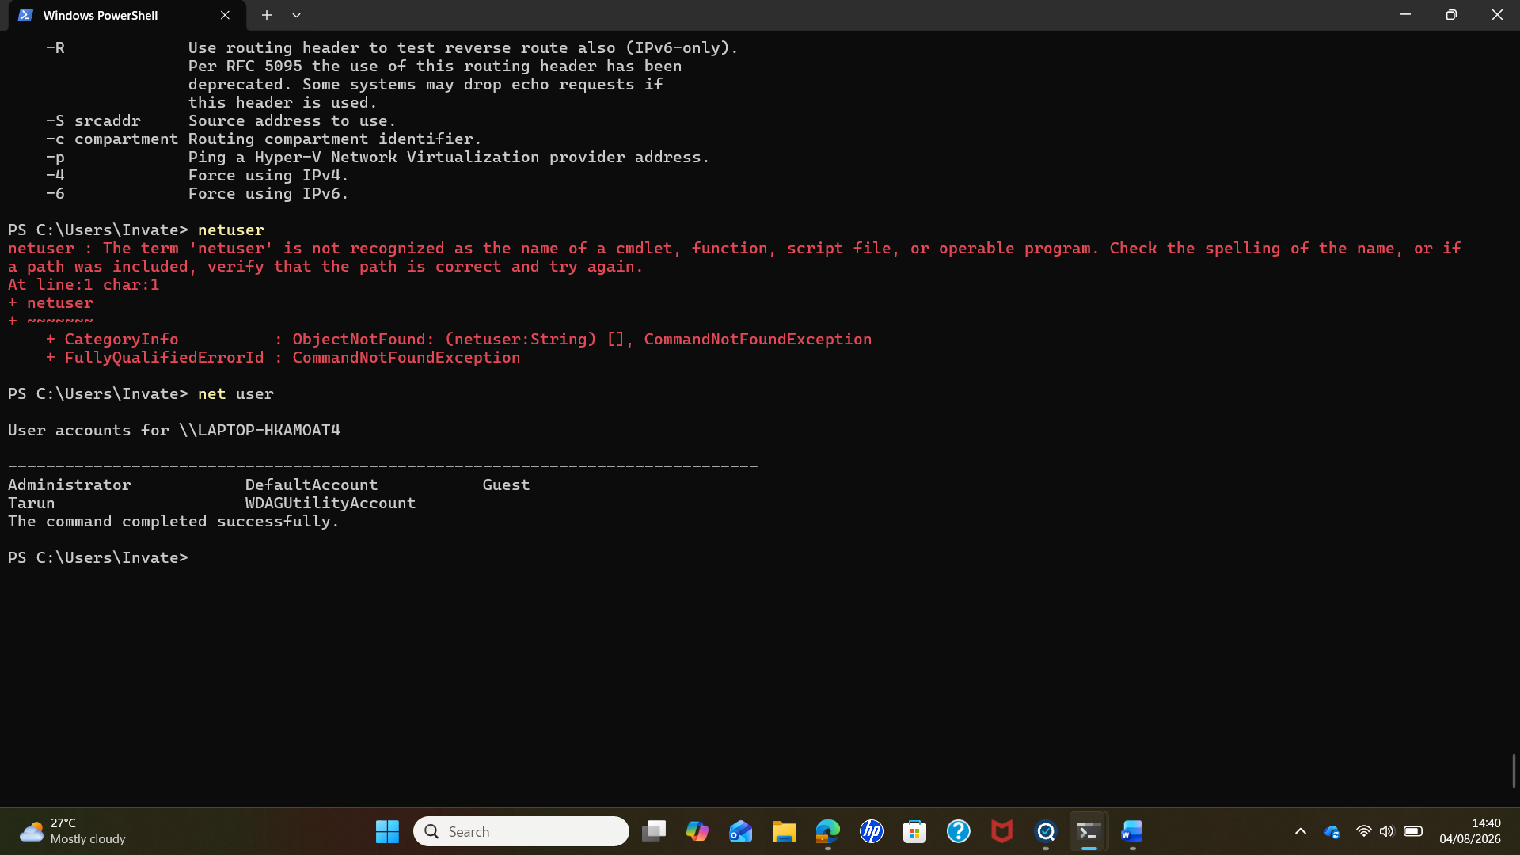
Figure: Output of the net user command window powershell
Explanation
The net user command was used to display the local user accounts configured on the Windows computer. The output provides a list of available user accounts, which can help an administrator identify and manage accounts through the command-line interface.

5 Command: Copy
File Management – copy
The copy command is used to make a duplicate of a file in Windows. It allows users to copy a file from one location to another or create a copy with a different file name.

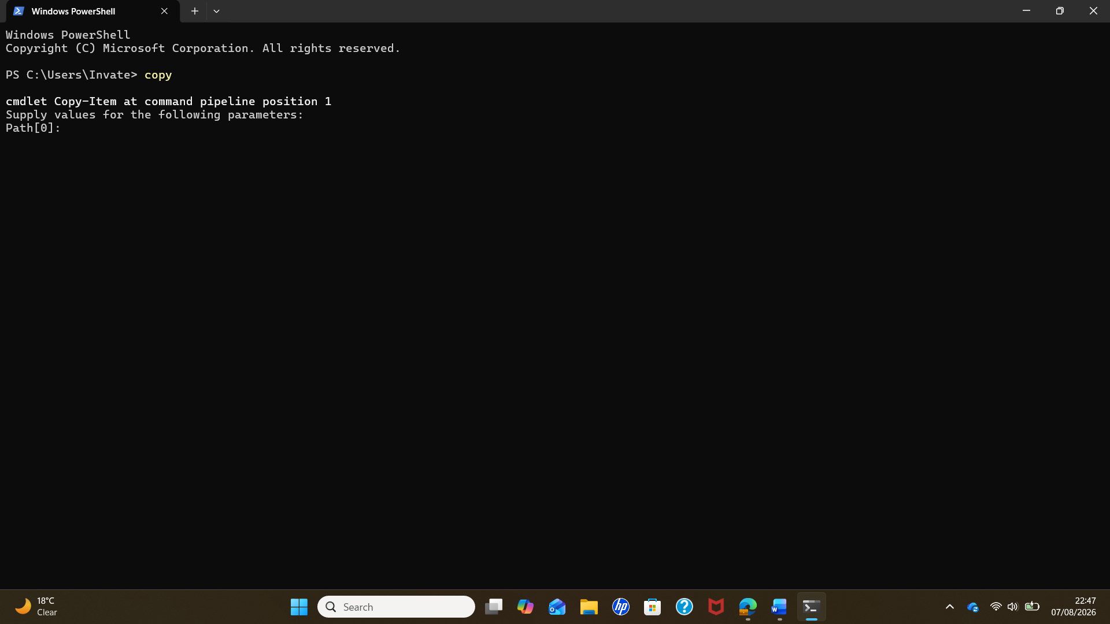

Figure: Output of the copy command window power shell.

Explanation
The copy command was used to create a duplicate of a file in another location or with a different file name. In PowerShell, copy can be used as an alias for the Copy-Item command. This makes it possible to manage and organise files directly through the command-line interface without using File Explorer.

6. Common: Taskkill
Process Management – taskkill
The taskkill command is used to terminate a running process on a Windows computer. It allows users or administrators to close a specific application or process by using its process name or process ID (PID).

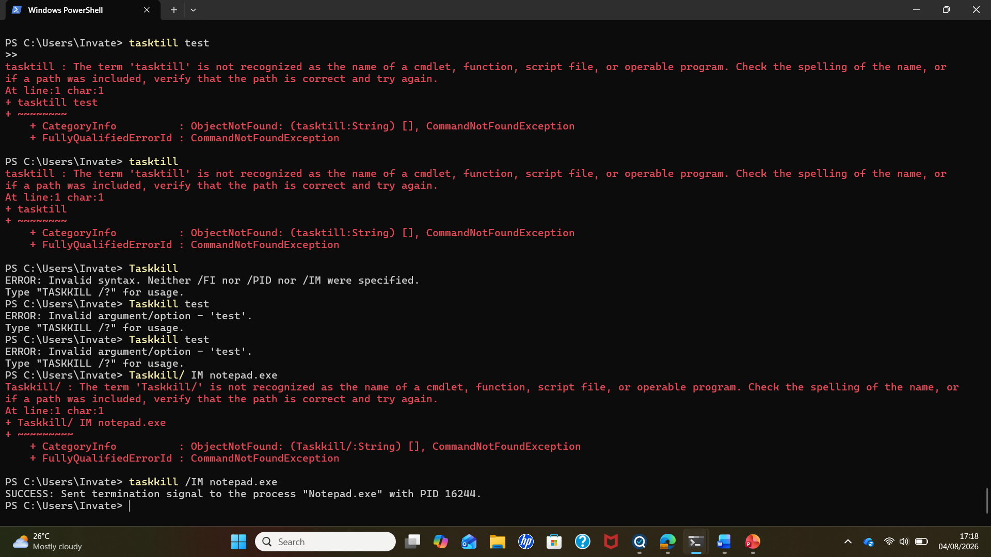
Figure: Output of taskkill command window power shell.
Explanation
The taskkill command was used to terminate the Notepad process. The /IM option specifies the process name, notepad.exe, allowing the application to be closed through PowerShell. This demonstrates how a running process can be managed using a Windows CLI command.
8 Command: Netstat ano
Network -Netstat ano
The netstat command is used to display active network connections and network statistics on a computer. It can also show listening ports and connection status. Additional options can be used with the command to display more detailed information. For example, netstat -ano displays active connections along with the IP addresses, ports, and Process IDs (PIDs).

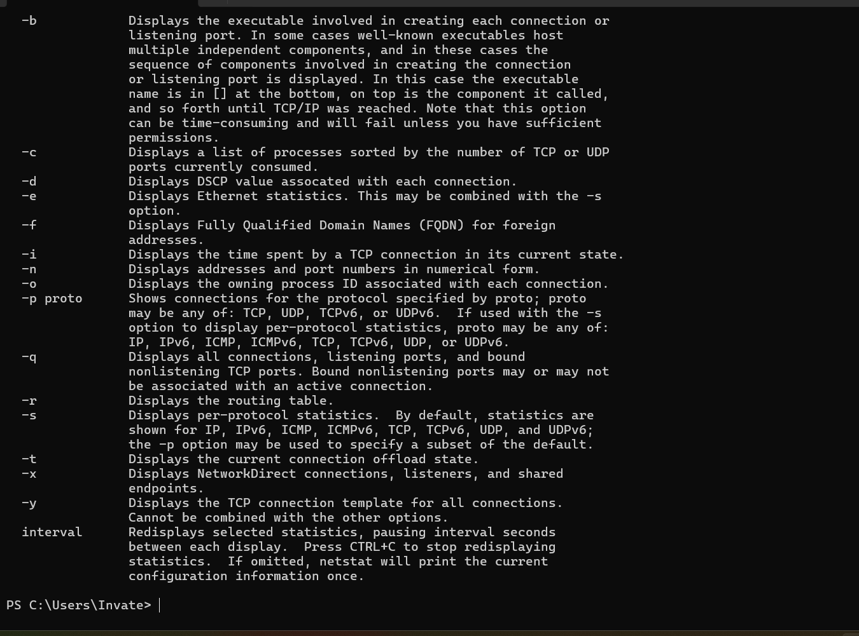

Figure : Output of netstat ano command window poershell.
Evaluation of windows CLI Commands
The practical use of Windows CLI commands demonstrates how command-line tools can efficiently manage operating system functions without relying only on graphical interfaces. Commands such as tasklist and task kill support process management, while ipconfig and netstat assist with network monitoring. File management commands such as dir, copy, and mkdir provide efficient methods for organising data. These tools are valuable for system administrators because they allow faster troubleshooting, automation, and control over Windows environments.

Task-3
Use of Linux OS CLI Commands
Linux provides a powerful command-line interface through the Bash shell, which allows users to interact directly with the operating system by entering commands. Bash (Bourne Again Shell) is widely used for system administration, automation, and troubleshooting tasks because it provides efficient control over files, processes, users, and network resources. This section demonstrates the practical use of Linux Bash commands covering process management, file and directory management, network testing and monitoring, user management, and task scheduling. Each command is executed in the Bash terminal and supported with screenshots showing the command and its output. The purpose of this section is to demonstrate how Linux command-line tools can be used to manage system resources and perform administrative tasks effectively.
Then start your first command:

1.Command: pwd
Category: File and Directory Management
Linux Bash environment (JDoodle platform)
JDoodle provides a command-line interface (CLI) window where you can execute Bash commands and view the output, similar to a Linux terminal.

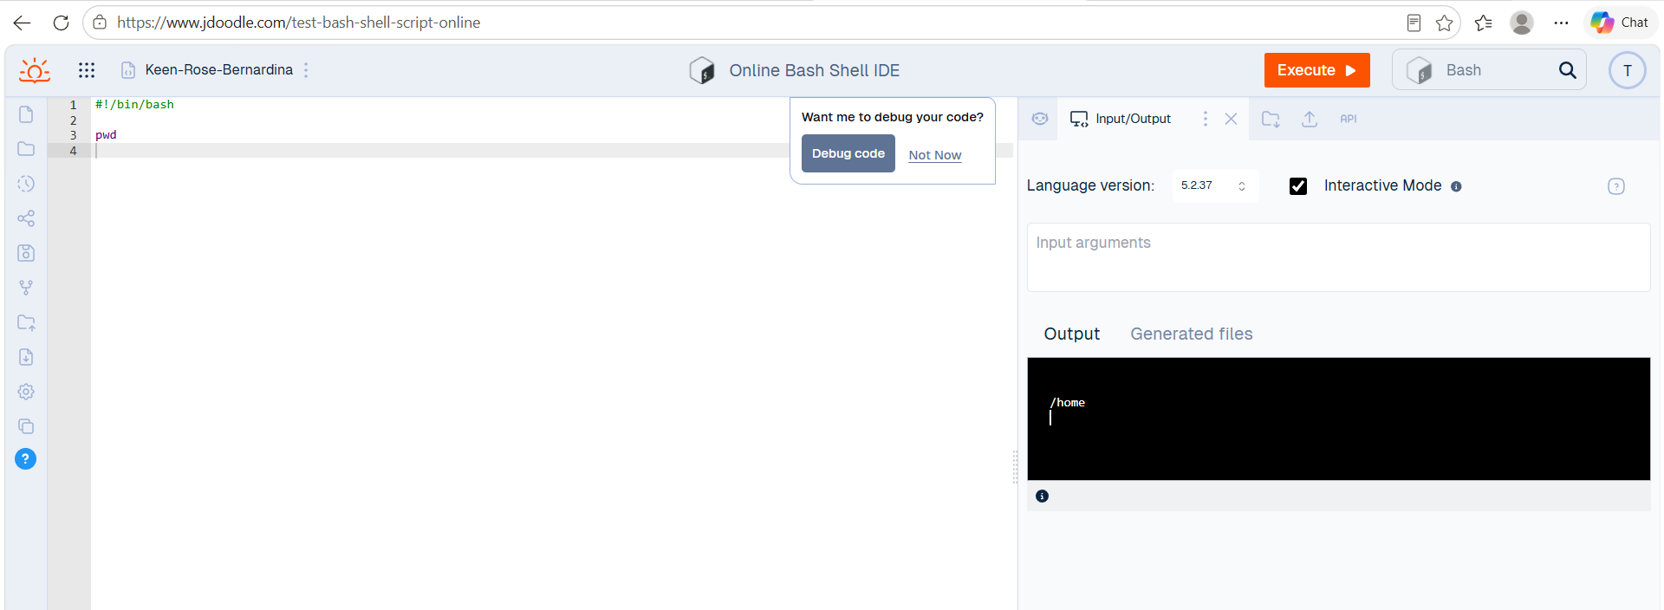

Figure: Output of the pwd command in the Linux Bash terminal using JDoodle platform.

Explanation
The command was executed in a Bash environment provided by the JDoodle platform. The output displays the current working directory path returned by the Linux shell.

2. Command: ls -la
Category: File and Directory Management
Linux Bash environment (JDoodle platform)
The following screenshot shows the execution of the ls -la command in the Linux Bash terminal using the JDoodle platform. The output displays detailed information about the files and directories available in the current working location, including hidden files and file permissions.

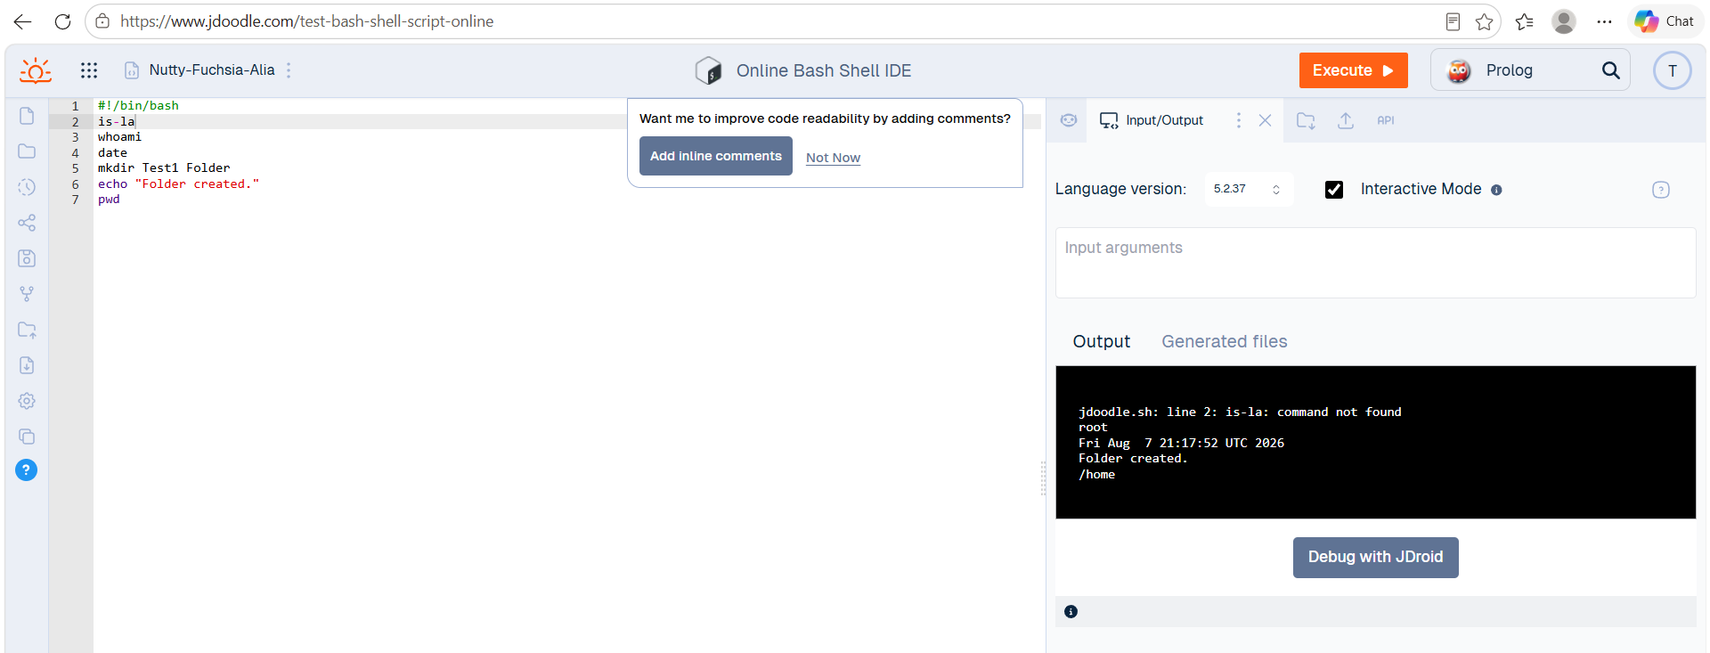

3.Command : mkdir
Category: File and directory managment
Linux Bash environment (JDoodle platform)
The following screenshot demonstrates the execution of the mkdir command in the Linux Bash environment using the JDoodle platform. The command creates a new directory named TestFolder, and the output confirms that the command was executed successfully.

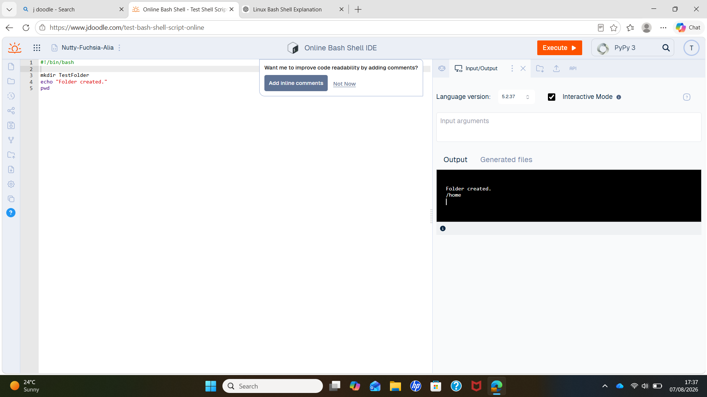

Figure: Output of the mkdir command in the Linux Bash environment using the JDoodle platform.

Explanation
The mkdir command was used to create a new directory named TestFolder in the current working directory. This command is commonly used in Linux to organise files by creating new folders through the Bash command-line interface. In this example, the echo command was included to display a confirmation message, while the pwd command displayed the current working directory where the folder was created.

5. Command: whoami
Category: user management
Linux Bash environment (JDoodle platform)

The following screenshot demonstrates the execution of the whoami command in the Linux Bash environment using the JDoodle platform. This command displays the username of the currently logged-in user. It is commonly used to verify the identity of the active user when performing system administration and user management tasks.

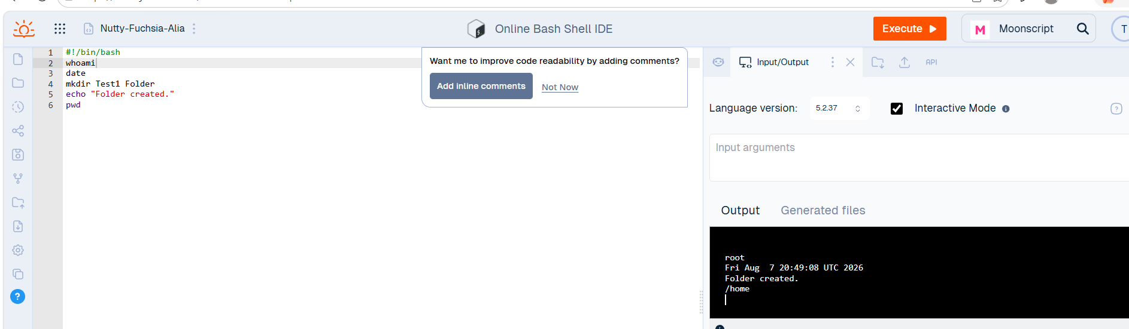

Figure: Output of the whoami command in the Linux Bash environment using the JDoodle platform

Explanation: The whoami command was used to display the username of the currently logged-in user. This command helps users confirm which account is currently being used to execute commands in the Bash shell. It is particularly useful for checking user identity before performing administrative or security-related tasks.

6 Commands: Ps
Category: Process Management
Linux Bash environment (JDoodle platform)
The following screenshot demonstrates the execution of the ps command in the Linux Bash environment using the JDoodle platform. The command is used to display information about processes currently running in the Bash session.
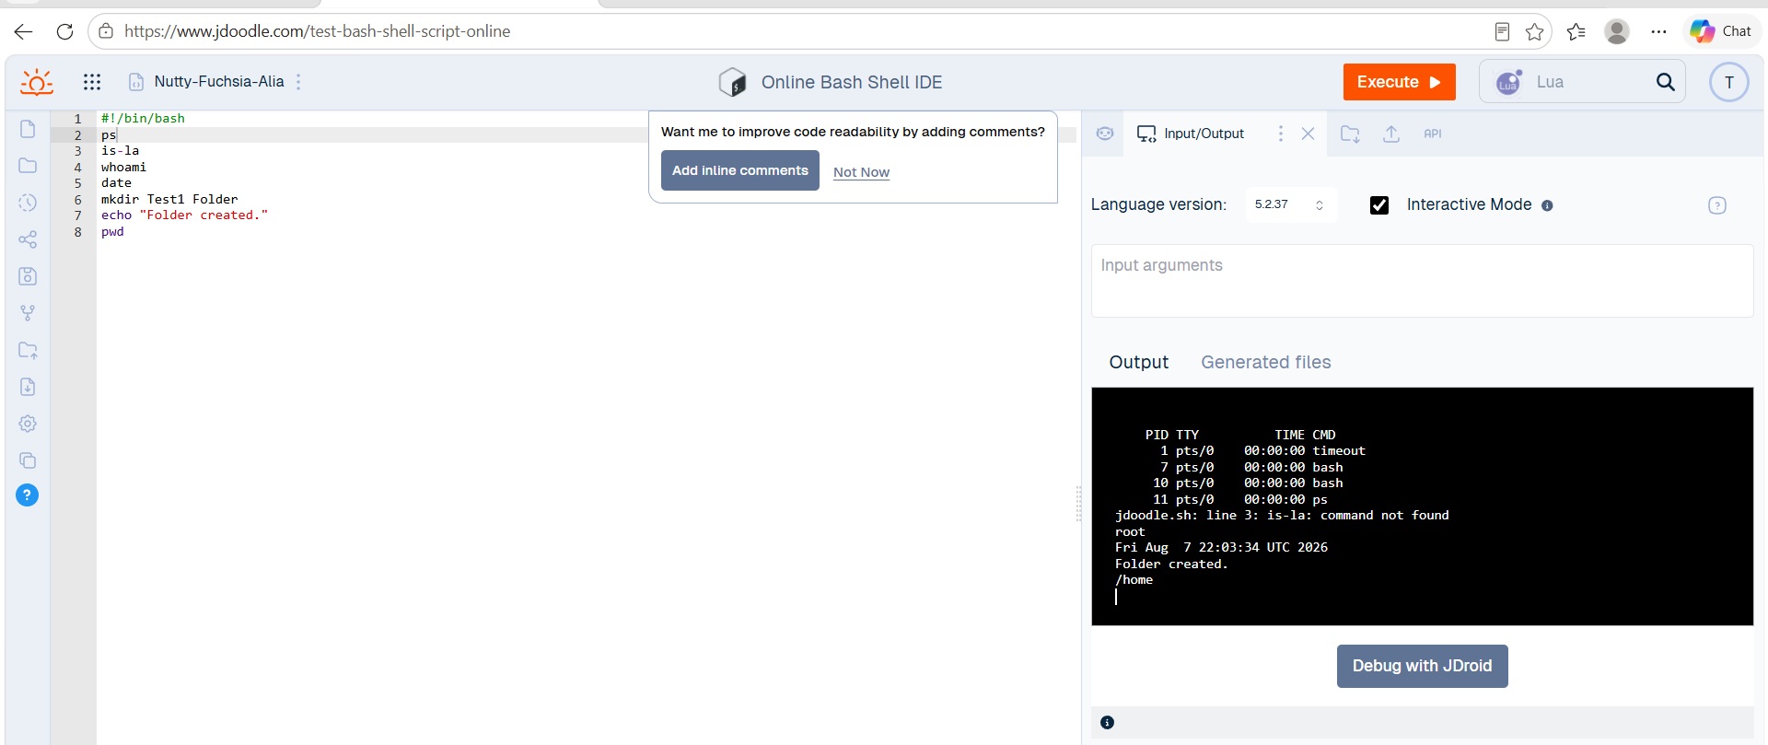

Figure 8: Output of the ps command in the Linux Bash environment using the JDoodle platform

Explanation:
The ps command was used to view the processes currently associated with the Linux shell. The output provides information such as the process ID (PID), terminal, CPU time, and command name. This command is useful for monitoring running processes and understanding how the Linux operating system manages processes.

7 Command: echo
Category: File and Directory / Basic Bash
Linux Bash environment (JDoodle platform
The following screenshot demonstrates the execution of the echo command in the Linux Bash environment using the JDoodle platform. The echo command is used to display text or messages in the terminal. It is also commonly used in Bash scripts to provide information to the user during program execution.

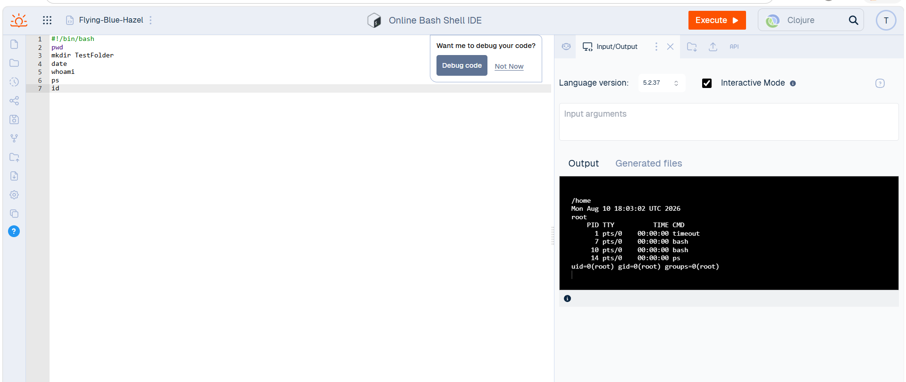

Figure 10: Output of the echo command in the Linux Bash environment using the JDoodle platform
Explanation
The echo command was used to display a text message in the Bash terminal. It demonstrates how Bash can provide output to the user and is commonly used when creating scripts, displaying messages, or showing the results of operations.

8.Command: Uptime
Category: system monitoring/system information
Linux Bash environment (JDoodle platform
The uptime command was used to check how long the Linux system has been running. It also displays the current system time, the amount of time the system has been active, the number of logged-in users, and the system load averages. This command is useful for monitoring system availability and checking the overall workload of the system.

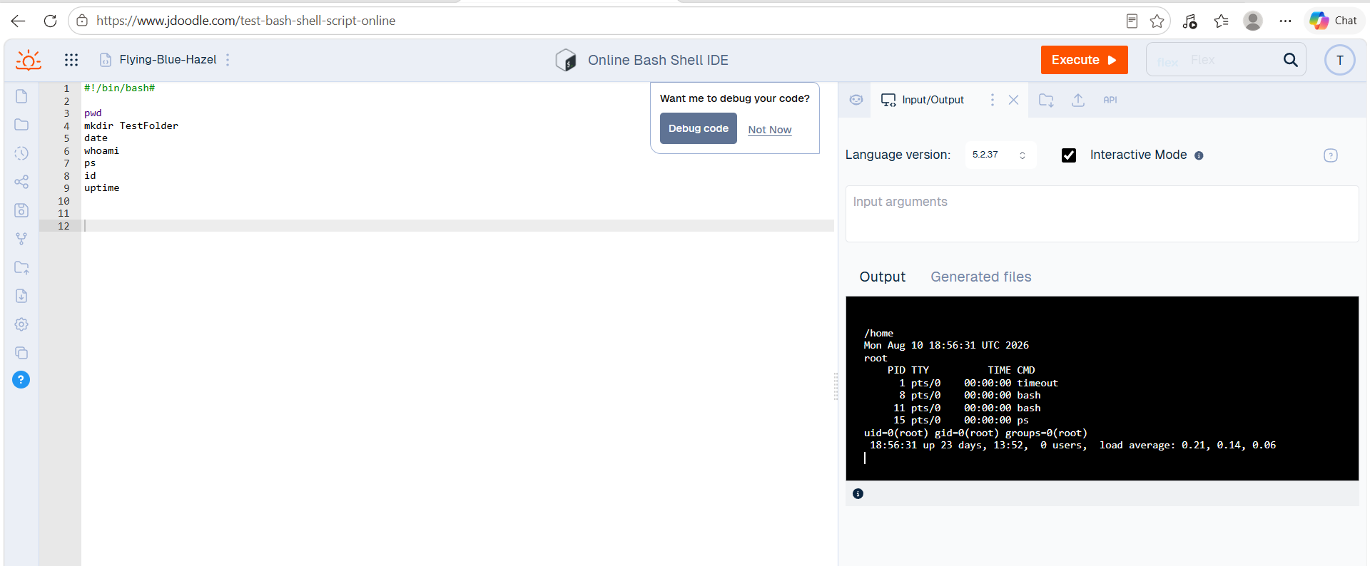

Figure 11: Output of the uptime command in the Linux Bash environment using the JDoodle platform

The output shows that the Linux system is currently running and provides information about its uptime and system load. The command confirms the amount of time the system has been active, along with the number of users currently logged in and the load averages. This demonstrates how the uptime command can be used to monitor the current status and activity of a Linux system.

9.Command: ip addr
Category: Network information
Linux Bash environment (JDoodle platform
The ip addr command was used to display information about the network interfaces available on the Linux system. It shows details such as the network interface names, IP addresses, MAC addresses, and the current status of each interface. This command is useful for checking and identifying the network configuration of a Linux system.

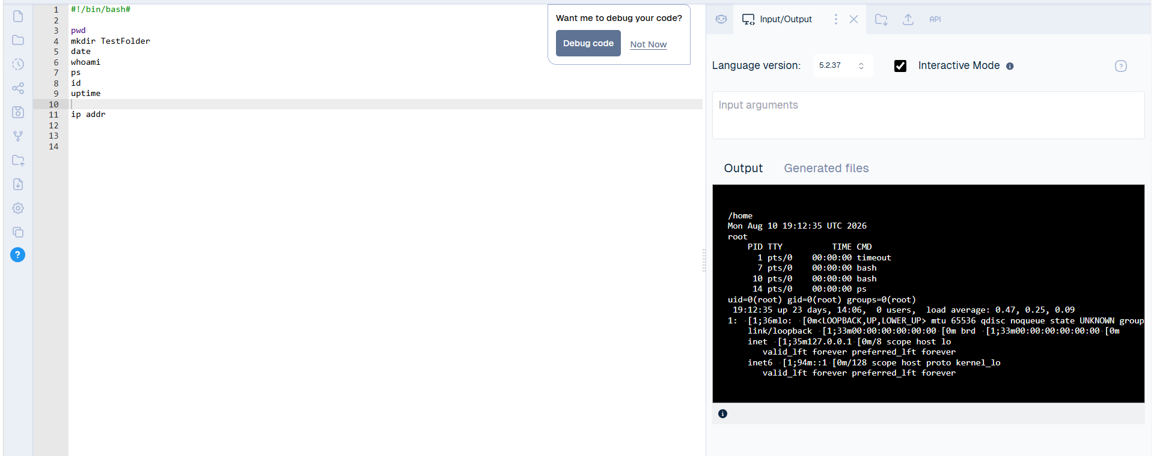

Figure: Output of the ip addr command in the Linux Bash environment using the JDoodle platform
The output shows the network interfaces configured on the Linux system, including their assigned IP addresses and interface status. The information can be used to identify the system's network configuration and determine whether the network interfaces are active. This demonstrates how the ip addr command can be used to inspect network connectivity and configuration.

11 Command: date
Category:
Linux Bash environment (JDoodle platform

The date command was used to display the current date and time of the Linux system. This command is useful for checking the system clock and confirming that the system is using the correct date and time.

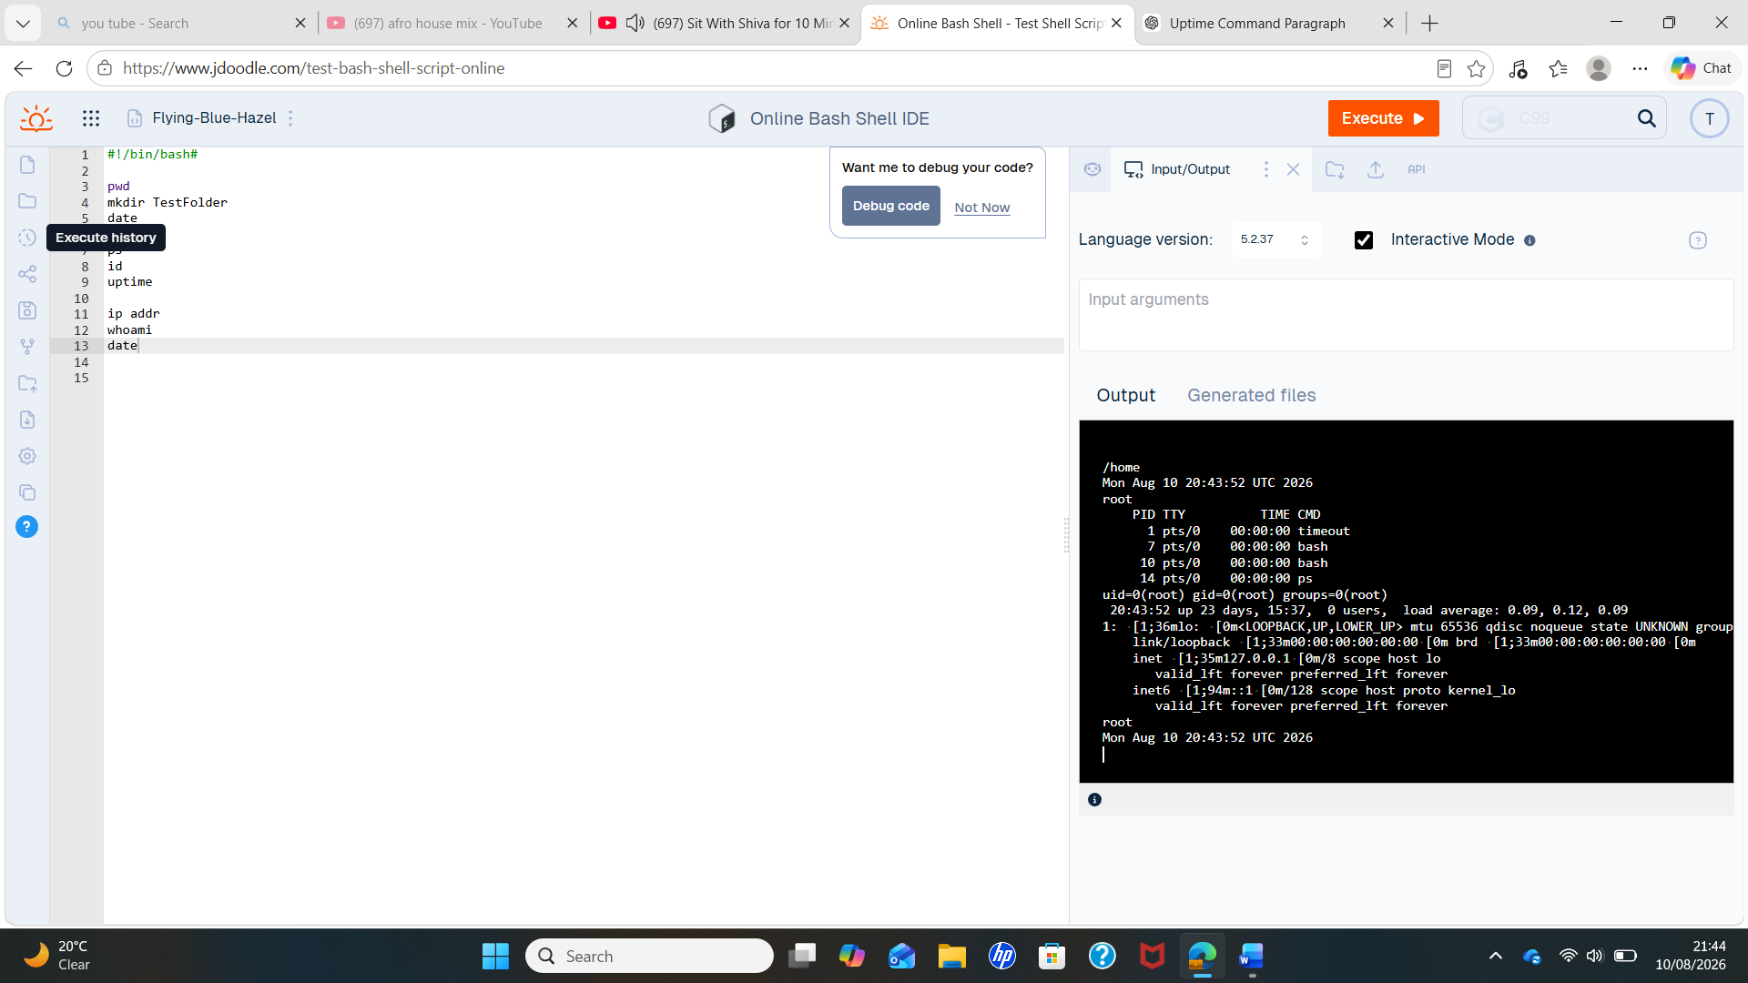
Figure: Output of the date command in the Linux Bash environment using the JDoodle platform .

The output shows the current date and time provided by the Linux system. This confirms that the date command successfully retrieved the system's current time information. The command can be useful when checking timestamps and monitoring system activities.

Task 4 – Windows Batch Scripting
This task demonstrates practical use of Windows batch scripting through the Command Prompt. Two batch scripts were created and tested to demonstrate the use of variables, numerical values, output commands and the combination of stored information. The practical work provides evidence of how batch scripting can be used to organise and display information efficiently. Testing the scripts also helped develop practical problem-solving skills by checking the commands, correcting errors and verifying that the expected output was produced.

Screenshot 1– Creating and Displaying Variables
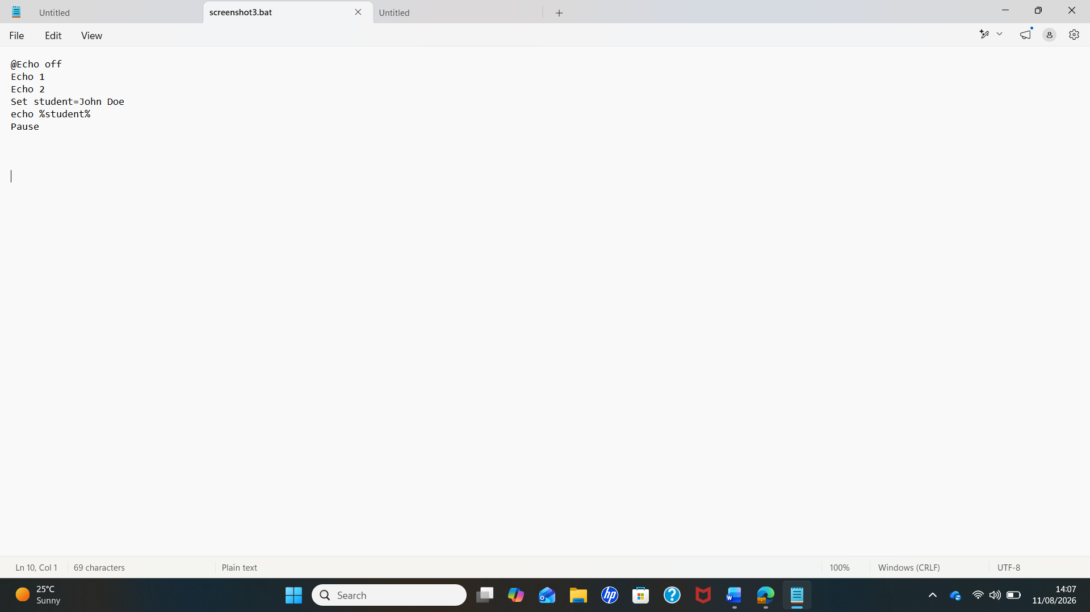

The first screenshot demonstrates the use of basic batch commands and variables. The @echo off command hides the commands while the script is running, allowing the output to be displayed clearly. The Echo commands display the numbers 1 and 2. The Set student=John Doe command creates a text variable, and %student% is used to retrieve and display its stored value. The Set /A age=25 command creates a numerical variable, which is then displayed using %age%. The Pause command keeps the Command Prompt window open so that the output can be viewed. This demonstrates how batch scripts can store, retrieve and display both text and numerical information.

Screenshot 2 – Combining Variables

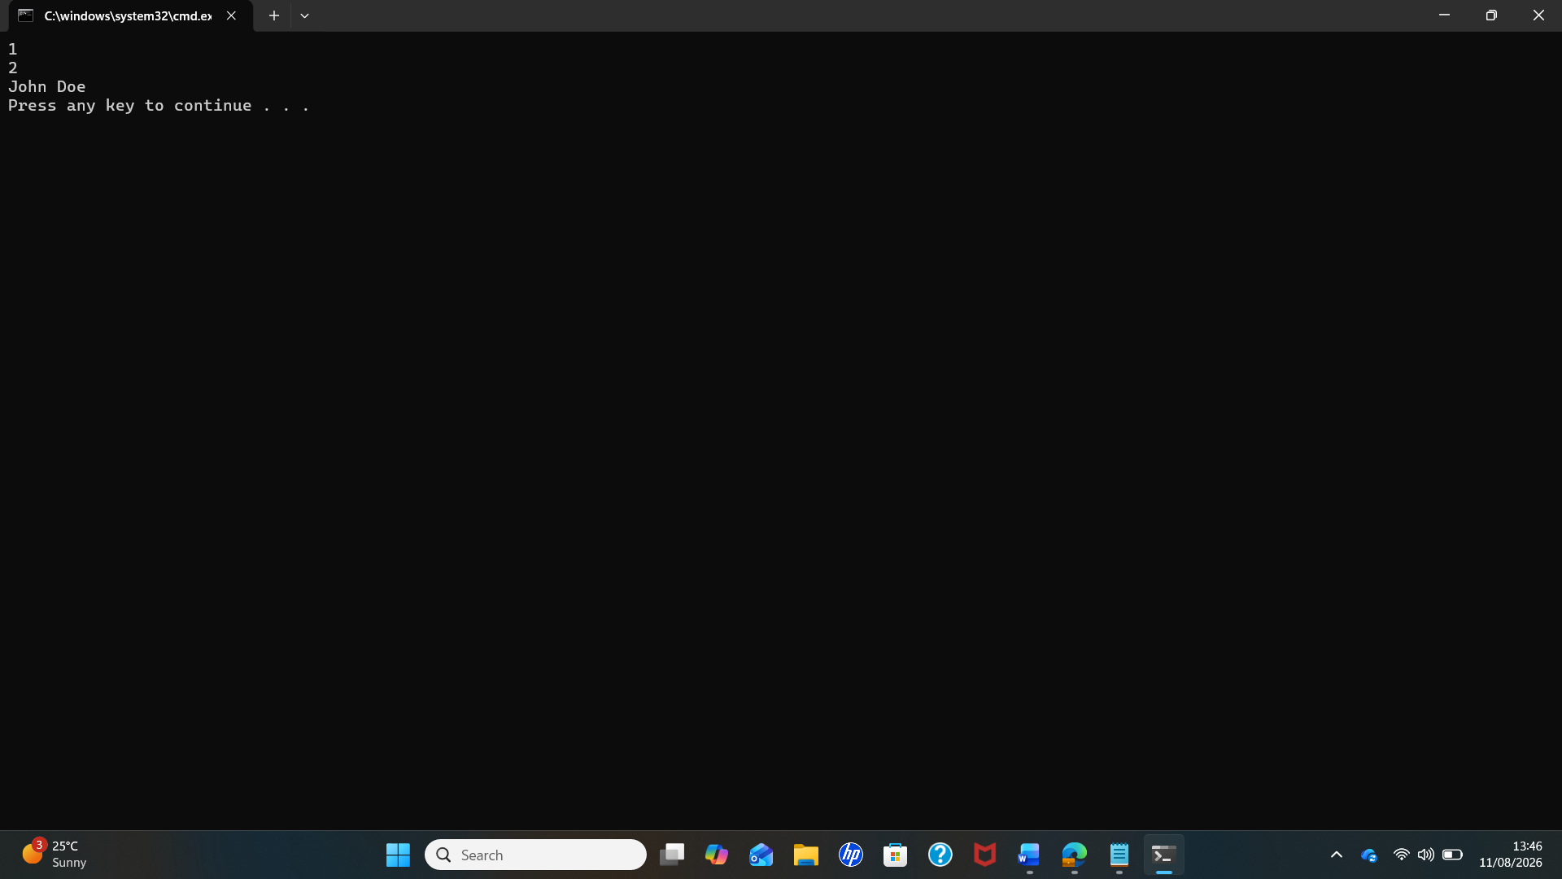

Screenshot 2 – Combining Variables
The second screenshot demonstrates how existing variables can be used together to create a more meaningful output. The name variable stores the value “john”, while the age variable stores the numerical value 21. These values are displayed using the echo command and are then incorporated into the info variable using %name% and %age%. When %info% is executed, the stored information is displayed as a complete message. This demonstrates how batch scripting can dynamically combine information and produce user-readable output.
Practical Skills Demonstrated
The practical activity demonstrates the ability to create, test and troubleshoot simple batch scripts independently. By running the scripts and checking the resulting output, I was able to verify that the commands and variables were functioning correctly. This activity developed my understanding of command-line scripting and strengthened transferable skills such as problem-solving, accuracy, attention to detail and independent working. The screenshots provide practical evidence of the completed work and support the explanations provided in this task.

5 Conditional statements
The first Bash script demonstrates the use of user input, variables and conditional control flow in a Linux environment. The read mark command allows the user to enter a mark, which is stored in the mark variable. The if statement checks whether the entered value is greater than or equal to 40 using the -ge comparison operator. If the condition is true, the script displays “Result: Pass”; otherwise, it displays “Result: Fail”. During testing, the value 65 was entered and the script correctly returned “Result: Pass”. This demonstrates how Bash can be used to automate decisions based on user-provided information.
Bash programme 1 — Conditional statements
Input: 65
Output: Result: Pass
Demonstrates:
- Variables
- User input
- Conditional (if/else)
- Comparison

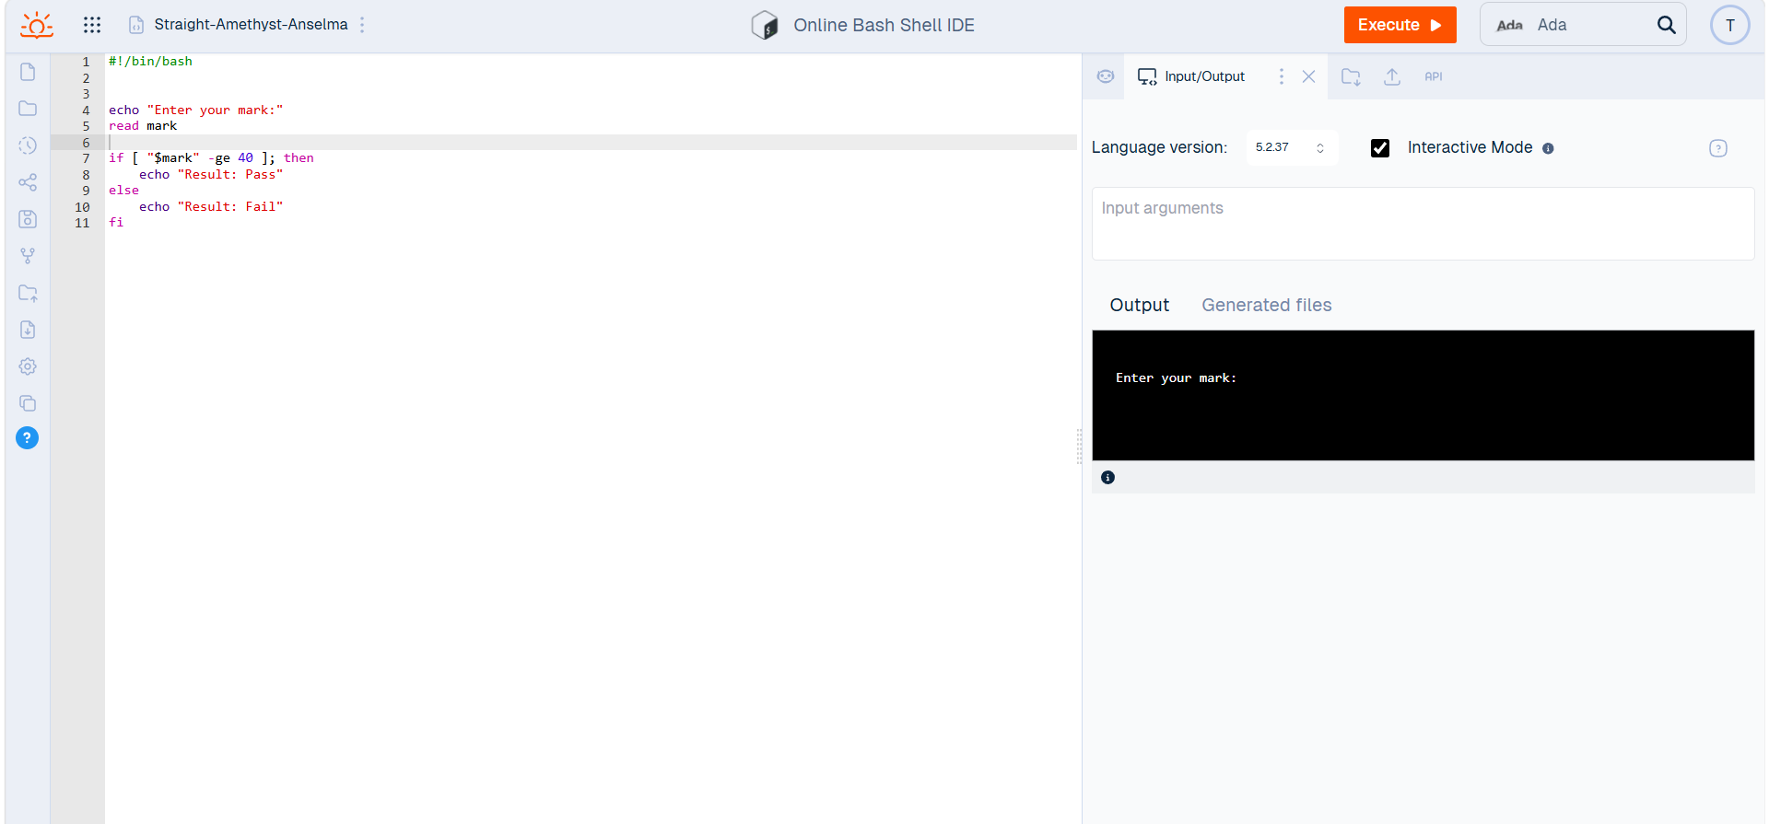

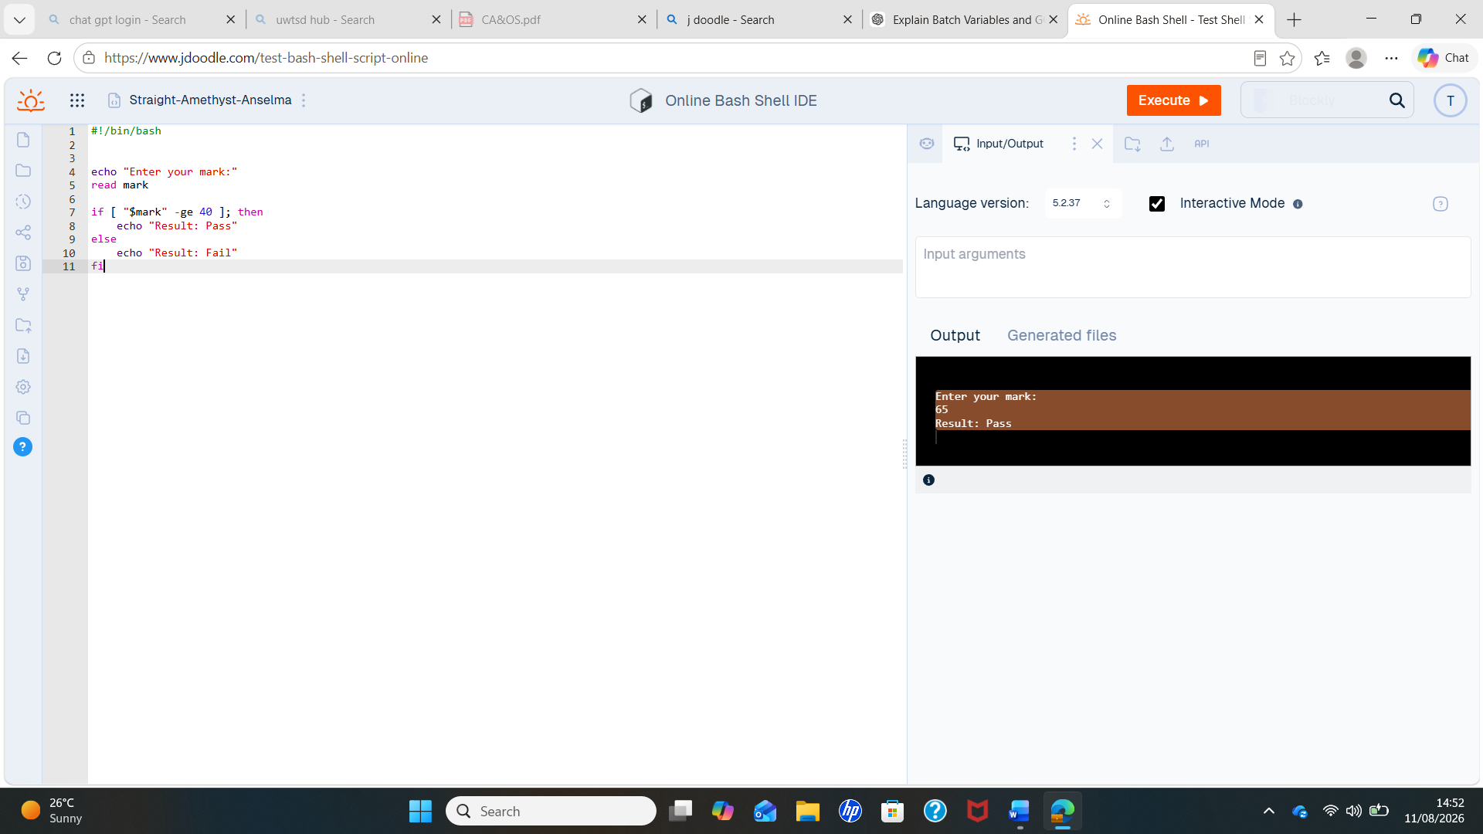

Figure : Bash conditional script and execution output

Bash programme 2
The second Bash script demonstrates the use of user input, variables, a for loop and arithmetic operations. The user enters a number, which is stored in the number variable. The for loop then repeats the calculation five times, while $((number * i)) performs the multiplication. When the value 5 was entered, the script automatically calculated and displayed the results from 5 × 1 to 5 × 5. This demonstrates how Bash scripting can automate repetitive calculations and reduce the need to perform each calculation manually.

Loop & Arithmetic
Input: 5
Output:
5 x 1 = 5
5 x 2 = 10
5 x 3 = 15
5 x 4 = 20
5 x 5 = 25
Demonstrates:
- Variables
- User input
- for loop
- Arithmetic operations
- Automated repeated calculations

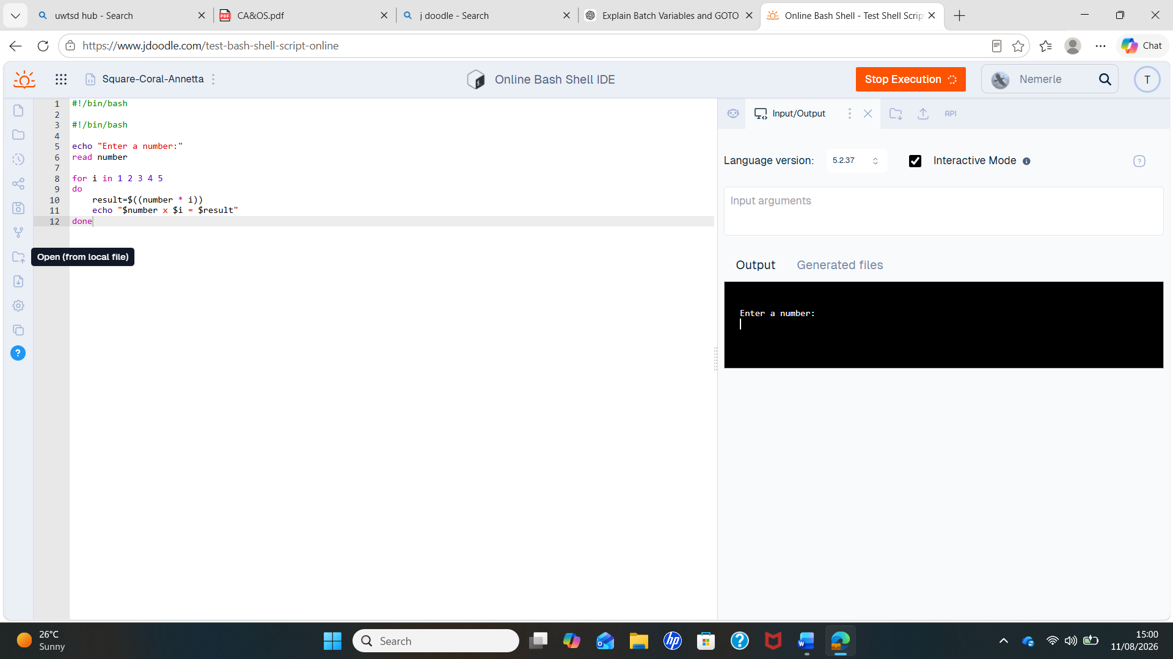

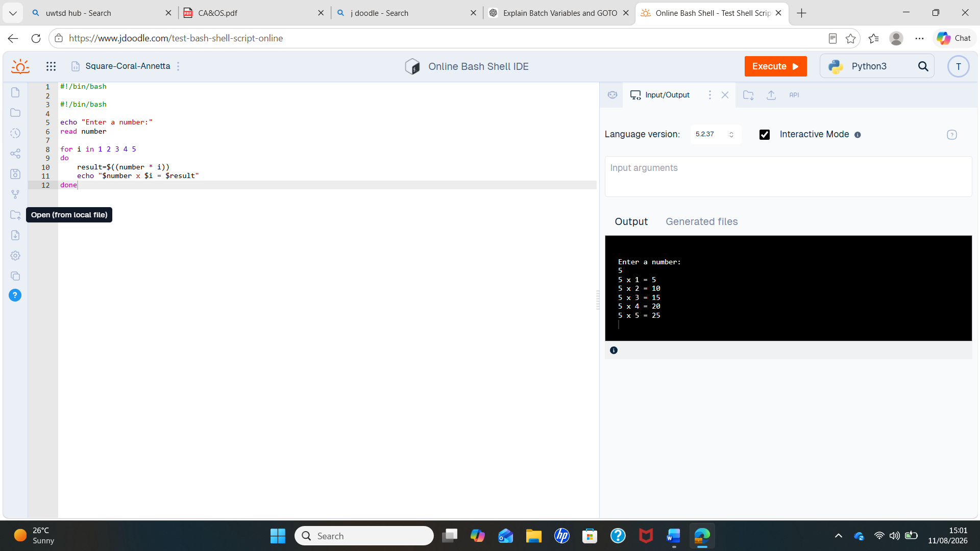

Figure : Bash script demonstrating a loop and arithmetic operations

Conclusion
This assessment provided practical experience of operating systems and their associated command-line interfaces. The practical activities demonstrated how operating systems manage resources and provide users with tools to interact with and control a computer system. Windows Command Prompt and Linux Bash were used to perform different tasks and demonstrate the practical application of operating system concepts.
The Windows batch activities demonstrated the use of commands, variables and basic control of program execution. The Linux Bash activities further developed these skills by using user input, variables, conditional statements, loops and arithmetic operations. Testing the programs and checking their outputs helped develop problem-solving, troubleshooting and attention-to-detail skills. The practical screenshots included in the report provide evidence of the work completed and the results obtained.
Overall, the assessment improved my confidence in using command-line interfaces and strengthened my ability to create, test and troubleshoot simple command-line programs. It also developed transferable skills including independent working, logical thinking, communication, organisation and accuracy. These skills are relevant to professional IT environments, particularly when carrying out system administration, troubleshooting and other tasks that require responsibility and effective use of operating system tools.

Appendix A: Tutorial Activity – OS Types
OS Tutorial 1: Operating System Types
An Operating System (OS) is system software that controls and manages a computer's hardware and software. It allows users to interact with the computer and provides services for applications. Examples of operating systems include Windows, Linux, macOS and Android.
Operating System Type | Description | Example
Batch Operating System | Processes a group of jobs together with little or no user interaction. | IBM OS/360
Time-Sharing Operating System | Allows several users or programs to use the computer system at the same time. | UNIX
Distributed Operating System | Manages several connected computers and makes them work together as one system. | Amoeba
Network Operating System | Manages computers on a network and allows users to share resources such as files and printers. | Windows Server
Real-Time Operating System | Processes information and responds to events within a specific time limit. | VxWorks

The difference between a Batch OS and a Time-Sharing OS
The main difference is how users interact with the system.
- A Batch Operating System processes jobs in groups without requiring continuous interaction from the user.
- A Time-Sharing Operating System allows multiple users or programs to interact with the system and share its resources at the same time.

Course Name: CERTHE Computing Skills for the Workplace
Short Reflection
Completing the online course helped me develop my knowledge beyond the classroom. It also improved my confidence in using online learning resources and encouraged me to continue developing my technical skills independently.
Short conclusion
This tutorial helped me understand different types of operating systems and how they are used. I also learned that operating systems can be designed for different purposes, such as processing batches of jobs, supporting multiple users, managing networks, or responding to events quickly.

References
[1] A. Silberschatz, P. B. Galvin, and G. Gagne, Operating System Concepts, 10th ed. Hoboken, NJ, USA: Wiley, 2018/2019. Wiley lists the 10th edition and its coverage includes OS functions, resource management, security, and distributed systems.
[2] A. S. Tanenbaum and H. Bos, Modern Operating Systems, 5th ed. Pearson, 2023. The book covers processes, memory management, file systems, I/O, and operating-system design.
[3] Microsoft, “tasklist,” Microsoft Learn. [Online]. Available: Microsoft tasklist documentation. [Accessed: Aug. 12, 2026].
[4] Free Software Foundation, “Bash Reference Manual,” GNU Project. [Online]. Available: GNU Bash Reference Manual. [Accessed: Aug. 12, 2026].
[5] M. Kerrisk, “Linux man-pages,” Linux man-pages project. [Online]. Available: Linux man-pages. [Accessed: Aug. 12, 2026].
[6] M. Kerrisk, “pwd(1) — Linux manual page,” Linux man-pages. [Online]. Available: pwd Linux manual page. [Accessed: Aug. 12, 2026].
An operating system manages hardware and software resources and provides services for applications [1].
For your Bash section:
Bash provides a command-line environment that supports variables, conditional statements and loops [4].
For Linux commands:
The pwd command displays the current working directory [6].
For Windows commands:
The tasklist command displays currently running processes on a computer [3].

References (IEEE examples)
You can include references similar to these in your report:
- [1] A. Silberschatz, P. B. Galvin and G. Gagne, Operating System Concepts, 10th ed. Hoboken, NJ: Wiley, 2018.
- [2] A. S. Tanenbaum and H. Bos, Modern Operating Systems, 5th ed. Pearson, 2022.
- [3] Microsoft, "Windows Documentation."
- [4] The Linux Documentation Project, "Linux Documentation."

