
learning in the digital era
BMPS4009 & BMPL4007

March 10, 2023
LACRAMIOARA SIMONA radu
2224697

CertHE Law and Legal Practice Level 4 Assessment
Level 4 assessment specification

Task 1: Preparing for Higher Education …………… pg.2
Task 2: Becoming a Digital Learner (mind map) ....... pg.4
Task 3: Video presentation ……………... ...……........ pg.6
Task 4: Reflection ………………………….………. pg.7
References ……………………………………........... pg.8

Task 1: Preparing for high education
In this task will be presented resources, tips how to prepare for higher education and Eisenhower’s Principle to prioritise tasks.
Preparing for higher education is a comprehensive process in terms of research for main subject to study, how to study, when and where. After all the research has been done and enrolment has been finalised the students consider having a plan how to achieve the best results with the studies, creating a study environment by minimising distraction, have access to equipment and tools useful to study and for further research (for example a laptop, a printer, books, library account, internet). When students choosing study space, they reflect and determine the best space because everything around can distract attention and minimise the ability to concentrate when using that space (Cottrell, 2013, p.10-34). Next step is to plan how to study and establish a routine to develop the study skills. To be efficient regular breaks must be included to allow them to rest spending too much time on a task minimise their performance. The key to a successful academic achievement is time management learning how to plan and prioritise workload (Cottrell, 2013, p.35-82). 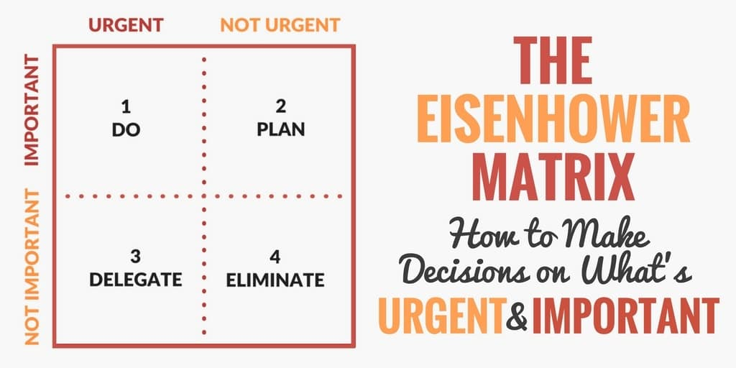
(Scott, 2018)
Eisenhower’s Principle help students to prioritise tasks in two main categories Urgent tasks and Important tasks (see the tab above). ‘When working on tasks is very important to identify areas for improvement on procrastination and ability to overcome procrastination (Scott, 2018). Overcoming perfectionism is also important, from mistakes we learn. Must need to be taken in consideration perfectionism is not a strength can be a weakness(media officer, 2021). In The Guardian, Donna Ferguson and Pragya Agarwal are suggesting a list with Dos and Don’ts based on lecturers of universities, tutors and doctors to be followed by everyone when started to study (Ferguson and Agarwal , 2017).
A very important tip when studying is students always to ask for help and advice to achieve best results with Higher Education.
Task 2: Mind map

This mind map will illustrate how I will become a Digital Learner and how this will contribute to prepare me to work in a law department.

Task 3: Video presentation

In this video I will describe my reflection how to become a Team player.

Task 4: Reflection
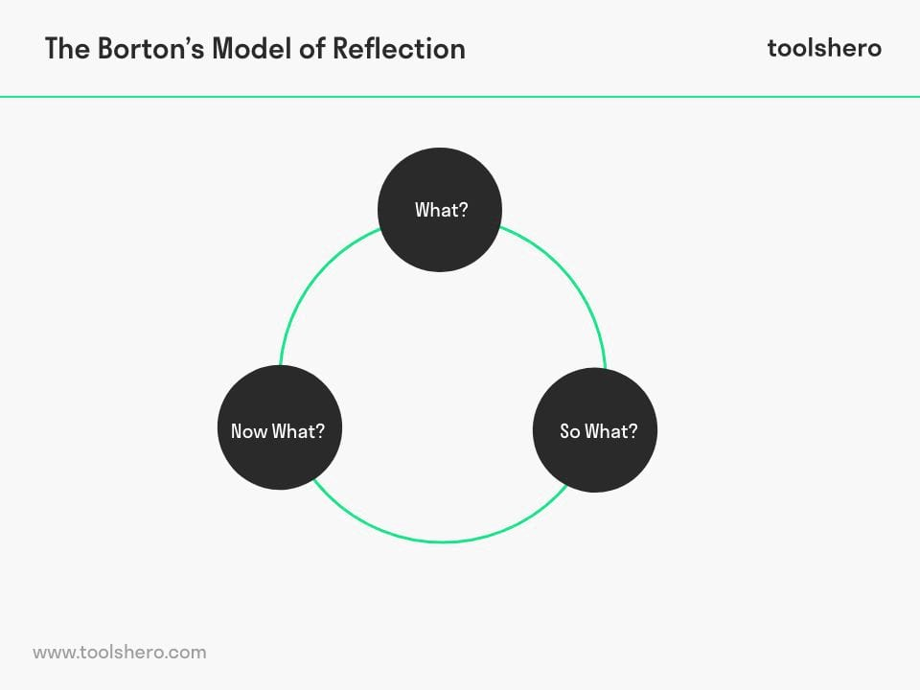 (Janse, 2022)
Starting university for me was a big step forward, lots of research about my options to study and work at the same time.
Following the Burton’s model of reflection to find What to study wasn’t difficult because I want to follow a dream that has been left behind for almost 20 years ago. What I will try to achieve is a Certificate in Higher Education and continue with my degrees in Law. In today’s days we have lots of online resources that will help me to process and write my first assignments. So, What I felt in the moment when all the enrolment has been finalised and I become very enthusiastic about it. Positive and negative aspects have come in way, but good changes happened in my life since then. Choosing to study laws brightened my ideas of life, culture, rights, and I am passionate about it. Now what may be the difficult to describe due to many potential barriers that I need to overcome such work life, family life and my personal and educational improvements I need to do. My working hours been reduced to allow time for classes and study and that has an impact on my family to due to reduce income and less time for home tasks. I need to do more efforts to ensure all my university work is done properly and on time, allow time for my online learning and resources. I identified areas for improvements on time management and communication with family members, colleagues at work, other students, and friends (Janse, 2022).
To be a student of higher education can be challenging especially for students on my age with family responsibilities and work commitment. In the other hand, to be a student is a beautiful experience to learn, develop and improve my skills and knowledges.

Reference list:
- Cottrell, S. (2013) The study skills handbook, ed 4th, UK: Macmillan Education

- Ferguson, D and Agarwal, P (2017) How to prepare for university: dos and don’ts. Available at: https://www.theguardian.com/education/2017/aug/29/how-prepare-for-university-tips-students (accessed: 25th February 2023).

- Gurler, G. (2019) John Locke's Theory of Personal Identity. Available at: https://www.researchgate.net/publication/339230681_John_Locke's_Theory_of_Personal_Identity (Accessed on: 7th March 2023)

- Janse, B. (2022) Borton’s Model of Reflection. illus 2. Available at: https://www.toolshero.com/personal-development/borton-model-of-reflection/ (Accessed on: 4th March 2023).

- Lencioni P.M (2020), Learn the key points in minutes. Summary of The Ideal Team Player- pdf. Available at: https://www.shortform.com/pdf/the-ideal-team-player-pdf-patrick-lencioni (accessed 4th March 2023).

- Media officer, (12 August 2021), What students need to know about transitioning into higher education. Available at: https://educationhub.blog.gov.uk/2021/08/12/what-students-need-to-know-about-transitioning-into-higher-education/ (Accessed on 1st March 2023)

- Perry, E. (2023), How to be a good team player: Tips for becoming the dreamy co-worker. Available at: https://www.betterup.com/blog/how-to-be-a-good-team-player#:~:text=10%20tips%20to%20be%20a%20good%20team%20player,...%208%208.%20Share%20information%20...%20More%20items (Accessed on: 6th March 2023)

- Rabontu, C. I and Babucea, A. G (2022) DIGITAL ERA – NEW FACETS OF THE SERVICES. Annals of the „Constantin Brâncuşi” University of Târgu Jiu, Economy Series, Issue 4/2022. Available at: https://www.utgjiu.ro/revista/ec/pdf/2022-04/11_Rabontu.pdf (accessed on: 27th February 2023)

- Scott, S.J, (15 November 2018) The Eisenhower Matrix: Make Urgent vs. Important Decisions with 4 Quadrants. illus 1. Available at: https://www.developgoodhabits.com/eisenhower-matrix/ (Accessed on: 12 February 2023).

- Vignoles, V. L., Chryssochoou, X., & Breakwell, G. M. (2000). Personality and Social Psychology Review. The distinctiveness principle: identity, meaning, and the bounds of cultural relativity. Available at: https://doi.org/10.1207/S15327957PSPR0404_4 (Accessed on: 7th March 2023)

