ROUTING & PACKET FILTERING WITHIN CORE TCP/IP SERVICES & CRITICAL FAILOVER/REDUNDANCY PRACTICES
Network Operating Systems and Services
Kai Hakkeem Bentley - Jennings
1807048@student.uwtsd.ac.uk

- Table of Contents
2 Introduction 2
3 Main Body 3
3.1 Practical Work Conducted 3
4 Conclusion & Appendices 17
4.1 Conclusion 17
5 Bibliography 18

Introduction

Worksheet 4 for this assignment requires adding Remote Access Services to the network, TCP/IP Services and the filtering of IP packets for both inbound & outbound.
Oracle VirtualBox will be used to further set up the already existing virtual machines from the previous worksheets. Because of limited resources, it may not be fully possible to carry out packet filtering with all 4 machines running parallel.

Main Body

Practical Work Conducted
On Server 1, an ARP-A check is carried out to check what IPs are currently mapped. Below contains the address of Client 1.
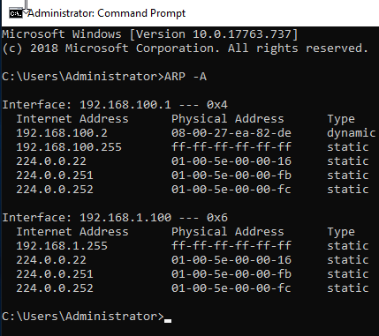
Figure 1: Initial ARP-A Check

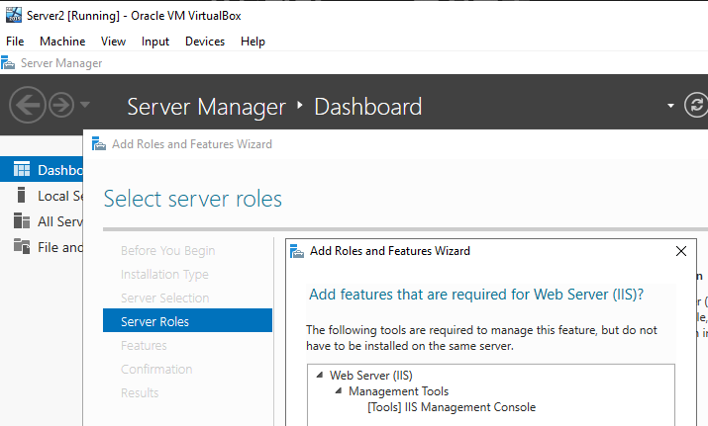
Figure 2: Adding IIS Role to Server 2
Figure 2 – 4 show the process of setting up a Web Server Role, as well as incorporating FTP Service to use later in the tasks.
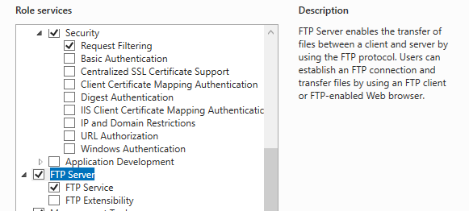
Figure 3: Enabling FTP Server
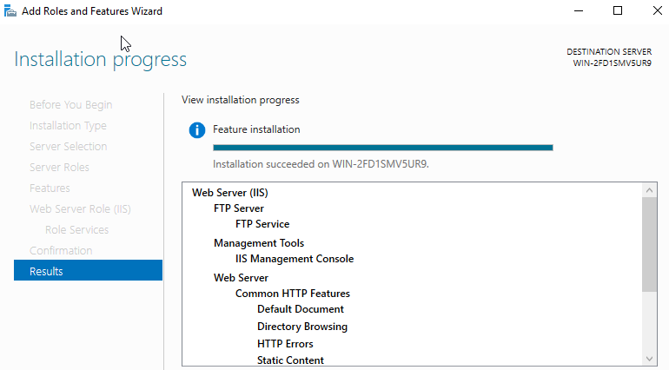
Figure 4: Installation of Web Server Complete
With the Role installed, a new user created in Server Tools will be used to upload a file through the FTP Service. This user is called ‘ftpuser’.
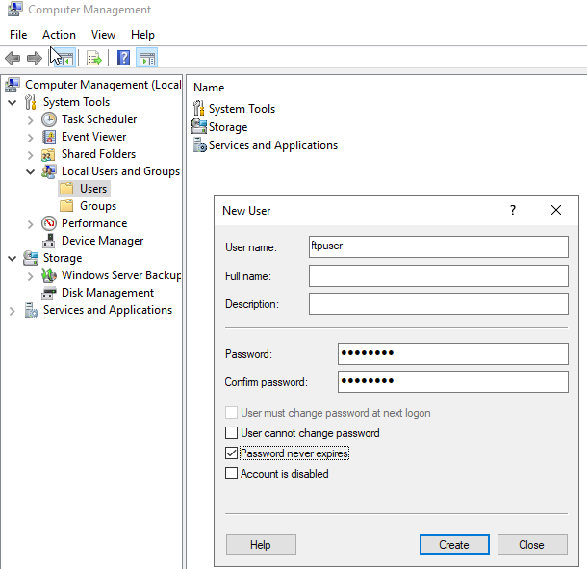
Figure 5: Creating Test User for FTP
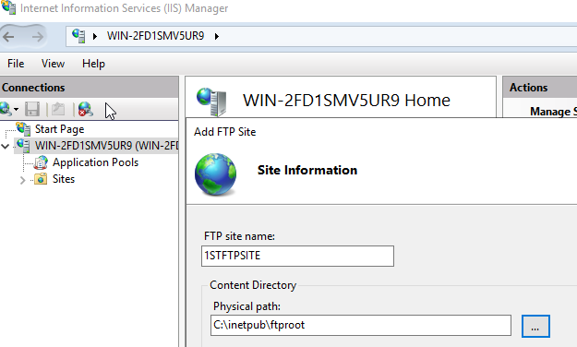
Figure 6: Creating FTP Site
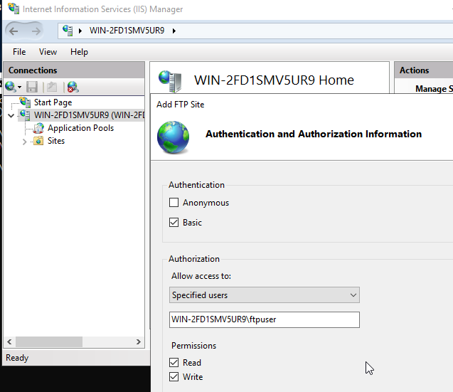
Figure 7: Authentication & Specified User Added
In Figure 6 & 7 a FTP Site is now being configured for use, selecting the root for the service and setting up Authorized users along with basic authentication. Read & Write are also enabled. The ‘ftpuser’ has also been given permissions to the root of the service as seen in figure 9. ‘Ftpuploads’ was also created within the root structure.
Figure 8 a FTP banner is set to display a message upon connecting through CMD later in the task.
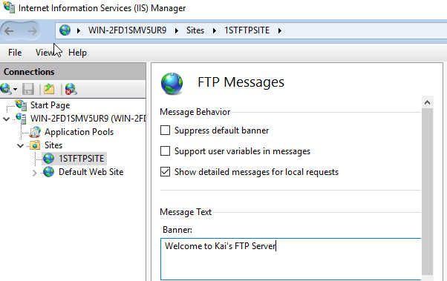
Figure 8: Applying a Banner for FTP Site
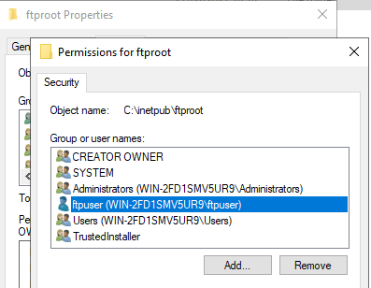
Figure 9: FTP User has been added to Permissions
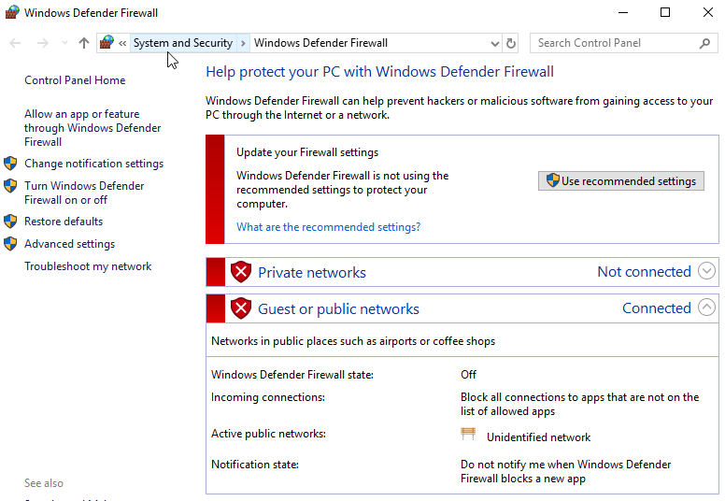
Figure 10: Confirming Firewall has been Disabled
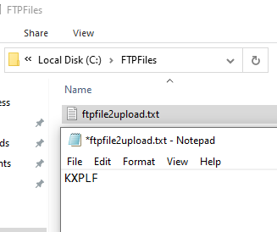
Figure 11: Creating FTP Folder & File on Client
The Firewall as depicted in Figure 10 is a precautionary measure in the event that uploading files to the FTP Server goes awry. The Firewall is also disabled on the Client Machines and a new folder and file are created on Client 2, ready for upload to the Server (Figure 11). The Upload worked as intended and appeared on the Server in Figure 12.
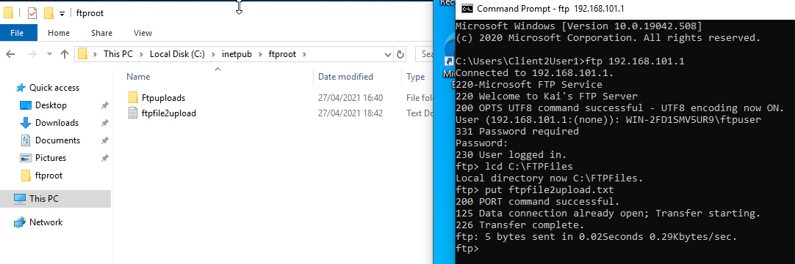
Figure 12: FTP File uploaded successfully
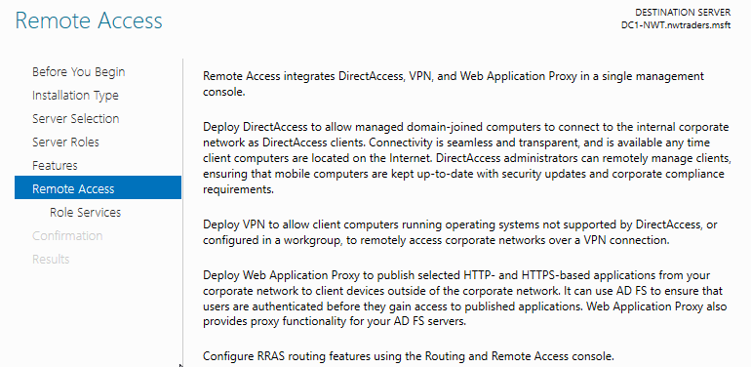
Figure 13: Setting up Remote Access on Server 1
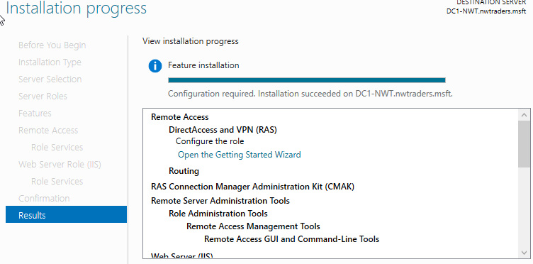
Figure 14: Installation of Remote Access Complete
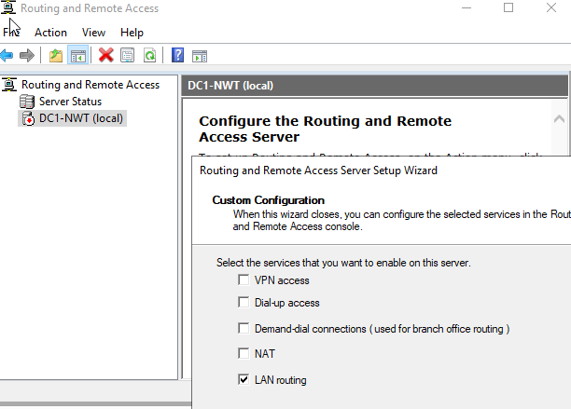
Figure 15: Remote Access Wizard Installer
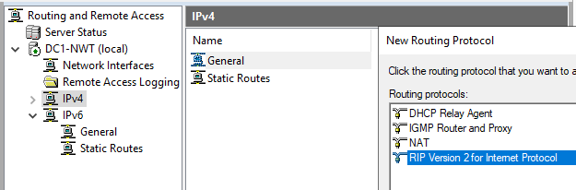
Figure 16: Service Enabled & Setting RIP V2
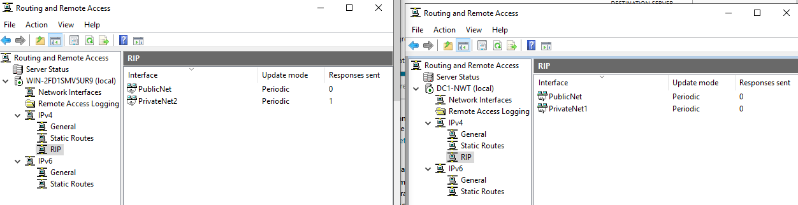
Figure 17: Both Servers have their Respective Interfaces Added
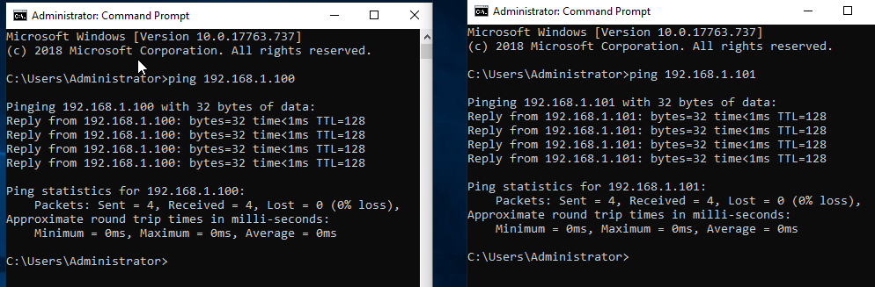
Figure 18: Left; Server 2 Pinging. Right; Server 1 Pinging
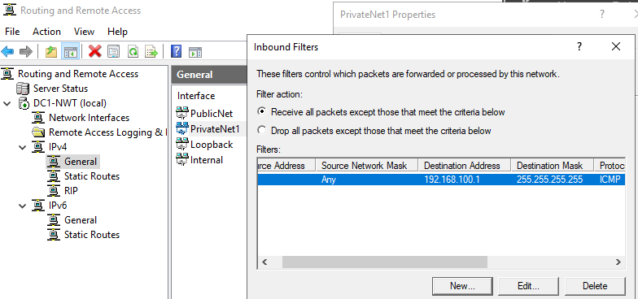
Figure 19: Inbound Filter for Server 1
Figure 13 – 19 displays the process of configuring Remote Access Services deployed as VPN only with LAN Routing. The Routing Protocols are configured for each Server using RIP V2. Both Servers are able to ping each other just fine, whilst the Clients do not receive a reply on trying to ping their Routers.
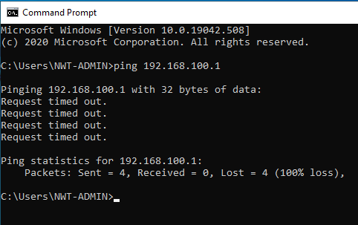
Figure 20: Client 1 Ping Failure to Server 1
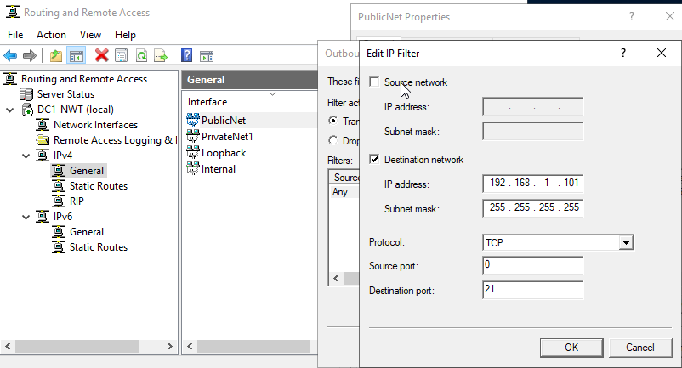
Figure 21: New Outbound Filter
Unfortunately, Wide Area Network Connectivity was not possible to carry out. This is due to the machines aborting on launch when there were 2 machines already active. This is likely due to a lack of resources – namely RAM – and as such unable to confirm Clients pinging one another.

Conclusion & Appendices

Conclusion
In conclusion, the practical part was for the most part completed. However, because of limited resources it wasn’t possible to double check ping connections with all 4 Virtual Machines active.

Bibliography

