Amanda Cazassa Saldanha - 2331032
2331032@student.uwtsd.ac.uk
Lecturer:
Dr Laila Maazouz
Individual Report
Strategic Management for Business -LCLM6001 BA LEADERSHIP AND MANAGEMENT SKILLS FOR THE WORKPLACE



1. Executive Summary

This report is prepared to examine VodafoneThree's strategic position after the 2025 forecast merger of Three UK and Vodafone UK and to suggest a growth direction. The analysis used is the PESTEL framework analysis, Porter’s Five Forces framework analysis, and SWOT analysis to analyse the external environment, industry pressures and internal capabilities. Results suggest that VodafoneThree has the scale, a bigger customer base, spectrum assets, and an investment programme of £11bn for the network. However, intense competition, regulatory obligations, customer price sensitivity and merger-integration risks remain challenges. As per the Ansoff Matrix, product development is considered an appropriate strategy with emphasis on 5G Standalone, IoT, AI-enabled, cloud and cyber security services. The SFA framework validates this choice as it is feasible and acceptable with ongoing integration and investments on course. The stakeholder analysis and the implementation plan focus on customer value, employee capability, innovation and regulatory compliance. Overall, execution and KPI-based monitoring can translate merger synergies to sustainable competitive advantage and long-term profitability.

Table of Contents
1. Executive Summary 1
2. Introduction to Vodafone 3
2.1 Company Background 3
2.2 Vision, Mission, and Core Values 3
2.3 Report Purpose 3
3. Evaluation of Current Market Situation 4
3.1 External Environment Analysis 4
3.2 Industry Analysis 5
3.3 Internal Analysis 6
4. Strategic Growth Options and Proposed Strategy 7
4.1 Ansoff Matrix 7
4.2 Recommended Strategy: Product Development 9
5. Strategy Evaluation 9
6. Stakeholder Analysis 11
7. Implementation and Monitoring 15
7.1 Implementation Plan 15
7.2 Monitoring and Performance Evaluation 16
8. Conclusion 16
References 17
Appendices 21
Appendix 1: Summary of SFA 21

2. Introduction to Vodafone

2.1 Company Background

Vodafone Group Plc is recognised as one of the leading telecommunications companies in the world, offering fixed connectivity, mobile, IoT (Internet of Things), broadband, digital services, and cloud solutions. The company is a leading African and European telecommunications company that is transforming the way of life of its customers through its technology, products, and platforms (Vodafone, 2025b). Furthermore, the company has decreased their net debt to £19.13 billion (€22.4 billion) from £28.35 billion (€33.2 billion) (Rudolph, 2025). The company has also launched a share buyback of about £1.71 billion (€2 billion) and maintained a dividend of 3.8 British pence (4.5-euro cents) (Rudolph, 2025). Moreover, according to Vodafone (2025c), VodafoneThree is known as the only operator within the UK with a fully funded and regulated network to reach 99.95% of the population with 5 G standalone coverage by the year 2034.

2.2 Vision, Mission, and Core Values

The vision of Vodafone is to develop a digital society which includes everyone and also helps in protecting the whole planet (Vodafone, 2023). The mission of the company is to connect everyone with fixed and innovative mobile connectivity (Vodafone, 2025a). Lastly, according to Vodafone (2023), the core values of the company include their provision of superfast technology and connectivity to unlock the potential of the UK while connecting businesses, people, and communities.

2.3 Report Purpose

The main purpose of this report is to identify the current strategic position of VodafoneThree in the UK telecommunications industry and successfully recommend a proper growth strategy which may support the competitive advantages. The report evaluates both internal and external business environments, along with the growth options and also assesses stakeholder implications to facilitate a successful execution of the strategy.

3. Evaluation of Current Market Situation

3.1 External Environment Analysis

PESTEL Factor | Data-centred Analysis and Strategic Implication
Political | The CMA had to approve the merger under conditions, including commitments to the combined network plan, to place limits on selected tariffs for three years, and to set fixed wholesale tariffs for virtual operators (CMA, 2024), were presented. At the same time, the £1 billion Shared Rural Network also achieved 95% geographic 4G coverage in 2025 (GOV.UK, 2025).
Economic | The CPI inflation rate for the United Kingdom was 2.8% in April 2026, and GDP grew 0.7% in the three months to April despite a 0.1% month-to-month decline (ONS, 2026). Thin margins among price-sensitive customers and costly infrastructure. Yet, with £11 billion invested and synergies of £700 million per annum by year five, VodafoneThree’s ability to scale is bolstered (Vodafone, 2025).
Social | In 2025, mobile data traffic in the UK had reached over 1.2 billion GB per month, growing by 18% year-on-year, with 5G usage growing by 53% (Ofcom, 2025). The need for streaming services, remote working and reliable digital solutions fuels growth.
Technological | In January 2026, Ofcom (2026) reported that 5G Standalone coverage outside premises ranged from 49% to 85% among operators providing the service. VodafoneThree’s integration already enables 28.6 million customers to use the strongest available network and has removed 16,500 km² of not-spots (Vodafone, 2026). This facilitates differentiation via 5G, IoT and automation, but risks of integration and cybersecurity do exist.
Environmental | Vodafone supplied 100% of electricity consumed to the network using renewable electricity, purchased from the grid, and 100% of waste in the network was reused or recycled in FY25 (Vodafone, 2025a). However, rising data traffic drives up energy use.
Legal | Since 17 January 2025, Ofcom has banned inflation-linked (or percentage) increases as clauses in new contracts and has mandated that price increases are set out in the contract clearly and in pounds and pence (Ofcom, 2024). A base level of protection is also required under UK product-security regulations for connected devices (GOV.UK, 2025). Violations may lead to fines, loss of customers, and a loss of reputation.
Table 1: PESTEL Analysis
(Source: Self-Made)

3.2 Industry Analysis
Competitive Force | Impact Level | Critical Analysis
Threat of New Entrants | Low | Entry in the nationwide network requires a lack of licensed spectrum, infrastructure, regulatory approvals and a considerable amount of capital infusion (CMA, 2024a). VodafoneThree alone is pledging £11 billion in ten years (Vodafone, 2025). MVNOs like Tesco Mobile, Sky Mobile, and Lebara have a lower entry cost and continue to rely on the wholesale access provided by already existing network owners (Mordor Intelligence, 2025).
Bargaining Power of Buyers | High | There were 91.1 million mobile subscriptions active in the UK in Q4 2025, with only £13.24 in average monthly revenue per line, on which the MVNO would have to pay a share to the mobile operator (Ofcom, 2026a). Customers can text to request a PAC, enhance price sensitivity and reduce loyalty (Ofcom, 2023).
Bargaining Power of Suppliers | Medium | VodafoneThree relied on a small number of specialist vendors for its multibillion-pound network programme, specifically Ericsson and Nokia (Vodafone, 2025b). However, its buying on such a scale, long-term contracts and the spreading of deployment work across various partners help to offset supplier leverage.
Threat of Substitutes | Medium | Internet-based communication overtaking existing communication services; like in the UK, mobile messages saw a decline of 26.5% YoY in Q4 2025, whilst mobile data volumes grew by 15.2% (Ofcom, 2026a). Some mobile usage is replaced by Wi-Fi, full-fibre broadband and satellite services; however, it could not be replaced entirely due to mobility and nationwide availability (Ofcom, 2025).
Industry Rivalry | High | The merger sees VodafoneThree continue to face the largest bid competition from BT/EE and Virgin Media O2, and several MVNOs increase competition in the retail price market (CMA, 2024b). The CMA (2024) discussed the risk of price increases, so they set caps and wholesale protection.
Table 2: Porter’s Five Forces Analysis
(Source: Self-Made)

3.3 Internal Analysis
SWOT Factor | Data-centred Critical Analysis
Strengths | The merger created a business serving approximately 28.6 million mobile customers. Network integration has already removed 16,500 km² of not-spots, and some 50 million users can see the fastest 5G services (Vodafone, 2026). UK adjusted EBITDAaL increased by 4.5% in FY26, while Vodafone's customer base improved to the leading position in terms of NPS and in fixed broadband, there were 222K net additions (Vodafone, 2026a). These features enhance network differentiation and customer reach and add to cross-selling opportunities.
Weaknesses | However, UK organic service revenue grew only 0.3% in FY26 as Three customer attrition and planned low-value business disconnections outweighed the growth (Vodafone, 2026a). Operating expenditure increased due to inflation and deployment of the network.
Opportunities | Vodafone's network programme with investments of £11 billion has committed to 99% population coverage of 5G Standalone by 2030 and 99.96% by 2034 (Vodafone, 2026b). This infrastructure can be monetised by VodafoneThree via IoT, private networks, smart-city apps, AI-based services and fixed-wireless access. It has a full fibre footprint of 21.8 million premises, and offers converged mobile and broadband packages (Vodafone, 2025c).
Threats | BT/EE, Virgin Media and low-cost MVNOs are price and service competitive (CMA, 2024). In addition, VodafoneThree must tie off a potential rural network plan within eight years, limit certain tariffs for three years, and defend wholesale providers, the CMA (2024b) stipulates. Deflections of integration, cyber-attacks, vendor reliance and no vendors can raise costs result in penalties and erode trust.
Table 3: SWOT Analysis
(Source: Self-Made)

4. Strategic Growth Options and Proposed Strategy

4.1 Ansoff Matrix

There are four business growth strategies, as shown by the Ansoff Matrix. All options have varying measures of risk and opportunity (Zugay and Zakaria, 2023). The matrix will enable VodafoneThree to choose the most appropriate strategy.
Market penetration focuses on maximising sales in existing markets using existing products. VodafoneThree has an opportunity to enhance its customer retention and competitive pricing, and to develop and expand its bundled mobile and broadband services. The lowest risk is this strategy as it utilises available resources. The telecommunications market in the UK is, however, very saturated. Competition with BT/EE and Virgin Media O2 is great and restricts further development (Evens and Donders, 2018).
Market development aims at selling the current products to new markets or customer groups. VodafoneThree can increase business services, enhance rural network coverage, and provide more international digital services. This is a strategy that offers medium growth prospects. It, however, needs to be invested in and has regulatory as well as competition risks. There are also the possibilities of slower growth.
Product development entails providing new products to the current customers. VodafoneThree will be able to create superior 5G services, Internet of Things (IoT) services, artificial intelligence services, cybersecurity services, and smart city services (Koppolu, 2021). Capacity and technology capabilities of the network have been boosted by the recent merger. This forms an ardent foundation of innovation. Another requirement being fulfilled by the strategy is the changing customer needs and the ability to undergo a long-term digital transformation.
Diversification paves the way to new products in new markets (Oladimeji, 2019). It will have the greatest growth opportunity, but greatest risk too. VodafoneThree might get into financial technology, healthcare technology, or digital entertainment. Nevertheless, this approach needs new skills, considerable investments, and increased complexity of operations as these markets are not in its core operations.
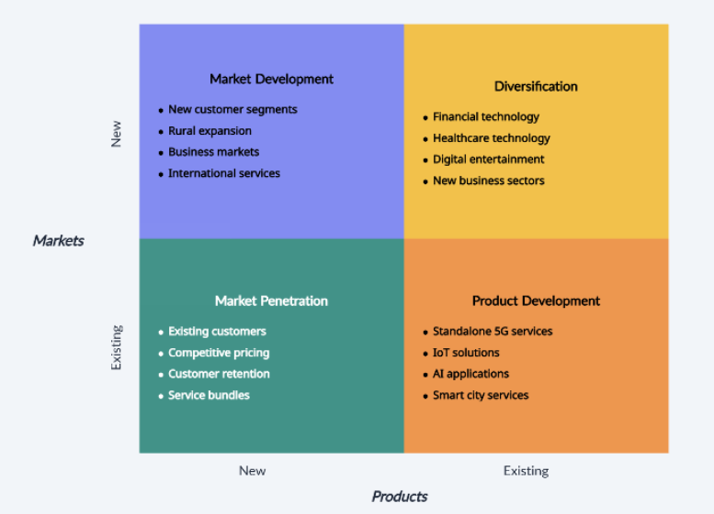
Figure 1: Ansoff Matrix
(Source: Self-Created)

4.2 Recommended Strategy: Product Development

The best strategy that VodafoneThree can employ is through product development. Recently, the company joined forces with Three UK and is currently spending £11 billion to create the top standalone 5G network in the UK (VodafoneThree, 2025). The innovation in this investment is the opening of new digital services rather than depending on conventional mobile connectivity. This is an improved approach compared to market penetration since the UK telecommunications industry is mature and competitive. The main competition would be based on lower prices, therefore lowering profitability. The development of products is a manner that generates value through innovation as opposed to competing on price.
It is more powerful than market development as well. New markets need greater infrastructure, regulatory acceptance, and advertising investment. The creation of new services, which will be offered to the existing customers, is easier since VodafoneThree already has a huge number of customers and the company is a well-known brand. The highest level of risk is associated with diversification, which should not be advised. Acquisition of new industries would add to financial and operating uncertainties in the post-merger integration process. VodafoneThree needs to first of all consolidate its telecommunications core business.
The plan complements the vision of Vodafone of creating connectivity to help people have a brighter future. It is also aligning its innovation, customer-centricity, and digital inclusion values. New 5G capabilities, IoT solutions, cloud services, and applications that will be powered by AI will enhance customer experience and customer loyalty (Hajar et al., 2022). They will also develop new sources of revenue and reduce reliance on conventional mobile services. The strategy will enhance the competitive advantage, retention rates, and average revenue per user, sustainable growth, and strengthen the long-term shareholder value.

5. Strategy Evaluation

The proposed strategy of product development has been further evaluated with the use of the SFA (Suitability, Feasibility, and Acceptability) framework. This framework, as per Zolfani et al. (2021), is known as a fundamental tool for the selection and development of any particular strategy.
Suitability

The strategy of product development is suitable as it directly responds to all the changing dynamics in the UK telecommunications industry. Businesses and consumers demand advanced services in digital technologies like IoT, standalone 5 connectivity, AI-enabled applications, cloud-based services, and cybersecurity. As per Grand View Research (2026), in the world, 5G network systems have a total CAGR rate of about 26.7% for the years 2026 to 2033. The final merger with VodafoneThree, Three UK possesses a better network capacity, technological capabilities, and spectrum assets, along with the ability to enable innovative digital products with efficiency. However, there are several strategic challenges which have been identified in the environmental analysis, such as increased market competition and declining profitability. The strategy also aligns with the vision of the company and helps in achieving sustainable growth.
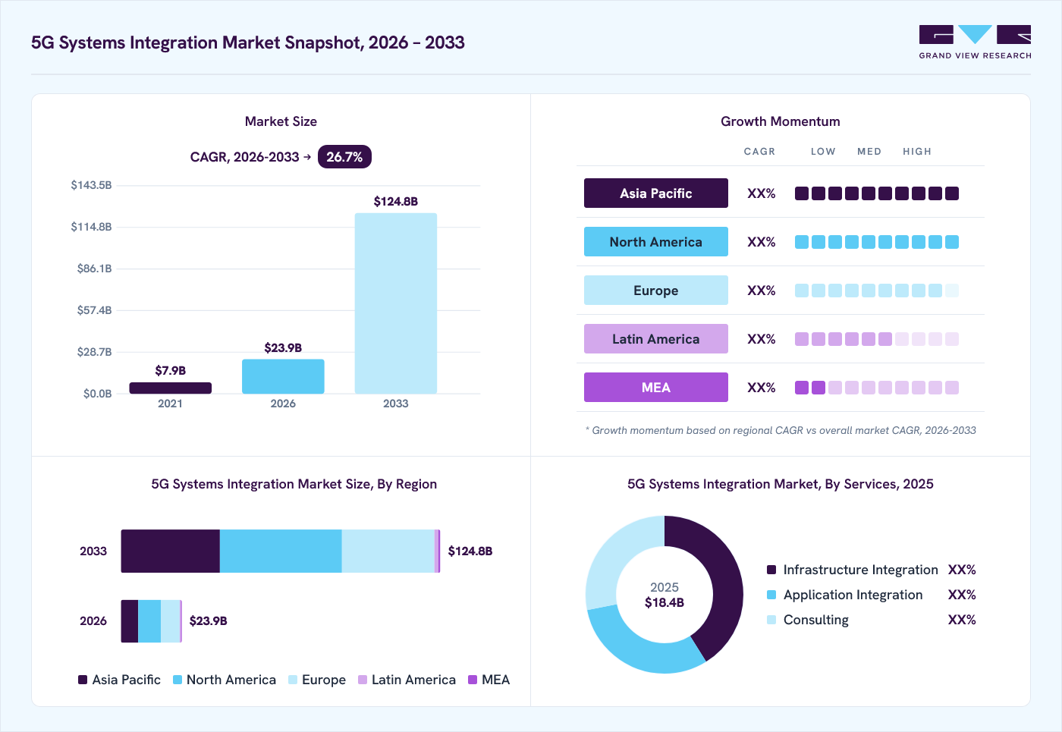
Figure 2: 5G Systems Integration Market
(Source: Grand View Research, 2026)

Feasibility
The strategy is considered feasible because the company possesses significant operational, technological, and financial resources. The company has announced a total investment of about £11 billion for the development of a leading standalone 5G network in the UK over the decade (Rudolph, 2025). Moreover, the annual synergy of about £700 million further targets to provide a significant opportunity for making improvements in emerging with a focus on certain benefits as well (Rudolph, 2025). All of these financial resources help in the provision of a strong foundation for an increased level of investment in the company in new digital services and products. Furthermore, as per Rudolph (2025), the company also benefits from the large customer base of about 27 million subscribers. The current technological expertise and partnerships support the final development of cloud computing, IoT, and AI solutions.
Assumptions: This particular evaluation assumes that the overall planned merger integration is completed and the projected investment programme progresses as scheduled to develop a new type of digital services.
Acceptability
The proposed strategy is expected to be highly acceptable to most of the stakeholders as it offers attractive benefits in the long term while managing all the risk levels. The shareholders also support the strategy because of its potential to develop a new stream of revenue and make improvements in profitability as well. Customers are further expected to benefit from improved quality of network and innovative services in digital technologies as well.
Overall, the analysis of SFA demonstrated that product development successfully represents a strategic, appropriate, stakeholder-supported, and operationally achievable strategy of growth. This makes it the most suitable option for the long-term growth in VodafoneThree [Referred to Appendix 1].

6. Stakeholder Analysis

According to stakeholder theory, organisations ought to bring value to all the stakeholders as compared to shareholders (Freeman et al., 2018). The suggested Product Development Strategy will have varying impacts on various stakeholder groups. Thus, VodafoneThree ought to deal with the stakeholders based on their power and interest level.
Mendelow's Power–Interest Matrix
Quadrant | Stakeholders | Impact of Product Development Strategy
High Power – High Interest (Manage Closely) | Board of Directors, Shareholders | Approve investment. Expect innovation, higher profits, and long-term growth.
High Power – Low Interest (Keep Satisfied) | Ofcom, UK Government | Ensure regulatory compliance, fair competition, and 5G development.
Low Power – High Interest (Keep Informed) | Customers, Employees | Customers expect better services. Employees need training for new technologies.
Low Power – Low Interest (Monitor) | Local Communities, Media | Communities benefit from connectivity and jobs. Media shapes public perception.
Table 4: Mendelow's Power–Interest Matrix
(Source: Self-Created)
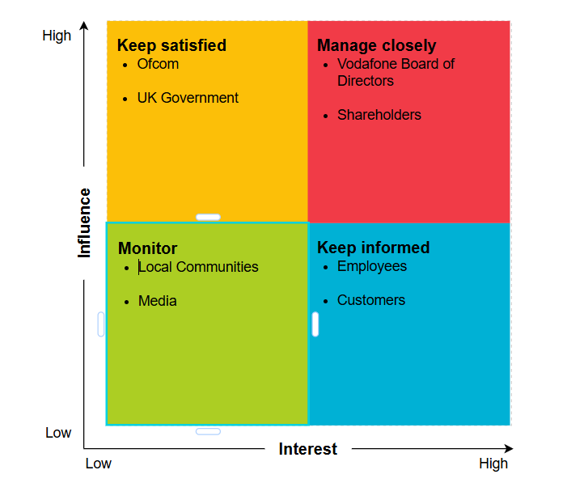
Figure 3: Mendelow's Power–Interest Matrix
(Source: Self-Created)
Stakeholder Engagement Plan
Stakeholder | Engagement Method | Objective | Frequency
Board of Directors | Strategy meetings | Approve investment and monitor performance | Monthly
Shareholders | Annual reports and investor briefings | Communicate financial performance and growth | Quarterly
Ofcom | Regulatory reports and consultations | Ensure compliance with telecom regulations | Quarterly
UK Government | Partnership meetings | Support national digital and 5G initiatives | Twice a year
Customers | Surveys, mobile app updates, social media | Improve satisfaction and collect feedback | Continuous
Employees | Training programmes and internal communication | Develop digital skills and support change | Monthly
Local Communities | CSR programmes and community events | Build trust and social value | Twice a year
Media | Press releases and media briefings | Maintain a positive corporate reputation | As required
Table 5: Stakeholder Engagement Plan
(Source: Self-Created)
Effective stakeholder engagement improves product development plan acceptance and reduces resistance to change (Hodges, 2018). Constant communication helps to build trust, improve cooperation, and provide VodafoneThree with sustainable development and the ability to meet the expectations of stakeholders.

7. Implementation and Monitoring

7.1 Implementation Plan
Strategic Objective | Key Actions | Responsibility | Timeline | KPI (Key Performance Indicator)
Develop innovative 5G-based digital products | Design and launch IoT, AI-powered, cybersecurity and cloud services using the enhanced 5G infrastructure | Product Development and Technology Teams | 12 months | Launch at least four new digital products; 95% project completion within schedule
Improve customer experience and retention | Enhance network quality, introduce personalised digital services and improve customer support | Customer Experience and Operations Teams | 6–12 months | Customer Satisfaction (NPS) increases by 10%; customer retention exceeds 95%
Increase digital service adoption | Implement integrated marketing campaigns, customer education and digital promotions | Marketing and Sales Teams | 12 months | 20% growth in digital service subscriptions; 15% increase in Average Revenue per User (ARPU)
Strengthen organisational capability | Provide employee training in AI, IoT, cybersecurity and digital technologies | Human Resources and Learning & Development | Ongoing | 90% employee training completion; improved employee productivity and engagement
Table 5: Implementation Plan
(Source: Self-Made)

7.2 Monitoring and Performance Evaluation

Effective monitoring is considered to be useful for ensuring the successful delivery of the proposed strategy for product development in all the financial and operational outcomes of VodafoneThree. The company needs to develop a structured management system for evaluating its performance while supporting it with quarterly review meetings for strategies and the use of real-time dashboards. This will help enable all the senior managers to successfully monitor the progress of the implemented strategy and identify all the growing risks. The success of the whole strategy needs to be measured with the use of balanced KPIs. The financial KPIs need to include the overall revenue generated from all the new digital products, growth within the ARPU (Average Revenue per User), and return on investment. Whereas the KPIs related to customers need to focus on customer retention, and operational KPIs need to monitor the availability of the 5G network. Where the whole performance falls below all the established targets, the company needs to then implement corrective measures like increasing employee training, redesigning products depending on customer feedback or straitening of all the marketing campaigns. Through proper monitoring, VodafoneThree can successfully respond to the proposed strategy.

8. Conclusion

VodafoneThree’s post-merger position offers a solid platform for growth, and size will not be the ultimate key to sustainable competitive advantage. The analysis shows that the growing demand for 5G, IoT, cloud, AI-powered and cybersecurity services presents opportunities, while fierce competition, regulatory requirements, customers' price sensitivity and integration complexities continue to be significant risks. Therefore, product development is the most suitable strategic move as it leverages the large base of customers, spectrum assets, technological capabilities and network investment of £11 billion by VodafoneThree. The SFA evaluation confirms that this strategy is suitable, feasible and acceptable to key stakeholders. Successful delivery will be dependent upon disciplined implementation, employee capability development, innovation and customer focused performance monitoring. VodafoneThree will gain differentiated services, customer loyalty, higher profitability, and sustain UK Telecom market leadership through tracking revenue growth, ARPU, NPS, retention, product adoption and network availability.

References

CMA (2024) CMA clears vodafone / three merger, subject to legally binding commitments, GOV.UK. Available at: https://www.gov.uk/government/news/cma-clears-vodafone-three-merger-subject-to-legally-binding-commitments (Accessed: July 27, 2026).
CMA (2024a) CMA provisionally finds vodafone / three could address competition concerns through network investment and customer protections, GOV.UK. Available at: https://www.gov.uk/government/news/cma-provisionally-finds-vodafone-three-could-address-competition-concerns-through-network-investment-and-customer-protections (Accessed: July 27, 2026).
CMA (2024b) How we are investigating the Vodafone/Three potential merger, GOV.UK. GOV.UK. Available at: https://www.gov.uk/guidance/how-we-are-investigating-the-vodafonethree-potential-merger (Accessed: July 27, 2026).
Evens, T., and Donders, K. (2018) Platform power and policy in transforming television markets. London: Palgrave Macmillan.
Freeman, R. E., Harrison, J. S., and Zyglidopoulos, S. (2018) Stakeholder theory: Concepts and strategies. Cambridge University Press.
Gitonga, G., Kariuki, P., and Kimani, E. (2025) ‘Market penetration strategies and competitive advantage of the telecommunication firms in Kenya', Int J Strateg Manag, 4(1), pp. 1-26.
GOV.UK (2024) Regulations: Consumer connectable product security, GOV.UK. Available at: https://www.gov.uk/guidance/regulations-consumer-connectable-product-security (Accessed: July 27, 2026).
GOV.UK (2025) Update on shared rural network total not-spots project, GOV.UK. Available at: https://www.gov.uk/guidance/update-on-shared-rural-network-total-not-spots-project (Accessed: July 27, 2026).
Grand View Research (2026) 5G Systems Integration Market Size Report, 2026-2033. Available at: https://www.grandviewresearch.com/industry-analysis/5g-system-integration-market (Accessed: 26 July 2026).
Hajar, M.A., Alkahtani, A.A., Ibrahim, D.N., Al-Sharafi, M.A., Alkawsi, G., Iahad, N.A., Darun, M.R. and Tiong, S.K. (2022) ‘The effect of Value innovation in the superior performance and sustainable growth of telecommunications sector: Mediation effect of customer satisfaction and loyalty’, Sustainability, 14(10), p. 6342.
Hodges, J. (2018) Employee engagement for organizational change: The theory and practice of stakeholder engagement. Routledge.
Koppolu, H. K. R. (2021) ‘Leveraging 5G Services for Next-Generation Telecom and Media Innovation', International Journal of Scientific Research and Modern Technology, pp. 89-106.
Mordor Intelligence (2025) UK MOBILE VIRTUAL NETWORK OPERATOR (MVNO) MARKET SIZE & SHARE ANALYSIS - GROWTH TRENDS AND FORECAST (2025 - 2030), Mordor Intelligence. Available at: https://www.mordorintelligence.com/industry-reports/uk-mobile-virtual-network-operator-mvno-market (Accessed: July 27, 2026).
Ofcom (2023) Switching - mobile. Available at: https://www.ofcom.org.uk/phones-and-broadband/switching-provider/switching-mobile (Accessed: July 27, 2026).
Ofcom (2024) Ofcom bans mid-contract price rises linked to inflation, www.ofcom.org.uk. Available at: https://www.ofcom.org.uk/phones-and-broadband/bills-and-charges/ofcom-bans-mid-contract-price-rises-linked-to-inflation (Accessed: July 27, 2026).
Ofcom (2025) Brits devour data at record levels as mobile networks race to improve 5G. Available at: https://www.ofcom.org.uk/phones-and-broadband/coverage-and-speeds/brits-devour-data-at-record-levels-as-mobile-networks-race-to-improve-5g (Accessed: July 27, 2026).
Ofcom (2026) Connected Nations update: Spring 2026. Available at: https://www.ofcom.org.uk/phones-and-broadband/coverage-and-speeds/connected-nations-update-spring-2026 (Accessed: July 27, 2026).
Ofcom (2026a) Telecommunications market data update, www.ofcom.org.uk. Available at: https://www.ofcom.org.uk/phones-and-broadband/telecoms-infrastructure/telecommunications-market-data-update (Accessed: July 27, 2026).
Oladimeji, M. S. (2019) ‘The effect of diversification strategy on organizational performance’, Journal of competitiveness.
ONS (2026) Consumer price inflation, UK: April 2026, Ons.gov.uk. Office for National Statistics. Available at: https://www.ons.gov.uk/economy/inflationandpriceindices/bulletins/consumerpriceinflation/april2026 (Accessed: July 27, 2026).
Rudolph, A. (2025). Vodafone-Three merger: What next after the creation of the UK’s largest mobile operator? IG. Available at: https://www.ig.com/en/news-and-trade-ideas/vodafone-three-merger--what-next-after-the-creation-of-the-uk-s--250611 (Accessed: 27 July 2026).
Vodafone (2023). About vodafone UK. www.vodafone.co.uk. Available at: https://www.vodafone.co.uk/about-us/about-vodafone-uk (Accessed: 26 July 2026).
Vodafone (2025) Completion of Vodafone and three merger in the UK, Vodafone UK News Centre. Available at: https://www.vodafone.co.uk/newscentre/press-release/completion-vodafone-three-merger-uk/ (Accessed: July 27, 2026).
Vodafone (2025a) Vodafone 2025 annual report, Vodafone.com. Available at: https://reports.investors.vodafone.com/view/897876789/ii/ (Accessed: July 27, 2026).
Vodafone (2025a). Our mission. Vodafone. Available at: https://www.vodafone.com/our-company/our-mission (Accessed: 26 July 2026).
Vodafone (2025b) VodafoneThree signs multibillion pound investment deals, marking another major milestone in building the UK’s best network, Vodafone.co.uk. Available at: https://www.vodafone.co.uk/newscentre/press-release/multibillion-pound-investment-deals-signed-to-build-uk-best-network/ (Accessed: July 27, 2026).
Vodafone (2025b). Our strategic priorities. Vodafone. Available at: https://www.vodafone.com/our-company/our-strategic-priorities (Accessed: 27 July 2026).
Vodafone (2025c) Max Taylor comments on VodafoneThree progress so far, Vodafone UK News Centre. Available at: https://www.vodafone.co.uk/newscentre/news/max-taylor-vodafonethree-progress/ (Accessed: July 27, 2026).
Vodafone (2025c). Welcome to Zscaler directory authentication. Vodafone.co.uk. Available at: https://www.vodafone.co.uk/newscentre/press-release/multibillion-pound-investment-deals-signed-to-build-uk-best-network/ (Accessed: 27 July 2026).
Vodafone (2026) VodafoneThree completes world-first network upgrade by integrating core and radio sharing while unlocking access to its fastest 5g speeds for up to 50 million people, Vodafone UK news centre. Available at: https://www.vodafone.co.uk/newscentre/press-release/world-first-network-upgrade-emocn-completed/ (Accessed: July 27, 2026).
Vodafone (2026a) FY26 results presentation, Vodafone.com. Available at: https://reports.investors.vodafone.com/view/213859904/9/ (Accessed: July 27, 2026).
Vodafone (2026b) VodafoneThree network improvement checker - vodafone UK news centre, Vodafone UK News Centre. Available at: https://www.vodafone.co.uk/newscentre/vodafonethree-network-improvement-checker/ (Accessed: July 27, 2026).
VodafoneThree (2025) VodafoneThree signs multibillion pound investment deals, marking another major milestone in building the UK’s best network, Vodafonethree.com. Available at: https://www.vodafonethree.com/multibillion-pound-investment-deals-signed-to-build-uk-best-network/ (Accessed: July 27, 2026).
Zolfani, S.H., Bazrafshan, R., Akaberi, P., Yazdani, M. and Ecer, F. (2021). Combining the Suitability-Feasibility-Acceptability (SFA) strategy with the MCDM approach. Facta universitatis, series: Mechanical engineering, 19(3), p.579. doi:10.22190/fume210711062z.
Zugay, B., and Zakaria, R. (2023) Ansoff matrix. SAGE Publications, Inc.

Appendices

Appendix 1: Summary of SFA

SFA Criteria | Evaluation | Justification
Suitability | High | Addresses digital transformation, leverages 5G investment, and differentiates VodafoneThree through innovation.
Feasibility | High | Supported by £11 billion 5G investment, £700 million annual cost synergies, a strong customer base, and technical capabilities (Rudolph, 2025).
Acceptability | High | Creates long-term value for shareholders, improves customer experience, supports employee development, with manageable implementation risks.

