

Problem Solving and Innovation, BMSW4014
A SWOT analysis of The Body Shop

Student Name : Hanyeh Modares Tehrani
Student ID :2324527
Word Count : 565

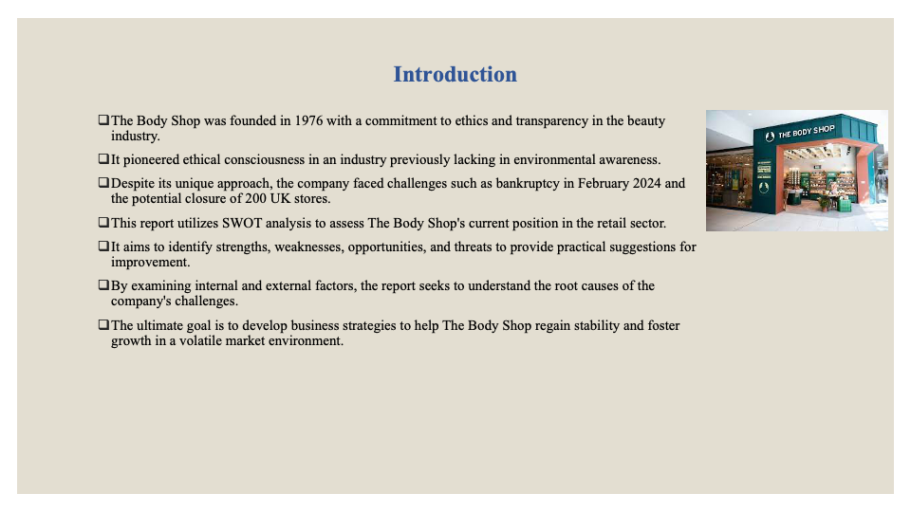Introduction
By having a commitment to ethics and transparency as its core values from the start after its establishment in 1976, The Body Shop has stood out as a pioneer in the beauty industry which had been notorious for its lack of environmental and ethical consciousness. Ethical baptizing is an emerging beautician discipline, and it is the makeup art industry where we stand. By going its own way the firm has managed to gain a niche among the competitive brands by promoting products that are caring and eco-friendly. However, the business has faced some difficulties apparently, with going bankrupt in February 2024 and 200 shops in the UK at the risk of closure. Therefore, they need to reconsider their approaches. This report is built on the foundation of the SWOT analysis to look at The Body Shop's current status in the inherently volatile retail environment and mention its strengths, weaknesses, opportunities and threats as well. By this thorough investigation we will be able to explore the internal and external factors which have affected these troubled times of business life and would yield some very good and practical suggestions.

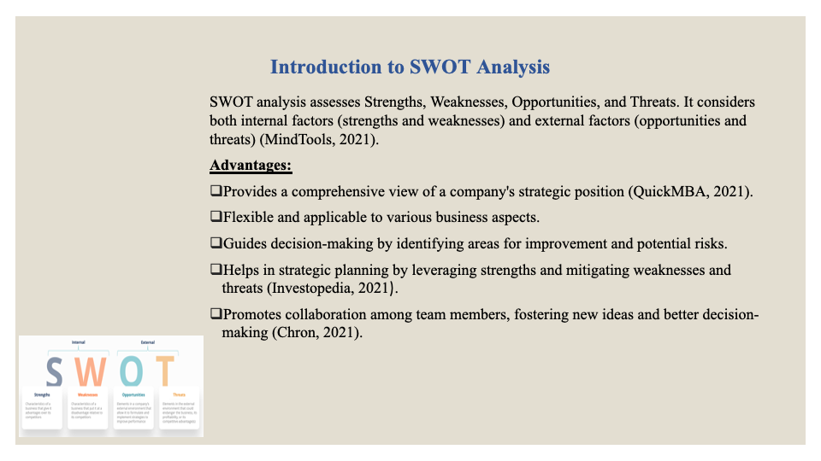Introduction to SWOT Analysis
SWOT analysis is a method of determining the mixed aspects of a company including Strengths, Weaknesses, Opportunities and Threats. This framework does not only consider the readiness of the organization but also takes into account the influence of outside variables as a very important part of business success. Opportunities and dangers are outside the organization and are affected by things like market conditions, competition, and resources (MindTools, 2021).
Advantages of SWOT Analysis
One of the best things about SWOT analysis is that it can give us a full picture of how a company is doing strategically. Because of this, it is an extremely useful tool for any business boss (QuickMBA, 2021). Business News Daily (2021) says it is very flexible and can be used for many things, such as projects, whole business units, or individual goods. It also helps companies make decisions by showing them where they can use their skills and where they need to work on their weaknesses. It also tells where to look for chances and how to protect from existential threats (Investopedia, 2021). SWOT analysis also helps with strategic planning by helping companies come up with plans that use their strengths to take advantage of chances outside the company while also protecting them from weaknesses and threats from outside the company (Chron, 2021).
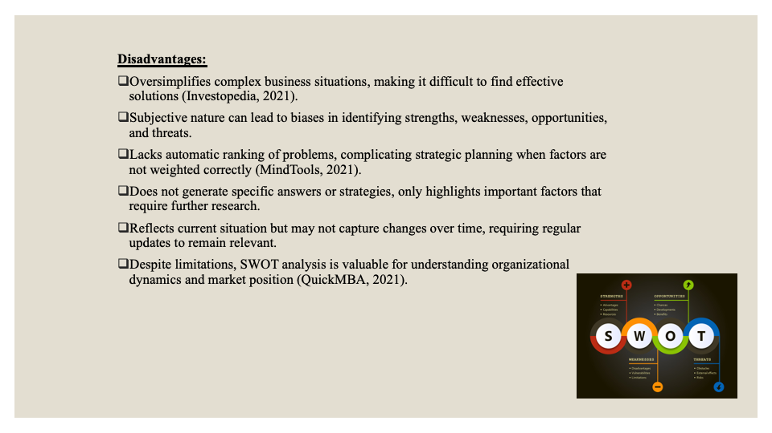Disadvantages of SWOT Analysis
There are some problems with SWOT analysis as well. One big problem with it is that it tends to oversimplify complicated business situations, which can make it hard to come up with good solutions to complicated problems (Investopedia, 2021). It's also subjective, which can lead to biases when figuring out strengths, weaknesses, opportunities, and threats, which could throw off the research (Chron, 2021). Also, SWOT doesn't automatically rank problems, which can make strategic planning harder if different factors aren't given the right amount of weight (MindTools, 2021). Another problem with SWOT is that it doesn't come up with specific answers or strategies on its own. It only points out important factors that need more research to be turned into workable plans (Business News Daily, 2021). Lastly, the analysis only shows how things are right now and might not reflect how things have changed over time. This means that it needs to be updated regularly to stay useful and relevant (QuickMBA, 2021).

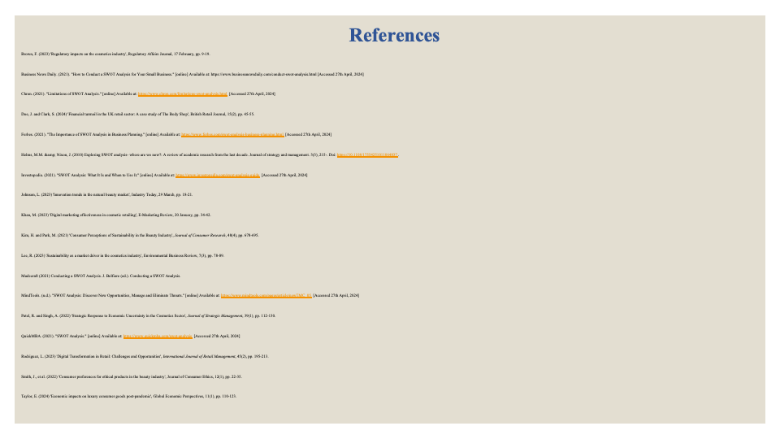

References

Business News Daily. (2021) How to Conduct a SWOT Analysis for Your Small Business. Available at: https://www.businessnewsdaily.com/conduct-swot-analysis.html (Accessed:27th April 2024)
Chron. (2021) Limitations of SWOT Analysis. Available at: https://www.chron.com/limitations-swot-analysis.html (Accessed:27th April, 2024)
Investopedia. (2021) SWOT Analysis: What It Is and When to Use It.
Available at: https://www.investopedia.com/swot-analysis-guide (Accessed:27th April 2024)
MindTools. (2020.). SWOT Analysis: Discover New Opportunities, Manage and Eliminat Threats. Available at: https://www.mindtools.com/pages/article/newTMC_05 (Accessed:27th April 2024)

QuickMBA. (2021) SWOT Analysis. Available at: https://www.quickmba.com/swot-analysis (Accessed: 27th April, 2024)

