University of Wales Trinity Saint David
Shape Up Gyms Database
Database Management Systems – Dr Kemi Ademoye
Gemma Dunlop (1801285)
23/03/2020

Abstract
The report contains details of the construction of Shape Up Gyms database. The brief was to concentrate on data queries and to identify three secondary indexes and to identify a suitable fragmentation schema, including horizontal, vertical, mixed and derived fragmentation. SQL Server was used to create the database.
Table of Contents
1. Performance Tuning 3
1.1. Secondary Index on First Name and Last Name 3
1.2. Secondary Index on Gym Name 4
1.3. Foreign Key Secondary Index on CustomerNo 5
2. Distributed Database Solution 6
2.1. Horizontal Fragmentation 6
2.2. Vertical Fragmentation 7
2.3. Derived Fragmentation 10
Conclusion 12
Bibliography 13

Performance Tuning
A secondary index enables records to be accessed efficiently in a database by using a piece of information other than the primary key which is the key usually used [1]. The Shape Up Gyms database contains a list of members of the gym, each of whom has a unique Customer ID number. The list of gym members was used as a primary key for the database.

Secondary Index on First Name and Last Name
The database uses gym member’s ID as the primary key, but the customer may not have this information with them. Therefore, a staff member would need to search for a gym member details another way. This could be done by using customer’s last name and first name. A secondary index was constructed where the secondary key was the last name and first name.
When data is inserted or deleted in a table, the secondary index also needs to be updated so insertion and deletion takes longer. More queries will be carried out by customer’s last name than data will be modified. Although customers will be created frequently in the database, more queries will be carried out by the staff in Shape Up Gyms.
The Gym would find it useful to access the data using another column, so a secondary index was created for the last name, while the CustomerID is the clustered index. From the staff member’s perspective, entering data into the database works exactly in the same way than it does without a secondary index.
This index will reduce the query’s execution time if you query the columns last name and first name together in the WHERE clause [2]. By indexing the last name and the first name together a query to search for a customer, e.g. Davies Rhys would execute quickly.
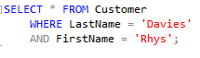
This index would enable the database to eliminate any rows because both fields are searched as opposed to one field, therefore decreasing the number of rows to be considered. Ultimately, there are more customers on the gym database whose last name is ‘Davies’ than customers whose last name is ‘Davies’ and whose first name is also ‘Rhys’. If a separate index was created on first name and last name, then one or the other would be chosen by the database as a single query can only use one index per table.
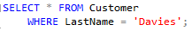
The use of WHERE clause lists specific columns in the table and has the advantage of limiting the number of rows which are returned. The use of this index is ideal for the gym to find specific records as the majority of searches on the database would involve searching for a specific customer.

Secondary Index on Gym Name
The index data is in a different table from the table’s data for secondary indexes, even though it is possible for both to be stored in different areas or the same area [3]. When a record is inserted into a table, the information data in the columns which are in the index after a copy is inserted into the index area. Therefore, if column data is altered within a table and the column makes up an index, the data in the index must be altered by SQL server so two updates would be completed instead of only one. Although the result of this will be a performance reduction for data-modification, the use of an appropriate index will offset this by increasing the data-retrieval performance.
Therefore, low maintenance data i.e. columns which are not frequently updated could be used as an index and would be an excellent choice of index. The database will be faster if SQL server has fewer disk writes. Since data in the Gym table will be retrieved more often than it will be modified then indexing the Gym’s Name column will improve performance overall.
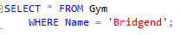
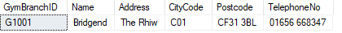
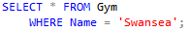

Foreign Key Secondary Index on CustomerNo
Foreign keys are separate to primary keys but are related [4]. Foreign keys maintain the relationship and enforces integrity with its referent.
Indexes are not automatically created by SQL Server on foreign keys. However, the creation of an index on the column of a foreign key was created because SQL Server identifies the foreign key values when it joins to the parent table. This referential constraint was added to the database because it is an important use of an index as particular actions would be constrained according to the data that exists.
The CustomerNo column is the foreign key in the MembershipPurchase table, where further information about the customer’s gym membership package is stored. The addition of a new Gym member to the Customer table, means it is not necessary for a row to be added for a membership purchase in table MembershipPurchase but when a row is added to MembershipPurchase, a corresponding CustomerID row has to exist in the Customer table.
However, if data is deleted, a CustomerNo row from the MembershipPurchase table can be deleted, but on deletion of a row from Customer table, corresponding rows from MembershipPurchase would need to be deleted first. The referential constraint prevents a customer record from being deleted whilst other data – gym membership purchase information – exists. With SQL Server, as the column containing the foreign key value must be identified, as it is joined to the parent table, the index was created on the foreign columns.
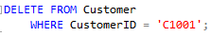
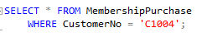

Distributed Database Solution

Horizontal Fragmentation
Horizontal fragmentation could be used on GymBranchID. This would mean each Gym branch would only see relevant information for a specific branch. Replicating relations at all gym branches would mean the database would only contain a small number of records at each branch [5].
Horizontal fragmentation could be used on the Shape Up Gyms database to group together the records in the Customer table that are collectively used by the transaction. Horizontal fragments are produced by a predicate performing a restriction on the table’s records, for example in a WHERE clause specifying an SQL SELECT statement. The SELECT statement would return the records when the condition that was specified in the WHERE clause was TRUE. A query transaction is used to query the Shape Up Gyms database. Queries are specified by a program that have a predicate which gives a designated answer of TRUE or FALSE. Predicates can be simple with single columns or complex with multiple columns. A horizontal fragmentation of Customer table by GymID is shown below.
C₁: SELECT * FROM Customer
WHERE GymID = 'G1001';
C₂: SELECT * FROM Customer
WHERE GymID = 'G1002';
C₃: SELECT * FROM Customer
WHERE GymID = 'G1003';
C₄: SELECT * FROM Customer
WHERE GymID = 'G1004';
This produces three fragments: G1, G2 and G3. Each fragment consists of the records belonging to that particular gym branch as shown below. Fragmenting the records in this way could be advantageous as each gym branch will have separate applications dealing with customer details.
C₁: σ_{GymID = ‘G1001’} (Customer)
C₂: σ _{GymID = C1002} (Customer)
C₃: σ _{GymID = C1003} (Customer)
C₄: σ _{GymID = C1004} (Customer)
Reconstruction: UNION: Original Customer Relation = G₁ ∪ (union) G₂ ∪ (union) G₃ ∪ (union) G₄

Vertical Fragmentation
Vertical fragmentation groups together the fields or columns in a table into fragments which are used based on the frequency of a user query [5].
For example, consider the Customer table with CustomerID, GymID, FirstName, LastName, DateOfBirth, EmailAddress, Passcode, HomeAddress, HomeCityCode, Postcode, ContactPhoneNo, MedicalSummary, JoinDate, BankAccountNo, SortCode. The vertical fragmentation of the table may be where the table is divided into different tables using columns from Customer.
C₁: SELECT CustomerID, FirstName, LastName, DateOfBirth, EmailAddress, Passcode
FROM Customer;
C₂: SELECT CustomerID, HomeAddress, HomeCityCode, Postcode, ContactPhoneNo, MedicalSummary
FROM Customer;
C₃: SELECT CustomerID, JoinDate, BankAccountNo, SortCode
FROM Customer;
C₄: SELECT CustomerID, GymID
FROM Customer;
C₁: ΠCustomerID, FirstName, LastName, DateOfBirth, EmailAddress, Passcode
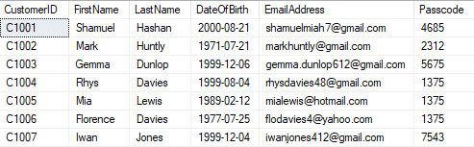
C₂: ΠCustomerID, HomeAddress, HomeCityCode, Postcode, ContactPhoneNo, MedicalSummary
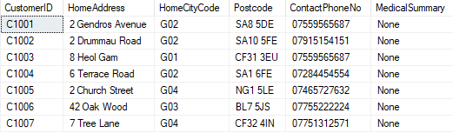
C₃: ΠCustomerID, JoinDate, BankAccountNo, SortCode
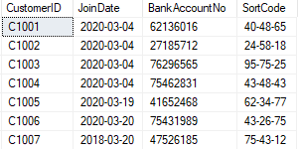

C₄: Π_{CustomerID, GymID}
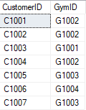

This produces 4 fragments C1, C2, C3, C4. All fragments contain the primary key CustomerID so the original Customer table can be reconstructed. The advantage of vertical fragmentation in the Shape Up Gyms database is the fragments are only stored at the required Gyms that need to use them. Additionally, the performance is improved because the fragments are smaller than the original table.

Reconstruction: JOIN: Original Customer Relation = C₁ ⋈ (natural join) C₂ ⋈ (natural join) C₃ ⋈ (natural join) C₄
Mixed Fragmentation
Horizontal or vertical fragmentation of the Shape Up Gyms database by itself sometimes inadequately distributes data so mixed fragmentation is required.
As well as vertically fragmenting customers for personal details, emergency contact, bank account details, id numbers, the gym could horizontally fragment G2, according to the GymID – there are four gym centres in the database.
C₁₁: SELECT CustomerID, FirstName, LastName, DateOfBirth, EmailAddress, Passcode
FROM Customer
WHERE GymID = 'G1001';
C₁₂: SELECT CustomerID, FirstName, LastName, DateOfBirth, EmailAddress, Passcode
FROM Customer
WHERE GymID = 'G1002';
C₁₃: SELECT CustomerID, FirstName, LastName, DateOfBirth, EmailAddress, Passcode
FROM Customer
WHERE GymID = 'G1003';
C₁₄: SELECT CustomerID, FirstName, LastName, DateOfBirth, EmailAddress, Passcode
FROM Customer
WHERE GymID = 'G1004';
C₁₁: σ_{GymID='G1001'} (C1)

C₁₂: σ_{GymID='G1002'} (C1)
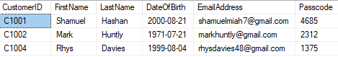

C₁₃: σ_{GymID='G1003'} (C1)
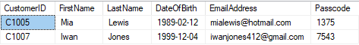
C₁₄: σ_{GymID='G1004'} (C1)

Reconstruction: Natural JOIN and UNION: Original Staff Relation = C₁ ⋈ (C₁₁ ∪ C₁₂ ∪ C₁₃ ∪ C₁₄)

Derived Fragmentation
Derived fragmentation uses constraints defined on one table to fragment another table. The two tables are linked together by primary and foreign keys and an Owner-Member relation is established. Primary horizontal fragmentation is used when a table is not dependant on another table. However, in most cases, the database needs to be fragmented as a whole. When a table is connected with another table by foreign key concept, data that is inserted into the foreign key column of the record must also be available in its own table. In which case, the parent table and the child tables cannot be fragmented. If the tables were to be fragmented separately, each time records are inserted, the existence of the values in the parent table must be verified. Thus, Primary Horizontal Fragmentation could not work.
Where applications require a join of several tables. If the different tables are stored at different Gyms, there could be a considerable overhead in order to process the join. In this case, it would be more appropriate to have the tables or fragments of tables in existence at the same location. This is achieved using derived horizontal fragmentation. The parent to the table contains the primary key, which is targeted, and the child refers to a table containing the foreign key.
GMP₁: SELECT gmp. * FROM GymMembershipPrice AS gmp, Gym AS g
WHERE gmp.GymID = g.GymBranchID AND g.Name = 'Bridgend';
GMP₂: SELECT gmp. * FROM GymMembershipPrice AS gmp, Gym AS g
WHERE gmp.GymID = g.GymBranchID AND g.Name = 'Swansea';
GMP₃: SELECT gmp. * FROM GymMembershipPrice AS gmp, Gym AS g
WHERE gmp.GymID = g.GymBranchID AND g.Name = 'Nottingham';G4
GMP₃: SELECT gmp. * FROM GymMembershipPrice AS gmp, Gym AS g
WHERE gmp.GymID = g.GymBranchID AND g.Name = 'Belfast’;

GMP₁ = GMP ⊳_{Name} G₁ (G₁ is a horizontal fragment Gym=Bridgend)
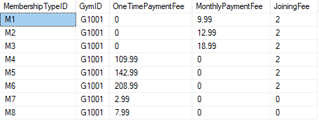

GMP₁ = GMP ⊳_{Name} G₁ (G₁ is a horizontal fragment Gym=Swansea)
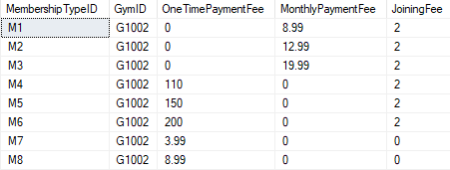
GMP₁ = GMP ⊳_{Name} G₁ (G₁ is a horizontal fragment Gym=Nottingham)
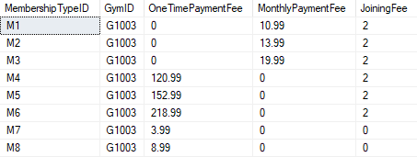
GMP₁ = GMP ⊳_{Name} G₁ (G₁ is a horizontal fragment Gym=Belfast)
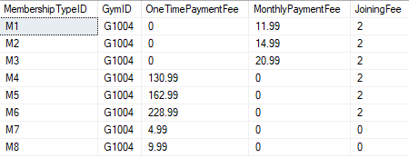

Storing customer data by GymID using the same horizontal fragmentation strategy is useful however there is no GymID column for the Customer table.

Reconstruction: GMP₁ ∪ GMP ₂ ∪ GMP₃ ∪ GMP₄ ∪ GMP₅ ∪ GMP₆ ∪ GMP₇ ∪ GMP₈.
Reconstruction: G₁ ∪ G₂ ∪ G₃ ∪ G₄.

Conclusion
A database was created that a gym could use for keeping track of its members. The database was designed to solve two of Shape Up Gyms database problems: performance tuning and Distributed Database Solution this was achieved using indexes and fragmentation schemas – horizontal, vertical, mixed and derived fragmentation.

Bibliography

[1] | Oracle, “Secondary indexes,” Chapter 3. Access Method Operations, 2020.
[2] | M. G. Cecilia CIOLOCA, “Increasing Database Performance using Indexes,” Database Systems Journal, vol. II, no. 2, pp. 13-19, 2011.
[3] | R. Dewson, Beginning SQL Server 2008 for Developers: From Novice to Professional, Apress, 2008.
[4] | E. Stellato, “The Benefits of Indexing Foreign Keys,” SQL Indexes, SQL Plan, T-SQL Queries, 20 November 2012.
[5] | C. E. B. R. H. Thomas Connolly, Business Database Systems, Pearson Education, 2008.

marking criteria and Student FEEDBACK

This section details the extent to which the assessment criteria are demonstrated by you, which in turn determines your mark. The marks available for each category of skill are shown. Lecturers will use the space provided to comment on the achievement of the task(s), including those areas in which you have performed well and areas that would benefit from development/improvement.

Common Assessment Criteria Applied (Assignment 1) | Marks available | Marks  awarded
1. Engagement with Literature Skills

2. Knowledge and Understanding Skills

A very good range of queries to create sample data for the database has been provided with additional, appropriate queries to test the constraints added to the tables. A good attempt at the required transaction to purchase a new membership but there is room for improvement. First, you should not be deleting previous records as this does not allow them to keep to a record of historical purchases for a customer and means they will not be able to measure customer loyalty and retention. The logic is also not quite correct. You need an IF statement to do the required check before committing the transaction. (Grade mark: 72.00%) | 25 | 18
3. Cognitive and Intellectual Skills

A good analysis of the case study, but there is room for improvement. The implemented/discussed indexes are generally good choices and you have also demonstrated the use of a multi-column index, but some of the chosen columns to index could be better. A good attempt at the distributed database design, but your proposed solution requires further improvements and there were a few mix-ups when discussing your strategy. See your report for suggested improvements. (Grade mark: 66.67%) | 30 | 20
4. Practical Application Skills

A very good attempt. Just a few minor things to note. Note the difference between the CHAR and VARCHAR types. CHAR is for fixed length string e.g. your student number, while VARCHAR is for varying string lengths e.g. names. PKs are usually better stored as CHAR. Integer type is not appropriate for the bank account number. This column should be stored as CHAR, as well as the sort code, as both are fixed length strings and to support account numbers and sort codes with leading zeroes. The passcode should be stored as either a CHAR or VARCHAR and not an integer so that again it can store any leading zeros. Use decimal instead of float for your numeric type for the fees. Good check constraints but you will find that some of them are a bit too restrictive and will limit the possible entries. For example, at the moment you can only record a maximum of 99 cities in the database. Similarly, your customer table will only allow a maximum of 9999 customers. DurationQty in MembershipType should be an integer - set DurationType to Day, Month, etc. For the OffPeakMembership and Cancel Anytime columns, use the BIT type which is used to store Boolean data (True/False or Yes/No). (Grade mark: 72.50%) | 40 | 29
5. Transferable Skills for Life and Professional Practice

The report is well-written and presented, but you really do need to learn the art of writing more concisely. (Grade mark: 80.00%) | 5 | 4

Assignment Mark (Assessment marks are subject to ratification at the Exam Board. These comments and marks are to give feedback on module work and are for guidance only until they are confirmed. ) | Late Submission Penalties (tick if appropriate) |  | 71%
 | Up to 1 week late (40% Max) |  | 71%
 | Over 1 week late (0%) |  | 71%

