Component 1: Design and Implementation of a Relational Database System
Introduction to Web and Database Concepts - ACCA4023

Sadhana Jha

Coursework Title:Design and Implementation of Relational Data Base System
Module Name: Introductin To Web And DataBase Concepts
Module Code: ACCA4023
Student Name: Elias Hassen Mohammed
Student ID:2433619
Lecturer Name: Sadhana Jha

Submission date: Thursday 9th March 2026

Contents
Scenario Analysis 2
Entity Relationship Diagram (ERD) 2
1. List of attributes and their descriptions 2
2. List of relationships and their meaning. 2
3. ER diagram: 2
Normalization 2
Sample Data Population 2
Query Development 2
Testing and Validation 3
Design Decisions and Future Work 3
1. Design Decisions: 3
2. Future Work: 3
References: 3

Scenario Analysis
MediLink Pharmacy is a growing community pharmacy chain currently managing medicine stock, prescriptions, suppliers, and customer records manually. This manual system results in frequent stock inconsistencies, misplaced prescription records, delayed reporting, and difficulty ensuring regulatory compliance.
The purpose of this database system is to design and implement a relational database using Microsoft Access to:
- Automate medicine inventory management
- Maintain accurate customer and prescription records
- Track suppliers and procurement sources
- Record and monitor sales transactions
- Generate management reports for stock control and compliance
The system aims to improve operational efficiency, reduce human error, and provide accurate real-time reporting for decision-making.

Entity Relationship Diagram (ERD)

List of attributes and their descriptions
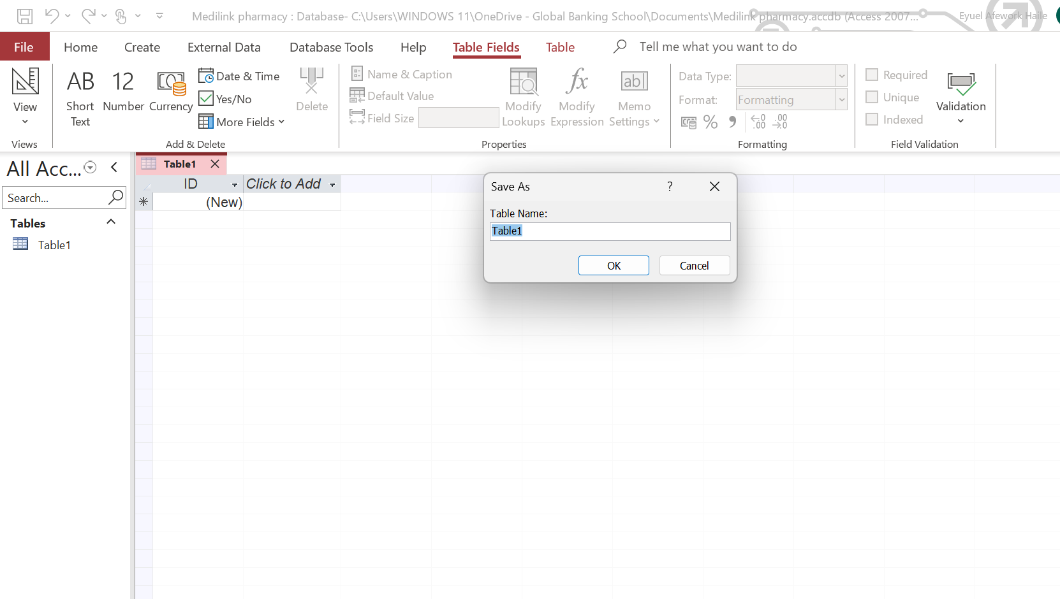
Fig 1 Creation of Tables

Customer
- CustomerID (PK): Unique identifier for each customer
- FirstName: Customer’s first name
- LastName: Customer’s surname
- DateOfBirth: Customer’s date of birth
- Phone: Contact number
- Address: Residential address

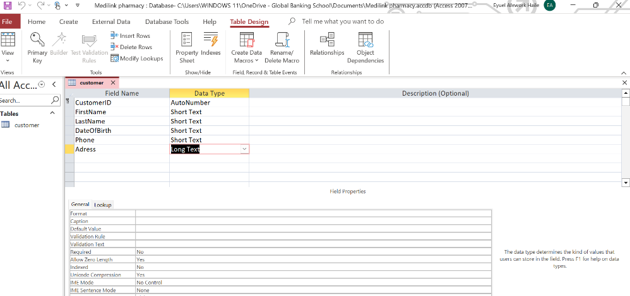

Fig 2 Customer Table

Supplier
- SupplierID (PK): Unique supplier identifier
- SupplierName: Company name
- ContactPerson: Primary contact person
- Phone: Supplier phone number
- Email: Supplier email address
- Address: Business address

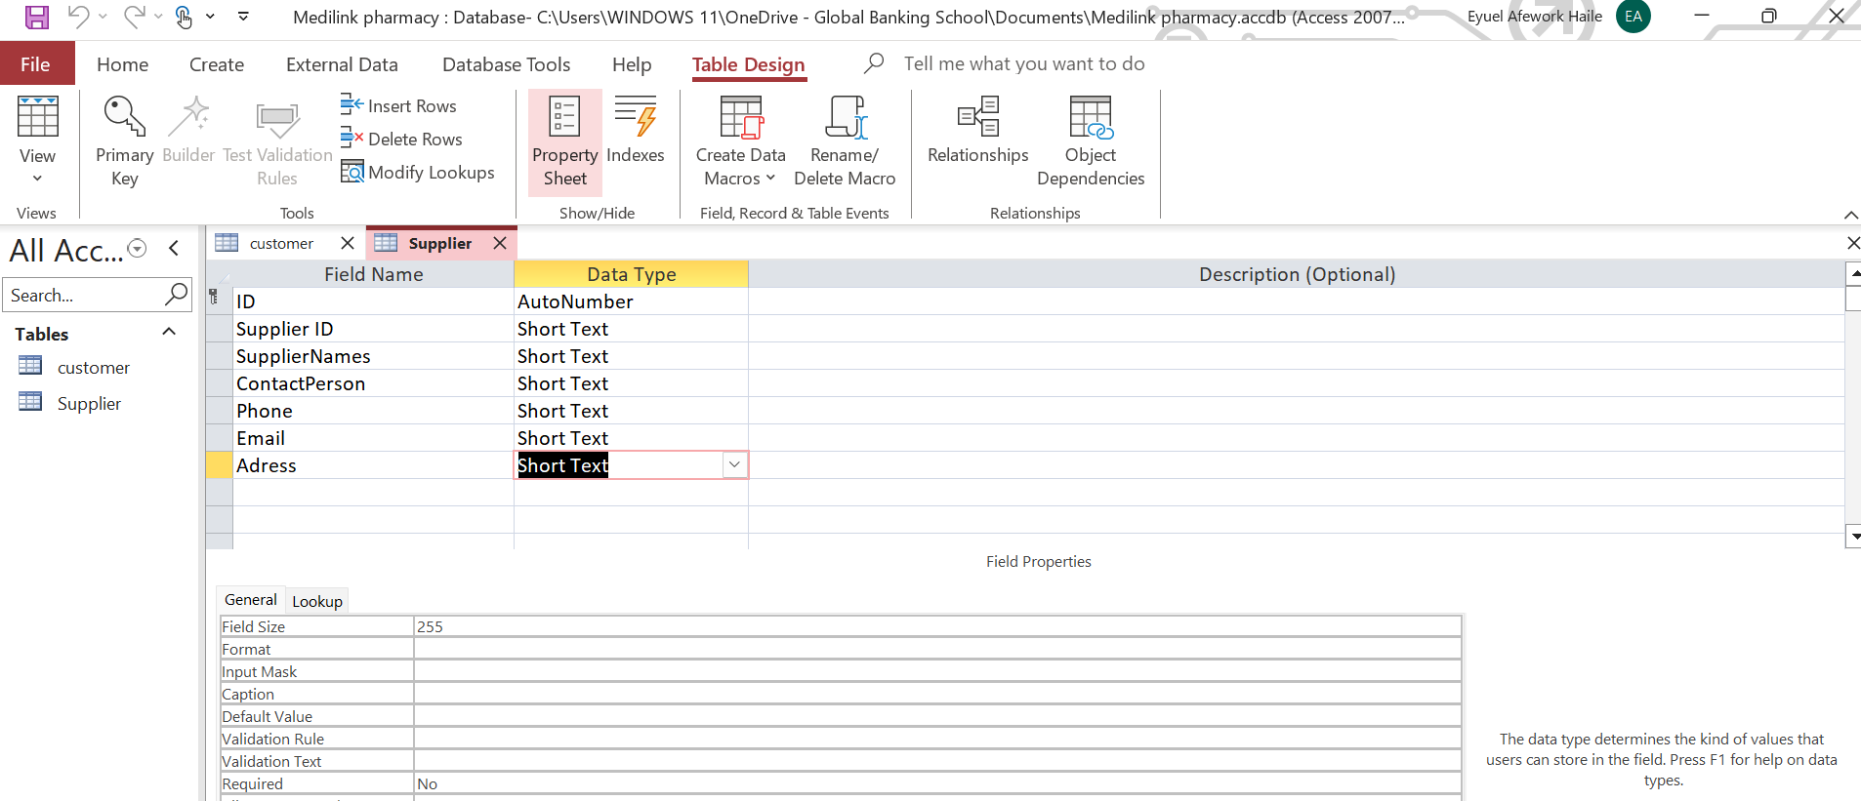
Fig 3 Suppler Table

Medicine
- MedicineID (PK): Unique medicine identifier
- MedicineName: Name of the medicine
- Category: Type (e.g., Antibiotic, Analgesic)
- UnitPrice: Selling price per unit
- StockQuantity: Current stock level
- ReorderLevel: Minimum required stock level
- SupplierID (FK): Links medicine to supplier

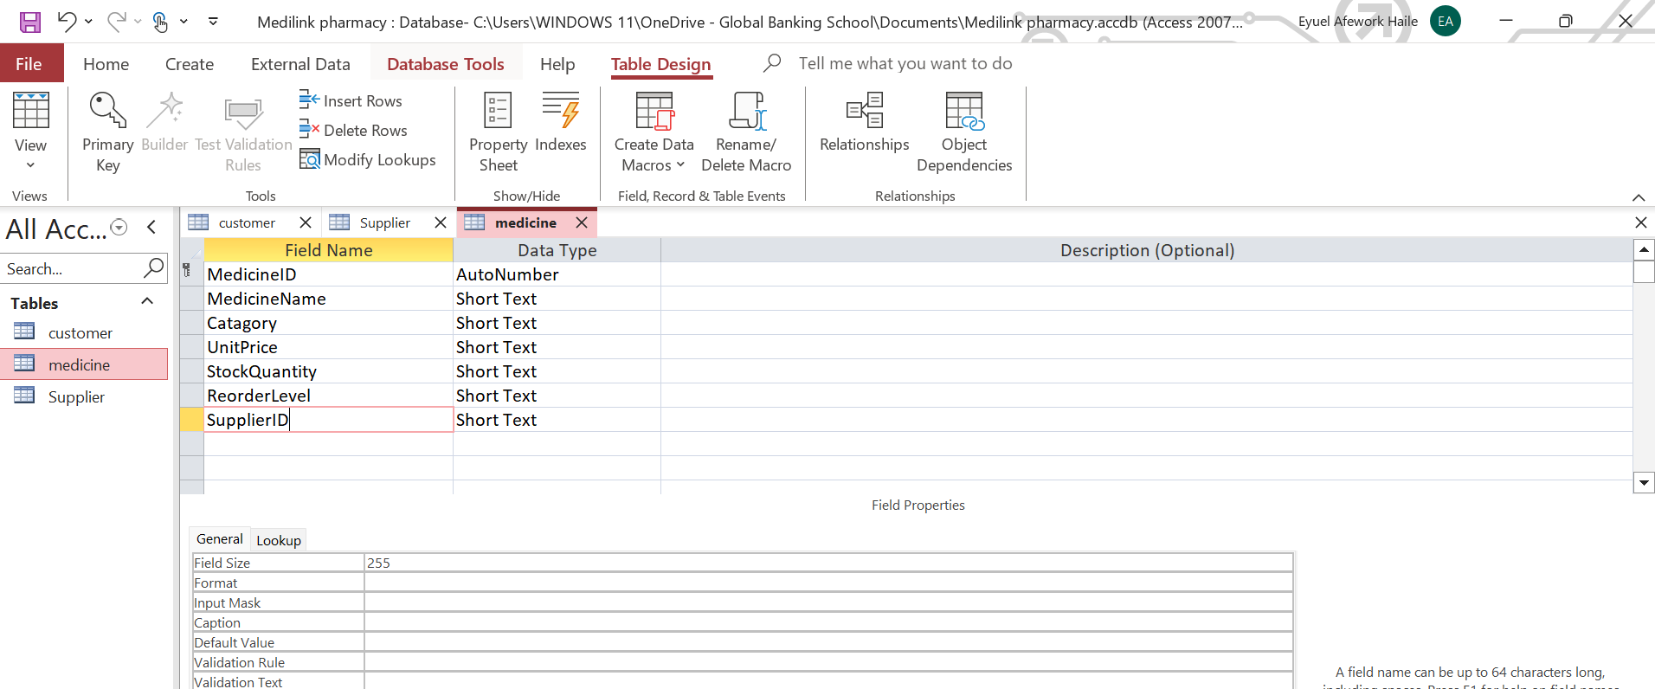
Fig 4 Medicine Table

Prescription
- PrescriptionID (PK): Unique prescription number
- PrescriptionDate: Date issued
- DoctorName: Prescribing doctor
- CustomerID (FK): Links to customer

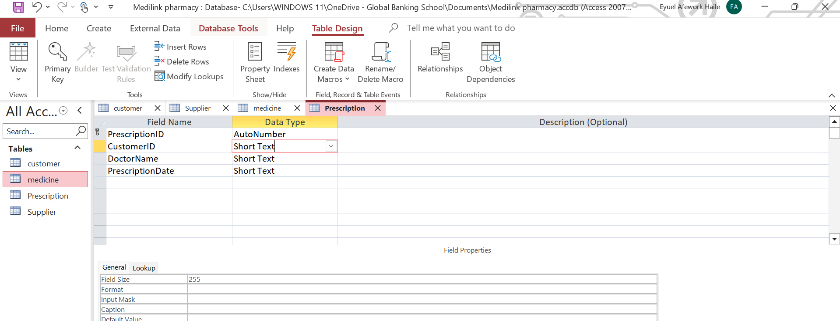
Fig 5 Prescription Table

Sales
- SaleID (PK): Unique sales transaction ID
- SaleDate: Date of transaction
- CustomerID (FK): Links to customer
- TotalAmount: Total sale value

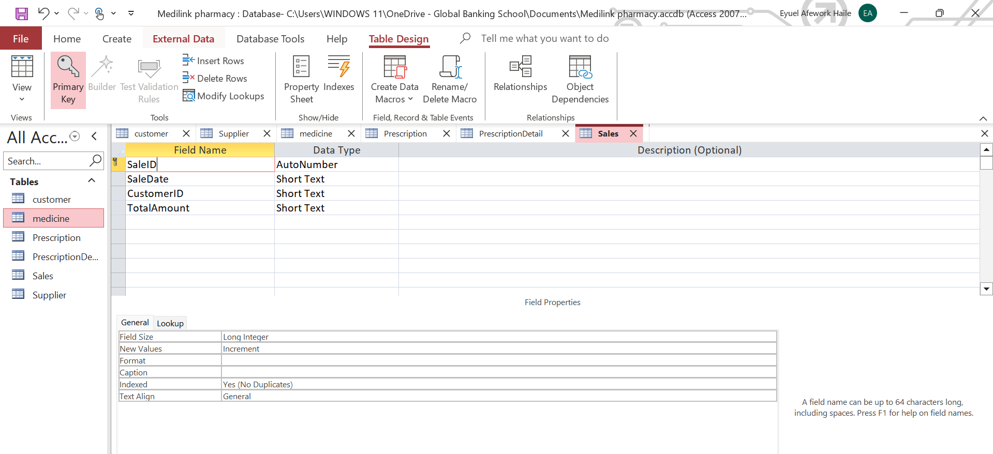
Fig 6 Sales Table

List of relationships and their meaning.

- Supplier → Medicine (1:M)
One supplier provides many medicines. Each medicine is supplied by one supplier.
- Customer → Prescription (1:M)
A customer can have multiple prescriptions. Each prescription belongs to one customer.
- Prescription → PrescriptionDetails (1:M)
A prescription can include multiple medicines.
- Medicine → PrescriptionDetails (1:M)
A medicine can appear in multiple prescriptions.
- Customer → Sales (1:M)
A customer can make multiple purchases.
- Sales → SalesDetails (1:M)
A sale can contain multiple medicines.
- Medicine → SalesDetails (1:M)
A medicine can appear in many sales transactions.

ER diagram:

Fig 7 ER Diagram

Normalization

First Normal Form (1NF)
- All attributes contain atomic values.
- No repeating groups.
- Each table has a primary key.

Second Normal Form (2NF)
- All non-key attributes fully depend on the primary key.
- Composite many-to-many relationships resolved using junction tables (SalesDetails and PrescriptionDetails).

Third Normal Form (3NF)
- No transitive dependencies.
- Supplier details are stored separately from Medicine.
- Customer information is not duplicated in Sales or Prescription tables.
This ensures minimal redundancy and high data integrity.

Sample Data Population

Customer (5 Records)

Fig 8 Sample data for Customer Table

Supplier (5 Records)

Fig 9 Sample Data For Customer Table

Medicine (5 Records)

Fig 10 Samplin for Medicine Table

Query Development

Query 1: Low Stock Medicines

Fig 11 Query 1 Low Stock Medicine It shows Medicines less than 100

Query 2: Sales by Customer

Fig 12 Query 2 Customer Purchase Shows that which medicine the customer Purchases

Testing and Validation
Requirement | Test Conducted | Result
Referential Integrity | Attempted to add linked supplier | Add successfully
Validation Rule | Add one row on all tables | Accept the result
Query Accuracy | Ran low stock query | Correct records returned
Sales Calculation | Created multi-item sale | Total calculated correctly
All functional requirements were successfully validated.

Design Decisions and Future Work

1. Design Decisions
- Use of separate junction tables to resolve many-to-many relationships.
- Enforcement of referential integrity to maintain consistency.
- Separation of Supplier and Medicine to eliminate redundancy.
- Use of AutoNumber for primary keys to ensure uniqueness.
- Inclusion of ReorderLevel to support automated stock control.

2. Future Work
- Add medicine expiry date tracking.
- Implement barcode scanning integration.
- Develop automated stock deduction after sales.
- Introduce user authentication and role-based access.
- Integrate reporting dashboard using Power BI.
- Enable automated reorder alerts.

Reports

Fig 13 Report For Low Stock Medicines

References:

[1] T. Connolly and C. Begg, Database Systems: A Practical Approach to Design, Implementation and Management, 6th ed. Pearson, 2015.
[2] R. Elmasri and S. Navathe, Fundamentals of Database Systems, 7th ed. Pearson, 2016.
[3] Microsoft, “Database Design Basics,” Microsoft Learn, 2023.

Link for MS Access

MediLinkPharmacyDB.accdb

