

Assignment title:
Planning and Delivering an International Meeting/Event.

International Meetings Management
BMIH6007

Lecturer’s name: Chris Wilkin
Student Name: Andreea Raluca Suciu
Student ID: 2206963

Table of Contents
1. Introduction 3
2. The Event Cycle 4
3. Event Concept 4
4. Aim and Objectives of the Meeting/Event 5
6. Event Management 7
7. Event Budget 8
8. Industry Trends/Issues/Impacts 9
9. Situational and Cultural Considerations 9
10. Conclusion 14
References 15

1. Introduction
The event of this consideration is Winter Wonderland 2 London. The event is a high-profile international corporate meeting where the agenda was to network and engage in business collaboration among professionals across different sectors. It takes place against the backdrop of a winter wonderland theme set in London's Greenwich Street, synchronising formal business processes with the festive experience of winter (Mitchell, 2021). This Winter Wonderland setting is a seasonal choice with an appeal offering participants the possibility to conduct business discussions in this London winter attraction par excellence.
The venue, Greenwich Street Winter Wonderland 2, has been selected because of its worldwide attraction as a place for all seasons, thus promising to leave an unmatched ambience among the delegates. Being in the heart of London, it promises ease and convenience for international visitors; top-class transport links and accommodations are available (Eldridge and Pappalepore, 2019). Its seasonal attraction is one of the excellent methods that would allow the winter celebrations to blur into corporate networking, a style that supports the general trend of experiential event management. The event was selected to grow interest in "business tourism" and experiential events, capitalising on the festive season as a leading motivator for attendees. The strategic objective is to facilitate high-level networking within a memorable ambience, which can easily boost attendance and active engagement.
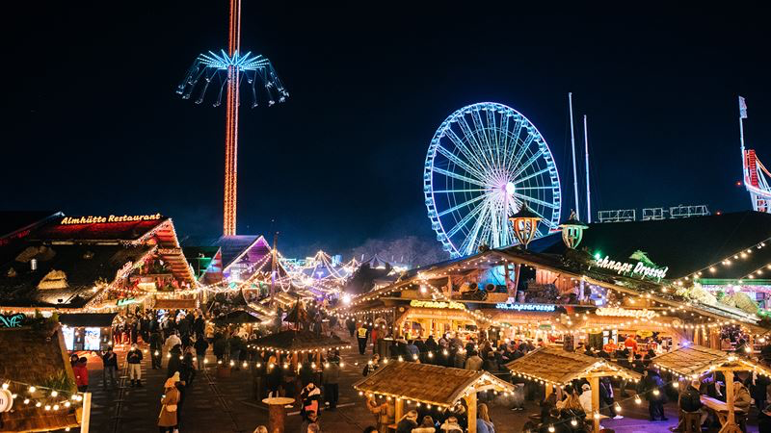
Figure 1: Winter wonderland 2024
(Source: Michael, 2024)

2. The Event Cycle
The Event Cycle is a cycle that outlines the stages in planning, delivering, and evaluating an event. Four main stages are contributing to the cycle: concept development, planning, implementation, and evaluation. All these stages are crucial for the Winter Wonderland 2 event’s success regarding operational effectiveness and attendee satisfaction.
- Concept Development: This concept idea will mix a winter-themed festive atmosphere with a professional meeting experience to give it that characteristic difference from regular corporate gatherings. In this case, the entire event will be held inside Winter Wonderland 2, which encompasses the festive atmosphere in the setting for this business networking event (Lakoff, 2023).
- Planning: Much of the detailed planning will be done at this stage, such as venue booking, sending invitations to delegates, the implementation of all logistics, and the handling of any required safety measures. Since the venue is in a winter setting, preparation concerning weather-related actions should be extraordinarily considered within this planning stage - cold-weather gear, snow clearance, and layout of paths around the venue for safe walking.
- Implementation: This would be the stage where the event would be implemented, where all the planned activities should be undertaken according to schedule. It will involve coordination with Winter Wonderland 2's event management to integrate this business activity with their existing winter attractions (Whitehead and Gordon, 2023).
- Evaluation: The event's success will be determined by the after-event feedback and evaluation. The performances will be assessed from the surveys and indicators on the experience offered by the delegates, elaborating on networking opportunities, the satisfaction of venues provided, and proper integration of the winter theme with the professional objectives (Simmie, 2020).
The event cycle will ensure all the complexities of merging a large-scale seasonal attraction with professional meetings will be managed under a structured approach.

3. Event Concept
Event Concept for Winter Wonderland 2 London: The event concept will give delegates the full-day experience of the immersive event blending business networking and festive winter attractions within the event calendar. The itinerary for the entire event experience is made in such a way that professional sessions will be distributed with time to relax and enjoy the seasons.
Itinerary:
Morning (9:00 AM - 12:00 Noon):
Registration will be in a designated event tent at Greenwich Street. One of the biggest keynotes addresses ever heard will be dished out by an industry leader who will still not be known, but speaking on the theme, "Building Global Business Networks in Festive Settings." Immediately after the keynote, there will also be panel discussions and breakout sessions on the more important business trends that will include global trade, business technology, and sustainability.
Lunch Break (12:00 PM - 1:30 PM):
Traditional holiday meals and drinks are arranged within a winter theme on lunch break. Casual networking will be held outside Winter Wonderland 2's ice-skating rink and within its festive stalls wherein delegates will be able to appreciate the environment.
Afternoon (1:30 PM - 4:00 PM):
Afternoon, Workshops and master business innovation/leadership/entrepreneurship, etc. Smaller groups will enable networking through discussing topics of their interest in a much less formal setting.
4:00 PM - 7:00 PM evening:
It will then be closed with a closing reception at the Winter Wonderland 2 Ice Bar, trying to put a business conversation in a festive atmosphere. This event will also be wrapped by fireworks as a celebration of the event's success, out of these live performances outside of the themes of the winter season.
The event caters to delegates ensuring them to have a holistic experience that will provide business opportunities while enjoying the seasonal setting by creating a festivity and relaxed atmosphere within the structure of the professional meeting.

4. Aim and Objectives of the Meeting/Event
To create a unique platform for global business professionals to network and collaborate in an immersive winter-themed setting, fostering both professional relationships and seasonal experiences.

SMART Objectives | Details
Specific | Attract 250 international delegates from at least 15 countries.
Measurable | Track the number of delegates and countries represented through registration data.
Achievable | Utilise targeted marketing campaigns and leverage existing industry networks.
Relevant | Focus on enhancing global professional collaboration in a themed, experiential setting.
Time-Bound | Reach this target by December 1st, 2024.

Objective 2 | Details
Specific | Facilitate a minimum of 50 business-to-business (B2B) meetings.
Measurable | Track meetings using pre-scheduled appointment software.
Achievable | Ensure proper scheduling and delegate involvement prior to the event.
Relevant | Maximize networking opportunities for delegates.
Time-Bound | To be completed during the event.

Objective 3 | Details
Specific | Achieve a 90% satisfaction rate from delegates.
Measurable | Use post-event surveys to gather feedback.
Achievable | Focus on balancing business activities with leisure elements.
Relevant | Ensure delegates enjoy both professional networking and the seasonal theme.
Time-Bound | To be evaluated after the event.

6. Event Management
The management of the Winter Wonderland 2 London event requires a range of specialised skills and resources to ensure seamless execution, considering both operational and strategic elements.
Operational Management:
- Logistics: Managing the logistics of hosting an event in an open winter environment involves considerations for weather conditions, safety, and accessibility. Coordination with Greenwich Street’s management team is crucial to secure dedicated areas for the event’s professional sessions while integrating them with Winter Wonderland 2’s attractions (Russo and Comi, 2020).
- Venue Setup: Specialised winter tents, equipped with heating and AV systems, will be required to host keynote speeches, workshops, and networking areas. Ensuring the comfort and safety of delegates in potentially cold conditions is a top priority (Silver, Byrne, and Adler, 2021).
- Risk Management: Contingency plans need to be in place to handle weather disruptions, such as heavy snow or transportation delays. This includes ensuring proper insurance coverage and working with local authorities to guarantee delegate safety.

Planning Activities:
- Scheduling and Coordination: A detailed timeline needs to be developed for the event, covering all aspects from delegate registration to closing activities. This requires collaboration with multiple stakeholders, including venue managers, catering services, and sponsors (Gyford, 2020).
- Delegate Experience: Creating a cohesive delegate experience involves balancing formal business sessions with the more informal festive elements. Special attention must be given to transitions between professional and recreational activities.
Marketing Activities:
- Digital Campaigns: A winter-themed marketing campaign will be launched, targeting global business professionals through digital channels such as LinkedIn, industry newsletters, and email campaigns. Promotional materials will emphasize the unique setting and networking opportunities (Keene, 2022).
- Partnerships and Sponsorships: Securing sponsorships from relevant brands (e.g., winter sports companies, and travel agencies) will not only provide funding but also enhance the event’s credibility and appeal.
In managing the Winter Wonderland 2 London event, an emphasis on detailed operational planning, careful risk management, and targeted marketing is essential to ensure its success.

7. Event Budget
The Winter Wonderland 2 London budget is crucial for the financial viability of the event. This budget will be broken down into income and expenditure, with sources of funding and strategies for generating more income (Chohan, 2023).

Income:
- Fees from Delegates: With a target number of delegates at 250 and a £500 per delegate registration fee, the total amount expected to be raised in delegate fees amounts to £125,000.
- Sponsorship: Sponsorship from firms like winter sports equipment companies travel agencies, or corporate sponsors could also add £50,000 more.
- Exhibitor Fees: Depending on the event's relevance, exhibitors such as businesses selling products with a winter theme may be charged a fee, for instance, £1,000 each, with 10 exhibitors and an aggregate of £10,000.
Total Projected Income: £185,000
Expenses
- Venue Costs: This will cover the costs of renting a dedicated space in Winter Wonderland 2 and arranging specialised tents and equipment. This is going to run £50,000.
- Catering: For 250 delegates, winter-themed food and beverages will run about £30 per delegate. This works out to £7,500.
- Marketing: A digital and print campaign will cost £10,000
- Logistics and Staffing: Event staff, AV technicians and logistics personnel will cost £20,000.
- Contingency Fund: The extraordinary expenses will account for a 10% contingency fund of £18,500.
Total Projected Expenditure: £106,000
Net Profit/Surplus: This event is going to make £79,000 net surplus that can be reinvested into future events or donated to a relevant charity to enhance the reputation of the event.

8. Industry Trends/Issues/Impacts
This industry of meetings and events is very high in the change curve. The reasons behind this high change are emerging trends as well as global challenges. Therefore, incorporating such changes into their planning and execution is the only way for Winter Wonderland 2 London to stay competitive and relevant (Butler and Dodds, 2023).
An event is sustainability-based. Clients and attendees require that these be environment-friendly practices, and thus the event organisers should strive to reduce their impacts on the environmental aspects of the event. Winter Wonderland 2 London will be administered with aspects of sustainability by doing away with the usage of plastics, use of recyclable materials, and adopting the use of products from local suppliers in the catering services. All these elements reduce the carbon footprint of the event and make it more attractive to environmentalists as attendants.
The new wave of experiential events revolutionises the traditional formats. The demand is no longer for standard business conferences but instead for immersive experiences that are a combination of leisure the business objectives (Maxim, 2023). Winter Wonderland 2 London offers the theme of festive value for delegates in a holiday-inspired environment, complementing networking opportunities, through such an approach, engagement will be increased, and the event will be more memorable as well as enjoyable while fulfilling its business function.
Another significant trend is the increased interest in hybrid events, as these events combine both physical and virtual events. Hybrid events are more versatile in allowing participation by those who cannot participate physically. Although Winter Wonderland 2 is an event designed mostly for a physical setup, offering it virtually allows international delegates who would be restricted from travel or do not have budgets. This hybrid model ensures inclusivity and high attendance without sacrificing the immersive experience for on-site participants.

9. Situational and Cultural Considerations
A sufficient plan to be laid down for Winter Wonderland 2 London must take into consideration situational and cultural aspects. PESTEL analysis will now consider the external influences that will be posed against the event (Thomas et al., 2021).
PESTEL Factor | Considerations for Winter Wonderland 2 London
Political | Brexit impacts international attendance due to stricter visa regulations and potential trade barriers. Adequate legal support will be planned to facilitate seamless entry for international delegates.
Economic | Economic fluctuations may lead to reduced travel budgets for delegates. To mitigate this, early-bird discounts and value-added services will be offered to ensure the event remains affordable.
Social/Cultural | Cultural sensitivity is vital, considering the international nature of the event. Diverse catering options and inclusive entertainment will ensure all delegates feel welcomed and accommodated.
Technological | Advances in event technology, such as virtual meeting platforms and delegate management software, will be employed to streamline processes like registration, scheduling, and collecting feedback from participants.
Environmental | The open winter setting presents environmental risks, such as inclement weather. Contingency plans, such as alternative venues or structures, will be in place to address any potential disruptions.

Given the situation and culture, Winter Wonderland 2 London can consider these factors to ensure that its event is well-positioned for international delegates and external influences (Dalirazar and Sabzi, 2023).
With the EMBOK model, the five major domains of the model can be related to Administration, Design, Marketing, Operations, and Risk, which as a whole can be applied to drive more strategic planning and delivery considerations when it comes to Winter Wonderland 2 London. Here's how each domain applies to the Winter Wonderland 2 event:

EMBOK Model Application for Winter Wonderland 2 London

EMBOK Domain | Application to Winter Wonderland 2 London
1. Administration | This domain covers financial, human resources, procurement, and legal considerations. For Winter Wonderland 2, financial planning (including budgeting and funding sources) and contract management (especially with international vendors and venues) will be crucial. Ensuring effective legal support for visa regulations, as highlighted in the PESTEL analysis, is also a part of this domain. Furthermore, human resources management will ensure that staff are well-prepared for the event.
2. Design | The design domain focuses on the attendee experience, including theme, decor, and overall atmosphere. The Winter Wonderland 2 theme should be immersive, featuring winter-themed decorations, festive lighting, and themed entertainment. The event design will also encompass the experiential aspect, blending business and leisure, and will need to cater to diverse cultural preferences, as highlighted in the Social/Cultural section.
3. Marketing | The marketing domain deals with brand management, communications, and media. The Winter Wonderland 2 event will use targeted marketing campaigns to attract the 250 international delegates, as defined in the SMART objectives. Additionally, digital marketing will be leveraged to reach international audiences, with a hybrid component offering virtual attendance. Marketing efforts will emphasize the event's unique combination of seasonal charm and professional networking opportunities.
4. Operations | The operations domain includes all logistical aspects, from venue management to on-site services. For Winter Wonderland 2, venue logistics, especially given the winter season, must be carefully managed. Contingency plans for weather disruptions are necessary, and delegate management software will help streamline operations such as registration and scheduling. Ensuring smooth event operations through detailed planning will enhance the guest experience.
5. Risk | The risk domain focuses on identifying and mitigating potential risks. Winter Wonderland 2 must prepare for risks related to safety, weather conditions, and economic uncertainties. For instance, contingency plans for severe weather are essential, as noted in the PESTEL environmental analysis. Additionally, backup systems for technology (e.g., virtual platforms) must be considered to ensure seamless event execution, both in-person and online.

How EMBOK Enhances the Event Strategy
- Administration consists of budgeting, staffing, and paperwork streamlining, related to reducing financial and legal risks, and efficient use of resources.
- Design concerns with general guest experience, focusing on a hotel to create an immersive environment which can strengthen professional networking and seasonal enjoyment.
- Marketing makes the event accessible to the target audience, especially international and digital strategies that support achievement in terms of attendance and engagement goals.
- Operations ensure that the logistical concerns can be met effectively, from managing on-site activities to mitigating some possible environmental risks.
- Risk management helps in preparing for any possible disruption or challenge toward the event's success, as against any occurrence of something out of the ordinary.
With the application of the EMBOK model, Winter Wonderland 2 London will be able to have a comprehensive approach towards event planning and delivery to ensure every strategic, operational, and experiential aspect is well-coordinated for the successful holding of the event.
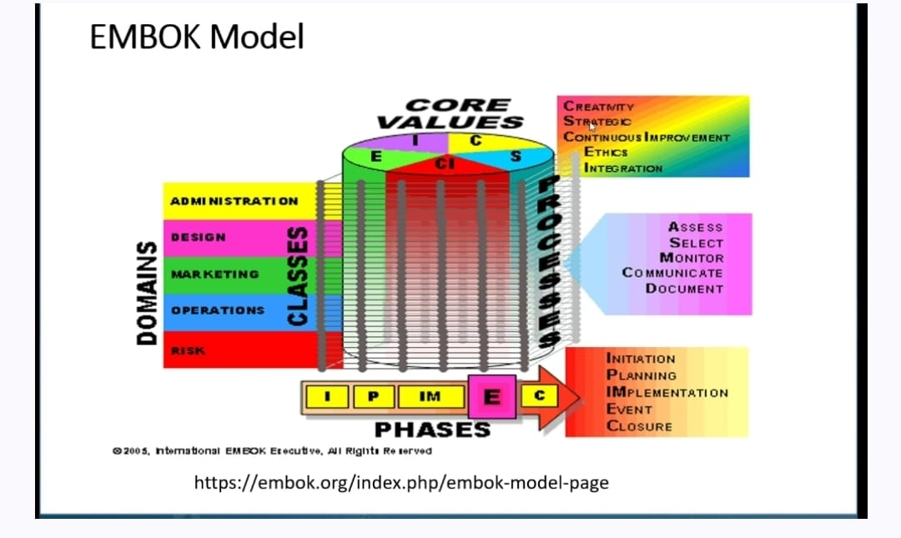
Figure 2: (EMBOK Model)
Source: (https://embok.org/index.php/embok-model-page)

10. Conclusion
As part of the experience, the Winter Wonderland 2 London event allows for synergy between professional networking and a festive, experiential setting. Careful adherence to the event cycle and application of strategic planning techniques promise to allow this event to meet specific objectives of attracting international delegates and offering memorable business experiences.
It would encapsulate the best of experiential event design with strong operational planning and alignment with industry trends to ensure that an event can be delivered successfully. Attention to cultural sensitivity, sustainability, and digital tools would further enhance its appeal, making it a model for future seasonal business events.
The event budget is a strong indicator of financial viability, but the PESTEL analysis requires seriousness toward external factors. Generally speaking, Winter Wonderland 2 London occupies a strategic position to deliver that perfect balance of professional and recreational experiences aligned with the latest industry trends.

References
Butler, R.W. and Dodds, R., (2023). Overtourism: Trends, issues, impacts and implications. In Routledge Handbook of Trends and Issues in Global Tourism Supply and Demand (pp. 246-255). Routledge.
Chohan, U.W., (2023). Budget Office. In Global encyclopedia of public administration, public policy, and governance (pp. 870-875). Cham: Springer International Publishing.
Dalirazar, S. and Sabzi, Z., (2023). Strategic analysis of barriers and solutions to development of sustainable buildings using PESTLE technique. International Journal of Construction Management, 23(1), pp.167-181.
Eldridge, A. and Pappalepore, I., (2019). Festive space and dream worlds: Christmas in London. In Destination London: The Expansion of the Visitor Economy (pp. 183-203). London: University of Westminster Press.
Gyford, J., (2020). Politics and planning in London. In Planning London (pp. 71-89). Routledge.
Keene, D., (2022). Shops and shopping in medieval London. In Mediaeval Art, Architecture and Archaeology in London (pp. 29-46). Routledge.
Lakoff, G., (2023). What is a conceptual system?. In The nature and ontogenesis of meaning (pp. 41-90). Routledge.
Maxim, C., (2023). Trends and issues in world tourism cities. Routledge Handbook of Trends and Issues in Global Tourism Supply and Demand.
Mitchell, D., (2021). To Go Again to Hyde Park: Public Space, Rights and Social Justice. In Public Space Reader (pp. 148-153). Routledge.
Russo, F. and Comi, A., (2020). Investigating the effects of city logistics measures on the economy of the city. Sustainability, 12(4), p.1439.
Silver, D., Byrne, U. and Adler, P., (2021). Venues and segregation: A revised Schelling model. PLoS one, 16(1), p.e0242611.
Simmie, J., (2020). Planning and London. In Planning London(pp. 1-18). Routledge
Thomas, P.J., Sandwell, P., Williamson, S.J. and Harper, P.W., (2021). A PESTLE analysis of solar home systems in refugee camps in Rwanda. Renewable and Sustainable Energy Reviews, 143, p.110872.
Whitehead, C.M. and Gordon, I., (2023). Strengthening the strategic core of London plans in the face of new and old challenges. LSE London.

