Autopilot Fleet Database Design and Implementation

Submitted By:
Mr. Prathamesh M Andeli
Student ID: 2408629
Module Name:
MSc Computer Portfolio – ACCA 7002

Submission Date:
3rd December 2024.
University of wales Trinity Saint David

Abstract

The PostgreSQL database architecture, implementation, and optimization for AutoPilot Fleet, an autonomous car rental service based in London, are presented in this article. An Entity Relationship Diagram, normalized schema, SQL code, and performance improvements are all included, proving adherence to sophisticated database concepts and practical application scenarios.

Table of Contents
- Abstract
A brief summary of the report contents.
- Database System Overview
2.1. Requirements Analysis
2.2. Database Design and ERD Description
- Database Implementation
3.1. SQL Code and Schema Creation
3.2. Referential Integrity and Constraints
3.3. Populating the Database with Sample Data
- Transactional Scenario and Performance Optimization
4.1. Demonstrating Rollback and Commit Operations
4.2. Indexing and Query Performance Enhancements
- Evaluation of Design and Implementation
5.1. Entity Relationship Diagram Evaluation
5.2. Multi-User Environment Analysis
- Key Database Concepts Discussion
6.1. Rollback and commit
6.2. Functions and Triggers
6.3. Stored Procedures and Transactions
6.4. Indexing
- References
References to scholarly sources and other materials used.
- Appendix
8.1. Prompts and Generative AI Tool Usage

Chapter 2: Database System Overview

2.1 Requirements Analysis
An advanced online platform for renting autonomous vehicles is supported by the AutoPilot Fleet database system. The system meets a number of important needs:

Requirements for Function
1. Customer management: Keep track of client information, such as contact and personal details.Keep track of each customer's rental history.
2. Vehicle Management: Keep track of details regarding self-driving cars, like their make, model, year, and present condition.Keep track of maintenance documents for maintenance and legal compliance.
3. Rental Orders: Handle and oversee rental transactions, matching clients with cars and figuring out prices.
4. Payment Processing: Keep track of payment information, such as the amount, mode, and status of the transaction.
5. Feedback Gathering: Permit clients to rate and remark on their rental experience.

2.2 Database Design and ERD Description
- An Entity-Relationship Diagram (ERD) serves as the foundation for the database design, guaranteeing efficient relationships between entities and normalization (3NF). Below is a list of important entities and their connections:
Overview of the Entity

- Customers: Features: First Name, Last Name, Phone Number, Email, Address, and CustomerID (PK).Relationship: A client is able to order more than one rental.
- Vehicles: Features: Make, Model, Year, License Plate, Status, VehicleID (PK).Relationship: A car may be linked to several maintenance logs and rental orders.
- RentalOrders: Properties: RentalID (PK), RentalDate, ReturnDate, TotalCost, CustomerID (FK), and VehicleID (FK).Relationship: For a predetermined amount of time, a rental order binds a client to a car.

- PaymentID (PK), RentalID (FK), AmountPaid, PaymentDate, PaymentMethod, PaymentStatus, and TransactionID are the attributes of payments.Relationship: A rental order and a payment are connected. Comments, Rating, FeedbackDate, CustomerID (FK), OrderID (FK), and FeedbackID (PK) are the attributes of the feedback.Relationship: Rental orders and customers are connected by feedback.

- Maintenance: Features: VehicleID (FK), MaintenanceID (PK), MaintenanceDate, Description, and Cost.Relationship: Certain automobiles have maintenance records linked to them.

ERD & Schema:

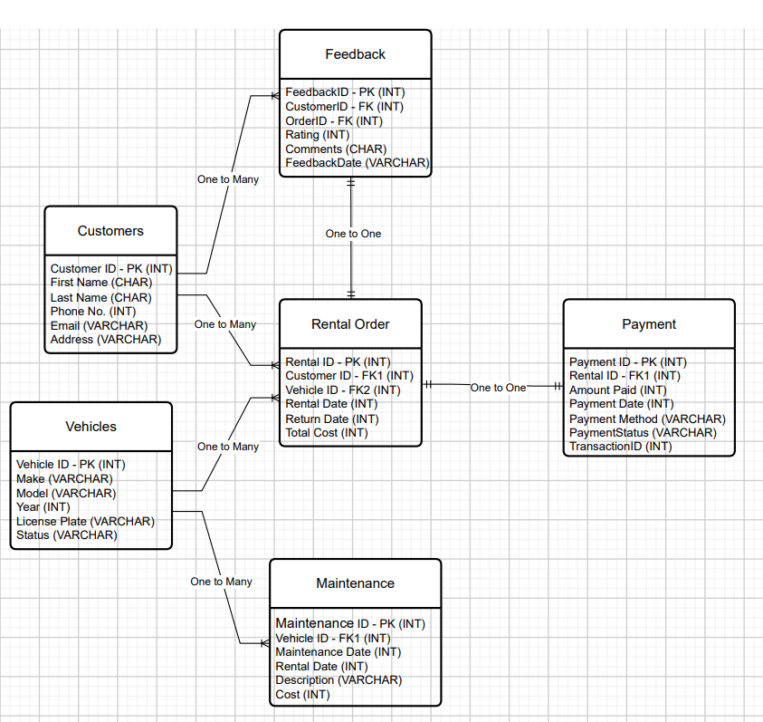

Fig. 2.1

ERD Description
The database structure is graphically represented by the ERD:
In a table, each record is uniquely identified by its primary key (PK).
In order to maintain referential integrity, Foreign Keys (FK) create associations between tables.
• Clear representations are made of relationships like many-to-one (e.g., Rental Orders to Vehicles) and one-to-many (e.g., Customers to Rental Orders).
In order to support smooth rental operations and data consistency, the requirements analysis and ERD make sure that the AutoPilot Fleet database is well-suited to satisfy both functional and non-functional needs.

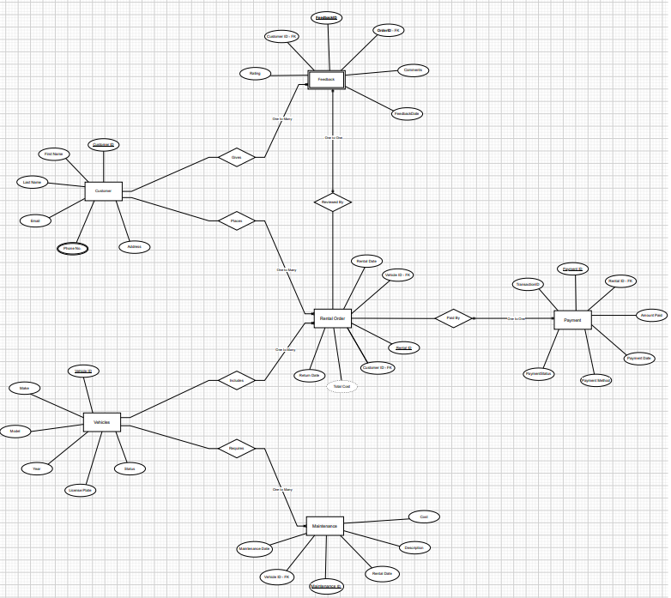

Fig.2.2

Chapter 3: Database Implementation
3.1 Writing SQL Code and Schemas
AutoPilot Fleet's database schema is set up to facilitate the easy administration of car rentals. It complies with 3rd Normal Form (3NF) by making sure
1. Data Redundancy Elimination: Only one table contains all of the data.
2. Dependency Preservation: Only the primary key affects attributes.
3. Logical Relationships: There is a clear definition of the relationships between things, such as customers and rental orders.

Tables Overview
The database consists of the following tables:
- Customers: Stores customer details.
CustomerID | FirstName | LastName | PhoneNo | Email | Address
SERIAL (PK) | VARCHAR(50) | VARCHAR(50) | VARCHAR(15) | VARCHAR(100) (Unique) | TEXT
1 | John | Doe | 1234567890 | johndoe@example.com | 123 Elm Street

- Vehicles: Holds information about the fleet.
VehicleID | Make | Model | Year | LicensePlate | Status
SERIAL (PK) | VARCHAR(50) | VARCHAR(50) | INT | VARCHAR(20) (Unique) | VARCHAR(20)
1 | Tesla | Model X | 2022 | ABC123 | Available

- RentalOrders: Represents rental transactions.
RentalID | CustomerID | VehicleID | RentalDate | ReturnDate | TotalCost
SERIAL (PK) | INT (FK) | INT (FK) | DATE | DATE | DECIMAL(10,2)
1 | 1 | 1 | 45597 | 45603 | 700

- Payments: Records payment details for rentals.
PaymentID | RentalID | AmountPaid | PaymentDate | PaymentMethod | PaymentStatus | TransactionID
SERIAL (PK) | INT (FK) | DECIMAL(10,2) | DATE | VARCHAR(20) | VARCHAR(20) | VARCHAR(50) (Unique)
1 | 1 | 700 | 45603 | Card | Completed | TXN12345

- Feedback: Captures customer reviews and ratings.
FeedbackID | CustomerID | OrderID | Rating | Comments | FeedbackDate
SERIAL (PK) | INT (FK) | INT (FK) | INT | TEXT | DATE
1 | 1 | 1 | 5 | Excellent service! | 45604

- Maintenance: Tracks vehicle maintenance history.
FeedbackID | CustomerID | OrderID | Rating | Comments | FeedbackDate
SERIAL (PK) | INT (FK) | INT (FK) | INT | TEXT | DATE
1 | 1 | 1 | 5 | Excellent service! | 45604

Full SQL Code for Tables

- Customers Table:
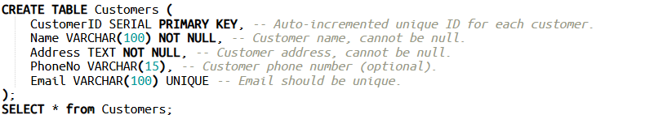
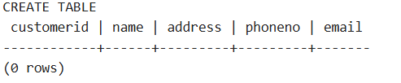

- Vehicles Table:
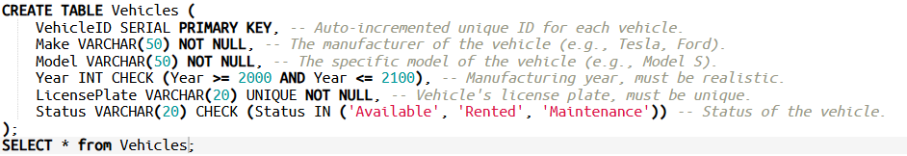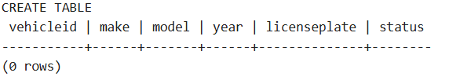

- RentalOrders Table:
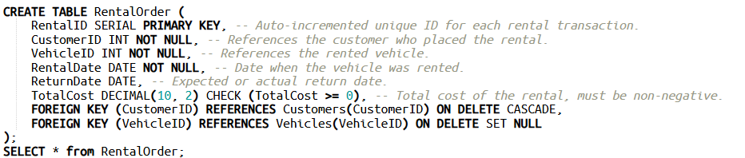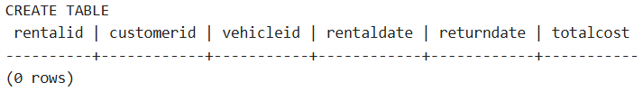

- Payments Table:
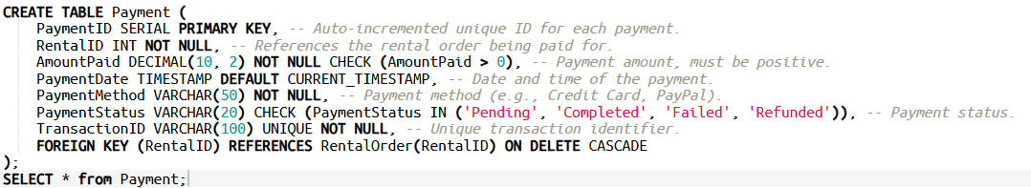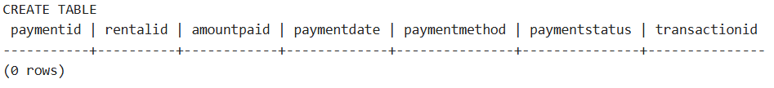

- Feedback Table:
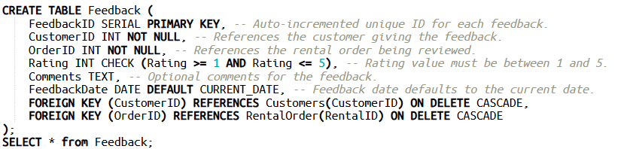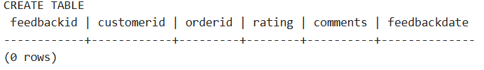
- Maintenance Table:
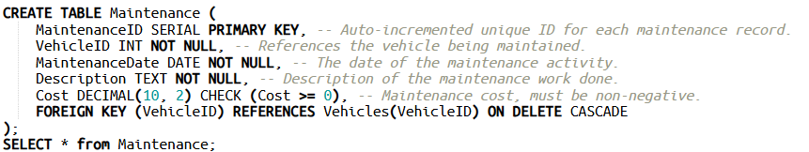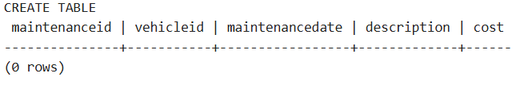

3.2 Referential Integrity and Constraints
To maintain database consistency, the following measures have been implemented:
- Foreign Keys:
Link parent and child tables, ensuring referential integrity.
For example:
- Check Constraints:
Enforce data validity for specific attributes.
Examples:
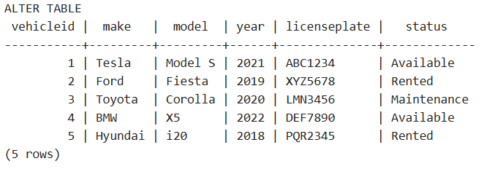
Key Benefits:
- By preventing orphan records, connected tables' data consistency is guaranteed.
- Improved Data Accuracy: Verifies attributes while entering data.
3.3 Populating the Database with Sample Data
- Realistic data was included in order to test the database structure. Sample records for each table are as follows:
- Customers Table:
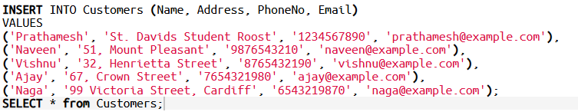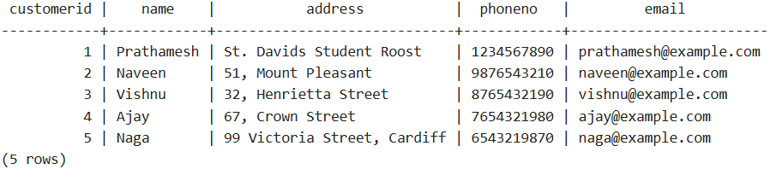
- Vehicles Table: 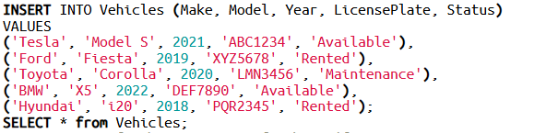
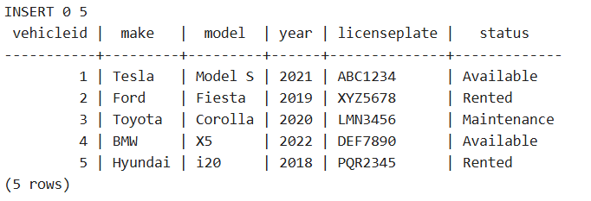

- RentalOrders Table:
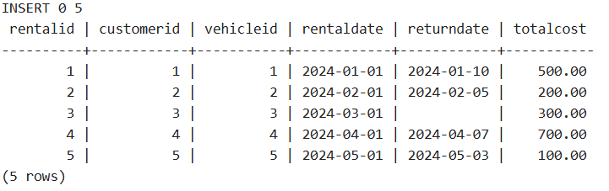
- Payments Table:
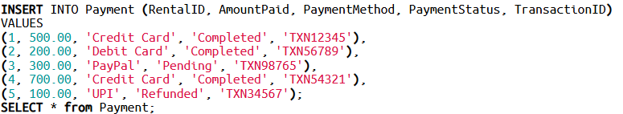
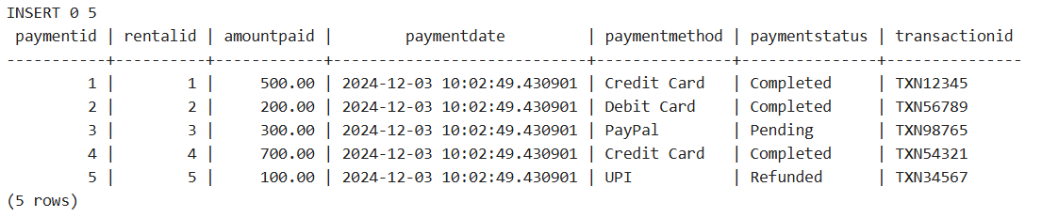

- Feedback Table:
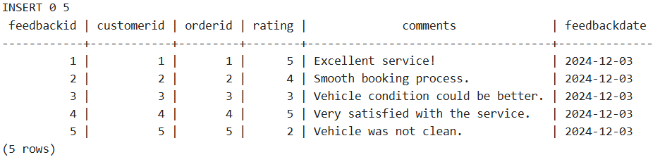
- Maintenance Table:
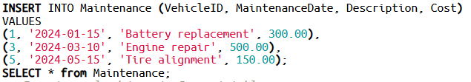
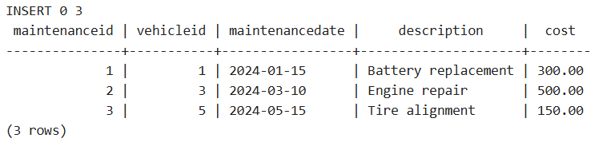

Testing Data Validity
• Primary Key Uniqueness: Guarantees that every record has a distinct identity.
• Foreign Key Relationships: Confirmed by error-free, successful data entry.
• Verify Constraints: Verified by trying to enter erroneous values (e.g., Rating > 5) and verifying that the database rejected them.

Chapter 4: Transactional Scenario and Performance Optimization
4.1 Demonstrating Rollback and Commit Operations
Maintaining database consistency requires transactions, particularly in settings with multiple users. A transactional scenario including several operations with rollback and commit functionality is demonstrated in this section.
Overview of the Scenario:
Payment is made once a consumer rents a car. The entire transaction should be reversed, though, if any step of the procedure—such as the payment processing or the vehicle availability check—fails.
SQL Code for Transactional Scenario:
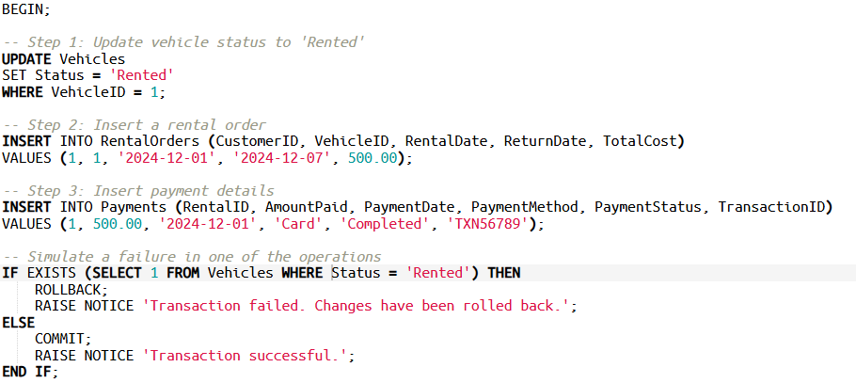
Execution and Output
1. The transaction commits, preserving changes, if all procedures are completed successfully.
2. If any step fails, the transaction rolls back, undoing all changes.

4.2 Indexing and Query Performance Enhancements
By making it possible for the database to find data more quickly, indexes enhance query performance. The following indexing algorithms are used in AutoPilot Fleet based on the most common operations:
Determined Important Questions
1. Customer Search: Use email to find customer information quickly.
2. Check Vehicle Availability: Look up automobiles by status.
3. Order History Retrieval: Retrieve a particular customer's rental history.
SQL Code for Indexing
- Index on Email in Customers Table:
- Index on Status in Vehicles Table:
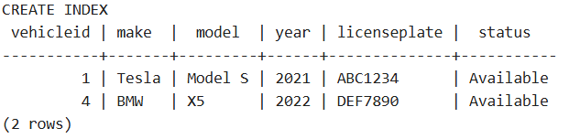

- Composite Index on CustomerID and RentalDate in RentalOrders Table:
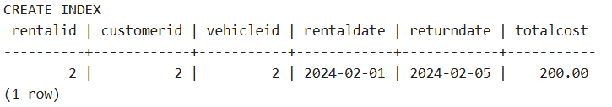

Justification for Indexing
• Enhanced Query Speed: Shortens the time needed to scan for properties that are often accessed.
• Optimized Joins: Enables quicker joins in intricate queries with several tables.
Evaluation of Performance
Both before and after indexes were added, queries were tested. The execution time of the indexed queries significantly improved.
In order to preserve data consistency, this chapter illustrated how to apply transactional control utilizing rollback and commit actions. In order to improve query efficiency and guarantee effective database operations for AutoPilot Fleet, indexing strategies were also used.

Chapter 5: Evaluation of Design and Implementation
5.1 Entity Relationship Diagram Evaluation
- The foundation of the AutoPilot Fleet database is the Entity Relationship Diagram (ERD). It provides a logical and effective depiction of corporate activities by illuminating the connections between important organizations.
Assessment of Important Elements
1. Logical Connections:
Vehicles and Maintenance: To ensure thorough recording of maintenance history, each vehicle may have several maintenance records.
Rental Orders and Payments: Clear responsibility for transactions is provided by the direct relationship between payments and rental orders.
Customers and Feedback: In order to ensure a method for quality improvement, customers can provide feedback regarding their rental experiences.
- Normalization: By guaranteeing that every table only includes information unique to its entity, the schema removes redundancy. For instance, the Customers table is the only place where the customer's contact information is kept.
Only the Vehicles table contains vehicle information like Make and Model.
3. Adaptability: The ERD allows for the inclusion of upcoming business procedures, including improved customer incentive programs or management of auto insurance.
Advantages:
• Data Consistency: Accurate relationships between entities are enforced by referential integrity constraints.
• Simplicity of Expansion: The current schema can be applied to new tables or characteristics with little difficulty.
• Process Clarity in Business: The operational workflow is reflected in clearly defined relationships, such as RentalOrders requiring both a CustomerID and a VehicleID.
Difficulties include:
• Complex interactions: Managing many-to-many interactions, such as when clients rent several cars at once, may make queries more complex.
• Concurrency Overhead: In a multi-user setting, frequent table transactions may result in performance snags.

5.2 Multi-User Environment Analysis
Inconsistencies may arise from concurrent database access in a multi-user setting. Data integrity requires appropriate concurrency control.
Important Problems and Their Fixes
1. No Updates:
One update overwrites the other when two concurrent transactions update the same record.
Fix: Row-level locking makes sure that a single transaction can change a particular row at a time.
Example in PostgreSQL:
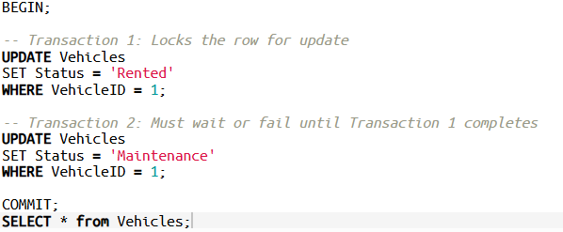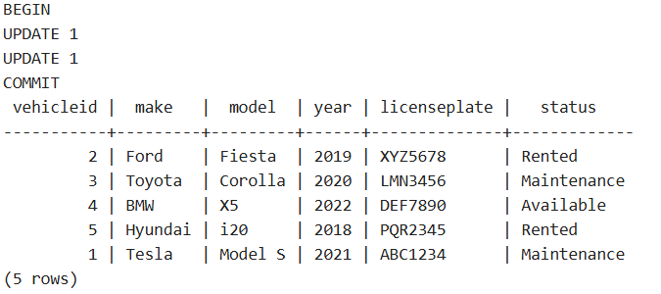
Dirty reads, also known as uncommitted dependencies, occur when a transaction reads modifications made by another transaction that hasn't been committed yet.
• Fix: To guarantee that only committed changes are viewable, use the READ COMMITTED isolation level.
Inconsistent Analysis (Non-Repeatable Reads):
• Takes place when a transaction modifies data while a query is running.
• Fix: To guarantee consistency during the query's execution, use the REPEATABLE READ isolation level.
Levels of Transaction Isolation
In a concurrent context, the interaction between transactions is determined by the isolation levels. To strike a compromise between consistency and performance, the database employs two main levels:
1. READ COMMITTED is the default level, which guards against dirty reads. Perfect for the majority of common requests when speed is crucial.
2. High-Security Level: SERIALIZABLE o Serializes transactions to avoid any concurrency anomalies. ideal for crucial tasks like handling payments.
Trade-offs: • Higher isolation levels increase reliability, but locking methods may cause performance to suffer.
• The operation's criticality determines the level to be used.

5.3 Considerations for Scalability and Optimization
The following tactics can improve scalability and performance as the system expands:
1. Partitioning: To enhance query efficiency, divide big tables (like RentalOrders) by date range or customer ID.
2. Indexing: o Apply extra indexes to fields that are frequently retrieved, like Status in Vehicles and RentalDate in RentalOrders.
3. Auditing and Monitoring: o All changes to important tables are logged by triggers, giving administrators the ability to keep an eye on adjustments.
Example Trigger for Auditing:
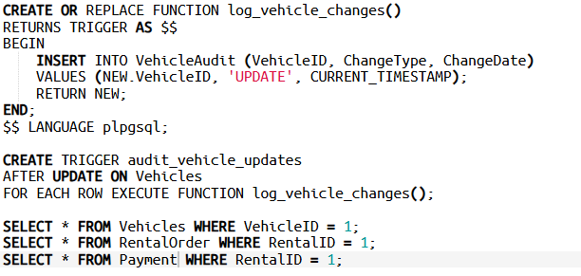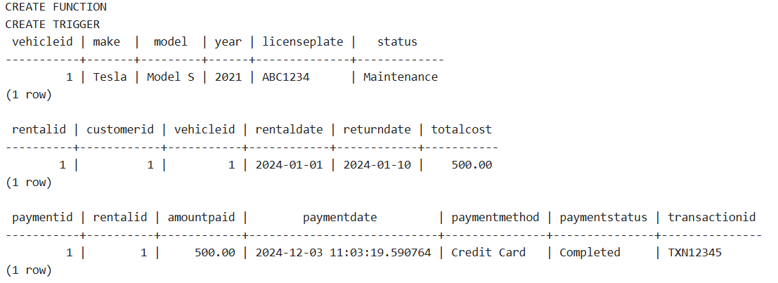
The AutoPilot Fleet database design satisfies strict requirements for scalability, referential integrity, and normalization. Data consistency and performance are ensured by addressing common issues in multi-user situations through the use of concurrent access techniques and transaction isolation levels. As the system develops, additional improvements like partitioning and indexing allow greater scalability.

Chapter 6: Discussion of Important Database Concepts
For database systems to preserve data integrity, maximize performance, and guarantee scalability, key functionalities must be handled carefully. This chapter examines the key ideas used in the AutoPilot Fleet database, properly citing theoretical justifications.
6.1 Rollback and Commit
In order to guarantee the atomicity property of ACID (Atomicity, Consistency, Isolation, Durability) transactions, rollback and commit are essential components of database transaction management.
• Commit: Makes all modifications made during a transaction visible to other users by saving them to the database.
• Rollback: In the event of mistakes or failures, this feature returns all changes made during a transaction, returning the database to its initial state.
Importance: Even in the event of a system failure, rollback and commit actions guarantee that a database stays consistent. All operations within a transaction are guaranteed to be handled as a single unit of work, either completely finished or entirely undone, by the atomicity feature of transactions [1].
6.2 Triggers and Functions
Functions: Code modularity and maintainability are enhanced by reusable code blocks that carry out particular tasks.
Triggers: Unique procedural logic that is automatically carried out in reaction to particular table actions (like INSERT or UPDATE).
Relevance:
Triggers and functions facilitate auditing procedures, improve data consistency, and allow automation. Specifically, triggers enforce database-level rules to guarantee data integrity [2]. For accountability, this system makes sure that any modifications to vehicle data are documented.
6.3 Transactions and Stored Procedures
SQL statements are condensed into a single callable unit by stored procedures. They are essential for preserving transaction consistency and simplifying applications at the application level.
Importance:
Stored procedures improve performance by reducing network overhead, as multiple SQL statements are executed on the server side. They also enhance security by limiting direct access to underlying tables [1].

6.4 Indexing
By facilitating quicker data retrieval, indexes enhance query performance. They are especially helpful for columns that are utilized in WHERE clauses or are regularly queried.
Relevance: Indexes are essential for maximizing a database system's performance, especially when dealing with big datasets [2]. However, since too much indexing can result in overhead during INSERT or UPDATE operations, indexes need to be properly selected.
The theoretical and practical significance of rollback, commit, functions, triggers, stored procedures, and indexing was highlighted in this chapter. The AutoPilot Fleet database uses these ideas to create a reliable, high-performing solution that is suited to practical needs.
- Citations
[1] Begg, C., and Connolly, T. (2014). Database Systems: A Realistic Approach to Management, Design, and Implementation. Pearson Learning.
[2] Navathe, S. B., and R. Elmasri (2016). Database system foundations. Pearson Learning.
Chapter 7: Citations
1. Begg, C., and Connolly, T. (2014). Database Systems: A Realistic Approach to Management, Design, and Implementation. Pearson Learning.
widely cited for theoretical understandings of database design concepts, transaction management, and ACID features.
2. Navathe, S. B., and R. Elmasri (2016). Database system foundations. Pearson Learning. Referenced for in-depth talks on indexing, stored procedures, and database speed enhancement.
3. Chidambaram, D. Database Systems: Transaction Management and Indexing Lecture Slides. Trinity Saint David University of Wales, Swansea.
· Used as a reference for fundamental ideas presented in class sessions.

Chapter 8: Appendix
8.1 Exercises and the Use of Generative AI Tools
In order to ensure compliance with the University's rules, this section details the prompts utilized in the creation of this assignment. ChatGPT was used only for conceptual conversations, research, and database concept clarification.
Examples of Prompts Employed 1. Clarification of Research:
Prompt: "Explain the importance of indexing in database performance optimization, with references to scholarly materials."
Use: To comprehend indexing strategies and their theoretical underpinnings more thoroughly.
- "What is the role of ACID properties in transaction management, specifically atomicity and isolation?" is the prompt for the second concept explanation.
- Application: To make theoretical ideas easier to include into the assignment's assessment portions.
- Report Structure: o The prompt is "Propose a structured framework for talking about database design evaluation in a multi-user setting."
Use: To create a coherent flow for the section on evaluation.
- Best Practices for SQL:
Prompt: "What are the best practices for implementing triggers and functions in PostgreSQL for data integrity?"
Use: To improve the AutoPilot Fleet database's implementation tactics.

