
University of Wales Trinity Saint David
School of Engineering

Can FEA replace physical testing?
(for Crash Helmet)

Advance Stress Analysis and FEA
(M6X00420)

Joshua Grant Brimecombe
1701440
10/03/2020
Table of Content
1 Introduction 1
1.1 Aims 1
1.2 Objectives 1
2 Research 2
2.1 FEA 2
2.1.1 Literature Review 3
2.2 Physical Testing 4
2.2.1 Standards 5
3 Conclusion 5
4 References 6

Introduction
The report evaluates the use of Finite Element Analysis (FEA) against the use of physical testing in crash helmets. Extreme sports are inherently dangerous, and the protection used whilst participating is massively important in the prevention of injury and preservation of life. Arguably the helmet is the most important and cross stream applicable peace of protective equipment. Helmets are used across many sports including snow sports, water sport, cycling and motor racing. This varieties makes for a massive market and opportunity for FEA influenced design for increased safety whilst also optimised of other characteristics such as durability, weight or strength.

Aims
The aim of this report is to evaluate the use of FEA in the design and testing of crash helmets, whilst correlating the use of FEA and physical testing within the design and product development process.

Objectives
To meet the aims set out above, an investigation of the method currently used by manufacturers and designers. To analyse the correlation between FEA and physical testing, both must be explored and the purpose and benefits of them laid out. Then a conclusion can be drawn on which method should be used and how.

Research
The design process of a product (sports crash helmet) traditionally is an iterative process that works on the bases of basic calculations, an elimination process that is based off of trial and error. This inherently has issues, one of those issues is the time taken for the design as the development goes through repetitive stages of design, development and testing. 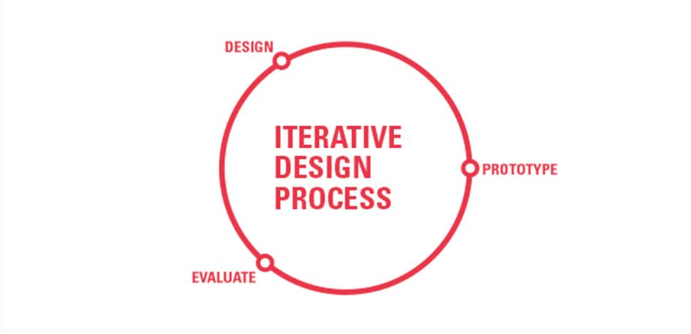
Figure 1 Iterative Design Process (MEEE, n.d.)
FEA and computational methods have a role in the model above (Figure 1), predominately in the evaluative stage (MEEE, n.d.). The use of computational testing allows to conduct many different tests without destroying any products this reduces cost in materials but takes computational time to run and solve the calculations.

FEA
Finite Element Analysis models a geometry in either one, two or three dimensions. The model is then turned in to a mesh structure or surface (volume or shape) the mesh consists of elements and nodes, which the software then uses a combination of matrixes, simultaneous equation and other stress calculation such as Navier-Stokes equations and von Mises, to calculate the stress, pressures and forces in the model or system. The benefit of computational method is that they are extremely efficient at running repetitive tasks which is ideal as each node and for every axis of freedom multiple calculation need to be calculated making the matrix grow exponentially. This is why the mesh quality is important as the smaller the mesh the more nodes and calculations this increases the computational time required but also increases the accuracy.

Literature Review
The report ‘Understanding how a sport-helmet protects the head from closed injury by virtual impact tests’ written by Yunhua Luo and Zhaoyang Liang (2017) was peer reviewed and appeared in the journal of Bio-Medical Materials and Engineering. The aim of the report was to understand how the helmet protects the head and the impact it has on the soft tissue of the brain, the performance of the helmet design was analysed by the results of the stress, strains and pressures found in the Finite Element Head Model (FEHM), which are indicators of traumatic brain injury. The methodology studies helmeted FEHM vs non-helmeted FEHM as well as shell stiffness, foam density and foam thickness of the helmet, each parameter was changed individually. The results of the non-helmeted model were validated against experimental data, which correlated with only a 4% total difference (Luo & Liang, 2017).
A case study published in the journal of ‘Materials: Design and Application’ by Teng et al. investigates “helmet design with respect to helmet performance in shock absorption tests” (Teng, et al., 2012). This study also validates the results of the method (FEA) against experimental results, this give these reports correlation and real-world application, allowing the results to inform design decisions. This use of FEA is evaluative of a model which allows pre-design decisions to be made. Teng et al. measures “linear accelerations, rotation accelerations, and impact forces” (2012), which is a more macroscopic approach than Luo and Liang’s microscopic approach of the “intracranial pressure and stresses/strains in the brain tissues” (2017). Teng et al. conclude that while “helmet safety in drop tests is useful” (Teng, et al., 2012), the validation of the helmeted head model “reduces the duration of research and design cycles, and cuts experimental costs.” (Teng, et al., 2012), meaning the “model serves as a valuable tool to assist the future development of safety helmet technologies.” (Teng, et al., 2012).
Helmet design is not only about safety. It is important to be safe whilst participation in dangerous sports but a helmet can only protect you if you are wearing it, 97% of cyclist who die in traffic accidents are not wearing a helmet (Teng, et al., 2012). To combat this, it is important that helmets are not a performance inhibiter, which is why the aerodynamics of a bicycle helmet are analysed in the report published in the ‘Movement, Health and Exercise’ journal. The report looks at FEA and CFD (Computational Fluid Dynamics) to evaluate the maximum stress values and the flow of air over the two different designs comparing them to each other. The second more streamline design was found to be both more aerodynamic and have a greater impact resistance (Abdullah, et al., 2015).
The previous reports look at bicycle helmets, motorcycle helmets can be looked at in the same way. Motorcycle helmets require different geometry and materials due to high speed nature of the sport. Two older reports both in the International Journal of Impact Engineering (Mills, et al., 2009) (Sadaq, et al., 2014). The report written by Sadaq et al. compiles test results for both ABS and PVC Plastic to compare the “von-mises stress, strain and deformation” (Sadaq, et al., 2014) at 50, 60 and 70 km/h in the front, right and back direction. There are many variables which were all tested against each other.
The other report that analyses motorcycle helmet impacts exclusively looks at oblique impacts as “In accidents, motorcycle riders full-face helmets often make oblique impacts with road surfaces.” (Mills, et al., 2009) the report analysis uses FEA to “predict the rotational and linear accelerations” (Mills, et al., 2009) the key factor in these forces is the friction in the system this was calculated using the validation of British Standard BS6658 and COST 327 experimental data. As a result of the FEA the report concludes that it saw a 15 Krad s⁻² of rotational force which “would probably cause rotational head injury” (Mills, et al., 2009).

Physical Testing
Physical tests are still conducted on crash helmets this is to prove the protectiveness of the helmets for marketing purposes and evaluation in the design stage, but most commonly physical testing is due to meet safety standards set out by governing bodies. Computer simulations can be incorrect for a large number of reasons including but not limited to errors in the calculations, smudge-factor error, but, the largest error is the human input of variables, units, boundary conditions including mesh strategy decisions. This makes computer simulations untrustworthy unless validated which is where the physical testing comes in, as there is fewer errors or factors for failure. If a helmet passes a physical test it is a lot more trustworthy than its simulation counterpart as it is a tangible real-world test. Validation is the key to using FEA properly, which requires either physical testing, practical testing or experimental data.
There are many physical tests that can be performed, these include different angles, speeds, weights, shapes of object and head forms. The factors that decide what tests are conducted is the sport or environment that the helmet is intended for as each sport has different incidents due to the forces, angles and environment where the sport takes place.

Standards
Standards are an agreed upon way of doing something, in the case of helmet safety standards it is a certified way of testing a helmets protectiveness, they also set out minimal limits. (BSI, n.d.)
There are different standards for different sports, products and scenario’s, several of which are covered in a report on ‘Current standards for sports and automotive helmets: A Review’ (Connor, et al., 2016). The report investigates numerous tests including impact tests, penetration tests, retention tests, roll off tests, crush tests and friction tests; whilst discussing the testing methods and errors and helmet design and usage.

Conclusion
In conclusion FEA should be used heavily to influence the design process. The use of computational methods to aid in the design process decreases time of design development which then decreases costs, which is less than the cost associated to manufacturing prototypes and physical sample to test. Computational software can also be used to optimise design for unique and specific requirements (weight, stiffness, ridgidity, aerodynamics).
But FEA cannot replace the physical testing for certification and standard’s testing, as the theoretical computational models is not the same as physical testing as no one wears the computer model. Simulations can have inaccuracies, errors and problems.
I think there is an important role for both FEA / computational methods as well as physical testing to validate models, prove concepts and meet standards and other test-based requirements. If both used correctly and too an optimum it can create an efficient, optimised and high-quality design solution for a perfect product.

References
Abdullah, M. N. et al., 2015. SIMULATING BIO-COMPOSITE CYCLING HELMET PERFORMANCE THROUGH FEA AND CFD APPROACHES. Movement, Health & Exercise, 4(1), pp. 77-91.
BSI, n.d. What is a Standard. [Online]
Available at: https://www.bsigroup.com/en-GB/standards/Information-about-standards/what-is-a-standard/
[Accessed 01 03 2020].
Connor, T. A., Meng, S. & Zouzias, D., 2016. Current Standards for Sports and Automotive Helmets: A Review, s.l.: s.n.
Luo, Y. & Liang, Z., 2017. Understanding how a sport-helmet protects the head from closed injury by virtual impact tests. Bio-Medical Materials and Engineering, 22 March, Volume 28, pp. 279-291.
MEEE, n.d. Iterative Design Process. [Online]
Available at: https://www.meee-services.com/why-prototype-iteration-in-a-product-development-is-needed/iterative-design-process/
[Accessed 01 03 2020].
Mills, N. J., Wilkes, S., Derler, S. & Flisch, A., 2009. FEA of oblique impact tests on a motorcycle helmet. International Journal of Impact Engineering, Volume 36, pp. 913-925.
Sadaq, S. I. et al., 2014. Impact Test on Motor Cycle Helmet for Different Impact angles using FEA. International Journal of Engineering Trends and Technology, Volume 12, pp. 278-281.
Teng, T.-L., Liang, C.-L. & Nguyen, V.-H., 2012. Development and validation of finite element model of helmet impact test. Materials: Design and Applications, 11 May, 227(1), pp. 82-88.

