Developing Employability for a UK
Occupational Therapy Assistant Role

Programme | BSc Health and Social Care
Module | Changemakers: Building your Personal Brand for Sustainable Employment
Module code | BMHP5015
Assignment title | Component 2: Assignment (Report)
Student name | Uzma Muhammad
Student number | 2406912
Lecturer | Olufemi Oluranti

Contents
Contents 2
1. Introduction 2
2. Current vacancy and person specification 2
3. Analysis of employability skills 5
4. Evaluation of my current skills and experience 7
5. Personal brand, professional identity and value 9
6. Five-year action plan and resources 9
7. Communicating my skills to employers 10
8. Conclusion 11
Reference list 12
Appendix 1: Vacancy evidence 14
Appendix 2: CV for targeted job application 18

1. Introduction
This report examines the UK role of Occupational Therapy Assistant in an acute mental health service. I chose this role because it combines practical support, communication and recovery-focused care. The report uses a current Band 3 vacancy at Devon Partnership NHS Trust in Exeter. It analyses the employability skills in the advert. It then compares those skills with my current abilities as a BSc Health and Social Care student. The final sections explain my personal brand, professional network and five-year action plan. My aim is to become ready for safe entry-level practice and then develop within the occupational therapy workforce.

2. Current vacancy and person specification
NHS Jobs (2026) advertises a permanent Occupational Therapy Assistant post on Delderfield Ward at The Cedars. The salary is £25,760 to £27,476 a year. The vacancy was posted on 10 July 2026 and closes on 22 July 2026. The ward supports adults during an acute mental health episode. The assistant works under qualified occupational therapists and alongside nurses, doctors and social workers.
The main duties include helping with assessment, planning, delivery and review. The worker runs therapeutic groups and one-to-one activities. They support service users to set goals, use coping activities and access suitable services. They also write clear records, support families and take part in quality improvement. The essential criteria include experience with vulnerable people and experience of therapeutic work. The applicant must organise tasks, meet deadlines, use creative ideas and want to learn more about occupational therapy and acute mental health care. An NVQ Level 2 or 3 is desirable, as is experience of activity groups.
The National Careers Service (n.d.) explains that OT support workers help people become more independent. This shows that the role is not only about keeping people occupied. Each activity should have a purpose. It may improve routine, confidence, communication, self-care or readiness for discharge.
Table 1: Current vacancy summary (Data Obtained from NHS Jobs, 2026)
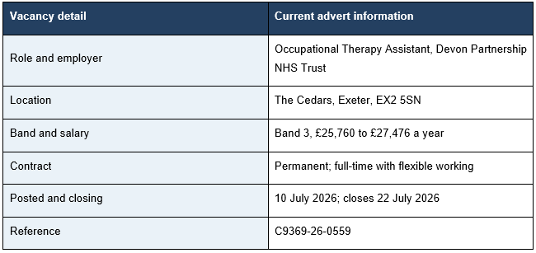
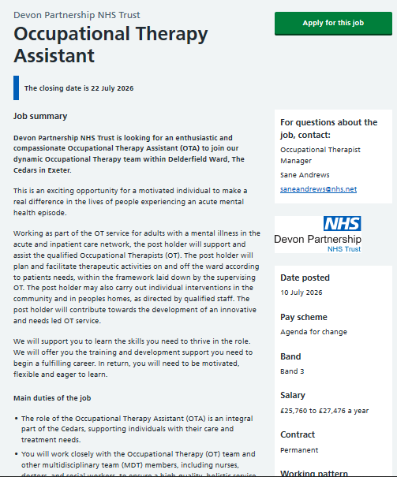
Figure 1: Evidence of Current Vacancy (Source: NHS Job, 2026) Available at: https://beta.jobs.nhs.uk/candidate/jobadvert/C9369-26-0559
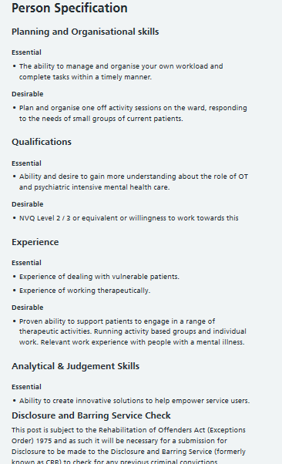
Figure 2: Evidence of Person Specification from Current Vacancy (Source: NHS Job, 2026) Available at: https://beta.jobs.nhs.uk/candidate/jobadvert/C9369-26-0559

3. Analysis of employability skills
The Occupational Therapy Assistant role requires strong communication, teamwork, organisation, safety awareness, resilience and the effective use of therapeutic activities (shown in figure 3).
￼
Figure 3: Employability skills for Occupational Therapy Assistant Role (Created by using MS Word)
The first core skill is person centred communication. Patients in an acute ward might feel scared, depressed, confused or distrustful. The assistant should listen rationally and speak clearly. They need to provide options and not make promises they can't keep. The Care Quality Commission (2025) says that care must be tailored to the person's needs and preferences. Communication is, therefore, a key enabler of dignity and safer interaction.
The second skill is therapeutic use of activity. Adelle et al. (2025) identified that occupational therapy is able to assist with choice, daily function, distress management and personal recovery in an acute mental health setting. Rocamora-Montenegro et al. (2021) also identified the psychosocial, educational, cognitive and OT interventions based on exercise for severe mental illness. It is important for an assistant to know the reasons behind using an activity. They are required to adhere to the direction of the therapist, monitor the effect and report changes.
Group facilitation is also important. Ngooi et al. (2022) related activity-based groups to coping confidence and wellbeing. Despite the limitations of the study, Meyer, Casteleijn and Silaule (2024) reported an increase in activity participation following occupational therapy groups for individuals with depression. The results reveal the importance of preparation. The assistant must have a clear goal, safe materials, simple directions and a means of integrating the quieter members. They also have to change or cease an activity if distress or risk rises.
Safety and professional boundaries are crucial. Mental health work may involve self-harm risk, agitation and past trauma which are acute. NHS England (2025) recommends staff to adopt trauma-informed and harm-aware care. The wording should be, "What might have happened to the person; not just, "What is the matter with the person? The assistant needs to identify limitations and request assistance as soon as possible. They should never deviate from the plan or claim to be a registered occupational therapist.
Another big skill is teamwork. The assistant discusses observations with the occupational therapist and others. Information is key to care plans and discharge. Safe, ethical and evidence-based behaviour is expected of the OT workforce (Royal College of Occupational Therapists, 2021). The Health and Care Professions Council (2023) also identifies Communication, Equality, Risk and Record keeping for the registered occupational therapist. Assistants should support their supervisor in ways that enable him or her to achieve these standards.
Organisation and digital skills support safety. The worker can create groups, book locations, clean up equipment, update notes and follow a number of goals. Records should be accurate and up-to-date. The Information Commissioner’s Office (2024) explains that health information is special category data. It should be well protected. The assistant is required to use approved systems, ensure the confidentiality of passwords and divulge information only to appropriate individuals.
Finally, the role needs equality awareness, resilience and reflection. The Equality Act 2010 safeguards against discrimination. NHS England (2024) also requires inpatient services to ensure the culture of these services is safe and respectful. Some of the key competencies important for acute mental health practice are cultural competence, risk assessment, crisis skills, supervision and professional resilience as identified by Mkhize et al. (2026). The assistant should be open to feedback and look over every session. This helps to teach without concealing errors.

4. Evaluation of my current skills and experience
My BSc Health and Social Care gives me a useful academic base. I am learning about person-centred care, safeguarding, equality, mental health and professional practice. Reports have improved my research and written communication. Presentations and group tasks have improved my speaking, planning and teamwork. I can use Word, email, online meetings and basic spreadsheets.
My strongest areas are respect, cultural awareness and clear written work. I can listen to different views and stay focused on a shared task. These strengths could help with activity planning, simple explanations and MDT communication. Succi and Canovi (2020) found that employers place strong value on soft skills. However, soft skills must be supported by real examples.
My main gap is direct experience. I have not yet shown that I can work safely with people during an acute mental health episode. I also need practice in therapeutic groups, clinical notes, risk awareness and professional boundaries. I will use supervision and feedback to test my self-rating. The Skills for Care (2025) Care Certificate standards can support basic learning in duty of care, safeguarding, privacy, equality and communication.
To make my self-assessment reliable, I will complete a SWOT review every six months, as shown in Table 2.
Table 2: SWOT Matrix
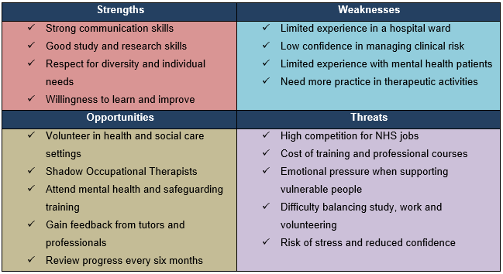
My strengths are communication, study skills and respect for difference. My weaknesses are limited ward experience and confidence with clinical risk. Opportunities include volunteering, shadowing and training. Threats include competition, costs and emotional pressure. A tutor can check whether my evidence is clear.
A careers adviser can improve my CV and interview examples. My behaviour towards service users can be seen by a supervisor. My activity planning, boundaries and records can be reviewed later by an OT. I will compare their comments to my own assessment. If there are conflicting views, I will request an example and come to 1 measurable improvement. This will help minimise bias and help ensure that the plan is realistic. From the skills audit in Table 3, there is a high level of communication and teamwork.
Table 3: Personal skills audit
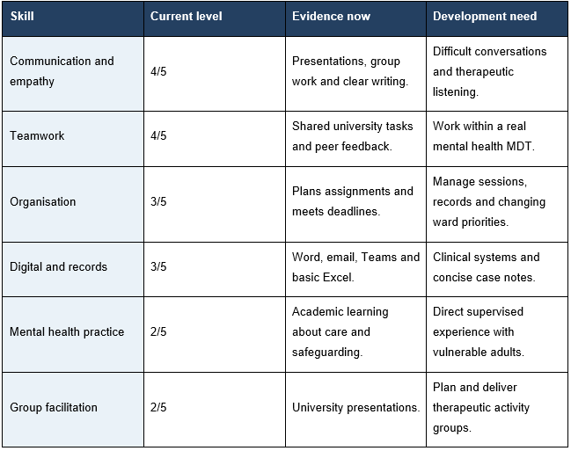

5. Personal brand, professional identity and value
My personal brand will be simple and honest: “A calm, respectful and culturally aware health and social care student who uses purposeful activities, clear communication and evidence to support recovery.” Gorbatov, Khapova and Lysova (2018) explain that a personal brand should be clear, consistent and credible. I will therefore avoid claims that I cannot prove.
I will demonstrate my professional identity through behaviour. I will come ready, guard privacy and take directions and ask for assistance. This is what differentiates me from others – Health & Social care knowledge with a cultural awareness and being interested in practical recovery. I can help by using simple language to describe activities, identifying blockages and making notes of helpful information. I can also make simple suggestions for safe improvements using basic evidence.
I will build my concentrated network. I will keep up to date with occupational therapists and OT assistants and mental health charities/NHS employers on LinkedIn. Attending University Career Events and 1 RCOT online event. I will ask an OT assistant for an informational interview. Networking must be a learning and contribution process, not a process of asking for a job.

6. Five-year action plan and resources
My plan is designed to close the main gaps in a safe order. Okita et al. (2024) show that shared, person-centred goal setting is important in mental health practice. I will use the same approach for my career goals. I will review the plan every six months with a tutor, careers adviser or supervisor.
The resources I need are online training, a laptop, travel money, supervision and access to real practice. Some courses may be free. Other learning may need employer funding. I will keep certificates, feedback, reflections and anonymised examples in a digital portfolio. I will not include any information that could identify a service user.
Table 4: Five-year SMART action plan
Timeline | Actions | Evidence and measure | Resources
0–6 months (Year 1) | Complete safeguarding, data protection, equality, trauma-aware care and Care Certificate learning. Improve note-writing skills. | Training certificates, six practice notes and monthly reflections. | University, Skills for Care, NHS learning and tutor support.
6–12 months (Year 1) | Start weekly volunteering in a mental health or community service. Observe group activities and arrange one OT shadowing day. | At least 100 volunteer hours, supervisor feedback and three STAR examples. | Charity, community service, OT contact and travel budget.
12–18 months (Year 2) | Continue volunteering and take more responsibility in supervised activities. Improve therapeutic listening and confidence with vulnerable adults. | Updated feedback, reflection records and examples of patient support. | Volunteer supervisor, tutor and online mental health courses.
18–24 months (Year 2) | Complete or begin a Level 3 care qualification if required. Apply for Band 2 or Band 3 support roles. | Qualification progress, tailored applications and interview feedback. | Employer training, NHS Jobs and careers adviser.
24–30 months (Year 3) | Secure an Occupational Therapy Assistant or related support role. Complete induction and mandatory training. | Job offer, induction record and completed training certificates. | Employer, OT supervisor and NHS training resources.
30–36 months (Year 3) | Co-facilitate therapeutic groups and support individual activities. Improve record keeping and outcome monitoring. | Observed sessions, case notes and supervisor feedback. | OT team, MDT members and workplace supervision.
36–42 months (Year 4) | Lead selected activities under supervision and contribute to one quality improvement project. | Activity plans, service-user feedback and project evidence. | OT supervisor, MDT and quality improvement team.
42–48 months (Year 4) | Develop stronger skills in recovery-focused practice, risk awareness and supporting families and carers. | Appraisal evidence, CPD record and reflective portfolio. | Employer CPD, mentor and professional workshops.
48–54 months (Year 5) | Take on greater responsibility in group work and support new staff or volunteers where appropriate. | Leadership examples, feedback and updated personal development plan. | Line manager, mentor and leadership training.
54–60 months (Year 5) | Review long-term career options, including Assistant Practitioner roles or an Occupational Therapy apprenticeship. | Updated CV, professional portfolio and agreed career pathway. | RCOT resources, employer funding, mentor and university guidance.

7. Communicating my skills to employers
I will communicate my skills through a targeted job application. I will create a two-page CV which will include my education, training, volunteering, skills and achievements. It will be updated on a regular basis. My supporting statement (NHS Jobs) and cover letter will be written directly to the essential and desirable criteria in the person specification. In its guidance, NHS Jobs (2026) urges candidates to provide concise and clear examples based on their own experience. So, I will be explaining situations in which I demonstrated communication, team working, organisation, empathy and learning from feedback using the STAR method.
I will also maintain a professional LinkedIn profile. It will contain a personal statement, qualifications and certificates, volunteering and career interests. I will use my digital portfolio to store training evidence, skills audits, reflective notes and feedback from supervisor. I will however delete any names and information about service users.
During interviews, I will speak honestly about my strengths and development needs. I will describe when I would consult with a competent professional for assistance. This will demonstrate safe judgement, self-awareness and respect of professional boundaries. Health and Care Professions Council (2024) suggests that professionals should be responsible and ensure the privacy of service users on social media. I will therefore maintain my online presence in an accurate, respectful, confidential and appropriate manner for employers.

8. Conclusion
The Occupational Therapy Assistant role is a realistic career goal, but academic study alone is not enough. My present strengths are communication, cultural awareness, teamwork and evidence use. My main needs are direct mental health experience, therapeutic group skills, risk awareness and clinical recording. The action plan addresses these gaps through training, volunteering, supervision and paid practice. A clear personal brand and a genuine network will help employers see my progress. My long-term aim is to become a trusted assistant who uses meaningful activity to support safety, choice and recovery.

Reference list
Adelle, A., Bedford, K., McMahon, S., Dun, C., Starbuck, R. and Doroud, N. (2025) ‘The role of occupational therapists in acute mental health inpatient settings: A systematic scoping review’, Australian Occupational Therapy Journal, 72(3), e70032. https://doi.org/10.1111/1440-1630.70032
Care Quality Commission (2025) Regulation 9: Person-centred care. Available at: https://www.cqc.org.uk/guidance-regulation/providers/regulations-service-providers-and-managers/health-social-care-act/regulation-9 (Accessed: 14 July 2026).
Equality Act 2010, c.15. Available at: https://www.legislation.gov.uk/ukpga/2010/15/contents (Accessed: 14 July 2026).
Gorbatov, S., Khapova, S.N. and Lysova, E.I. (2018) ‘Personal branding: Interdisciplinary systematic review and research agenda’, Frontiers in Psychology, 9, 2238. https://doi.org/10.3389/fpsyg.2018.02238
Health and Care Professions Council (2023) Standards of proficiency: Occupational therapists. Available at: https://www.hcpc-uk.org/standards/standards-of-proficiency/occupational-therapists/ (Accessed: 14 July 2026).
Information Commissioner’s Office (2024) What is special category data? Available at: https://ico.org.uk/for-organisations/uk-gdpr-guidance-and-resources/lawful-basis/special-category-data/what-is-special-category-data/ (Accessed: 14 July 2026).
Meyer, A.F., Casteleijn, D. and Silaule, O. (2024) ‘The therapeutic impact of occupational therapy groups on the activity participation of persons with major depressive disorder in an acute mental health setting’, South African Journal of Occupational Therapy, 54(2). https://doi.org/10.17159/2310-3833/2024/vol54no2a3
Mkhize, P.Z., Mpanza, D.M. and Naidoo, D. (2026) ‘Exploring competencies that prepare occupational therapy students for acute mental health practice: A document analysis’, Occupational Therapy International, 2026, 5063621. doi: 10.1155/oti/5063621.
National Careers Service (n.d.) Occupational therapy support worker. Available at: https://nationalcareers.service.gov.uk/job-profiles/occupational-therapy-support-worker (Accessed: 14 July 2026).
NHS England (2024) Culture of care standards for mental health inpatient services. Available at: https://www.england.nhs.uk/publication/culture-of-care-standards-for-mental-health-inpatient-services/ (Accessed: 14 July 2026).
NHS England (2025) Trauma-informed and harm-aware inpatient care. Available at: https://www.england.nhs.uk/long-read/trauma-informed-harm-aware-inpatient-care/ (Accessed: 14 July 2026).
NHS Jobs (2026) Occupational Therapy Assistant, Devon Partnership NHS Trust, reference C9369-26-0559. Available at: https://beta.jobs.nhs.uk/candidate/jobadvert/C9369-26-0559 (Accessed: 14 July 2026).
Ngooi, B.X., Wong, S.R., Chen, J.D. and Koh, V.S.Y. (2022) ‘Exploring the use of activity-based group therapy in increasing self-efficacy and subjective well-being in acute mental health’, Hong Kong Journal of Occupational Therapy, 35(1), pp. 52–61. https://doi.org/10.1177/15691861221075798
Okita, Y., Kaneko, T., Imai, H. and Tomori, K. (2024) ‘Goal setting in mental health: A scoping review to inform occupational therapy practice’, Irish Journal of Occupational Therapy, 52(1), pp. 3–16. https://doi.org/10.1108/IJOT-03-2023-0007
Royal College of Occupational Therapists (2021) Professional standards for occupational therapy practice, conduct and ethics. London: RCOT. Available at: https://www.rcot.co.uk/explore-resources/standards-guidelines/professional-standards-conduct-ethics (Accessed: 14 July 2026).
Rocamora-Montenegro, M., Compañ-Gabucio, L.-M. and Garcia de la Hera, M. (2021) ‘Occupational therapy interventions for adults with severe mental illness: A scoping review’, BMJ Open, 11(10), e047467. https://doi.org/10.1136/bmjopen-2020-047467
Skills for Care (2025) Care Certificate standards: March 2025. Available at: https://www.skillsforcare.org.uk/resources/documents/Developing-your-workforce/Care-Certificate/Care-Certificate-Standards/Care-Certificate-standards-March-2025.pdf (Accessed: 14 July 2026).
Succi, C. and Canovi, M. (2020) ‘Soft skills to enhance graduate employability: Comparing students and employers’ perceptions’, Studies in Higher Education, 45(9), pp. 1834–1847. https://doi.org/10.1080/03075079.2019.1585420

Appendix 1: Vacancy evidence
Vacancy evidence extract from the current NHS Jobs advert, reference C9369-26-0559, accessed 14 July 2026. The image presents the published vacancy details used in this report.
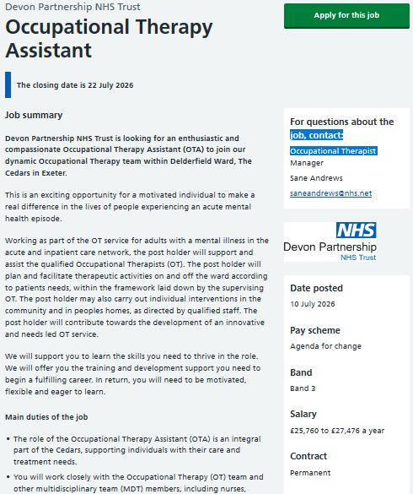
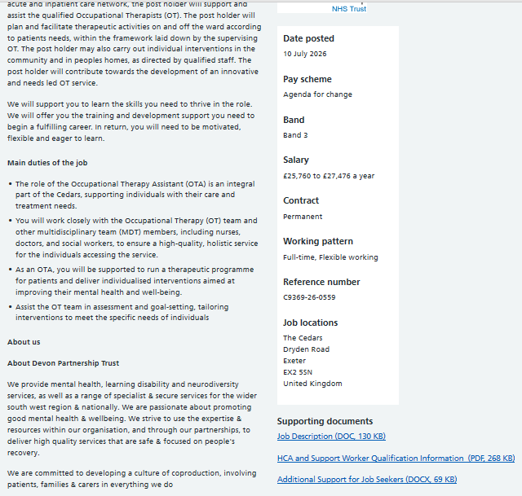
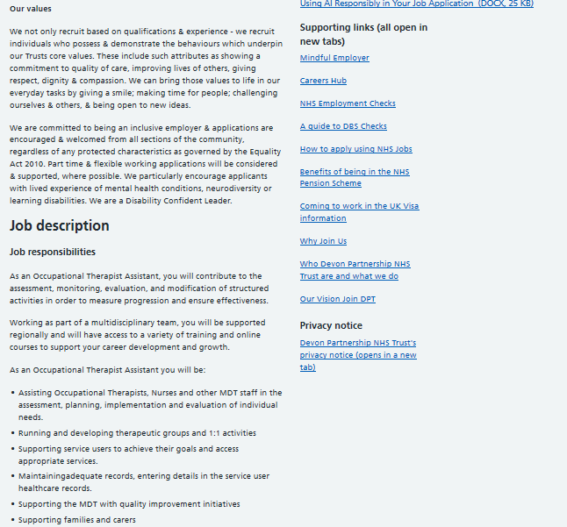
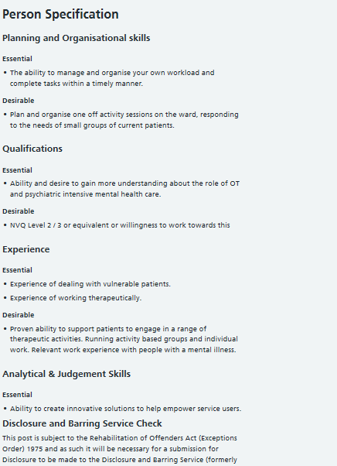
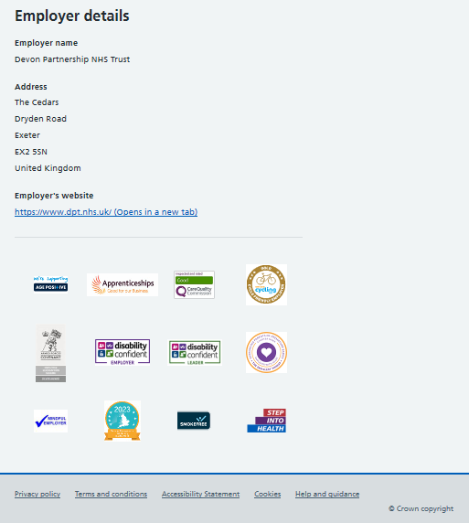

Appendix 2: CV for targeted job application
￼

