Author: Liliya Hristova
Student ID: 1816238
Date: 20.08.20
Professor’s name: Dr. Rexon Nting
Program of study (LCBB5002)
Management ACCOUNTING – BUDGETING Assignment 1

INTRODUCTION
In this essay will be introduced some type of budgeting which are used in management accounting and decision making from Managers and the advantages and disadvantages from using different approach in budgeting’s. Managers use this approaches to improve Companies performance and to adapt to the constant change in the business and management environment.
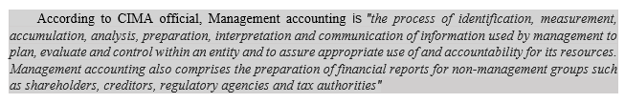 https://www.cimaglobal.com/Our-locations/UK/

The role of Management accounting expands and continues to evolve because the business needs and as a response to the environmental changes that impact the businesses and their strategies. Some of the changes are change Company sizes, better quality, new regulations, and the rapid development and implementation of technology, new management tools, and processes. The increase in the importance of the Service industry and non-tangible assets.
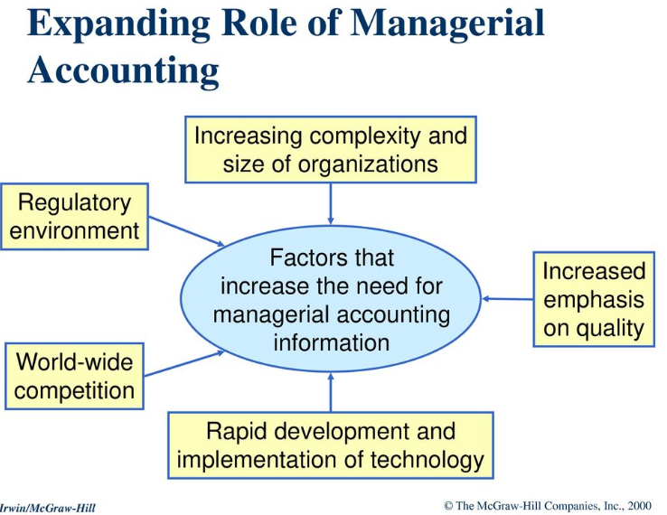

BUDGETING:
When managers start planning, they should consider the capacity, scope, receipt, and expenditure for the long term, i.e. three to ten years, and short term, i.e. one to two years, of the company for achieving the objectives. (see fig1). The long-term budget is set by the CEO or the executive in the Company and the short by Managers. (https://businessjargons.com/budget.html)
Fig.1
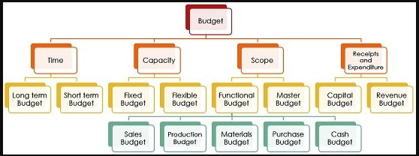
https://businessjargons.com/budget.html

BUDGETING & SHORT-TERM DECISION MAKING
The main reason for budgeting is for managers to be able to plan and control the time, money, and the scare resources and to allocate them the way that will benefit the Company. They control and ensure that the plan is carried out successfully within time and cost limits. Usually, the budgeting is done on a year base and separated on months or quoters to check and evaluate the performance of the management and the Company. And to compare with the budgeted with the actual spending and to find the variances and the reasons WHY they occurred. According to Colin Durry (2018): "control can be defined as the process of measuring and correcting actual performance to ensure that plans for implementing the chosen course are carried out".

THE MASTER BUDGET
“The planed operating budget is helping to plan future earning and results and the Financial budgeting is helping management plan the financing of assets and the results in a projected balance sheet” (Atril, P & McLaney, E., 2015)
The first budget to be prepared is the sales budget. The master budget depends on the sales budget accuracy (fig.2), which helps to decide how many units need to be produced, which means that the Production budget is prepared after the Sales budget. And the information from the production budget is used to prepare the cost of goods sold budget, which includes the manufacturing cost (materials, labor, and Manufacture overheads). All the budget information is combined with the Selling and administrative expense budget to prepare the Cash budget. The Cash budget explained how cash resources will be acquired and use. When all the budgets are prepared then the Income statement is prepared from the data. The budget balance sheet is prepared by using the data from the beginning of the budget period and various schedules.

Fig.2. The master interrelationship
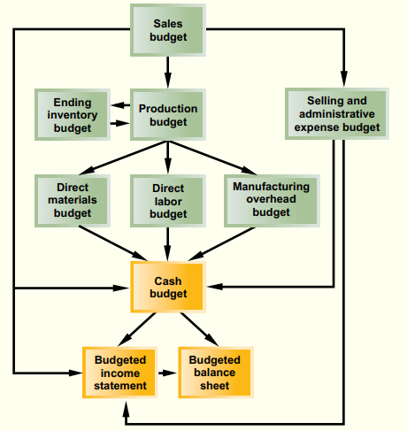
Source: Noreen E.W. Ph.D., CMA, Brewer, P.C. Ph.D., CMA and Garrison, R.H. Ph.D., CMA (2011). “Managerial accounting for managers” 2nd edition. Publisher: McGrow-Hill Irwin

The process of budgeting is the planning for the foreseeable future of the Company's profitability, ROI, and return on the resources used and all the events that may occur. There are four main reasons for budgeting (1) formalize the plan of the managers in quantitative terms, (2) motivate individuals to achieve the targets, (3) encourage the managers to think ahead, and to take action accordingly and to improve their possible results and (4) managers can show their operating plans for the future periods.

Advantages of budgeting are business can see the performance of the individuals and the company, Managers can better coordinate the activities in the company, they can see and review the changes and make quick adjustments. Employees are more cost-conscious, and the managers can be aware of other managers' plans and work together to achieve the company's objectives. In uncertain periods is more difficult to prepare a budget than in stable times, even though budgeting is vital. Managers could rely more on past experience in stable times when they are making future plans and the expected activities.
The budget describes managers' assumption of the state of the economy, the nature of the industry the effects of possible regulations by the government, and the plans for adjusting, changing the product lines. Managers should analyse all the changes that take place and include this in the performance evaluations by comparing a set budget with the actual results for the given period.
Budgeting involves the planning and coordination of Financial and nonfinancial organizational objectives. The Budget should consider the following conditions. The support of the top management, which means that the top management should set long-term objectives such as the growth rates in sales and earnings, expanding market share, quality of the products or services, etc, and all level of management should be aware of them. All people involved should be clear and promptly informed in timeliness, reasonable accuracy, and improved understanding. (Coombs, H., Hobbs, D., Jenkins, E., 2005).

FOUR METHODS OF BUDGETING
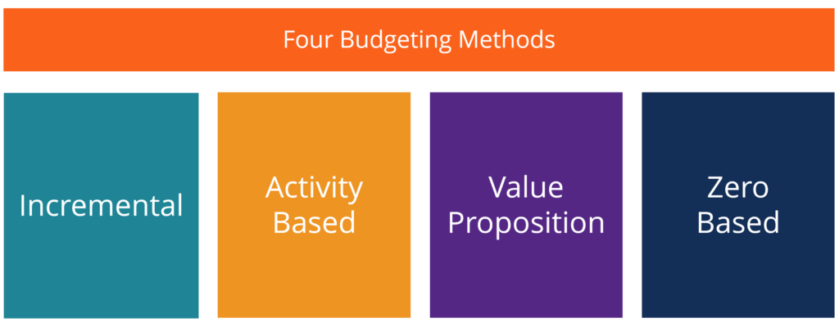
Source:https://corporatefinanceinstitute.com/resources/knowledge/accounting/types-of-budgets-budgeting-methods/

INCREMENTAL BUDGETING:
The incremental budget uses the information from the previous period(year's) actual figures by adding or subtracting a percentage to obtains the budget for the current year. This method is used by managers because it is easy and simple to use if the main cost drivers do not change every year.
Disadvantages of using this type of budget are: (1) Managers will have an opportunity to grow the business and attain a bigger budget, but not putting any effort to economize and cutting the costs, (2) Manager could overstate the budget and it seems like they never exceed the set budget. (3) Ignores the external factors and set an assumption of an increase for the whole year without to take updated.

ACTIVITY BASED BUDGETING
The method from top-down budgeting, which means that the Company sets output targets and predetermined the activities that need to be undertaken and then finds out about the cost of these activities that will help to achieve the targets and goals of the Company.
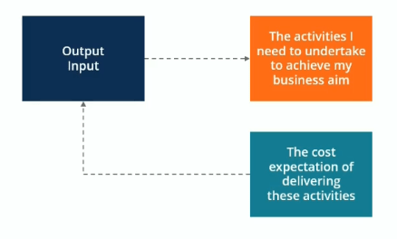
Source:https://corporatefinanceinstitute.com/resources/knowledge/accounting/types-of-budgets-budgeting-methods/

VALUE PROPOSITION BUDGETING
A value-based method is used to consider the answer to the next few questions. For example, why a certain amount is part of the budget? How this item create value for the stakeholders? And is this item outweigh its cost, if not why the cost is justified? Managers ensure that everything that is part of the budget will bring value to the business. The advantage of this method is to avoid unnecessary expenditures even though is not as precise as the zero-base budgeting.

ZERO-BASED BUDGETING
Zero-based budgeting is one of the most used methods that is rebuilt from scratch for each department's budget. All the expenses need to be approved and justified If they appear in the budget. This method is well suited for urgent needs for cost containment and addressed discretionary cost rather than operating costs. This method consumes a lot of time, money, and paperwork involved especially in big Companies. That is why this method is used occasionally. These are some of the advantages of using a Zero-based budget:
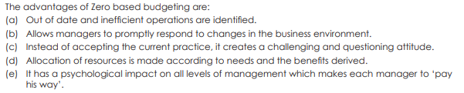
Source: (February 2013) Cost& Management accountancy – Intermediate, published by The institute of Cost accountants of India (ICA), CMA Bhawan. Website: www.reproindialtd.com

LEVELS OF INVOLVEMENT IN BUDGETING PROCESS
These are the three main type of budgeting are: (1) Imposed budgeting, which means that it goes from Top-down type of budgeting where the managers follow the imposed budget targets for activities and the cost. (2) Negotiated budgeting, which is a shared responsibility in budget preparation. The top (CEO, executives, etc) and the bottom (managers, line managers, etc) share and negotiate the budget. For example, the Executive may want to hit some targets, but they have the responsibilities share with managers and employees. By this method everyone even the low-level employees feel included and have more interest in the set objectives and the success of the Company. (3) Participative budgeting.

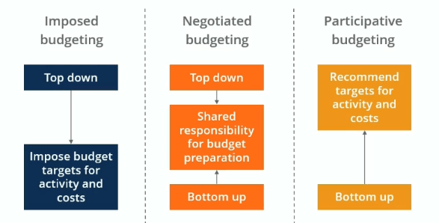
Source:https://corporatefinanceinstitute.com/resources/knowledge/accounting/types-of-budgets-budgeting-methods/

PARTICIPTIVE BUDGETING & BUSINESS PERFORMANCE
This method is a roll-up, which means the budgeting decisions are from the bottom (employee and managers) to top(executive). The managers from lower levels will participate by making the budget and the highest level of management will refine and coordinate the budgets, all managers prepare the budgets for their area of responsibilities. The employees' attitude, involvement, the leadership style, the organization's size, and structure play roles how successful this type of budgeting is.
The advantages are: 1) people are more likely to be part and to accept the challenge, 2) the assumption gap will be reduced, sometimes the lowest managers have more relevant information about inputs, outputs and the constraints on day-to-day activities, they are involved with the customers or stakeholders. 3) goals and the objective will be more realistic and motivation drive for the management of all levels and the rewards, their commitment to the success of achieving the set targets (Durry C, 2018).

STATIC BUDGETING:
The static budget is used to compare with the actual results and see the variances. With this analysis, the manager can see how much the budget is over or under the original forecast. It can be used for future budgeting. (Garrison, R. & Noreen, E. Brewer, 2011)
According to Garrison, Noreen, Brewer, (2011, p.346) “the assumption that all cost are fixed, when static planning budget cost are compared to actual costs, with no adjustment to the level of activities”…………and “comparing budgets to actual results is to assume that all costs are variable”. (Garrison, Noreen, Brewer, 2011, p.346)
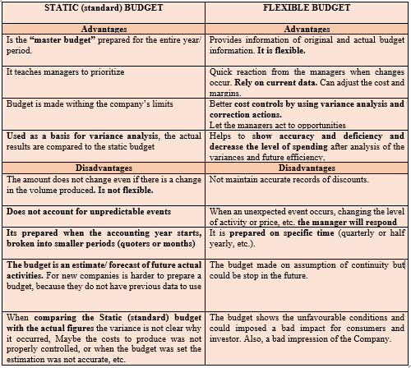
SOURCE: Garrison, R. Ph.D., Noreen, E. Ph.D. & Brewer, P.C. Ph.D. (2011). “Managerial accounting for managers”, 2nd edition. McGraw-Hill, USA, New York. & (Collier P. M., 2003). ” Accounting for managers – Interpreting accounting information for decision-making”, Published by WILEY

FLEXIBLE BUDGETING
Flexible budgeting provides a better investigating of variances than the original budget. Flexible budgets consider the variances in the volume of activity and production volume, when there are changes due to an increase or decrease and adjust the original budget to the actual level of activity (Bragg, S. M., 2007).
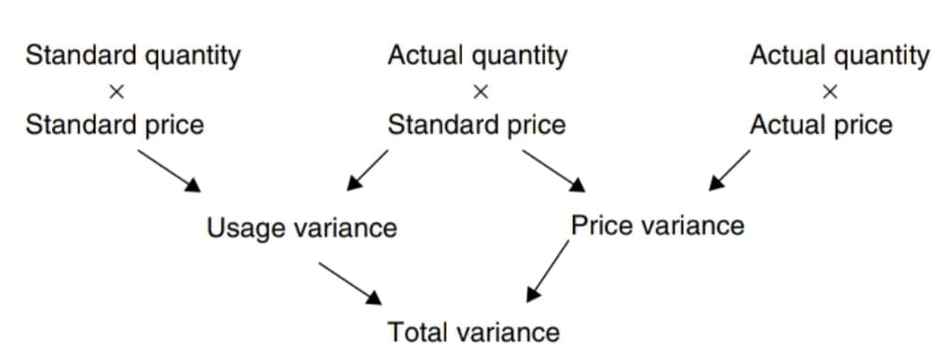
Source: Paul M. Collier (2003).” Accounting for managers – Interpreting accounting information for decision-making”

According to Nucor Corporation, there are numerous reasons for variance, such as (1) The row materials and the supply cost may change unexpectedly, (2) the market demand may change, (3) competitive pressures from substitutes and imports may intensify, (4 ) uncertainty of the global economy may affect the demand, (5) changes between countries trades, import, and export, government regulation, new laws, and regulations. These are just some of the factors that static budget revenue and/or costs to differ from actual results. (Garrison, Noreen, Brewer, 2011)

CONCLUSION
From the information in this report becomes clear how important is to use the accurate and appropriate budgeting model and how important in making decisions and how this will impact the company’s performance.
When managers prepared the budget by estimating it becomes the standard or the point from their performance is measured. By comparing the actual quantity and actual cost to the standards set, is they differ from the standards managers investigate the discrepancy, what causes the problem, and fix it. The process is called management by exception. Usually, companies use financial and non-financial performance measures to plan and control. (Honrgen, Datar, Rajan,, 2012)
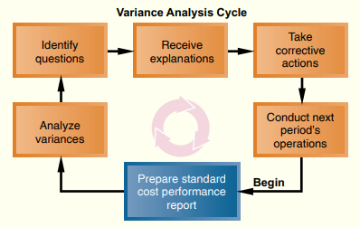
Source: Noreen E.W. Ph.D., CMA, Brewer, P.C. Ph.D., CMA and Garrison, R.H. Ph.D., CMA (2011). “Managerial accounting for managers” 2nd edition. Publisher: McGrow-Hill Irwin

BUDGETING PROCESS and CHANGING ENVIRONMENTS
With the rapidly changing environment and with the new technologies and innovation in this competitive business world, the set budget which is a "short-term" is not changed and therefore they became quickly outdated. The 12 months commitment of the Company to the set goals and budgets is risky because:
- unpredictable environment and future.
- “fixed performance contract” is evaluated since the beginning of setting the objectives, and many things might have changed

The term beyond budgeting used by Hope and Fraser is another approach instead of annual budgeting. They support the quarterly based budgeting because it can be revised and constantly updated. The performance will be more accurate and as Hope and Fraser (2003) said: "based on economic conditions prevailing at the time".
One of the budget strategies of Samsung is to make more "affordable" mobile phone, because of the pandemic customers are demanding cheaper phones. Sammobile (2020).
Some company, such as Apple, Panasonic, Sharp, and Toyota use Target prise and target costing by using (1) performing value engineering to achieve target costs, (2) choose target price for the product base on customer's perceived and competitors' prices, (3) making products that satisfy the needs and wants, (4) Deduct the target cost by deducting the desired profit margin from the target price. (Maher, M. W., Stickney C.P. and Weil, R. L. 2008)

REFERENCES:
Academia, 2020. Case study of Samsung’s mobile phones business”, by Boon-Young Lee and Seung-Joo Lee, published by MBA KDI School of Public, Policy and Management. [online] Available at: https://www.academia.edu/16268203/Case_Study_of_Samsung_s_Mobile_Phone_Business. (Accessed July 2020)
Atril, P & McLaney, E. (2015). “Management accounting for decision makers”, 8th edition, pdf. Pearson Ltd, UK
Bragg, S.M. (2007). “Management accounting best practices”, pdf. Published by: John Wiley& Sons, Inc.
Collier, P.M. (2003).” Accounting for managers – Interpreting accounting information for decision-making”, pdf. Published by WILEY, NY
Durry, C. (2018) Management and costing accounting, 10th edition, pdf. CENGAGE – Anabel Ainscow, UK
Garrison, R. Ph.D., CMA & Noreen, E. Ph.D., CMA, Brewer, P.C. Ph.D., CMA (2011). “Managerial accounting for managers”, 2nd edition, pdf. McGraw-Hill, USA, New York.
Horngren, C.T, Datar, S.M., Rajan, M.V. (2012) “Cost accounting – Managerial emphasis” edition 14th, pdf. Published by Prince Hall, New Jersey
Hope J. and Fraser R. (2003) “Beyond budgeting - How managers can break free from annual performance trap”, pdf. Harvard Business school Publishing Corporation, USA
Charactered Institute of Management Accounting (CIMA) London (2020). [online] Available at: https://www.cimaglobal.com/Our-locations/UK/ (Accessed 15 July 2020)
Coombs, H., Hobbs, D., Jenkins, E. (2005). “Management Accounting- Principles and applications”. 1st edition, pdf. Published by SAGE Publications Ltd, London
Maher, M. W., Stickney C.P. and Weil, R. L. 2008. “Managerial accounting- an Introduction to concepts, methods and use” 10th edition, pdf. Published by THOMSON- South-Western
Sammobile, 2020. “Samsung Galaxy A01 hands-on Budgeting for success?”, by Adnan F. [online] Available at: https://www.sammobile.com/samsung/galaxy-a01/hands-on (Accessed at 01 August 2020)
The institute of Cost accountants of India (ICA), (February 2013) “Cost & Management accountancy – Intermediate”, published by the institute of Cost accountants of India (ICA), CMA Bhawan. [online] Available at: Website: www.reproindialtd.com (Accessed 01 August 2020)

