
Looking at the Software and Displaying data on the MapInfo Window
MapInfo Tutorial 1

Beverley Holland

Looking at the Software and Displaying data on the MapInfo Window (Tutorial 1)

In this lesson you will learning how to
- open a MapInfo table from the Quick Start dialog box.
- view your data in both a Map window and a Browser window,
- how to manipulate these windows to display the data the way you would like.
- how to create your own subset of data from an existing data set.
- graph this data,
- save your work session in a Workspace file.

Objectives
- View a Map
- View Tabular Data
- Create a Subset of Data
- Save a Subset of Data
- Create a Graph
- Save a MapInfo Session

Viewing a map is an integral part of every MapInfo function.

To Open the STATES table in a Map window:
1. Start MapInfo
2. Choose Open a Table from the Quick Start dialog.
3. Press Open. The Open Table dialog displays.
The data for this class is located in the directory Tutorial Data.
The Tutorial Data folder contains several folders that are used throughout the class:
4 . Open the Tutorial Data folder.
5 . Open the US folder.
6 . Choose STATES.
7 . Press Open.
You will see a window display with a map of the United States. This window is called a Map window.
You can resize the Map Window by clicking and dragging the sides of the window.
Alternatively, you can maximize the window by clicking the middle button in the top right of the Map Window.
Notice that on the right you will have two overlapping Toolbars.
Close the Drawing toolbar since it will not be needed in this lesson. Leave the Main Toolbar open, and position it by dragging it to a location that is convenient for you.
Glance at the menu at the top of the window. Note that Map is now an option on the menu bar.
This is a window-specific menu option and is present only when a Map Window is the active window.

You may want to see your data as text, in database or spreadsheet form.

To display the database information in the STATES table, we use a Browser Window which is used to show the tabular view of your table.
To view the STATES table in a Browser window:
1. Choose Window on the menu bar.
2. Choose New Browser Window.

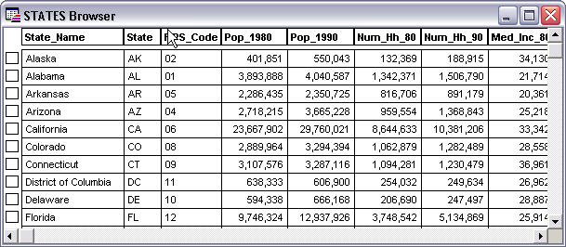

The tabular information associated with the STATES table displays.
Glance at the menu at the top of the screen. Note that Browse has replaced Map as an option on the Menu bar. This is a window-specific menu option and is present only when a Browser Window is active.

You may only want to display certain parts of your table. This may be necessary because tables can hold extremely large amount of data, and some of the analysis you do may only require a specific subset of that table. To view only a portion of data from a table, we make a selection. A selection is a temporary table used to store a chosen subset of records from your table and can be viewed separately from the rest of the table.

In MapInfo it is possible to work with an entire table at once, or with a subset of that table.
For example, lets say we want to create a graph comparing the population of several states. We can make a selection from the STATES table, and choose states we wish to display in our graph.
1. Make sure the Select button is chosen from the Main Button Pad.
2. On the map, point and click on three or four states.
3. Hold down the SHIFT key and click to select more than one state.
Notice that the small boxes in the left-hand column of the browser are also highlighted. It is possible to select records from the browser by clicking in these boxes.

4. Switch to the Browser window and click on the small square to the left of the state(s). Hold down the shift key to select more than one state.
The selected states are now in the temporary table called Selection. This selection is temporary because it only exists in the working memory of your computer. The selected states can now be viewed separately from the rest of the STATES table.
5. From the Window menu, choose New Map Window
6. Choose Selection and press OK. A new Map window will be displayed.
Notice that whether you select states from the Browser window or from the Map window, the selection is made in both windows. In a MapInfo table, the database information is hot-linked to the map. A selection made in any view of the STATES table is immediately reflected in all the windows showing that table.

Graphs are a very important way to present data within Mapinfo, and are used extensively.
Walkthrough
MapInfo can create graphs and charts from database information. To create a graph of your selected states:
1. Choose Window on the menu bar.
2. Choose New Graph Window .
3. Select a Graph and template
4.Press Next
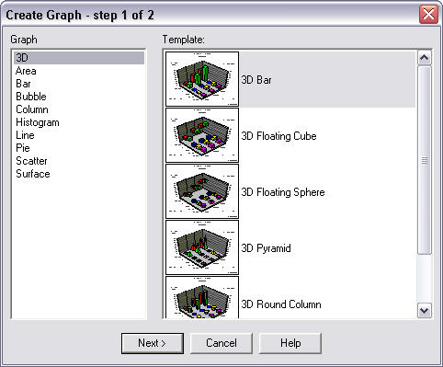.

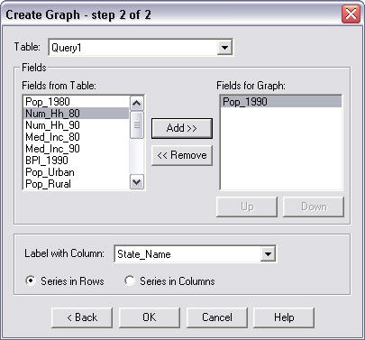

MapInfo assumes as its default choice that when you are creating a graph, you will be graphing the entire table. We will create a graph of only the states we chose:

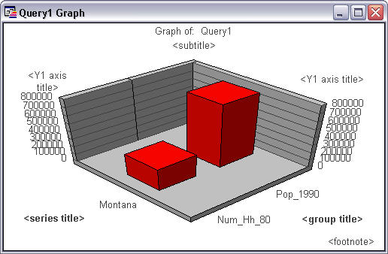
5 . Choose Query1 from the Table drop-down list.
6 . Select Pop_1990 from the Fields from Table drop down list and press Add.
7. Press OK.
The graph displays. Notice that Graph replaces Browse as an option on the Menu bar. You will always see this Graph menu option when a Graph window is the active window.
The name of this Graph is Query1. Graphs that you create will be named Query1, Query2, and so on. These queries will be numbered sequentially.
You now know the basics for creating a graph.

Saving a MapInfo workspace allows the user to continue work done at a previous time.

1. Choose File on menu bar.
2. Choose Save Workspace
3. At the File Name box, type Lesson1.
4. Choose the folder to save your workspace.
5. Press Save.
Note that rather than explicitly typing Lesson1.WOR we only typed Lesson1. Because MapInfo knows that we are saving a Workspace, it appends the .WOR extension.
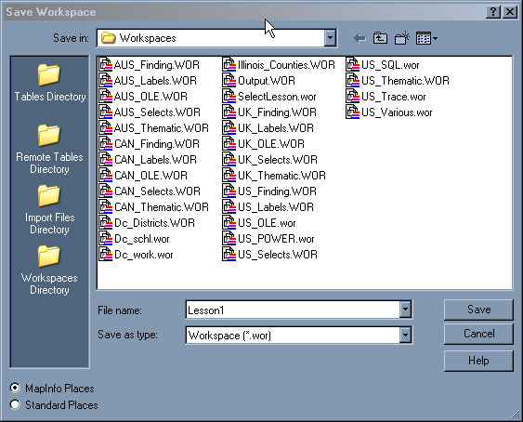
Now that we have saved our workspace, let's close all open tables.
1. Choose File menu on menu bar.
2. Choose Close All.
Now, let's open the workspace we just saved.
1. Choose File on menu bar and Open.
2. Navigate to the directory you saved your workspace.
3. From the Files of Type drop down, choose Workspace (*.wor)
4. Choose LESSON1
5. Click Open.

Any windows that you had on your screen when you saved the LESSON1 workspace, now display. A workspace is simply a text file of instruction that MapInfo reads to recreate your work session. These instructions tell MapInfo which tables to open and what windows to display on your screen. A workspace is not the data you are working with; it just opens those tables for you.

