BIM- Client Letter

Name: Cerith Owen Davies
Student Number: 2115743
Module Code: ACBA 5010

Contents
Task 1- Letter 3
BIM Maturity 4
Common Data 5
BIM execution plan (BEP) 6
BIM ISO Standards 6
BS EN ISO 19650-1:2018 6
BS EN ISO 19650-2: 2018 incorporating corrigendum February 2021 6
BS EN ISO 19650-3:2020 7
BS EN ISO 19650-4:2022 7
BS EN ISO 19650-5:2020 7
PD 19650-0: 2019 7
PAS 1192-6:2018 7
BS 8536 7
LOD & LOI throughout RIBA stages 7
LOD (Level of detail) 7
RIBA Stages 8
LOD100 8
LOD200 8
LOD300 9
LOD400 9
LOD500 9
LOI (Level of information) 9
References 12

Task 1- Letter

OD Design Ltd
Unit 13, Cross Hands Industrial Estate, Carmarthen, SA14 6RB.
(t) 01269 825141
queries@ODDesign.co.uk
www.ODDesign.co.uk

Project Number: 5010
Project Name: Ysgol yr Afan
Description: 1 entry infant school for 90 pupils, with 48 part time nursery provision.

Dear Sir/Madam,
As the new leading consultant for this project Ysgol yr Afan collaborated with the Welsh Government. This letter is to outline the use of BIM throughout the entire lifecycle of the project from the construction phase to the potential decommissioning in the future. This letter will include information on the BIM execution plan (BEP) as well as international standards and different BIM maturity stages. Also discussed is the level of information throughout the RIBA stages in an LOD LOI format. Giving you an understanding of what to include in your exchange Information requirements.
Creating and maintaining information about a construction project throughout the course of its entire life cycle is done through the BIM process. Using the proper technology, a coordinated digital description of each component of the constructed item is created as part of this process. This digital description most likely consists of a combination of linked structured data, such as product, execution, and handover information, and information-rich 3D models. (Hamil et.al. 2019)
A cooperative team is put together early on in a BIM project. To guarantee that the design information produced is coordinated and will be most helpful to those involved in the construction and operation stages, it agrees on the procedures and information structures. Those who will be participating later in the project (manufacturers, the client's FM team, etc.) can be of great assistance in getting things started.
With the information gathered, planning and construction may be done more effectively as the project moves into the building phase. If the design needs to be revised, the agreed-upon procedure can be followed in a transparent and documented manner.
Ultimately, the modelled data can be utilised to control the built asset once the building project is finished, and the in-use phase starts. The performance data of the asset is simulated in real time, giving a "digital twin" equivalent to some features of the physical asset.
The overall goal is to allow all relevant personnel access to the same information to avoid any confusion from different sectors having different information and resulting in mistakes.

BIM Maturity

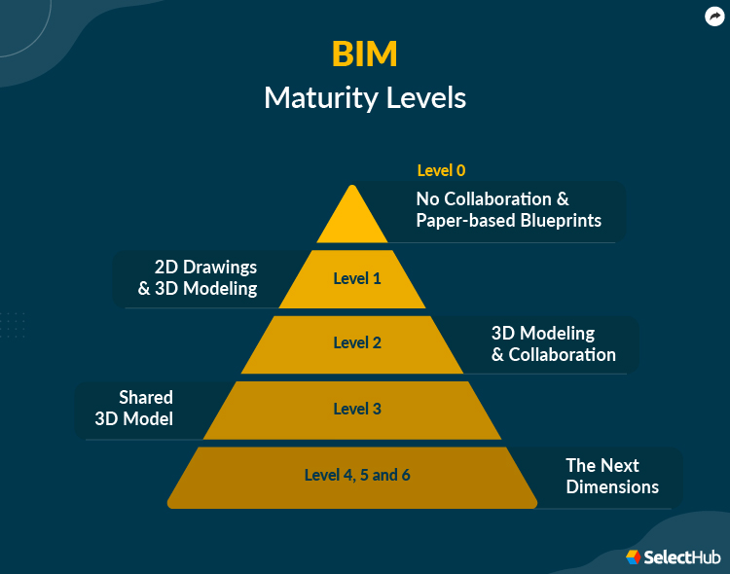
Image available at: https://www.selecthub.com/construction-management/bim/
As noted, it is required for the entire lifecycle of the project to be monitored in order to comply with this a level 3 BIM maturity will be adequate as well as the use of a CAFM system. BIM ranges from level 0 to 3. Level 0 being the most basic form of BIM, this is where there is no collaboration and the use of 2D drawings are used via a mixture of paper or electronic prints. At level 3 it would give all the information needed for the project. Level 3 BIM raises the level of collaboration. Stakeholders use a single shared 3D model for the project in a central location that can be accessed and altered by all, as opposed to each team member utilising their own. Open BIM is an additional layer of conflict prevention that benefits the project continuously.
Benefits include:
- Better 3D visualization of the entire project
- Easy collaboration between trades and multiple teams
- A simplified understanding of design intentions and communication
- Reduced revisions and rework every project stage.

Common Data
Common data environment (CDE) is the sole information source that the entire project team uses to gather, organise, and distribute documentation, the graphical model, and non-graphical data. A CDE holds many benefits those being increased collaboration, this is due to all information being sourced from one location improving coordination, it also creates a single source of truth, allowing all members involved to gather graphical and non-graphical information from one place instead of different sectors having different standards of drawing which could lead to clashing of works, resulting in better decision making and overall results.
Another big benefit is lower risks whether that’s to do with the physical side of the project or the strengthening of security with it being only accessible to authorised personnel as well as it being a central hub for all required information there is no need to transfer details over email, text and paper drawings.
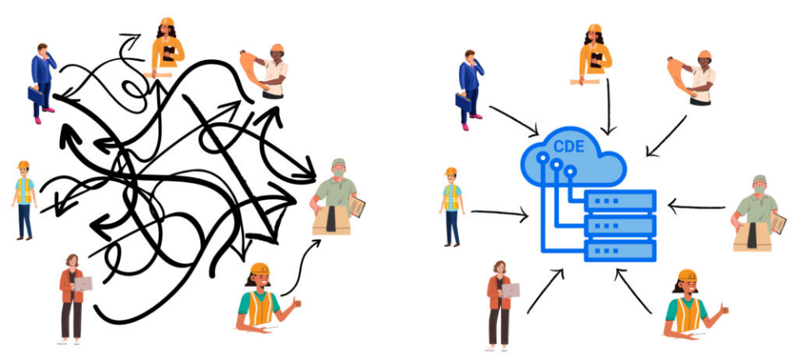

Image available at: https://morethandigital.info/wp-content/uploads/2022/07/Image-1-Data-workflow-in-a-project-without-a-CDE-vs-implemented-CDE-concept-1024x465.jpg
(Accessed 5th January 2024)

BIM execution plan (BEP)

We are currently doing the building execution plan (BEP) and will have it sent over as soon as possible, the BEP is split into two separate plans, one being Pre-contract plan and the other being post-contract plan, information will vary depending on the type of plan used.
The first plans that are offered during the tendering process are called pre-contract implementation plans. The supplier will outline their suggested methodology, capability, and further information. Employer's Information Requirements (EIR) or other employer-specified requirements may be addressed in the pre-contract strategy, or the supplier may develop the specifics.
post-contract BIM plan, will be created after the contract is awarded to verify supply chain capabilities and make future detail corrections. Furthermore, added can be a master plan. It is possible to further demonstrate who oversees each information delivery strand by using individual task information delivery plans.
In order to give you our best execution plan we will consider involving the following:
- Roles and responsibilities of each team will be defined clearly.
- Strategic planning, BIM scope definitions and defined key deliverables.
- Realistic timeframes in correlation with the project milestones.
- Project goals
- Model quality control procedures
- Project reference information
- Working procedures
- Naming conventions
- Tolerance expectations
- Annotations, abbreviations and symbols
- Technology infrastructure needs
- Data transfer

BIM ISO Standards

Please see below all core UK BIM standards, and the main purpose of these individual standards.

BS EN ISO 19650-1:2018
Organization and digitization of information about buildings and civil engineering works, including building information modelling (BIM) – Information management using building information modelling Part 1: Concepts and principles.

BS EN ISO 19650-2: 2018 incorporating corrigendum February 2021
Organization and digitization of information about buildings and civil engineering works, including building information modelling (BIM) – Information management using building information modelling Part 2: Delivery phase of the assets.

BS EN ISO 19650-3:2020
Organization and digitization of information about buildings and civil engineering works, including building information modelling (BIM) – Information management using building information modelling Part 3: Operational phase of the assets.

BS EN ISO 19650-4:2022
Organization and digitization of information about buildings and civil engineering works, including building information modelling (BIM), Information management using building information modelling – Part 4: Information exchange.

BS EN ISO 19650-5:2020
Organization and digitization of information about buildings and civil engineering works, including building information modelling (BIM) – Information management using building information modelling Part 5: Security-minded approach to information management.

PD 19650-0: 2019
Transition guidance to BS EN ISO 19650.

PAS 1192-6:2018
Specification for collaborative sharing and use of structured Health and Safety information using BIM.

BS 8536
Promotes the smooth delivery and operation of built assets throughout their lifecycle by maximising the value that can be derived from information and data. BS 8536:2022 is also a consolidation and update of its predecessors, BS 8536-1:2015 and BS 8536-2:2016 into one single document.

Thank you for taking the time to read this letter, I hope I have covered about BIM level 3 enough to give you a better understanding on the subject and eliminated any of your concerns. Please ask any questions on the matter and hopefully I will be able to help.
We hope to hear from you soon and thank you for choosing us to work alongside yourselves during this project.
Kind regards,

LOD & LOI throughout RIBA stages

LOD (Level of detail)
Project managers, architects, engineers, and other project managers can use the established industry standard known as LOD, or Level of Development, to indicate the status and completion of various design phases. It is essentially a standardised method of determining what data the BIM model is required to have at the end of every RIBA stage.
The levels of LOD below are the standardised abbreviations for American institutes however the levels still require the same detail all over the world. Those abbreviations being:
- LOD100- Concept design
- LOD200- Developed design
- LOD300-Technical design
- LOD400-Construction documentation
- LOD500-AS-Built model

RIBA Stages
The eight steps that compose the RIBA Plan of Work are intended to function in tandem to provide guidance for the planning, designing, constructing, handing over, and using a building. Any member of the project team can use the plan as a point of reference to remind them of the crucial activities that need to be accomplished at each stage, or a client can use it to assist set up the project at the beginning. Those stages can be seen in the image below.
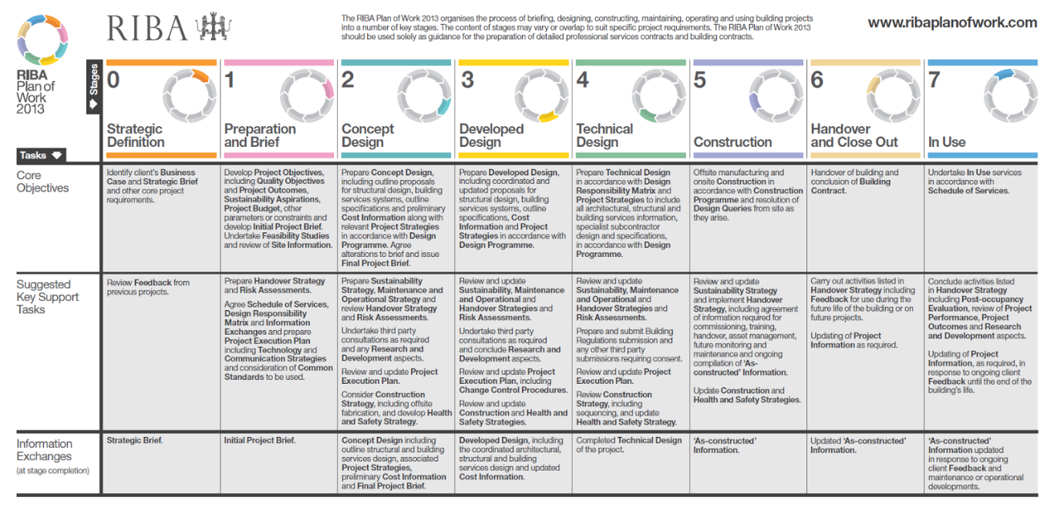
Image available at: https://2.bp.blogspot.com/-OGCz6zQ-7Ps/V3uk82ycgcI/AAAAAAAAApw/quN1x-dY1psfg6zer9rW0KGv109qvqdRQCLcB/s1600/RIBA%2BPlan%2Bof%2Bworks%2Btable.png (accessed 12th January 2024)
You might ask yourself how the level of detail link to the RIBA stage. The best explanation is The steps of the planning, design, and construction processes from inception to completion are outlined in the RIBA Plan of Work. Similar objectives are pursued by LOD, but its focus is on characterising the dependability of 3D models at each step. To comprehend LOD, take into account how it progresses similarly to the RIBA Plan of Work from 0 (Strategic Definition) to 7 (In Use).

LOD100
With this stage being a concept design there is very little level of information as the model is only used for design intent, with basic shape and size elements. This links with stages 0,1 and 2 of the RIBA works plan as it forms some sort of concept.

LOD200
This level of detail links to the 3rd stage of the RIBA work plan, at this stage the model becomes more refined and approximate sizing, quantities and locations of each element. Collaboration between stakeholders will be involved in this as design aspects becomes more visual.

LOD300
This is the technical design stage which also links with the 4th stage of RIBA works plan, which is also labelled as the technical design stage, this will include precise detail on individual components as well as exact dimensions. This will also link into the construction phase as it will show details of placements, manufacturing requirements in order for components to meet their standards, collaboration will be required between designers and engineers during this phase.

LOD400
Moving into the next stage, which is the construction phase, this phase is where all the modelling work becomes a real-life visual model. At this stage details will include assembly information from manufacturers to allow all components to be completed correctly, if model is complete to a high standard this will benefit the efficiency of the project at this stage as it will give managers a clear scope on the adequate sequence of works and any clash detection that might result in setbacks on time scales and so on.

LOD500
This links with the handover and in use RIBA stages (stages 6 and 7) This is where an as built model will be accessible, the model at this point will be the most up to date ‘revision’ all information will be precise with the real life project, any changes made during the construction phase will be noted on the as-built this will allow any maintenance team to have the correct information to keep all components working correctly and running smoothly. This will also be vital during the decommissioning stage.

LOI (Level of information)
The proper degree of detail required for non-graphical data, such as performance metrics, materials, and sustainability information, at every stage of a project is referred to as the "Level of Information" (LOI) by the BIM Forum. This is a crucial component of BIM since non-graphical data can significantly affect a construction project's sustainability and efficiency.
The idea of LOI is crucial given that a BIM model contains data-rich information that supports facility management, construction, design, and other processes in addition to visual representation. LOI makes ensuring that the BIM model has the information needed to support stakeholder cooperation and enable decision-making.
During the concept stage the LOI is this is the beginning of the non-graphical data, this will include concept materials used for the design, these might change at later stages of the modelling as its only the concept phase. Moving on to the technical design this is where collaboration between stakeholders and the design team to agree on design details whether that be components or materials specifications. At this stage the information will be more detailed and likely to be the final decision before the construction stage begins, only reason the information in this stage will need to be altered is when it results in clashes or information is incorrect or does not meet industry standards.
On to the construction stage, this is where having the correct information or as much information as possible is vital as it is what will allow all roles to fulfil their part within the project. Those being detailed dimensions, instructions and preferred sequence in order to avoid clashing. Also giving quantities to avoid overordering and increasing project costs. Preventing errors and allowing the job to be done to the best standard as well as in appropriate timeframes.
Once construction is complete handover will begin, the LOI will be still required at this stage for maintenance reasons, the as built will have all the required information in order for the facility to be managed throughout its lifecycle. With both LOI and LOD giving relevant information both graphical and non-graphical it will allow any works to be easily altered due to the information all being accessible.

References
NBS (2019) What is building Information modelling (BIM). Available at: https://www.thenbs.com/knowledge/what-is-building-information-modelling-bim
(Accessed 3rd January 2024)
NBS (2014) BIM levels explained. Available at: https://www.thenbs.com/knowledge/bim-levels-explained
(Accessed 3rd January 2024)
AVVIVR (2022) What is BIM and its benefits for construction. Available at: https://www.avvir.io/blog-posts/what-is-bim-and-its-benefits-to-construction-building-information-modeling#:~:text=Level%203%20Benefits%3A%20Better%203D%20visualization%20of%20the,communication%20Reduced%20revisions%20and%20rework%20every%20project%20stage (Accessed 5th January)
Autodesk (2022) What’s a Common Data Environment and Why It Matters. Available at: https://constructionblog.autodesk.com/common-data-environment/
(Accessed 5th January 2024)
Trimble construction (2022) What is an execution plan and what should it include. Available at: https://constructible.trimble.com/construction-industry/what-is-a-bim-execution-plan-and-what-should-it-include (Accessed 5th January 2024)
UK BIM FRAMEWORK (2024) Core Standards. Available at: https://www.ukbimframework.org/standards/ (Accessed 6th January 2024)
Archisoup (2024) RIBA work stages: The 7 (8) stages explained. Available at: https://www.archisoup.com/riba-work-stages-explained (accessed 12th January 2024)
Advenser (2024) Understanding BIM LOD, Levels, and LOI: Navigating the Depths of Building Information Modeling. Available at:https://www.advenser.com/2023/09/28/understanding-bim-lod-levels-and-loi-navigating-the-depths-of-building-information-modeling/
(Accessed 13th January 2024)

