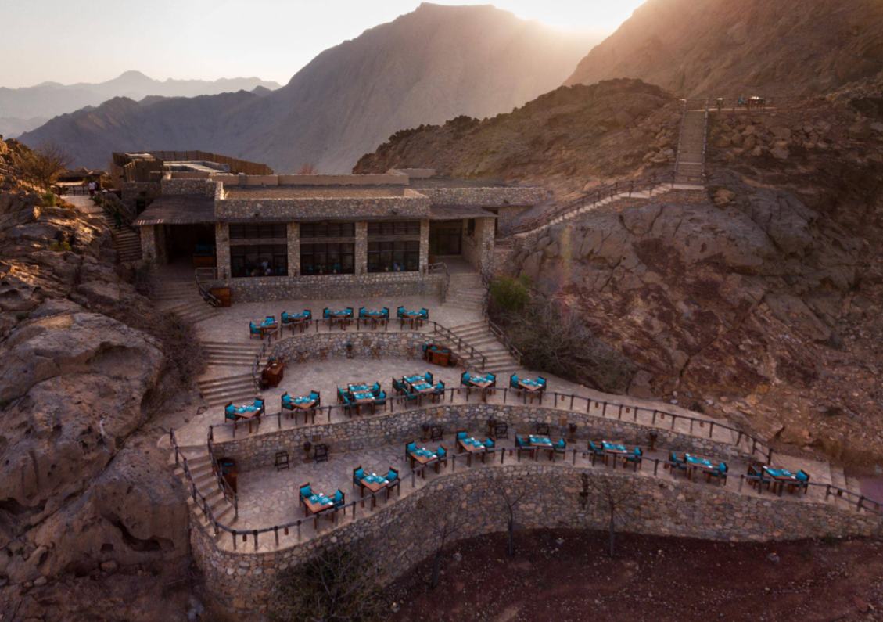 | Marketing plan for six senses zighy bay (omAN)  MARKETING ESSENTIALS  (BMIH4005)  Lecturer: dale clarke  VASILICA BETA (1918835)

INTRODUCTION

This marketing plan offers a thorough study of the Six Senses Zighy Bay resort in Oman. It also establishes a marketing strategy consistent with the resort's goals and objectives. SOSTAC, 4'Ps, SWOT analysis, client segmentation and targeting, perceptual positioning maps, and PESTLE analysis will all be used in the strategy. These frameworks will give a thorough insight into the resort's present market position, strengths and weaknesses, opportunities and threats, customer segmentation, and external variables that may affect operations. The market strategy will strive to raise brand recognition, attract new consumers, strengthen customer loyalty, and ultimately generate revenue growth for the resort.

Situation Analysis
The 5C Analysis is a marketing methodology for analysing a company, revealing his critical success variables and numerous environmental risks. It comprises the 5Cs: Companies, Customers, Competitors, Collaborators, and Climate (Talerico, 2022).

COMPANY
Six Senses is a luxury hotel chain founded in 1995. Customer delight comes from its unique locations around the world. The Oman branch opened in 2008, providing clients with the sense of remoteness. (Nast, 2013).
SWOT Analysis is a method used to evaluate the strengths, weaknesses, opportunities, and threats of a project or organisation:
- STRENGHTS: Breath-taking location, opulent amenities, sustainability, and extraordinary food.
- WEAKNESSES: Its isolated position and limited surrounding activities.
- OPPORTUNITIES: Marketing to luxury and eco-conscious passengers, working with tour operators, and offering wellness experiences.
- THREATS: Competition, economic downturns, and political instability (CIPD, 2021).

CUSTOMERS
Customers can be segmented into discrete groups based on their wants and preferences. Then, they pick the most promising segment to market on (Oates, 2014).
Zighy Bay resort is a premium resort targeting high-end guests seeking leisure and adventure. Their consumer base includes affluent families and individuals who enjoy history, culture, sustainable travel, wellness experiences, and personalized services (www.sixsenses.com, n.d.).

Competitors
Bowman's Strategy Clock is a detailed but accessible strategy tool that gives alternatives to market positioning based on pricing and estimated value (Lucidity, 2021).
- Differentiation: Oman location offers unique experiences which allow it to charge a higher price.
- Hybrid: By offering a combination of luxury and affordability allow to range customers who seek both luxury and value.
- Focused Differentiation: By focusing on eco-conscious travellers allow them to become leaders in their specific market segment.
- Low prices: Let them attract new customers.
Main competitors from the same luxury segment are Alila Jabal Akhdar or Anantara Al Jabal Al Akhdar Resort (SimilarWeb, 2023). In competition with them Zighy Bay Six Senses is a luxury, exclusive, sustainable and adventure destination. The brand can achieve high perceptual positioning with its excellent location, memorable experiences, customized services, and eco-friendliness (Kotler et al., 2012).

COLLABORATORS
Six Senses Zighy Bay Resort in Oman is a premium resort that provides guests with unforgettable memories. To advertise its resort, the brand has established strong B2B contacts and collaborations with agencies and travel operators. Six Senses has also expanded through franchise options, which allow other hotels to adopt its brand and management style. Six Senses has expanded its scope and reputation in the premium hotel market through these partnerships and franchises.

CLIMATE
PESTLE Analysis for Six Senses Zighy Bay in Oman:
- POLITICAL: Oman is famous for its political stability, which contributes to the tourist industry (Nseir, 2022).
- ECONOMIC: Oman's economy is expanding, which might contribute to a rise in tourist and hotel industry income (Nseir, 2022).
- SOCIAL: Tourists admire Oman's culture and traditions, and Six Senses Zighy Bay supports Oman's culture by offering entertainment packages and services.
- TECHNOLOGICAL: The resort in Oman utilises the latest innovations to improve visitor experiences while preserving operational efficiency.
- LEGAL: Oman's hotel laws and regulations benefit foreign investors and international hotel operators.
- ENVIRONMENTAL: Six Senses Zighy Bay supports environmental sustainability and conservation by using renewable energy sources and reducing plastic and waste. In addition, an organic garden is hosted to give back to the land through composting and healthy soil. Many of the plants in their landscapes serve as vital components of their restaurants and wellness centres (www.sixsenses.com, n.d.).

MARKETING MIX
Six Senses Zighy Bay in Oman has a marketing mix that includes a luxurious product with premium pricing, distribution through travel agencies and tour operators, promotion through social media and influencer partnerships, exceptional staff training, an easy booking process, and physical evidence that reflects the resort's luxury positioning as well as their commitment to sustainability.

SMART OBJECTIVES
- SPECIFIC: Increase turnover by 10% over the next three months through focused advertising and promotional initiatives.
- MEASURABLE: Improve employee training and visitor experience to increase client happiness by 15% in the following six months.
- ACHIEVABLE: Reduce operational expenses by 5% over the next year by implementing energy-efficiency measures and improving resource utilization.
- RELEVANT: Increase food and beverage sales by 20% in the coming quarter through menu redesign and focused marketing initiatives.
- TIME-BOUND: In the next three months, increase the resort's social media following by 25% through influencer collaborations and advertising on social media.

STRATEGY
Ansoff's Matrix is an excellent way to assess prospective expansion methods. Oman's resort can think about product development, such as providing novel attractions or services, or market expansion, such as expanding into new geographic regions or targeting new client categories. Furthermore, the resort might pursue diversity by entering other markets such as high-end property or spa equipment.
TACTICS
The Six Senses Zighy Bay Oman may promote its business using the four steps of the RACE marketing strategy: Reach, Act, Convert, Engage (Eriksen-Coats, 2018).
- REACH: Use social media, blogs, and influencer marketing.
- ACT: Emails and personalised advertising can be beneficial.
- CONVERT: Website and booking process to be simple.
- ENGAGE: Using customer feedback and delivering loyalty programmes that create stronger connections between them.
Six Senses Zighy Bay Oman's social media and communications strategies could be improved with the following recommendations:
- Boost engagement: To promote user-generated content, the resort might reply to comments and messages faster and offer social networking competitions and discounts.
- Diversify content: To keep consumers interested, the resort may publish different types of information, such as backstage peeks regarding the property's environmentally friendly efforts or guest feedback.
- Involve influencers: The resort might collaborate with influencers to reach targeted audiences and highlight distinctive services.
- Use generated customers' material: The resort might repost and share user-generated content to highlight and promote the brand community.
- Share sustainability projects: Six Senses Zighy Bay has a strong sustainability focus, and the resort should do more to publicise its activities and educate followers on the significance of environmentally friendly practices in hospitality.
Six Senses Zighy Bay might increase interaction, attract new consumers, and reinforce its brand identity by applying these techniques.
In the past month, Six Senses' website has had an increase in global visitors. The U.S., China, France, Spain, and the U.K. are at the top of the website performance list. Also, most traffic is generated from mobile devices on Facebook. It's almost fifty-fifty between men and women, and the age distribution ranges from 25 to 34. (SimilarWeb, 2023b).

ACTION

Gantt Chart Communication Plan
A tool used by businesses to demonstrate different courses of action done during a specific time period to promote the company (Duke, 2019).

- TV (18:00 – 22:00), 4 times/day, 120 times/month, Jan – May.
- RADIO (8:00 – 16:00), 8 times/day, 240 times/month, Oct – May.
- PPC 1.3Mil / 10Mil X 100% = 0.13%, Dec – Nov (SimilarWeb, 2023b).
- Online Ads (Facebook/ Instagram), Oct – May.
- Online Influencers, Oct – May.
- Loyalty Cards, Nov – April.
- Coupons, Nov – Jan.
- Social Media Campaigns, Oct – May.
- Influencers collaboration contracts, Oct – May.

CONTROL
To assess the performance of Six Senses Zighy Bay's marketing initiatives, must measure the performance, track and review the goals of the business (FreshBooks, 2019).
- The number of new consumers gained as a result of marketing initiatives.
- Customer interaction metrics include website traffic, social media participation, and email open rates.
- Customer satisfaction indicators and feedback.
- Marketing initiatives contribute to revenue and profit (Smith, 2022).

CONCLUSION
Finally, for Six Senses Zighy Bay Oman to be competitive and highly regarded on the market as one of the promoters of luxury services, it will need to use both traditional and new-age marketing methods. To determine their strengths, and notably their weaknesses, they also must use several methods, such as SWOT, SMART, PESTLE, or SOSTAC.

REFERENCES:

CIPD (2021). CIPD | SWOT Analysis | Factsheets. [online] CIPD. Available at: https://www.cipd.org/uk/knowledge/factsheets/swot-analysis-factsheet/ [Accessed 6 Jun. 2023].
Duke, R. (2019). What is a Gantt Chart? Gantt Chart Software, Information, and History. [online] Gantt.com. Available at: https://www.gantt.com/ [Accessed 10 Jun. 2023].
Eriksen-Coats, F. (2018). How To Use The RACE Framework For Digital Marketing Planning. [online] Oxford College of Marketing Blog. Available at: https://blog.oxfordcollegeofmarketing.com/2018/08/06/using-the-race-framework/ [Accessed 10 Jun. 2023].
FreshBooks (2019). How to Measure Business Performance in 3 Steps. [online] FreshBooks. Available at: https://www.freshbooks.com/hub/reports/measure-business-performance [Accessed 10 Jun. 2023].
Kotler, P., & Armstrong, G. (2012). Principles of Marketing. Pearson Education Limited.
Lucidity (2021). Introduction to Bowman’s Strategy Clock | Resources | Get Lucidity. [online] getlucidity.com. Available at: https://getlucidity.com/strategy-resources/introduction-to-bowmans-strategy-clock/ [Accessed 6 Jun. 2023].
Nast, C. (2013). Six Senses Zighy Bay. [online] CN Traveller. Available at: https://www.cntraveller.com/spa/six-senses-zighy-bay-oman [Accessed 6 Jun. 2023].
Nseir, R. (2022). OMAN TOURISM THE BUSINESS ov er BREAKFAST EVENT EU-GCC Dialogue on Economic Diversification EU-GCC Political Dialogue, Cooperation and Outreach. [online] Available at: https://www.eeas.europa.eu/sites/default/files/documents/Oman%20Tourism%20Future%20Prospects%20-%20Summary%20Report%20Nov%202022.pdf [Accessed 8 Jun. 2023].
Oates, D. (2014). The Six Elements of Customer Profiling | Consumer & Client Profiling. [online] Experian UK. Available at: https://www.experian.co.uk/blogs/latest-thinking/marketing-solutions/profiling-customers/ [Accessed 6 Jun. 2023].
SimilarWeb (2023). SimilarWeb Identity. [online] secure.similarweb.com. Available at: https://pro.similarweb.com/#/digitalsuite/websiteanalysis/audience-geography/ [Accessed 8 Jun. 2023].
SimilarWeb (2023b). Website Performance. [online] secure.similarweb.com. Available at: https://pro.similarweb.com/#/digitalsuite/websiteanalysis/overview/website-performance/ [Accessed 9 Jun. 2023].
Smith, P. (2022). SOSTAC® Planning. [online] PR Smith. Available at: https://prsmith.org/sostac/ [Accessed 10 Jun. 2023].
Talerico, A. (2022). 5C Analysis. [online] Corporate Finance Institute. Available at: https://corporatefinanceinstitute.com/resources/management/5c-analysis-marketing/ [Accessed 6 Jun. 2023].
www.sixsenses.com. (n.d.). Environment. [online] Available at: https://www.sixsenses.com/en/sustainability/environment [Accessed 8 Jun. 2023].
www.sixsenses.com. (n.d.). Zighy Bay Resort & Oman Luxury Hotels | Six Senses. [online] Available at: https://www.sixsenses.com/en/resorts/zighy-bay [Accessed 6 Jun. 2023].

APPENDICES

COMPETITORS

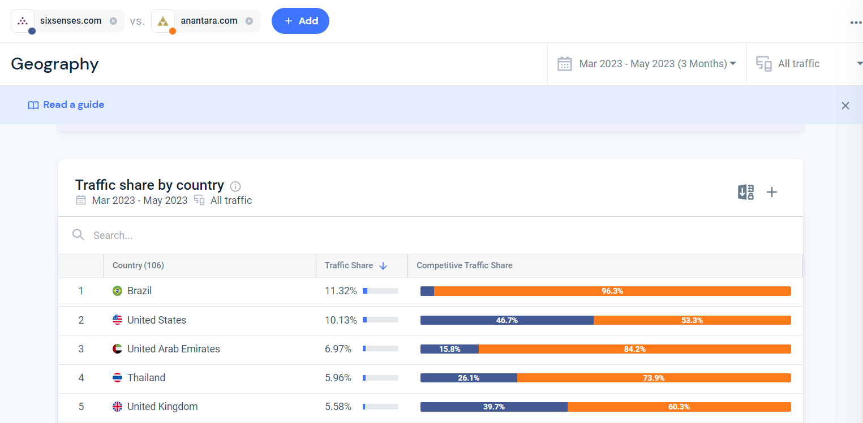
(SimilarWeb, 2023).

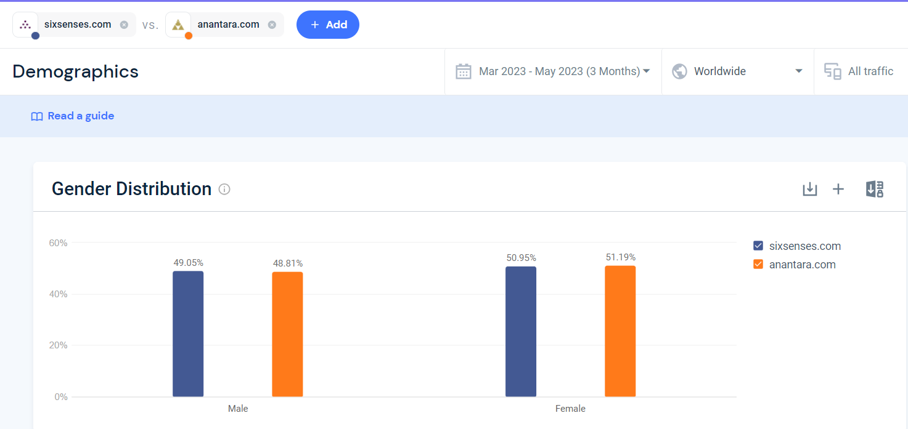
(SimilarWeb, 2023).

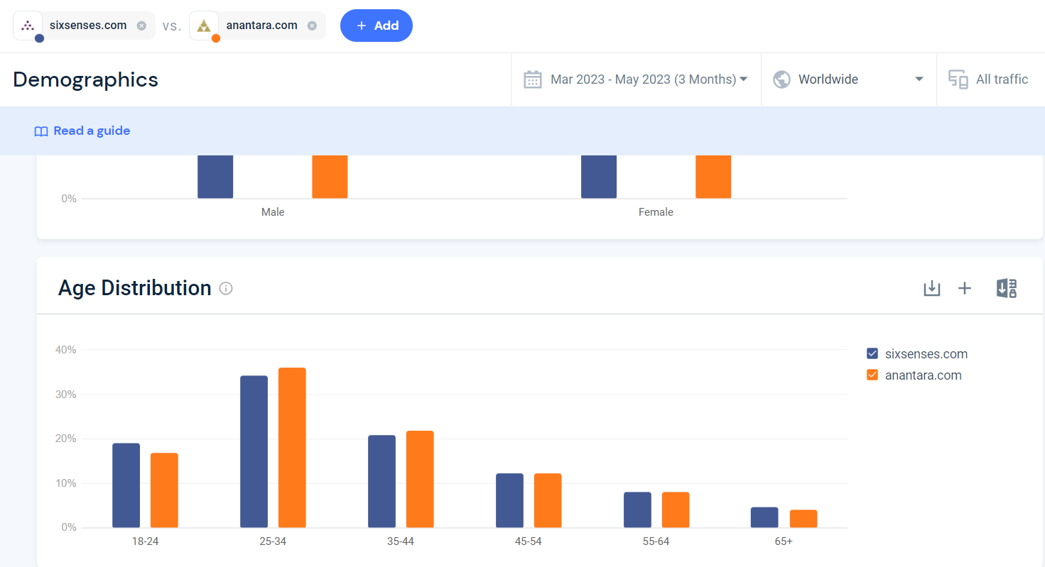
(SimilarWeb, 2023).

WEBSITE PERFORMANCE

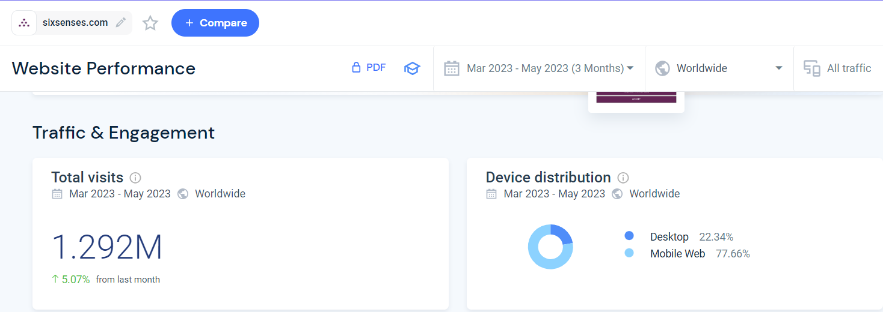
(SimilarWeb, 2023b).

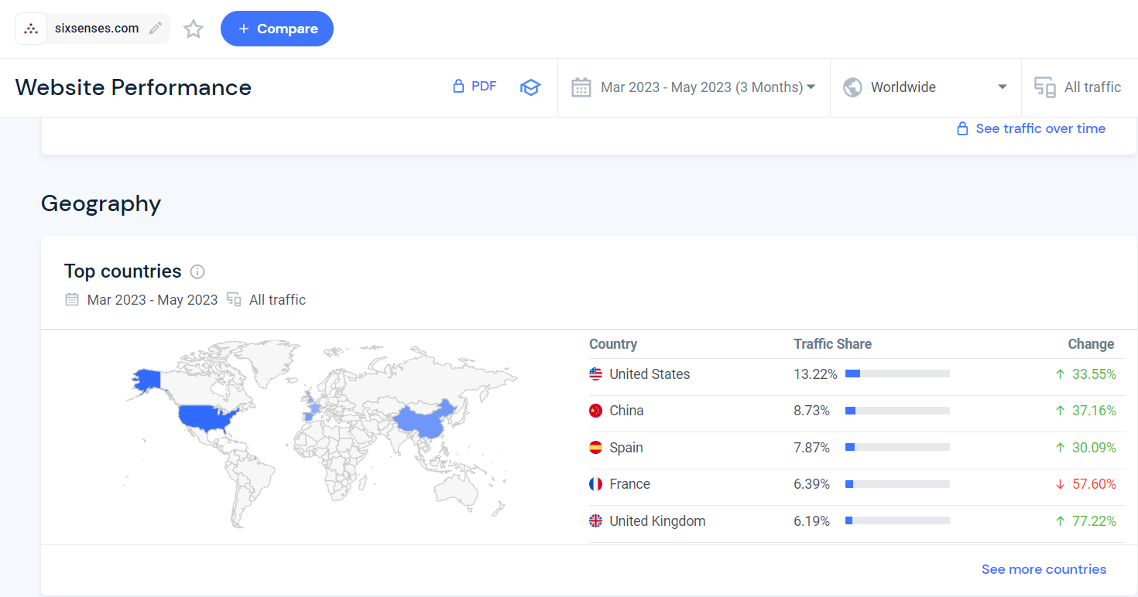
(SimilarWeb, 2023b).

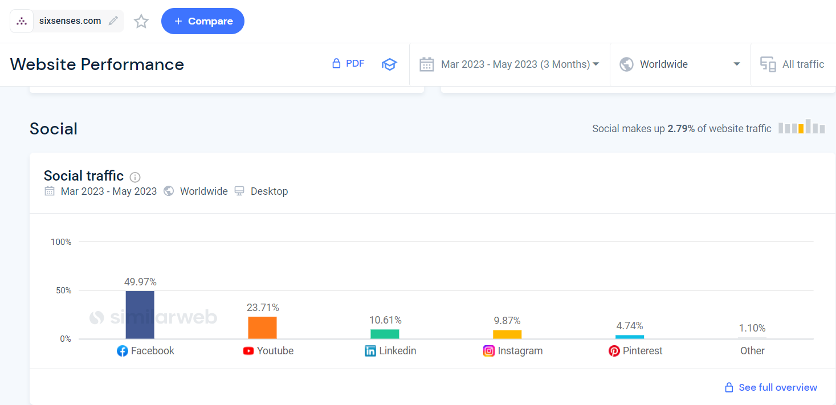
(SimilarWeb, 2023b).

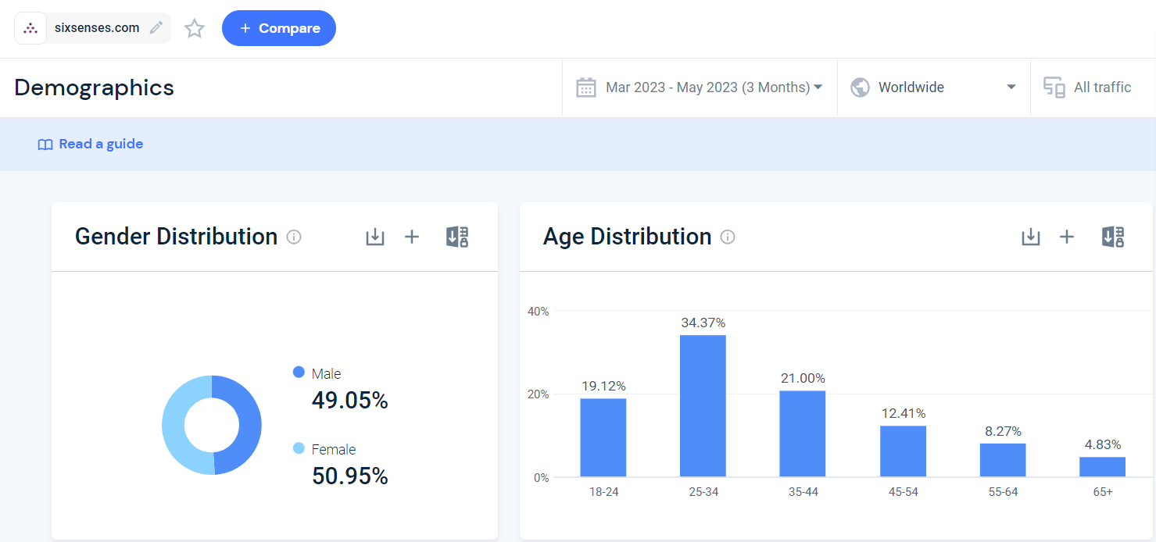
(SimilarWeb, 2023b).

Gantt CHART COMMUNICATION PLAN

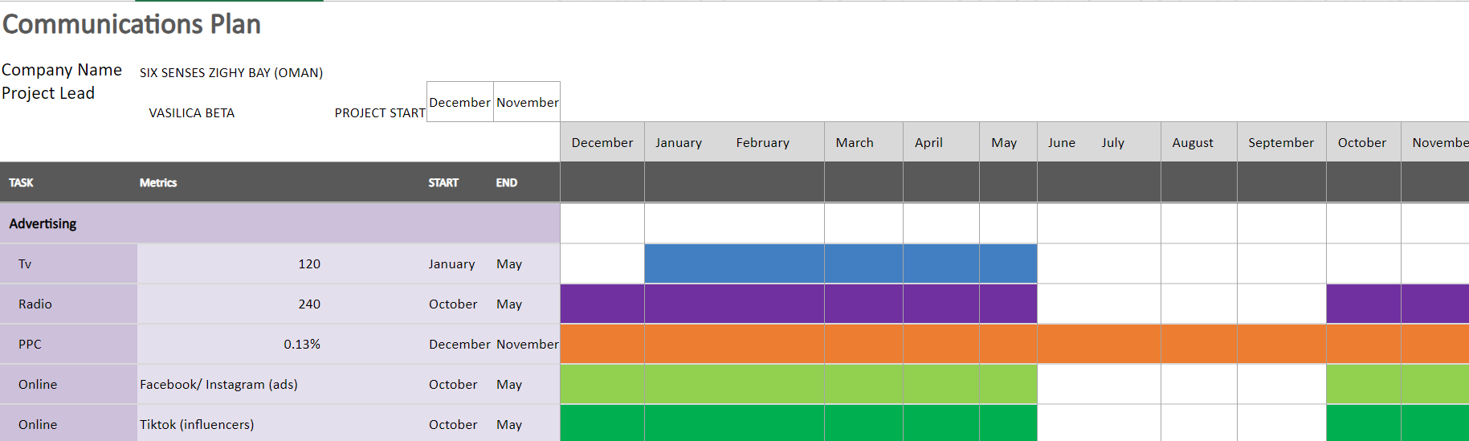
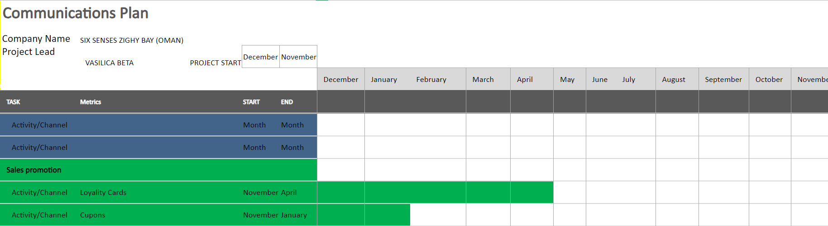

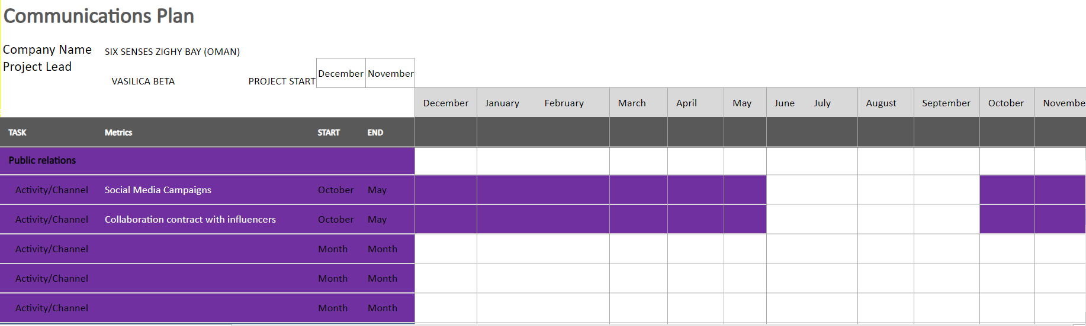

POWERPOINT PRESENTATION



