Children and Young People’s Mental Health and Well-being

Children and Young People's Mental Wellbeing (ECIE5009)

ECIE5009

Erin Walker

2316333

Contents Page

Essay ……………………………………………………………………………Pages 3 to 9

Appendices …………………………………………………………………………..Page 10

Reference List ………………………………………………………………Pages 11 to 17

This essay will examine the vital role that children’s mental health and well-being play in their learning and overall development. It will explore relevant theories and policies that support and promote positive mental health, as well as the impact mental health can have on children’s well-being. In addition, the essay will discuss the strategies used in schools to encourage positive outcomes and provide effective support for children’s mental health needs.
According to Whole Wellness Counselling (2019), children’s mental health is a fundamental factor in their ability to form meaningful relationships and engage fully in learning. Research has consistently shown that early intervention is crucial in improving long-term outcomes and supporting children’s emotional well-being. Noble (2022) notes that addressing emerging issues through school-based programmes helps to enhance learner engagement and reduce the likelihood of mental health difficulties developing over time.
Theoretical perspectives also highlight the importance of early emotional experiences. Attachment Theory, developed by John Bowlby and Mary Ainsworth, emphasises the significance of a secure early bond between a child and their primary caregiver. This early attachment is believed to support the development of social skills, emotional regulation, well-being and overall development. According to the NSPCC (2021), children who do not experience secure early attachments may struggle to form and maintain relationships, which can negatively impact their mental health, emotional stability, and social competence.
According to Freud (2020), “Mental health is a state of emotional, psychological, and social well-being that influences how individuals think, feel, act, and cope with life’s stresses.” Mental health affects all aspects of an individual’s life and can also influence physical health depending on the person’s overall state of well-being. Poor mental health can contribute to the development of conditions such as anxiety, depression, and bipolar disorder. An individual’s mental health therefore shapes how effectively they make decisions, manage challenges, and respond to everyday situations.
MIND (2020) suggests that good mental health enables individuals to build healthy relationships, feel productive, engage in meaningful activities, and cope with difficulties. Similarly, Whole Wellness Counselling (2019) defines good mental health as a state of well-being in which individuals can understand and express their emotions appropriately and feel capable of managing daily demands. In contrast, Mental Health UK (2024) describes poor mental health as experiencing persistent sadness, anxiety or feelings of hopelessness.
It has been shown that in recent years, mental health concerns among children have increased significantly. Data from 2020 to 2023 shows that 1 in 5 children aged 8–16 are now experiencing a mental health disorder. Contributing factors include bullying, online safety issues, and financial pressures. NHS Digital (2022; 2023) reports that children aged 11–16 with poor mental health are more likely to experience face-to-face bullying compared to their peers without such difficulties. Furthermore, the Royal College of Psychiatrists (2022) found that by 2024, the number of children and young people accessing mental health services had risen by 27% in just three years.
Additionally, the importance of good mental health is essential in supporting a healthy physical and mental well-being. A positive mental well-being helps improve physical health and boost productivity (World Health Organization, n.d.). According to Better Health Channel (2022) “A good state of well-being is being linked to happiness and satisfaction.” Well-being is a combination of an individual’s physical, mental, emotional and social health, and how they feel within themselves. WPA (2023) believes good well-being acts as a preventative to mental health illnesses. Helping to prevent negative feeling and emotions and supporting individuals to be resilient against negative experiences. Poor well-being can stem from factors such as financial strain and stress, leading to a decline in mental health and well-being, often increasing the risk of severe mental health issues, such as, depression, anxiety, chronic stress and suicidal ideation. Not only does a poor state of well-being result in a decline of mental health but can also have a significant impact on an individual’s physical, emotional and social well-being. An impression of a social and emotional impact of poor well-being may be shown to others as heightened feelings of negativity and low self-worth. It is important to note that these negative feelings and emotions could be intensified by an individual’s environment, effects of poverty or social exclusion could ultimately worsen the individuals mental state, Aswell as impacting their well-being (Mayo Clinic, 2022). Significantly, poor physical and mental health can lead to long-term effects on well-being, often triggering health conditions, illnesses and disorders (ONS, 2022).
Furthermore, it has shown that children living in poverty are four times more likely to develop severe mental health issues before reaching the age of 11. Highlighting the early effects poverty has on children’s mental health. Likewise, between early 2023 and late 2024 1 in 5 children and young people between the ages of 8 – 25 associated early mental health issues in relation to financial pressures (GOV.WALES, 2025). These statistics showing the substantial impact child poverty has on children and young people’s mental health. Office (2025) provides The Welsh Government’s 2025 Child Poverty Strategy Progress Report unveiling that at least 31% of young people in Wales lived in relative income poverty after the cost of housing in 2025. The impact of poverty and the causes it has on mental health shows the effects it has on young people from lower income backgrounds, frequently resulting in reduced brain development, poorer physical health and long-term effects on emotional well-being (Child Poverty Action Group, 2024; Gearon, 2025).
Children and young people living in poverty are more likely to have negative experiences surrounding their educational learning and development, leaving them to fall behind with grades and finish education with fewer qualifications, later leading them to suffer with employment difficulties throughout adulthood. Also impacting on early education, poverty can leave children suffering from poor physical health due to lack of money to buy nutritional food and poor housing conditions, such as damp or unheated homes (RCPCH, 2020; Office of Disease Prevention and Health Promotion, 2024).
These background disadvantages can go on to influence a child’s schooling by creating barriers to learning and development. For example, a child living in poverty may face limited access to resources, such as books to support their learning and a stable learning environment to concentrate and focus, making it harder for them to engage in their learning. Another example of a disadvantage stemming from a lower income background could be the financial hardship creating feelings of stress or anxiety, which can have an impact on a child’s emotional regulation, behaviour and ability to focus. It is essential to note that these background differences have a significant effect on the way children learn within a school environment and impact not only areas of learning but development also. Consequently, resulting in negatively adjusting the way a child is viewing themselves and going on to support an unhealthy mindset and potentially cause mental health issues in the future (Cooper and Stewart, 2013; Foster, 2015). Comparing a child who has been exposed to early poverty to an individual from an affluent background, it is well-defined that they face additional barriers to learning and long-term development due to their disadvantaged home environments. (Miller et al., 2021; Allen and Donkin, 2015).

The impact of the Covid-19 pandemic severely intensified for families living in poverty by reducing household income, due to job losses, and increasing the number of people relying on food aid networks. The unprecedented increase of family’s dependant on food banks caused a rise in mental health issues linked to food-insecurity according to Fang, Thomsen and Nayga (2021). Constant food uncertainty caused by poverty causes a severe impact on a child’s mental health, leaving them worried and anxious, whilst also being closer associated with higher rates of depression (The Food Foundation, 2024). Alongside the physical impacts on living standards affecting mental health, pandemic related uncertainty heightened psychological vulnerability worsening pre-existing mental health issues (Araújo et al., 2025; Howes et al., 2020).
Following this, statistics show poverty increases the risk of children experiencing bullying within schools, showing close to 1 in 3 children living in poverty face bullying. These often being related to the child’s financial situation and targeting factors being visible markers, such as, wearing the same dirty clothes, lacking school equipment or inability to join in with additional trips due to additional expenses. According to Newson (2016) at least 4 in 10 teachers have noticed pupils being bullied in school due to lack of basic hygiene. These factors contributing feelings of embarrassment and anxiety around the child’s school environment, negatively impacting their well-being and effecting their self-esteem, often leading them to social exclude themselves and lowering their engagement in educational activities. Following on from the many factors connecting to poverty-related bullying, the effects of bullying can create a self-perpetuating cycle of poor mental health by combining the child’s existing physical and emotional trauma and supporting a negative mindset, frequently impacting children long-term (Newson, 2016).
Schools play a critical role in identifying and supporting children’s mental health and offering a secure environment to promote a sense of belonging for all children. Making links to theoretical perspectives, Abraham Maslow’s Hierarchy of Needs believed a sense of acceptance and belongingness was essential for psychological well-being (See Appendix A) According to McLeod (2020) acceptance reflects the need for social connections, these connections including friendship, relying on a secure base to form attachments and explore environments confidently. Without these meaningful connections children can struggle with feelings of distress and worthlessness, later challenging social situations and being a factor of poor mental well-being.
Furthermore, the building and maintenance of strong connections supports against stress and the adverse effects of trauma. High quality social networks have been associated with improved health and lower risk of mortality, reinforcing positive relationships and supporting improved health and well-being in children (McLeod, 2025).Above all, schools play a vital role in providing early interventions and integrating a positive outlook on mental well-being for children to foster, whilst supporting the development of social and emotional skills to provide them with the tools they need to manage self-regulation techniques and improve long-term mental well-being (Freud, 2020).
Additionally supporting links to theory, Bronfenbrenner’s Ecological Systems Theory (See Appendix B) and Maslow’s Hierarchy of Needs, both support the work of schools working in partnership with parents to support targeted areas of development and meet a child’s basic physiological needs. Bronfenbrenner’s theory believes an individual’s development emerges from systems working in partnership through communication, “He also believed the interactions the child has with these people and environments directly impact development.” For example, a positive interaction through an educational resource with a parent may positively influence cognitive and learning skills. This is a system positively interacting with the child to encourage and support learning and development. An example of a negative interaction may be a child who is being bullied at school by friends, this may have a negative influence on a child’s development causing them to develop self-esteem or self-worth issues. Showing the effects systems can have when they work together to support a child’s development.
The influence these systems have on a child is dependent on how the child views them, if a child feels they have formed a secure attachment and feel comfortable, they are more likely to share information that can be used to support their needs. Whereas if a child feels under pressure to perform to a certain standard and feels judged for their feeling and emotions, they may socially withdraw themselves, making it difficult to fully understand the child’s needs and how they can be managed (McLeod, 2025; Guy-Evans, 2025; Woods Academy, 2024).
Schools demonstrate the use of multi-agency working by working closely with outside organisations and agencies to provide additional support and intervention for children and young people. According to the Welsh Government (2025) research shows there is a close link between health well-being, poverty and attainment. Showing children with better quality health and well-being performing better and achieving higher, due to facing fewer challenges along the way impacting their development and learning. The engagement of partnership working is essential for effectively implementing a whole school approach on mental health and well-being, recognising and supporting individual needs. An example of schools implementing a whole school approach to mental health and well-being is the practice of Emotional Literacy Support Assistants (ELSA) groups.
According to Palphreyman (2023) The key purpose of ELSA groups is to improve emotional literacy and supporting the understanding of emotions to help children better cope with challenges such as, bereavement, anger or anxiety. Groups are led by trained teaching assistants who build connections with individuals to support the development of key areas, including their social, emotional and mental health needs. For best effectiveness schools work with parents, ensuring individual needs are recognised and supported, showing the importance of fostering a positive home-school partnership to reinforce the learning strategies put in place and to discuss the child’s progress. Occasionally sessions use interactive resources and techniques to support engagement from individuals lacking confidence in social situations (Palphreyman, 2023; No Limits on Learning, n.d).
ELSA interventions can be helpful for individuals having difficulty in regulating emotions, managing feelings or dealing with conflict. An example of where this intervention would be valuable for a child’s mental health and well-being could be if they are dealing with bullying or friendship issues. The intervention would be focused around targeting the child’s needs, in this case, building the child’s self-esteem, managing and regulating emotions and developing social skills. Overtime the sessions intend to support the development of coping strategies to positively assist the child’s mental health and well-being, helping them feel safer and more empowered (Elsa Support, 2019). ELSA Interventions provide support by addressing emotional needs early on, helping to remove barriers and enabling children to progress to their full capacity.
ELSA interventions show clear links to children living in poverty by addressing the emotional, social and developmental challenges that can come from economic disadvantages. Statistics show that children and young people exposed to early poverty are more likely to suffer from long-term stress, low self-esteem and social exclusion (Change Mental Health, 2024). The influence of poor mental health can negatively impact on a child’s behaviour towards their learning and the relationships they build. Recognising these factors and offering support through an emotional literacy intervention such as ELSA can help to provide a consistent programme where a child can feel supported to grow and develop. Although the intervention does not directly address the child’s living circumstances, ELSA can help to provide a safer space for the child to speak freely whilst supporting the child’s emotional well-being (Knights Enham Federation, 2026).
By taking a preventative approach when considering children’s mental health, it can support and encourage children to learn and understand their feelings and emotions and know how to handle them positively and effectively. This helps to support children in verbalising their emotions, helping to reduce stress and prevent them from becoming overwhelmed. As well as this, interventions allow children to feel seen, helping them to feel supported through 1:1 sessions or group sessions, helping them to feel a sense of belonging and build meaningful connections, also making links to Maslow’s Hierarchy of Needs (Palphreyman, 2023; No Limits on Learning, n.d; Hamworthy Primary Schools, 2025; School P, 2025; McLeod, 2025).
However, while intending to improve outcomes and support additional needs, interventions can have a negative impact, including increased anxiety, self-esteem and stigmatization. An example of how this could affect a child could be the stigma that comes with interventions, and as a result of this, making a child feel labelled or targeted. Children may view interventions as a negative experience and may foster a negative experience towards their learning, overall, negatively effecting on development and increasing the risk of poor mental health. The repetition of a child attending an intervention and it being highly visible to others may cause the child to feel embarrassed and view the intervention as conformation to being eligible rather than seeing it as a support system around them (Rozental and Řiháček, 2025; NCBI, 2016; Guzman‐Holst et al., 2025).
Another significant factor standing in the way making ELSA interventions as successful and accessible to chidren and young people is the cost of training for school staff complete to be able to deliver sessions. According to Adyach Cymru (2023) The cost of training for the school-based intervention is between £600 to £1000 per staff member, with the cost of training so high, depending on the school’s financial situation, the number of children able to access the intervention is limited. Following this, limited access can create pressures to deliver measurable outcome whilst many children in need of additional support are left without, making the risks for poor mental health and well-being to increase (Better Health Channel, 2022).
Furthermore, another intervention designed to support the emotional well-being in children and young people is an Emotional Available Adult (EAA). According to Bristol Early Years (2024) an EAA is a designated member of staff who will do regular check ins with an individual to check on their well-being and mental state, offering guidance to empathy to support the child physically and emotionally. The role of an EAA is to listen and create a positive setting for a child to feel comfortable to express their thought and feelings without rejection or punishment (Super User, 2024). An example of a positive intervention should be an adult modelling a healthy relationship, positively praising and encouraging others for their efforts. From these interventions children should learn how to treat each other from observing the adult modelling skill such as empathy, respect and resilience.
When making links to childhood poverty, an emotionally available adult can play an important role in providing a sense of safety and stability for children. An individual suffering from the effects of poverty, such as housing instability, food insecurity or financial strain may depend on a EAA for consistent support and reassurance (Liberzon et al., 2015). As well as reassurance an EAA can help children to develop the skills to help emotional regulation and building resilience, also supporting a positive mindset (Mental Health Foundation, 2021). From the development of these skills children have an increased chance of bettering academic outcomes through learning problem solving skills and resilience and lowering the risks of poor mental health through building and developing emotional regulation skills, stronger emotional security and healthy social skills (Motional, 2023; Bristol Early Years, 2024).
However, according to Saba (2025) the consistency of the interventions is dependent on staff availability, if a school has a shortage of staff children may go without an EAA, causing them distress and feeling vulnerable. In addition to this, the consistency of a key person has great importance on the child’s development. A consistent routine provides stability for a child, helping to reinforce a safe and secure space for them to learn. With the predictability of a key member of staff children have an opportunity to build meaningful relationships and make attachments whilst being given clear expectations and boundaries (Buckinghamshire.gov.uk, 2021)
Without consistency children can feel anxious and insecure, later leading to behavioural issues and difficulty in regulating emotions. The unpredictability that comes with a lack of routine can leave children feeling unstable and according to Follows (2018) has been linked with physical health symptoms, such as headaches and colds. Making clear links to children suffering the impacts of poverty, Molloy (2019) believes effective early interventions that provide consistency can lessen the negative effects of childhood poverty on learning and development.
To summarise, it is significantly clear that schools play a vital role in the early identification of mental health and well-being needs in children. According to The Knowledge Academy (n.d.) the key differences between mental health and well-being are the overall psychological state of an individual connecting with the holistic state, including physical, social and economic wellness (World Health Organization, n.d.). Schools are appropriately trained and equipped to identify changes in behaviour, emotianl well-being, social interactions and learning that may show difficulties in development. Early recognition allows any concerns to be addressed before becoming more challenging for children and allows them to feel supported through the interventions.
Negative factors that often stem from childhood poverty, such as poor physical health, poor mental health, social isolation and material deprivation regularly fall under Adverse Childhood Experiences (ACEs’) (Bristol Early Years, 2024a; Child Poverty Action Group, 2024). According to Bristol Early Years (2024) an ACE is a negative event that a child experiences causing them chronic stress, either through a direct experience or through a shared environment. An example of a direct ACE may be physical abuse, the consequences from a negative experience such as this often increases the risks of poor mental health and mental health issues, such as depression, post-traumatic stress disorder (PTSD) or anxiety (Office on Women’s Health, 2015). For a child experiencing poverty an ACE such as a poor and unsafe living environment can link to mental health issues, once this is targeted, schools can put measures in place to offer support. This is where an ELSA intervention would be appropriate to support the individual’s needs. For example, for a child who is suffering the effects of poverty and poor living conditions the consistency of a secure and safe setting can help support the individual in emotional regulation techniques and encourage the development of coping strategies, overall supporting the child’s long-term mental health and increasing their chances of achieving better grades (Change Mental Health, 2024).
Furthermore, interventions delivered by schools are helping to support and create a structured and nurturing environment, helping to promote resilience, emotional litracy and social skills. The creation of an openly supportive environment helps children to feel a sense of belonging to the setting, also supporting physical and mental well-being, academic success and increasing long-term development (Little Beam Foundation, n.d.; Department for Education, 2025). In addition, it has been shown that an EAA can heavily support an individual suffering from the trauma of ACE’s linked to early exposure of poverty. It has been shown that the role of an EEA plays significant importance in lowering the risks of poor mental health and well-being in children and young people. Children can become dependent on an EAA displaying empathy and patience when communicating their concerns, for a child suffering from the effects of peer rejection and having no friends an EEA can provide a sense of belonging – making links to Maslow’s Hierarchy of Needs (See Appendix A), and support the development of self-esteem and social skills, positively impacting on the child’s mental health and overall supporting their well-being (Bristol Early Years, 2024b; Change Mental Health, 2024; McLeod, 2025) Overall, concluding that children and young people’s mental health plays an essential role in their overall well-being and can be supported by schools through the correct interventions.

Appendices
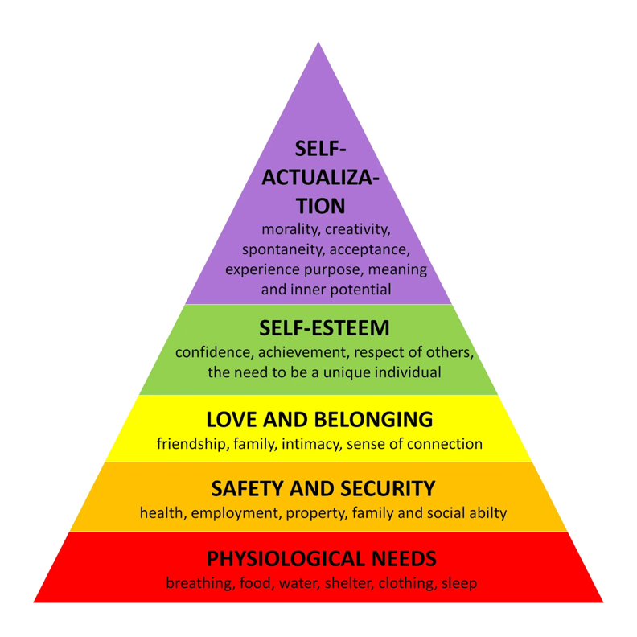
Appendix A – Maslow’s Hierarchy of Needs - (McLeod, 2025)

Appendix B – Bronfenbrenner’s Ecological System – (Guy-Evans, 2025)
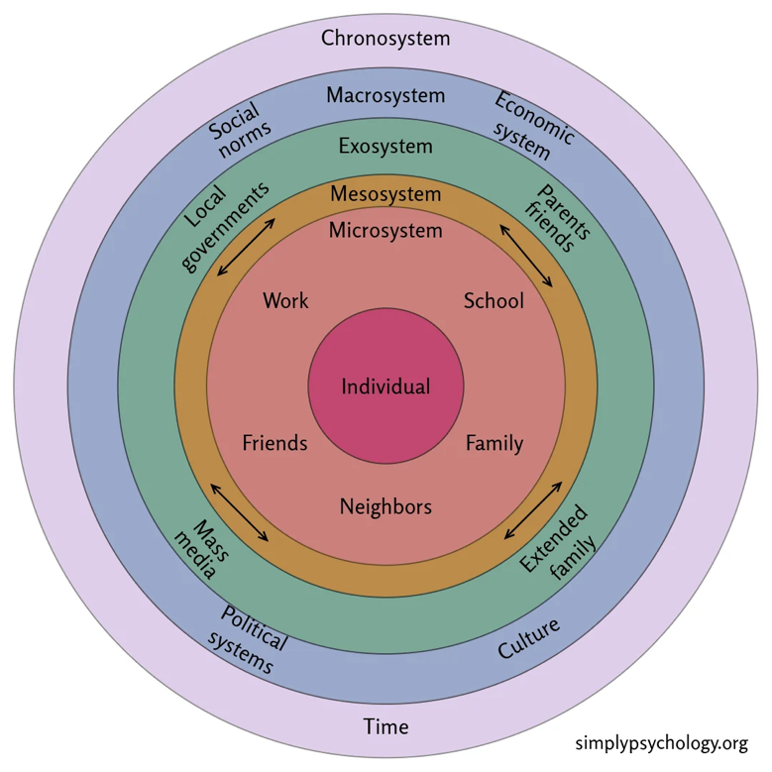

Reference List
Adyach Cymru. (2023). ADYaCh - ELSA Emotional Literacy Support Assistants. [online] Available at: https://www.adyach.cymru/en/Parents/Access-to-the-Service/Educational-Psychology-Service/ELSA-Emotional-Literacy-Support-Assistants.aspx. [8 Feb. 2026].
Allen, M. and Donkin, A. (2015). The Impact of Adverse Experiences in the Home on the Health of Children and Young people, and Inequalities in Prevalence and Effects. [online] UCL Institute of Health Equity. Available at: https://www.instituteofhealthequity.org/resources-reports/the-impact-of-adverse-experiences-in-the-home-on-children-and-young-people/impact-of-adverse-experiences-in-the-home.pdf. [11 Feb. 2026].
app.croneri.co.uk. (n.d.). Supporting disadvantaged children in the early years | Croner-i. [online] Available at: https://app.croneri.co.uk/feature-articles/supporting-disadvantaged-children-early-years. [11 Feb. 2026].
Araújo, O., Freitas, O., Sousa, G., Ribeiro, I., Carvalho, J.C. and Martins, S. (2025). Psychometric proprieties analyses of psychological vulnerability scale for secondary school students. Frontiers in Psychology, 15. doi:https://doi.org/10.3389/fpsyg.2024.1462830. [11 Feb. 2026].
Better Health Channel (2022). Wellbeing. [online] Better Health Channel. Available at: https://www.betterhealth.vic.gov.au/health/healthyliving/wellbeing. [17 Feb. 2026].
Bristol Early Years. (2024a). ACEs (Adverse Childhood Experiences). [online] Available at: https://bristolearlyyears.org.uk/trauma-informed-practice/aces-adverse-childhood-experiences/. [8 Feb. 2026].
Bristol Early Years. (2024b). Emotionally available adult. [online] Available at: https://bristolearlyyears.org.uk/trauma-informed-practice/an-introduction-to-trauma-informed-practice/emotionally-available-adult/. [17 Feb. 2026].
Buckinghamshire.gov.uk. (2021). Principle 3: Developing relationships is fundamental | SchoolsWeb. [online] Available at: https://schoolsweb.buckinghamshire.gov.uk/send-and-inclusion/send-and-inclusion-toolkits/emotionally-based-school-non-attendance-ebsna-toolkit/part-2-identification-and-early-intervention/intervention-planning/principle-3-developing-relationships-is-fundamental/. [11 Feb. 2026].
Change Mental Health (2024). Poverty and mental health. [online] Changemh.org. Available at: https://changemh.org/resources/poverty-and-mental-health/. [11 Feb. 2026].
Child Poverty Action Group (2024). The Effects of Poverty. [online] Child Poverty Action Group. Available at: https://cpag.org.uk/child-poverty/effects-poverty. [2 Feb. 2026].
Cooper, K. and Stewart, K. (2013). Does money affect children’s outcomes? | Joseph Rowntree Foundation. [online] www.jrf.org.uk. Available at: https://www.jrf.org.uk/care/does-money-affect-childrens-outcomes. [10 Feb. 2026].
Department for Education (2025). Mental Health and Wellbeing Support in Schools and Colleges. [online] gov.uk. Available at: https://www.gov.uk/guidance/mental-health-and-wellbeing-support-in-schools-and-colleges. [1 Feb. 2026].
Elsa Support. (2019). Is it Bullying? - Item 192 - Elsa Support Bullying Rude Mean. [online] Available at: https://www.elsa-support.co.uk/resources/bullying-item-192/ [Accessed 8 Feb. 2026].
Fang, D., Thomsen, M.R. and Nayga, R.M. (2021). The association between food insecurity and mental health during the COVID-19 pandemic. BMC Public Health, [online] 21(1), pp.1–8. doi:https://doi.org/10.1186/s12889-021-10631-0. [11 Feb. 2026].
Follows, B. (2018). Why consistency in parenting is vital, especially for children with challenging behaviours - Special Needs Jungle. [online] Special Needs Jungle. Available at: https://www.specialneedsjungle.com/why-consistency-in-parenting-is-vital-especially-for-children-with-challenging-behaviours/ [Accessed 25 Feb. 2026].
Foster, D. (2015). How being poor can lead to a negative spiral of fear and self-loathing. [online] the Guardian. Available at: https://www.theguardian.com/society/2015/jun/30/poverty-negative-spiral-fear-self-loathing. [2 Feb. 2026].
Freud, A. (2020). What’s Mental health? : Mentally Healthy Schools. [online] www.mentallyhealthyschools.org.uk. Available at: https://www.mentallyhealthyschools.org.uk/getting-started/whats-mental-health/. [2 Feb. 2026].
Gearon, R. (2025). How does poverty affect children’s mental health? [online] Action for Children. Available at: https://www.actionforchildren.org.uk/blog/how-does-poverty-affects-childrens-mental-health/. [2 Feb. 2026].
GOV.WALES. (2025). Child Poverty Strategy for Wales: progress report 2025 [HTML] | GOV.WALES. [online] Available at: https://www.gov.wales/child-poverty-strategy-wales-progress-report-2025-html. [11 Feb. 2026].
Guy-Evans, O. (2025). Bronfenbrenner’s Ecological Systems Theory. [online] Simply Psychology. Available at: https://www.simplypsychology.org/Bronfenbrenner.html. [11 Feb. 2026].
Guzman‐Holst, C., Davis, R.S., Andrews, J.L. and Foulkes, L. (2025). Scoping review: potential harm from school‐based group mental health interventions. Child and Adolescent Mental Health. doi:https://doi.org/10.1111/camh.12760. [Accessed 24 Feb. 2026].
Hamworthy Primary Schools. (2025). Emotional Literacy Support (ELSA) | Federation of Hamworthy Primary Schools. [online] Available at: https://www.hamworthyprimaryschools.co.uk/emotional-literacy-support-elsa/ [Accessed 8 Feb. 2026].
Howes, S., Monk-Winstanley, R., Sefton, T. and Woudhuysen, A. (2020). Poverty in the pandemic: the impact of coronavirus on low- income families and children Written and researched. [online] Available at: https://cpag.org.uk/sites/default/files/2023-08/Poverty%20in%20the%20pandemic-%20The%20impact%20of%20coronavirus%20on%20low-income%20families%20and%20children.pdf. [Accessed 30 Jan. 2026].
Knights Enham Federation. (2026). ELSA. [online] Available at: https://www.knightsenhamfederation.co.uk/elsa [Accessed 24 Feb. 2026].
Liberzon, I., Ma, S.T., Okada, G., Shaun Ho, S., Swain, J.E. and Evans, G.W. (2015). Childhood poverty and recruitment of adult emotion regulatory neurocircuitry. Social Cognitive and Affective Neuroscience, 10(11), pp.1596–1606. doi:https://doi.org/10.1093/scan/nsv045. [11 Feb. 2026].
Little Beam Foundation. (n.d.). Quick Wins for Mental Health and Wellbeing in UK Children and Young Adults. [online] Available at: https://www.littlebeamfoundation.com/news/quick-wins-for-mental-health-and-wellbeing-in-uk-children-and-young-adults. [Accessed 30 Jan. 2026].
Mayo Clinic (2022). Mental Illness - Symptoms and Causes. [online] Mayo Clinic. Available at: https://www.mayoclinic.org/diseases-conditions/mental-illness/symptoms-causes/syc-20374968. [Accessed 30 Jan. 2026].
McLeod, S. (2025). Maslow’s hierarchy of needs. [online] Simply Psychology. Available at: https://www.simplypsychology.org/maslow.html. [11 Feb. 2026].
Mental Health Foundation (2021). Children and Young People. [online] Mental Health Foundation. Available at: https://www.mentalhealth.org.uk/explore-mental-health/a-z-topics/children-and-young-people. [Accessed 30 Jan. 2026].
Mental Health UK (2024). Burnout. [online] Mental Health UK. Available at: https://mentalhealth-uk.org/burnout/. [8 Feb. 2026].
Miller, P., Podvysotska, T., Betancur, L. and Votruba-Drzal, E. (2021). Wealth and Child Development: Differences in Associations by Family Income and Developmental Stage. RSF: The Russell Sage Foundation Journal of the Social Sciences, [online] 7(3), pp.154–174. doi:https://doi.org/10.7758/RSF.2021.7.3.07. [8 Feb. 2026].
MIND (2020). Information for 11-18 year olds on understanding mental health. [online] Mind.org.uk. Available at: https://www.mind.org.uk/for-young-people/introduction-to-mental-health/understanding-mental-health/. [8 Feb. 2026].
Molloy, D. (2019). Child poverty and early intervention. [online] Early Intervention Foundation. Available at: https://www.eif.org.uk/blog/child-poverty-and-early-intervention. [8 Feb. 2026].
Motional. (2023). Emotionally Available adults in school. [online] Available at: https://www.motional.io/blog/emotionally-available-adults-in-school/. [11 Feb. 2026].
NCBI (2016). Approaches to Reducing Stigma. [online] Nih.gov. Available at: https://www.ncbi.nlm.nih.gov/books/NBK384914/. [11 Feb. 2026].
Newson, R. (2016). Growing up in poverty detrimental to children’s friendships and family life. [online] National Children’s Bureau. Available at: https://www.ncb.org.uk/about-us/media-centre/news-opinion/growing-poverty-detrimental-childrens-friendships-and-family. [2 Feb. 2026].
NHS Digital (2022). Mental Health of Children and Young People in England 2022 - Wave 3 Follow up to the 2017 Survey. [online] NHS Digital. Available at: https://digital.nhs.uk/data-and-information/publications/statistical/mental-health-of-children-and-young-people-in-england/2022-follow-up-to-the-2017-survey. [2 Feb. 2026].
NHS Digital (2023). Mental health of children and young people in england, 2023 - wave 4 follow up to the 2017 survey. [online] NHS Digital. Available at: https://digital.nhs.uk/data-and-information/publications/statistical/mental-health-of-children-and-young-people-in-england/2023-wave-4-follow-up. [11 Feb. 2026].
No Limits on Learning. (n.d.). Available at: https://www.cognus.org.uk/wp-content/uploads/2024/06/ELSA-information-for-parents.pdf. [2 Feb. 2026].
Noble, K. (2022). Early Intervention Mental Health Programmes for Schools. [online] www.worthit.org.uk. Available at: https://www.worthit.org.uk/blog/early-intervention-mental-health-programmes-schools. [11 Feb. 2026].
NSPCC (2021). Attachment and child development. [online] NSPCC Learning. Available at: https://learning.nspcc.org.uk/child-health-development/attachment-early-years. [2 Feb. 2026].
Odgers Psychology. (2025). ELSA. [online] Available at: https://www.odgerspsychology.com/ELSA [Accessed 24 Feb. 2026].
Office of Disease Prevention and Health Promotion (2024). Poverty. [online] Health.gov. Available at: https://odphp.health.gov/healthypeople/priority-areas/social-determinants-health/literature-summaries/poverty. [Accessed 24 Feb. 2026].
Office on Women’s Health. (2015). Abuse, trauma, and mental health | Office on Women’s Health. [online] Available at: https://womenshealth.gov/mental-health/abuse-trauma-and-mental-health. [Accessed 24 Feb. 2026].
Office, W. (2025). Thousands of children in poverty across Wales to be helped by UK Government’s historic Child Poverty Strategy. [online] GOV.UK. Available at: https://www.gov.uk/government/news/thousands-of-children-in-poverty-across-wales-to-be-helped-by-uk-governments-historic-child-poverty-strategy. [8 Feb. 2026].
ONS (2022). UK Health Indicators - Office for National Statistics. [online] Office for National Statistics. Available at: https://www.ons.gov.uk/peoplepopulationandcommunity/healthandsocialcare/healthandlifeexpectancies/bulletins/ukhealthindicators/2019to2020. [8 Feb. 2026].
Palphreyman, D. (2023). What is ELSA Intervention? [online] ELSA Support. Available at: https://www.elsa-support.co.uk/what-is-elsa-intervention/. [11 Feb. 2026].
RCPCH (2020a). Child poverty – RCPCH – State of Child Health. [online] stateofchildhealth.rcpch.ac.uk. Available at: https://stateofchildhealth.rcpch.ac.uk/evidence/family-and-social-environment/child-poverty/. [8 Feb. 2026].
RCPCH (2020b). Child poverty – RCPCH – State of Child Health. [online] stateofchildhealth.rcpch.ac.uk. Available at: https://stateofchildhealth.rcpch.ac.uk/evidence/family-and-social-environment/child-poverty/. [2 Feb. 2026].
Royal College of Psychiatrists (2022). Children’s mental health crisis deepens: severe shortage of psychiatrists to meet growing demand. [online] www.rcpsych.ac.uk. Available at: https://www.rcpsych.ac.uk/news-and-features/latest-news/detail/2024/11/28/children-s-mental-health-crisis-deepens--severe-shortage-of-psychiatrists-to-meet-growing-demand. [2 Feb. 2026].
Rozental, A. and Řiháček, T. (2025). How to measure negative effects of psychological interventions. Current Opinion in Psychology, 65, p.102084. doi:https://doi.org/10.1016/j.copsyc.2025.102084. [Accessed 30 Jan. 2026].
Saba (2025). What Does It Really Mean to Be Emotionally Available?: How to Go From Emotionally Unavailable to Building Real Connection for Healthier Relationships - Take Root Therapy. [online] Take Root Therapy. Available at: https://www.losangelesmftherapist.com/post/what-does-it-really-mean-to-be-emotionally-available-how-to-go-from-emotionally-unavailable-to-building-real-connection-for-healthier-relationships/. [Accessed 30 Jan. 2026].
School, P. (2025). ELSA - Emotional Literacy Support Assistant. [online] Powell’s C of E Primary School. Available at: https://www.powells.gloucs.sch.uk/ELSA-Emotional-Literacy-Support-Assistant/. [Accessed 30 Jan. 2026].
Super User (2024). our mission. [online] Trauma Informed Schools UK. Available at: https://www.trauma-informed.uk/home/our-mission. [Accessed 30 Jan. 2026].
The Food Foundation (2024). People with a mental health condition more than twice as likely to be living in food insecure households. [online] Foodfoundation.org.uk. Available at: https://foodfoundation.org.uk/press-release/people-mental-health-condition-more-twice-likely-be-living-food-insecure-households. [Accessed 30 Jan. 2026].
The Knowledge Academy (n.d.). Mental Health vs Wellbeing: What’s the Difference. [online] www.theknowledgeacademy.com. Available at: https://www.theknowledgeacademy.com/blog/mental-health-vs-wellbeing/. [12 Feb. 2026].
Welsh Government (2025). Annex 5: developing multi-agency engagement in Community Focused Schools [HTML] | GOV.WALES. [online] GOV.WALES. Available at: https://www.gov.wales/annex-5-developing-multi-agency-engagement-community-focused-schools-html. [12 Feb. 2026].
Whole Wellness Counseling (2019). Whole Wellness Counseling. [online] Whole Wellness Counseling. Available at: https://wholewellnesscounseling.org/child-and-adolescent-therapy [Accessed 30 Jan. 2026].
Woods Academy. (2024). The Importance of Happiness in a Child’s Learning Environment. [online] Available at: https://www.woodsacademy.org/dynamic-posts/~board/blog/post/the-importance-of-happiness-in-a-childs-learning-environment. [8 Feb. 2026].
World Health Organization (n.d.). Promoting well-being. [online] World Health Organization. Available at: https://www.who.int/activities/promoting-well-being. [12 Feb. 2026].
World Health Organization (n.d.). Promoting well-being. [online] World Health Organization. Available at: https://www.who.int/activities/promoting-well-being. [12 Feb. 2026].
WPA (2023). What is wellbeing and why is it important? [online] www.wpa.org.uk. Available at: https://www.wpa.org.uk/health-wellbeing/articles/importance-of-wellbeing. [12 Feb. 2026].

