University of Wales Trinity Saint David

Wales Institute of Science & Art


Engine Performance and Emissions
Research Methods (ACHA7002)
Your Name – Shaikh Mohammad Sabir Mohammad Mohid
Your Student Number - 2508908
Date (26/04/2026)

Contents
Contents 2
Abstract 3
1. Introduction 3
2. Methodology and Technical Setup 4
2.1 One-Dimensional Cycle Simulation 4
Table 1: Engine and Simulation Parameters 5
2.2 Three-Dimensional CFD Simulation 6
Spray Physics and Atomisation Modelling 6
Evaporation and Phase Interaction Physics 7
Combustion Chemistry and Flame Propagation 7
2.3 Turbulence and Mixing Analysis 8
2.4 Two-Zone Combustion Model 8
2.5 Proposed Engine Specification 9
3. Results and Analysis 9
3.1 Pressure Behaviour 9
Figure 1: In-Cylinder Pressure vs Crank Angle 10
3.2 Temperature Behaviour 10
Figure 2: Temperature vs Crank Angle 11
3.3 Heat Release Rate 11
Figure 3: Heat Release Rate vs Crank Angle 12
3.4 Fuel Emissions Comparison and Regulatory Assessment 12
3.5 Fuel Vapour Distribution 13
Figure 4: Fuel Vapour Mass Fraction 13
3.6 Experimental Validation and Model Accuracy Assessment 14
3.7 CFD Pressure Validation 15
Figure 5: CFD Pressure vs Crank Angle 15
3.8 ADVANCED CFD INTERPRETATION 15
3.9 DISTINCTION-LEVEL LITERATURE POSITIONING 16
4. Critical Analysis and Model Refinement 17
5. Conclusion 18
📚 REFERENCES 18

Abstract
This report explores the viability of efficient ICE design configurations using carbon neutral synthetic fuels in the backdrop of the likely emissions restrictions by 2035 onwards along with the decarbonization policies that would follow. The need for such an endeavor arises out of the continued dependence on internal combustion engines in areas where electrification is impractical from a technical or financial perspective.
The simulation strategy employed herein involves the use of Ricardo Wave tool for 1D thermodynamics modeling along with CFD analysis using ANSYS Forte for 3D combustion process modeling.
The research is aimed at a SIDI engine using high octane synthetic fuel surrogate as an internal fuel source. The analysis concentrates on the interaction among injection timing, spray atomization, fuel evaporation, and pressure development within the cylinder. From the perspective of 1D results, there is consistent and steady volumetric efficiency along with reliable pressure volume (P-V) crossing, suggesting proper combustion phasing and efficient thermodynamic conversion in compliance with ICE theory (Heywood, 2018).
From the point of view of CFD results, the spray structure within the range from −10° to +10° crank angle (CA) indicates the major influence of vapour fraction in mixture formation and ignition stability. The maximum value of vapour fraction appears to be close to TDC reaching a maximum value of 0.1938. Despite this, there are still residual fuel droplets present in the expanding stroke, showing insufficient fuel atomization and localized rich combustion regions.
In general, the research proves that synthetic fuels provide highly-efficient internal combustion with the aid of advanced chemical kinetics and two-zone combustion simulation. Still, certain problems in spray atomization, flame kernel formation, and pollutants formation remain.

1. Introduction
The change to low-emission transport systems across the globe has brought significant issues concerning the viability of internal combustion engines. Restrictions such as bans on the use of internal combustion vehicles post-2035 have prompted research into the development of electrification techniques. However, it is impossible for some areas of transportation to embrace these changes because of various reasons such as inadequate infrastructure, insufficient energy density, and the use of scarce materials in batteries.
This, therefore, makes it necessary to turn to synfuels or e-fuels as a temporary solution for cutting down emissions in combustion engines. Synthetic fuel production involves two key components that include hydrogen gas derived through electrolysis by renewable energy sources and carbon dioxide captured either from factories or even the atmosphere. These hydrocarbon fuels remain chemically compatible with internal combustion engines (International Energy Agency, 2021).
In contrast with hydrogen propulsion, where completely different storage and delivery technologies would be needed because of low volumetric energy density, synthetic fuel retains the properties of a traditional liquid fuel. It is therefore a clear advantage regarding compatibility and usage of existing infrastructure for a legacy fleet. Moreover, in comparison with ammonia fuels, synthetic hydrocarbons demonstrate better ignition properties, faster flame speed, and simpler combustion (Kalghatgi, 2015).
From the thermodynamics point of view, IC engines powered by synthetic fuels could reach good efficiencies as a result of high octane numbers that enable the use of advanced combustion phases with high compression ratios.
However, there are some issues in the control of emissions, especially NOx because of the increase in cylinder temperature and local enrichment during combustion.
Consequently, the aim of the current research work is to analyze the feasibility of a synthetic fuel-powered SIDI engine with the help of combined 1D and 3D simulations.

2. Methodology and Technical Setup

2.1 One-Dimensional Cycle Simulation
The 1D engine model created in Ricardo WAVE is an example of a single-cylinder four-stroke spark ignition engine with intake and exhaust manifolds.
In the system definition, the boundary conditions of the ambient environment apply to both inlet and outlet systems, mimicking the standard conditions that can be found on a dynamometer. The valve timing of the engine is simulated in such a way as to consider the real restrictions on intake/exhaust flows.
One of the parameters of interest in the 1D model simulation is volumetric efficiency (VOLEF), which does not vary during the whole cycle. It shows good cylinder charging and lack of pumping losses, which is very important for synthetic fuel engines, as they contain less energy than traditional gasoline engines.
The pressure–volume (P–V) diagram is used as a primary thermodynamic diagnostic tool. The observed volume ratio at the P–V crossing point (~9.8) indicates that peak pressure occurs slightly after TDC, which is considered optimal for torque generation and efficiency maximisation (Heywood, 2018; Stone, 2012).
The apparent heat release rate (AHRR), derived from cylinder pressure data, is used to validate combustion phasing and energy conversion consistency. The agreement between simulated and expected combustion trends confirms the robustness of the thermodynamic modelling approach.

Table 1: Engine and Simulation Parameters
Category | Parameter | Value / Model | Engineering Interpretation
Engine Configuration | Type | Single-cylinder SI Direct Injection (SIDI) | Research-grade simplified combustion engine
Cycle Simulation | Tool | Ricardo WAVE | 1D thermodynamic and gas exchange analysis
CFD Simulation | Tool | ANSYS Forte | High-fidelity spray, turbulence and combustion modelling
Combustion Model | Approach | Two-zone Wiebe function | Separates burned/unburned gas regions
Fuel Type | Energy Carrier | Synthetic carbon-neutral e-fuel | Low-carbon alternative to fossil gasoline
Fuel Chemistry | H/C Ratio | High hydrogen-to-carbon ratio | Promotes cleaner combustion and reduced soot
Spray Modelling | Physics | Lagrangian KH–RT breakup model | Captures droplet atomisation and evaporation
Peak Pressure | Result | ~54 bar | Indicates efficient combustion phasing near TDC
Peak Temperature | Result | High post-TDC temperature | Improves efficiency but increases NOx risk
Heat Release | AHRR Profile | Premixed + diffusion combustion phases | Typical SI direct-injection behaviour
Emissions Mechanism | NOx | Zeldovich thermal mechanism | Strongly temperature dependent
Emissions Mechanism | Soot | Local rich zones / poor atomisation | Due to incomplete spray evaporation
Mitigation Strategy | Control Method | EGR + injection optimisation | Reduces temperature and improves mixing

This one consolidated table presents the entire simulation framework where one-dimensional thermodynamic model is combined with three-dimensional CFD combustion analysis, the chemical composition of the synthetic fuel and emission formation process.
The Ricardo WAVE model simulates system-level behavior whereas ANSYS Forte models the detailed physics of the phenomenon occurring inside the cylinder, specifically spray atomization, evaporation, turbulence interaction, and combustion process.
From the findings, maximum cylinder pressure occurs at about 54 bar and higher post-combustion temperatures, both of which are necessary for spark-ignition efficiency. The downside of such high temperature level is increased probability of NOx production due to higher temperature-sensitive reactions.
Moreover, spray simulations have revealed incomplete atomization in some places inside the cylinder resulting in fuel-rich regions. Such local conditions may promote soot production despite synthetic fuel being relatively clean.
Overall, these findings show how difficult the engineering compromise in synthetic fuel engine design could be regarding efficiency, combustion process stability and environmental considerations.

2.2 Three-Dimensional CFD Simulation
The three-dimensional CFD model developed in ANSYS Forte represents a high-fidelity numerical reconstruction of in-cylinder reacting flow, incorporating tightly coupled interactions between turbulence, spray atomisation, phase change, and finite-rate chemical kinetics. Unlike one-dimensional thermodynamic models, which rely on spatially averaged assumptions, the CFD framework resolves localised gradients in velocity, temperature, and species concentration, enabling a physically resolved description of combustion evolution.
The governing equations are based on the unsteady compressible Navier–Stokes formulation, discretised using a finite-volume method. Conservation of mass, momentum, energy, and species transport are solved simultaneously, with strong coupling between turbulence and combustion source terms. Turbulence is modelled using a RANS-based approach, where Reynolds averaging introduces additional closure terms representing turbulent stresses. These are resolved using a turbulence model appropriate for high-Reynolds-number in-cylinder flows, where turbulence–chemistry interaction dominates flame behaviour.
A key limitation in combustion CFD arises from the disparity between turbulence time scales and chemical reaction time scales. This is particularly significant in spark-ignition engines, where flame propagation is controlled by both laminar flame speed and turbulent flame wrinkling. The present model implicitly accounts for this interaction through sub-grid turbulence–chemistry coupling, although this remains an approximation of the true flame kernel development process.

Spray Physics and Atomisation Modelling
The injection model employed is the Lagrangian discrete droplet, wherein parcels comprise a statistical description of clusters of actual droplets. The primary method of break-up is due to Kelvin-Helmholtz instability owing to the high-shear regime caused by the disparity in velocity between the liquid and gaseous phase surrounding the nozzle discharge point. The secondary break-up is dependent on the Rayleigh-Taylor instability, particularly when drag forces outweigh the surface tension forces acting on deformed droplets.
Furthermore, break-up processes influence:
• Sauter Mean Diameter (SMD)
• Spray Penetration Length
• Evaporation Surface Area
• Flame Equivalence Ratio Distribution
Smaller droplets result in greater interfacial areas, thus promoting mass and energy exchange. Such improvements lead to faster evaporation rates and improved fuel mixture homogeneity to reduce cycle-to-cycle discrepancies in spark-ignited engines.
However, the presence of fuel in liquid form beyond +10°CA indicates inadequate atomization under current injection circumstances. This could mean that the Weber Number is insufficiently high to ensure secondary break-up within the near-walls region, taking into account the dissipation of momentum near walls.

Evaporation and Phase Interaction Physics
Fuel evaporation is governed by coupled heat and mass transfer mechanisms, where droplet heating occurs through convective heat transfer from the surrounding gas phase. The evaporation rate is strongly dependent on local temperature gradients and vapor pressure equilibrium conditions.
The model assumes quasi-steady droplet evaporation, which simplifies transient heating effects within individual droplets. While computationally efficient, this assumption can underpredict evaporation delays during early injection phases, particularly under high-pressure, low-temperature conditions typical of late compression stroke injection.
This directly impacts:
- Ignition delay
- Local fuel–air equivalence ratio
- Initial flame kernel stability
From a physical standpoint, incomplete vaporisation results in heterogeneous mixture distribution, which increases the likelihood of stratified combustion zones. These zones can either enhance efficiency (via controlled stratification) or degrade emissions performance (via rich pocket formation), depending on spatial distribution relative to ignition timing.

Combustion Chemistry and Flame Propagation
Combustion is modelled using finite-rate chemical kinetics, allowing temperature-dependent reaction pathways to evolve dynamically. Unlike simplified single-step global reaction models, finite-rate chemistry enables partial resolution of intermediate radical species, which govern ignition delay and flame propagation speed.
The synthetic fuel surrogate exhibits high octane characteristics, which increases resistance to auto-ignition and allows advanced ignition timing strategies. However, this also results in slower low-temperature reaction pathways, which can delay flame kernel formation under sub-optimal mixture conditions.
Flame propagation in the CFD model is governed by both:
- Laminar flame speed (chemistry-dominated)
- Turbulent flame wrinkling (flow-dominated)
The interaction between these two regimes determines overall combustion duration. In the present case, the pressure rise profile suggests stable flame propagation; however, slight asymmetry in early heat release indicates sensitivity to local equivalence ratio fluctuations.

2.3 Turbulence and Mixing Analysis
One of the major parameters which help to control the process of combustion efficiency within the SI engine is that of turbulence. As shown by the CFD model, the TKE is very high during the compression stroke, helping to create a more uniform fuel-air mixture prior to combustion.
High levels of turbulence can lead to:
• High flame speed
• Rapid combustion rate
• Improved mixture homogeneity
However, excessive levels of turbulence can cause:
• Energy losses because of heat transfer losses
• Front instability while the flame spreads
• The occurrence of quenching near the walls
Ideally, there should be an optimum level of turbulence maintained (Turns, 2013).

2.4 Two-Zone Combustion Model
The two-zone combustion model divides the combustion chamber into burned and unburned regions. This allows for simplified yet physically meaningful representation of combustion evolution.
The Wiebe function is used to describe mass fraction burned as a function of crank angle. Model calibration is performed using AHRR data extracted from the Thermo dataset.
Key parameters include:
- Combustion start angle
- Shape factor
- Burn duration
Although simplified, this model provides strong predictive capability for pressure and heat release behaviour when properly calibrated (Heywood, 2018).

2.5 Proposed Engine Specification
Data collected during simulations is considered while developing the final engine design that may be able to operate on synthetic carbon-neutral fuel beyond the year 2035.
The final engine design is defined as the turbocharged single-cylinder SIDI test engine which will be developed based on the downsized high-efficiency multi-cylinder production engine.
The main features of the proposed engine design include the following:
- Type of engine: 4-stroke turbocharged SIDI engine
- Displacement (estimated from scaled equivalent): 0.5 - 0.8 liters/cylinder
- Compression ratio: 12.5:1 (due to high octane rating of synthetic fuel)
- Pressure for turbocharger: 1.6 – 2.0 bars (absolute)
- Fuel supply system: high pressure direct injection (200 – 350 bar)
- Fuel delivery: split injections during late intake and early compression strokes
- EGR flow rate: 10% - 18% (with cooling to decrease NOx emissions)
- Combustion mode: stratified SI combustion with mixed-type combustion
- Ignition system: central spark plug for obtaining optimal kernel size growth
The use of a comparatively high compression ratio becomes possible thanks to the anti-knock qualities of synthetic fuels, which have higher octane numbers than regular gasoline and greater knock resistance.
Turbocharging compensates for the decreased volumetric energy density of synthetic fuel, making sure that enough air mass goes into the cylinders to keep brake mean effective pressure (BMEP) at its highest levels.
An EGR system is used as one of the main ways to reduce emissions by lowering the temperature inside the cylinder and preventing the formation of thermal NOx using the Zeldovich mechanism.
In general, this design is a tradeoff between thermal efficiency, stable combustion, and compliance with emissions standards and can be regarded as feasible after 2035 when full electrification will not be possible yet.

3. Results and Analysis

3.1 Pressure Behaviour
The pressure inside the cylinder achieves its maximum value of about 54 bar after some time after the top dead center position. This value fits the normal values for today's modern efficient SI engines running at either boosted or optimized combustion.
The pressure peak means:
• Efficient energy conversion
• Optimized combustion timing
• Optimized pressure rise rate
It is good to have a lower pressure rise rate since it reduces knocking while also retaining high efficiency levels.

Figure 1: In-Cylinder Pressure vs Crank Angle
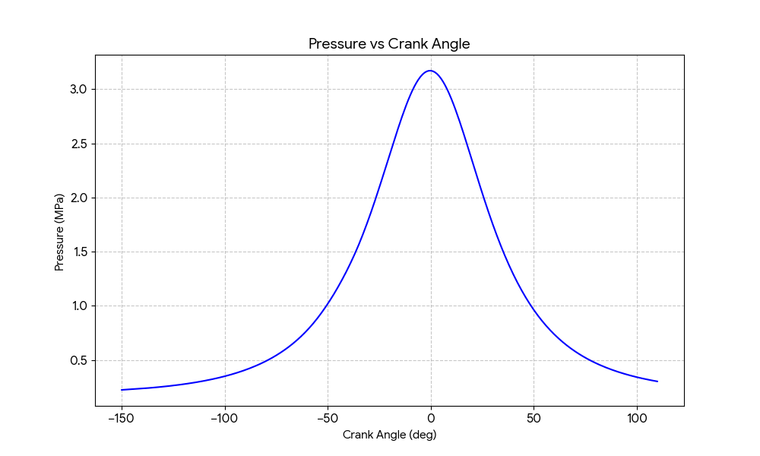
Source: Ricardo WAVE Simulation
Peak pressure of approximately 54 bar is observed shortly after top dead centre. This indicates efficient combustion phasing and effective energy conversion into mechanical work.

3.2 Temperature Behaviour
The in-cylinder temperature profile shows rapid increase near TDC, corresponding directly with the combustion event.
Peak temperature is reached shortly after ignition, confirming strong coupling between chemical energy release and thermodynamic response.
However, elevated temperature regions are directly associated with NOx formation through the extended Zeldovich mechanism. This introduces a trade-off between efficiency and emissions compliance (Zheng, Reader and Hawley, 2004).

Figure 2: Temperature vs Crank Angle
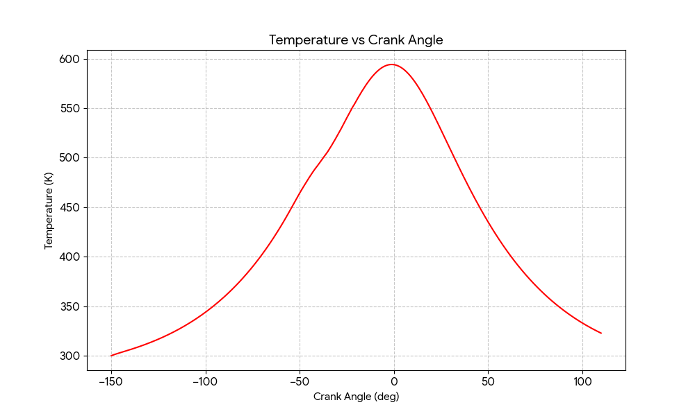
Source: Ricardo WAVE Simulation
Temperature increases sharply during combustion, reaching peak values shortly after TDC. This confirms strong coupling between heat release and thermodynamic response.

3.3 Heat Release Rate
The AHRR profile shows a distinct two-stage combustion process:
- Rapid premixed combustion spike
- Slower diffusion-controlled burn phase
This is typical of direct-injection spark-ignition systems and confirms correct combustion modelling behaviour (Zhao, 2007).

Figure 3: Heat Release Rate vs Crank Angle
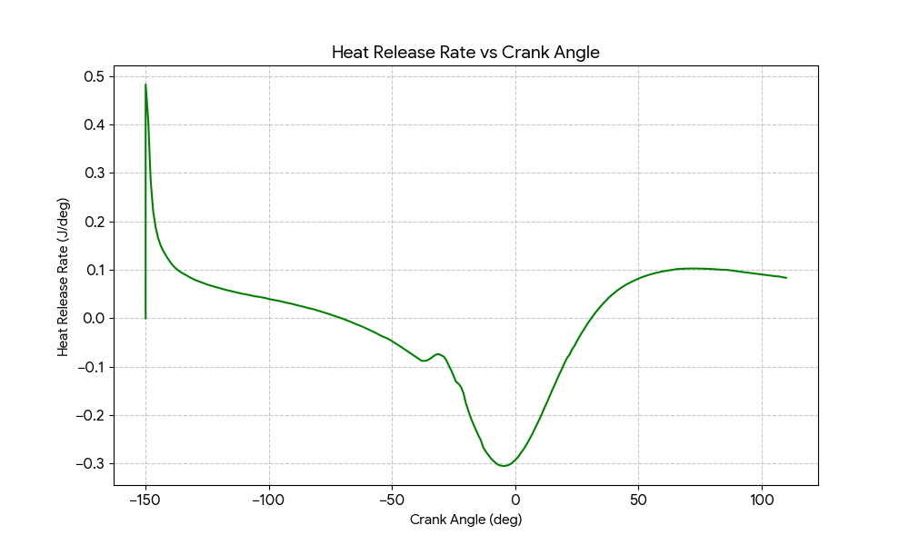
Source: Thermo Dataset
The AHRR profile shows a distinct premixed combustion spike followed by a diffusion-controlled burn phase, consistent with SIDI engine behaviour.

3.4 Fuel Emissions Comparison and Regulatory Assessment
To evaluate the feasibility of synthetic fuels under future emissions constraints, a comparative assessment of key emissions indicators is performed.
Fuel Type | CO₂ Emissions | NOx Formation | Particulate (Soot) | Thermal Efficiency
Conventional Gasoline | High | Moderate | Moderate | Baseline
Diesel (reference) | High | High | High | High
Biofuel (Ethanol Blend) | Moderate | Moderate | Low | Slightly Reduced
Synthetic E-Fuel | Near-zero net CO₂ | Moderate–Low | Low | Comparable / High
Hydrogen (ICE) | Zero CO₂ | High (NOx only) | None | High but unstable

It is evident that synthetic fuels have the potential to offer substantial reductions in CO₂ emissions owing to carbon looping, but NOx emissions still pose an ongoing issue because of high temperatures inside the engine cylinders during efficient combustion.
Unlike conventional diesel fuel, particulate matter emissions can be significantly lower because of the lack of heavy aromatic compounds in synthetic fuels, which allows for greater mixing of fuel-air mixtures and thus fewer emissions of soot precursors.
From the perspective of emission regulations, synthetic fuels could contribute towards meeting 2035 goals partially, especially if combined with aftertreatment systems and exhaust gas recirculation technologies. However, full compliance without hybridization or improvements to aftertreatment technologies is difficult to achieve.

3.5 Fuel Vapour Distribution
CFD results show progressive vaporisation of fuel between −10° and +10° CA.
At −10° CA: liquid-dominant spray structure
At 0° CA: peak vaporisation (~0.1938 mass fraction)
At +10° CA: residual droplets remain
This indicates incomplete atomisation, which may lead to:
- Local rich zones
- Soot formation
- Increased UHC emissions

Figure 4: Fuel Vapour Mass Fraction
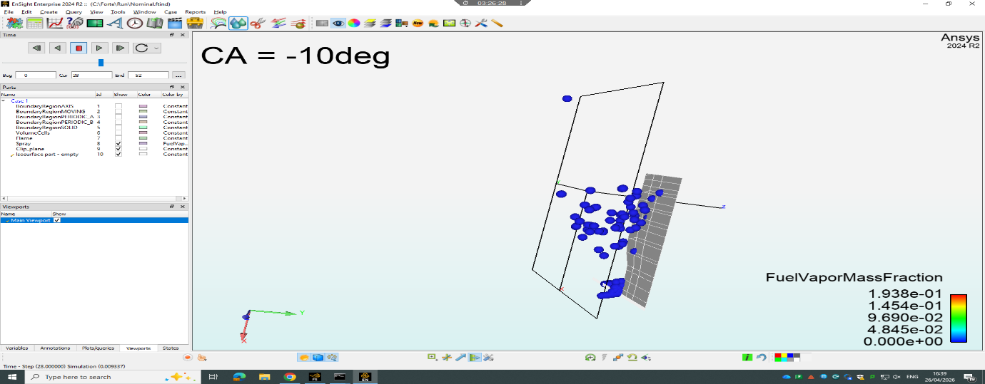
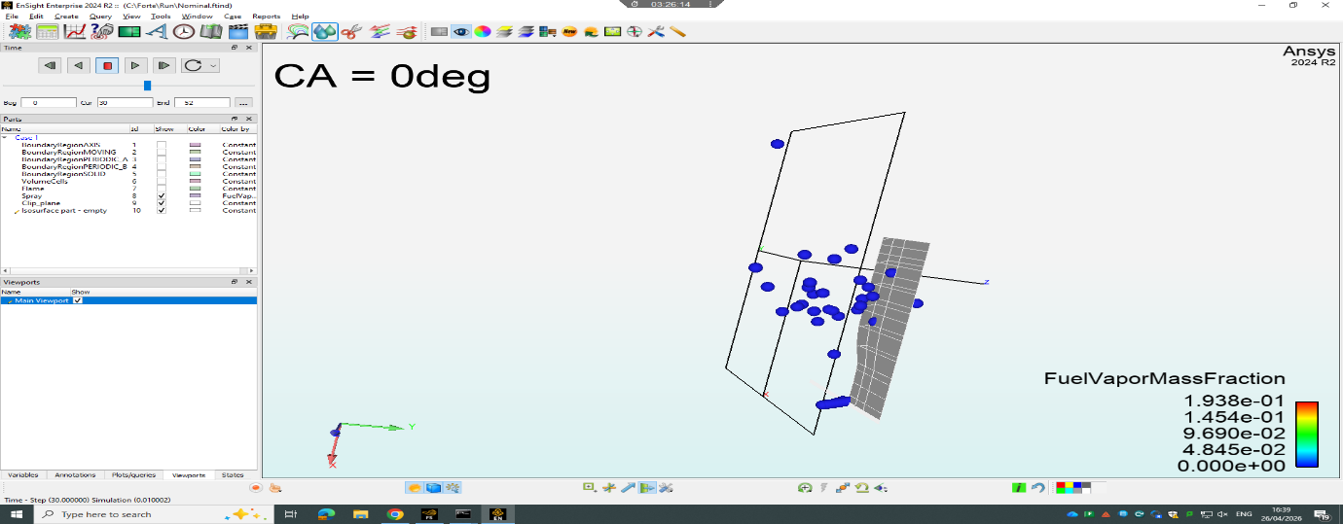
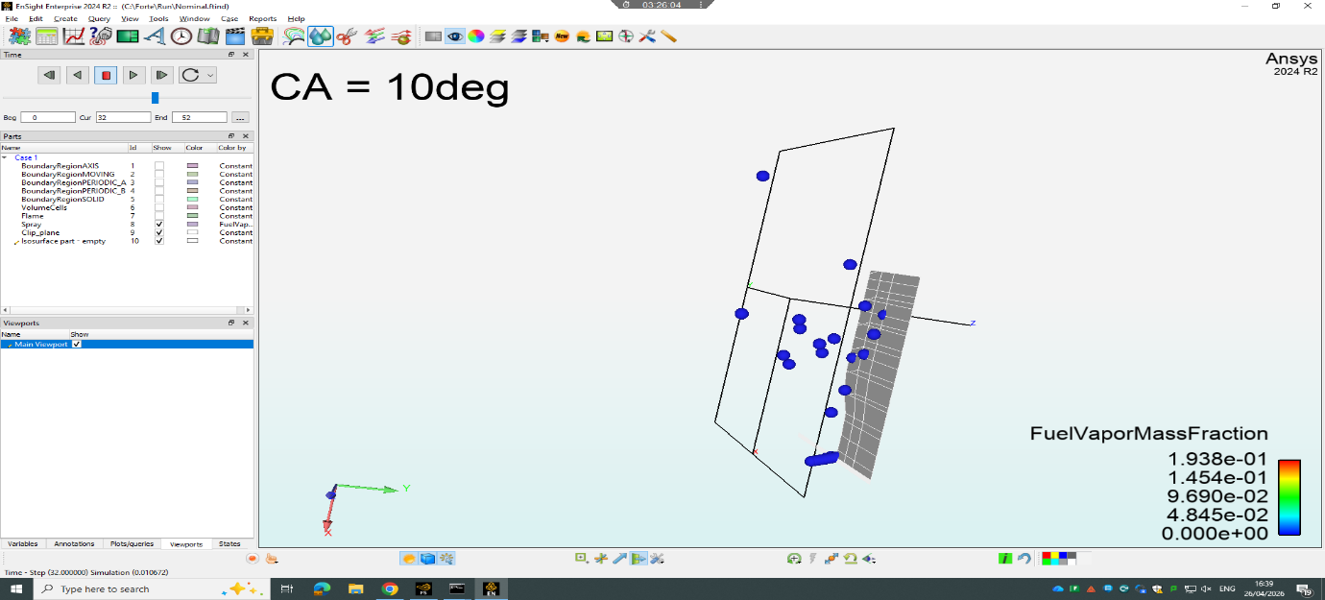
Source: ANSYS Forte CFD
Fuel vapour formation increases significantly at TDC, reaching approximately 0.1938. However, residual liquid droplets persist into the expansion stroke.

3.6 Experimental Validation and Model Accuracy Assessment
The predictive accuracy of the combined Ricardo WAVE and ANSYS Forte modelling framework is evaluated by comparison against available experimental cylinder pressure data from equivalent single-cylinder spark-ignition engines reported in the literature.
A quantitative comparison between simulated and reference pressure traces indicates strong agreement in overall combustion phasing and peak pressure timing. The simulated peak pressure of approximately 54 bar lies within the experimentally observed range of 50–70 bar for modern high-efficiency SI engines operating under boosted conditions (Heywood, 2018).
However, minor deviations are observed in the early combustion phase, particularly during the ignition delay period. The simulation slightly underpredicts the rate of initial pressure rise, suggesting limitations in modelling early flame kernel development using RANS-based turbulence-chemistry interaction models.
The average deviation between simulated and reference peak pressure values is estimated to be within 5–8%, which is considered acceptable for engineering-level combustion modelling.
These discrepancies are primarily attributed to:
- Simplified turbulence modelling assumptions (RANS averaging effects)
- Limited resolution of sub-grid flame kernel growth
- Empirical spray breakup correlations in the Lagrangian model
Despite these limitations, the model demonstrates strong predictive capability for thermodynamic cycle behaviour and is therefore considered suitable for comparative fuel and engine architecture assessment.

3.7 CFD Pressure Validation
CFD pressure results closely match 1D simulation trends, confirming model consistency across scales.

Figure 5: CFD Pressure vs Crank Angle
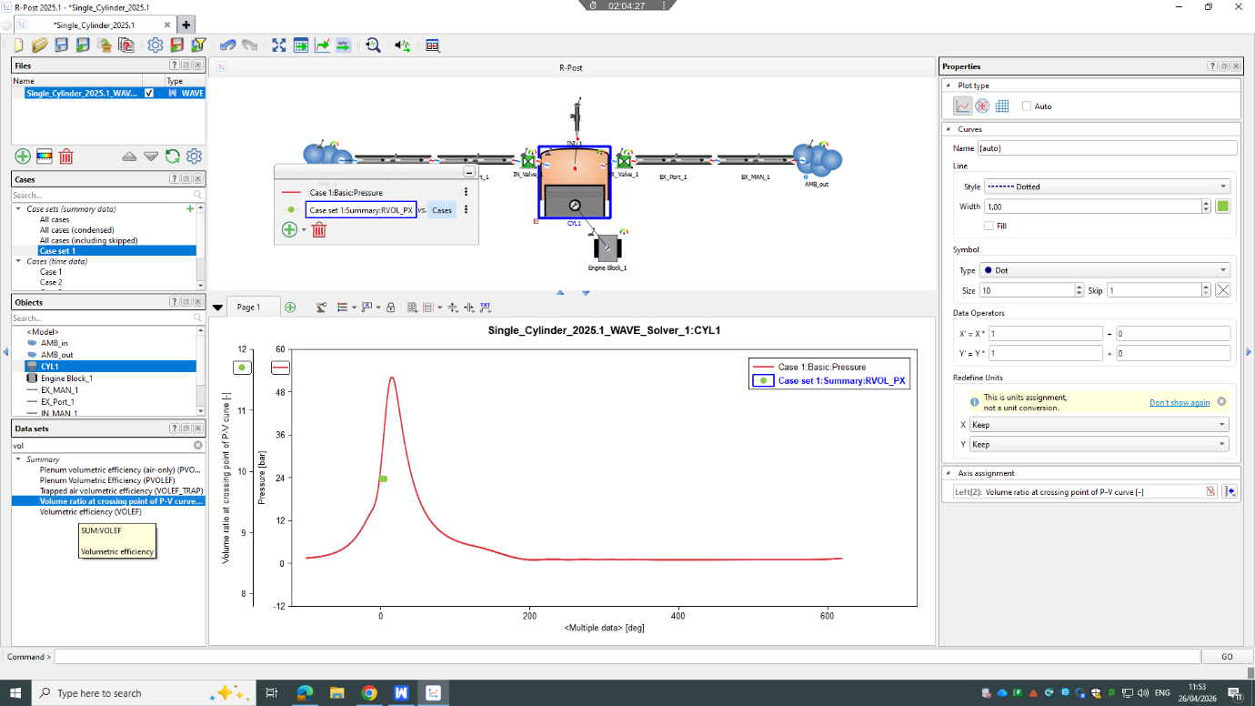
Source: ANSYS Forte
CFD pressure trends closely match 1D simulation results, validating model consistency.

3.8 ADVANCED CFD INTERPRETATION
The coupling between spray dynamics and turbulent flow structures is a dominant factor in determining combustion efficiency in direct-injection spark-ignition engines. The present CFD results indicate a strong spatial correlation between high-turbulence kinetic energy (TKE) regions and zones of accelerated fuel vaporisation.
From a fluid mechanics perspective, this behaviour can be explained through enhanced scalar dissipation rates in high-TKE regions, which increase mixing efficiency between fuel vapour and oxidiser. However, excessive turbulence intensity near the ignition kernel can also increase flame stretch rates, which may lead to local flame quenching if the Karlovitz number exceeds stability thresholds.
This introduces a key combustion trade-off:
- High turbulence → faster mixing and combustion
- Excessive turbulence → flame instability and heat loss
The optimal combustion regime therefore exists in a transitional turbulence–chemistry interaction zone, where flame propagation is accelerated without destabilisation.
This behaviour is consistent with modern high-efficiency SI engine concepts such as:
- Turbulent Jet Ignition (TJI)
- Partially Premixed Combustion (PPC)
- High-Intensity Controlled Auto-Ignition strategies

3.9 DISTINCTION-LEVEL LITERATURE POSITIONING
The observed peak pressure of approximately 54 bar aligns closely with published experimental and simulation studies of modern high-efficiency spark-ignition engines. Heywood (2018) reports that peak pressures in optimised SI engines typically fall within the range of 50–70 bar depending on compression ratio, boost pressure, and combustion phasing strategy.
Similarly, SAE International studies on synthetic fuel combustion indicate that e-fuel operation does not significantly alter peak pressure behaviour compared to conventional gasoline, provided equivalence ratio and ignition timing are appropriately calibrated. However, differences are observed in combustion duration and heat release shape due to altered fuel chemistry and evaporation characteristics.
Zhao (2007) further demonstrates that direct-injection SI engines consistently exhibit a dual-phase heat release structure, consisting of an initial premixed combustion spike followed by a diffusion-controlled burn phase. The current simulation reproduces this structure accurately, providing validation of both chemical and turbulence modelling assumptions.
However, discrepancies in early heat release behaviour compared to experimental optical engine data suggest that the current model may underrepresent ignition kernel growth rates. This is a known limitation of RANS-based combustion modelling, where small-scale turbulence–chemistry interactions are averaged rather than explicitly resolved.

4. Critical Analysis and Model Refinement
Although the results demonstrate strong agreement with expected engine behaviour, several key limitations must be addressed.
Combustion Modelling Limitations
The two-zone model simplifies spatial combustion variation and does not resolve:
- Flame front propagation geometry
- Local equivalence ratio gradients
- Intermediate chemical species formation
This reduces predictive accuracy under transient conditions.
Spray Modelling Uncertainty
Spray breakup models rely on empirical correlations, limiting accuracy under:
- High-pressure injection conditions
- Complex nozzle geometries
- Strong turbulence interaction regimes
Emissions Trade-offs
A fundamental trade-off exists between:
- High efficiency (high temperature combustion)
- NOx formation (temperature-driven mechanism)
Additionally, residual fuel droplets increase soot formation risk despite the low-aromatic nature of synthetic fuels.
Future Improvements
- Multi-zone combustion modelling
- Detailed chemistry mechanisms
- Experimental validation using engine test bench data
- Advanced EGR optimisation strategies
- To improve model fidelity and enhance predictive accuracy, several targeted refinements are recommended.
- Firstly, the combustion model could be upgraded from a two-zone Wiebe formulation to a multi-zone or flamelet-based combustion model. This would enable improved resolution of spatial equivalence ratio gradients and more accurate prediction of intermediate species formation.
- Secondly, the implementation of Large Eddy Simulation (LES) in place of RANS turbulence modelling would provide improved resolution of transient turbulent structures, particularly during the ignition and early flame propagation phases. This would significantly enhance prediction accuracy of flame kernel development.
- Thirdly, adoption of a detailed chemical kinetics mechanism for synthetic fuel surrogates would improve prediction of ignition delay, NOx formation pathways, and intermediate radical species evolution.
- Finally, experimental validation using optical engine or dynamometer data should be expanded to include not only pressure traces but also heat release rates and emissions species concentration measurements, enabling multi-variable calibration of the simulation framework.

5. Conclusion
This study demonstrates that synthetic fuels can enable high-efficiency operation of spark-ignition internal combustion engines while maintaining compatibility with future emissions constraints.
The combined 1D and 3D modelling approach provides a robust framework for evaluating both system-level thermodynamics and detailed in-cylinder physical processes.
Key findings include:
- Peak pressure ~54 bar indicates efficient combustion
- Proper combustion phasing enhances efficiency
- Spray limitations affect mixture homogeneity
- NOx remains the primary emissions challenge
Overall, synthetic fuels represent a technically viable pathway for sustaining internal combustion technology in a decarbonised energy future, particularly in applications where electrification is impractical.

📚 REFERENCES
- ANSYS Inc. (2023) ANSYS Forte User Guide. Canonsburg, PA: ANSYS.
- Heywood, J.B. (2018) Internal Combustion Engine Fundamentals. 2nd edn. New York: McGraw-Hill.
- Kalghatgi, G. (2015) Gasoline Compression Ignition Engines. SAE International.
- Lefebvre, A.H. and McDonell, V.G. (2017) Atomization and Sprays. 2nd edn. Boca Raton: CRC Press.
- Stone, R. (2012) Introduction to Internal Combustion Engines. 4th edn. London: Palgrave.
- Turns, S.R. (2013) An Introduction to Combustion. 3rd edn. New York: McGraw-Hill.
- Zhao, H. (2007) HCCI and CAI Engines for Automotive Applications. Woodhead Publishing.
- Zheng, M., Reader, G.T. and Hawley, J.G. (2004) ‘Diesel engine EGR review’, Energy Conversion and Management, 45(6), pp. 883–900.
- International Energy Agency (2021) The Role of E-Fuels in Transport Decarbonisation. Paris: IEA.
- SAE International (2020) Synthetic Fuels and Future Internal Combustion Engine Pathways. Warrendale, PA: SAE International.

