Student Name: | Gheorghe Mihalka
Student Number: | 1711806
Module No: | BMSK4003
Module Title: | DIGITAL SKILLS AND RESEARCH METHODS
Lecturer: | Balendran Kandasamy

Table of Contents
Introduction…………………………….……………………..……………3
Part 1…………………………………………………………………..…...3
Modern technology – definition…………………………………………..3
Comparison between Yahoo and Gmail at workplace……….………..3
Yahoo……………………………………………………….…….………..3
Gmail………………………………………………………………………..3
Conclusion for comparison between Yahoo and Gmail……………....4
Comparison between Word and Excel at workplace ……….………..4
Microsoft Word…………………………………………….…….………..4
Microsoft Excel…………………………………………….…….………..5
Conclusion for comparison between Word and Excel…………..…....5
Social media as a tool for marketing, information gathering and communication within the workplace………………………………………………………...…...6
Differences and similarities between Facebook and LinkedIn..……..6
Facebook…………………………………………………………………..6
LinkedIn..…………………………………………………………………..6
Conclusion for comparition between Facebook and LinkedIn………..7
Part 2..…….………………………………………………………………..9
New Linkedln account (snapshot)..……………………………………..9
New Linkedln account (link)……….……………………………………..9
New Facebook account (snapshot)..…………………………………….9
New Facebook account (link)……….………………………………..…..9
References…………………………………………………………….....10

Introduction
The aim of this report is to evaluate the effectiveness of the modern technologies, in this case use of two different mail providers, Yahoo and Gmail in the workplace and also to explore social media as a tool for marketing, information gathering and communication within the workplace to improve workplace efficiency.
Part 1
Modern technology – definition
Technology is the collection of techniques, skills, methods, and processes used in the production of goods or services or in the accomplishment of objectives, such as scientific investigation. Technology can be the knowledge of techniques, processes, and the like, or it can be embedded in machines to allow for operation without detailed knowledge of their workings. (Wikipedia, 2018)

Comparison between Yahoo and Gmail at workplace
The most effective use of technology within the workplace is to transmit data, orders, spreadsheets etc, using internet mail services, and two of the most important examples are Yahoo and Gmail.
Yahoo
Yahoo Mail is an e-mail service which was launched in 1997. Until December 2011, Yahoo! Mail had already 281 million users, becoming the third largest web-based email service in the world. After 2015 its webmail client also supports managing non-Yahoo e-mail accounts.
In 2010, Yahoo! released a beta version of Yahoo! Mail, which included improvements to performance, search, and Facebook integration, and in 2011, this became the default interface and the current Webmail interface was introduced in 2017. A short description of features and options of yahoo could be: email storage capacity of 1 TB, email attachment limit: 25 MB up to 100 MB via the built-in 'Attach Large Files' app, 100 filters to automatically sort incoming messages, spam and virus protection, advertising is displayed on the screen while working with the email account. (Wikipedia, 2018)

Gmail
Gmail is a free, advertising-supported email service developed by Google. Gmail started as a limited beta release on April 1, 2004, and ended its testing phase on July 7, 2009, and at launch, Gmail had an initial storage capacity offer of 1 GB per each user, much more that any competitors at the time. Today, the service comes with 15 GB of storage, the emails can be up to 50 MB in size, including attachments, while they can send emails up to 25 MB. Also, to send larger files, users can insert files from Google Drive into the message. ‘Since July 2017, Gmail has 1.2 billion active users worldwide, and was the first app on the Google Play Store to hit one billion installations on Android devices. According to a 2014 estimate, 60% of mid-sized US companies, and 92% of startups, were using Gmail. As of March 2015, the Gmail interface supports 72 languages.
Gmail was ranked second in PC World's "100 Best Products of 2005", behind Mozilla Firefox. Gmail also won 'Honourable Mention' in the Bottom Line Design Awards 2005. In September 2006, Forbes declared Gmail to be the best webmail application for small businesses. In November 2006, Gmail received PC World's 4 star rating.’ (Wikipedia, 2018)

Conclusion for comparison between Yahoo and Gmail
The internet webmail services used at workplace have a large coverage today. Reports, orders, data, any other type of paper or information’s used for work can be transmitted using webmail services between offices, different places of works, clients, providers and the list is virtually infinite.
The benefits are obvious, time and distance now can be ignored, fully or partial information’s can be distributed shortly. For the example, using a computer or a smart phone, orders and/or information’s can be distributed in a chain of command, only seconds after approval, the required measures can begin at the place where the action is necessary, no matter is a warehouse operation, a bank, a store or an airport.
The raising employability is one of the main effects of using smart technology at workplace. The staff of any organization will be connected at information’s, fully or shared, depending of internal policy and relevance for every and each employee.

Personally, my opinion is that Gmail is the one to be used when it comes to choosing between two email providers at work. The advantages it has are decisive: attachments can be larger, the cloud is more generous, and compatibility with Adroid or Ios systems is already resolved.

Comparison between Word and Excel at workplace
Microsoft WORD
Microsoft Word is a word processor developed by Microsoft. It was first released on October 25, 1983. Commercial versions of Word are licensed as a standalone product or as a component of Microsoft Office, Windows RT or the discontinued Microsoft Works suite, Microsoft Word Viewer and Office Online are freeware editions of Word with limited features.
Microsoft EXCEL
Microsoft Excel is a spreadsheet developed by Microsoft and it features calculation, graphing tools, pivot tables, and a macro programming language called Visual Basic for Applications.

Conclusion for comparison between Word and Excel
Both Word and Excel are the most used programs in the office suite in any workspace. Their orientation is different, one being a publisher of texts that convey information in a "literary" form, the other works in particular with data with numbers that they can arrange in graphics, sort, pivot, and so on. The comparison cannot be made directly between the two programs, but they do not really go into reality, but we can show the difference between the problems they can solve.

When I need to sort out a string of data, sort them or choose for a certain purpose, I will always choose Office Excel. On the other hand, when you have to send an official notice or just write down the discussion at a meeting, or reduce it only to the succinct presentation of the ideas, you cannot claim anything other than Office Word. We cannot say that the two programs in the Office suite discussed may be favored by one another, they will fill one another's water, always.

Employability of staff that currently uses advanced, up-to-date technology to meet market requirements cannot be discussed, of course, of course. We can discuss how much each person's personal qualities will prove that their recommendations will have a more effective form when they are written and aligned correctly. The fact that they can use graphics, sort the data for a particular purpose, cannot make a future employer than to enjoy the idea of ​​bringing such a man to the team. Communication, based on ideas, business needs to be based on figures. When an employee needs to correctly articulate an idée, he will say word. When a report will need figures to support a technical discussion, it will require a graphic or a rearrangement of even statistical data, he will claim Excel. When an employer, a business man will claim a new employee, he will claim the person who uses them both.

Social media as a tool for marketing, information gathering and communication within the workplace
Differences and similarities between Facebook and LinkedIn
Facebook
Facebook is free social networking website wich became popular by allowing registered users to create profiles, upload photos and video, send messages and keep in touch with friends, family and colleagues. The site is available in 37 different languages and include includes public features such as marketplace wich allows members to post, read and respond to classified ads, groups where members with common interests can find each other and interact, events where members publicize an event and can invite guests and track who plans to attend, pages where members can create and promote a public page built around a specific topic and presence technology wich allows members to be aware of which contacts are online and chat.
Within each member's personal profile, there are several key networking components like the wall, an essentially a virtual bulletin board or photo album where photos can be uploaded from the desktop or directly from a smart phone camera. An interactive album feature allows the member's contacts, called generically called "friends" to comment on photos and identify (tag) people in the photos. All interactions between members or groups are published in a news feed, which is distributed in real-time to the member's friends.
Facebook offers also a range of privacy options to its members, than a member can make all his communications visible to everyone, he can block specific connections or he can keep all his communications private. Members can choose decide which parts of their profile are public, decide what not to put in their news feed and determine exactly who can see their posts.
LinkedIn
LinkedIn is a social network for professionals from a wide range. Whether you're a marketing executive at a major company, a business owner who runs a small local shop or even a first year college student looking to explore future career options, LinkedIn is for anybody and everybody who's interested in taking their professional lives seriously by finding new opportunities to grow their careers and to connect with other professionals. (Lifewire, 2018)
On LinkedIn, similarly with Facebook you can make friends request, you converse via private message but now you also have all of your professional experience and achievements laid out in a organized profile to show off to other users or friends, because here you can meet an actual or future colleague or employer as well.
LinkedIn is very similar to Facebook in terms of its broad feature offering. These features are more specialized because they cater to professionals, but in general, if you know how to use Facebook or any other similar social network, LinkedIn is somewhat comparable.

For the main features of LinkedIn we do not need to present much, because the very name of the feature speak for itself, in this case, most important are: Home, Profile, My Network, Jobs, Interests, Search bar, Messages, Notifications, Pending Invitations

What you yan use LinkedIn is a question where anybody can have answers like: get back in touch with old colleagues, use your profile as your resume, find and apply to jobs, find and connect with new professionals, participate in relevant groups, blog about what you know.
Conclusion for comparition between Facebook and LinkedIn
At workplace, can be used Facebook can at advertising, used for informal change of information’s. On the other part, in case of LinkedIn, can be used to announce your achievements and also your network will make recommendations, they can certified if you are good at some aspects of your line of work, if you have some special skills.
Advantages:
- Facebook – is more visible, work will mix with personal life, can show your human face, not only your credentials.
- LinkedIn – visible, but especially for appropriate persons, you can meet with possible clients, colleagues, employers, you can join and become member on right associations for your work line.
Disadvantages:
- Facebook – is too visible, your work can be mixed with personal life, can show your employers your personal network or your personal thoughts, wich maybe are not what they hope (Too much joy).
- LinkedIn – visibility is not for anyone, you will be compared with better persons, your achievements will be already known by a future employer, so your special ability will not be presented as new or interesting (Too boring).
In personal life, i can use Facebook which became annoying and i can not be focused on my area of interest.The one i prefer for workplace is Linkedln, because the sum of advantages is much more than the sum of disadvantages.
Although at first glance, Linkedln seems to be the only one that offers an increase in chances for employability skills, Facebook is very close.

Yes, Linkedln has all the chances of demonstrating that a member is correctly rallied to the primordial elements of his area of ​​expertise, that he is appreciated by those working in the field, whether employers or colleagues, but this is more oriented towards the professions technical. An engineer, a professor, an architect, a chemist will have a good, fair and honest presentation on the Linkedln profile.

On the other hand, Facebook shows the human face of the employee, how he interacts with others, which is the "look" of his work, sometimes. So, if the domain is public relations, social interaction is at home on Facebook. Even a tricky mechanical mechanic can have a plus here, because by showing in stages, from what started when it came to restoring a car; a picture has more effect for the profane than the technical details.

My conclusion is that it depends greatly on the field you are engaged in when you rely on one of the two, Linkedln or Facebook, but the digital era is making them slowly offer the same opportunities, the idea is just that the right employer is in the right place where they look for the right employee.

PART 2
New Linkedln account (snapshot):
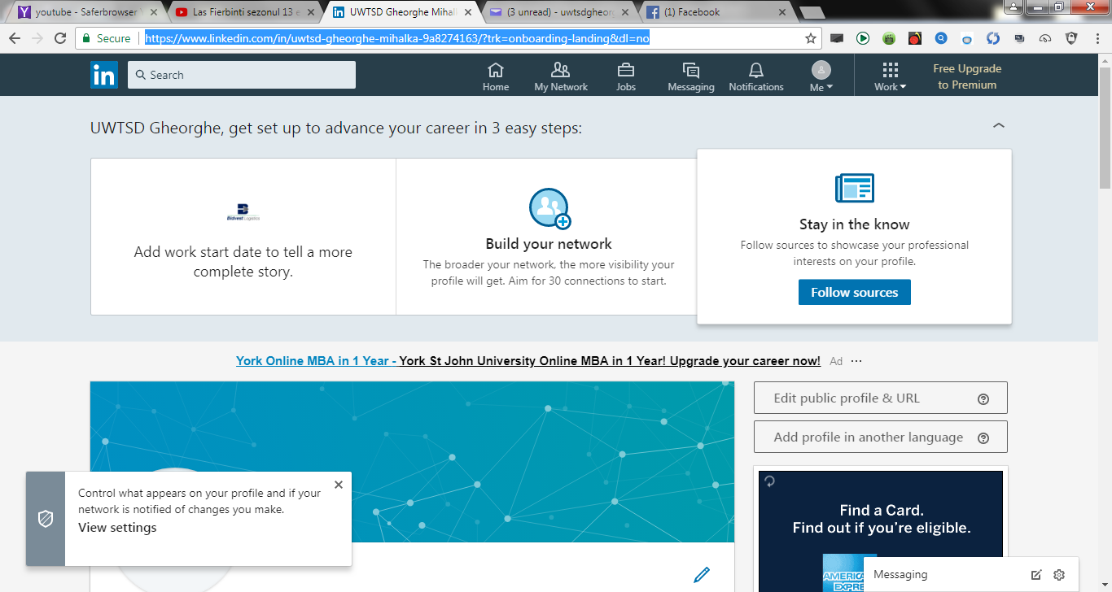
New Linkedln account (link):https://www.linkedin.com/feed/?trk=nav_back_to_linkedin
New Facebook account (snapshot):
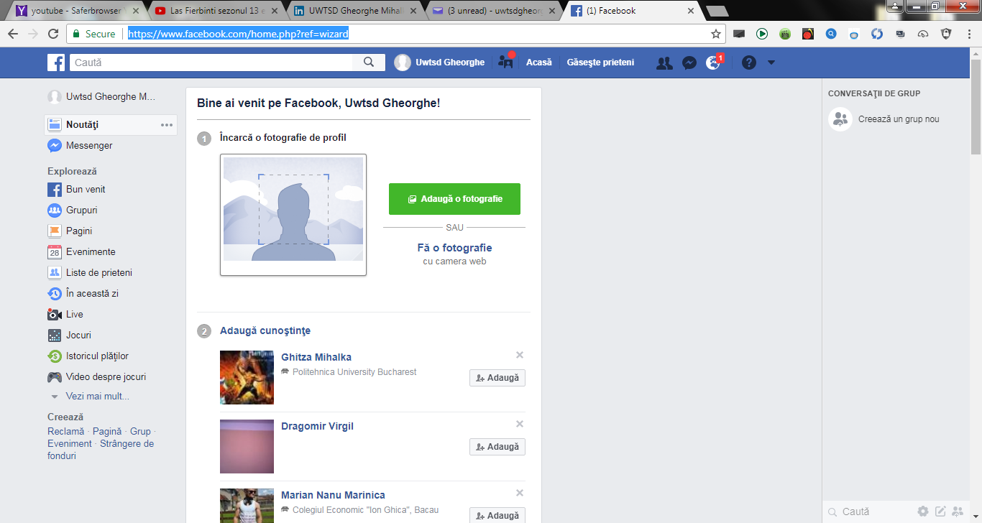
New Facebook account(link):
https://www.facebook.com/uwtsdgheorghe.mihalka/media_set?set=a.113114859553777.1073741827.100025657909129&type=3&uploaded=14
References
Wikipedia,(2018)Technology [Online] Available from: https://en.wikipedia.org/wiki/Technology (Accessed: 30.04.2018)
Techtarget network, (2018) Facebook. Definition. [Online] Available from: https://whatis.techtarget.com/definition/Facebook (Accessed: 28.04.2018)

Lifewire, (2018)What Is LinkedIn and why should you be on it? [Online] Available from:
https://www.lifewire.com/what-is-linkedin-3486382 (Accessed: 28.04.2018)

