
Applied Leadership and Management in the Workplace
Module Assignment Submission
Student Name: | Linda Cullen
Student Number: | 2416910
Module No: | BMSK4013
Module Title: | Developing Professional Practice

Statement of Confirmation of Authenticity
By the act of making this submission, the student declares that this is the work of the student named above. The work has not, in whole or in part, been knowingly presented elsewhere for assessment, or where assessment has been built on a previous assessment, this has been identified. Where materials have been used from other sources it has been properly acknowledged. If this statement is untrue, the student acknowledges that an assessment offence has been committed.
Attention is drawn to the plagiarism and unfair practice policies of both the University and of ILM.

Contents
1 Introduction 2
2 Theoretical Overview of communication 2
3 Communication in My Workplace 4
4 Communication Types and Modalities 4
5 Barriers to Communication 6
6 Communication in Your Workplace 8
7. Factors Affecting Performance and Motivation in the workplace 12
7.1 Intrinsic and extrinsic models 15
8 Conflict Management 17
9 Self-Evaluation of communication Skills 20
10 Personal Development Plan 20
11 Conclusion 20
Reference 20
Appendices 21
Appendix A - PDP 21
Appendix B – PERSONAL QUESTIONAIRRE 21

1 Introduction
(Martin, 2020) states that workplace communication is any type of interaction you have at work.
Workplace communication is how people talk and share information at work. It can include things like giving feedback, talking to your manager or coworkers, updating others about a project, or working together on a task. Good communication helps everyone work better and get things done. But if people do not communicate well, it can cause confusion, conflict, and make an uncomfortable working environment.
In this report I will critically assess the following four models of communication, The basic communication cycle, Shannon and weaver, Schramm and Berlow SMCR. I will give a brief outline of each and discuss the pros and cons to each one. I will then identify which one we use in my workplace and then talk about Formal and Informal communications in the workplace, The barriers to communication we may face and how we may overcome these, The Verbal, written and digital communication we use in my workplace. After this I will move onto the Motivation factors I will critically assess four Motivation theories these are Maslow’s Hierarchy of needs, McCelland’s Three Needs Theory, Herzberg’s Two-Factor theory and McGregor’s Theory X and Theory Y. I will briefly describe these models and again consider the pros and cons of each and then discuss how Motivation affects my workplace. I will then discuss Conflict in the workplace and introduce the CLEAR model of managing conflict. I will give workplace examples throughout this Report and finish on a self-evaluation of my personal communication and produce a PDP on my findings.

2 Theoretical Overview of communication

Morrison & Morrison (2023) state that it is important to communicate clearly to get the outcome you want in a situation therefor it is important to understand the tools communication models give us and to understand how they work. We will be focusing on 4 models and breaking down the way they work to understand them fully and identify which one is best for our workplace.

MODEL | DIAGRAM | DESCRIPTION and HOW IT WORKS | PROS AND CONS TO USING THIS MODEL
BASIC  COMMUNICATION  CYCLE | 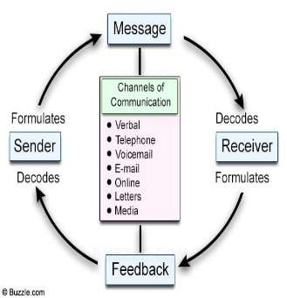 | Is a simple and circular model that explains how messages are sent and received. It has a sender who creates a message, a method to send the message, and a receiver who gets and understands the message. The receiver then gives the sender feedback, completing the circle and making the conversation continuous. | PROS  Easy to use.  Communication methods are ones we use in day-to-day life.  CONS  Limited to only sending words, symbols and images.  Messages are easily misconstrued
SHANNON AND WEAVER (1949) | 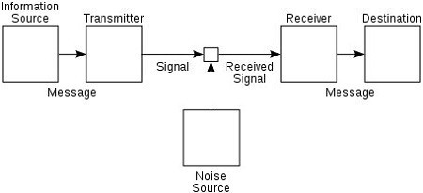 | Is more detailed than the BCC. It has a sender who encodes the message, then passed through a transmitter and sent along a channel to a receiver who decodes it. This model also includes noise, which can disrupt or distort the message. The message flows in one direction from the sender to receiver so is a linear model. | PROS  Effective for using simple methods of communication.  Good for face-to-face communication  CONS  Not effective for mass communications  The receiver remains passive while the  sender plays a more active role.
SCHRAMM (1954) | 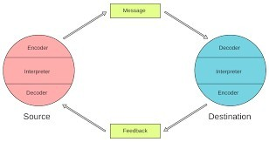 | Is a simple, circular model where both sender and receiver take turns sharing and understanding the messages. This is best used when you have similar knowledge within your workplace. It also includes feedback, making it a two-way process and again can be continuous. | PROS  Works well for companies.  Encourages correct interpretation of the messages.  CONS  Has more limitations when addressing more complex scenarios.  Is an older model which was designed when there were less communication methods available.
BERLO (SMCR) | 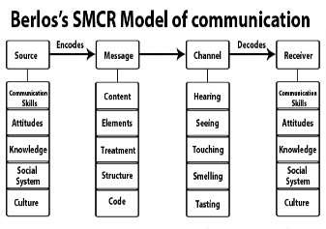 | Is the most complex of the 4 models. And goes on the theory that Communication depends on four main parts: Source, Message, Channel, and Receiver (SMCR). For communication to work well, the source and receiver need to have similar skills, knowledge, and background. This model is linear, meaning the message moves one way from sender to receiver and does not consider the sender’s feedback. | PROS  Encourages sending a clear message and focusing on making sure the receiver understands.  Identifies potential barriers across all avenues.  CONS  Does not allow for free-flowing longer communication.  Does not allow for real life complications.

Depending on the individual situation all the above models work very well and once you have identified which one works best for you in your workplace you can implement this to help develop communications in your workplace.

3 Communication cycles in My Workplace
I have identified that in my workplace the best model to use is the Berlo model as this model allows us to make sure that the receiver understands the message and gives us feedback and identifies any potential barriers we may face. For example, we always ask employees what they are doing before finishing the pre shift briefing this allows staff to clarify and ask any questions they may have about the task ahead.

4 Formal and Informal Communications in my workplace
An article by Intellezy (2024) tells us that Clear and respectful communication is the key to effective teamwork. It helps prevent conflicts and ensures that everyone is working towards the same goal. It is important to know the difference between using a formal and an informal tone when communicating within your workplace and knowing when it is appropriate to use formality. The table below explains the formal and informal type of communication we use in my workplace and when and why you should use this.
Formal Communication | When you would use this | Why you would use this
Structured emails | Official announcements and updates to clients and suppliers | Keeping people updated and keeping a record.
Presentations | Sharing complex information and updates | Keeps the receiver informed and allows for feedback from questions.
Tone in a conversation speaking with a clear and confident mindset | In meetings, phone calls, face to face discussions and appraisal and disciplinary situations | Gives receiver confidence in your competency.  Portrays the seriousness of the situation.
Body Language | Adapting your body language to stand/sitting straight. And only using appropriate gestures. | Highlights the seriousness of the situation and gives the receiver confidence.

Informal Communication | When you would use this | Why you would use this
Messenger services | Talking to colleagues,  Giving general updates | Quick and easy way to send information.
Talking in a break area | Non-work-related conversations | You are not in a work-related environment.
Casual conversations | Social events, team building events. | Building relationships and trust.
Meetings | situations where a little more sensitivity is needed such as conflict meetings, an employee has something they need to discuss | Shows empathy and encourages open, honest and calm conversations.

Ensuring your tone and body language align. Assess the situation, prepare, and adjust communication to connect effectively and achieve the desired outcome. For example, I was called into a formal meeting about a new property right after a busy lunch service. Although I knew the topic and attendees, coming from an informal setting left me overwhelmed and unprepared. With more notice, I could have prepared better and answered more confidently.

5 Barriers to Communication
Pinto (2025) tells us that Communication barriers are things that can block or delay the sharing and receiving of ideas, information, or messages between people or groups. In the table below I will outline some of the barriers I face in my workplace and list ways to overcome these.
Barriers to communication | Examples from my workplace | How to overcome these barriers
Language barriers | We have many guests from overseas coming to stay in the Hotel | Using Google translate and appropriate hand gestures.
Using words to describe things on daily plan that staff may not understand, | We use the term PAX X (25) to indicate the number of guests, how many of each thing are needed and for place setting, reception drinks etc. | Make sure you include these onto staff training days.
Loud background noises | During Events with people in different areas we communicate with walkie-talkies and earpieces messages can be misheard, and you can miss incoming messages. | Get the person who has received the message to repeat it back to the sender to make sure all information has been correctly received.
Food order checks not written correctly | The kitchen can be extremely busy; checks need to be written clearly with details but brief so the chefs can quickly read and get the orders out quickly. | When training new servers show them the style you use and get them to write sample checks.
Inconsistent messages | There are a lot of managers of various departments throughout the hotel sometimes staff will get mixed and conflicting instructions from different managers. | Devise a team sheet at the beginning of the day instructing each staff member of their role and location for the time indicated on the sheet you may need different ones for various times throughout the day.

By acknowledging the barriers and working on the recommendations it can help to identify and work through these barriers before a situation arises.

6 Communication types in my Workplace
In my workplace we use many methods of communications I have included a table of all the written, verbal and digital methods that we use and discussed the advantages and disadvantages we have found using these and some recommendations to how we can improve these.
Types of communication | Advantages | Disadvantages | Recommendations
Face-to-face | - Able to get immediate feedback.  - Encourages strong relationships.  - Allows the use of body language.  - You can be confident that message is received and understood. | - Disruptions.  - Distractions.  - Can be costly if travel is required.  - Time consuming.  - May Limit attendance if people cannot attend. | - Choose the fight time and place to minimise distractions and disruptions.  - Encourage two-way communication.
Telephone | - Fast.  - Immediate feedback and answers.  - Easily accessible.  - Flexibility you are able to take a phone call in most places. | - Coverage and reception issues.  - Cannot read body language.  - Can be disruptive to the receiver’s workload.  - Cannot share files or data. | - Use clear and concise language and encourage clarification from the receiver.  - Make sure your environment is quiet and send important information prior to the call.
Email | - Easily assessable.  - Fast delivery.  - Convenient.  - Cheap.  - Allows to share files and data.  - Good for mass communication. | - Lacks Tone and can be easily misinterpreted.  - Security risk of being scammed and hacked.  - No immediate feedback.  - Is internet dependant.  - Urgency is not prioritized. | - Use a clear subject line and mark as urgent.  - Use a VPN.  - Give a response deadline.
Video Calls | - Saves money and time.  - Encourages productivity and brainstorming.  - Can include people in various locations. | - Technical difficulties such as poor coverage.  - Time zone implications.  - Can increase tiredness from looking at a screen for long periods.  - Background noise and distractions. | - Regular checks on your equipment to make sure they are in good condition.  - Plan in advance schedule a break for toilets/refreshments if call with last for a long period.
Letters | - Can keep to refer back to.  - Can add personal touches.  - Can ease feelings of isolation and loneliness. | - Slow communication.  - Is a lot of effort and takes a lot of time.  - Costly.  - Not great for sending to large groups.  - Risk of not being received.  - Privacy risk. | - Keep letters clear and formal, to the point and include other mean of contact if need to clarify anything.  - Takes a long time.
Reviews and Appraisals | - Personal.  - Allows feedback.  - Supports employee development.  - Encourages stronger relationships. | - If executed wrong can cause a negative effect and missed opportunities.  - Time consuming. | - Provide regular feedback on targets.  - Plan and have a structure to the meeting.  - Listen and pay attention to language, tone and body language.
Daily plan for Events/jobs | - Better organisation.  - Everyone knows what is expected from them.  - Increased accountability. | - Lack of flexibility.  - No feedback.  - Harder to manage unforeseen circumstances. | - Offer the list the day before so employee can offer feedback and ask questions.  - Have a designated person to make changes.

Through analysing communication methods in my workplace, I’ve found some are more effective than others. The most effective methods include face-to-face communication, emails, daily plans, reviews, and appraisals. These suit our fast-paced, public-facing environment, allowing quick delivery, feedback, and clarification. Less effective methods include telephone calls this is due to noise and availability also letters, which can be delayed or lost and make quick responses impossible.

7. Motivation in the Workplace
Cal (2021) tells us that Motivation is what we use to get things we care about done. While we thrive with motivation, we are also prone to easily loose motivation even though we know we must do these things. Having highly motivated employees increases productivity, engagement and focus which improves job satisfaction this can help your business thrive. I am more motivated when I am confident in what I am doing and feel like I am being trusted to get my work done. I am motivated by doing something I enjoy and seeing the finished result.
There are many motivation theories, but we will be focussing on the following four at this time.
MODEL | DIAGRAM | DESCRIPTION and HOW IT WORKS | PROS and CONS
MASLOWS HIERARCHY OF NEEDS | 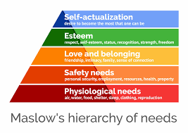 | This is a 5-tier pyramid of human needs that covers Physiological, Safety,  Belonging, Esteem and  Self-actualization needs.  It believes that as our lower-level needs are met our higher-level needs appear which allows us to progress up the table and reach our full potential. | PROS  Structured framework  Encourage motivation.  Creates fulfilling environments.  CONS  Quite rigid no room for flexibility  Does not allow for individual differences and cultural needs.  Can allow manipulation and not address the personal needs of employees.
McClelland’s THREE NEEDS THEORY | 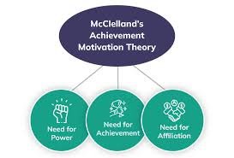 | Explains what drives people at work and in life. The three key needs are:  Need for Achievement the desire to do well and succeed.  Need for Power the desire to influence/control others.  Need for Affiliation the desire to build friendly and close relationships.  Everyone has these needs but one usually stands out as the strongest motivator.  These needs can be assessed and trained through a TAT.  Cramer (2004) tells us The Thematic Apperception Test (TAT) is a psychological tool where people tell stories about pictures shown to them these are recorded then analysed. | PROS  Helps understand what motivates people.  Allows managers to know what drives employees.  Encourages people to learn more about themselves and their needs.  Can be used for different situations.  Identifies people who may be good leaders.  CONS  Hard to measure employee’s needs.  Does not consider all possible motivators.  Does not give clear steps for how to use the model.  Might make motivation seem simple.
HERZBERGS TWO-FACTOR THEORY | 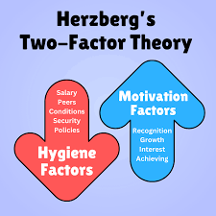 | States job satisfaction depends on hygiene factors which prevent dissatisfaction such as pay, job security and working conditions and motivators which drive satisfaction such as recognition, growth and achievement. Both must be addressed to motivate employees and make a happy content workplace. | PROS  Helps improve job satisfaction.  Easy to apply in the workplace.  Separates satisfaction from dissatisfaction.  Encourages personal growth.  CONS  May not suit all employees.  Ignores outside influences.  Can be hard to distinguish which factor your employees are.
McGregor’s THEORY X AND THEORY Y | 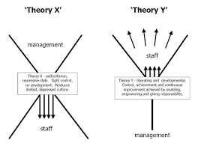 | Identifies that there are 2 contrasting types of Managers.  Theory X is one that assumes people do not like work, avoid responsibility and must be controlled where Theory Y is that people enjoy work, activity seek responsibility and are self-motivated. This can influence how managers view and lead their teams. | PROS  Highlights different management styles Encourages positive approaches to leadership.  Supports employee development.  CONS  Might make generalization on how people work.  Can be hard to apply in certain workplaces.  May lead to unfair and wrongful judgements.  Could influence unfair management choices when selecting a new leader.

McGregor’s Theory X and Theory Y appear in how managers treat staff. At the hotel I work in the housekeeping manager follows Theory X constantly checking work and giving strict instructions this often makes staff feel untrusted and demotivated. Whereas the front-of-house manager uses Theory Y, giving employees freedom to solve problems and contribute ideas, this creates confidence and involvement. A better approach may be to combine both styles and identify which employees work well independently and which ones need more guidance, then adapt your management style to improve motivation and performance.
You should also consider that there are many things that can affect motivation in the workplace these include.
- Conflicts.
- Poor pay.
- Being unsure of tasks.
- Feeling undervalued.
- Feeling overwhelmed.
- Boredom. No opportunities for development and career progression.
By identifying these factors and acknowledging them you can help make changes before these become demotivators.
7.1 Intrinsic and extrinsic models
Intrinsic motivation, which refers to doing something because it is inherently interesting or enjoyable, and extrinsic motivation, which refers to doing something because it leads to a separable outcome (Ryan & Deci, 2000)
Motivation theories can be organised into two categories intrinsic which is people who are driven by their internal desires like the love of learning new skills, being challenged and feeling accomplished. The other is extrinsic this is people who are driven by external factors such as salary, working to receive a bonus, praise and validation and meeting targets. The following diagrams outline these two types of motivation and categorize where the motivation theories sit within these. Created by GPT (personal communication, May 26th, 2025)
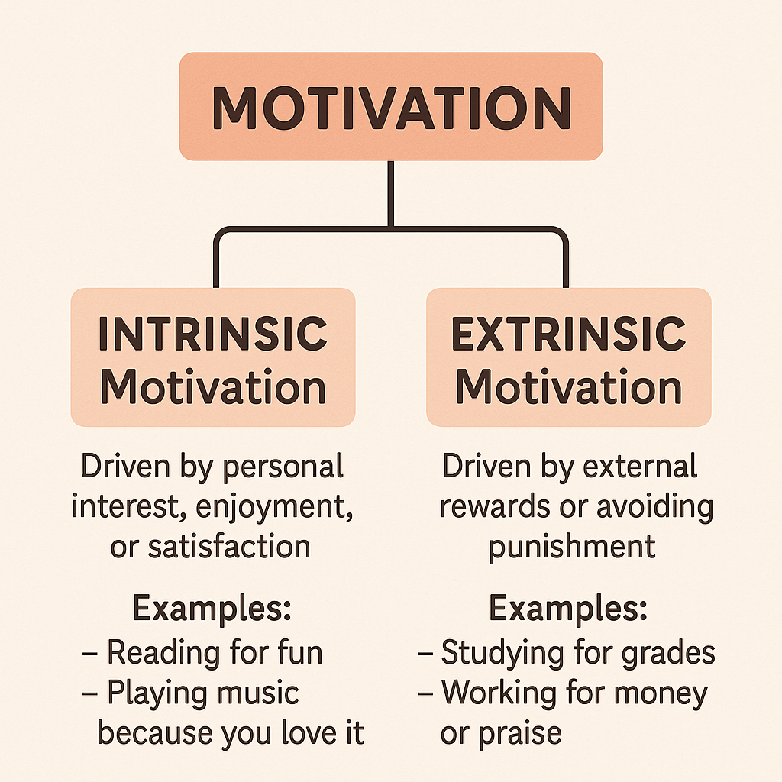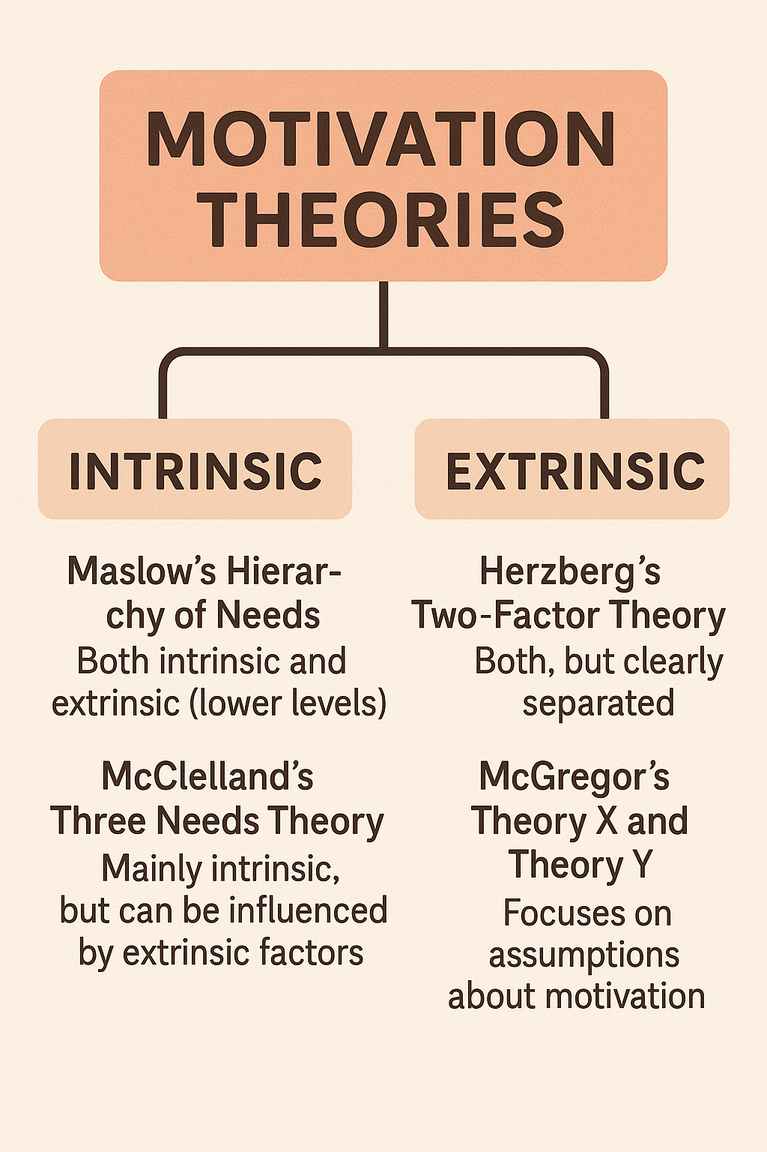

By being able to distinguish between intrinsic and extrinsic motivators, managers will know how to engage and inspire their employees and which motivation theory is best to apply.

8 Conflict Management
Ronquillo et al (2023) States that Conflict happens when people disagree or have different opinions. In the workplace it usually comes from personal goals or ideas clashing within the team. Conflict can happen for many reasons in the workplace and as a manager it is important to identify and rectify any conflicts.
Types of Conflict can include.
- Trust being broken.
- Lack of Respect.
- Personality clashes.
- Boundaries being pushed.
- Misunderstandings.
- Varying opinions.
- Culture and personal beliefs.
- Conflicting ideas on how tasks should be executed.
- Opinions on decisions made.
- Bullying, harassment or discrimination.
- Job security and role changes.
- Stress.
- Workload not being equally balanced between the team.
Conflicts can lower morale, job satisfaction, and positivity, increase stress, and lead to high staff turnover. It is important to identify and address conflicts early. By using a model such as CLEAR this can help solve conflicts quickly and confidently. Frank (2024) tells us that it promotes a respectful agreement, by active listening, identifying real issues, creating a mutual plan, along with following up.
All conflicts can be resolved by good communication and by following a simple and structed Model. I created a quick look guide to the CLEAR model on Chat GPT (personal communication, May 26th, 2025).
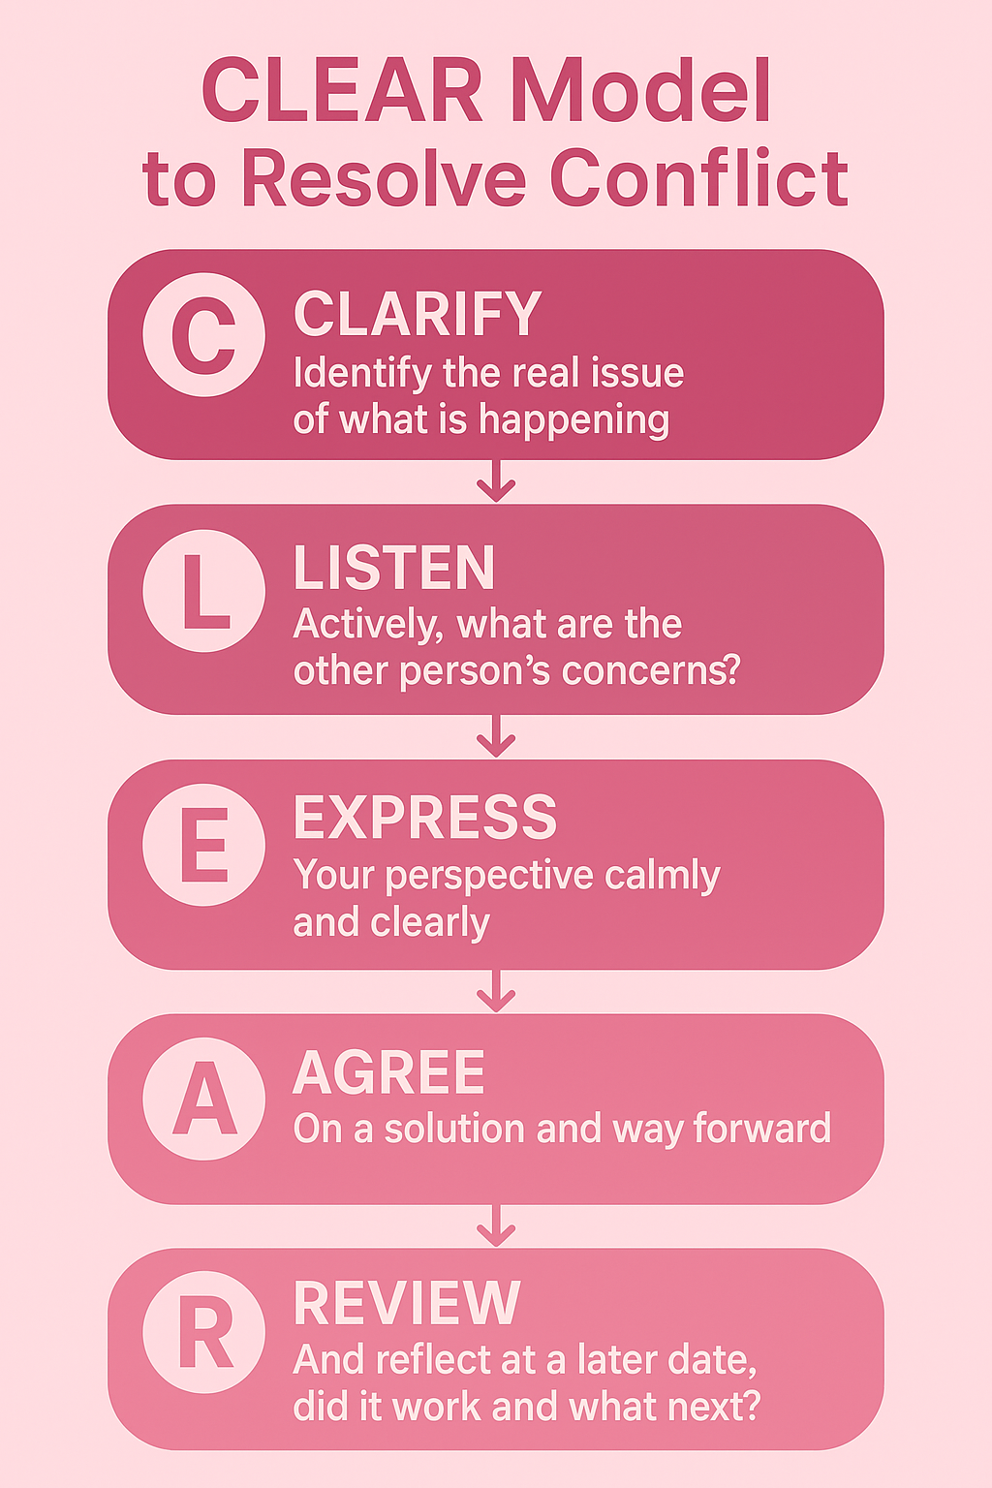
This approach would have helped during a disagreement with a fellow manager in the hotel restaurant. He started his shift and let staff leave early, even though I had asked for tasks to be completed first which with a full team would take 2–3 hours. I was annoyed and we argued loudly, I left for a break without telling anyone. When I returned, I ignored him and we did not speak for weeks, this damaged our working relationship. By using the CLEAR model, we could have resolved the issue quickly by Clarifying the issue (poor communication), Listening to each other, Expressing our views, agreeing on a solution, and reviewing where we were a few weeks later.

9 Self-Evaluation of communication Skills
Grossman (2024) tells us that to communicate well, you must inspire your audience to think differently, learn, care, reflect, or act toward a goal.
To learn how I communicate I made a personal questionnaire (see Appendix B) about my own personal management communications which I handed out to colleagues, I also took a communication styles questionnaire to identify what type of communicator I am. The results of this stated that I am a passive communicator. Matveyeva (2024) tells us that a passive communicator finds it difficult to express their own thoughts, feelings, or needs openly. These are areas I need to work on.

10 Personal Development Plan
From using the self-evaluation listed above I was then able to produce a PDP to develop my own personal management communications. Please find the PDP attached in Appendix A.

11 Conclusion
From doing this report I have found that Effective communication is essential for a successful and motivated workplace. Through critically analysing various communication models such as the Basic Communication Cycle, Shannon and Weaver, Schramm, and Berlo’s SMCR, by highlighting the strengths and weaknesses of each model I was able to identify the most effective approach for my workplace and implement them.
Understanding the difference between formal and informal communication has helped ensure that the correct tone and method are used depending on the situation. Identifying barriers to communication and developing some best practices to overcome them has helped improved team efficiency. Reviewing the different communication methods has shown me that while each has their own benefits, their effectiveness depends on the context. Motivation theories like Maslow, McClelland, Herzberg, and McGregor have highlighted the importance of learning what motivates my employees, I have also identified that I am intrinsically motivated.
Learning about handling conflict and applying structured models like CLEAR helps resolve conflicts in a calm and clear way and help to maintain a healthy work environment. This report has helped me reflect on my communication strengths and weaknesses, I have learnt I am strong a written communication and sound confident in emails and on the telephone, but I need to work on becoming more confident with Verbal communication especially during face-to-face communication which I will continue to develop through my Personal Development Plan.

Reference
Cal, P. (2021, June 21). Work motivation: what it is and why it is important. Betterup.com; BetterUp. https://www.betterup.com/blog/work-motivation-the-value-behind-the-task
Cramer, P. (2004). Stress, Autonomic Nervous System Reactivity, and Defense Mechanisms. Advances in Psychology, 325–349. https://doi.org/10.1016/s0166-4115(04)80040-2
Frank, M. (2024, February 27). Learn how to use the CLEAR model, a coaching framework that helps you navigate conflict situations with confidence and clarity. The CLEAR model guides you through five steps to resolve the conflict in a constructive way. Linkedin.com. https://www.linkedin.com/advice/0/how-can-you-use-clear-model-clarify-goals-conflict-jsnvf#:~:text=The%20CLEAR%20model%20helps%20you%20establish%20a,the%20progress%20and%20outcomes%20of%20the%20action.&text=Acknowledge%20the%20emotions%20involved%2C%20creating%20a%20safe%20space%20for%20both%20parties%20to%20express%20themselves.
Grossman, D. (2024). What Makes a Good Communicator? (& How to Be Better). Yourthoughtpartner.com. https://www.yourthoughtpartner.com/blog/what-makes-a-good-communicator
Intellezy. (2024, July 30). Use Professional Language Effectively at Work | Intellezy. Intellezy.com; Intellezy. https://www.intellezy.com/blog/how-to-use-professional-language-in-the-workplace#:~:text=Clear%20and%20respectful%20communication%20is,goals%2C%20expectations%2C%20and%20timelines.
Martin, C. (2020, February 12). 5 Real-Life Examples of Effective Communication in the Workplace. Moderngov.com. https://blog.moderngov.com/examples-of-effective-communication-in-the-workplace#:~:text=As%20simple%20as%20it%20sounds,or%20collaborating%20on%20a%20task.
Matveyeva, A. (2024, November 11). 5 Examples of Passive Communication and How to Deal with It. Chanty. https://www.chanty.com/blog/passive-communication/
Morrison, S., & Morrison, S. (2023, October 4). Why Communication Models Are Important in the Workplace. Human Focus. https://humanfocus.co.uk/blog/why-communication-models-are-important-in-the-workplace/
Pinto, I. (2025, February 24). Communication barriers in the workplace: Complete guide. Oneteam.io. https://www.oneteam.io/en/blog/communication-barriers-in-the-workplace
Ronquillo, Y., Ellis, V. L., & Toney-Butler, T. J. (2023, July 3). Conflict Management. Nih.gov; StatPearls Publishing. https://www.ncbi.nlm.nih.gov/books/NBK470432/#:~:text=Conflict%20is%20the%20disagreement%20or,of%20the%20group%20or%20team.
Ryan, R. M., & Deci, E. L. (2000). Intrinsic and Extrinsic motivations: Classic Definitions and New Directions. Contemporary Educational Psychology, 25(1), 54–67. https://doi.org/10.1006/ceps.1999.1020

Appendices

Appendix A – PDP
Areas to work on | Specific Goal | Actions Required | Resources Required | How will I know this done | End Date
Avoids Conflict | To become more confident when addressing and resolving conflict. | Researching conflict management models such as CLEAR, getting to know the model and how best to use it and becoming confident is using it. | Asking friends and family for scenarios and then taking them and acting them out and trying out the methods to see how they play out and getting used to using them. | By successfully resolving conflict in a calm and controlled way where everyone is happy with the outcome. | End of August 2025
Becoming more Assertive | To have the confidence to speak up and voice my own opinions in professional calm manor. | Setting boundaries and reviewing these regularly. Attending training courses online which specialise in confidence and communication, | Having someone to practice scenarios with,  Books and computer to take these courses. Time to reflect what I have learnt. | By being able to have the confidence in meetings to stand up and express my opinion without the fear that I will be walked over or called silly. | End of October 2025
Speaks to quietly | To develop a clear and confident speaking voice and adapting tone to suit the situation | Record myself speaking from across a room to see if I can pinpoint any issues.  Take part in speaking in discussions and presentations then ask people in the room that I know well for reviews and recommendations for the next one. | A phone or recording device to record the videos.  Friends and colleagues to provide feedback. | By watching others and knowing that the message I have sent has been clearly received. | End of October 2025
My body language does not portray my confidence. | To have my body language match what I am trying to say and giving the receiver confidence that I know what I am talking about. | Watching online tutorials and learning the correct facial expressions and how to not laugh in serious situations.  Practice in a mirror and recording myself on video. Watching these back and reviewing them and identifying areas that need more work. | Computer and phone for research and video recording.  Access to online tutorials such as TED talks. Reflecting on feedback. | When I notice improvement on posture and hand movements in conversations. Maintained eye contact and confidence in social situations. | End of December 2025

Appendix B – PERSONAL QUESTIONAIRRE
PERSONAL QUESTIONNAIRE
Instructions:
Please answer the following questions truthfully based on any interactions we have had in the past there is space at the end to add your own comments or suggestions if wanted.
All information will be treated as confidential.
Verbal Communication
- I communicate clearly and concisely in meetings or discussions.
☐ Strongly Agree ☐ Agree ☐ Neutral ☐ Disagree ☐ Strongly Disagree
- I listen actively and allow others to express their opinions.
☐ Strongly Agree ☐ Agree ☐ Neutral ☐ Disagree ☐ Strongly Disagree
- I ask appropriate questions to clarify information or instructions.
☐ Strongly Agree ☐ Agree ☐ Neutral ☐ Disagree ☐ Strongly Disagree
- I speak confidently and professionally.
☐ Strongly Agree ☐ Agree ☐ Neutral ☐ Disagree ☐ Strongly Disagree
Non-Verbal Communication
- My body language (posture, gestures) supports my message.
☐ Strongly Agree ☐ Agree ☐ Neutral ☐ Disagree ☐ Strongly Disagree
- My facial expressions are appropriate and engaging.
☐ Strongly Agree ☐ Agree ☐ Neutral ☐ Disagree ☐ Strongly Disagree
- I maintain good eye contact during conversations.
☐ Strongly Agree ☐ Agree ☐ Neutral ☐ Disagree ☐ Strongly Disagree
- My tone of voice helps deliver my message effectively.
☐ Strongly Agree ☐ Agree ☐ Neutral ☐ Disagree ☐ Strongly Disagree
Written Communication
- My emails and written documents are clear and easy to understand.
☐ Strongly Agree ☐ Agree ☐ Neutral ☐ Disagree ☐ Strongly Disagree
- I use correct spelling, grammar, and punctuation.
☐ Strongly Agree ☐ Agree ☐ Neutral ☐ Disagree ☐ Strongly Disagree
- My written messages are professional and respectful.
☐ Strongly Agree ☐ Agree ☐ Neutral ☐ Disagree ☐ Strongly Disagree
- I adapt my writing style to suit different audiences or situations.
☐ Strongly Agree ☐ Agree ☐ Neutral ☐ Disagree ☐ Strongly Disagree
Comments or suggestions.
Thank you for taking the time to complete this questionnaire, please use this space to list any comments or suggestions you may have regarding communication these can be from your own experiences or anything that may have been brought up whilst taking this questionnaire.

