

Programme
BA (Hons) Leadership and Management Skills for the Workplace

Module
On
Developing Emotional Intelligence Skills for the Workplace
Student Name: Amma-harar Russell Young
Student id: 1808757

Table of Contents
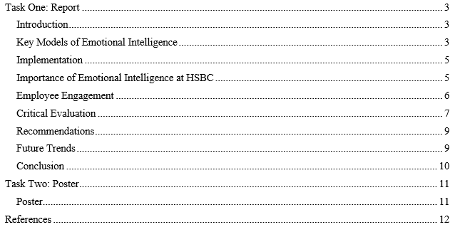

Task One: Report

Introduction
HSBC is a global banking and financial services firm established in London and one of the largest firms globally. It was established in 1865 and has spread over the world reaching and serving over 64 countries as well as territories in the continents of Europe, Asia, the Americas, Middle East, and Africa. HSBC is the worldwide leading bank which is situated in Hong Kong, New York and London and it provides a wide variety of services such as retail banking, commercial banking, investment banking and wealth management services (Bar-On, 1997). Large numbers of branches in different countries as well as the wide range of activities performed make the organisation being one of the key players within the sphere of the worldwide financial sector. The aim of the present paper is to investigate the application of EI within HSBC accenting on the organisational perspective and, primarily, the impact on leader and employee. Emotional intelligence can be defined as a set of skills within an individual that helps him or her to manage and understand both his or her own emotions and the emotions of other people. Critical to the world of banking and finance is that decision-making, stress, and personal-interactions skills are essential components for survival within this competitive market which makes EI an important factor for leadership and staff. In HSBC, EI forms the core of organisational culture, cultural leaders, and culture of people that leads to the overall improvement of work engagement (Bar-On, 2006). In specific terms, this analysis will examine how EI is being implemented by HSBC in management strategies, the training of its people managers, and the organisation’s culture of people management. This study seeks to examine the fact that in today’s cut throat competition in the financial world how EI influence the leadership effectiveness and employee satisfaction so as to help HSBC project itself as a successful competitor in the global market.

Key Models of Emotional Intelligence
EI frameworks offer a lot of information about the role of emotional skills in individual and organisational achievement (Boyatzis, 2006). One prominent framework is Daniel Goleman’s model of EI, which comprises five key components: These are the five core competencies that have been identified as important namely Self-Awareness, Self-Regulation, Motivation, Empathy, and Social Skills. All of these components are valuable in optimising the performance of an individual and an organisation, most especially in pressured organisations such as the HSBC.
Self-Awareness refers to acknowledging and appreciating one’s emotions and the effect they might have on the actions and results. HSBC promotes self-awareness as a way through which leaders and other staff members can be in a position to handle stress and arrive at the right decisions. HSBC’s training activities require employees to self-reflect and to ask others’ opinions about the self, thus enhancing self-identity development.
Self-Regulation may be defined as the capacity of an individual to regulate his or her feelings especially during difficult circumstances (Boyatzis and McKee, 2005). In the banking sector, where the stock market and customers’ demands put a lot of pressure on, self-regulation enables employees to stay calm and think logically. In addition to the concepts of stress management and the use of problem-solving strategies, HSBC has included self-regulation into the leadership training.
Motivation is the energy that is aimed towards achieving certain goals and to continue working even in the presence of factors that are likely to hinder success. For HSBC, the key factor that has been noted to be crucial to the performance of the company is motivation of employees. The utilisation of motivational techniques in the training and development of employees is achieved in the organisation by the formulation of goals and objectives, use of incentives, and job openings.
Empathy is one of the genetic components that include the ability to understand and respond to the feelings of other people (Cherniss, 2001). This is especially so at HSBC since the company relies on the relations with clients and the teams’ dynamics to achieve the set goals and objectives. HSBC encourages understanding by offering its employees different training sessions aimed at making them attentive listeners, culturally intelligent, and good at creating customer rapport.
Social Skills are the skills related to interpersonal communication, interpersonal relationship, and negotiations. Interpersonal skills are important in the context of the tasks that involve collaboration with others, bargaining, and management within HSBC.

Implementation
Some of the EI frameworks mentioned above are already implemented in the processes of HSBC’s training and personal development. Some of the leadership development activities implemented by the organisation are the workshops and seminars aimed at improving EI competencies. These programs include workplace exercises based on the application of ‘exercises,’ ‘role-play,’ along with ‘coaching feedbacks,’ specifically designed for the assessment of EI (Cherniss, 2010). Further, EI is incorporated in HSBC where targets are set and employees are appraised based on the performance management system not only on their technical expertise but also on their EI strengths. This approach, in turn, guarantees that emotional intelligence becomes the norm at the company level and, as a result, promotes personal and corporate performance improvement.

Importance of Emotional Intelligence at HSBC
Leadership Development: Organisational EI work at HSBC relates to leadership development, where EI constitutes a major part of the interaction between leaders and subordinates, as well as the actual processes of achieving organisational objectives. EI greatly enhances the job’s relevance in nurturing leadership skills and competencies necessary for operating in the globalised financial environment.
Self-Awareness and Self-Regulation: An HSBC leader is indeed required to be quite knowledgeable and show a significant level of self-awareness and self-control. Self-awareness helps those in positions of leadership to recognise when they are at their best and when they need help, while self-regulation helps the leaders to control their stress levels and keep their cool in a time of pressure (Cherniss and Goleman, 2001). This self-mastery assists the leaders in setting the right example for their subordinates and maintaining stability in organisations. One approach utilised within HSBC’s leadership programs involves EI training that focuses on the abilities of the leaders to determine and manage emotions of the stressors that may be affecting their work.
Empathy and Social Skills: Understanding and communication skills are important virtues of leaders in the management of the workforce especially in ensuring that the employees work as a team. Having empathy is being able to know what concerns and what may motivate people in the organisation, thus, the morale and loyalty produced can be increased. Interpersonal communication is an important element of interacting and working with other people as well as leading groups (Clarke, 2006). HSBC’s leadership development practices include such activities as workshops and coaching in which these aspects of EI are developed, there are specific activities that enable leaders to cultivate and sustain the positive interpersonal relationships within organisational subgroups.
Motivation: Most times, for leaders to obtain the objective of an organisation, they must motivate their team towards it. At HSBC, motivation is instilled in leaders to provide direction and to observe others and provide them with constructive criticism as well as for envisioning a High-quality vision that would be consistent with the laid down strategic direction of the firm. To be specific, EI training enables a leader to tap into their deep desire and use it to make understandings that will foster productivity among subordinates.

Employee Engagement
This paper posits that emotional intelligence is central to improving engagement and job satisfaction at the workplace, specifically in HSBC. According to the literature, engaged employees are productive, committed, and satisfied within the workplace. Promoting EI culture among working employees of HSBC enables the firm to help workers control their emotions and effectively work on their jobs thus increasing their satisfaction (Day and Carroll, 2004). EI allows a manager to identify and respond to the emotional side of the employees. Empathy helps managers to realise the difficulties of their subordinates and to give them the required encouragement and appreciation. High EI enables the employee to manage conflict than low EI employees hence enhancing order at the workplace. Thus, with the help of training in EI skills including active listening and empathy, HSBC ensure that employees can effectively address conflicts and preserve the good relations between them.
Customer Relations: Thus, emotional intelligence plays a significant role in strengthening the customer relationships and delivering superior services in the financial sector. EI allows the employee to effectively address the client’s emotional and needs by being fully aware of them. Friendly and compassionate communication is important in establishing a relationship with the clients especially for a long-term business (Dulewicz and Higgs, 2004). EI is used in training the customer-facing staff in HSBC so as to handle its clients professionally with compassion and in a manner that responds to the clients’ needs. Good interpersonal skills and emotional intelligence enhance clear and efficient communication with the clients. EI helps the employee to deliver sensitive messages politely and avoid offending the client while at the same time giving him or her the feeling that his or her opinion has been considered. This way not only issues are resolved faster but the satisfaction of the clients is increased in general. EI is well incorporated in HSBC’s training of customer service, this will guarantee that the staff is able to cope with the pressure while at the same time being professional and courteous.

Critical Evaluation
Effectiveness of EI Practices: Studies have stated several positive outcomes that EI brings in developing HSBC’s organization performance of which includes the following. To assess the effectiveness of EI in terms of HSBC’s organizational performance, the organisation has established the following strategies. For instance, leadership programs that integrate EI have indicated enhanced team performance as well as leadership efficiency (Goldman and Salovey, 2006). Studies done on the organisations internal experiences and surveys reveal that participants who have received EI training portray high levels of increase in self-awareness, ability to regulate emotions, and increased social skills as compared to other leaders. This leads to better controlling of team dynamics and, therefore, results in improved total organisational efficiency. Moreover, comparing the results of the HSBC’s employee engagement surveys, it is possible to state that teams led by the managers who completed the programs for the improvement of EI skills have higher level of job satisfaction and reported higher morale (Goleman, 1995). Additional proof from HSBC shows how EI has brought good outcomes in the organisation as well. For instance, in a stressful situation, the leaders who were working according to the focus of the EI were able to handle emergent conditions in a better way resulting in the accomplishment of projects and enhanced relations among the staff (Goleman, 1998). Secondly, those customer care personnel who have undergone through EI training have been in a better position to handle confrontational clients more professionally and securely hence higher customer satisfaction results and better business relations with the customers. These anecdotal successes, complemented by the measurable enhancements to HSBC’s performance objective figures, demonstrate that EI approaches yield value in that corporation.
Challenges: However, introducing and establishing both the awareness and implementation of EI as part of HSBC’s organisational culture and business strategies, has its own set of setbacks especially given the cut-throat competitive environment typical of the financial services sector (Goleman, 2006). A major concern towards the integration of knowledge management is resistance to change. In many cases, the learning of emotional intelligence is preceded by a shift in paradigms concerning emotional and interpersonal skills. Especially within a known high-stress context such as banking, there might be trench resistance from the employees who have adjusted to the old model of business where the focus was simply on the delivery of services and hitting targets. This resistance can negatively influence the application of EI practices as well as their possible advantages (Goleman, 2011). This problem cannot be eliminated without a long-term campaign that would convince the organisation of the importance and necessity of EI. HSBC works beyond regional borders and it was also established that applying practices in one geographical context may differ significantly from that in another. Thus, different cultures can interpret the concept of EI in different ways, which causes differences in the level of success of training programs and, accordingly, the impact on performance (Goleman and Cherniss, 2001). For example, one can establish that something may perform well in one culture but may not be the same in another culture. HSBC managers have to manage these differences in the sense that they need to localise EI training initiatives and address them within local contexts while ensuring that the strategy for the global organisation is coherent. Another challenge is a difficulty in assessing the effectiveness of EI on the enhancement of the company’s performance in the long run. Since organisational EI is a long-term development practice, the impact of short-term change at the organisational leadership level and increases in employee engagement are the first noticeable benefits of EI practices; however, the benefits of EI practices cannot be fully measured within a short period, it requires constant evaluation (Goleman et al., 2013). This includes measuring the general and specific performance indicators over long intervals, and then associating them with the outcomes of the EI trainings. In order to guarantee that the implemented EI practices lead to the sustainment of organisational performance, there is need to have adequate measurement mechanism and accountability for improvement (Higgs and Dulewicz, 2016). Thus, it is important to state that in the banking sector, particularly in large international organisations, the focus is made both on technical skills and specialised financial training and experience. This is a conflict that managers and organisations, as well as students, often face when trying to promote and ensure the use of EI alongside the importance of the technical aspects of a business.

Recommendations
Enhancing EI Integration: Existing ones can be complemented with a set of specialised courses that address certain competencies within the framework of the selected level or position within the company. For instance, specific EI training could be administered where there is a difference between the need of managers and directors as opposed to ordinary workers. Holding WI regular EI workshops, seminars, and interactive activities are relevant as they can contribute to constant reminders of EI principles and retraining of the employees’ EI abilities (Jordan and Ashkanasy, 2006). Besides, ensuring that EI forms part of leadership development initiatives can reinforce the consideration of EI and its application in the operations. The incorporation of EI in the process of recruitment is effective to guarantee that the organisation’s hired employees embrace its standard values and ethical practices as represented by HSBC firm. It is important to create the forms of assessment that would allow rating the emotional intelligence of the candidate along with the creation of the interviews’ techniques (Koman and Wolff, 2008). For example, SJT or BI that is concerned with the assessment of EI skills including intersession, flexibility, or stress tolerance can be applied in selection. If HSBC directed more attention to the recruitment of candidates with high EI, the company can employ people who can professionally manage problems of the banking sector and whose attitudes will improve the overall organisational climate. Practical measures used in supporting the EI training include planning for ways of supporting the development of the employees’ EI skills in the long run through products like coaching and mentoring (Lopes et al., 2005). Offering an opportunity to engage with a professional trainer or mentor may help follow sophisticated individual development plans and foster employees’ self-improvement by applying EI concepts and strategies at work. Further, organisational development that entails formation of communities of practice among the employees to share harms and gains in relation to EI can bring about culture of learning (Mayer and Salovey, 1997). Another way to evaluate the impact for HSBC’s EI initiatives is if the company can set certain indices to determine the success of the program eventually, and ensure the employees share their feedback more often.

Future Trends
EI in HSBC should be oriented to respond to new technologies and adjustment of the banking industry. Technological advancements such as digitisation of banking services, remote controlled customer service using artificial intelligence and other self-service trends can influence roles of the employees as well as interactions with clients. HSBC should consider working on the factors of EI that are relevant to technological proficiency like managing virtual teams and studying communication over the several digital platforms available. Flexibility at the workplace and telecommuting as a result has become even more evident than before. HSBC should factor in its method of EI strategies to reflect on the following issues to do with managing remote teams and employee engagement (Mayer and Salovey, 2007). It will be critical to continue building practical knowledge by offering training in areas such as remote leadership, virtual communication, and emotional regulation in a digital environment so that EI continues to be part of HSBC’s organisational culture. HSBC has a presence in many countries, learning about or enhancing the acceptance of various cultural approaches and concepts of EI would become even more crucial. Employing EI requires that the organisation incorporates features of culture and make consequent changes to organisational EI strategies; this also means that training and development, should preserve cultural sensitivity (Mayer et al., 2008). Better cross-cultural trainings and establishing international EI competency frameworks may enable the workers to run efficiently the international businesses and cope with other intercontinental challenges. The increase in the concern for the psychological state of employees also remains a prime area that HSBC can explore for the expansion of EI in the organisation.

Conclusion
Therefore, EI being a special focus of HSBC, becomes important to UP & improve leadership, employee and customer relations in banking. More EI training, incorporating EI into the recruitment process, and sustained HSBC support can help the company strengthen its defences even further for creating a sturdy and malleable workforce (Mayer et al., 2004). Fighting other trends that HSBC has yet to face in the future like digital transformation, remote working, and cultural differences will help the company to maintain the leadership position into the field of effective EI practices. Altogether, the strategic management of EI leads the organisations’ success and enhanced employee and customer experiences in an increasingly competitive industry.

Task Two: Poster

Poster
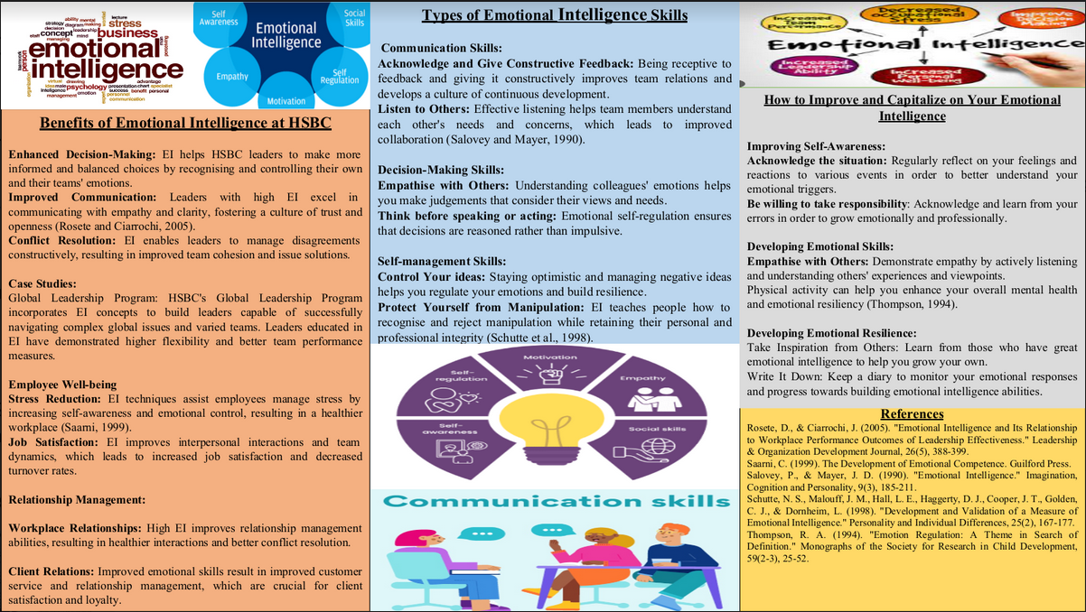

References
Bar-On, R. (1997). Bar-On Emotional Quotient Inventory (EQ-i): Technical Manual. Multi-Health Systems.
Bar-On, R. (2006). The Bar-On Model of Emotional-Social Intelligence (ESI). In The Handbook of Emotional Intelligence (pp. 249-270). Jossey-Bass.
Boyatzis, R. E. (2006). "An Overview of Intentional Change from the Perspective of Emotional Intelligence." Journal of Management Development, 25(7), 768-777.
Boyatzis, R. E., & McKee, A. (2005). Resonant Leadership: Renewing Yourself and Connecting with Others Through Mindfulness, Hope, and Compassion. Harvard Business Review Press.
Cherniss, C. (2001). "Emotional Intelligence and Organizational Effectiveness." In The Emotionally Intelligent Workplace (pp. 110-139). Jossey-Bass.
Cherniss, C. (2010). Emotional Intelligence: Toward Clarification of a Concept. Industrial and Organizational Psychology, 3(2), 110-126.
Cherniss, C., & Goleman, D. (2001). The Emotionally Intelligent Workplace: How to Select for, Measure, and Improve Emotional Intelligence in Individuals, Groups, and Organizations. Jossey-Bass.
Clarke, N. (2006). "Emotional Intelligence and its Relationship to Transformational Leadership and Key Project Manager Competencies." Project Management Journal, 37(2), 5-23.
Day, A. L., & Carroll, S. A. (2004). "Using an Ability-Based Measure of Emotional Intelligence to Predict Individual Performance, Group Performance, and Group Citizenship Behaviors." Personality and Individual Differences, 36(6), 1443-1458.
Dulewicz, V., & Higgs, M. (2004). "Can Emotional Intelligence Be Measured and Developed?" International Journal of Selection and Assessment, 12(4), 248-255.
Goldman, M., & Salovey, P. (2006). "Emotional Intelligence: Key Readings on the Mayer and Salovey Model." Springer.
Goleman, D. (1995). Emotional Intelligence: Why It Can Matter More Than IQ. Bantam Books.
Goleman, D. (1998). Working with Emotional Intelligence. Bantam Books.
Goleman, D. (2006). Social Intelligence: The New Science of Human Relationships. Bantam Books.
Goleman, D. (2011). The Brain and Emotional Intelligence: New Insights. More Than Sound.
Goleman, D., & Cherniss, C. (2001). The Emotionally Intelligent Workplace: How to Select for, Measure, and Improve Emotional Intelligence in Individuals, Groups, and Organizations. Jossey-Bass.
Goleman, D., Boyatzis, R. E., & McKee, A. (2013). Primal Leadership: Unleashing the Power of Emotional Intelligence. Harvard Business Review Press.
Higgs, M. J., & Dulewicz, V. (2016). "Emotional Intelligence and Leadership: The Importance of Emotional Intelligence for Effective Leadership." Leadership & Organization Development Journal, 37(1), 109-125.
Jordan, P. J., & Ashkanasy, N. M. (2006). "The Effects of Emotional Intelligence on Attitudes, Behavior, and Performance." Human Resource Management Review, 16(2), 262-276.
Koman, E. S., & Wolff, S. B. (2008). "Emotional Intelligence Competencies in the Team and Team Leader: A Multi-Level Examination of the Impact of Emotional Intelligence on Team Performance." Journal of Management Development, 27(1), 55-75.
Lopes, P. N., Salovey, P., Côté, S., & Beers, M. (2005). "Emotion Regulation Abilities and the Quality of Social Interaction." Personality and Social Psychology Bulletin, 31(7), 884-898.
Mayer, J. D., & Salovey, P. (1997). "What is Emotional Intelligence?" In Emotional Development and Emotional Intelligence: Educational Implications (pp. 3-31). Basic Books.
Mayer, J. D., & Salovey, P. (2007). The Emotionally Intelligent Manager: How to Develop and Use the Four Key Emotional Skills of Leadership. Jossey-Bass.
Mayer, J. D., Roberts, R. D., & Barsade, S. G. (2008). "Human Abilities: Emotional Intelligence." Annual Review of Psychology, 59, 507-536.
Mayer, J. D., Salovey, P., & Caruso, D. R. (2004). "Emotional Intelligence: Theory, Findings, and Implications." Psychological Inquiry, 15(3), 197-215.

