ACBA 6000
Construction Management
Programme control
Liam Morgan: 1806324
Lecturer: DR Deborah Hughes
Deadline: 8/12/20
Word Count:2360

Table of Contents
Table of Figures 3
1.0 Introduction 4
2.0 Develop and evaluate site reports 4
2.1 Cost 5
2.2 Time 5
2.3 Resources 6
3.0 Address performance issues and recommend incentives 7
4.0 Site sketch 9
4.1 Site sketch summary 10
5.0 Granite paving delay 11
6.0 Conclusion 11
7.0 Reference list 13
8.0 Bibliography 15
9.0 Acknowledgement 17

Table of Figures

Figure 1: Gantt Chart of UWTSD Library project 4
Figure 2: Gantt Chart showing the allocated time frame given to the different tasks 5
Figure 3: Gantt Chart showing the assignment of workers, materials, and the cost to that specific task 6
Figure 4: Gantt Chart resource sheet 7
Figure 5: Site sketch layout 9
Figure 6: Gantt Chart showing the effect of critical path 11

1.0 Introduction
This assignment will be looking at using software to produce a Gannt chart for the construction of the UWTSD Library, using the Gannt chart to analyse cost time and resources with site-specific reports that will be developed and evaluated. It will also look at the different ways of addressing performance and productivity issues that arise and what incentivisation will get implemented to help within this project. Within this assignment, a sketch of the recommended site layout will be available. There will also be a summary of the reasoning behind the choices made. The report will look at how to deal with the delay of the granite paving.

2.0 Develop and evaluate site reports
A Gantt chart is developed to help with the planning and tracking of progress on a construction project. It gives a better understanding of the task needed to be carried out and to which order they need to be completed. The Gantt chart is an essential tool used to manage and control projects from start to finish. Understanding how to use and make them is essential to anyone who is going to be apart of the management team on a construction site. For this assignment, a Gantt chart has been created for the construction of the UWTSD library. Below will look at some of the vital information to aid the running of the project.
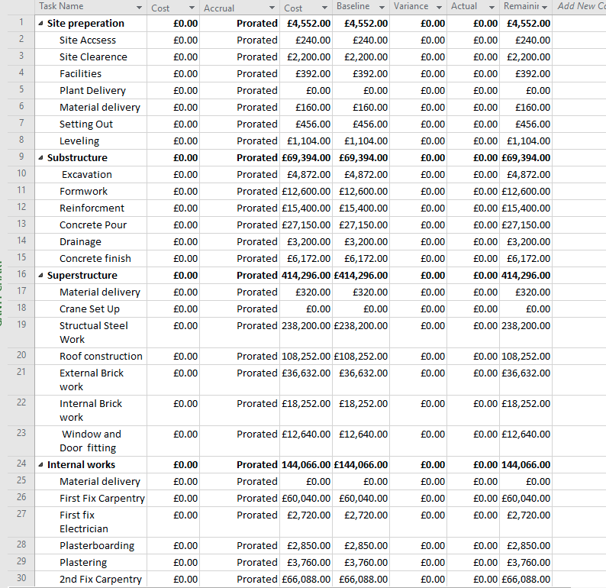
Figure 1: Gantt Chart of UWTSD Library project

2.1 Cost
Figure one, above, is a Gantt chart for the UWTSD project and shows the estimated cost for each task. Using the Gantt chart to manage the finances of the project will allow for a quick understanding of the budget as the project progresses. It will automatically make variations to the cost as changes get made. It shows the original estimated cost, and the actual cost, making it easy to compare and understand the differences (Gantt Excel, 2018). It is an essential tool in maintaining and controlling cost throughout this project.

2.2 Time
The Gantt chart gives the ability to see the allocated time given to each task and allows for changes to be made easily. Using the critical path when changes get made will give a better understanding of how the project will be affected and the impact it will have on the pre-arranged deadline. If the changes effect the critical path, then there will be a change to the deadline. However, using the Gantt chart gives the ability to easily see if there can be time saved elsewhere in the project (Mindtools.com, 2017). Figure two, below, is the Gantt chart showing the allocated time frame given to the different tasks that will get carried out on the construction of the UWTSD library. This will allow for adequate time management and allow for progress to be updated and recalculated regularly. As the project progresses, the chart will be updated to show the percentage of completion of each task.
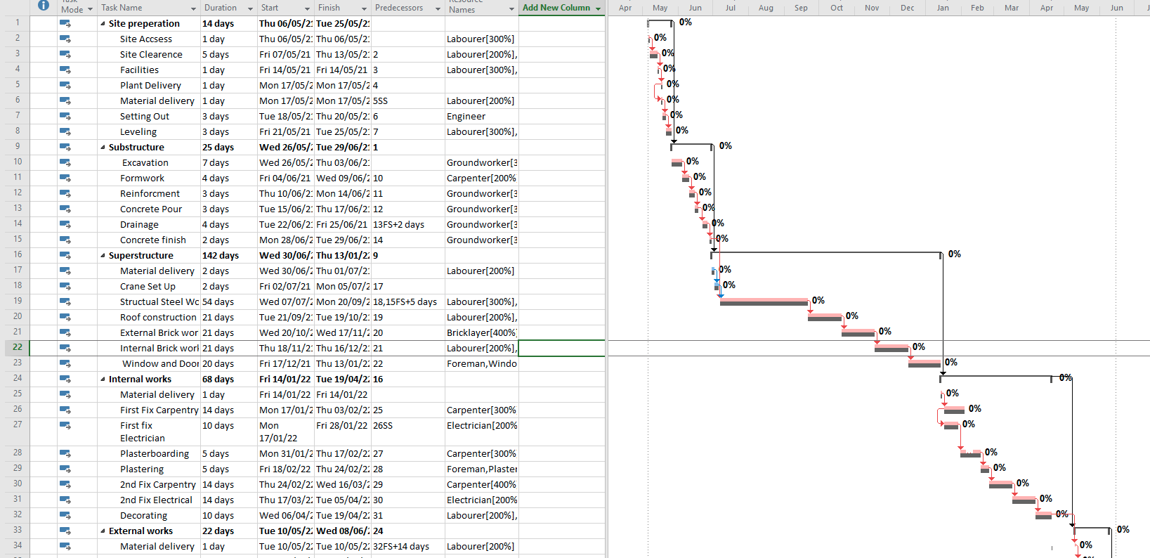
Figure 2: Gantt Chart showing the allocated time frame given to the different tasks

2.3 Resources
Once tasks get assigned in the Gantt chart, resources can be attached to show what is needed to fulfil that specific task. As seen below, Figure three, on the UWTSD Gaunt chart when allocating resources, it is possible to assign workers, materials, and cost to that specific task. This will allow for quickly understanding what is needed for that task to get completed. This will help when ordering materials or knowing how many workers will be required on-site. It will help with understanding the cost of the project as the resources are what makes up the cost (ProjectManager.com, 2020), so the correct resources must be allocated to the correct task.
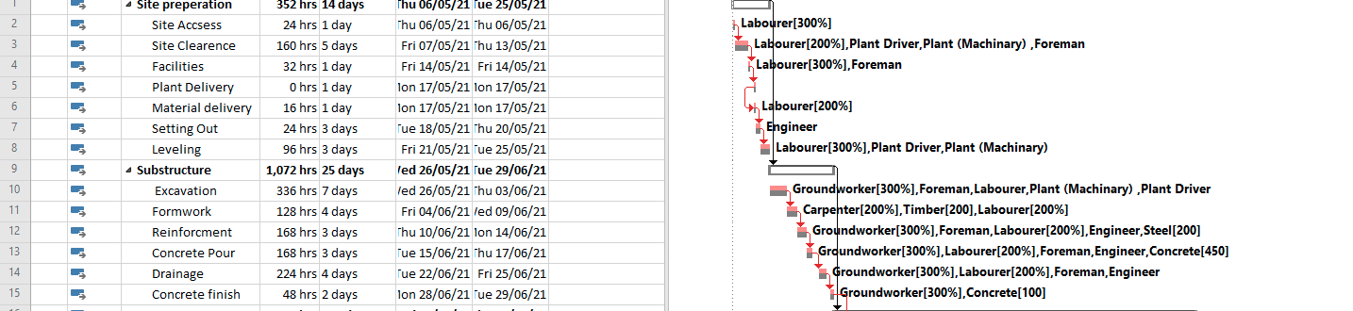
Figure 3: Gantt Chart showing the assignment of workers, materials, and the cost to that specific task

For this current project, this resource sheet below, Figure four, has been created. It will allow quick allocation of resources to tasks. It will also allow for a comparison of the budget to the cost of adding resources to the task. It will be useful when allocating overtime as a different rate can get inputted to give an accurate cost of the changes. Different materials that will be needed have been inputted and assigned a price; this will make it easy to add more materials if needed and update the cost.

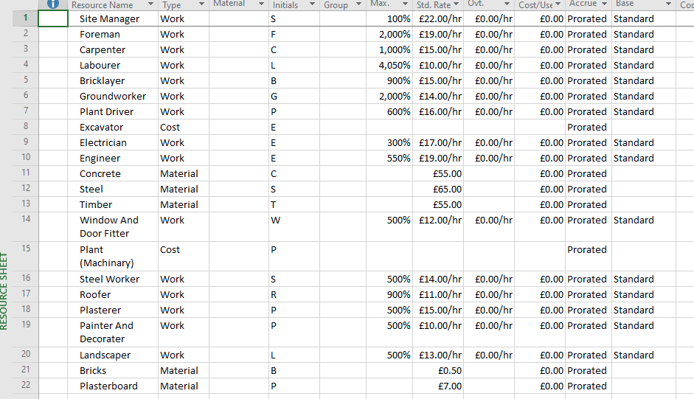
Figure 4:Gantt Chart resource sheet

3.0 Address performance issues and recommend incentives
The perception of the UK construction industry was that it does not give good value for money to its customers. Due to this, there have been many reports showing suggestions on how the construction industry can improve. One of these is the Latham Report 1994, where Sir Michael Latham said that collaborative working within the construction industry would be a way forward (Latham, 1994). Sir John Egan gave another report called Rethinking Construction; this also stated that collaborative and long-term relationships were the way forward. He also said that the client should not receive the full benefit of saving cost but should be shared sufficiently giving the contractor an incentive to provide value for money (Cms-lawnow.com, 2020).
When considering how to use incentivisation on a project, it is crucial that the project's objectives are not only considered, but fully understood. All projects are different, and therefore not all incentives will work the same on each project. Some projects are big and complex and can last years and have significant risk factors involved, therefore, the incentives should then be weighed in the same way, making it fare.
Carrying out the construction of the UWTSD library is going to be a complex project and taking into account the assumption that the adjacent IQ building will be active and will have staff and students carrying out their regular activities in the proximity of the planned construction, it will be vital that the main work of the building should be completed before the start of term to lower this risk of exposure to dangerous machinery to the staff and students. It will mean that time is critical to the client, and any delays would likely have a negative effect on the University. Most people believe that to incentivise there needs to be an award; however, this is not the case; it is possible to incentivise them by giving a negative penalty. It is known as the carrot or the stick approach and is an old management style that came from the story of a donkey and the best way to make him move: Reward him with the carrot or poke him with a stick (Norton, 2020). A negative incentive for the contractor is using Liquidated and Ascertained Damages (LADS). Its commonly used today on most projects and is unlikely to motivate the contractor. However, using LADS is important to ensure that everyone fulfils the contract to the agreed budget and time frame. Going over the time frame could be costly to the client, so they need to have this in place to protect against financial loss and damage to public image. So after carefully reading through the reports and considering the University's objectives, it is recommended that the University and contractor should form a partnership agreement to carry out this complex project; this would be a great benefit to both client and contractor. As stated in the reports above, this will help improve performance and address performance issues early. Collaborating with the contractor early on will give them the chance to use their experience to advise the client on potential money-saving opportunities and foresee any potential issues that could arise (Mosey, 2019). A recommendation to use a target cost contract NEC option C to incentivise and motivate the contractor into helping the client save on cost would also be beneficial to both parties. This contract is a pain or gain method, it means that whatever savings made is then shared between the contractor and client on the pre-arranged percentages. However, vice versa if the project were to go over the allocated budget, then both client and contractor would share the burden (Godwin et al., 2013). The partnership and target cost contract is a substantial incentive for the contractor to complete the project to a high quality, and within the set time frame whilst giving the client value for money.

4.0 Site sketch

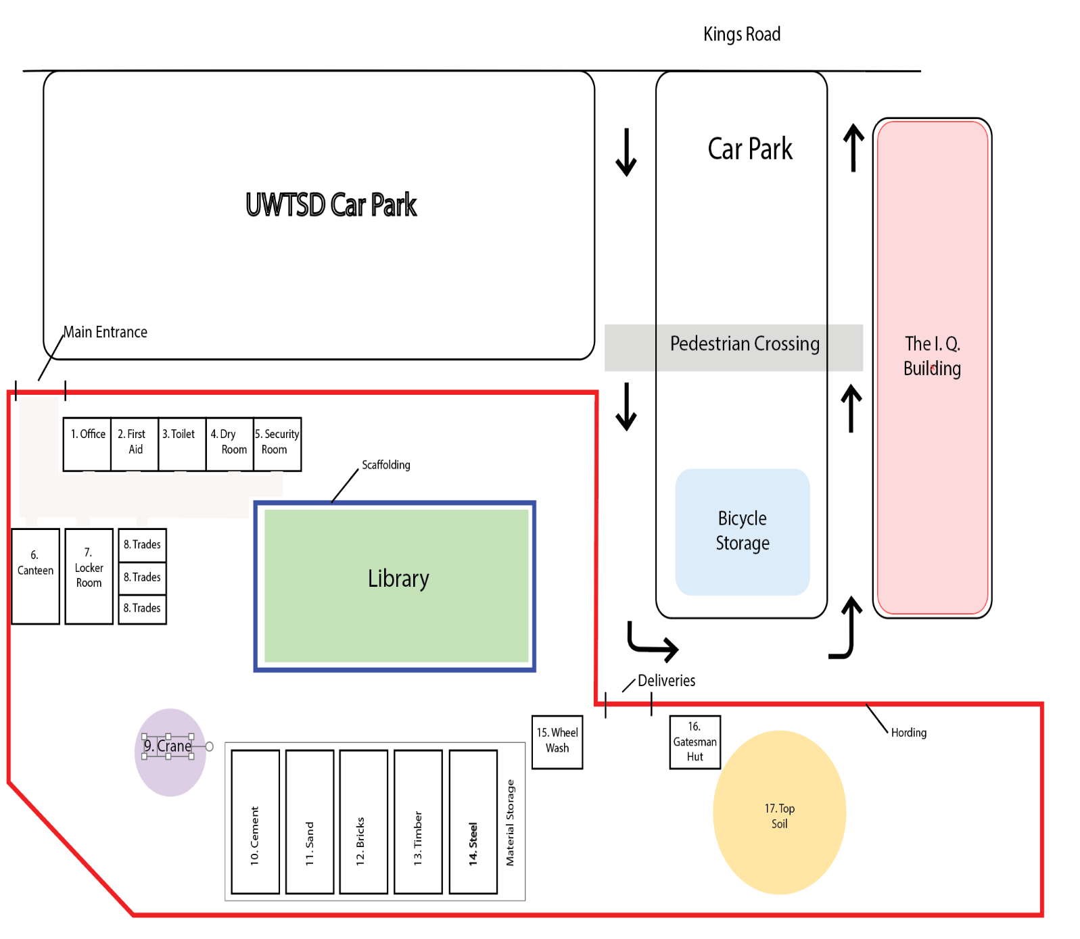
Figure 5: Site sketch layout

4.1 Site sketch summary
When creating the site layout, it is important to consider the health and safety of the workers, visitors, and general public. It is also important to consider the impact on the local environment making sure that noise pollution and site contaminates are contained as much as possible to the site (Moran, 2017). Below is a summary of the reasons behind the positioning of materials and equipment on this site.
- Site office positioned at the entrance to minimise the risk to people visiting the site and keeping them away from building works and plant machinery (R Chudley and Greeno, 2016).
- First aid room positioned away from the dangerous area, making a safer area to give medical assistance or await emergency services.
- Toilets positioned for easy access for visitors and all staff members, in a safe distance from building works.
- Drying room positioned away from building works to ensure clothes stay clean and dry and give the workers somewhere to change without having to go back through site and risk getting dirty.
- Security room will monitor CCTV and carry out patrols of boundaries when the site is locked to protect against theft and to protect the public.
- Canteen positioned away from construction work so that users can relax without the noisy environment. Also, to be safe for the workers to remove PPE without risk of injury.
- The lockup store is there to keep valuables safe but also to ensure safety from dangerous tools and equipment.
- Trade containers for subcontractors to keep tools and equipment safe.
- Crane positioned to be away from over sailing issues and protected against other plant machinery.
- Cement will be stored in a dry area in bags until needed for mixing.
- Sand will be stored close to the cement storage ready for mixing; it will need to be covered to protect against weather and cross-contamination from the site.
- Bricks will be stored on their pallets here until the bricklayers need them moved to their work area.
- Timber will be stored separately and be lifted off the ground and covered till needed.
- Steel storage has been kept away from other materials keeping a clean, tidy storage area. It is easily assessable by plant machinery for use when needed.
- Wheel washer installed here to ensure machinery gets cleaned before leaving the site to keep the local area mud-free.
- Gatesman hut has been positioned at the delivery gate; this will be manned by the Gatesman who will also act as the banksman for the delivery drivers ensuring the safety of workers and members of the public.
- Topsoil will be stored here, allowing for easy access when needed.
- Scaffolding is correctly installed by licenced scaffolders and ticketed correctly. Any adjustment that is needed will need to be carried out by the scaffolders.

5.0 Granite paving delay
Due to travel restrictions, the delivery from China of granite paving stones has been delayed by two weeks. After analysing the Gantt chart below, Figure five, it is clear to see that this has affected the critical path of this project. This means that the pre-arranged deadline will now be affected as all other work will also be delayed (Tran, 2015). It is also easy to see by looking at the baseline the difference between the time scales. This shows the original agreed time scale and the new up to date time scale. The original finish date on this project was 25/05/22; however, as seen on the chart below the delay has changed the finish date to 14/6/22. As it was the client who was responsible for the delivery of materials, the contractor wishes to apply for a compensation event. If excepted, the contractor will give a quotation within the required three weeks. If terms are agreed, then the changes can be implemented to the contract (Burges-salmon.com, 2017).
A compensation event is when an event has taken place and is usually not the fault of the contractor. It would likely change the cost and time of the project. It is giving the contractor the right to ask for extra time and additional cost.

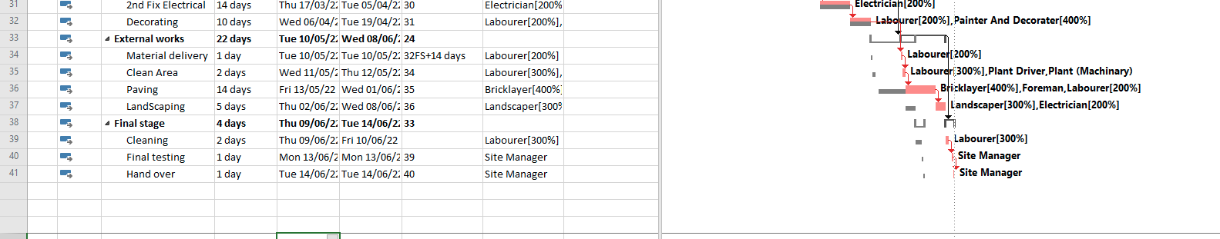
Figure 6: Gantt Chart showing the effect of critical path

6.0 Conclusion

This assignment looked at using software to produce a Gantt chart for the construction of the UWTSD Library, using the Gannt chart to analyse cost, time, and resources, with site-specific reports that got developed and evaluated. It showed how important keeping an accurate and up to date Gantt chart is to the success of any project.
This report also looked at the different ways of addressing performance and productivity issues that arise and what incentivisation should get implemented to help within this project. The research carried out suggested that the best way to address performance and productivity was to collaborate and build on partnering. It additionally concluded that a target cost contract would be beneficial to this project as both client and contractor would share the profit giving good incentivisation to both parties.
This report also contained a sketch of the recommended site layout along with a summary. It was a great way to understand the importance of how and why a construction site layout gets implemented in specific ways. Making sure the local environment and the general public get considered when designing the layout is essential.
The report also looked at how to deal with the delay of the granite paving from China. It was updated on the Gantt chart to show the client the differences that have occurred with the delay. It got established that it was the client who was responsible for providing the materials. Therefore, the contractor requested a compensation event to cover the extra time and cost that would occur as a result of the delay.

7.0 Reference list
Burges-salmon.com. (2017). NEC3 compensation events: don’t get caught out. [online] Available at: https://www.burges-salmon.com/news-and-insight/legal-updates/nec3-compensation-events/ [Accessed 10 Dec. 2020].
Cms-lawnow.com. (2020). A review of the Egan Report “Rethinking Construction.” [online] Available at: https://www.cms-lawnow.com/ealerts/1998/10/a-review-of-the-egan-report-rethinking-construction?cc_lang=en [Accessed 10 Dec. 2020].
Gantt Excel. (2018). Project Costs - Gantt Excel. [online] Available at: https://www.ganttexcel.com/documentation/projects/project-costs/ [Accessed 10 Dec. 2020].
Godwin, P., Gilmore, D., Kratochvilova, E. and Roughton, D. (2013). Target cost contracts. [online] Lexology.com. Available at: https://www.lexology.com/library/detail.aspx?g=1bac0ad9-4f70-4825-b034-7fe158d08ff9#:~:text=The%20pain%20or%20gain%20share%20adjustment%20is%20made,This%20will%20set%20out%20a%20pain%2Fgain%20share%20mechanism. [Accessed 30 Nov. 2020].
Latham, M. (1994). CONSTRUCTING THE TEAM Joint Review of Procurement and Contractual Arrangements in the United Kingdom Construction Industry Final Report. [online] Available at: https://constructingexcellence.org.uk/wp-content/uploads/2014/10/Constructing-the-team-The-Latham-Report.pdf.
Mindtools.com. (2017). Gantt Charts: Planning and Scheduling Team Projects. [online] Available at: https://www.mindtools.com/pages/article/newPPM_03.htm [Accessed 10 Dec. 2020].
Moran, S. (2017). Site Layout Principles 1 | SciTech Connect. [online] Elsevier.com. Available at: http://scitechconnect.elsevier.com/site-layout-principles-1/#:~:text=The%20purpose%20of%20a%20good,product%20reliably%20and%20cost%2Deffectively. [Accessed 10 Dec. 2020].
Mosey, D. (2019). Collaborative construction procurement. [online] Hoboken, Nj: Wiley-Blackwell. Available at: https://www.wiley.com/en-us/Collaborative+Construction+Procurement+and+Improved+Value-p-9781119151913 [Accessed 7 Jan. 2020].
Norton, J.D. (2020). Is the Carrot and Stick Method Useful in Higher Education? - Iobint. [online] Iobint. Available at: https://iobint.com/is-the-carrot-and-stick-method-useful-in-higher-education/ [Accessed 24 Nov. 2020].
ProjectManager.com. (2020). Gantt Chart: The Ultimate Guide (with Examples) - ProjectManager.com. [online] Available at: https://www.projectmanager.com/gantt-chart [Accessed 10 Dec. 2020].
R Chudley and Greeno, R. (2016). Building construction handbook. London: Routledge.
Tran, L. (2015). The Importance of the Gantt Chart and the Critical Path for Project Management. [online] Inloox.com. Available at: https://www.inloox.com/company/blog/articles/the-importance-of-the-gantt-chart-and-the-critical-path-for-project-management/ [Accessed 10 Dec. 2020].

8.0 Bibliography
6 Compensation events CORE CLAUSES. (n.d.). [online] Available at: https://www.neccontract.com/getmedia/b8b13798-a983-41d9-9b60-d31c9f24b154/Term-Service-Contract-Guidance-Notes.pdf.aspx.
An economic analysis of the sector. (2013). [online] Available at: https://assets.publishing.service.gov.uk/government/uploads/system/uploads/attachment_data/file/210060/bis-13-958-uk-construction-an-economic-analysis-of-sector.pdf.
Business Jargons. (2015). What is Carrot and Stick Approach of Motivation? definition and meaning - Business Jargons. [online] Available at: https://businessjargons.com/carrot-and-stick-approach-of-motivation.html [Accessed 24 Nov. 2020].
Constructingexcellence.org.uk. (2014). Constructing the Team (Latham) – Constructing Excellence. [online] Available at: https://constructingexcellence.org.uk/constructing-the-team-the-latham-report-2/ [Accessed 24 Nov. 2020].
Construction-student.co.uk. (2008). Rethinking Construction – 10 years on? – Construction Student. [online] Available at: https://construction-student.co.uk/news/rethinking-construction-ten-years-on/ [Accessed 24 Nov. 2020].
Consumer Protection Association (2017). Is there a problem with the construction industry’s image? | The CPA. [online] The CPA. Available at: https://www.thecpa.co.uk/news/construction-industry-image-problem/ [Accessed 24 Nov. 2020].
D Richmond-Coggan and Construction Industry Research And Information Association (2001). Construction contract incentive schemes : lessons from experience. London: Ciria.
Davis, B. (2017). How to Motivate your Contractors and Temp staff | ReachOutSuite. [online] ReachOutSuite. Available at: https://www.reachoutsuite.com/5-tips-motivate-contractors/ [Accessed 30 Nov. 2020].
Fenwick Elliott. (2015). August 2015. [online] Available at: https://www.fenwickelliott.com/research-insight/newsletters/insight/50#:~:text=Compensation%20events%20are%20events%20which,to%20more%20time%20or%20money. [Accessed 10 Dec. 2020].
Gardiner, J. (2014). Latham’s report: Did it change us? [online] Building. Available at: https://www.building.co.uk/focus/lathams-report-did-it-change-us/5069333.article [Accessed 24 Nov. 2020].
Mulholand, B. (2018). Don’t Micromanage: How It Destroys Your Team and How to Avoid It | Process Street | Checklist, Workflow and SOP Software. [online] Process Street. Available at: https://www.process.st/micromanage/ [Accessed 30 Nov. 2020].
Placker.com. (2020). Show the critical path in the Gantt chart. [online] Available at: https://help.placker.com/en/articles/677902-show-the-critical-path-in-the-gantt-chart#:~:text=The%20critical%20path%20in%20the%20Gantt%20chart%20is%20the%20sequence,performance%20of%20the%20Gantt%20chart. [Accessed 10 Dec. 2020].
Rees, A. (2013). An economic analysis of the sector. [online] Available at: https://assets.publishing.service.gov.uk/government/uploads/system/uploads/attachment_data/file/210060/bis-13-958-uk-construction-an-economic-analysis-of-sector.pdf [Accessed 30 Nov. 2020].
Sketchley, E. (2019). Gauging the true value of the construction industry. [online] Planning, BIM & Construction Today. Available at: https://www.pbctoday.co.uk/news/planning-construction-news/value-of-the-construction-industry/61702/ [Accessed 24 Nov. 2020].
Steven C Evans Ltd. (2020). NEC3 Compensation Events – a Practical Guide. [online] Available at: http://www.stevencevans.com/nec3-compensation-events-a-practical-guide/ [Accessed 10 Dec. 2020].
Thebcfgroup.co.uk. (2020). Carrot and Stick Approach to Motivation | The BCF Group. [online] Available at: https://www.thebcfgroup.co.uk/business-coaching/articles/carrot-and-stick-approach-to-motivation.php [Accessed 24 Nov. 2020].
Tyler (2016). eSUB. [online] eSUB Construction Software. Available at: https://esub.com/blog/best-practices-for-motivating-construction-workers/ [Accessed 30 Nov. 2020].
Wendt, S., Strunk, K.S., Jürgen Heinze, Roider, A. and Czaczkes, T.J. (2019). Positive and negative incentive contrasts lead to relative value perception in ants. [online] eLife. Available at: https://elifesciences.org/articles/45450 [Accessed 10 Dec. 2020].
Your Article Library. (2015). Carrot and Stick Approach to Motivation | Theory of Motivation. [online] Available at: https://www.yourarticlelibrary.com/organization/motivation-organization/carrot-and-stick-approach-to-motivation-theory-of-motivation/69839 [Accessed 24 Nov. 2020].
‌

9.0 Acknowledgement
I have completed this assignment with the help and aid of many different people. I want to start by thanking my lecturer Dr Deborah Hughes for providing me with valuable information and resources I needed to complete this report. I would also like to thank my university colleagues Esther Anderson, Daniel Stone, and Liam Benner, for helping me with research and sharing their knowledge. I would also like to thank my wife for all her encouragement and support throughout my assignment. Lastly, I would like to thank my student support Cherry for all her help and guidance throughout this year at University.

