An Evaluation of the C++ Console Game ‘Adventure Game’ and its Implementation as a Display of Object-Oriented Programming.

Oliver Bird
Apprentice Software Engineer – BT , Data Services
1910716@student.uwtsd.ac.uk
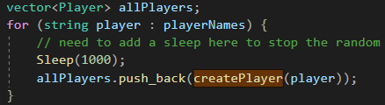
Fig. 2 Looped Player Instantiation

ABSTRACT – A detailed evaluation of the console game ‘Adventure game’ in which its implementation as an object-oriented project will be considered. The game is tested with implementations of happy path end to end testing methods, along with some integration and unit tests. The game is found to be functional and repeatable with randomised values with each playthrough. Consideration is also given to object-oriented programming and its importance in creating such an application.

- Evaluation
A) C++ has been used to create a simple text-based adventure game allowing the players to fight increasingly difficult enemies in a turn-based format. As an object-oriented (“OO”) language, this has allowed for the use of specific custom object types to allow the game to function in the form of classes.
The use of classes has massively reduced the overall number of lines of code within the application, as there is no need to duplicate object types with different values against their properties. Standardisation of types of objects across the game has meant the central game file has no need for consideration of the objects it instantiates; All methods and properties are contained and managed at the class level.
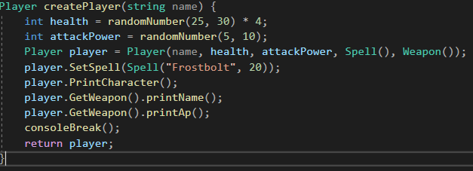
As seen in Fig. 1 and Fig.2 players can be created easily with custom names and randomised values.
Fig. 1 - Player instantiation

B) Memory referencing has been used within the game to directly access created objects inside of iterator loops. In the specific case detailed below, the ‘&’ is used as a reference when passed to the method to allow the player objects to be modified over the loop.
Fig. 3 Player Turn Loop
C) Within OO programming, classes may be defined in a ‘parent – child’ relationship [1], allowing for the use of inheritance. The child class may be instantiated with its own unique properties but is able to inherit extended properties and methods from the parent which it extends. Fig. 4, 5 and 6 illustrate this concept within the game via both the player and monster classes. These classes inherit properties from a parent class ‘Character’. This allows common attributes such as name´ and health to be set in the parent, while the differences between the classes are assigned in each of them separately; namely that a monster has an attribute of the loot which it can drop, and a player has their weapon.

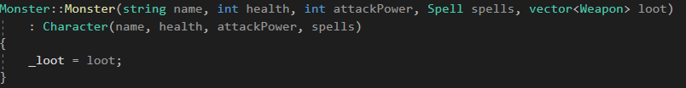
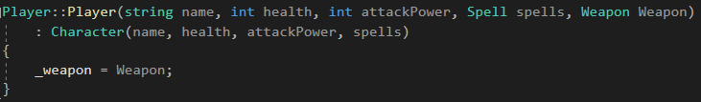
Fig. 5 Inheriting Player Constructor
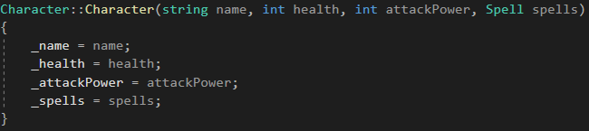
Fig. 6 Character Specified Constructor 1
D) As seen in Fig.6, objects can be instantiated with no default types. Both Monster and Player are able to be created whilst dependent on further classes, thus allowing more complex child classes to be constructed, without directly relying on inheritance.
E) Compile Time Polymorphism (CTP) via function overloading has been used to reduce the overall number of methods within the primary source file. CTP has allowed for the same named method to be re-written with different parameter types, drastically improving the readability of the program. In addition, CTP adds no overhead or increase in execution time of the application, as the methods are evaluated at compile time [2]. Two examples in Fig.7 and Fig.8 show this.
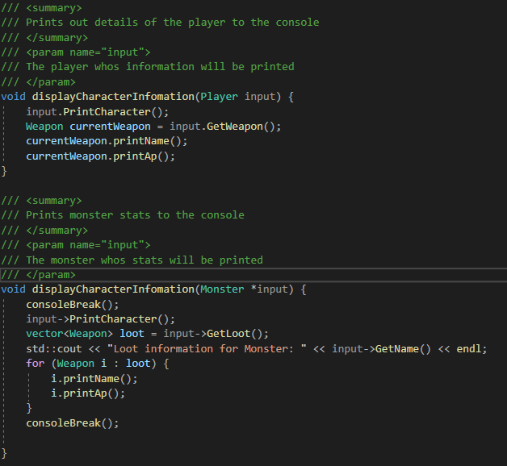
Fig. 7 Display Character Overloading
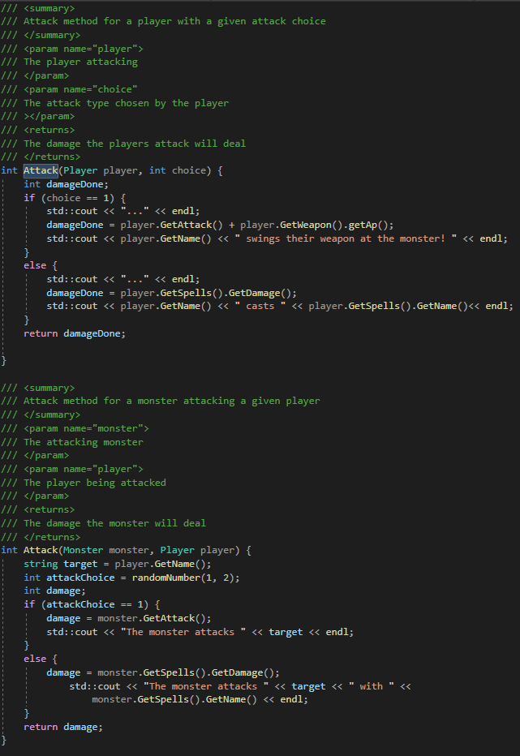
Fig. 4 Inheriting Monster Constructor
Fig. 8 Attack Method Overloading
F) Runtime polymorphism (RTP) via function overriding has also been implemented via inheritance and virtualisation of parent / base methods. Within the application, two scoreboard types have been implemented in the form of a base generic scoreboard, with a child for to display information regarding a specific player. Base Scoreboard methods have been virtualised to allow the child PlayerScoreboard class to override them to print information specific to the instantiated player. Similar to the @Override notation for methods in Java, RTP and method overriding in C++ allows a subclass to override the methods provided in the base class, in order to change functionality or to add flexibility to the method and allows many more implementations of it. Figs. 9 and 10 display examples from within AdventureGame.
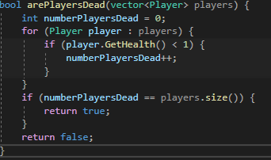
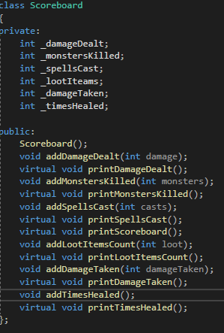
Fig. 11 Readable method declaration
Fig. 9 Base class method virtualisation
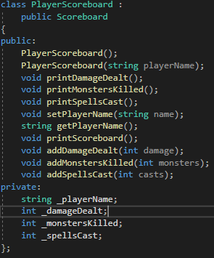
Fig. 10 Child class method overriding 1
G) Scalability is easily achieved within OOP due to simple instantiation of objects. In the case of AdventureGame, object creation has been limited due to the nature of the game. Players are limited to 4, and monsters to 5. This is to purely for demonstrative purposes and could be scaled much larger in later versions. With the use of classes, it is simple to make changes to the underlying design of all aspects of the game, potentially such as adding new spells, adding further combat choices such as healing or using items within an inventory system. The player class could be modified to allow for these kinds of additions, and only the instantiation method calls would need to be modified. Additional logic could be added for these; however the game would still function in its current state regardless of these additions to the described classes.
H) Security is considered minimally within the AdventureGame application. Implementations of private attributes, string management and validation and specific method input types are used throughout the application, to provide stability and security. Coding standards such as ISO 14882:2020 [3] or SEI CERT C++ [4] have not been considered.
I) OOP allows for easier code readability and partitioning into smaller ‘chunks’ when debugging. The use of classes, class methods and inheritance allow for code to be split into its relevant and related parts easily. Methods are more easily identifiable and understandable from their creation, as object types and descriptions are obvious in both their calling and display. Readability is demonstrated in Figs. 11 and 12.
Fig.11 shows easily its function, only by reading the method name and observing its input types. Without reading the underlying logic, it is easy to discern that the method will return a Boolean depending if all players are alive or dead.

Fig. 12 Readable method call
The natural separation of object types also allows for clearer testing strategies. Unit tests for each method and class reduce the need for their testing within the scope of where they are instantiated. Developers can have more confidence in their code due to this.
- Testing
Testing strategies will be employed as shown in Table 1.
Both end to end tests and unit tests [5] will be employed to evaluate the functionality of the code. Some code has been left within the application purely to demonstrate testing of custom object types.

Table 1
Test Name + Type | Test Description | Expected outcome + status
End to end happy path – E2E integration | A full test of the game with 1 player and 2 monsters | The game will play to completion and quit upon finish -  PASSED
Input Sanitisation - unit | Incorrect input types passed to getline methods | Input methods should not allow incorrect input types - PASSED
Player death - Integration | A player will be killed by a monster | Game of 2 players will continue with 1 player dead – PASSED
All player death - Integration | All players will be killed | Game of 2 players will end when all players are dead -  PASSED
Pickup loot  - Unit | Attempt to pickup loot from a slain monster | The associated loot object will be returned from the pickLoot method  - PASSED
Reject loot pickup  - Unit | Choose to keep the current equipped weapon | The weapon will not be updated  - PASSED
Weapon pickup updates the attack  - Integration | Killing a monster and looting a new weapon and attacking the next monster | The weapon attack damage will be correctly passed upon looting  - PASSED
Player heals  - Integration | Test if a player is healed between fights | The player should be healed for 50 health if below 100 between fights  - PASSED
Game restart  - Unit | Attempt to restart the game upon completion | The game should restart if that option is selected  - PASSED
Display Scoreboard  - Unit | Request to display the scoreboard upon completion | The scoreboard will display  - PASSED
Game quit  - Unit | Attempt to quit the game upon completion | The game will close  - PASSED
Display player scoreboard individually  - Integration | Attempt to load the player scoreboard | The scoreboard will load and populate  - FAILED

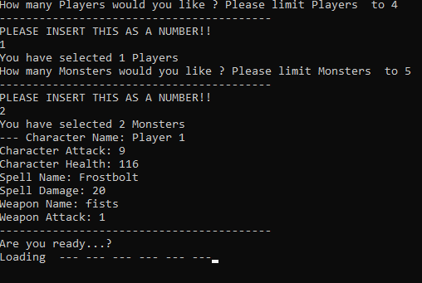
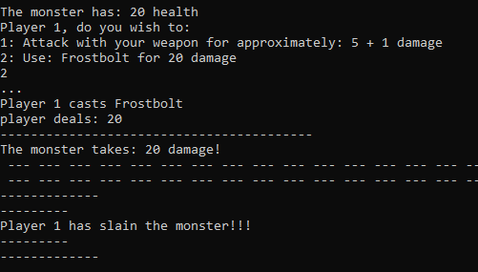
A) End to end happy path – E2E Integration
The game is initialised with 1 player and 2 monsters. 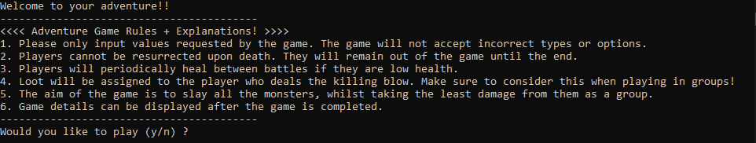
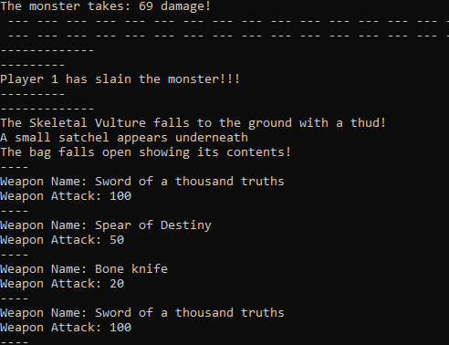
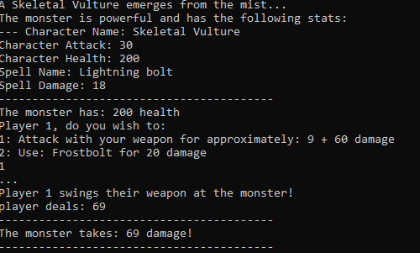
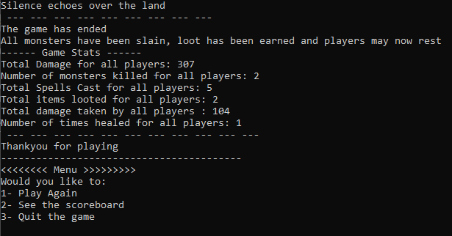
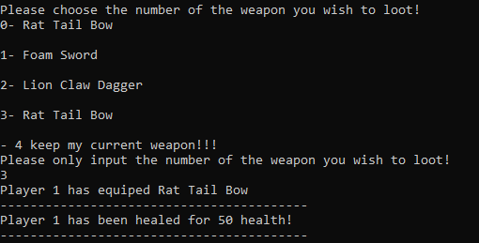
The game successfully completes once all monsters are slain.
B) Input Sanitisation – Unit
Incorrect input types will be passed to input methods to test if they are accepted.
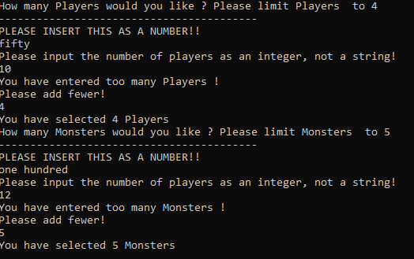
As shown, incorrect values are not accepted
C) Player death – Integration
The game will be run until the player dies. The game should finish as there is only a single player present.
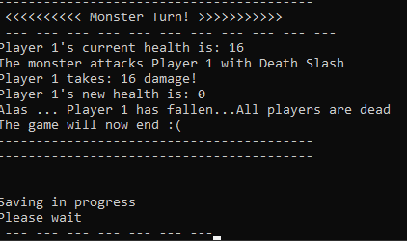
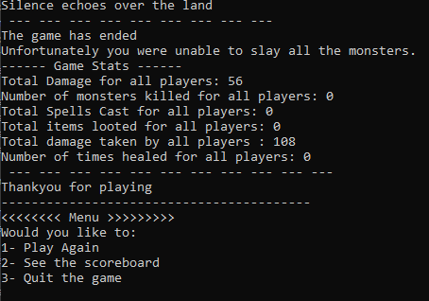
The game ends successfully upon single player death

D) All player death – Integration
The game should end upon all players being slain
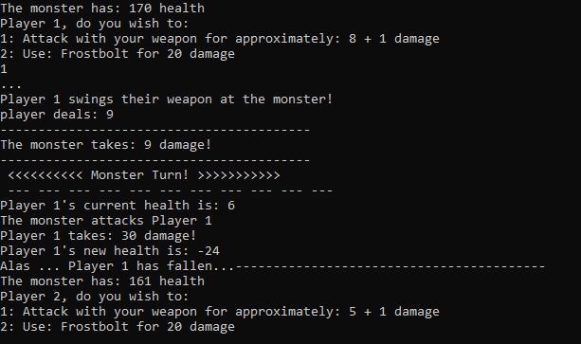
Player 2 can continue playing whilst player 1 is slain.
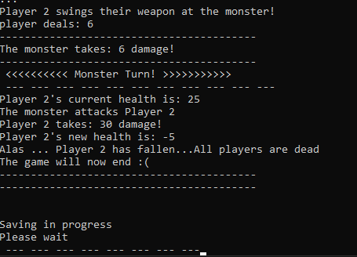
The game completes successfully once all players have been slain.

E) Pickup loot – Unit
A player should be able to equip a new weapon upon killing a monster.
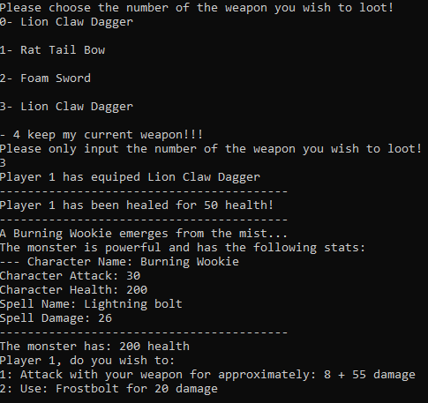
The player has successfully equipped a new weapon.
F) Reject loot pickup – Unit
A player should be able reject a weapon pickup if their weapon is more desirable.
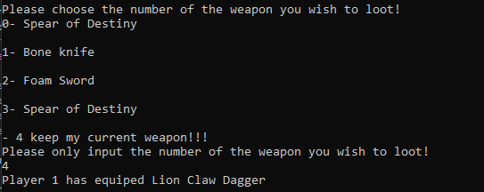
The player was able to keep their current weapon and continue to play the game.
G) Weapon pickup updates the attack – Integration
The players overall attack should be updated after picking up a new weapon.
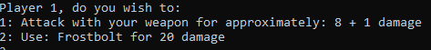
The player has his original attack prior to slaying the monster and looting a new weapon.
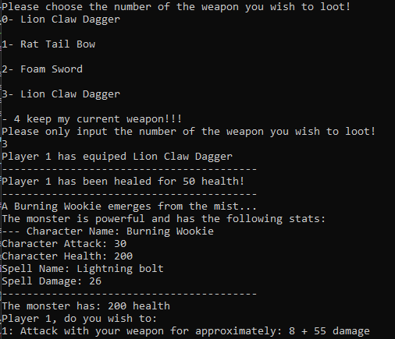
The player’s attack has been updated with the damage value corresponding to the new weapons attack value.
H) Player heals between turns - Integration
The player should heal for 50 health between each battle, given that they were below 50 upon battle completion.
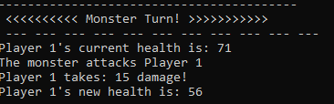
The player is on 56 health prior to slaying the monster
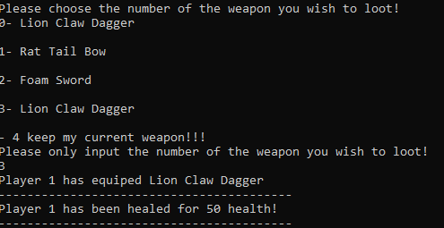
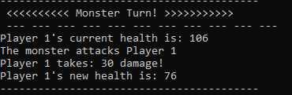
The player is successfully healed as shown by the health values.
I) Game restart upon completion - Unit
The game should be able to be restarted upon selecting the correct option in the ending menu.
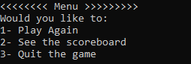
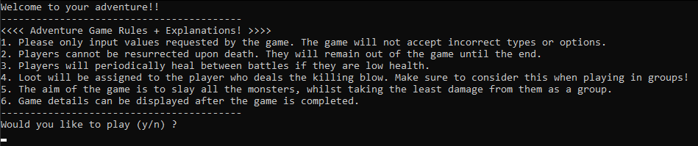
The game successfully restarts and is playable.
J) Display Scoreboard – Unit
The final scoreboard should display correctly when the play selects the associated value.
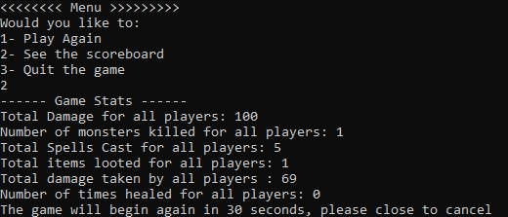
The final scoreboard displays as expected.
K) Game quits upon completion – Unit
The game should quit upon the exit game option being selected
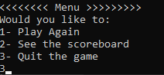

The game quits as expected.

J) Display player scoreboard individually – Integration
Player scoreboards are able to be instantiated and have access to their inherited attributes and methods from the generic scoreboard class as shown below.
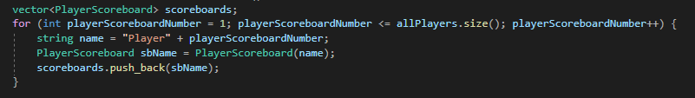
Binding these scoreboards to a specific player object was unable to be completed, and hence the objects remain empty and do not update for each specific player. A more efficient implementation is needed with considerations for scoreboards being directly linked to players, or via an index based loop as opposed to an iterator. The proposed test will always fail in this case.

3. Video Submission
The following link will provide access to a video demonstration of the game. This will detail 2 playthroughs of the game showing actions for both single and multiplayer.
https://youtu.be/Xd89VR5SoGQ

References

[1] | M. Patel, "Inheritance and Its Type in Object Oriented Programming Using C++," International Journal of Recent Technology and Engineering, vol. 8, no. 4, pp. 1991-1998, 10 September 2019.
[2] | B. Kahanwal, "Function Overloading Implementation in C++," International Journal of Advances in Engineering Sciences, vol. 3, no. 4, pp. 12-18, 2013.
[3] | ISO, "ISO/IEC 14882:2020," 12 2020. [Online]. Available: https://www.iso.org/standard/79358.html?browse=tc. [Accessed 01 12 2021].
[4] | "SEI CERT C++ Coding Standard: Rules for Developing Safe, Reliable, and Secure Systems (2016 Edition)," March 2017. [Online]. Available: https://resources.sei.cmu.edu/library/asset-view.cfm?assetID=494932. [Accessed 02 12 2021].
[5] | H. Vocke, "The Practical Test Pyramid," 26 February 2018. [Online]. Available: https://martinfowler.com/articles/practical-test-pyramid.html. [Accessed 20 11 2021].

