
A Critical Evaluation of The Role of Digital Innovation in Professional Practice
Laurence Blake (1806184)

May 30, 2023
UNIVERSITY OF WALES TRINITY SAINT DAVID
ECPT6006

Table of Contents
Introduction 2
The Role of Creativity and Digital Innovation 2
Selection and Justification of appropriate teaching tools and resources 4
Application of the chosen learning tools 7
Evaluation and Reflection 14
References 18
Appendices 20
Appendix A: Lesson Plan 20

Introduction
The digital age has revolutionized the way we live, work, and educate. Within the education setting, digital innovation has brought about significant changes in the way we engage, communicate, and collaborate. This report reviews the role and creativity and digital innovation by compiling a literature review to critically evaluate the role of digital innovation in professional practice, with a focus on its impact on digital education practice.
Following the literature review this report will critically evaluate the justification of the application and functionality of Mentimetre as a digital teaching tool, within professional practice. Reasons behind the selection will be taken further by critically evaluated with other digital teaching tools. Justification of the digital tool selection is important requirement for digital innovation in professional practice. Continuous learning and development of new skills and competences, as well as adaptation to new and innovative forms of delivery are required for professionals within education. Organisations must plan strategically and invest in digital infrastructure, as well as adhere to regulatory and ethical frameworks.
Following onto the next section, the application of Mentimetre within the post compulsory education will detail the various functionalities. This will be supported by screenshots of the engagement of the tool and will be supported by a link of the lecture recording within the appendices.
Finally, by evaluating and reviewing Mentimetres application within the classroom setting, it would indicate how this digital tool has an essential component of professional practice, with multiple benefits and limitations. This report will use the Gibbs reflective model to conduct the evaluation and reflection. To realise its full potential, it must critically analyse its function and impact, as well as linked to the UK Professional Standards Framework (Advance HE, 2023).

The Role of Creativity and Digital Innovation
The primary purpose of the literature review is to analyze the role of creativity and digital innovation, with a focus towards how technological application and pedagogy can be supported within the post compulsory sector.
To begin with there has been clearly identified that there are some significant benefits associated with the application of digital technology within the classroom setting. According to Boland's (2020) research, digital technologies enable more engaging and dynamic learning experiences, which can help students build a deeper comprehension of complicated subjects. They also emphasize the necessity of educator-student collaboration and communication in the creation and implementation of digital innovations. This has been seen to have significant links towards development and innovation within the education setting. Research from Bozic and Dunlap (2013), suggests digital innovation can increase student engagement in postsecondary education by providing interactive and personalized learning experiences. They do warn, however, that while technology can be useful in the classroom, it must be utilized in conjunction with sound teaching to be truly effective. Following the research, it is considered that educators be trained on how to successfully integrate technology into their teaching practices. By integrating technology within two the educational practise has drawn to significant links between student engagement and student motivation within the classroom setting. Has this approach should be compounded and scaled to maintain appropriate effectiveness for the role of digital innovation and creativity within the education sector.
However, as we have reviewed some benefits particularly surrounding the implementation of creativity within the digital education setting there has been noted of some drawbacks. Ramirez and Inga (2022) address the problems and opportunities of integrating digital innovation into postsecondary education. According to the authors, while digital innovation can improve learning results and increase student engagement, it also raises issues of accessibility, equity, and privacy. Lopez-Martinez et al (2022) argue that fostering creativity is essential for students to develop the skills and knowledge necessary to succeed and not solely related to the digital landscape. The authors suggest that educators should encourage students to experiment with new ideas and approaches, and to take risks in their learning.
With drawbacks have stipulated that you need to have creative approaches within the education sector and that you can't have an over reliance on digital implementation, the Welsh government have set out appropriate guidelines to ensure that appropriate measures are taking place. According to the Welsh government (2020) for organisations to playing integral part in society the Welsh government have created the digital 2030 strategy plan for Wales. As part of this plan indicates how practical approaches to the inclusion of technology can be aligned within their own digital 2030 aims and objectives. Such initiatives and incentives of the Welsh government 2030 strategy is to encourage Welsh culture within education, to promote the use of Welsh language within education is also and to ensure that delivery of digital platforms both face to face and online can both facilitate synchronous and asynchronous learning activities to support all learning environments. By following in utilising government objectives, you enhance the ability to successfully align yourself with appropriate practise emerging practise which can benefit students within the future of the education setting.
As a final part of this literature review considering the role of creativity and digital innovation, we will now begin to examine the TPACK model as there has been significant linkages to support pedagogy within the post compulsory sector. When examining the details of course design and pedagogy related to digital invention and use, the TPACK model created by Mishra and Koehler in 2006 (cited in Brauer, Decker, & Van der Pol, 2013) is extremely useful. This approach is built on three knowledge sources: (TK) Technical Knowledge, (PK) Pedagogical Knowledge and (CK) Content Knowledge. In summary, this approach considers the available technology and the instructors' experience with it, the optimal way for the student to achieve educational outcomes, and topic knowledge. There is a risk to the learner if there is insufficient knowledge in either of these domains.
In conclusion of the literature review there are significant benefits associated with the role of digital innovation and creativity play within the education setting. Search benefits of included that it enables more engagement and collaboration between the educator and the student. There have also been some issues associated with the implementation of technology as it has been noted that you cannot have a solely technological based approach as creativity to teaching should be utilised. This literature review has also been linked to the Welsh government's digital strategy of 2030 and has been expanded and explained to see the road map the Welsh government must achieve their objectives. And lastly the literature review managed to highlight the TPACK model as this has seen great links to support pedagogy in the post compulsory sector.

Selection and Justification of appropriate teaching tools and resources
This section will be describing the selection and justification of digital tools and frameworks, more specifically relating to the application of Mentimeter during the lecture environment. To further support the selection and justification of this tool it will be critically analysed and compared with Vevox which is an alternative to Mentimeter.
Mentimeter is described as an interactive platform which enables its users to engage in real time (Mentimeter, 2023). It is further described as a web-based tool which possesses a significant volume of engagement activities for example it includes surveys, quizzes brainstorming and is used for gathering user feedback. Mentimeter is often described as a great tool for engaging its uses through its user-friendly interface and real time functionality makes it an ideal platform for any interactive presentation.
An alternative option to mentimeter would be the digital tool of Vevox. This tool does possess similar functions as Mentimeter for example it is a web-based tool, and it can be used for conducting surveys, quizzes, brainstorming activities and gathering feedback (Vevox, 2023). Vevox is seen to be an engagement tool because it does possess very similar functionalities to Mentimeter but does have a different online platform interface. A further study from Greenwood (2023) suggests that a high level of participation and engagement had been associated with the poll function of Vevox, however Greenwood describes further there had been lower participation rates that had been associated numerous external factors which impacted students willing to willingness to engage.
Even though each of the digital engagement tools have quite similar functionalities, the choice and primary focus will be associated with Mentimeter because of the variety of functionalities and consisting of a track record of greater levels of student engagement. One such example is through the anonymous question function. Belton (2018) describes how the anonymous feedback function or mentimeter has significantly changed the dynamics of the presentation. Benton further describes that with the use of mentimeter fat everyone has a voice within the room as much as the person who is most vocal during these sessions. This has also been linked towards reducing student anxiety in lectures, and not feeling embarrassed for asking, or responding to questions incorrectly. Furthermore, there is seen to be other significant benefits with the use of mentimeter. As Hill (2020) have identified that mentimeter has had a significantly positive impact to student satisfaction an engagement through different levels of study. Hill goes on to identify that such functionality such as the use of leader boards and point scoring system have significantly contributed to the effectiveness of mentimeter. This approach the learning environment can be referred to as the assessment for learning, as Race and Pickford (2007) discussed the importance of using assessment as a tool for learning rather than just measuring the outcomes. Further research from Race and Pickford (2007) even indicate that assessment practises have been strongly linked to enabling students to reflect on their progress and improve their own learning.
This section will now begin to apply Mentimeter to the TPACK model developed by Mishra and Koehler in 2006 (cited in Brauer, Decker & Van der Pol, 2013). A crucial part of this model being applied to mentimeter, is that within the lesson environment you need to ensure that there is an integration of these types of knowledge. By combining all these areas simultaneously teachers can create engaging and effective learning experiences for their students.
Technological Knowledge (TK):
To maximise the usage of Mentimeter it would be the responsibility of teachers to have a basic level of understanding the technology of which is involved. Having such basic knowledge of the digital tool can significantly support any troubleshooting issues that may arise during class and ensure that the planned activities are meeting the specific learning goals. Along with this reason it is also important to ensure that the teacher’s technological knowledge is linked to the UK professional standards framework (Advance HE, 2023), as K4 indicates that the use of digital resources and technology is applied as part of the core knowledge. As further emphasis to this point, Race (2020) acknowledges digital innovation with higher education and indicates that it is very effective for the learning experience to apply technology.

Pedagogical Knowledge (PK):
When applying the pedagogical knowledge to Mentimetre within the classroom environment, it should be made clear that the teachers have a clear understanding of the objectives of what they are hoping to achieve and how mentimeter can support the teachers reach those objectives. It is clear the teachers using Mentimeter should be familiar of the different types of interactive activities that can be created using this platform. Such activities can include quizzes and word clouds to name a few. Mayhew et al (2020), describes that even though the use of Mentimeter, it can be challenging to balance the learning goals due to the vast amount of different engagement functions but have noted some drawbacks with the free edition. Moreover, there has been clear strong links with Mentimeter enabling real time assessments which enables to the teacher to identify blind spots within the lesson experience and the teaching can be adjusted accordingly to support achieving and understanding the lesson objectives.
Content Knowledge (CK):
Last of all with regards to content knowledge it is crucial that teachers should have a deep understanding of the content of which they are delivering and how it can be presented effectively by using mentimeter. This can include creating questions and activities that are very much in line with the lessons learning objectives and that strong links towards encouraging critical thinking an engagement. Tarazi and Ortega-Martín (2023) describes that Mentimeter has been used to meet the lesson objectives and has been strongly linked towards students meeting the lesson objectives through the multi-dimensional learning experience. This approach has even been linked towards developing students critical thinking, collaborative skills, and students’ overall engagement. The application of Mentimeter has been linked enhance the learning experience in various education contexts.
In summary, this section has described the selection of the digital tool of Mentimeter and has highlighted the many functions with the tool. By applying the TPACK model by Mishra and Koehler, 2006 (cited in Brauer, Decker & Van der Pol, 2013) to Mentimeter, this has supported the justification of this tool as it has provided balance to the justification of the tool choice. For example, where there can be issues balancing the lesson objectives using the tool, there is strong evidence the tool increases engagement and supports the development of student skills such as collaborative working and critical thinking. Finally, Mentimeter can support identifying the blindspots in the student learning, which indicates that the teacher can support achieving the student objectives.
Following the selection and justification of Mentimeter, the next section will demonstrate the application of Mentimeter within the online lecture environment.

Application of the chosen learning tools
This section will demonstrate the application of Mentimeter within the post compulsory education setting. The lecture of Organisational Consultancy was for level 6 students studying International Hotel Management. Present during this lecture were twenty students in an online classroom setting. The students had a small amount of experience of using this tool, but through clear guidance and effective communication with the students they managed to utilise the tools key functions.
As stated previously within the justification of the use of Mentimeter you can clearly see that answers are anonymous which is linked to greater levels of engagement. Unfortunately, a survey was not carried out as part of this lecture which would demonstrate the thought around the use of Mentimeter. However, on the basis that there was maximum participation with the use of the digital tool and no major setbacks during this session when using Mentimeter, it is considered that engagement during the online lecture was successful.
In the table beneath, is split into two separate sections. The first section indicates two tools which we used during the lecture. This is due to the lesson plan (Appendix A) would include a breakout room activity with the randomizer has been used, and the break questions slide which is used during break periods of the lecture. The second part of the table indicates the lecture recap quiz, of which is placed at the end of the lecture to confirm send student acknowledgement and understanding of the topic.

Table of Mentimeter engagement activities use during the lecture
Randomizer for the group activity

The spin the wheel randomizer activity is initiated post a breakout room activity. Instead of calling a room at random to present their findings, this displays an interactive slide of which a room is selected at random. This is supposed to either a blank slide or a general team’s panel grid being displayed. This approach has seemed to create significant engagement and excitement around the activities as any room can be called with this randomizer.
Break questions slide
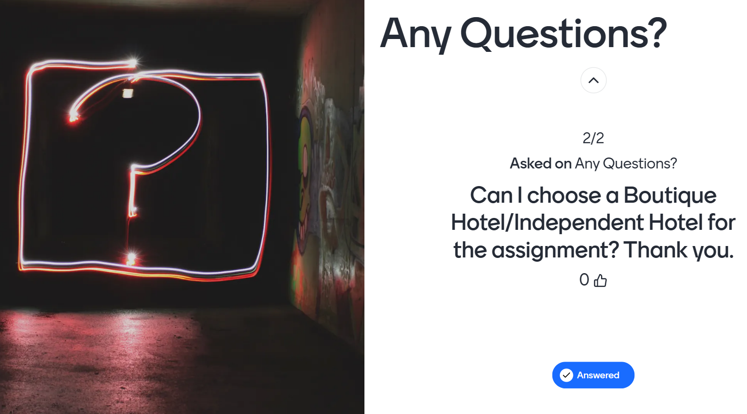
The break question slide would be included just before the break period of the lecture. This is being included within the break periods of the lecture to maintain and utilise all time within the lecture in an effective manner. The response is from the break slide I responded in a group discussion once the second part of the lecture commences. Along with the break slide the responses are anonymous so that equal opportunity is granted to all students who wish to ask a question during the lecture.
End of lecture recap quiz
Instructions
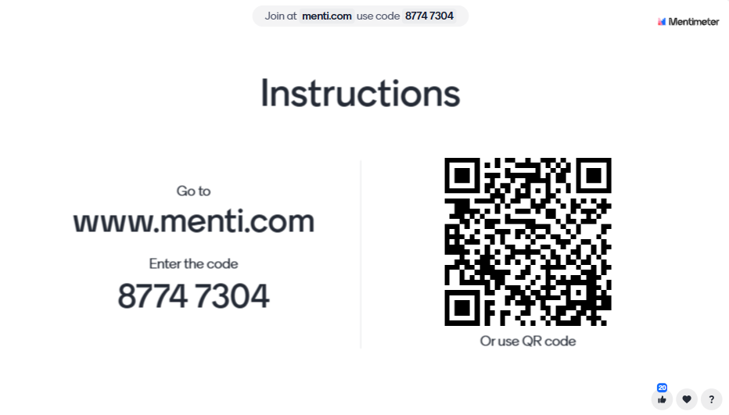
This commences the start of the end of lecture recap quiz. From this slide you can see that there are clear instructions how you can access the engagement activity. Instructions are indicated verbally by the lecture, QR code or a website link as presented on the slide above. To the bottom right off the slide you can see reactions as this is an indication to the lecturer that once a student has accessed the engagement tool that they can simply react using the various icons to determine that they are ready to engage.
Overarching question of the lecture

Title of the lecture and topic recap.
Word Cloud activity
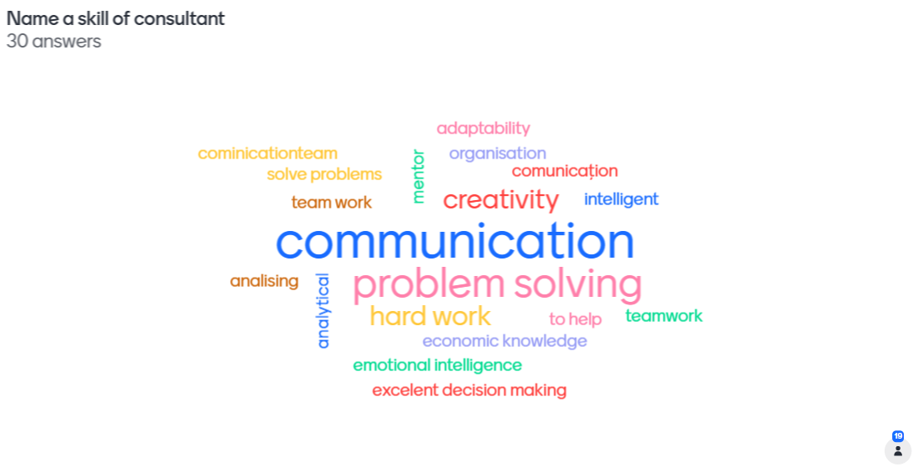
The word cloud activity consisted of the students providing three possible answers to the question which they must write in individually. Furthermore, how the word cloud functions is that all student responses are displayed as a former cloud, and when more participants respond with the same answer, that answer grows. For example, as you can see from the world cloud activity it indicates that the most common skill for a consultant was communication.

Why do Consulting Projects Fail?
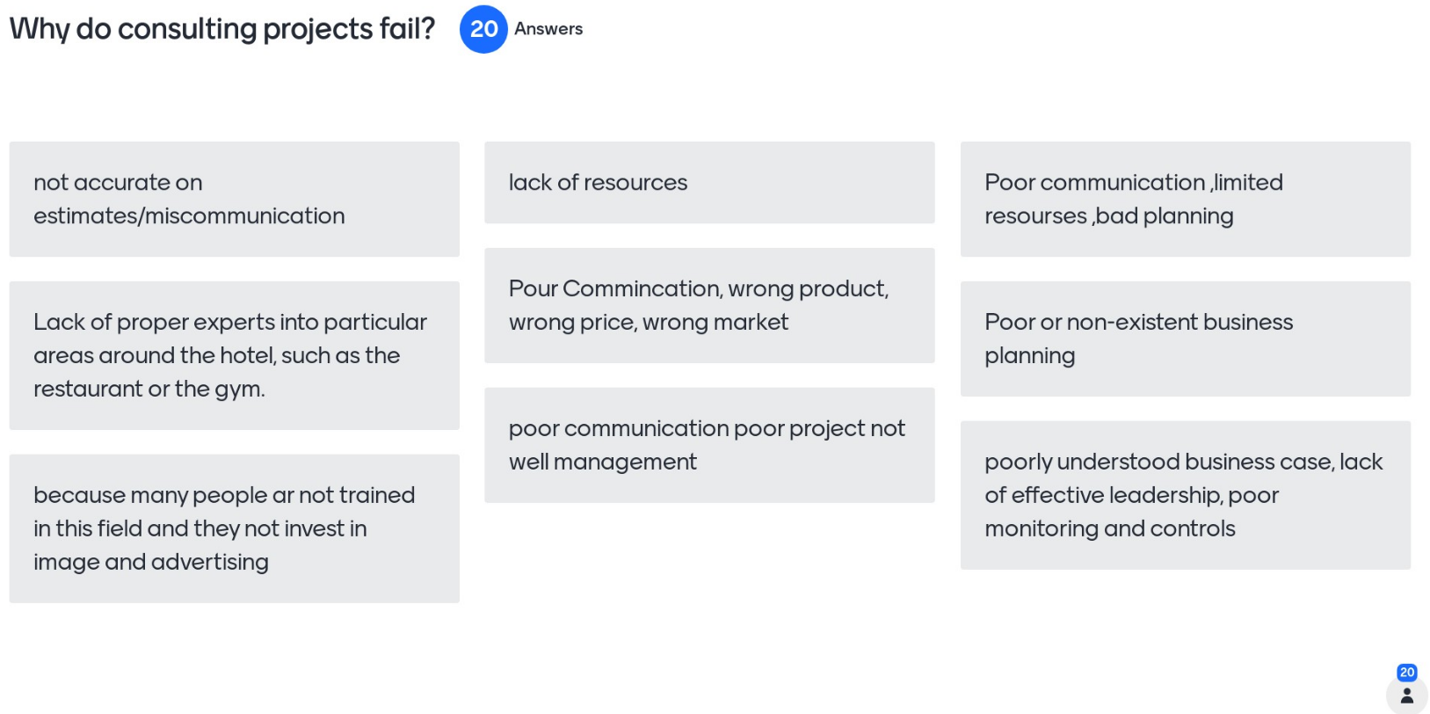
This use of mentimeter enabled the students to write full sentence answers for the question “why do consulting projects fail”. Here you can see there was maximum participation an engagement during this activity, this can be observed through the icon in the bottom right-hand side through the number of participants who engaged in this activity.
Quiz under timer (15 seconds)
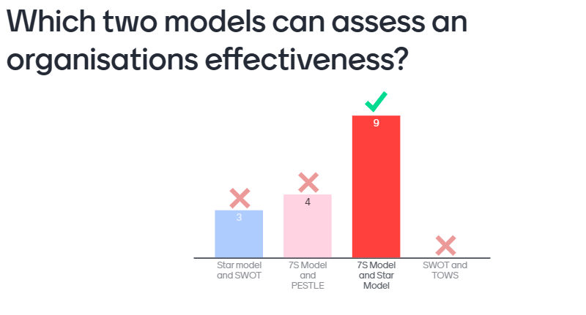
Leaderboard from responses
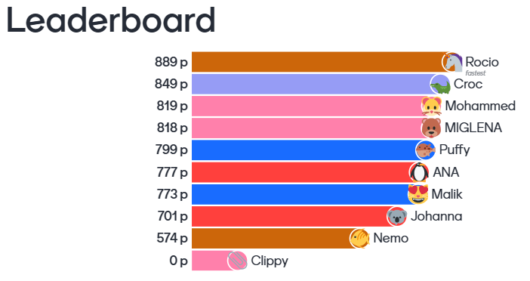
By including areas surrounding a competition element, this increases the student participation. Through a time, limit to increase student suspense, students are tasked to answer the multiple-choice question. The quicker they answer the question, the more points they receive.
What is the difference between an internal and an external consultant?
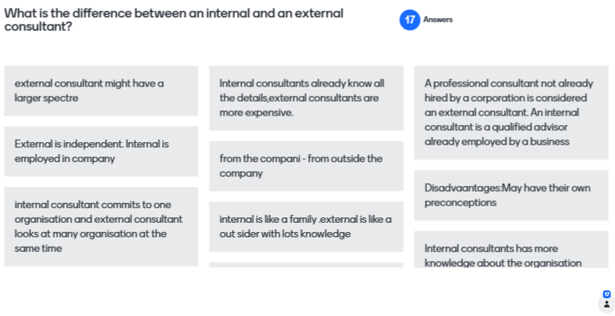
This use of mentimeter enabled the students to write full sentence answers for the question “what is the difference between an internal and an external consultant”. Here you can see there was maximum participation an engagement during this activity. A drop in student answers could be down to technical issues, or not enough time given to answer the question.
Assignment Confirmation multiple choice question
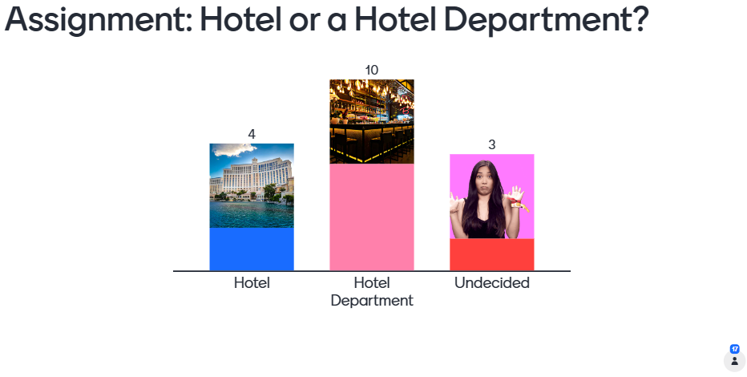
This question is designed for the students to confirm to me if they have made a start or given some thought about their assignment. Depending on the answers would determine if I would need to provide any further guidance and support to the students.

Assignment deadline question
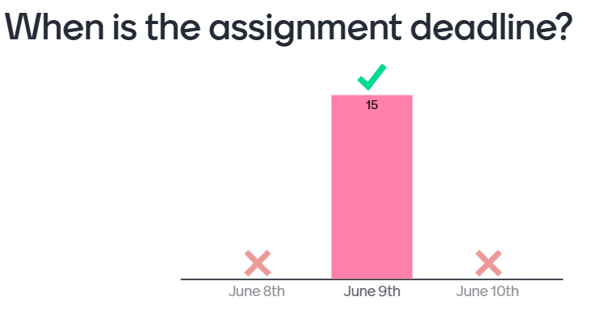
Leader board from the responses
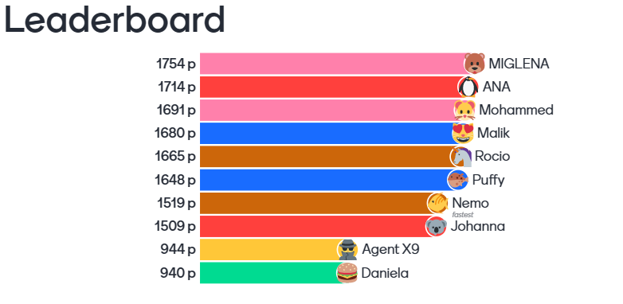
By including areas surrounding a competition element, this increases the student participation. Through a time, limit to increase student suspense, students are tasked to answer the multiple-choice question. The quicker they answer the question, the more points they receive. The purpose of this question is for students to confirm to me that they understand when the deadline is for the assignment.

Evaluation and Reflection
The Gibbs Reflective has been selected to evaluate and reflect on the application of the digital tool within the post compulsory lecture environment (Gibbs, 1988).
Description:
To begin with, this section provides a description a digital tool which has been used in an online lecture setting to increase levels of student engagement. The tool used within this lecture is called Mentimeter, and this tool was used during a level 6 lecture of organisational consultancy. This lecture included twenty students. The purpose of this tool is to provide a unique and innovative approach to the teaching environment, more specifically by using the digital tool during varied times within the lecture to greatly enhance student engagement and productivity. The lecture did have high levels of engagement, and this was monitored by the various discussions and application of the tool. Furthermore, it was appealing to see high levels of engagement throughout the lecture. As part of the lecture planning phase, it was insured that as many of the different variables associated with the UK professional standards framework was achieved (Advance HE, 2023). By adopting this approach this ensures that we can use the UK professional standards as a benchmark to ensure that we are in line with these standards.
Feelings:
I felt that my previous application and use of the tool would greatly enhance and support the lecture. By having previous knowledge and experience of the tool this would allow me to communicate effectively with students on how to access and engage in the lecture by using the mentimeter digital tool. I felt that during the lecture that the use of the tool was a success, as this can be seen within the application and use of the tool. However, during periods of using the application, more specifically towards the end of the session that there was a slight decline within the engagement numbers. This could be a result of student technical difficulties or not allowing students enough time to answer the question. As a result, this could be seen that a total success of the application of this digital tool was not fully achieved. Moving forward from this I feel that if I increased the time that students had to answer questions could result in far greater levels of student engagement.
Evaluation:
It was clearly identified that great levels of student engagement had been achieved. For example, there was multiple forms of engagement either vocally or through the students submitting their answers to the questions using the digital tool. However periodically they had been noted about some minor issues with access in the tool, but through communication and clear guidance this problem had been overcome. Further to this point it also had been noted that there had been a dip in engagement, which could be a result of this part of the lecture being at an increased pace. However, with there had been some minor issues associated with the digital tool application I would say that its application was a success due to a large amount of students’ responses answering the questions correctly. As a result, this has been measured that the tool has worked successfully, but the pace of the lecture would need to be slowed down for all students to benefit from this tool.
Analysis:
It is deemed that the tools application was it success because of the gamification aspect being applied, and this has resulted in students motivation to take part and contribute within the lecture. Additionally, by benchmarking the lecture preparation practises with the UK professional standards framework this could be seen to have supported the lecture engagement and environment of the session. With the application of this digital tool did not go so well could be down to a resulting factor of an increased pace that the students had to respond to the questions, or alternatively students could be demotivated because of not understanding the lecture content fully, as a result this could have been the concluding factors to why there was a slight decline in student responses. A further determining factor to why the application use had a slight decline could be because they had been no student feedback about the tool provided which could be linked towards some student demotivation during this session.
Conclusion:
To conclude this reflection has identified that by applying a variety of digital tools but it has been linked significantly with increased student participation and engagement. I have learnt not from this experience the student participation and engagement can be used as a benchmark which can determine the success of the application of the tool. I have also discovered that through hypotheses analysis that simply by giving the students more time to answer and respond to the questions could greatly enhance and support the student engagement and motivation within the session. Furthermore, it is also identified that a survey was not carried out by applying the digital tool, as by not asking the students for feedback the students may feel demotivated that the opinions around the tool have not been addressed. This has also inspired me to explore a greater variety of tools and engagement which can enhance the student engagement and lecture experience.

Action Plan:
An action plan has been formulated and have been developed using SMART objectives (Specific, Measurable, Achievable, Realistic and Timebound). Furthermore, practices which will be maintained are highlighted within the to continue section.
 | Action Points: | Success criteria: | To be achieved by:
Imporvement areas:
 | Explore alternative digital tools to enhance student engagement during lectures. | As a result, this would evidently achieve far greater levels of student engagement. | Within four weeks
 | Consider student feedback after the inclusion of digital tools. | By providing the student voice to raise the feedback of any digital tools, this can greatly enhance the student and class engagement. | Within all lectures moving forward
To continue:
 | Ensure that the digital tools and frameworks used in lectures are linked to the UK professional standards framework. | By using the UK professional standards framework as a benchmark for all lectures and lecture planning this will ensure that all professional standards are achieved for quality assurance. | Within one week
 | Continue to develop my own skills and expertise around applying mentimeter into lectures and experiment with variety of different functions to support the student engagement. | By maximising all various functions surrounding digital tools, this could be greatly linked towards continuously supporting the learning environment. | Within one week

References
Advance HE (2023) The UK Professional Standards Framework for teaching and supporting learning in higher education. Available at: x173570 HEAY.pdf (Accessed: April 26, 2023)
Brauwer, N, Dekker, P, Van der Pol, J. (2013) e-Learning Cookbook. TPACK in Professional Development in Higher Education. 1st edition. Amsterdam: Creative Commons Attribution 3.0 Netherlands license
Belton, P (2018) Grindr? Doodles? What do you do during boring meetings?[Online] Available at: Grindr? Doodles? What do you do during boring meetings? - BBC News. (Accessed: May 8th, 2023)
Bonfield, C.A., Salter, M., Longmuir, A., Benson, M & Adachi, A (2020) ‘Transformation or evolution?: Education 4.0, teaching and learning in the digital age’, Higher Education Pedagogies, (5), 1, 223-246, DOI: 10.1080/23752696.2020.1816847
Bozic, C & Dunlap, D. (2013). ‘The Role of Innovation Education in Student Learning, Economic Development, and University Engagement’. The Journal of Technology Studies, 39(2), 102–111. https://doi.org/10.21061/jots.v39i2.a.4
Gibbs, G. (1988). Learning by doing: A guide to teaching and learning methods. London: Further Education Unit.
Gorman, E. (2021) ‘Increasing student engagement using an amazing Race-style competition’, Journal of Medical Library association, 109 (3), pp 478-482. DOI: 10.5195/jmla.2021.1178
Greenwood, J (2023). ‘Ready player one: using Vevox to elicit student participation in lectures’. Journal of Learning Development in Higher Education. 27.
Hill, L (2020) ‘Book Review: Mentimeter: A Tool for Engaging Large Lecture Cohorts’. Academy of Management, Learning and Education, 19 (2).
López-Martínez, A, Meroño, L., Cánovas-López, M., García-de-Alcaraz, A., & Martínez-Aranda, L. M. (2022). ‘Using Gamified Strategies in Higher Education: Relationship between Intrinsic Motivation and Contextual Variables’. Sustainability (Basel, Switzerland), 14(17), 110–114. https://doi.org/10.3390/su141711014
Mayhew, E Davies, M., Millmore, A., Thompson, L., & Pena Bizama, A. (2020). ‘The impact of audience response platform Mentimeter on the student and staff learning experience’. Research in Learning Technology, 28, pp 1–16. https://doi.org/10.25304/rlt.v28.2397
Mentimeter (2023) Mentimeter. [Online] Available at: Interactive presentation software - Mentimeter (Accessed: May 2nd, 2023)
Mumford, A and Honey, P. (1992) ‘Questions and answers on Learning Styles Questionnaire’, Industrial and Commercial training, 24(7), pp10. DOI: 10.1108/00197859210015426.
Race. (2020). The lecturer’s toolkit : a practical guide to assessment, learning and teaching (Fifth edition.). Routledge.
Race, & Pickford, R. (2007). Making teaching work “teaching smarter” in post-compulsory education. SAGE
Ramirez, A. and Inga, E., (2022).’Educational Innovation in Adult Learning Considering Digital Transformation for Social Inclusion’. Education Sciences, 12(12), pp. 882.

Tarazi, A & Ortega-Martín, L (2023). ‘Enhancing EFL students’ engagement in online synchronous classes: The role of the Mentimeter platform’. Frontiers in Psychology, 14. https://doi.org/10.3389/fpsyg.2023.1127520
Vevox (2023) Vevox. [Online] Available at: Vevox - Dashboard (Accessed: May 2nd, 2023)
Welsh Government (2020) A digital standards framework for post-16 education in Wales, [Online] Available at: Digital 2030 - Digital Standards.pdf (jisc.ac.uk) pp1-33 (Accessed: May 1st, 2023)

Appendices

Appendix A: Lesson Plan


Lesson Plan
Topic: Organisational Consulting |  | Class: Level 6
Date: 02/05/23 | Length of lesson: 3 hours, 30 minutes |  | Number of students: 20
Resources required:
Laptop or desktop
A working camera and microphone (Headphone with microphone would be useful)
Access to Microsoft Teams
Ability to take notes, either from your device or from pen and paper.
A phone or secondary device for the engagement tool activities. For example, Mentimeter.
Aim of Lesson
The primary aim of the lesson is to acknowledge and critically evaluate the purpose of a consultant, and to review internal and external consulting. Furthermore, the lesson will review organisational design, and provide tools and frameworks which can be applied to existing industry examples.
Learning Outcomes – The Learners Should Be Able To:
- Critically analyse internal and external consultancy.
- Demonstrate and apply the functionality of models and frameworks to organisational examples.
Previous student knowledge required for the session:
- Learners would have been briefed about expectations during online lecture. For example, engagement requirement and digital etiquette.
- Students would have been introduced to the digital tools from previous lectures, as this would support the lecture engagement.
Anticipated difficulties (if applicable):
Technical problems would be the main reason. As a contingency plan the classroom is live from 09:00 and gives students 30 minutes before the lecture starts to address any technical concerns.
Professional Standards (where are these being met within the session)
Professional Values:
V1- By creating an open and equal learning environment.
V5- Collaboration is achieved through parts of discussion and through breakout room activities and through periods of discussion.
Core Knowledge:
K2- Students are being taught to a level 6 standard and aspects defined through Blooms Taxonomy.
K4- Including engagement tools such as Mentimeter to support student engagement and learning.
Areas of Activity:
A1- This was achieved in the preparation and planning phase of the lecture, in accordance with the professional standards framework.
A3- Through formative assessment at the end of the lecture. Furthermore, by using a break question slide would give the students the opportunity to as questions and discuss after the break periods.
A5- By continuously reviewing and assessing my own practice I have been able to apply new features to enhance the lesson. This includes the application of the break questions slide and the randomizer to enhance student engagement.

Lesson Detail:

Stage | Focus | Strategy | Time
Introduction  Development  Plenary/conclusion | Before the lesson commences 30 minutes is given prior to the lecture to resolve any technical issues that they may have.  The recording start and lecture expectations are named. The purpose of having the lecture expectations is to ensure that students demonstrates maximum engagement and equally contribute in the lectures.  The lecture commences with the theoretical aspect around organisational consultancy and periods are given four group breakout room activities of which the student would demonstrate their understanding through group work activity.  After the series of theoretical lectures and group activities as students would go onto a break. Just before this break. Commences students are instructed to access the anonymous break question slide to ask any questions that they have thought of during the lecture.  After the break Students are introduced to organisational design models and frameworks and they are applied to industry examples. As part of the activity students are put into breakout rooms are requested to demonstrate their understanding by applying the models to a hotel of their choice.  To conclude the lecture students are tasked to access Mentimeter for a formative assessment. By following the instructions detailed. On the slide the students are required to use a secondary device to scan the QR code, or simply access the website provided with an access code provided.  The lecture is concluded by reviewing the outcomes of the session and time is given for students to ask any final questions before the lecture concludes | By adopting this approach this ensures that all students are on an equal footing when it comes to student engagement.  The students are given a short time period to answer the questions and feedback their findings to the class. At this point there is a great level of discussion amongst the students as this would demonstrate great levels of collaborative working. A randomizer is used to support the student engagement within the group activities.  Here is the inclusion of the break question slide to support the students learning experience, and when the lecture resumes those questions proposed are answered to the students.  The students are given a short time to answer the questions and feedback their findings to the class. At this point there is a great level of discussion amongst the students as this would demonstrate great levels of collaborative working. A randomizer is used to support the student engagement within the group activities.  Being an engagement platform, students can test their own understanding around the lecture topic, and through gamification increased engagement is anticipated. | 30 Minutes  10 Minutes  1 Hour  30 Minutes  50 Minutes  20 Minutes  10 Minutes
Assessment Strategies: when and how are they included within the lesson?
A formative assessment of Mentimeter was included at the end of the lecture. This would confirm if students had achieved the learning outcomes through a series of questions.

