Design for Industry 4.0
Assignment 2 – Reflective Essay
MSc Industry 4.0 Advanced Manufacturing
Module Code: ACPA7001
Supervisor: Richard Morgan

Reflective Essay on application of Industry 4.0 technologies in Product Design & Product assembly.

21st Jul 2022
Student: Vikram Vhanmane
Student ID: 2116969
Email: vikramvhanmane@gmail.com

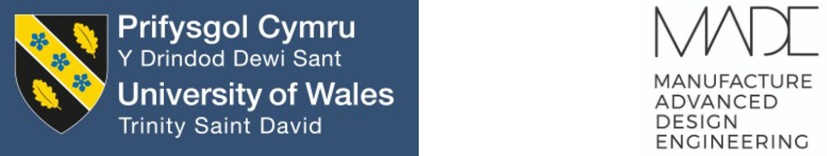

Contents
- Introduction 3

- Traditional Manufacturing – Design relations 4

- Current Manufacturing considerations in the Product design 4

- Design for X" approaches in product and process design 5

- Industry 4.0 manufacturing technologies success stories 6

- Application of Additive manufacturing (3D Printing) 6

- Generative Design 7

- Application of Generative Design & Additive manufacturing 8

- Augmented reality in Manufacturing 9

- Stamping Simulation Softwares 10

- Conclusion 11

Impact of Industry 4.0 technologies on Manufacturing

Impact on the environment

- Recommendation 12
- References 13

Application of Industry 4.0 technologies in Product Design & Product assembly (to improve manufacturing processes)

- Introduction
product design is the key process in the product life cycle. It is the process of imagining, sketching, creating, iterating & developing products that meets end users’ requirements or solve specific problem in any given market. Design is the starting point and manufacturing & assembly of parts are the next stages of the product lifecycle.

If we look at the cost distribution within any manufacturing project, we can see that design contributes to only 5% whereas material & labour costs around 65% of overall project cost. But Design has 70% impact on the final product whereas material & labour has only 25% impact. This clearly indicates importance of Product design & manufacturing consideration during product design stage. Design for manufacture and assembly will positively impact manufacturing and assembly operations. And lack of manufacturing consideration will result in rework, wastage, added costs impacting overall project adversely. More emphasis needs to be given during design stage to ensure that manufacturing and assembly are at the centre of design considerations. (Munro and associates, 1989)

Design & Manufacturing are connected to each other. Good design improves manufacturing efficiency & bad design delays manufacturing & adds up costs in terms of quality issues, defects, rework. Product manufacturing companies have opportunity to choose from new and emerging industry 4.0 technologies. Depending on the product type & company performance indicators each manufacturing company will choose which is best technology to adopt. Aim will be to improve product quality, reduce overall project cost, reduce time to reach potential market.

This short reflective essay explains how Industry 4.0 manufacturing technologies are successfully implemented in aerospace & automotive sector. Product manufacturing companies are ensuring that these technologies are implemented into the product development processes prior to introducing the products to the manufacturing teams.
We are going to discuss few important industry 4.0 technologies e.g. Additive manufacturing, Generative Design, Augmented reality. This reflective essay will be helpful for manufacturing companies who have yet to start industry 4.0 technology adoption journey. All new & emerging Industry 4.0 technologies have capability to improve manufacturing & assembly operations productivity & efficiency.

- Traditional Manufacturing-Design relations

Traditionally product manufacturing companies have departmental structure. Design department design products & hand over inputs to manufacturing where parts are manufactured & products are assembled. Manufacturing departments are directly affected by design department. Manufacturing costs are simply a reflection of design engineering methods.
Poor relationships between design and manufacturing departments results in at least some productivity-killing impact on the final product in terms of quality, cost or project timelines. Design department commonly believes that manufacturing people should be smarter & better able to interpret design methods. Whereas Manufacturing team may believe that design department should provide more clearer & simpler information on their drawings. Or the tolerances specified are either too difficult to maintain or are more precise than necessary. This could result in more expensive manufacturing & more quality inspection resulting in more rejection. (Lynch, 2017)
The key to a better working arrangement is mutual understanding. People on both sides need to understand that other departments are doing their best within their limitations & based on their targeted priorities. This perspective will be helpful to understand complete picture & it can give insight of total problems/issues across the whole product life cycle. Design engineers are often under great pressure to produce new designs under tight delivery schedule to attract new business or to solve customer problems. But designs produced without manufacturing consultation mostly result in delay in final product manufacturing due to errors in the design.
- Current Manufacturing considerations in Product design
In Aviation domain top product manufacturing companies already consider manufacturing processes, its limitations, materials, assembly procedures during product design phase. Structural sub-assemblies & moving mechanisms are important elements in the aircraft seating system product. Based on the primary load path & certification test requirements important design parameters are defined. Designer designs main structural sub-assemblies & mechanisms. Stress engineer validates design & provides inputs based on certification test load cases. Then prototype parts are manufactured & necessary trials are conducted.

Standard machined blocks:
While designing structural sub-assemblies & mechanisms standard machined blocks are used for location, mounting, joining purpose. These machined blocks are designed in such a way that they can be used at multiple location & across multiple projects. These blocks are manufactured with standard pre-defined material & finish process. Those can be made available in different sizes. In Composite panel & in main structural assemblies these standard machined blocks are effectively used.

Standard Sheet metal brackets:
Similar to machined blocks, standard sheet metal brackets are also used in the design. These sheet metal brackets are used for mounting of electrical harness, supporting closeouts or for structural support. These standard sheet metal brackets are made available in lots of different sizes, material thickness & different material grades. These brackets are manufactured with standard pre-defined material & finish process.

Designers choose standard blocks/brackets from standard library created in CAD software. This approach offers consistency in design & saves design time. Few drawings are created & more standard library parts are used. This standardisation results in quick design, fast & accurate manufacturing, less quality inspection process, simpler & smaller assembly.

Standard drawing for colour sensitive aesthetic parts :
Fabric, leather, soft Kydex parts, foam-cushions, Paints are available in different colour & finish options. For these parts material size & shape is same as per structural assembly. And each customer can have their choice about the colour and finish. To achieve this 2-step process is used. On the drawing shape & size of the part/assembly is defined. This drawing provides bill of material, child part assembly sequence, part geometry & important dimensions. On separate color document these materials trim and finish information is stored. Using this practice multiple iterations of product can be produced. The internal structure remains same & each customer gets its own choice of aesthetics color & finish combination.

- Design for X" approaches in product (and process) design

We already discussed about standardisation of parts to improve product design. Use of standard parts offers consistent quality parts, simpler & smaller assembly. This makes assembly process quick & accurate. This also ensures reliability & maintainability of the child parts & assembly. New and emerging industry 4.0 manufacturing technologies can help in achieving these benefits. With latest technologies we can produce more accurate, reliable & maintainable parts & assemblies. In the next section we will see implementation cases of these Industry 4.0 technologies.

- Industry 4.0 manufacturing technologies Success stories
We need to incorporate I4.0 technologies into our product development processes prior to introducing the products to our manufacturing teams. In the aviation sectors companies have started implementing few core I4.0 technologies into our product development processes. Additive manufacturing , Generative design, augmented reality, virtual reality, artificial intelligence are examples of these technologies.
5a. Application of Additive manufacturing (3D Printing)
Traditional machining process involves metal removal from slab of metal to achieve final part. In additive manufacturing part is directly created from CAD data using layers of fine metal powder. Using additive manufacturing complex shaped fully dense parts without any material wastage are being produced in comparatively less time.
In 2016 GE Aviation successfully produced fuel nozzles for the GE LEAP aero engine. This fuel nozzle is produced using additive manufacturing. Approved metal material Ti-6Al- 4V is used for making this part. Results are approximately 25% lighter and stronger part than the existing conventional design & manufacturing. In new design whole assembly is created as single part & build as a single piece. Internal geometry is optimized as the requirements. This fuel nozzle was reduced from 20 different parts previously welded and brazed together to single final part.
GE Aviation started making additively-produced fuel nozzle tips for the LEAP engine, in 2016. In Aug 2021 company declared that total 1,00,000 3D printed parts are produced & successfully used in the LEAP engine. This LEAP engine is one of the bestselling aircraft engines with up 15% fuel efficiency than the competition. (GE Website, 2018)

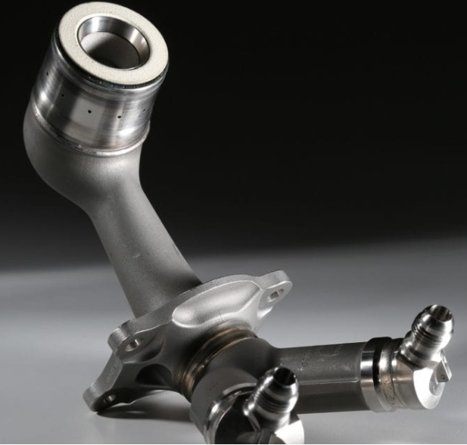
Fuel Nozzle of the LEAP aero engine From GE Aviation
This is classic example of Design for manufacture & assembly. By simplifying design using Industry 4.0 manufacturing technology GE aviation achieved simpler assembly (actually zero% assembly time as it now single part.)

5b.Generative Design
Generative design is latest Industry 4.0 technology in which 3D models are generated and optimized by using artificial intelligence on cloud computing. Designer has to set all the constraints & specifications for the model. These specifications & constrains includes manufacturing processes, load conditions, positional constraints, factor of safety and then the software offers designs that meets the set criteria. After carefully reviewing all possible solutions designer can choose best option. Designer need to consider weight limits, machining processes, raw material availability, previous design experience, physical constraints, and any other application specific design criteria. When effectively utilized, Generative design can add a lot of value to design engineer’s work. Significant amount of time can be saved & human bias can be reduced in the design process.
Generative design can generate manufacturing-ready designs based on our requirements, constraints, materials and manufacturing options. Generative design allows us to explore product solutions based on manufacturing & performance needs. Traditional design process involves multiple iterations & feedback loops, whereas generative design provides multiple viable CAD ready designs to choose from at the start. This helps in amplifying our ability to innovate & reach to market faster. (Autodesk website , 2022)
Generative design combined with 3D printing offers several benefits including, Faster product development, Improved design optimization, Improved efficiency, better optimisation and performance.

5c.Application of Generative Design & Additive manufacturing
Generative design is part of the family of Design for Additive manufacturing. Generative design with additive manufacturing as a preferred process can produce optimized complex shapes and internal profiles. Ti-6Al-4V is one important material in aerospace industry for such part manufacturing. Airbus experimented this material using additive manufacturing of below brackets (Child parts of the fuel system) and similar other parts.
Airbus used Laser beam melting additive manufacturing to manufacture these Ti-6Al-4V brackets. New generative design resulted in 30% weight reduction as compared to existing traditionally manufactured brackets.
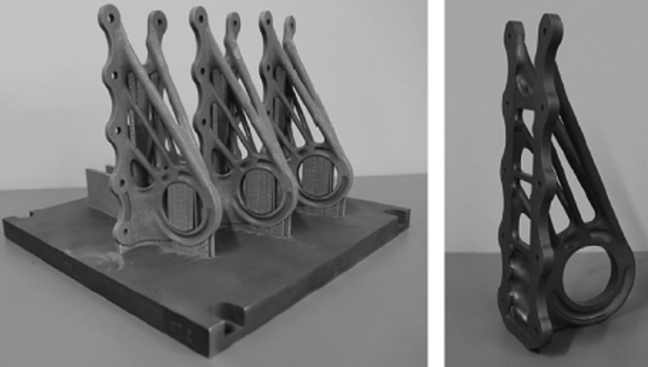
Three Brackets with support structures Finished Part
(Laser Zenturm Nord GmbH and Airbus)

Below is another example of generative design optimized part geometry with substantial weight reduction. And then part can be manufactured using traditional manufacturing or Additive manufacturing depending on the complexity of the geometry & preference of the business.
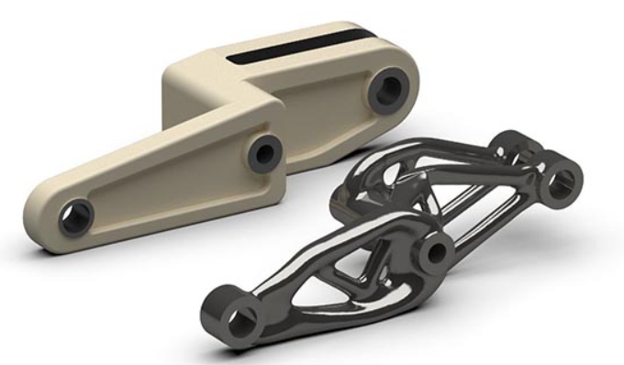
Image source: https://www.3dnatives.com

5d.Augmented Reality in Manufacturing

Augmented reality (AR) is an improved version of the real world. This new world is achieved by using advance technological elements like digital visuals, sound, or other sensory stimuli. Augmented reality uses the existing real-world environment and puts virtual information on top of it to enhance the experience. Hayes (2020)
In aviation sector companies augmented reality is applied in the definition of complex assembly procedure, aircraft harness routing inspection & quality checking. Augmented reality is proved to be very effective and accurate for complex assembly Installation & Maintenance.
During Covid pandemic time lots of aerospace domain projects got delayed. Design, prototyping got delayed & now overall project timelines are also delayed. But in this situation Augmented reality has offered unique solution. Augmented reality offers opportunities to train employees for installation & maintenance of complex machinery, products. Today due to delay in design production parts are not available. But company can utilise augmented reality to train assembly operators in assembly operation. When the parts will be available in near future assembly team will be ready with all training & with experience of assembly procedure.
Safran electrical & power showcased augmented reality capability at 2017 Paris air show. Augmented reality is used at Safran for installation of power wiring in the aircraft. It can be then useful to check any defect in the wiring which not visible from outside. Augmented reality helps in identifying potential maintenance issues in advance & correct them before any accident happens. (Safran E & P website video)
Augmented reality is effectively used in quality inspection. Ericsson company uses augmented reality for complex assembly inspection. It offers wider visualisation which results in increased accuracy & reduced time spent in the checking. This technology uses real time data to predict hazard and any unexpected situation. (Ericsson website)

5d.Stamping Simulation Softwares PAMSTAMP / Autoform
Pam-Stamp & Autoform simulation softwares are widely used in the automotive industry for BIW skin panels. Using these simulation software high quality & cost-efficient sheet metal stamping parts can be manufactured right first time.
Traditionally sheet metal parts are formed in the metal dies using hydraulic or pneumatic presses. As per old design and manufacturing practice dies were designed & then physical try-outs were conducted. And only after physical trials we used to realise that produced component suffers from spring back or wrinkles or thinning in important areas. Any of these error & manufacturing defect will lead to start design & manufacturing process from the beginning. These post-production changes used to be very costly & more importantly time consuming. Simulation software’s like Pam-stamp or Auto form can predict spring back or wrinkles or thinning. These software’s use artificial intelligence & specified algorithm to get these simulation results.
These simulation softwares have reduced sheet metal stamping cycle time. In early design stage additional time is needed to refine simulation results but then try-outs, production becomes much more predictable & accurate as per the requirements.Different type of materials can be simulated in these softwares. These softwares offer solutions for the assembly of closure panels, such as doors. (ESI Website 2023)

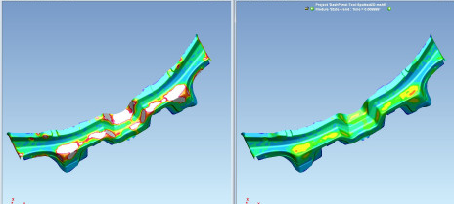

Image source: https://www.esi-group.com/

- Conclusion

Impact of Industry 4.0 technologies on Manufacturing

Industry 4.0 technologies like 3D printing & Generative design are more efficient & traditional manufacturing process create more waste & consume more energy. Industry 4.0 technologies offer reduced energy consumption, less or almost zero scrap, simpler manufacturing.
These new technologies are offering digitization, real time data accessing from any remote location, quick response. Due to global data access manufacturing companies can respond and action quickly to customer demands. This will help in building local supply chain. Local supply chain & reduced scrap results in less logistics, which in turn helps reducing carbon footprint. Industry 4.0 technologies will help in optimizing raw material usage. This will offer benefit of reduced material & manufacturing cost. And products can be launched in the market in shorter time span. This reduced cost will give opportunity to manufacturers to offer discounted price to end customer and maintaining product quality.

Impact on the environment

Industry 4.0 technologies Additive manufacturing, artificial intelligence, generative design, cloud computing is playing significant role in the manufacturing, inspection, maintenance operations. These new & emerging technology implementation is resulting in efficiency & productivity enhancements. Raw material consumption is reduced which is saving material cost. And these technologies produce very less wastage. Raw materials and the energy consumption needed for manufacturing of the products can be optimised using data analytics, digital twin, AR, and big data. Important benefit will be reduced carbon emission & less utilisation of natural resources. This in turn will result in environment conservation & restring natural beauty.
Big data, Cloud computing needs larger storage capacity. Hardware required for these advance applications will add extra cost. This will generate extra e-waste. Use of large hardware may result in high heat dissipation increasing temperature resulting in global warming.
Cyber security is one important topic for the implementation of industry 4.0 technologies. All digital data has risk of cyber-attack. Within business all confidential information and personal information need to be protected from any kind of criminal activities. Criminals can use stolen information for financial fraud. And competition use technology information for using advantage. Manufacturing companies need to ensure that they are taking care of cyber security before implementing industry 4.0 technologies.

- Recommendation
All global Businesses will experience more dynamic technology-driven changes in next decade than in last 40-50 years. Artificial intelligence, cloud computing, Additive manufacturing, augmented reality, blockchain, the Internet of Things, 5G networks, and autonomous machines will combine to redefine every aspect of industry. In today’s competitive and dynamic world product manufacturing companies need to adopt new and emerging industry 4.0 manufacturing technologies. This will help them improve their product offerings & transform manufacturing and assembly operations. (Brown, 2020)
These new and emerging Industry 4.0 technologies are driven cloud computing, high speed internet data, artificial intelligence, machine learning. And all this protected by cyber security, blockchain applications. All these technologies are digital & available on central cloud servers, all the information is real time, it offers accurate, detailed, reliable, connected, and holistic approach. All this data can be analysed & effectively used to enhance productivity, efficiency. This will offer reliable, maintainable & cost-effective manufacturing. Faster & simpler manufacturing will result in less electricity consumption, which in turn will reduce carbon footprint. This is positive economical & environmental impact.
In last decade product manufacturing companies are experiencing more technology-driven changes. Machine learning, generative design, cloud computing, Artificial intelligence, augmented reality, virtual reality, high speed internet and autonomous machines are completely changing every manufacturing industry. To stay ahead in the competitive market all product manufacturing will have to adopt new & emerging industry 4.0 technologies. These technologies will enhance company’s product offering and transform operations. (Brown, 2020)
But we need to be careful about side effects of these technologies. When Industry 4.0 technologies are digitally connected & all the data is available on central servers there is high risk of hacking data and tampering with it. Companies & End users’ sensitive information can be misused. Financial data might be tempered. There is potential risk of financial loss & personal data exposure to wrong people.
Industry 4.0 technologies are going affect everyone’s life greatly. We are seeing ease of operation, automation & improvement in the lifestyle. At the same time we need to be careful about its cyber hacking potential and we need to implement proper cyber security solutions to reduce these risks.

- References

Boothroyd, Geoffrey. Assembly Automation and Product Design, Taylor & Francis Group, 2005. ProQuest Ebook Central, https://ebookcentral.proquest.com/lib/trinity/detail.action?docID=262182 (Accessed on 15-May23)

Womack, J.P., Jones, D.T. and Roos, D. (1997) The Machine That Changed the World : How Lean Production Revolutionized the Global Car Wars. London: Simon & Schuster, Limited. (Accessed on 20-May23)

McClintock Cat. (2023) A Beginner’s Guide to Generative Design https://www.ptc.com/en/blogs/cad/beginner-guide-generative-design (Accessed on 25-May23)

Cosire, (2014) Design casts the longest shadow

https://medium.com/@cosire/design-casts-the-longest-shadow-e40efe878169 (Accessed on 15-May23)

Lynch M, (2017) Design vs. Manufacturing — Can We All Just Get Along? https://www.mmsonline.com/articles/design-vs-manufacturing-can-we-all-just-get-along (Accessed on 15-Jun23)

GE Website (2018) GE Additive

https://www.ge.com/additive/stories/new-manufacturing-milestone-30000-additive-fuel-nozzles (Accessed on 25-Jun23)

Autodesk (2022) Generative Design

https://www.autodesk.com/solutions/generative-design (Accessed on 5-Jul23)

Froes, F. & Boyer, R. 2019 Additive manufacturing for the aerospace industry.

(Accessed on 02nd Jul 2023)

Carlota V, (2020) Is generative design changing additive manufacturing

https://www.3dnatives.com/en/generative-design-changing-additive-manufacturing-130720204/ (Accessed on 20th Jun 2023)

Hayes, A. (2020) Augmented Reality: : What is Augmented Reality available at https://www.investopedia.com/terms/a/augmented-reality.asp (Accessed on 10th Jul 2023)
The Department for Business, Energy and Industrial Strategy (2017) Made Smarter Review. Available at: https://www.gov.uk/government/publications/made-smarter-review (Accessed: 24th Jun 2023).
Brown, S. (2020) The Innovation Ultimatum: How six strategic technologies will reshape every business in the 2020s. New Jersey: John Wiley & Sons, Inc.
(Accessed on 30th May 2023)
ESI Website, (2023)PAM-STAMP Stamping Simulation Software
https://www.esi-group.com/products/pam-stamp (Accessed on 30th May 2023)

Ericsson webite
https://www.ericsson.com/en/industries/manufacturing?gclid=CjwKCAjwuYWSBhByEiwAKd_n_sN9rTRtuzKEmw4f4UvSxbS5TJpPQSbDZB2h-zJRdEDK_yvNEbYPghoCYv8QAvD_BwE&gclsrc=aw.ds
(Accessed on 10th Jul 2023)

Safran electrical & power website video
https://www.safran-group.com/videos/augmented-reality-safran-electrical-power(Accessed on 18th Jul 2023)

