Economics of Sustainability BMSP6007 - Assignment 2
Module Tutor: Anthony Burns
Nicola Louise Bragg
Student Number: 1910223
BA Business and Management

Sustainable Development 10-year Outlook Risks
Impacts and Solutions
Word Count: 2,528

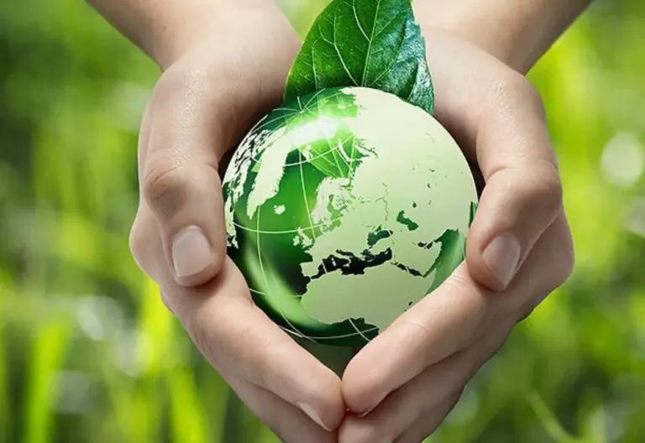

Contents
Introduction
Sustainable Development
Sustainable Development Goals
Identification of Risks
Impact of Risks on Sustainable Development
Assessment of Risks
Achieving Sustainable Development
Conclusion
Recommendations
References
List of Figures

Introduction
This report will provide insight into sustainable development (SD) and identify sustainable development goals (SDG’s) along with mention of green and sustainable economies. Thorough investigation will identify global risks for the next 10-years and the impact of those risks on global efforts concerning SD. Further analysis will be directed from the principal researchers perspective of risks found. Different approaches will be discovered which help achieve SD. Thus, leading to summary of all findings and recommendations on how to move forward to minimise future risk.
Environmental Kuznets Curve
Research suggests that there is a technical relationship built from economic growth and its pollution. A model developed from this theory is the Environmental Kuznets Curve (EKC) the connection is that industrialisation initially negatively impacts the environment with high levels of pollution however once economic growth has reached a certain level, society then rectifies the environmental impact by developing/implementing regulations/policies/systems which correct the environmental relationship as well as slowing and/or neutralising degradation (Williams, 2014., Pettinger, 2019).
Figure 1 displays the model which presents itself as an inverted U shape. Before economic growth (pre-industrial economies) the impact on the environment and pollution is minimal, during the growth period (industrial economics) there comes a turning point to which these environmental issues and pollutants are addressed by implementing structure/legislation to which the environmental impact becomes lesser and more manageable over-time (post-industrial).
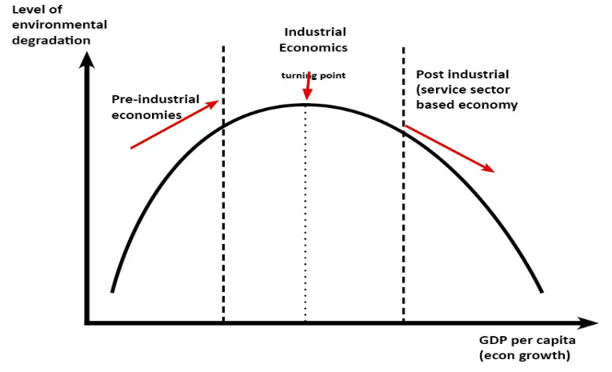
Figure 1 - Environmental Kuznets Curve (EKC)
For developed countries it seems this model has been followed as well as assisted in the appliance of SD ideals however developing countries are being pressured into establishing SD principles before their economic growth has reached the turning point as demonstrated in figure 1 or before proper infrastructure is established. Therefore, in practice there are concerns as using SD as policy. Sustainability is a broad concept, instead should be considered as a responsibility to prospective generations (Rifai, Rahangmetan, 2021., Solow, 1991).
Sustainable Development
A green economy is an infrastructure used by public/private sectors guided by environmentalist ‘green’ activities. These systems aim to encourage growth in income/employment by lowering pollution and carbon emissions along with improving efficiency of resource/energy usage and reserving ecosystems/biodiversity. Whereas sustainable economies are a framework that “provides a good quality of life for everybody” adhering to the main global objective of keeping the earth below 2°c concerning the issue of global warming. Both economies push towards a sustainable advancement, adhering to this concept helps society move towards a circular approach rather than a linear one thus preserving the worlds resources for future generations and utilising resources already in use. Defining Sustainable Development (SD) as a global objective is a long-term plan which aims to achieve intergenerational equity which involves an essential change in how market decisions are made throughout the world concerning production as well as consumption. Although SD seems to be a positive approach for developed countered SD tends to be a more pressing issue for developing countries like China/India due to their rising populations and great growth rates (UN Environment Programme, 2022., Worldwide Fund for Nature, 2022., UNESCO, 2022).
Sustainable Development Goals (SDG’s)
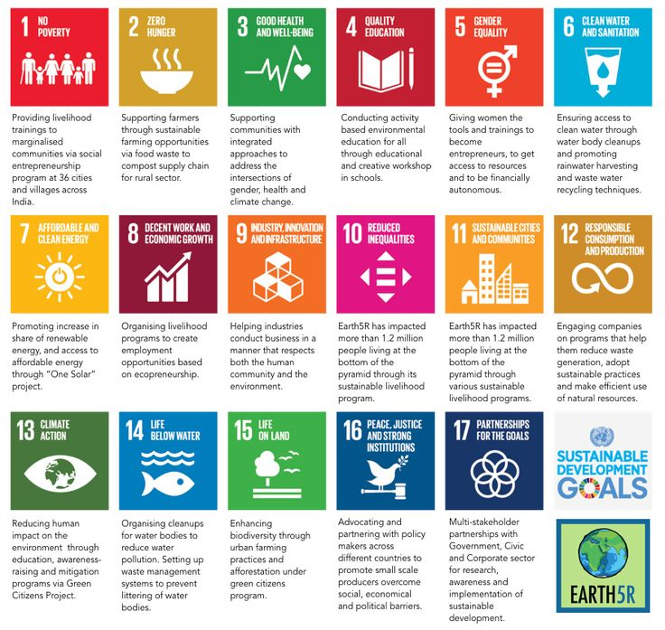
Figure 2 - Sustainable Development Goals
For the world to engage in a circular green sustainable economy the United Nations developed a 17-goal agenda in 2015 which each country should aspire to meet. Figure 2 presents these goals with brief description of their objectives. SDG’s are crucial to the worlds growth as it unifies a push in the same direction for individuals, companies, and governments (social mobilization) as well as providing common purpose for stakeholders to deal with intricate issues (stakeholder mobilization). This achieves epistemic results by giving humanity chance to recommend alternative approaches through their use of expertise/knowledge along with generating peer pressure to ensure action is made (Sachs, 2015., United Nations, 2022).
Identification of risks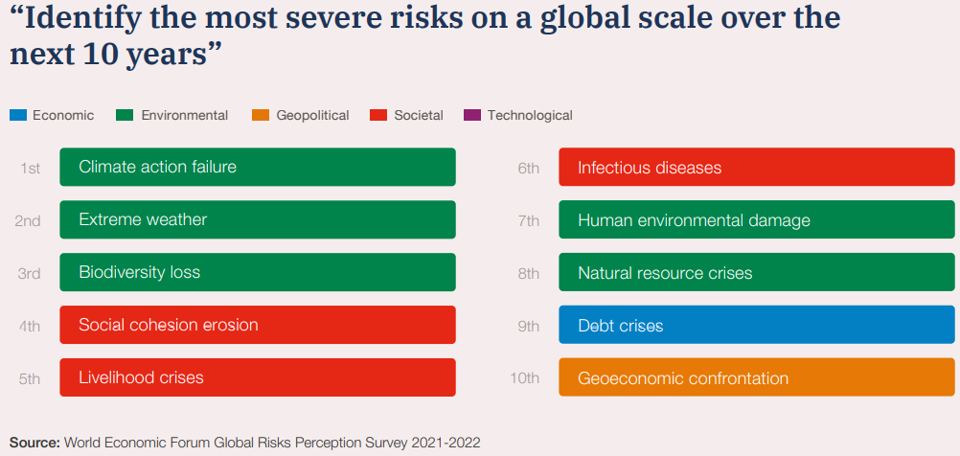
Figure 3 - Identification of most severe risks on a global scale next 10-year period
Figure 3 identifies the most detrimental global risks concerning the economy over the next 10 years. They are shown in order of relevance. Highlighted in green are the environmental issues; climate action failure (1st), extreme weather (2nd), loss of biodiversity (3rd), human environmental damage (7th), and natural resource crises (8th). Red outlines the social issues social cohesion erosion (4th), livelihood crises (5th), and infectious diseases (6th) Blue are the economic problems; debt crises (9th). Mustard colour are the geographical risks; geoeconomic confrontation (10th) (World Economic Forum, 2022).
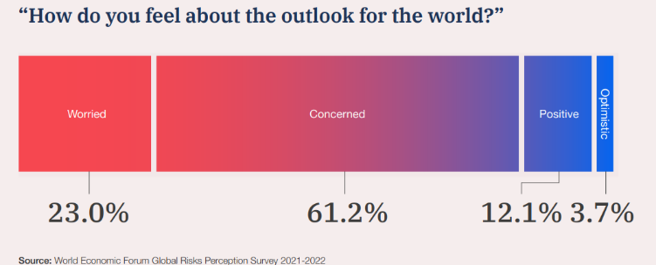
Figure 4 - Society’s Perceptions for World Outlook
The report also found the populations outlook concerning challenges the globe faces. Figure 4 states these findings; 23% of participants are worried, 61.2% are concerned with a collective 15.8% positive or optimistic. More must be done to ease societies perspective (World Economic Forum, 2022).
Impact of Risks on Sustainable Development
Extreme weather
Heightened with the rise of global warming 2017 recorded highest economic loss because of increasing hurricanes, destructive rainfalls, heatwaves, wildfires, and drought. Rectifying the issues made from these natural events takes funding away from SD along with adding strain to education/health/social care systems because of unbearable temperatures within facilities, buildings which become damaged, or accessibility denied due to floods or cold waves like snow/ice (Kuwonu, 2021., Asariotis, 2018., Curtis, Fair, Wistow, Val, Oven, 2017).
Climate Action Failure
Can affect health, poverty, and hunger. Impacts concerning health have been previously mentioned in the ‘Extreme Weather’ section, climate change failure impacts upon hunger as these weather events can halt production/transportation of food and poverty implications could be caused from job losses due to company/home building damage. If climate action doesn’t make progress, it could reverse efforts already made thus undermining SDG improvement along with decreasing societal faith. Faith is important to SD as representation of communities overall outlook can provide new systems from society to tackle change. If faith is lost, trust is destroyed and civilisation will have lesser effort, the reliance will then lie upon government intervention which may make society feel forced rather than collaborative (United Nations Framework Convention on Climate Change, 2019., World Economic Forum, 2022., Mahmood, Ashmawey, 2015).
Loss of biodiversity
Human population has since doubled from 1970 which puts a strain on the worlds ecosystems/resources urging the need to preserve these vital assets. Biodiversity is the underpinning framework enabling survival on earth, when these systems are endangered quality of life lowers effecting economies, health, food security, and livelihoods (Adebayo, 2019., United Nations, 2022).
Human Environmental Damage
Mankind damaging the environment faster than it can heal can jeopardize SD as basic approaches that could have been used prior may now be obsolete as more drastic measures will need to be implemented (Harvey, 2016).
Livelihood Crisis
Having a stable livelihood allows individuals to move away from poverty it has been found an est. 736 million people (10% of world population) live on less then £1.54 per day, this is below the poverty line. An un-stable livelihood impacts SD as low money means minimum food intake, education may suffer due to lack of focus, more time/finance is needed to address the crisis less time/finance dedicated to SD and diminished trust from society (United Nations Development Programme, 2013., Concern Worldwide, 2022., United Nations, 2022).
Social cohesion erosion
Is a hard term to truly define, simply it is a shared moral by communities within a country/state or nation that allows trust among them to flourish. Erosion of this category can be enhanced by loss of social capital which can break down social networks negatively effecting economic productivity as well as human well-being thus can impede time dedicated to SD on carrying out national policymaking along with reduced attention and focus needed on international mutual effort for global challenges. COVID-19 pandemic causing national lockdowns is a way in which social networks have been broken (Larsen, 2013., Swaroop, 2022).
Infectious disease
COVID-19 pandemic has put significant pressure on the health care systems therefore effecting well-being of the population, together with increasing unemployment rate. Leading society suspectable to illness along with poverty/hunger due to insufficient funds (Elavarasan, Pugazhendi, Shafiullah, Kumar, Arif, Jamal, Chopra, Dyduch, 2021).
Debt crisis
Data obtained in 2018 found that 40% of low-earning countries are either struggling to pay debt or in arrears distress this is an increase of 21% compared to 2013 not to mention developing countries like Haiti and Chad are falling hard in relation to per capita income. Many factors contribute to these issues, tax evasion, low tax intake, narrow tax bases as well as weak administrations. Sustainable development suffers as budgets/finances will be stretched leaving less for long-term planning (Harris, Lane, 2018).
Geopolitical - Geoeconomic confrontation
Each country is unique, therefore adhere to different standards of living/policies/beliefs and economies thus it is hard to become geoeconomically unified globally. It impacts domestic challenges which require quick attention. Trends which emerge from this category tend to be inequality as well as lack of importance concerning growth by some countries. Pandemic/economic ramifications show the global risks don’t respect political frontiers. Society faces shared/compounding threats of economic fragmentation and planetary degradation (Leonard, 2015., Rej, 2016., Sharma, 2021).
All factors previously mentioned within this section dramatically effect global efforts of SD.
(World Economic Forum, 2022).
Assessment of Risks
Loss of biodiversity along with human environmental damage are the ultimate risks damaging SD without the earth’s resources and ecosystems life would cease to exist. Reducing biodiversity can have so many knock-on effects that never end already previously discussed was the concerns that the earth can not heal quick enough approaches should be implemented quickly to stop this damage and allow the earth breathing time (recovery).
Whilst action can be taken to tackle climate change when extreme weather events happen sometimes these can be natural occurrences bound to happen hence funding must be used to re-build facilities/communities therefore extreme weather is a risk contingency should be used for however applying more pressure to elevate issues brought on by climate change could result in these weather events being less detrimental. The same contingency should be used for infectious disease sometimes these incidences cannot be foreseen or stopped but managed with appropriate finances to ensure the worst is dealt with.
The debt crisis is the next most important risk to deal with concerning SD if debt increases the harder it is to climb out, if debt is cleared it generates a positive domino effect for all involved whether this be individuals, governments, countries to implement new approaches, overall population moral increases and time could be dedicated to generating innovative ideas as individuals minds are not foreshadowed by stress which could affect their intelligence.
Social cohesion erosion should be the least of the worlds worries. Just because a countries society is not joined in mutual beliefs does not mean they cannot work together. This allows constructive discussion which may bring to light new ideas to tackle certain sustainable issues. If all are on the same page, there is not necessarily room for growth or to think freely, trust can still be maintained.
Gender inequality is another SDG which can be affected by geoeconomic confrontation as well as geopolitics. Religion beliefs can play a part too.
Achieving Sustainable Development
To carry out SD approaches should cover three main objective types: economic, environmental, and social (GOV.UK, 2012).
Industrial Ecology (IE)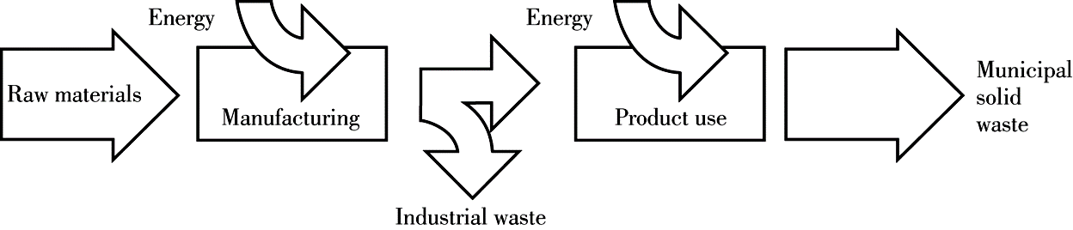
Figure 5 - Linear Flow
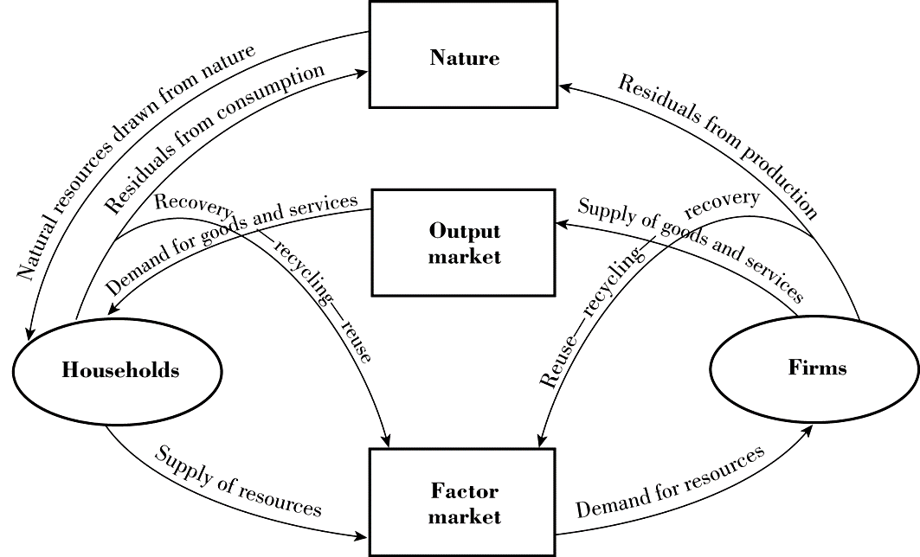
Figure 6 - Circular Balanced Model
Figure 5 depicts a linear system flow in which raw materials are found then manufactured using energy, once manufactured industrial waste is generated and disposed, the product is then used with energy and at its end of life is disposed. Meaning materials flow in one direction and end as waste, this method is unsustainable as it does not address the long-term implications of pollution therefore a cyclical flow as shown in figure 6 should be achieved to solve the issues presented within linear flow model. The circular ideology assumes that a products process activity can be altered to limit environmental effects. Implies that policies can be implemented throughout the cycle to re-use/reduce waste and/or pollution that negatively affect the environment, resulting in a more sustainable economy (Britannia, 2022., Jelinski, Graedel, Laudise, McCall, Patel, 1991).
Pollution prevention (P2)
Front-ended long-term strategy that halts or eradicates pollution from a product/service prior to recycling or disposal. Techniques can be product substitution swapping polluting materials for safe ones, changes to manufacturing processes like those in industrial ecology. P2 differs from IE as it requires government oversight and does not view recycling as the solution. Establishing P2 can provide a positive re-structure however it may cause an organisation to become obsolete as their systems might not be able to adhere to government intervention therefore resulting in fines/sanctions (EPA, 2012., EPA, 2022).
Green Chemistry
Focuses on chemical engineering concerning design and manufacturing goods using environmentally friendly methods instead of harmful/hazardous ones. This would reduce pollution or resource usage at the source therefore adhering to a more sustainable approach however when new manufacturing processes are developed new equipment/chemical plants will need constructing, increasing cost (Boro Pharm Inc, 2017., UN Environment Programme, 2022).
Global Information Sharing
Strategy/technology application advancement on a global scale. Consists of physical capital investment, education, research, communication, financial resources. With a universal effort so much can be shared/learned/gained when applying SD activities on the other hand data protection legislation can make it hard to share information freely along with risks regarding cyber security (Albrectsen, 2017., Unesco, 2022., IGI Global, 2022., Oliveira, 2016).
Debt-for-Climate Swaps
Although pressure should not be applied to developing countries to aspire SD alternative approaches like this could be established. They would relieve debt for climate action allowing reduced payments for climate objectives compared to original debt amounts as well as freeing up resources. This can be two solutions in one approach which would have a positive effect on identified risks nonetheless if countries are already struggling to pay their debt would they be able to keep up payments for climate activities (Ainio, 2020, Widge, 2021., Picolotti, Zaelke, Silverman-Roati, Ferris, 2020).

Conclusion
To conclude, for developed countries sustainable development is a must due to pollution and resource use-age, for developing countries more time should be allocated for growth therefore should not be forced (less pressure) to adhere to this type of development. Sustainable development goals were discovered and their importance toward social/stakeholder mobilization. The outlook of risks for the next 10 years were identified along with their impact on sustainable development activities. Next the principal researcher brought in their own assessment of risks which lead to several approaches which could achieve sustainable development action. Lasty three recommendations have been suggested to limit concerning risks as well as aspire to sustainable standards.
Recommendations
- Industrial Ecology
Worldwide implementation would decrease the need to use already limited resources whilst nourishing and re-using those already in use whilst preserving/re-using energy consumption using a circular flow.
- Global Information Sharing
Although businesses/countries tend to be in competition sustainable development is a collaborative effort if all are on the same page, sharing ideas/information can only help positively to achieving goals worldwide, this approach would improve relationships as well as lessening conflict possibilities.
- Debt-for-Climate Swaps
Considering growing debt is a major risk among a lot of countries even developed ones applying this type of approach would allow opportunity as well as continued growth.

References
Adebayo, O. (2019) Loss of Biodiversity: The Burgeoning Threat to Human Health
Available at: https://www.ncbi.nlm.nih.gov/pmc/articles/PMC6871202/pdf/AIPM-17-1.pdf
Albrectsen, A. (2017) Why Collaboration will be key to Achieving the Sustainable
Development Goals
Available at: https://www.weforum.org/agenda/2017/01/realising-the-potential-of-cross-sector-partnerships/
Ainio, S. (2020) How Debt for Climate Swaps can Spur Green Recovery
Available at: https://www.weforum.org/agenda/2020/10/debt-climate-swaps-spur-green-recovery/#:~:text=1%20To%20%E2%80%9Cbuild%20back%20better%E2%80%9D%2C%20we%20must%20make,should%20be%20lower%20than%20original%20debt%20service%20payments.
Asariotis, R. (2018) 2018 Demonstrates Extreme Weather Impact on Development
Available at: https://unctad.org/news/2018-demonstrates-extreme-weathers-impact-development
Boro Pharm Inc (2017) The Pros and Cons of Green Alternatives in Chemical Manufacturing
Available at: https://www.boropharm.com/pros-cons-green-alternatives-chemical-manufacturing/#:~:text=There%20are%20some%20potential%20downsides%20to%20the%20move,be%20necessary.%20The%20set-up%20costs%20can%20be%20prohibitive.
Britannia (2022) Industrial Ecology
Available at: https://www.britannica.com/science/industrial-ecology
Concern Worldwide (2022) Livelihoods
Available at: https://www.concern.net/what-we-do/livelihoods
Curtis, S., Fair, A., Wistow, J., Val, D., Oven, K. (2017) Impact of Extreme weather Events
and Climate Change for Health and Social Care Systems
Available at: https://www.ncbi.nlm.nih.gov/pmc/articles/PMC5773887/pdf/12940_2017_Article_324.pdf
Elavarasan, R., Pugazhendhi, R., Shafiullah, G., Kumar, N., Arif, M., Jamal, T., Chopra, S.,
Dyduch, J. (2021) Impacts of COVID-19 on Sustainable Development Goals and Effective Approaches to manoeuvre them in the post-pandemic environment
Available at: https://www.ncbi.nlm.nih.gov/pmc/articles/PMC8760582/pdf/11356_2021_Article_17793.pdf
EPA (2022) Pollution Prevention (P2)
Available at: https://www.epa.gov/p2
EPA (2012) Sustainable Futures / P2 Framework Manual
Available at: https://www.epa.gov/sites/default/files/2015-05/documents/02.pdf
GOV.UK (2012) National Planning Policy Framework
Available at: https://www.gov.uk/guidance/national-planning-policy-framework/2-achieving-sustainable-development
Harris, E., Lane, C. (2018) Debt as an Obstacle to the Sustainable Development Goals
Available at: https://www.un.org/development/desa/en/news/financing/debt-as-an-obstacle-to-sdgs.html
Havery, F. (2016) Humans Damaging the Environment Faster than it can Recover, UN Finds
Available at: https://www.theguardian.com/environment/2016/may/19/humans-damaging-the-environment-faster-than-it-can-recover-report-finds
IGI Global (2022) Information Sharing
Available at: https://www.igi-global.com/dictionary/integration-information-sharing-government/14501
Jelinski, L., Graedel, T., Laudise, R., McCall, D., Patel, C. (1991) Industrial Ecology:
Concepts and Approaches
Available at: https://www.ncbi.nlm.nih.gov/pmc/articles/PMC48326/pdf/pnas01077-0009.pdf
Kuwonu, F. (2021) Extreme Weather Events will be the New Normal if Global Warming
Increases at Current Speed
Available at: https://www.un.org/africarenewal/magazine/september-2021/extreme-weather-events-will-be-new-normal-if-global-warming-increases
Larsen, C. (2013) The Rise and Fall of Social Cohesion: The Construction and De-
construction of Social Trust in the USA, UK, Sweden, Denmark
Oxford: Oxford University Press
Leonard, M. (2015) 5 Things to Know about Geo-Economics
Available at: https://www.weforum.org/agenda/2015/02/5-things-to-know-about-geo-economics/
Mahmood, S., Ashmawey, M. (2015) How Faith can Support the Sustainable Development
Goals
Available at: https://www.weforum.org/agenda/2015/08/how-faith-can-support-the-sustainable-development-goals/
Oliveira, S. (2016) Challenges to Information Sharing: Perceptions and Realities
Available at: https://static.rusi.org/20160708_ines_challenges_to_info_sharing_final1.pdf
Ozer, M. (2018) Sustainable Development and it Challenges in Developing Countries
Available at: https://medium.com/@iynf/sustainable-development-and-its-challenges-in-developing-countries-487a333184a0
Pettinger, T. (2019) Environmental Kuznets Curve
Available at: https://www.economicshelp.org/blog/14337/environment/environmental-kuznets-curve/
Picolotti, R., Zaelke, D., Silverman-Roati, K., Ferris, R. (2020) Debt for Climate Swaps IGSD
Background Note
Available at: https://www.igsd.org/wp-content/uploads/2020/08/Background-Note-on-Debt-Swaps-11Aug20.pdf
Rej, A. (2016) A Geoeconomic Strategy for the New Normal
Available at: https://www.orfonline.org/wp-content/uploads/2016/02/ORF-Occasional-Paper-89.pdf
Rifai, A., Rahangmetan, R. (2021) Sustainable Development in Developing Countries
Available at: https://cose-eu.org/2021/10/11/sustainable-development-in-developing-countries/
Sachs, J. (2015) Why the Sustainable Development Goals Matter
Available at: https://www.weforum.org/agenda/2015/03/why-the-sustainable-development-goals-matter/
Sharma, M. (2021) Three Trends in Geopolitics and Geoeconomics 2021
Available at: https://www.orfonline.org/expert-speak/three-trends-geopolitics-geoeconomics-2021/
Solow, R. (1991) Sustainability: An Economist’s Perspective: The 18th J. Seward Johnson
Lecture
Woods Hole, MA Woods Hole Oceanographic Institution
Swaroop, D. (2022) What is Social Cohesion and What is the Risk in its Erosion?
Available at: https://www.linkedin.com/pulse/what-social-cohesion-risk-its-erosion-swaroop-d-1c
UN Environment Programme (2022) Green Economy
Available at: https://www.unep.org/regions/asia-and-pacific/regional-initiatives/supporting-resource-efficiency/green-economy
UN Environment Programme (2022) Green and Sustainable Chemistry
Available at: https://www.unep.org/explore-topics/chemicals-waste/what-we-do/policy-and-governance/green-and-sustainable-chemistry
UNESCO (2022) Sustainable Development
Available at: https://en.unesco.org/themes/education-sustainable-development/what-is-esd/sd
UNESCO (2022) Sustainable Development Goals for Communication and Information
Available at: https://en.unesco.org/sustainabledevelopmentgoalsforcommunicationinformation
United Nations (2022) Life on Land
Available at: https://www.un.org/sustainabledevelopment/biodiversity/
United Nation (2022) Poverty Eradication
Available at: https://sustainabledevelopment.un.org/topics/povertyeradication
United Nations (2022) The 17 Goals
Available at: https://sdgs.un.org/goals
United Nations Development Programme (2013) Livelihoods and Economic Recovery in
Crisis Situations
Available at: https://www.undp.org/sites/g/files/zskgke326/files/publications/20130215_UNDP%20LER_guide.pdf
United Nations Framework Convention on Climate Change (2019) Impacts of Climate
Change on Sustainable Development Goals Highlighted at High-Level Political Forum
Available at: https://unfccc.int/news/impacts-of-climate-change-on-sustainable-development-goals-highlighted-at-high-level-political-forum
Widge, V. (2021) Debt for Climate Swaps
Available at: https://www.climatepolicyinitiative.org/publication/debt-for-climate-swaps/
Williams, J. (2014) The Environmental Kuznets Curve
Available at: https://earthbound.report/2014/03/11/the-environmental-kuznets-curve/
World Economic Forum (2022) The Global Risks Report 2022 Insight Report 17th Edition
Available at: https://www3.weforum.org/docs/WEF_The_Global_Risks_Report_2022.pdf
WWF (2022) Sustainable Economies
Available at: https://www.wwf.eu/what_we_do/sustainable_economies/#:~:text=A%20sustainable%20economy%20is%20one%20that%20is%20resilient,requires%20bold%20leadership%20and%20strong%20commitment%20to%20action.

List of Figures
Figure Number | Reference
1 | Pettinger, T. (2019) Environmental Kuznets Curve  Available at: https://www.economicshelp.org/blog/14337/environment/environmental-kuznets-curve/
2 | Bing (2022) Sustainable Development Goals  Available at: https://www.bing.com/images/search?view=detailV2&ccid=wX1r1k%2Fx&id=B4BBDB3FD5CCFB03B7DF36CE9C261B92269AB383&thid=OIP.wX1r1k_xdgTJ2irg73JvUgHaHA&mediaurl=https%3A%2F%2Fi.pinimg.com%2F736x%2F00%2F60%2F93%2F00609302c9b34d4d52e36befe8f0c9bf.jpg&cdnurl=https%3A%2F%2Fth.bing.com%2Fth%2Fid%2FR.c17d6bd64ff17604c9da2ae0ef726f52%3Frik%3Dg7OaJpIbJpzONg%26pid%3DImgRaw%26r%3D0&exph=697&expw=736&q=sustainable+development+goals&simid=608014988281196053&form=IRPRST&ck=9BA635FDAE63AC9E577C8196A34F0FD9&selectedindex=0&ajaxhist=0&ajaxserp=0&pivotparams=insightsToken%3Dccid_R0A8anDo*cp_63DF055BBDCAE48EE7EA481F2ABAC374*mid_61E60F67C807277B3D18A8DC86B1A54383F73C58*simid_608018892412369457*thid_OIP.R0A8anDolQbnQiXu9rsr7gHaJ4&vt=0&sim=11&iss=VSI&ajaxhist=0&ajaxserp=0
3 | World Economic Forum (2022) Identification of most severe risks on a global  scale next 10-year period  Available at: https://www.weforum.org/reports/global-risks-report-2022
4 | World Economic Forum (2022) Society’s Perceptions for World Outlook  Available at: https://www.weforum.org/reports/global-risks-report-2022
5 | Burns, A. (2022) Linear Flow  Module: Economics of Sustainability  Available at: University Trinity St. David’s Moodle
6 | Burns, A. (2022) Circular Balanced Model  Module: Economics of Sustainability  Available at: University Trinity St. David’s Moodle

