How Important was a concept of economic reward in motiving people to go on crusade?

The First Crusade lasted from 1096-1099 and during this Crusade, thousands of people – men and women, rich and poor, old and young – travelled across Christendom, through the Byzantine Empire and down to Jerusalem to liberate it from the Turks who had captured it years previously. There seems to be many different motives for why the Crusades began and why ordinary people signed up for it; revenge for the Christian deaths and torture taking place in Jerusalem, people hoping to further their economic wealth and political power, people who were just looking for an adventure, a reason to leave their home and see the world, and the desperate need to get rid of the violent types, give them an enemy outside of Christendom to face (Peace God Movement, set up by the Church to limit violence through any means). There were also people who were doing it for religious reasons; because the Pope said so, being God’s hand, or even just in hopes to gain access to Heaven despite previous sins. But how important were each of these motivations in the hearts and minds of the crusaders?
The concept of economic reward was definitely present in some crusaders, for example Emico of Leiningen who “slaughtered and exiled the Jews through greed of money”, it seems that Albert of Aix, the author of the source, believed that Emico’s actions against the Rhineland Jews in 1096 had nothing to do with “God’s justice” and everything to do with the concept of economic reward. Coulton stated that men pitched battles with no other motive than “insatiable greed” and that “whatsoever was open to the sight of these covetous men was exposed to their ravage” and it didn’t matter who owned these things, whether they were ‘pagans’ or ‘heathens’ or ‘Turks’ or Christians, or even fellow Crusaders – anyone was a target for these greedy men. Hans Eberhad Mayer drew attention to Urban promising, in his speech at Clermont that anyone who went on Crusade would enjoy “undisturbed possession of the lands they conquered” and while I cannot find a source where Urban II says anything about the land of the enemy he does say that “the possessions of the enemy, too, will be yours” and encourages them to “make spoil of their treasures”. Urban II also promised that those who went on Crusade could “rent their lands and collect money for their expenses” and for those lacking money “divine mercy will give him enough”. There was also a crisis in the “agrarian economy” of southern France and Italy that began in 850 and got steadily worse until around 1000, and basically meant that agricultural production could not keep up with the rising population. In France, because of th
ese economic problems, they developed “primogeniture” where the eldest son inherited everything, and any younger sons had to look after themselves. They did this either through joining the Church or signing up to the military careers available. The Crusades became a great “safety valve” for these younger sons, as it offered a real chance for them to become independent and while no Knight was bound “by duty” to follow their lord on Crusade, many joined eagerly but expected wages and rations, at least until they reach the “lands of the infidel” and could survive off plundering what they find. The agricultural failure of the time meant that the lowest classes of people were hit really hard, Coulton says that the fact that they were “desperately needy” directly led to the violence against the Jews, and that an estimated 10,000 Jews were slaughtered by the needy peasants. John Francis Lowe argued that Crusaders remained in the Holy Lands after re-conquering them because they had gained some property and at least a small degree of wealth that needed to be protected and defended, as was the case of Baldwin the first Latin King of Jerusalem in 1100. It is also clear from above, Europe was struggling to create the food to sustain the population, so it made sense for people to remain outside of Europe.
However, Erdmann states that the Crusades were a ‘Holy War’ and that Holy Wars can be defined as “any war that is regarded as a religious act” rather than an act of the greed of man. According to some Historians one of the major catalysts of the first Crusade was Pope Urban II’s speech at Claremont in 1095 where he said that anyone who claimed to love God, and the “shrines which are the marks of His footprints on Earth”, and anyone who wishes to follow God into Heaven needed to “strive with their utmost efforts to cleans the Holy city” from the pollution from those who had invaded. This is important because not only is Urban insinuating that those who do not at least whole heartedly attempt to cleans Jerusalem will find it difficult to advance to Heaven after death, but it is coming from the mouth of the Pope. The Pope has always acted as God’s representative on Earth, the Vicar of Christ, and also the direct successor of Jesus’ friend and the ‘Prince of the Apostles’ Simon Peter – therefore, in this time, most Catholics would adhere to his every word as everything he says is the direct word of God so, the Pope advocating for a Holy War against the Turks residing in Jerusalem would have been a major motivation for people to join the Crusades. Especially considering at this time every person was fixated on getting into Heaven upon their deaths, according the British Library the “very purpose” of an entire life was to prepare for the afterlife. This was done through avoiding sins (and confessing those committed and begging for forgiveness), preforming ‘good works’, participating in the Sacraments of the Church and following its teachings and the scriptures, people during this period also believed that those who were guilty of committing mortal sins were sentenced to eternal life in Hell and Paradise, or eternal life with God, was the reward for those who abstained. People wanted to get into Heaven and following the words of the Church, Pope and God and abstaining from sin was one way to do this, another was to do good deeds to make up for the sins – such as going to war in God’s name to defend his religion and his people. Also, earlier, Pope John VIII made a speech that shows that many people in 878 expressed interest in whether those who died fighting to defend the Catholic Church would receive indulgences for their past sins. To which he replied – “those who, out of love to the Christian religion, shall die in battle fighting bravely against pagans or unbelievers, shall receive eternal life.” It is also impossible to ignore the impact of Peter the Hermit who was arguably the most successful of the preachers after Clermont and was so inspirational that thousands took the cross, and even took the hairs off his mule to keep as Holy relics, he is also, of course, the leader of the People’s Crusade – or the first wave of the first crusade.
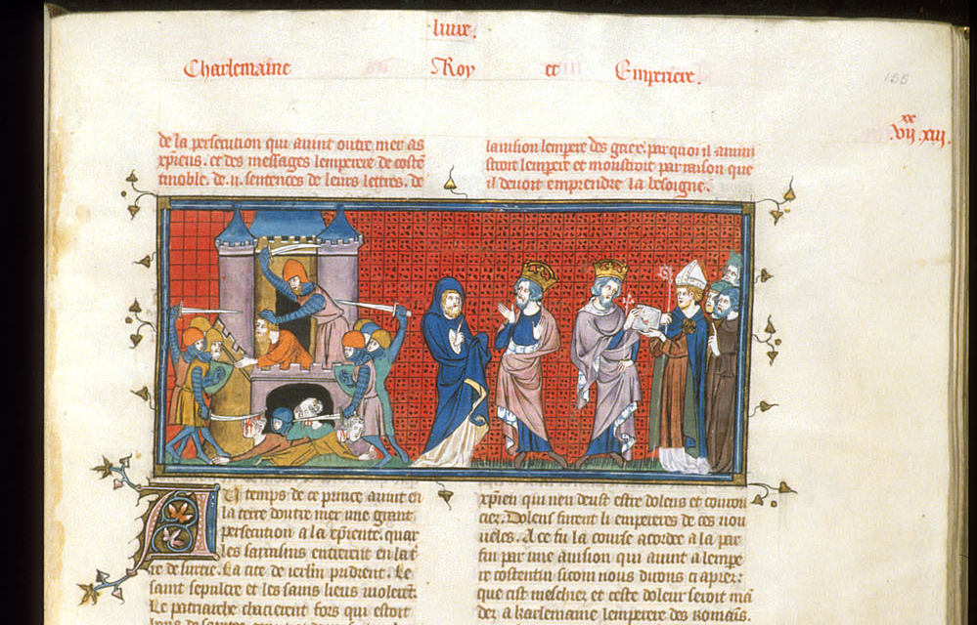
The above photo is of a miniature in three parts, the first depicting the Saracens viciously attacking and killing the Christian residents of, and those on Pilgrimage to Jerusalem. The second part depicts the Patriarch of Jerusalem asking Constantine for assistance to defeat said Saracens, and the third is Constantine sending envoys to Emperor Charlemagne. This picture provides evidence that a possible motive for people to go on Crusade was to defend their Holy Land, and their Christian Brethren. To further support this possible motive is Gregory VII,a Bishop’s, Call for a Crusade in 1074, which was issued three years after the battle of Manzikert, in which the Byzantine Empire lost control of their hold in Asia Minor and, according to J.J. Saunders, in turn “faced total ruin, and appeals for help to the Pope and the Latin world went out from Constantinople which produced twenty-five years after Manzikert the preaching of the First Crusade.” Gregory’s writing in 1074 contains explicit details of the “horrible cruelty” and the “tyrannical violence” the “Pagan race” was subjecting the Christians in their newly conquered land and beseeches the Christians to “undertake the difficult task of bearing aid to your brethren” it is said that when Urban II made his speech in 1095 he had nothing more in mind than what Gregory VII did when he called for Crusade and that the situation hadn’t much changed in between these calls. Thomas Fuller summed this up in one sentence “religion bindeth men to relieve their brethren in distresse”
Peoples argues that the Crusades were one of the most transformative series of events in all of European history, but that Crusaders didn’t sign up with the same motives in mind, some joined because it was a ‘Holy war’, others just for the opportunities that arose, and some for the sheer adventure of it all For example, William IX, Duke of Aquitaine, is believed to have gone purely for an adventure. It was also believed that all Europeans were gifted with a “sense of adventure” but it is important to remember that “love of adventure, lust for booty – these are the characteristics of individuals”
As mentioned above parts of Europe had suffered a terrible agricultural season, and there wasn’t enough food to feed people, the situation became so dire that the “poor folk must march or starve”. So perhaps at least some of the poor people of Europe had no motive other than economic reward, but not for greed, just for basic survival. While others, like Emico of Leiningen, and those who ransacked and pillaged whatever they could get their hands on were motivated by nothing other than personal greed. However, it is impossible to deny that religion played a part. At this period of history religion would most probably have been the single most important thing to a person, the need to get them and their loved ones into Heaven in the afterlife would have been of utmost importance. In fact, Coulton says that the preachers at Clermont were only successful in their call for a crusade because they made promises of indulgences for sins, which would mean no matter what they had done, or what they did during the crusades, crusaders would be accepted into Heaven with God. Speeches at Clermont also promised men “all the freedom of a warrior with all the sacredness of a pilgrim.” Despite this, Whilst it was “once fashionable” to suggest that Crusaders were inspired to “take the cross” purely by greed or that the crusades were a “grand adventure” Asbridge argues that it is almost impossible to pick apart the motivations of the Crusaders because “most crusaders were motivated by a complex combination” of motives possibly including; Christian devotion, economic and political greed, thirst for adventure, and a myriad of others. Asbridge states that people wouldn’t have gone on Crusade purely for economic greed, or the hope of a reward, because Crusades were “cripplingly expensive”, for a Knight to be able to go on Crusade, it is estimated that he would have had to raised 5 times his annual income, which is an extortionate amount. Asbridge also says that for every crusader who entered the Crusades purely hoping for an economic reward, there were “countless more” who weren’t interested in economic rewards at all.

Bibliography

Asbridge, Thomas, The First Crusade: A New History (Oxford, Oxford University Press, 2005) pp 66-68
Bongars, Gesta Dei per Francos, 1, pp. 382 f., trans in Oliver J. Thatcher, and Edgar Holmes McNeal, eds., A Source Book for Medieval History, (New York: Scribners, 1905), 513-17

Bovey, Alixe, Death and the afterlife: how dying affected the living (2015) <https://www.bl.uk/the-middle-ages/articles/death-and-the-afterlife-how-dying-affected-the-living> [10/03/18]
Coulton, C.G., Crusades, Commerce and Adventure (London, Thomas Nelson and Sons, LTD, 1930) p27
Duggan, Alfred,The Story of the Crusades (London, Faber and Faber,1963) p24
Erdmann, Carl,The Origin of the Idea of Crusade (Surrey, Princeton University Press, 1977) p3
Fuller, Thomas, The Crusades: What Was Their Justification in The Crusades: Motives and Achievements (Massachusetts, D.C. Heath and Company, 1965) p1
In Migne, Patrologia Latina, 126: 816
trans. Oliver J. Thatcher, and Edgar Holmes McNeal, eds., A Source Book for Medieval History, (New York: Scribners, 1905), 512
In Migne, Patrologia Latina, 148:329
trans. Oliver J. Thatcher, and Edgar Holmes McNeal, eds., A Source Book for Medieval History, (New York: Scribners, 1905), 512-13
Krey, August. C., The First Crusade: The Accounts of Eyewitnesses and Participants, (Princeton: 1921), 53-54
Lockman, Zachary, Contending visions of the middle east: the history and politics of orientalism (Cambridge, Cambridge University Press, 2004)
Lowe, John Francis, ‘Baldwin I of Jerusalem: Defender of the Latin Kingdom of Jerusalem (M.A Thesis, Portland State University, 2013) https://pdxscholar.library.pdx.edu/cgi/viewcontent.cgi?article=2028&context=open_access_etds [Accessed on 8/03/18]
Mayer, Hans Eberhard, The Crusades second edition (New York, Oxford University Press, 1972) pp 21-22
Royal 16 G VI f. 155 Saracens
Origin: France, Central (Paris)
Saunders, J.J., A History of Medieval Islam (London, Routledge, 1978) chpt 9
Shaw, Jeffrey M., Timothy J. Demy, War and religion: an encyclopaedia of faith and conflict (California, ABC-CLIO, 2017) p208

August. C. Krey, The First Crusade: The Accounts of Eyewitnesses and Participants, (Princeton: 1921), 53-54
C.G. Coulton, Crusades, Commerce and Adventure (London, Thomas Nelson and Sons, LTD, 1930) p27
Hans Eberhard Mayer, The Crusades second edition (New York, Oxford University Press, 1972) pp 21-22
Krey, The First Crusade 33-36
Bongars, Gesta Dei per Francos, 1, pp. 382 f., trans in Oliver J. Thatcher, and Edgar Holmes McNeal, eds., A Source Book for Medieval History, (New York: Scribners, 1905), 513-17
Krey, The First Crusade 28-30.
Mayer, The Crusades pp 21-22
Alfred Duggan, The Story of the Crusades (London, Faber and Faber,1963) p24
Coulton, Crusades, Commerce and Adventure P28
John Francis Lowe, ‘Baldwin I of Jerusalem: Defender of the Latin Kingdom of Jerusalem (M.A Thesis, Portland State University, 2013) https://pdxscholar.library.pdx.edu/cgi/viewcontent.cgi?article=2028&context=open_access_etds [Accessed on 8/03/18]
Carl Erdmann, The Origin of the Idea of Crusade (Surrey, Princeton University Press, 1977) p3
Krey, The First Crusade 28-30.
Alixe Bovey, Death and the afterlife: how dying affected the living (2015) <https://www.bl.uk/the-middle-ages/articles/death-and-the-afterlife-how-dying-affected-the-living> [10/03/18]
In Migne, Patrologia Latina, 126: 816 trans. Oliver J. Thatcher, and Edgar Holmes McNeal, eds., A Source Book for Medieval History, (New York: Scribners, 1905), 512
Coulton, Crusades, Commerce and Adventure P25
Royal 16 G VI f. 155 Saracens Origin: France, Central (Paris)
J.J. Saunders, A History of Medieval Islam (London, Routledge, 1978) chpt 9
In Migne, Patrologia Latina, 148:329 trans. Oliver J. Thatcher, and Edgar Holmes McNeal, eds., A Source Book for Medieval History, (New York: Scribners, 1905), 512-13
Thomas Fuller, The Crusades: What Was Their Justification in The Crusades: Motives and Achievements (Massachusetts, D.C. Heath and Company, 1965) p1
Jeffrey M. Shaw, Timothy J. Demy, War and religion: an encyclopaedia of faith and conflict (California, ABC-CLIO, 2017) p208
Zachary Lockman, Contending visions of the middle east: the history and politics of orientalism (Cambridge, Cambridge University Press, 2004)
Mayer, The Crusades pp21-22
Coulton, Crusades, Commerce and Adventure P28
Coulton, Crusades, Commerce and Adventure P28
Thomas Asbridge, The First Crusade: A New History (Oxford, Oxford University Press, 2005) pp 66-68

