Element 2
The National Health Service (NHS) was established in the United Kingdom in 1948 with the aim of providing comprehensive health care to all people, regardless of their financial means. Since then, the NHS has undergone several changes and developments, both in terms of its structure and the services it provides.
Here are some of the most important developments in the history of the NHS:
Expansion of services: Over the years, the NHS has expanded its services to cover a wider range of health needs, including mental health, dental and optometric services.
Changes in funding: Originally, the NHS was fully funded by the government through general taxation. However, in recent years there has been a move towards increasing private funding, including patient co-payments and public-private partnerships.
Structural changes: The NHS has undergone several structural changes since its inception, including the introduction of Primary Care Trusts, Strategic Health Authorities and Clinical Commissioning Groups. These changes aimed to improve efficiency.
Element 1
The idea of a nationalised health system had been discussed in Britain for many years before its creation, but the devastation of the Great War II provided the impetus for the creation of the NHS. The war had exposed the inequalities of the existing health system and highlighted the need for a more comprehensive and equitable system that could provide care for all, regardless of income.
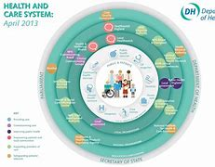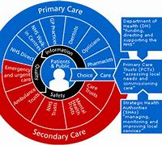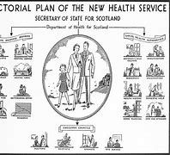
The National Health Service (NHS) was established in the United Kingdom in 1948 as a publicly funded and publicly provided health care system. Prior to the establishment of the NHS, healthcare in the UK was a patchwork of private and voluntary providers, with access to care largely dependent on ability to pay.
Element 3
The Equality Act 2010 outlines nine protected characteristics, which are:
- Age
- Disability
- Gender reassignment
- Marriage and civil partnership
- Pregnancy and maternity
Who is the current Secretary of State For health and Social Care
At the time of my knowledge in September 2021, Sajid Javid was the current Minister for Health and Social Care in the UK. However, it is possible that this position has changed since then.
Name two key pieces of legislation from the SCIE webpage relating to health and social care
There are many laws that relate to the health and social care sector, but two of them are the most important:

The Health and Social Care Act 2012: this Act introduced major reforms to the structure and organisation of the National Health Service (NHS) in England. It introduced Clinical Commissioning Groups (CCGs) to commission health services at a local level and created new bodies such as Healthwatch England to provide independent oversight of health and social care services.

The Care Act 2014: This Act consolidated and clarified adult social care law in England and introduced a number of important changes. It placed a greater emphasis on prevention and wellbeing and introduced a new duty on local authorities to promote people's independence and choice. It also introduced new standards for the quality of care, including a duty of candour and requirements for staff training and development.

