

Software development
Writing programs using C.
Author: Anne McDonnell Student number 1809128.
Module Code: ACCA4017
Lecturer: Gaynor Thomas

Part C.

The Card matching game.

1.1– Pseudocode.
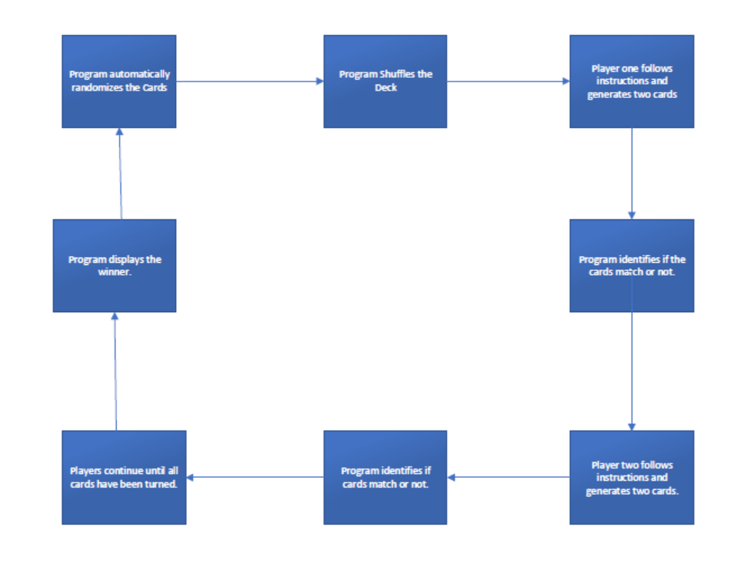

1.2 – Annotated Code.
#include <stdio.h>
#include <stdlib.h>
#include <time.h>

void fillDeck(Card * const int); //prototypes
void shuffle(Card * const Deck);

int main(void)
{
Card Deck[12]

srand(time(NULL)); //seed randomness

fillDeck(deck); //load the deck
shuffle(deck); //shuffle deck
deal(deck); //deal

}

void fillDeck(Card * const int [i])
{
int i;

for (i = 0; i <= 12; i++)

}

void shuffle(Card * const int)//shuffle
{
int i;
int j;
Card temp;

for (i = 0; i <= 12; i++) //loop through deck randomly swapping cards
{
j = rand() % 12;
temp = int [i];
int [i] = int [j];
int[j] = temp;
}

{
printf("player 1: Press enter to turn a card!\n");
int p1 = (rand() % 12) + 1;

printf("player 2: Press enter to turn a card!\n");
int p2 = (rand() % 12) + 1;

printf("Player one turned a %i and player turned a %i.\n", p1, p2);

if (p1 == p2);
{
printf("Its a Draw!");
}

else if (p1 > p2);

{
printf(" Player 1 has won");
}

else
{
printf("player 2 has won");
}

}

2nd Attempt to create a card game on screen:

#include <stdio.h>

/*
int cardgame[30] = {
:,:,:,:,:,:,
:,1,1,2,2,:,
:,3,3,4,4,:,
:,5,5,6,6,:,
:,:,:,:,:,:,
}
*/

const int ConvertTo30[12] =
{
7,8,9,10,
13,14,15,16,
17,18,19,20,
};

void Initialisecardgame(int *cardgame)
{
int index = 0;

for (index = 0; index < 30; ++index)
{
cardgame[index] = BORDER;
}

for (index = 0; index < 12; ++index)
{
cardgame[ConvertTo30[index]] = EMPTY;
}
}

void Printcardgame(const int *cardgame)
{
int index = 0;
printf("\ncardgame:\n");
for (index = 0; index < 30; ++index) {
if (index != 0 && index % 5 == 0) {
printf("\n");
}
printf("4%d", cardgame[index]);
}
printf("\n");

}

int main()
{
int cardgame(30);
Initialisecardgame(&cardgame);
Printcardgame(&cardgame);

return 0;
}
RESULT – All of my attempts failed, unable to create this program.

