STRATEGIC PLAN FOR SAINSBURY'S
Student name: Mariya Georgieva Malamova
Number: 2028275
Lecture Leader: Dr Piyumika Gamaze

Table of Contents
Introduction 2
Company Background 2
Key Business and Corporate Strategies 2
Resources and Capabilities of Sainsbury's 7
Strategy in Action 11
Sustainability Efforts of Saindbry’s 12
Conclusion 14
References 15

Introduction
Strategic planning is essential for a business to enhance operational efficiency, bring innovation, attract investors, minimise organisational risk, get higher profit and sales, motivate employees, and many more. The main objective of the report is to analyse strategic plans for the business of Saindbry’s which is listed on the London Stock Exchange and a British Plc company. The research analyses the overall background of the organisation and its corporate strategies. After that, it focuses on the overall capability and resources of the organisation. Then, the strategic actions of the organisation are also going to be illustrated here. Finally, the report evaluates the sustainability efforts of the selected organisation.

Company Background
Sainsbury's is a British supermarket chain which is the second largest in the UK and 2022 it has a 14.6% market share in the UK. The organisation was opened in 1869 to provide a convenient shopping experience and great value food to its consumers. As per the research, Sainsbury's has more than 600 supermarkets, more than 800 convenience stores, and 152,000 integral colleagues which makes the organisation '3rd most visited retail website in the UK' (Sainsbury's, 2023). Therefore, the organisation aims to help every consumer eat better by providing a sustainable shopping experience.
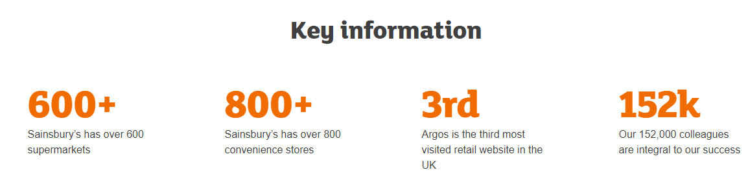
Figure 1: Key information of Sainsbury's
(Source: Sainsbury's, 2023)

Key Business and Corporate Strategies
The organisation is based on cost-saving programs and operational peace that aim to invest in its products to improve food quality. Therefore, Sainsbury's business strategy supports innovation and better value of their product and tries to serve that at the lowest possible price (Sainsbury's, 2023d). Moreover, Salisbury focuses on its consumers and overall profit by supporting its core food business. It ensures lower operating costs and tries to cut complexities within the business. A key fundamental of Siandbury's success is understanding its consumers better than anyone else. Their business strategy also shows responsibilities towards the planet and out of such responsibility they committed to invest over 1 billion pounds in the next 20 years to make net zero emission by 2035 (Sainsbury's, 2023d).
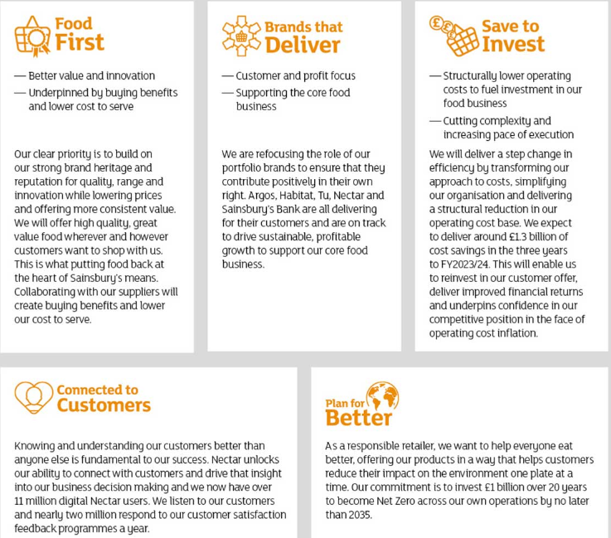
Figure 2: Business strategy of Sainsbury’s
(Source: Sainsbury's, 2023d)
The corporate strategy of Sainsbury is based on five pillars as it aims to be a trusted retailer and make its consumers' lives easier every day with good quality products from the organisation. Key five pillars of Sainsbury's corporate strategy are providing "great products and services at fair prices", "knowing its customers better than anyone else", " being there for our customers whenever and wherever", "their our values making them different" and "colleagues making the difference" (Sainsburys.co.uk, 2023). Moreover, Sainsbury's has made it responsible for providing quality services, delivering fresh food, ensuring equal delivery facilities in its 33 distribution centres, and creating a flexible shopping experience for its consumers.
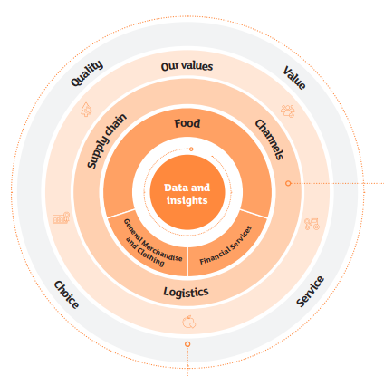
Figure 3: Business model of Saonsbury’s
(Source: Sainsburys.co.uk, 2023)
Porter's Generic Strategies
Porter's strategy has three key factors Differentiation, Cost Leadership, and Focus (Islami et al. 2020). Based on such factors the position of Sainsbury’s is going to be illustrated below.
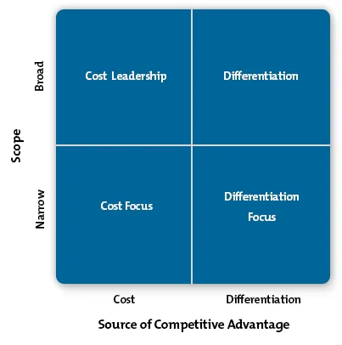
Figure 4: Porter's Generic model
(Source: Islami et al. 2020)
- Cost leadership:
The organisation has started focusing on its 'cost-saving programmes' to ensure lower operational costs and provide products to its consumers at the lowest possible price (Sainsbury's, 2023d). The organisation also aims to provide its services and products at fair prices to ensure better relationship management with its consumers.
- Differentiation:
Sainsbury’s aims to differentiate its services by using recyclable materials and renewable energy sources. It also tries to know its consumers better than others to provide great product services and encourage its colleagues to make a difference.
- Focus:
The organisation focuses on developing better relationships with its consumers and providing quality services to improve consumers' shopping experience (Sainsburys.co.uk, 2023). Sainsbury's aims to reduce global footprint, mitigate organisational risk, reduce plastic usage, and ensure a fast delivery network to manage the changing lives of consumers.
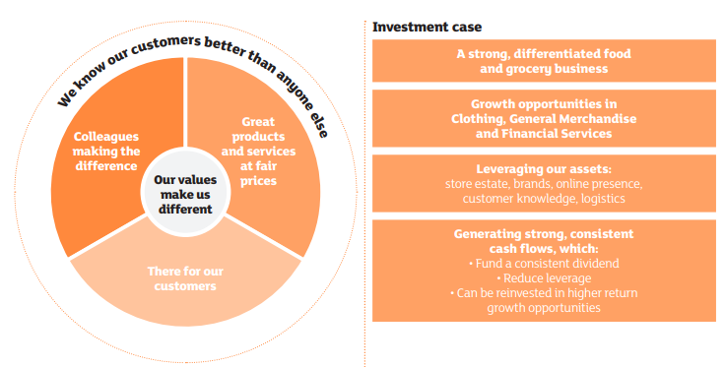
Figure 5: Some strategies of Sinsbury’s
(Source: Sainsburys.co.uk, 2023)
- Position of Sainsbury: Through the analysis, it has been evaluated that Sainsbury's has positioned itself as a consumer-focused and quality service prodigy service chain. Sainsbury's also positioned itself in the fair price service providing and quality product delivery giant segment. (Ansuri bibi)
- (Sufir)
Ansoff Matrix
The theory helps in evaluating growth initiatives and planning the overall business strategy of an organisation. The matrix has four key segments such as product development, market development, market penetration, and diversification (Patra et al. 2020). Sainsbury’s strategic direction is going to be illustrated below based on the matrix.
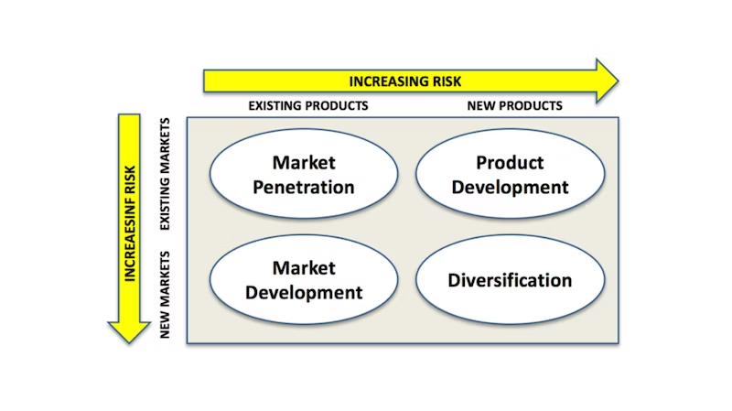
Figure 6: Ansoff Matrix
(Source: Patra et al. 2020)
Market Penetration: Sainsbury has started adopting a competitive pricing strategy for some of its products to compete with its competitors like TESCO, ASDA, and so on (Similarweb. 2022). It has started making sales promotions, increasing advertising, and providing offers to attract more consumers from its business market.
Product Development: Sainsbury's has started introducing a new range of products such as frozen goods, chilled items, fresh foods, and so on. They have started serving based on the changing needs of its consumers such as they serve gluten-free bread, freshly baked bakery items, and more (Sainsburys.co.uk, 2022).
Market Development: Sainsbury's aims to expand its services in new emerging markets where there is demand for its products. It will help them to open new services stored in more locations.
Diversification: Sainsbury's has diversified its product or service range as initially it used to provide grocery services and later it started emphasising the garment segment (Sainsbury's, 2023). Moreover, it also brings product diversification into its food segment.

Resources and Capabilities of Sainsbury's
Various strong resources of Sainsbry's improve its overall capabilities such as strong marketing practices, a fair pricing strategy, a wide range of products, and more. The overall analysis of its capabilities and resources is provided below:
Value Chain and Value System Analysis
- Value Chain Analysis
It is a strategic process that provides competitive advantages and profit margins for different organisations based on their size. It has five key primary activities such as inbound logistics, outbound logistics, operations, services, and marketing and sales (Jones et al. 2019).
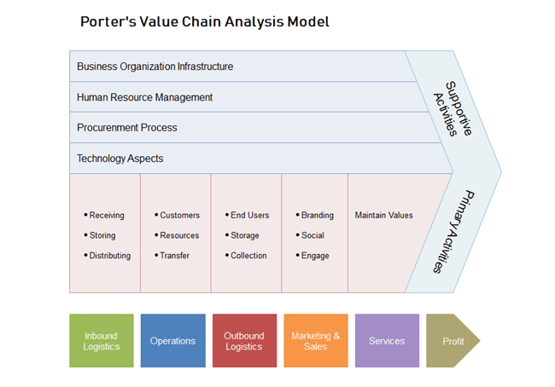
Figure 7: Value Chain Analysis
(Source: Jones et al. 2019)
Primary activities
1. Inbound logistics
Sainsbury's inbound logistics provides market-leading product availability in its online stores and offline stores. Its logistics system helps to meet all consumer's requirements by ensuring a convenient and flexible shopping experience. It operates nearly 34 distribution centres to cover services of its stores like grocery, food, merchandise, general clothing, and so on (Sainsbury, 2021). Its logistics system helps to complete the same-day delivery system for its consumers.
2. Operations
Sainsbury's operates over 2,300 supermarkets, Argos stores, and convenience stores in Ireland and in the UK along with its growing online business (Sainsbury's, 2023). Its popular online services fulfil 20% of total food orders in the UK from its convenience stores. Sainsbury's operates through different formats of retail outlets including its online outlets (GlobalData Plc, 2021). Moreover, its operation includes offerings of various products such as juice, pet food, fish, dairy, eggs, fruits and vegetables, toddler products, meat, beer, spirits, chilled and frozen food, and more.
3. Outbound logistics
Sainsbury's delivers its product through different online channels and completes the entire process from their fulfilment centres. The organisation ensures same-day delivery of their products with a fast delivery system.
4. Marketing and sales
Sainsbury's completes its marketing procedure through various advertising strategies, loyalty programs, promotional activities, and more. The organisation also focuses on developing its digital marketing strategy to connect with its consumers regularly. The organisation maintains its sales through both online stores and offline stores which helps to maximise organisational revenue. For instance, in October 2023 the organisation experienced a 9.1% growth in its sales rate which amounted to 30.9 billion British pounds of sales (Bedford, 2023).
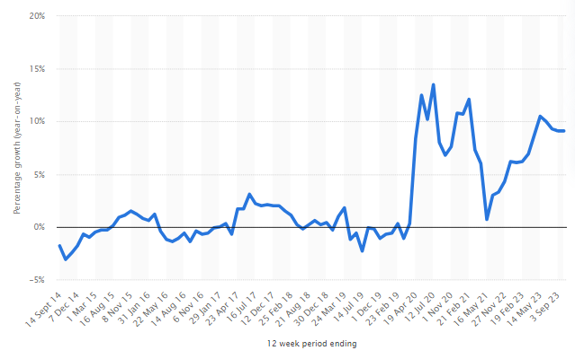
Figure 8: Sales of Sainsbury’s
(Source: Bedford, 2023)
5. Services
Sainsbury's provides in-store services, online services, and consumer services via a customer service desk. Some of its in-store services include cafes, pharmacies, party platters, and so on (Sainsbury's, 2023e). Its main services include garments, retailing, groceries, and food.
Supportive activities
1. Business organisation infrastructure: Sainsbury’s has spring logistics, corporate functions, and management process
2. Human resource management: The organisation has proper leadership with an employee management process which maintains its entire human resources.
3. Procurement process: It maintains proper goods and services management and positive relationships with its suppliers.
4. Technology aspects: Sainsbury provides online services through people's technological development.
- Value System analysis
Consumers: It serves nearly 320,000 customers in the UK in 2022 from its different convenience stores.
Suppliers: They provide necessary raw materials, food items, and sustainable materials to Sainsbury’s. It helps the organisation to supply their products through more than 60 countries and around 2,200 sites in the globe (Sainsbury’s 2023f).
Partners: Sainsbury collaborates with various partners to ensure on-time product delivery and avoid supply chain disruption.
VRIO analysis
VRIO analysis helps to make an internal analysis of an organisation categorising the different internal resources that provide competitive advantages to the organisation (Ariwibowo et al. 2021). VRIO analysis of Sainsbury is provided below:
Capabilities and resources | Valuable | Rare | Inimitable | Organised | Competitive Impact
Financial resources or investment | Yes | No | No | Yes | It provides temporary advantage to Sainsbury’s
Proper marketing expertise of the organisation | Yes | No | No | Yes | It also provides temporary advantage to the brand
Contribution to E-Commerce services | Yes | No | Yes | Yes | It provides competitive parity to Sainsbury’s
The loyal consumer base of Sainsbury's | Yes | Yes | Yes | Yes | It generates a competitive advantage for Sainsbury's
Access to lower-price resources | Yes | No | No | No | It provides a competitive disadvantage
Strong employee base of Sainsbury’s | Yes | Yes | No | Yes | Sainsbury’s gets competitive parity from such resources
Local and global presence | Yes | Yes | No | Yes | It provides competitive parity to Sanusbury’s
Access to sustainable raw materials | Yes | Yes | Yes | Yes | It provides a competitive advantage to Sainsbury
Organisational leadership | Yes | Yes | Yes | Yes | Siansbury's gets a competitive advantage from such resources
Table 1: VRIO analysis of Sinsbury’s
(Source: Self-created)

Strategy in Action
The success of Sainsbury’s corporate strategies can be evaluated through the use of the SAF framework which stands for Suitability, acceptability, and Feasibility (Kazankov, 2023).
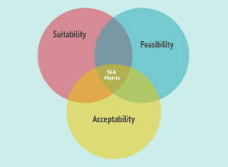
Figure 9: SAF Framework
(Source: Kazankov, 2023)
Suitability: The main purpose of Sainsbury's service is to provide quality food service at a fair price which is suitable to attract consumers and gain competitive advantage (Sainsbury's, 2023c). Its focus on sustainability initiatives and becoming a net zero-emission company by 2035 is another suitable strategy to protect consumers' health and the health of the planet. After that, the strategy of advertising is also suitable to spread brand awareness and communicate with consumers regularly. Its online and offline services remain suitable to provide relevant services to its consumers based on their necessities. For example, in the UK total of 20% of food delivery is done from Sainsbury's site (GlobalData Plc, 2021). The changes in its product category based on consumers' needs become suitable to enhance consumer satisfaction rate.
Acceptability: Proper financial resource management, technological advancement in online services, and marketing initiative remain acceptable to the consumers as it increases product visibility to the organisation. Its seasonal offers and promo code get huge acceptability as it helps consumers to avail their services at a fair price (Sainsbury's, 2023c). Therefore, launching online services and faster delivery options giants huge acceptability among consumers. Its sustainable initiatives regarding the use of renewable energy and elimination of plastic packaging also get huge acceptability among the environment-conscious people (Sainsbury's, 2023b). For example, in 2021 Sainsbury reduced 17.5% plastic usage from its packaging (Sainsbury's, 2023b) Moreover, proper global and local presence management improves the brand's acceptability. Despite that, the loyal consumer base of Sanisbry increases the acceptability of its services in its business market and helps to gain a competitive advantage.
Feasibility: The entire corporate strategies of sainsbury's remain feasible as they focus on "cost saving programmes" and try to simplify their operational aspects. Moreover, overall improvement in food quality, easy access to them, and a faster delivery system enhance the feasibility of Sainsbury's business strategies. Hence, the technological expertise of the organisation enhances the feasibility of their online services. For example, in 2022 Sainsbury received 39% of its sales from online stores which includes Argos sales of 80% and grocery sales of 17% (Rigby, 2022). Hence, partnership with delivery giants remains feasible enough for Siasbury's.

Sustainability Efforts of Saindbry’s
Since its opening, the organisation aimed to provide socially, economically, and environmentally responsible services. Saindbry's has committed to invest over £1 billion in the next 15 years to become a Net Zero emission creating business by 2035 by aligning with the "Paris Climate Change Agreement" (Sainsbury's, 2023). They align their sustainable initiatives with "UN Sustainable Development Goals” to create the biggest difference in sustainable initiatives. According to the 2022- 23 report the organisation has made progress in ensuring 81.2% healthy sales for its consumers. The organisation has donated 10 million meals by making a neighbouring partnership since 2021. Therefore, Saindbry's has made an absolute reduction of 17.5% of its plastic packaging to ensure sustainable services (Sainsbury's, 2023b). After that, it has committed to use 100% renewable electricity from its "Longhill Burn Wind Farm" to ensure sustainability. Hence, in the next 15 years, Saindbry has targeted to invest millions of pounds to purchase and use renewable electricity.
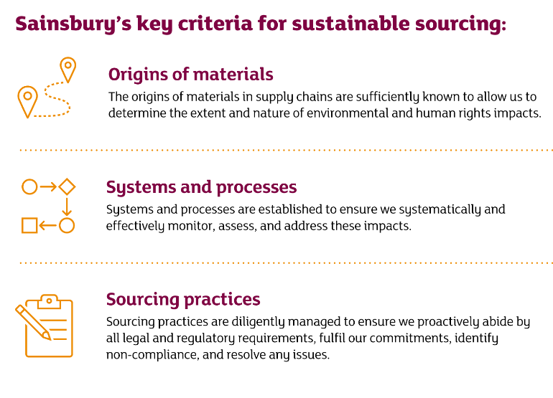
Figure 10: Sustainable sourcing of Sainsbury’s
(Source: Sainsbury's, 2023c)
According to the above-mentioned figure, the organisation focuses on sustainable sourcing to address their service impact and fulfil their commitment. A new wind farm of Sainsbury's in the UK has started providing renewable electricity up to 33% of the total estate of Sainsbury's (Sainsbury's, 2023b). Hence, the organisation has started introducing cardboard babywear hangers that are going to reduce 103 tonnes of plastic usage and use recycled materials. Sainsbury focuses on SDG 17 which is 'partnership for the goals' to plan better for tier sustainable initiatives. Moreover, Siansbury's has started making sustainable sourcing as its "Plan for Better'' helps to remain committed towards sustainability and ensure people, the planet, and its consumer's health (Sainsbury's, 2023c). The organisation committed to reducing its "absolute Scope 3 GHG emissions" or " whole value chain carbon footprint" by 30% by the year 2030 (Sainsbury's, 2023c). It also commits to making its supply chain to be free from conversion and deforestation by 2025. The organisation also aims to focus on the impact of its services on human rights by making a "Human Rights Saliency Report".

Conclusion
It can be summarized that the organisation has made effective strategies to ensure sustainability by making net zero emissions in the next fifteen years, making sustainable sourcing, and using renewable energy. Therefore, the organisation has emphasised to maintain better relationships with consumers by providing quality services at a fair price which is also a part of its strategic choices. Moreover, it processes service diversification like grocery, food, garments, and more so that it can implement higher brand value in the market. Therefore, the strategy of maintaining a lower cost of their services is effective to grab a higher percentage of its business market and gain a competitive advantage.

References
Ariwibowo, P., Saputro, B., Research Paper, H., Manajemen, J., Dan, S. and Bisnis, A. (2021). Analysis of Strength & Weakness, Using the Concept of Resource-Based View with the VRIO Framework in Sharia Cooperatives JMSAB 279. Analysis of Strength & Weakness, Using the Concept of Resource-Based View with the VRIO Framework in Sharia Cooperatives, [online] 4(1), pp.279–294. doi:https://doi.org/10.36407/jmsab.v4i1.313.
Bedford, E. (2023). Sainsbury’s sales growth Great Britain 2022. [online] Statista. Available at: https://www.statista.com/statistics/386729/sainsburys-sales-percentage-change-great-britain-uk/#:~:text=Sainsbury.
GlobalData Plc (2021). J Sainsbury Plc Company Profile - Overview. [online] Globaldata.com. Available at: https://www.globaldata.com/company-profile/j-sainsbury-plc/#:~:text=The%20company%20operates%20retail%20outlets.
Islami, X., Mustafa, N. and Latkovikj, M.T. (2020). Linking Porter’s Generic Strategies to Firm Performance. Future Business Journal, 6(1), pp.1–15. doi:https://doi.org/10.1186/s43093-020-0009-1.
Jones, L., Demirkaya, M. and Bethmann, E. (2019). United States International Trade Commission Journal of International Commerce and Economics Global Value Chain Analysis: Concepts and Approaches. [online] Journal of International Commerce and Economics. Available at: https://innovaluechain.eu/wp-content/uploads/2022/07/Global-Value-Chain-Analysis-Concepts-and-Approaches.pdf.
Kazankov, V. (2023). Suitability, Acceptability, Feasibility (SAF) Framework to Score Strategic Options - MarketingForIT. [online] marketingforit.com. Available at: https://marketingforit.com/strategy/suitability-acceptability-feasibility-saf-framework#:~:text=Strategic%20Options%20%2D%20MarketingForIT- [Accessed 18 Dec. 2023].
Patra, R., Bharatiya, V. and Bhavan (2020). BIMS Journal of Management. [online] Available at: https://bimskol.org/pdf/E-copy-BIMS-Journal-Management-Kolkata-Vol5-Issue-1-July-2020.pdf#page=26.
Rigby, C. (2022). 39% of Sainsbury’s sales online in latest full-year – including 17% of grocery and 80% of Argos sales. [online] Internet Retailing. Available at: https://internetretailing.net/39-of-sainsburys-sales-online-in-latest-full-year-including-17-of-grocery-and-80-of-argos-sales-24749/.
Sainsbury’s (2023f). Increasing transparency in our supply chain. [online] www.about.sainsburys.co.uk. Available at: https://www.about.sainsburys.co.uk/sustainability/plan-for-better/our-stories/2022/increasing-transparency-in-our-supply-chain#:~:text=In%20order%20to%20supply%20the.
Sainsburys (2021). Our business model How we create value and build customer loyalty. [online] Available at: https://www.about.sainsburys.co.uk/~/media/Files/S/Sainsburys/pdf-downloads/sainsburys-ar-2017-business-model.
Sainsbury's (2023). About Us. [online] www.about.sainsburys.co.uk. Available at: https://www.about.sainsburys.co.uk/about-us.
Sainsbury's (2023b). Sustainability. [online] www.about.sainsburys.co.uk. Available at: https://www.about.sainsburys.co.uk/sustainability.
Sainsbury's (2023c). Sustainable sourcing. [online] www.about.sainsburys.co.uk. Available at: https://www.about.sainsburys.co.uk/sustainability/plan-for-better/sustainable-sourcing.
Sainsbury's (2023d). Our business strategy. [online] Sainsburys.co.uk. Available at: https://www.about.sainsburys.co.uk/about-us/our-business-strategy.
Sainsburys, (2023e). Instore Services. https://www.sainsburys.co.uk/webapp/wcs/stores/servlet/gb/groceries/get-ideas/delivery-and-guides/our-instore-services?storeId=10151&langId=44&krypto=ShqjX%2Fqgdjcu6yAbE%2B1I1G422LEqeI6dwMX55udC0Uzjv5Q4wbYrUpD%2F2hkSrVbInrjE6l05r%2Fn8lZEbrDiiGSMhiCkarLPDR41GfLIg2LG01Tnqhm8erNIujqOpMuRI6cIiotCBYFrDosCgObEFeAHcygJnTr02TpWmboOyz54%3D&ddkey=https%3Agb%2Fgroceries%2Fget-ideas%2Fdelivery-and-guides%2Four-instore-services
Sainsburys.co.uk, (2022). Further enhance our differentiated food proposition. https://www.about.sainsburys.co.uk/~/media/Files/S/Sainsburys/pdf-downloads/sainsburys-ar-2017-priority-1#:~:text=We%20have%20doubled%20the%20new,baked%20in%20our%20store%20bakeries.
Sainsburys.co.uk, (2023). Our business model. https://www.about.sainsburys.co.uk/~/media/Files/S/Sainsburys/documents/reports-and-presentations/2019/ar-docs/sainsburys-ar2019-businessmodel-strategy.pdf
Similarweb. (2022). Similarweb. [online] Available at: https://www.similarweb.com/website/sainsburys.co.uk/competitors/.

