BMIH4010
Personnel Resourcing and Development
Module Leader: Scott James
Presentation
Student Id: 2009573
Student Name: Nicoleta Andreea Roșca

Table of Contents
Introduction 3
Attraction and Recruitment 4
Onboarding 6
Development 7
Retention and Separation 8
SWOT Analysis 10
Conclusion 12
References 13

Introduction
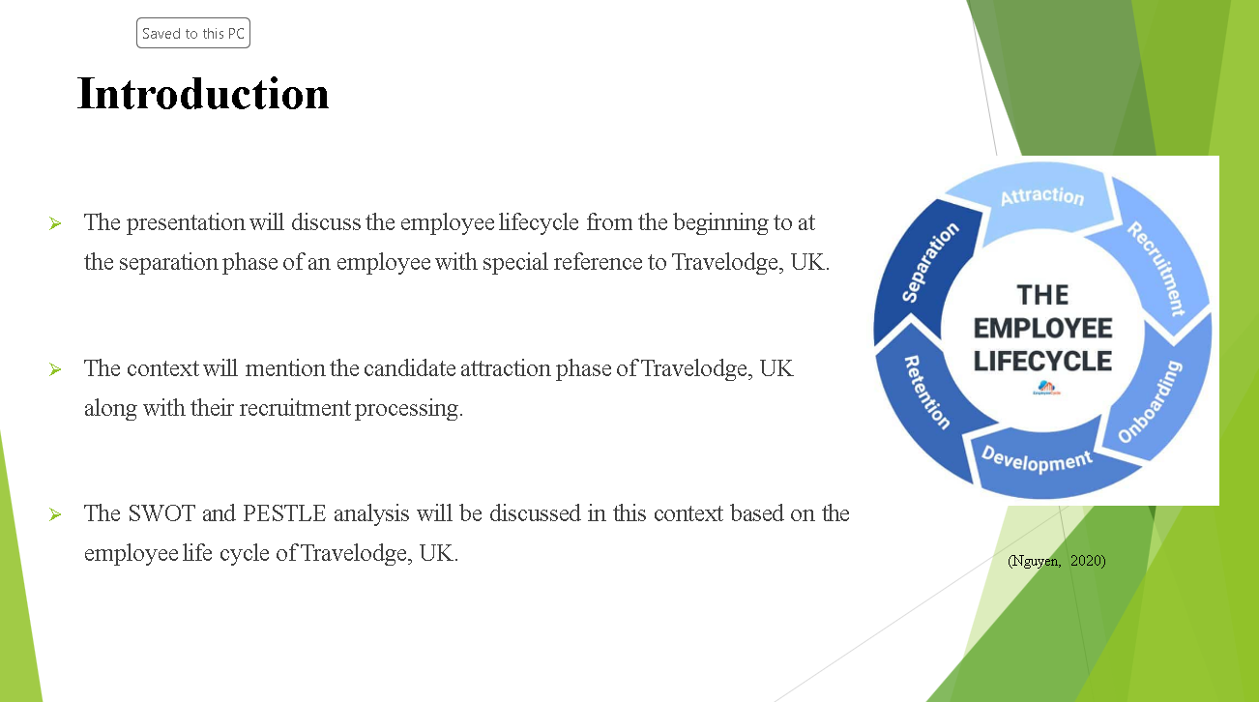
The presentation will discuss the employee lifecycle from the beginning to at the separation phase of an employee with special reference to Travelodge, UK. It is the most popular hotel in the UK and provides a positive work environment to their employees. The context will mention the candidate attraction phase of Travelodge, UK along with their recruitment processing. The employee will move to the onboarding phase after qualifying the recruitment phase. The section will provide specific strategies of development of newly hired managers and employees. The retention and separation phase of the employee lifecycle will be highlighted properly. The SWOT and PESTLE analysis will be discussed in this context based on the employee life cycle of Travelodge, UK.

Attraction and Recruitment
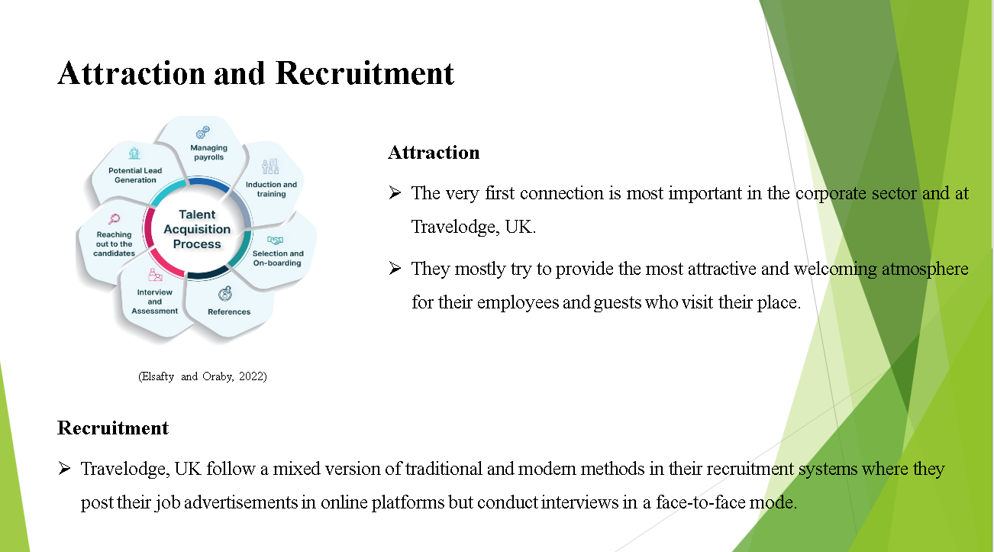
Attraction
The very first connection is most important in the corporate sector and at Travelodge, UK they prioritize the foremost experiences of their employees (Elsafty and Oraby, 2022). They mostly try to provide the most attractive and welcoming atmosphere for their employees and guests who visit their place. The brand tries to promote teamwork and inclusivity where they provide their workers value, respect and support that they deserve. The Travelodge, UK try to maintain their commitment from the very first day to every day operations and try to create a strong relationship which helps employees to improve their performance.
Recruitment
Travelodge, UK follow a mixed version of traditional and modern methods in their recruitment systems where they post their job advertisements in online platforms but conduct interviews in a face-to-face mode. The brand posts their job advertisements online to expand their reach of candidates which increase their talent pool. Whereas they perform one-to-one interaction in their interview process and also provide the option of video conferences to those candidates who are situated some distance away (Nguyen, 2020). They also employ an applicant tracking system which help them to assess the individual’s information effectively. These ways the brand follows traditional and modern approaches in their hiring system to meet the requirements of candidates and company.
Onboarding
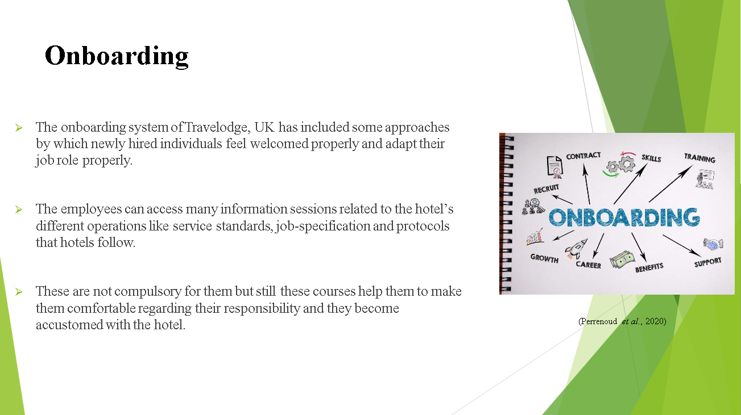
The onboarding system of Travelodge, UK has included some approaches by which newly hired individuals feel welcomed properly and adapt their job role properly. They get orientation sessions to make them accustomed to the company policies, values, cultures and systems. The employees can access many information sessions related to the hotel’s different operations like service standards, job-specification and protocols that hotels follow (Perrenoud et al., 2020). These are not compulsory for them but still these courses help them to make them comfortable regarding their responsibility and they become accustomed with the hotel.
Development
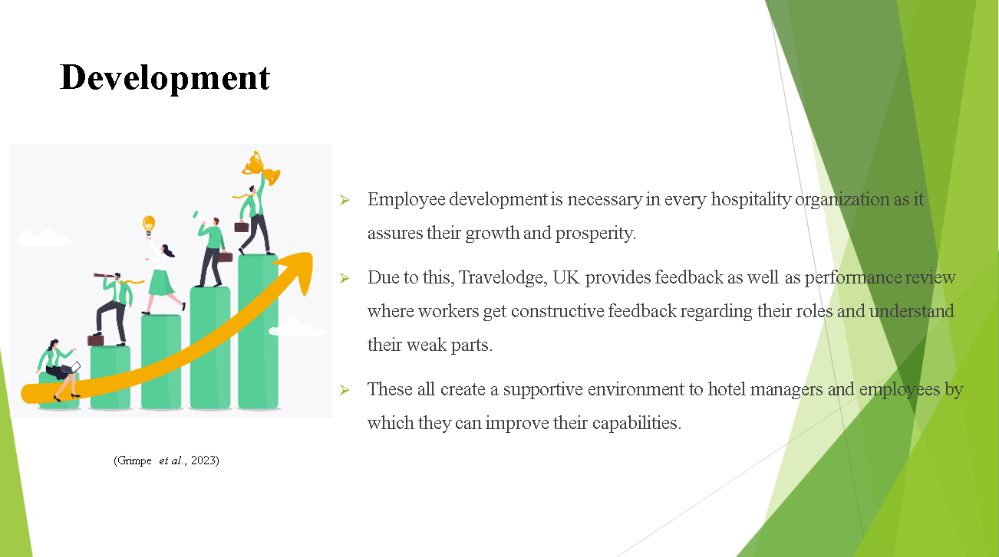
Employee development is necessary in every hospitality organization as it assures their growth and prosperity. Due to this, Travelodge, UK provides feedback as well as performance review where workers get constructive feedback regarding their roles and understand their weak parts. On the other hand, employees can understand their progress, through performance review sessions where they receive proper guidance and set goals. These all create a supportive environment to hotel managers and employees by which they can improve their capabilities.

Retention and Separation
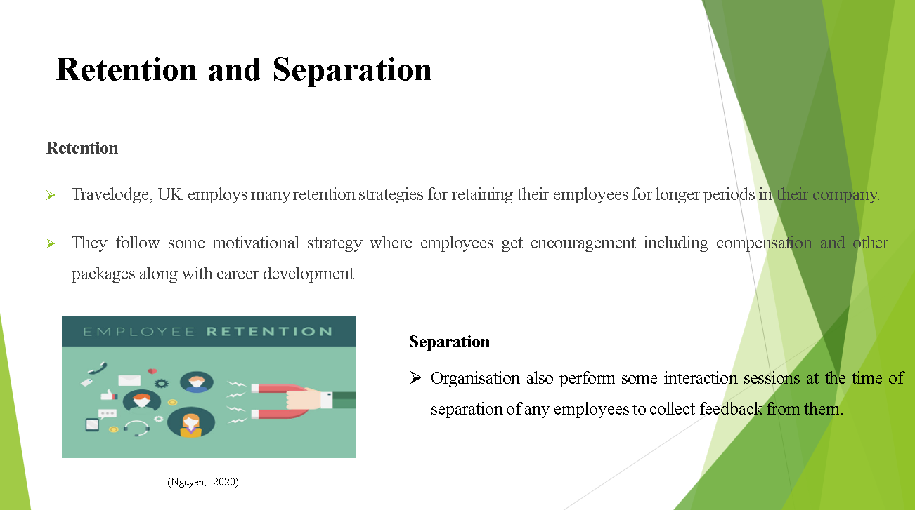
Retention
Travelodge, UK employs many retention strategies for retaining their employees for longer periods in their company. They follow some motivational strategy where employees get encouragement including compensation and other packages along with career development (Grimpe et al., 2023). They also provide workers recognition of their good work and give them rewards as per their good performance. They also try to provide their staff with a positive work atmosphere which helps employees to work easily and make them feel valued and respected.
Separation
Organisation also perform some interaction sessions at the time of separation of any employees to collect feedback from them. The Travelodge, UK also perform such exit interviews where they try to understand the reason for their separation of employees and try to gather feedback about the company and the period when they ate with the said company. They also provide return equipment besides providing them guidance and support of individuals at the time of their transition. Travelodge, UK try to maintain a good and positive relationship with their former employees and maintain their respect.
SWOT Analysis
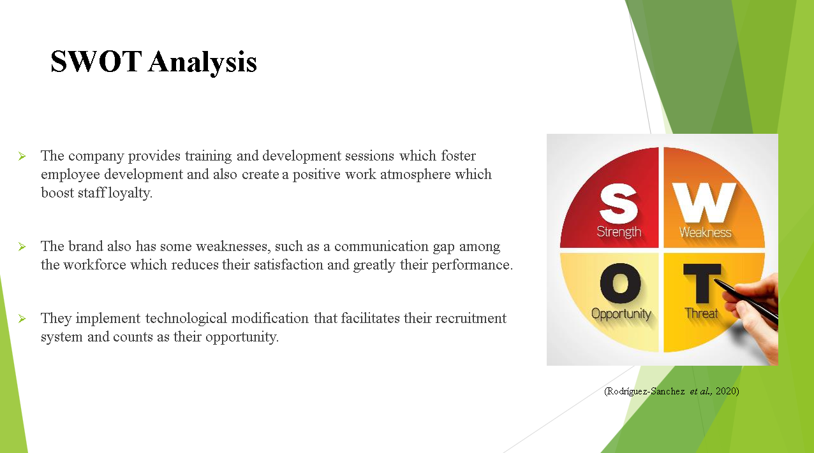
Travelodge, UK has many strengths related to their employee lifecycle. The company provides training and development sessions which foster employee development and also create a positive work atmosphere which boost staff loyalty (Rodríguez-Sanchez et al., 2020). The brand also has some weaknesses, such as a communication gap among the workforce which reduces their satisfaction and greatly their performance. They implement technological modification that facilitates their recruitment system and counts as their opportunity. On the other hand, they face some threats like turnover rate and talent competition with other hospitality organisations.
Conclusion
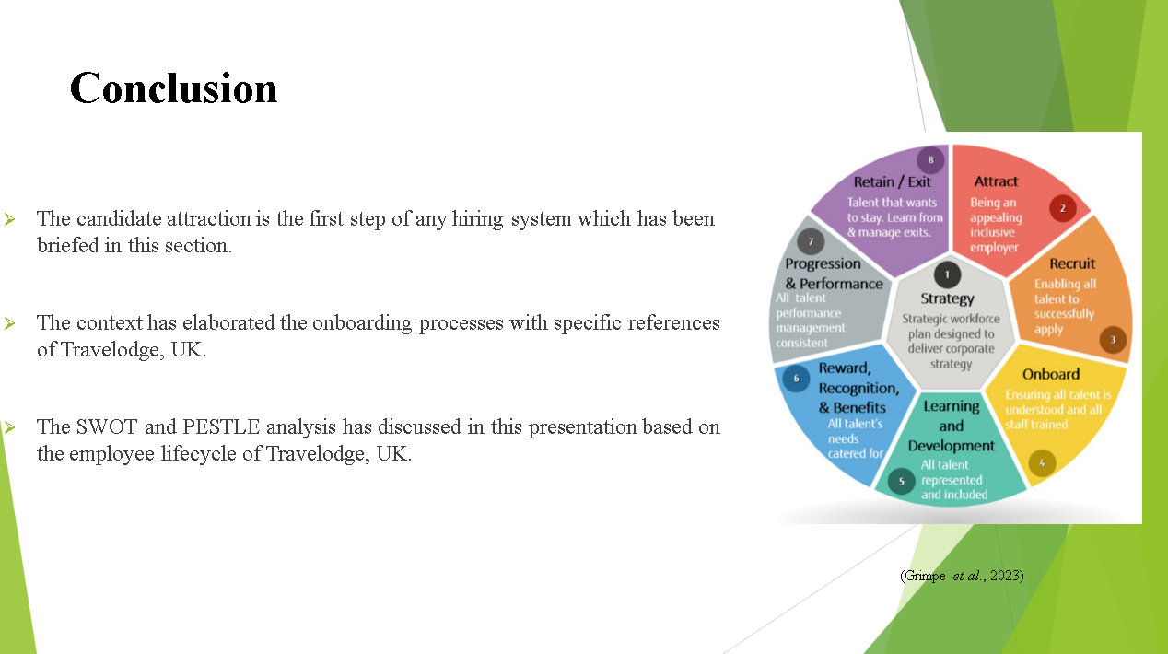
The employee lifecycle of Travelodge, UK has focused on this discussion. The candidate attraction is the first step of any hiring system which has been briefed in this section. The recruitment system of Travelodge, UK has been mentioned in this presentation. The context has elaborated the onboarding processes with specific references of Travelodge, UK. The development of workers has been highlighted here properly. The employee retention program of Travelodge, UK has discussed in this section along with their separation proceedings. The SWOT and PESTLE analysis has discussed in this presentation based on the employee lifecycle of Travelodge, UK.

References
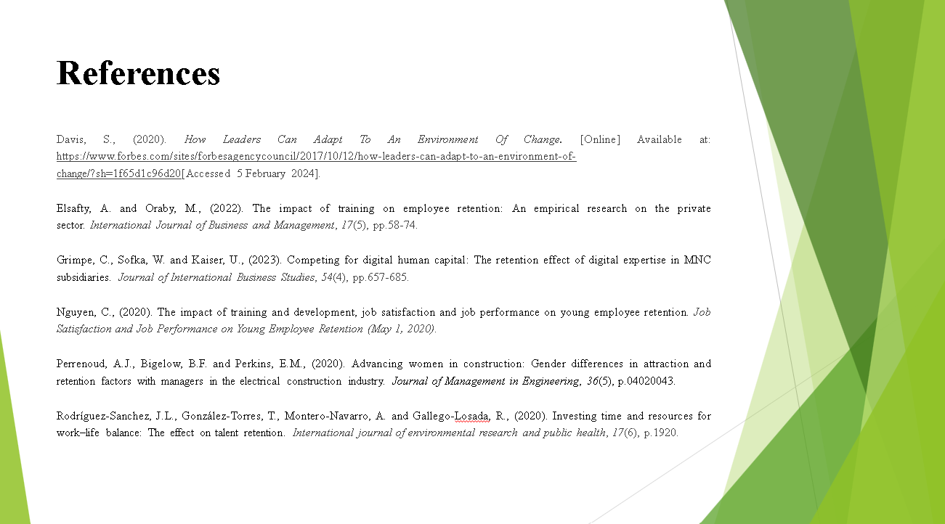
Davis, S., (2020). How Leaders Can Adapt To An Environment Of Change. [Online] Available at: https://www.forbes.com/sites/forbesagencycouncil/2017/10/12/how-leaders-can-adapt-to-an-environment-of-change/?sh=1f65d1c96d20. Accessed 7 February 2024
Elsafty, A. and Oraby, M., (2022). The impact of training on employee retention: An empirical research on the private sector. International Journal of Business and Management, 17(5), pp.58-74.
Grimpe, C., Sofka, W. and Kaiser, U., (2023). Competing for digital human capital: The retention effect of digital expertise in MNC subsidiaries. Journal of International Business Studies, 54(4), pp.657-685.
Nguyen, C., (2020). The impact of training and development, job satisfaction and job performance on young employee retention. Job Satisfaction and Job Performance on Young Employee Retention (May 1, 2020).
Perrenoud, A.J., Bigelow, B.F. and Perkins, E.M., (2020). Advancing women in construction: Gender differences in attraction and retention factors with managers in the electrical construction industry. Journal of Management in Engineering, 36(5), p.04020043.
Rodríguez-Sanchez, J.L., González-Torres, T., Montero-Navarro, A. and Gallego-Losada, R., (2020). Investing time and resources for work–life balance: The effect on talent retention. International journal of environmental research and public health, 17(6), p.1920.

