Escaping smoke and mirrors: The client encounter with cult rhetoric in therapy after leaving a UK Sufi group

being a dissertation submitted in partial fulfilment of the
requirements for the degree of

Master of Arts
Psychotherapeutic Practice (Humanistic)

in the University of Wales Trinity Saint David
under the supervision of Dr. Beverley Cole

by

Elaine Greener BA (Hons)
July 2026

© 2026 by Elaine Greener. All rights reserved.

Epigraph

It is not possible for any person to see how far another one has already progressed on his path; in the robber and dice-gambler, the Buddha is waiting; in the Brahman, the robber is waiting. […] I see whatever exists as good, death is to me like life, sin like holiness, wisdom like foolishness, everything has to be as it is, everything only requires my consent, only my willingness, my loving agreement, to be good for me, to do nothing but work for my benefit, to be unable to ever harm me. I have experienced on my body and on my soul that I needed sin very much, I needed lust, the desire for possessions, vanity, and needed the most shameful despair, in order to learn how to give up all resistance, in order to learn how to love the world, in order to stop comparing it to some world I wished, I imagined, some kind of perfection I had made up, but to leave it as it is and to love it and to enjoy being a part of it.
-Hesse (2001, ch.12, para. 19) ‘Siddartha’

Acknowledgements

Wa lam yakun lahu kufuwan ahad

(And there is none that compares to my Beloved)

(Qur’an, 112:4)

I am grateful to my academic supervisor, Dr. Beverley Cole, for encouraging my creative, heuristic process and offering academic guidance where needed. I also thank my student peer and friend, Kalindi (Kal) Black for critically engaging with my work and for the joyful chats which kept me going.
I thank my friends and family for their support, patience, understanding and witnessing of my journey. I also thank all my therapists and Sufi teachers. Truly, we are all in this together.
Last, but by no means least, I thank the buffalo.

AI Statement

I confirm that I have not used any AI tools in the research and creation of this assignment. I confirm that I have not presented any AI generated materials as my own work. I confirm I have copies of my drafts, notes, and other resources I used, which I may be asked to provide in evidence.

Declarations
This work has not previously been accepted in substance for any degree and is not being concurrently submitted in candidature for any degree.

Signed: 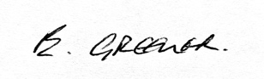 (Candidate: Elaine Greener)
Date: 09/06/2026

STATEMENT 1

This dissertation is being submitted in partial fulfilment of the requirements for the degree of Master of Arts Psychotherapeutic Practice (Humanistic)

Signed: (Candidate: Elaine Greener)
Date: 09/06/2026

STATEMENT 2

This dissertation is the result of my own independent work / investigation, except where otherwise stated.

Other sources are acknowledged by footnotes giving explicit references. A bibliography is appended.

Signed: (Candidate: Elaine Greener)
Date: 09/06/2026

STATEMENT 3

I hereby give consent for a redacted version of my dissertation, if accepted, to be available for photocopying and for inter-library loan, and for the title and summary to be made available to outside organisations.

Signed: (Candidate: Elaine Greener)
Date: 09/06/2026

Abstract

Background: Cult rhetoric exerts a significant influence in the emergence and development of therapeutic approaches to working with survivors of harm in religious and spiritual contexts. Research concerning client experience and contextual validity of these approaches is sparse. The aims were to explore and illuminate the researcher’s encounter with cult rhetoric in therapy; address the research gap evaluating therapeutic approaches to working with this population; contribute to discourse around cults and new religious movements; inform the researcher’s professional practice and consider implications for the counselling profession.
Methods: Focussing on the researcher’s experience of cult rhetoric in therapy after exiting a Sufi group, a literature review and heuristic self-search inquiry were undertaken. A creative synthesis captured the experience, and themes were discussed in the context of extant literature.
Findings: Clusters of themes emerged explicating how cult rhetoric creates therapy that mirrors cult dynamics, obscures client capacity and sense of self and causes internal splitting. The minimising and pathologising of spiritual experience and faith were found to be especially damaging.
Conclusions: Cult rhetoric in therapy contains a hidden activist agenda, can exert a harmful influence on the client’s physical, mental and spiritual wellbeing, and acts as a barrier to integration. Cult rhetoric that shapes therapy poses an array of ethical concerns for the counselling profession.
Recommendations: Further research is needed to evaluate the influence of cult rhetoric in therapy. Client-led creative modalities may be beneficial.

Key words: cult; psychotherapy; new religious movement; minority religion; religious trauma; spiritual abuse; Sufism.

Abbreviations

APA American Psychiatric Association
ARE Adverse Religious Experience
ARM Alternative Religious Movement
BACP British Association for Counselling and Psychotherapy
BITE Behaviour, Information, Thought and Emotion
ARSE Adverse Religious and Spiritual Experience
C-PTSD Complex Post Traumatic Stress Disorder
DID Dissociative Identity Disorder
DSM-5 Diagnostic and Statistical Manual (5th Edition)
GDPR General Data Protection Regulation
HDG High Demand Group
HI Heuristic Inquiry
HSSI Heuristic Self-Search Inquiry
ICSA International Cultic Studies Association
IJCAM International Journal of Coercion, Abuse and Manipulation
Inform Information Network Focus on Religious Movements
IRF International Freedom Roundtable
LGBTQ+ Lesbian, Gay, Bisexual, Transgender, Queer/Questioning, plus
MR Minority Religion
NGO Non-Governmental Organisation
NPD Narcissistic Personality Disorder
NRM New Religious Movement
PCC Post Cult Counselling
PTSD Post Traumatic Stress Disorder
RA Religious Abuse
Rit.A Ritual Abuse
RTI Religious Trauma Institute
SA Spiritual Abuse
TA Thematic Analysis
UWTSD University of Wales Trinity Saint David

Contents
Epigraph i
Acknowledgements ii
AI Statement iii
Declarations iv
Abstract v
Abbreviations vi
List of Figures x
List of Tables xi
Chapter 1 Introduction 1
1.1 Context 2
1.2 Researcher Background and Statement of the Problem 4
1.3 Research Question, Aims and Objectives 5
1.4 Structure 6
Chapter 2 Literature Review 8
2.1 Introduction 9
2.1.1 Search Terms and Databases 9
2.1.2 Inclusion/Exclusion criteria 9
2.2 Cult Wars 10
2.3 The Problem of Defining the ‘C-word’ 14
2.4 The Problem of Defining Sufism 17
2.5 The Problem of Defining Cultic, Spiritual and Religious Abuse 19
2.5.1 Religious Abuse (RA) 19
2.5.2 Spiritual Abuse (SA) 19
2.5.3 Ritual abuse (Rit.A) 20
2.5.4 Cultic Abuse (CA) 20
2.6 Therapeutic Approaches 22
2.7 Conclusion 24
Chapter 3 Methodology 25
3.1 Heuristic Inquiry 26
3.1.1 Limitations and Critiques of HI 28
3.2 Ethics 28
3.3 Data Collection and Analysis 30
Chapter 4 Findings 31
4.1 Themes 32
4.2 Creative Synthesis: Smoke and Mirrors (Meta) 43
Chapter 5 Discussion and Conclusion 45
5.1 Discussion 46
5.2 Personal and Professional Implications 48
5.3 Limitations 50
5.4 Future Research and Development 50
5.5 Conclusion 51
Chapter 6 Epilogue 53
Reference list 54
Appendix 1: Desire I
Appendix 2: I Believe You are Right II
Appendix 3: The Scholar and the Boatman III
Appendix 4: Journal Excerpt (highlighted themes) IV
Appendix 5: Process of Refining Themes V
Appendix 6: The Test VI
Appendix 7: Poking at Shit (Printed words) VII
Appendix 8: The Weight of the Stones VIII
Appendix 9: The People who Attain IX

List of Figures
Figure 1.1: Desire 1
Figure 2.1: I Believe You are Right! 8
Figure 3.1: The Scholar and the Boatman 25
Figure 4.1: The Test 31
Figure 4.2: Particulate of Themes 39
Figure 4.3: Projection 40
Figure 4.4: Smoke and Mirrors (Meta) 43
Figure 4.5: Detail: Poking at Shit 44
Figure 5.1: The Weight of the Stones 45
Figure 6.1: The People Who Attain 53

List of Tables
Table 4.1: Breakdown of Themes 32

Introduction

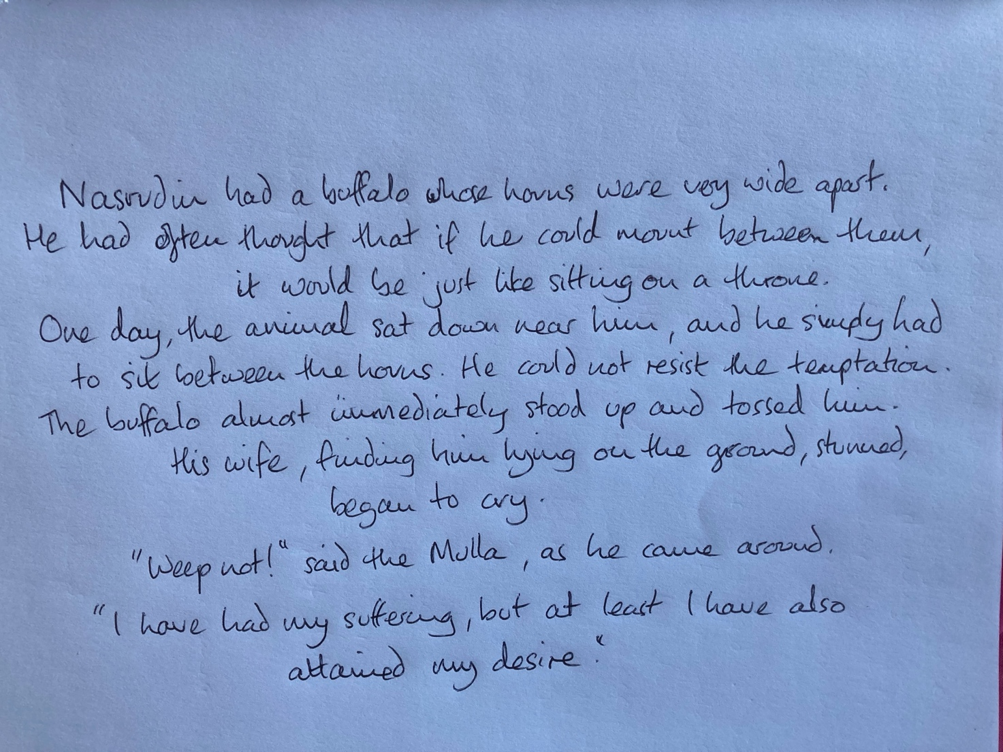
Figure 1.1: Desire
(Shah, 1993a, p.115)
(Appendix 1: printed words)

Context
Desire and surrender are innate human drivers (Yadlin-Gadot, 2023) also integral to many spiritual paths, such as the diverse Orders within the Sufi Way, where the initiate practices the surrender of individual will to the Divine, under the guidance of a master (Khan, 1990). This human desire can be seen as susceptibility or vulnerability to coercive systems of subjugation associated with cults and the traumatising, narcissistic personality of the leader (Shaw, 2014; 2023; 2025). Moderating this perceived vulnerability, some suggest that cults recruit highly intelligent individuals possessing a significant capacity to withstand the pressures within a high-demand environment (Hilliard, 2025). But despite these humanising narratives, cults and cult survivors largely remain sensationalised and othered and the conflation of cults and new religious movements (NRMs) is unhelpfully entrenched through media stereotypical representations (Dubrow-Marshall, 2024). Cult rhetoric has become hybridised, with cultic influences found in gangs, business, therapy, political arenas and one-to-one relationships. And whilst Thomas and Graham Hyde (2024) suggest that research ignoring the nuance within this wider intersection of influences risks a lack of academic rigour, a longstanding, murky association between concepts of cults, spirituality and religion persists. This murky association within cult rhetoric is the context for this research.
Where popular, mainstream and academic culture intersect, cult-survivors are at worst pathologised, in a manner likened to that in which gays were treated in the 1950s (Palmer, 2023), or at best viewed through trauma-informed lenses as victims of abuse and coercion. For example, the recent BBC2 documentary Inside the Cult of the Jesus Army (2025) presented scenes of survivor distress and therapeutic process, and academics and cult-recovery therapists aligned to underscore issues of sexual abuse and mechanisms of coercive control under the charismatic, authoritarian leader. Representation of resilience and integrity in the ex-member population is extremely sparse, a contributing factor being the inaccessibility of the silent majority that leave (Gregg and Chryssides, 2017; Chryssides, 2024). Further, many people have meaningful spiritual experiences in these environments, such as Kelly’s (2025) vision of golden light around the guru and experience of divine love. These narratives are lost in the academic wrangling concerning religious freedoms, the validity of terms such as ‘cult’ or ‘NRM’, or the endeavour to define harmful cult dynamics. They also remain hidden behind media sensationalism such as that propagated by the plethora of Netflix documentaries about cults within the last few years.
Whilst cult rhetoric is generated at this intersection of influences, therapeutic approaches to working with survivors are emerging, such as Jenkinson’s Post Cult Counselling (2016; 2017; 2019b; 2023) and Anderson’s (2023) model for recovering from religious trauma. However, research focussing on the lived experience of this therapy, its contextual validity, and the impact of cult rhetoric in therapy from the perspective of the client, is extremely sparse.
Some academics welcome ex-member testimonies or subjective experiences as rich sources of ‘insider’ information (Thomas and Graham-Hyde, 2024). However, Chryssides (2024) notes that other NRM scholars suggest apostates are not objective and are motivated to vindicate themselves and establish a positive self-concept by presenting themselves as victims of brainwashing and coercion. She suggests a cautious approach, noting that it is “vociferous ex-members that tend to get heard” (Chryssides, 2024, p.46) – those who have had bad experiences and recount atrocities to avenge and raise the warning alarm for the benefit of others and who are more accessible via social media platforms and other organisations, such as the International Cultic Studies Association (ICSA). The construction of theories that support a narrative of abuse and are inherently anticult are at the root of theories generated by ex-member-turned-academics such as Shaw (2014; 2023; 2025) and cult-recovery therapist Jenkinson (2016; 2017; 2019b; 2023). This theoretical, academic endeavour may also be seen as edifying and projecting their personal narrative. Further, of the silent majority that leave organisations alluded to as cults, the vociferous population are an estimated minority of only 0.23 per cent (Chrissydes, 2024). Far from being trapped and coerced, many leave easily, for benign reasons. Anecdotal examples from people who left my Sufi group include: the leader not aligning with their reincarnation beliefs; not wanting to travel outside their home town for meetings; finding more time to learn cooking skills and become independent of their parents.
My intersectional position qualifies me to speak to, and from, these different perspectives. An academic and trained counsellor, I had an abusive experience in a UK Sufi group and, paradoxically, a transformative, mystical experience. After leaving, I sought counselling. Google searches led me to a cult-recovery specialist, and through that I began to identify as a cult-survivor. Later, I distanced myself from this identification and, although I recognise the dynamics and experience of abuse, I no longer refer to the group as a ‘cult’. I have come to a place of equanimity, and I continue to practice Sufism. I am neither vociferous nor dismissive of the harm experienced. Rather, my perspectives are nuanced. Unlike the ex-member testimony discussed above, my research focus is not concerned with constructing a narrative around what happened in the group. This research is a heuristic self-search inquiry (HSSI) into my experience in therapy after leaving the group.

Researcher Background and Statement of the Problem
Heuristic inquiry (HI) demands that the researcher as participant has a significant, personal interest and investment in the research which holds the potential for universal or social significance (Moustakas, 1990). In HSSI, the researcher is also the sole participant (Sela-Smith, 2001). In terms of universal significance, religion and spirituality are widely understood as integral to human experience and meaning making. The complexities of spiritual, religious and cultic abuse are largely unrecognised, yet are a common phenomenon (Anderson, 2023) around which awareness is growing and therapeutic approaches to working with this population are evolving. Further, cult rhetoric is flourishing in popular culture and across social media platforms (Graham-Hyde, 2021). Indeed, most of the population develop their understanding of cults through fictional and non-fictional, lurid and scandalous media representations (Thomas and Graham-Hyde, 2024) and ephemeral cultic influences have been observed across social media, such as the construction of the elusive, quasi-religious, apocalyptic QAnon (Crockford, 2024). This research fits into wider debates around NRMs and the spectrum of human rights issues concerning freedom of faith, autonomy, control and influence.
In terms of personal investment, I initiated into a UK-based Sufi path in my late thirties. I experienced a profound mystical journey – like Nasrudin, I attained my desire! Over the course of seventeen years, spiritual joy incrementally entwined with misery. As I awakened to an awareness of having been exploited and abused, the Master’s hidden agendas came into focus. Sleuthing uncovered a wider web of lies and abuse. I confronted the Master and left, my stark discoveries consolidated through shunning and vilification by the remaining group. I sought therapy to try to integrate my dichotomous experience: how could I have experienced this mystical journey when I had also experienced exploitation and abuse?
I received therapy from two professional therapists – six sessions with one who advertised as a cult recovery specialist and twenty-five with one who did not. The latter was undertaken to fulfil the professional requirements of this MA in humanistic psychotherapeutic practice. Each used a variety of modalities including gestalt, transpersonal, integrative, and other methods in the humanistic field. I also experienced creative processes as a participant in a PhD research project concerning cult recovery. As part of my humanistic counselling training, I experienced therapy in the role of client in triad practice. The professional counsellors and the PhD researcher self-identified as cult-survivors and were aware of my experience, but this information was only shared between three of my counselling student peers.
I found therapy to have some utility but discovered myself already adept at the processes involved. Mostly, I found therapy limiting and problematic; I battled the perceptions of the professional therapists and could not fully align with the constructs I encountered. A pattern emerged; these issues surfaced between myself and therapists who identified as cult-survivors and where I had divulged my experience in the Sufi group. These problems were not evident where the counsellor was unaware of my experience in the Sufi group and where the term ‘cult’ was not introduced. Problems were absent during creative, therapeutic processes where the facilitator successfully bracketed their role as a counsellor, such as the PhD research project I participated in. I identified the problem as rooted in cult rhetoric. Unable in that arena to resolve deeper questions concerning my experience, I rested within my own creative, cognitive and heuristic processes. I did not return to the Sufi group, but this organic process led me to reconnect with Sufism as my way of ‘becoming’, facilitating integration and fluid understandings that were meaningful to me. This research explores my encounter with cult rhetoric in therapy after leaving the Sufi group and before re-embracing Sufism – a period spanning five years.

Research Question, Aims and Objectives
The research question is defined, “What was my encounter with cult rhetoric as a client in therapy after leaving a UK-based Sufi group?” The aims of this research are to explore this encounter in depth; to discover what was helpful or not helpful; to facilitate the integration of personal experience; to inform my own professional therapy practice; to address the gap in lived-experience research in this area; to inform therapeutic approaches to working with survivors of cultic, spiritual, or religious abuse and to contribute to the wider academic debate around cults and spirituality.
The objectives of this research are to conduct a critical literature review contextualising this research within current debates concerning cults and therapeutic approaches to working with survivors; to undertake a pure Heuristic Self Search Inquiry (HSSI) and to critically discuss the generated themes in relation to extant literature.

Structure
This paper is presented in six chapters. This chapter has introduced the context and significance of this research, the researcher background, and the aims and objectives. Chapter two presents a critical literature review which further contextualises this research and highlights its relevance. Modern day ‘cult wars’ and controversies concerning the definition of NRMs or cults are explored, with a specific focus on Sufism. Therapeutic approaches to working with survivors are also critiqued. Chapter three explains the methodology, data collection and analysis, and pertinence of HSSI. Ethical considerations are also addressed. Chapter four presents the findings: the creative synthesis and themes that emerged from the HSSI. Chapter five discusses these findings with reference to current academic discourse. Implications for the counselling profession and personal and professional implications for the researcher are considered. The limitations of this research are evaluated and suggestions for further research and development are offered.
Whilst this paper largely adheres to a conventional academic format, its overarching form represents my inner life and journey. Allegorical tales acted as material for contemplation during the HSSI. These are presented as an epigraph, figures within each chapter and an epilogue in Chapter six. Straddling and stretching the chapter boundaries in this way reflects my alignment with the radical nature of meta modernism which humbles the epistemic goals of academia, recognising them as upheld by structures and processes given a measure of power relative to our measure of investment in them (Storm, 2021). The broader intention is to provide a wider ontological framework and to invoke and represent the spiritual ground upon which this research is laid. Reflecting tension between rational and spiritual modes of communication, engaging with these tales deepened my heuristic process and facilitated deeper integration.
Integral to the guidance within the Sufi path, the tales of ‘Mulla Nasrudin’ (Shah, 1983; 1993a) provide a flavour of that guidance and offer insight into my experience and inner feeling. “Desire” in figure 1.1, for example, whilst it appears comedic, contains a serious teaching: the Sufi path demands a passionate desire combined with focus and patience. While others may see an outward manifestation of foolishness, suffering or harm, they do not understand the motivation or the “kingly” inner state that is experienced. The Mulla does not deny the harm but does not waste energy admonishing the buffalo since it is just doing what buffalos are inclined to do. Nor does he attempt to explain his attainment. Rather, he quickly shuts down his wife’s concern, which is valid but also a distraction rooted in a different state of consciousness. Complementing the substance of each chapter, these tales are intended to directly impact the reader and serve to frustrate and expose the limitations of the reasoning mind. An invitation to shared existence beyond words and dualistic perception, there are layers of meaning within each tale which from hereon I leave uninterpreted, for the reader to reflect on.

Literature Review

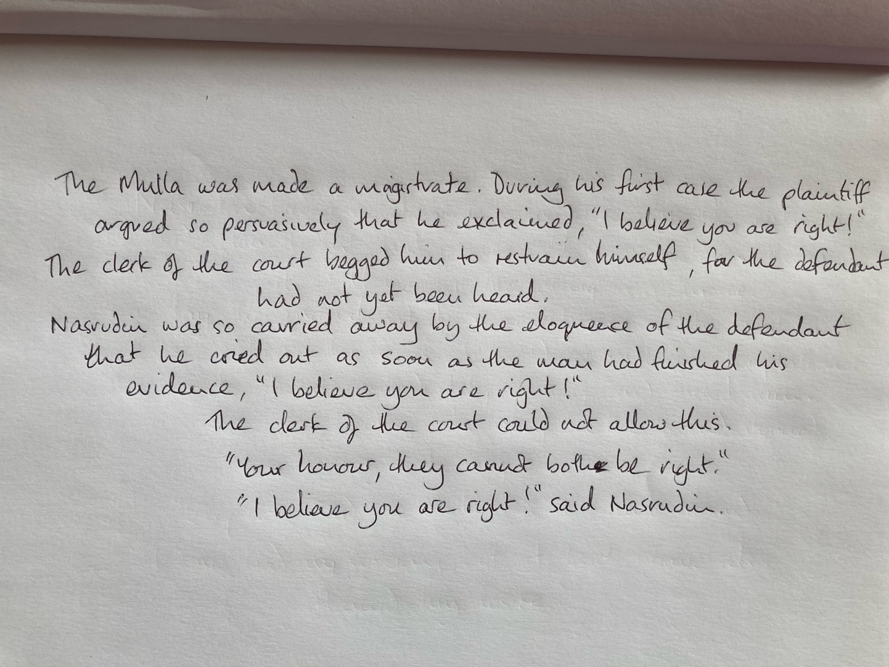
Figure 2.1: I Believe You are Right!
(Shah, 1993a, p.67)
(Appendix 2: printed words)

Introduction
This literature review describes an ideological divide that organises itself into distinct camps, each with its own set of biases and agendas. The battle between these camps, commonly referred to as the ‘cult wars’, is critically examined. Problems with terminology and definitions are explored, such as whether a group can be classified as a ‘cult’ or ‘NRM’, with a specific focus on Sufism. This process demonstrates how ideological divisions create organisational divisions, supported by academic divisions which filter down to influence clinical perceptions and therapeutic interventions for survivors of abuse in cultic, spiritual or religious contexts. Gaps in research are identified concerning therapeutic process and outcome, and the relevance of my research is highlighted.

Search Terms and Databases
Literature was selected using a varied combination of Boolean operators with the following search terms: cult; cult survivor; ex-member; new religious movement; alternative religious movement; minority religion; Sufi; psychotherapy; therapy; counselling; intervention; harm; spiritual abuse; religious trauma; religious abuse; recovery; mindfulness; meditation; transgender rights; law; legal.
Databases searched included: Google Scholar; UWTSD library; International Journal of Coercion, Abuse and Manipulation; ResearchGate; Wiley; APA PsychNet; Taylor and Francis; Springer; ProQuest and EBSCOhost.

Inclusion/Exclusion criteria
Literature produced from searches was not exhaustive and was mainly selected from the last five years for its currency and critical relevance. Some seminal texts and research papers are referenced outside of this period to contextualise and show the evolution of concepts.
While it is recognised that a good review is typically founded upon peer reviewed, academic literature, some grey literature is referenced. Thomas and Graham-Hyde (2024b) examine cult rhetoric in contemporary culture and highlight that the term ‘cult’ is prevalent in popular culture together with stories of lived experience propagated across social media and podcasts. There is a mutual influence between academic discourse and popular culture such that it is important to examine the impact and context in which cult rhetoric arises. Further, a substantial amount of heuristic research is generated through Masters and PhD theses and some are included to evidence subjective, lived experience. Because Sufism is often taught by word of mouth, unrecorded live talks are also referenced.
Extant research refers to adults who join or are recruited into cults as ‘first-generation’ survivors. Those who are born or raised in a cult are known as ‘second generation’. A ‘multi-generational’ category is also recognised (Aebi-Mytton, 2021). These latter two categories are understood to experience a different set of issues than first-generation survivors. As I fit the first-generation category, literature referencing second- or multi-generation survivors was excluded. Literature where the primary focus of the groups referenced was not spiritual or religious was also excluded.

Cult Wars
The ‘cult wars’ have been raging for decades and are fought not only in academic journals and at conferences, but also in the press, the courts and legislative arenas (Mann, 2023). Scholars are divided along partisan lines concerning how to understand and define these groups. Some perceive the flourishing of a variety of spiritual groups as a sign of healthy culture (Palmer, 2023), while others such as Kent (2023) and Baker et al. (2024) interpret their emergence as a negative sign of cultural, moral and ideological dissolution or decay. Both perspectives agree that cults satisfy essential human and social needs concerning meaning, purpose, identity, gnosis, guidance, leadership, belonging and connection, yet the fundamental root and purpose of their emergence is contested. This generates significant differences in opinion in respect of the potential for harm and the apportioning of responsibility for that harm. At the anticult extreme, the idea of ‘dangerous cult’ (Hassan and Shah, 2019) together with ‘pathological spirituality’ (Crowley and Jenkinson, 2022) persists. Some scholars transcend these polarised positions by looking for deeper, existential significance. For example, Sponholtz’s (2005) heuristic PhD research utilised a depth-psychological perspective and proposed that cults necessarily manifest within the collective unconscious from a universal and mythical intelligence and function as a brutal yet creative arena for soul-making.
Anticult sentiment has been traced back as far as 186 BC when opposition to the worshipping of Dionysus broke out (Kent, 2023). Modern-day cult wars began in the 1960s and 70s following an explosion of diverse spiritual groups in the West. Concerned with issues around pure doctrine, a counter-cult movement emerged, opposing groups perceived as sinful or an endangerment to salvation. In broader society, some groups were perceived as benign and tolerated, while others, such as the Unification Church (Moonies), the Charles Manson Family and Jim Jones’ Peoples’ Temple sparked horror and sensationalism. For example, cultural unease was generated on witnessing that Charles Manson had a devout female following even after his conviction for murder, and anticult sentiment reached fever pitch following the murder-suicide of over nine-hundred followers of Jim Jones at Jonestown. Concerned parents of adult children who had joined organisations such as Children of God, in which the sexual abuse of children was normalised, coalesced to form anticult groups. Over time, supporting academic theories of thought reform (Lifton, 1961), mind control (Hassan, 2025) and brainwashing (Stein, 2016) emerged with the idea that some kind of exit counselling or deprogramming of cult members was required. Primarily a secular concern, the anticult movement which began in the 1970s became the grass roots of the ICSA (2025a) of today. With an agenda to advance education, research and understanding of cultic influence, and assist survivor recovery, it holds conferences and promotes an emergent body of supporting academic literature in its own journal, the International Journal of Coercion, Abuse and Manipulation [IJCAM] (2020 - present).
A strong sense of activism and body of survivors remain at the core of ICSA, and cult survivors are understood as victims of manipulation, coercion and control. Other anticult organisations across the Western globe have emerged, such as Decult (2025; 2026). There are also strong links between academic members of ICSA and the development of a unique MSc programme in the psychology of coercive control at Salford University (Dubrow-Marshall and Dubrow-Marshall, 2017). The anticult movement is currently pushing hard for a change in the law concerning coercive control, first criminalised in the context of intimate partner or family relationships in the Serious Crime Act (2015). The endeavour is focussed on extending the recognition of coercive control as a crime to include groups (ICSA, 2025b). Efforts to persuade have led to extreme, alarmist conflations and lack of nuanced representation. For example, a recent article published in the IJCAM based on research by Challacombe (2022) asserts that similar dynamics and recruitment tactics, such as love-bombing and isolation, are indicative of a synergy between cultic religious groups and terror organisations – the latter often being the subject of government debate and policy. Challacombe suggests that religious cultic studies can be tapped by governments and academics to further understand the dynamics of terrorist groups. More cynically, Challacombe’s research could be interpreted as an attempt to centralise anticult rhetoric riding on the back of the fear of terrorism. At the least, there are strong agendas and biases at play here, where such conflation leads to highly charged rhetoric.
In contrasting poise, the educational charity Information Network Focus on Religious Movements (Inform, 2025) seeks to elevate itself above the political and ideological fray and claims to be founded upon a neutral, scholarly stance. Founded in 1988 as a mitigating response to the anticult movement of the 1970s (Newcombe and Harvey, 2024), it remains non-political whilst recognising and acknowledging that changes in the law may be necessary, such as law concerning coercive control, safeguarding children and vulnerable adults, rights to medical attention, habeas corpus and cooling off periods as part of consumer protection. It believes that where groups break the law, they should be prosecuted (Inform, 2025). The aims of Inform are to collect, assess and disseminate information about religious groups and other non-mainstream groups and present accurate, objective and balanced information according to the inquiry or question being asked. In this way, individuals and organisations can make their own assessment and decisions about specific issues or groups, based on their own values.
Inform’s ethos is non-discriminatory and assumes equal rights and responsibilities irrespective of beliefs. As a network, Inform seeks to sustain contact and facilitate dialogue with all groups believing that this is ultimately more productive than both direct and indirect confrontation or media attacks. The method of triangulation as a core principle engages the nuanced perspectives of other professionals, such as clergy, social scientists, civil servants, lawyers and counsellors. Unlike ICSA, perspectives are not limited to current or former group members who include survivors turned academic. On par with ICSA, Inform also produces its own literature. Their Religion at the Boundaries series (Newcombe et al., 2013-2026) offers diverse perspectives concerning NRMs and aims to foster public engagement and debate. True to the spirit of triangulation, the series includes a token amount of critical, anticult literature, such as Dubrow-Marshall’s (2024) essay on the need to recognise and label cults. In contrast, it is notable that ICSA does not currently publish any material produced by Inform or which does not align with anticult sentiment. Further, Inform had been given a platform to speak at past ICSA and Decult conferences but in recent years this has been curtailed. The justification is that it makes cult survivors feel unsafe (Hassan, 2025).
The survivor-victim narrative of feeling unsafe which shuts down alternative perspectives is a troubling dynamic that can be observed across similarly emotive social and political issues, such as transgender rights. It can lead to more hardline, entrenched and inflated, oppositional perspectives which become increasingly difficult to reconcile. As each voice becomes louder, and battles are fought through social media, nuance, diversity, inclusivity, and solution focussed debate which might foster appropriate changes in society and law, are potentially compromised. In the UK, we currently have a situation where cancel culture has inhibited free speech around transgender issues, health care provision in respect of gender transitioning is being rolled back and reassessed (Cass, 2024), and a recent change in the law (Equality and Human Rights Commission, 2025) such that transgender women can no longer automatically use single sex spaces for women and sex is now defined according to biological sex at birth rather than that recorded on a Gender Recognition Certificate (‘For Women Scotland Ltd v The Scottish Ministers’, 2025). This is a situation which completely disregards nuance around biological sex, including intersex conditions, as well as women’s rights and gender identification issues which are not limited to ideology. It ultimately complicates and restricts transgender rights. A similar situation may be evolving regarding cult survivors and the current ‘cult wars. Janja Lalich (2026) participated as a cult expert-witness in ‘Chiles v Salazar’ (2026) resulting in the overturn of a total ban on LGBTQ+ conversion therapy for minors (‘Ferguson v Jonah’, 2015). It is notable that the APA (2026) subsequently raised concern that by labelling therapy-client communication as free speech, the ruling left the regulation of mental health practitioners unaddressed.
In current anticult rhetoric, academics such as Hassan (2020; 2025) often turn to social media to attack organisations such as Inform or individual NRM scholars. For example, in a recent podcast circulated on Facebook, Hassan called NRM scholars “cult apologists that dismiss survivors and protect abusive systems” (Hassan, 2025, npa). An argument that frequently follows on the heels of these disparaging criticisms is that NRM scholars do not recognise that cults are not always spiritual or religious, but cult-like dynamics can be found in one-on-one relationships, families, marketing, celebrity, brands, entrepreneurship, self-help, wellness, therapy, intellectualism, politics and even artificial intelligence (Baker et al., 2024; Dubrow-Marshall, 2024; Hassan, 2025). However, these criticisms and arguments dismiss the subtlety and diversity behind Inform’s academic endeavour, obfuscate the core message, and inflate a counterargument in a manner and ferocity reminiscent of a tactic known as ‘Deny (or Deflect), Attack, Reverse Victim and Offender’ (DARVO). DARVO is often used to deflect responsibility and undermine the credibility of the other party in the context of interpersonal violence (Harsey and Freyd, 2020). Ironically, these tactics and criticisms from anticult academics, propagated through transient social media posts, also mimic the ephemeral influences highlighted by Crockford (2024) and which were key to the construction of the cult-like conspiracy theory QAnon. Further, a recent IJCAM paper demonstrates a similar level of perceived conspiracy, claiming that:
[there is a] network of transnational contacts and collaborations linking academic defenders of cults, libertarian think tanks, [non-governmental organisations] NGOs committed to the defence of religious freedom, anarcho-capitalist foundations, and non-governmental platforms, such as the International Religious Freedom Roundtable (IRF) […] thought to be working together to delegitimise criticism of high-demand religious groups and somehow redefine the hierarchy of rights […] a deliberate political strategy to shield authoritarian religious groups from scrutiny (Corvaglio, 2026, p.103).

By analysing the experience of cult rhetoric in therapy, my research is not part of a transnational collaboration but an individual, lived experience. Unfortunately, this risks ‘poking the anticult bear’, thereby inciting attack and inviting the derogatory label ‘cult apologist’.
The ideological positions of Inform and the anticult ICSA and Decult organisations then, generate qualitatively different literature whilst perpetuating modern-day ‘cult wars’. Just as language and definitions are core to transgender rights, they are critical to cult rhetoric and its potential social, political and interpersonal impact. Controversy persists around the use and definition of terms such as ‘cult’ or ‘NRM’ and specific concepts such as brainwashing and thought reform.

The Problem of Defining the ‘C-word’
The use of the term ‘cult’ has fuelled controversy such that those in the field often refer to it as the ‘c-word’ (Graham-Hyde, 2021). A core issue is that ‘cult’ evades clear definition and therefore lacks academic rigour. Anticult academics attempt to create definitions around the mechanics of abuse, control, manipulation, group structure and pathology of the leader. The portrayal of the leader as a traumatising narcissist is often central to the concept of ‘cult’, a concept legitimised through the DSM-5 listing of narcissistic personality disorder (NPD) (APA, 2013). NPD is characterised by a lack of empathy, grandiosity, entitlement, tendency toward interpersonal exploitation, self-importance and the projection of shamed parts of self onto others (Shalchian, 2022). It is claimed that traumatic, narcissistic abuse in cults creates a blend of dependency and adoration mixed with terror (Stein, 2016; Jenkinson, 2023) and is perpetuated through shame (Shaw, 2014; 2019; 2023; 2025). The structure of these groups is said to be sharply pyramidal, built upon a broad base of members, a close inner circle, second in command and topped by an authoritarian leader (Jenkinson, 2023). Such groups have been described more vaguely as abusive and deeply traumatising to their members through “relationship [that] seems to enforce an exploitative compliance through subterfuge” (Goldberg et al., 2017, p.xviii). Lalich defines ‘cult’ as a “closed social system featuring charismatic authority, a transcendent belief system, and systems of control and influence” (Lalich, 2004, p.17). The BITE model of authoritarian control measured against a continuum of influence (Hassan, 2020; 2023) outlines a framework of tactics used by cults to recruit and maintain control of members whereby pervasive control is exercised over ‘Behaviour, Information, Thought and Emotion’.
Most of these loose definitions rest upon dated, enmeshed concepts of brainwashing, mind control, hypnosis, thought reform and undue influence, all of which remain controversial but are continually re-hashed and recycled in anticult rhetoric. For example, Lifton’s (1961) theory of thought reform consists of eight components: milieu control; mystical manipulation; demand for purity; confession; sacred science; loaded language; doctrine over person; dispensing of existence. But these only apply holistically to the original study concerning Chinese totalism and do not consistently apply in any other context. Further, Wright (2025) references a body of empirical research dating back to the 1980s which evidenced that even the most controversial groups had difficulty holding on to their members, thereby dispelling the myth that members were unable to leave due to brainwashing or thought reform. Barker’s (1984) landmark study The Making of a Moonie: Choice or Brainwashing? demonstrated that over ninety-nine percent of new members left within two years. For those that remained, a more subtle interplay between free-will and influence was evident. Yet ICSA academic members continue to push the same narratives by reframing these concepts. For example, Corvaglia (2023) reframes brainwashing as manipulation and preference shifting, couching it in scientific terms to give the theory positivist credence. Introgvigne (2022) notes that the brainwashing-hypnosis concept returns as a convenient explanation whenever unexplainable, deviant behaviours arise. Perhaps more deceptively and in tune with the market, dated research continues to resurface in the IJCAM, such as Whitsett and Rosow’s (2026) article about thought reform, charismatic leadership and the sexual exploitation of women in cults. The article summarised Lalich’s (1997) research, which is almost thirty years old, yet is presented to coincide opportunistically with International Women’s Day in 2026.
In spite of these controversies and nebulous definitions, Dubrow-Marshall argues for acceptance of the term ‘cult’:
[It] provides a clarion call for victims as a deliberately pejorative term which is used with the intention to call out systemic abuse and coercion in groups, organizations and in societies in a similar way in which calling out specific forms of harassment, bullying and sexual assault or rape can highlight specific abuses to an individual (Dubrow-Marshall, 2024, p.96).
This is a clear expression of the anticult activist agenda, often leading to the bandying of pathologising insults which parallel those used in popular culture around narcissistic abuse. Further, Wright (2025) highlights that in the same article Dubrow-Marshall later denies that the term ‘cult’ is derogative, and notes that this kind of contradictory double-speak is prevalent in anticult forums. Critics of the term concede that it may have limited utility in enabling survivors to articulate abuse, yet avoid using it (Newcombe and Harvey, 2024) and argue that it is catch-all, loaded, value laden and othering, and can be weaponised to delegitimise and potentially disband any group one does not like. Problems occur due to a rise in academics using the popular term without awareness of the consequences. Not only is it harmful when it negatively demarcates minority religions and conflates them with danger, it can be used to sweep spiritual and religious experience under a rug (Thomas and Graham-Hyde, 2024b). Calling for an end to its use, Graham-Hyde (2021) asserts that ‘cult’ is not applicable to religious groups in the present day and its use merely reflects the author’s position and bias. Divided opinion concerning the term ‘cult’, has led to the evolution of alternative terms.
The term ‘high demand group’ (HDG) has been used as a more precise and seemingly less pejorative label than ‘cult’. However, Laycock (2024) notes that the terms are used interchangeably and this merely creates an illusion of scholarly expertise whilst it conceals underlying prejudice. The academic use of the term NRM evolved to recalibrate and refine discussion around religion as it intersects with the individual (Graham-Hyde, 2021). However, there are also problems and ambiguities surrounding this term (Newcombe and Harvey, 2024). Some scholars assert that NRMs are alternatives to mainstream religion, whilst others define them as emergent. Chryssides (2016) defines them as religious, having taken root within the past one-hundred-and-fifty years, and which operate separately from the main culture. Critics, such as Kent (2023), argue that many religious or spiritual groups are not new and asks when does a group stop being new? Many groups are multifaceted and transnational, with only a part-emphasis on religion. Further, the word ‘movement’ usually describes an effort toward particular social goals and often comprises many different organisations. Thomas and Graham-Hyde (2021; 2024) regard the term NRM as unfit for purpose and propose ‘minority religion’ (MR) as an alternative. MR might be conceived of as groups other than the five main religions: Christianity, Islam, Buddhism, Hinduism and Judaism. However, it could be argued that with increasing globalisation, it may be difficult to culturally distinguish between ‘mainstream’ and ‘minority’. Also, given the Western interpretations of Buddhism, or the different expressions of Christianity, for instance, the question of pure doctrine further complicates any definition. Such disparity and ambiguity in definitions potentially allows preexisting biases to determine classification (Patel, 2021). These issues arise when attempting to categorise and define Sufism, the spiritual path at the centre of my research.

The Problem of Defining Sufism
Sufism eludes definition and most attempts rest upon external, observable phenomena. In respect of doctrine, scholarly debate persists concerning whether Sufism is at the core of Islam, extra-Islamic, or entirely separate (Dickson, 2022). Viewed through anticult lenses, the association with Islam can lend Sufism to interpretation as a dangerous cult. Entrenched, Western Islamophobia and the association between Islam and terrorism was exacerbated after a terrorist attack in 2001 destroyed the twin towers of the World Trade Centre. The conflation of dangerous cult with fringe Islamic groups features in many anticult academic papers, such as Crowley and Jenkinson’s (2022) Pathological Spirituality. Attempts to mitigate these associations are often still rooted in prejudice. For example, Dickson (2022) notes that after the American ground-zero-mosque event in 2011, the investigation strived to distinguish Sufi Muslims from other Muslims on the perceived basis of them as a Western, hybridised group.
Indeed, Sufism has spread in the West. Dickson (2022) notes that while some groups identify as Islamic such as the Shadhiliyya Order in America or the Alawiyya in France, others, such as the Inayati Order have centres across the Western globe. The Inayati Order teaches that Sufism can connect to Islam (observing practices such as prayer and Ramadan) but remains independent and initiates can practice Sufism in the context of whatever faith they already belong (Khan, 2022). Further, the Inayati order originates from India and culturally intersects with Hinduism. The perceived connection with Islam and Hinduism then, which both belong to the main five mainstream religions, frustrates the potential categorisation of Sufism as a MR or NRM.
This frustration amplifies with the question of whether Sufism can be considered new, especially where groups attract the label neo-Sufism (Asbury, 2024). The Pir of the Inayati Order states, “Sufism […] is not a religion nor even a cult with a distinct or definite doctrine. No better explanation of Sufis can be given than by saying that any person who has a knowledge of both outer and inner life is a Sufi. Thus, there has never at any period of the world’s history been a founder of Sufism, yet Sufism has existed at all times” (Khan, 1990, p.282). Asbury (2024) suggests that newness is not necessarily identified by new innovations in doctrine but breaks from traditional understanding may also indicate newness. Individuals constantly engage with religion and spirituality in new ways (Asimos, 2024) and throughout the history of Sufism, the spiritual revelations of saints understanding continuously unfold. However, a focus on mysticism at the core of Sufism reveals continuity between the present day and distant past (Asbury, 2024). These understandings can only be accessed through experience, and Sufism is a mystical journey of the heart. Experiential research, such as DiPippo’s (2024a; 2024b) foregrounding of the heart as an organ of perception and anthropological study of a Bakshir Sufi group, is extremely sparse. My research addresses this sparsity. Moreover, the disparity between spiritual and rational modes of perception, a core element of my heuristic research, is apparent here.
Whilst the spiritual encompasses unity, the rational leans toward separation and othering. The Inayati Pir claims that Sufis do not need a name and do not call themselves anything – it is other people who call them Sufis (Khan, 2026). Further ‘Sufism’ is a neologism, or misnomer, since ‘-ism’ connotes ideology, doctrine or closed community. The original Arabic word ‘tasawwuf’ is more accurate and pertains to a dynamic process of becoming. Sufism is not an organisation to which one belongs, but a transformative experience unique to the individual, with practices adapted to the culture and moment in time in which it emerges (Khan, 2005). This would seem to parallel Roger’s (1961) humanistic concept of becoming a person. Viewed through anticult lenses, however, the pyramidal structure of any Sufi group, with a Pir at the top, might lend itself to interpretation as a cult. Further, the process of the Sufi path involves the seeker cultivating an attitude of humility, devotion and idealisation. Through this the seeker becomes a devotee and merges with the love of the Pir. This is followed by a merging with the love of ‘rasul’ (the personification of divine light and guidance) which finally leads to merging in the love of God. Ultimately, the devotee themselves becomes love and a source of divine love (Khan, 2022). Increasing levels of acceptance imbue this process. At one stage the devotee accepts both love and poison with equanimity (Khan, 2022). For the devotee, this is liberating. However, from an external, anticult perspective, the pyramidal structure, seemingly transcendent belief system, combination of love and poison, and process of merging with the Pir might be seen as a pathological, funnel-like process of indoctrination, and opportunistic for an exploitative, traumatising, narcissistic leader.
How Sufi groups are defined then, and whether emic or etic analysis is appropriate (Westbrook, 2024), is highly problematic. Moreover, ideological divisions between NRM and anticult scholars influence clinical perceptions of survivors of abuse in these environments and the therapeutic approaches that are evolving to support this population.

The Problem of Defining Cultic, Spiritual and Religious Abuse
Whether an adverse experience is defined as cultic, spiritual or religious abuse reveals underlying bias and can influence clinical perceptions of the survivor and therapeutic approaches.

Religious Abuse (RA)
Anderson, a co-founder of the Religious Trauma Institute (RTI) (Anderson and Peck, 2025), defines an adverse religious experience (ARE) as:
[…] any experience of a religious belief, practice, or structure that undermines an individual’s sense of safety or autonomy and/or negatively impacts their physical, social, emotional, relational, or psychological well-being. For example, fear of hell or eternal conscious torment, purity culture (especially around sex and abstinence), alter calls, healings, scary sermons, spanking and corporal punishment, patriarchy and oppression (Anderson, 2023, p.53).

Abuse may be exploitative, sexual or ideological and perpetrated in ways that mirror domestic abuse. The Duluth model of power and control (Domestic Abuse Intervention Program, 2025) is mapped onto RA, outlining a cycle of phases: love-bombing, tension building, explosion and honeymoon, where seemingly benign behaviours become mechanisms of control over time. Whilst the theory of RA seems to align with concepts of coercive control underpinning anticult rhetoric, they recognise that much of what is perceived as proper or improper is culturally defined. They note that for some, religion is regarded as essentially traumatising and embracing atheism is part of recovery. However, the impact of leaving a religion may also be traumatising (Dille, 2023). Primarily aligned with Christianity and abuse within mainstream religion, the RTI approach to recovery is not anti-religion, but seeks to maintain and repair the survivor’s relationship with religion or spirituality. This validation of mainstream faith aligns with broader cultural bias - it is acceptable for the survivor to remain in the church, move to a different church, or find a new understanding of it without disparaging or uprooting their fundamental faith. In terms of healing, some suggest it is possible to use counselling and other forms of support to remain in the group or community (Swindle, 2023). Spiritual abuse is perceived similarly, with respect for client faith and autonomy.

Spiritual Abuse (SA)
In some contexts, spiritual and religious abuse are interchangeable terms. However, anticult rhetoric intersects with SA, with some cult-recovery therapists, such as Jenkinson (2023), now using the term. Damgaard (2021) favours the term SA over cultic abuse because it more closely describes a concrete experience. Further, by including mainstream religion, it embraces a wider population. Those who leave Christian groups or other mainstream religions do not perceive them as cults. Both terms refer to manipulative, exploitative environments, but spiritual abuse suggests that one’s spirit or inner core, and one’s relationship to God has been deeply wounded. The types of abuse experienced could be understood and treated as specific issues, such as sexual and financial abuse, or even coercive control and narcissistic abuse, since these occur in many social contexts and relationships. However, because spirituality and religion are perceived as protective factors in counselling (Dille, 2023) and the trauma is inherently connected to their spirituality, Anderson (2023) asserts that there are unique elements which can complicate the healing process.
Clinically, survivors are perceived as potentially presenting with a wide variety of symptoms, such as anxiety and depression, identity issues, loss, grief, shame, issues around sexuality, PTSD and C-PTSD. Clinical perceptions of survivors of abuse defined as ritual or cultic include these, yet exhibit more extreme bias.

Ritual abuse (Rit.A)
Rit.A is sometimes referred to within the concepts of religious, spiritual and cultic abuse. All these perspectives acknowledge that it is a subject surrounded by controversy and disbelief. This is especially true of satanic ritual abuse, where it is claimed that teenagers are used to breed babies for torture and ritual sacrifice (Ross, 2017). The concept of Rit.A is underpinned by a theory of mind control which involves a deliberate, traumatic engineering of the personality, splitting it into ‘alters’, programming these to become obedient and implanting false memories and triggers (Miller, 2024). It is claimed that this can lead to dissociative identity disorder (DID). Although DID is listed in the DSM-5 (APA, 2013) it remains a controversial diagnosis. Trauma from Rit.A has been described as a “culture-bound condition, uniquely born out of the subculture of isolation, torture, religious indoctrination, and coercive programming, inherent in ritual trauma and mind control, understandable only in that context” (Lacter and Lehman, 2018, p. 115). However, given the controversies around defining groups, any clinical diagnosis formed by association and definition of a group is spurious. Yet it persists in the concept of Rit.A and cultic abuse.

Cultic Abuse (CA)
The co-authors of Pathological Spirituality (Crowley and Jenkinson, 2022) claim that clinical diagnosis is dependent on determining whether symptoms have been induced by cultic influence so that appropriate treatment is given. Suggesting that survivors typically present with PTSD, dissociative disorders, and other stress disorders, they reference the Other Specified Dissociative Disorder 300.15 (F44.89), described in the DSM-5 as:
[…] identity disturbance due to prolonged and intense coercive persuasion: Individuals who have been subjected to intense coercive persuasion (e.g., brainwashing, thought reform, indoctrination while captive, torture, long-term political imprisonment, recruitment by sects/cults or by terror organisations) may present with prolonged changes in, or conscious questions of, their identity (APA, 2013).

These fundamentally pathologising, clinical perceptions are a feature of anticult rhetoric, where the trauma from cultic abuse is presented as extreme and manifesting in culturally epidemic proportions. This is exemplified in Healy’s (2017) assertion that post-cult C-PTSD is uniquely and especially traumatising. Giving his work positivist validation, Healy draws on the work of Herman (1997) and Van der Kolk (2015) - who, at that time, represented the latest neuroscientific understanding of trauma - to embellish concepts at the root of anticult rhetoric, such as thought reform, mind control, and coercive control. He claims that victims often present in therapy suffering from a loss of safety and trust, heightened reactivity to triggers, phobic avoidance, chronic hypervigilance, dissociation, difficulty regulating emotion, identity fragmentation, susceptibility to external control, impaired critical thinking and decision making, installed phobias and superstitions, and somatic or motor issues including numbness, paralysis, or coordination. While this paints a pathological picture that Healy claims clinicians should assume, he gives out a mixed message by suggesting that any treatment and therapeutic relationship should be non-pathologising.
Expanding cult-survivor pathology into a cultural concern, Healy asserts that “multiple studies have concluded that the prevalence of PTSD is greater for former cult members than for any other specific population” (Healy, 2017, p.60). Comparing statistics from other studies, he asserts that:
[…] while lifetime PTSD prevalence is 6.8 percent in the general population and 10-25 percent among post-deployment military personnel, studies of former cult members report rates of 28-44 percent in Spain and over 60-70 percent in U.S. samples (Healy, 2026, npa).

However, both general and ex-military populations are broad and easily identifiable. It must be remembered here that ex-cult members are not easily identifiable, those that leave organisations that may be perceived as cults are a silent majority, and those that are seen to identify as cult survivors are estimated to represent less than 0.23 percent of this demographic (Chrissydes, 2024). Healy’s proportional representation of statistics then, is highly misleading. The combined distortion of statistics and amplification of pathology, and regurgitation of this somewhat dated research in the latest ICSA journal (Healy, 2026), sensationally promotes the anticult activist agenda. The implicit messaging is that there is an alarming social problem with cults causing significant harm and cult-competent practice and awareness is much needed.
That cults present a massive, unrecognised public health issue and create trauma and mental health issues that last a lifetime is often articulated by public speakers, authors and journalists, such as Richter (2025), and academics, such as Parsons et al., who describe unseen CA as producing “profound, lasting, detrimental emotional, cognitive, social, practical, physical and behavioural effects” (Parsons et al., 2020, p.2). However, since only detailed scrutiny can reveal these distortions and biases, it is highly concerning that academic articles such as Healy’s are written to inform a wide professional sector spanning mental health, social work, pastoral care, victim support and advocacy services. This kind of anticult, academic bias is also frequently used to inform or develop counselling approaches and specialist counselling training.

Therapeutic Approaches
I think it is really important to use the cult word. I managed to get away with using it in my PhD. I think my university didn’t know enough about it, so I got away with, ‘What helps former cult members recover?’. You know, I was in a cult. And there has been no training for therapists, and that’s probably true worldwide. So, I set off on this road (Jenkinson, 2025a, npa).

Addressing the Decult (2025) conference, Jenkinson’s statement proclaims anticult agenda and bias and, aware of the controversy around using the term ‘cult’, raises fundamental concern around academic credibility. A self-identified cult survivor, academic, therapist, member of ICSA and cult ‘expert’, Jenkinson increasingly appears in documentaries about cults, such as Inside the Cult of the Jesus Army (2025). Building on her PhD research Jenkinson (2016) developed a specialist framework for counselling cult survivors called Post Cult Counselling (PCC) and a specialist training for counsellors in using this framework. Her book Walking Free from the Trauma of Coercive, Cultic and Spiritual Abuse (Jenkinson, 2023) is designed for survivors, therapists and other health and social care professionals. PCC is rooted in theories of thought reform, brainwashing, traumatic narcissism and undue influence. Expanding on these, Jenkinson developed the concept of ‘confluential trance’ whereby the member develops cult-aligned introjects such that a pseudo-identity develops, overlaying their true identity (Jenkinson, 2019b).
PCC is a linear, phased approach. In the first phase, it is emphasised that the member must physically leave the group. The second phase is focussed on psychoeducation and leaving psychologically. To discover what the cult has done to them, the client tells their story into a series of concepts, including thought reform, narcissism and confluential trance. Emotional healing in phase three includes processing shame, loss, grief, C-PTSD, and looking at pre-existing vulnerabilities. Through these processes, the client deconstructs indoctrinated teachings as well as the cult pseudo-identity and begins to reconnect with their authentic self. In the last phase, the client is assumed to have stopped blaming themselves and got rid of the cult personality. Post-traumatic growth may occur with the flourishing of the authentic self which has been revealed.
There are many biases and assumptions in the PCC framework, which minimise client autonomy and faith. Unlike approaches to RA or SA, where healing approaches are open to the survivor remaining in the group, PCC is a secular endeavour which assumes that recovery is dependent upon the member leaving the group. It is suggested that an ex-member is vulnerable to being recruited again, or by other cults, if the PCC process is not completed or the ex-member is not given the ‘right’ support. This is labelled ‘cult hopping’, which carries recidivist undertones. Rooted in questionable theories of thought reform and brainwashing, the model is inherently pathologising. Jenkinson (2023) concedes that a client may not see the relevance of certain concepts in the model, but rather than respecting the client’s insight, suggests that they should spend more time reflecting to discover the relevance. The implicit messaging is that the client holds faulty belief systems, which need to be undone or replaced with ‘healthy’ ones. This prejudice is not too distant from that underpinning cult interventions in the 1960s and 70s where members would be kidnapped and subjected to a deprogramming process. Further, Jenkinson asserts that the model is suitable for people who self-identify as cult survivors. This implies that the client has already explored and come to some understanding about what has happened to them. Yet the model is designed to both initiate and facilitate this understanding. What are the implications then, for a client who knows little about counselling or seeks to integrate a dichotomous experience? The latter is a core component of my HSSI.
There is an assumption of shame, vulnerability and lack of sense of self. The PCC model rests upon a Western, egocentric sense of self, which is incompatible with more expansive, spiritual and religious concepts of self and unity. The client is funnelled through a process of deconstruction, not just around personality, but also spiritual experience; they are potentially psychoeducated until they accept that the cult “sold [them] a lie” (Jenkinson, 2025b, npa). The corollary is apostasy.
Crowley and Jenkinson (2022) state that the latest research shows that the phased approach is fundamental to recovery. However, this latest research is not evidenced. Approaches to recovery from RA and SA are more flexible and encompass faith and spirituality. For example, Farrel (2025) suggests that eco-spirituality can facilitate grounded spiritual experiences as part of recovery from RA. Zhao (2022) hypothesises that Internal Family Systems, which has a strong spiritual component, may be an effective way to treat victims of religious trauma suffering with PTSD or C-PTSD, by facilitating continued engagement with spirituality. All these approaches claim to be evidence based. However, the evidence base usually resides in the shared, trauma-informed dynamic and where the buzz-phrase ‘latest neuroscience’ appears. Moreover, a scoping review by Zeaske et al. (2024) exposed a dearth of research concerning the outcome and process of interventions across the whole spectrum of RA, SA, CA, and adverse religious and spiritual experiences (ARSEs). Most studies consisted of PhD or Masters qualitative research, where the impact of therapy was not the focus and was discussed tangentially, in relation to harm from the adverse religious or spiritual experience. My research addresses this research gap by directly exploring the experience of therapy.

Conclusion
The ideological divide that perpetuates the modern day ‘cult wars’ creates rhetoric that filters down to influence clinical perceptions and therapeutic approaches toward the survivor population. This review has exposed controversy and bias around definitions and categorising groups, with a more detailed focus on Sufism. Critical examination of concepts around RA, SA, and CA, and theories underpinning anticult rhetoric, such as brainwashing and thought reform, reveal a cluster of issues concerning bias and respect for client autonomy and faith, which pose ethical concerns for the counselling profession. A significant gap in literature exists concerning process and outcome of therapeutic approaches for survivors. Research is particularly sparse concerning the client experience of such therapy. My heuristic research addresses this gap and explores the experience, implications and potential consequences of cult rhetoric in therapy for the client.

Methodology

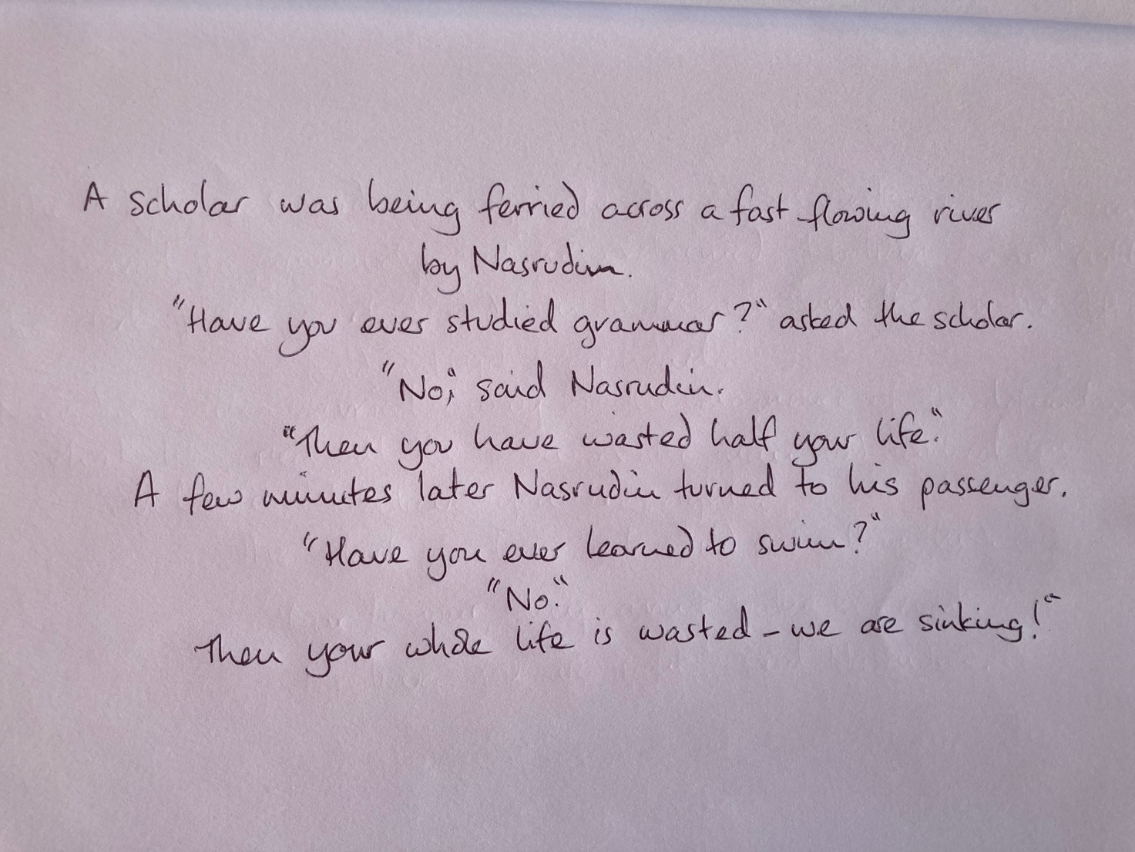

Figure 3.1: The Scholar and the Boatman
(Shah, 1983, p.27)
(Appendix 3: printed words)

Heuristic Inquiry
Heuristic inquiry (HI) is a qualitative research methodology, outlined in the first instance by Moustakas (1961; 1990), which involves a deep dive into the self to discover the nature of a human experience or phenomenon. Positioned within the realm of social constructivism, the creative process presents a direct challenge to positivist perspectives. In conceptualising HI, Moustakas (1990) cites several formative influences: Gendlin (1981) and the concept of focusing and the felt sense; Buber (1970) with the concept of the I-Thou relationship and sense of betweenness; Maslow’s (1956; 1971) theory of self-actualization; the person-centered ideology of Carl Rogers (1961) and idea of the actualizing tendency; and Polanyi’s (1966; 1969) concepts of tacit, inner knowledge, indwelling and internal frame of reference.
Moustakas (1990) outlined six stages of HI: initial engagement; immersion; incubation; illumination; explication; and creative synthesis. During initial engagement the researcher engages with an issue that has “personal and compelling implications” (Moustakas, 1990 p.127) to distil the focus of inquiry and research question. During immersion, the researcher becomes absorbed in the focus of inquiry, attuned to and engaging fully with their inner and outer experiencing. Incubation entails stepping back from the intense focus, allowing the experience to settle so that meanings emerge. Illumination is marked by clarity or revelation, and initial understandings may be reframed. Themes emerge and meanings are examined and depicted in the process of explication. The whole experience is then expressed through creative synthesis, and the researcher can address the initial question.
The process is non-linear, and several concepts underpin and deepen it: identification with the focus of inquiry; self-dialogue; tacit knowledge; intuition; indwelling; and focusing (Moustakas, 1990). The researcher demonstrates a holistically passionate interest in the focus of inquiry, which may have social or universal significance. Self-reflective methods are employed here such as journalling, and a review of extant literature can situate the inquiry within a broader social context. Self-dialogue occurs in a state of attuned receptivity and often involves creative processes such as art, songwriting or poetry. Tacit knowledge emerges as the researcher accesses hidden, creative sources of energy. This results in revelation and can induce a sense of unity. Moustakas describes intuition as a “bridge between the explicit and the tacit” (Moustakas, 1990, p.23) and essential “to the subject of scientific enquiry and of the holding of scientific knowledge” (Moustakas, 1990, p.23). Indwelling entails turning inward to seek qualities or themes of experience. Throughout the HI process the researcher turns inward and outward until the experience can be explicated externally (Sultan, 2019). Focusing assists the process of identifying connecting feelings and thoughts and refining meaning and perception according to internal shifts. Emergent material engages in a cyclic process with the researcher’s internal frame of reference which catalyses self-reflexivity and deepens understanding.
Since Moustakas, HI has been critiqued and further evolved, with each critique signifying shifts in philosophical awareness. Sela-Smith (2001; 2002) critiqued Moustakas’ use of co-researchers, suggesting that an ambivalent model was created in this attempt to avert criticism from positivist perspectives combined with unconscious resistance. Instead, she proposed HSSI - a total surrender to the subjective, feeling self, as a form of self-therapy. She reframed HI concepts as self-experience, inward reach, surrender, self- dialogue, self-search, and transformation (Sela-Smith, 2002), and emphasised the need for reflexive awareness of resistance. Her perspective aligns with a popular concept of that time – one can change the world by changing oneself. Kenny (2012) offered a postmodern critique and raised concern around how language distances the researcher from inner experience. Sultan (2019; 2020; 2024) re-emphasized the relational dynamic between co-researchers. He proposed that HI bridged the gap between counselling research and practice and could also be used within contemplative practices.
Expanding contemplative practice, Kilrea and McCaslin (2020) proposed that deep heuristics are possible, whereby the six stages of HI transpose to deep ecological engagement, deep immersion, creative transcendence, enlightenment, revelation and cultivating creative synergy. Tudor (2023) amalgamated all these concepts to date with the element of social justice to create an overall framework, proposing a shift from the concept of the “I that feels” to the “We who care – and act”. These shifts since 2019 are in alignment with an emergent, metamodern and posthuman paradigm shift whereby concepts of power, self and individuality are fluid, processual, interdependent and co-created contextually between both human and non-human entities (Nayar, 2025). Within these shifts the concept of transcendence persists in an embodied and grounded form (Severan, 2022), and new epistemologies emerge that move away from absolutes and embrace fluid and soft universals (Storm, 2021). In terms of therapy, there is an alignment here with Carl Roger’s (1961) humanistic concepts around self-actualization and self as a process of becoming.
I align with these paradigm shifts. Moreover, Najafi et al. (2025) draw a direct comparison between HI and Persian Illuminationism, which is saturated with Sufi concepts and poetry, and Cardo and Tudor (2024) draw a parallel between the stages and process of HI with the Sufi purification of the spiritual heart. This resonance potentially amplifies my personal agency and deepens my research process. HI has been used to explore issues that intersect with spirituality. For example, the practicing of presence and experiencing holiness (Inglis, 2021) and the phenomenology of making art from a spiritual perspective (Kawka, 2024). As well as its utility in exploring spirituality and lived-experience, HI can navigate the researcher’s own liminal identity. For example, one researcher placed themselves between “identities as a British white female, a convert Muslim, a Transactional Analysis psychotherapist, and a trainee Islamic psychotherapist” (Cardo and Tudor, 2024, p.84). My identity, as expressed in the introduction, is similarly liminal. This, together with the broader convergence of epistemologies, makes HSSI the most fitting methodology for this research.

Limitations and Critiques of HI
Some of the critiques and limitations of HI can be interpreted as strengths. For example, Milahache (2019) claims that HI is not situated within a clear philosophical frame, yet this flexibility allows HI to creatively engage with the unknown and evolve alongside significant paradigm shifts, such as the metamodern and posthuman, described above. HI has been critiqued as fostering narcissistic preoccupation, or privileging solipsistic narratives (Etherington, 2004), and revealing difference rather than similarity (Sage, 2019), yet HI celebrates difference, lived experience, and unique intersectionality, as does the metamodern paradigm (Storm, 2021). It has been suggested that HI lacks objectivity since studies cannot be replicated (Archibald, 2024) and small sample sizes mean that results cannot be generalised (Silvia, 2023), but many may resonate with the findings.

Ethics
Ethical approval was granted by UWTSD. The researcher being the only participant in HSSI necessitates ethical consideration regarding self-care, confidentiality, General Data Protection Regulation (GDPR), mitigating bias and ensuring academic rigour.
HSSI creative processes can result in raw data in the form of physical or digital artwork and/or a reflective journal. As researcher and sole participant, I had full control of the data. To mitigate the risk of transfer of data, physical data were locked in a home filing cabinet. Digital data were stored on my password-protected laptop, kept at home and only used at home and university and backed up on the UWTSD Office 365 cloud which is encrypted, password protected and uses a double authentication process.
The researcher as participant has a responsibility to keep some data confidential and safeguard themselves from potential harm (Yin, 2014). I had full control over the data and was mindful of what personal information to include in the dissertation. My dissertation in progress was only shared with a critical student peer and academic supervisor, both bound by professional policies concerning confidentiality. The dissertation was submitted through the secure UWTSD Turnitin portal on Moodle and a redacted version stored in the university repository. To protect the anonymity of others, such as my personal therapists, I applied practices used to protect anonymity as in all types of research, such as non-disclosure of personal details, life events, circumstances, and geographical locations. (Saunders et al., 2015). Degendered language was also used.
HSSI has the potential to create emotional distress and sensitive issues may arise. However, this research involved a historical issue and as a trained counsellor I am proficient in processing emotions and detecting distress early. As both researcher and participant I had full control concerning the direction and process of the HSSI. I also had the support of both my placement and academic supervisor, who are both professional counsellors. I had an arrangement with my therapist whereby I could have a session at short notice should I need it. Self-care is core to the HSSI process, and I maintained a healthy routine of swimming, good diet, adequate sleep, and a balance of social activities.
Mitigating bias and ensuring academic rigour are ethical considerations applicable to all research methods. With this objective, HI is often paired with another method of analysis, such as Braun and Clarke’s (2021) thematic analysis (TA). I considered using TA but did not feel this was appropriate as it disrupted the immersive flow of my heuristic process. Moreover, HSSI functions as a pure, stand-alone method (Butcher, 2024) wherein themes emerge organically (Ozertugrul, 2017). To mitigate unconscious bias, I regularly shared my process, raw data and emergent themes with a trusted student peer. They challenged me by asking critical questions and reviewed my creative synthesis and themes to confirm that I had captured the full experience. Further, I engaged with a diverse spectrum of literature to produce the critical literature review. Engaging with this material, and an additional array of literature for the discussion, also ensured academic rigour. Rigour is integral to the cyclic, disciplined and systematic HSSI process, whereby themes and meanings emerge and are repeatedly returned to, producing insight and personal transformation.

Data Collection and Analysis
Using Moustaka’s (1990) six stages of HI, I conducted an HSSI between November 2025 to April 2026 to produce raw data. A reflective journal was kept (Appendix 4) and a variety of artwork produced. From the raw data, themes emerged as part of the pure heuristic process (Butcher, 2024) and were refined, amalgamated and named (see process example in Appendix 5). A creative synthesis was produced to capture the full experience. The creative synthesis and themes are presented in the next chapter.

Findings

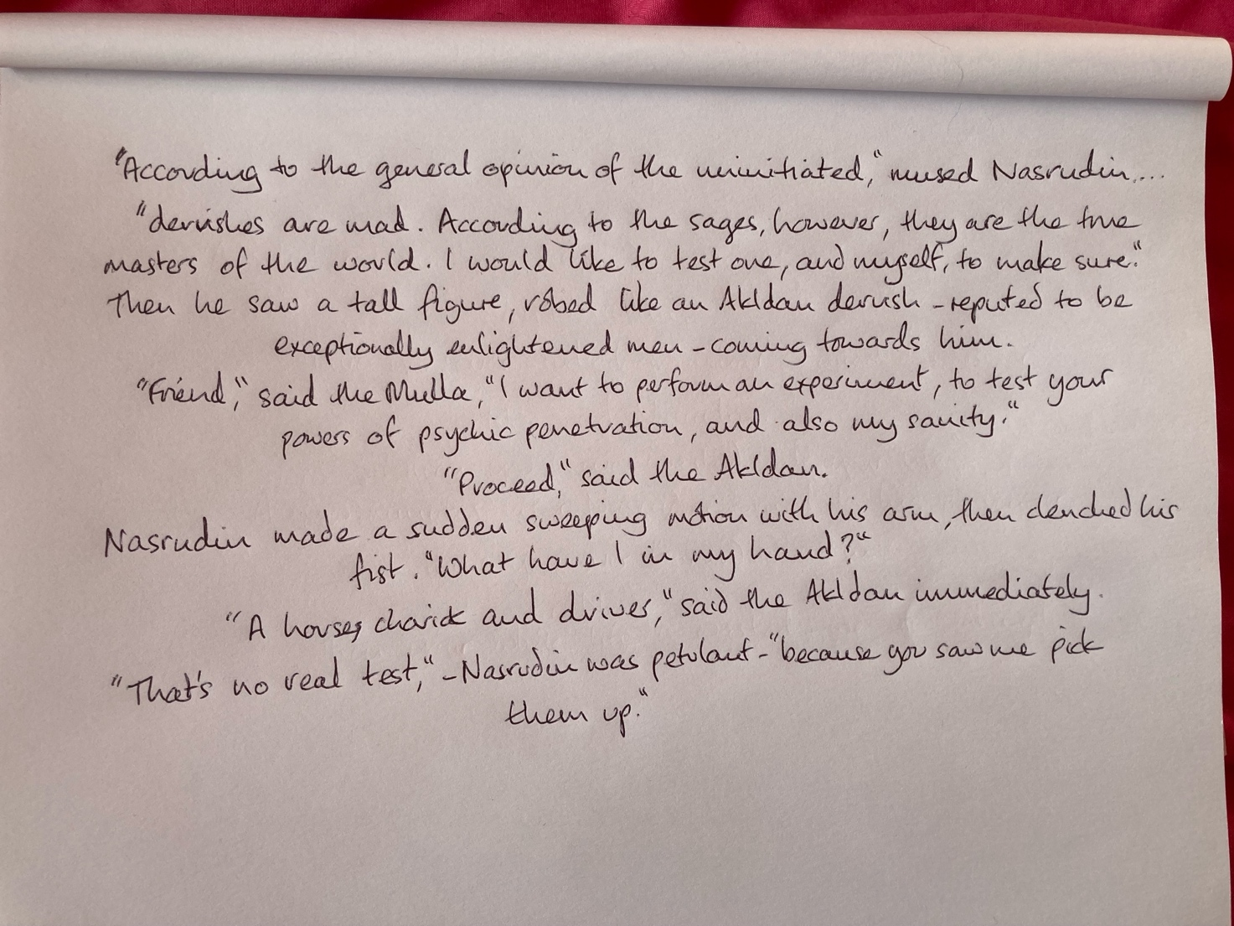

Figure 4.1: The Test
(Shah, 1993a, p.79)
(Appendix 6: printed words)

Themes
‘Smoke and Mirrors’ idiomatically describes acts which obscure, inflate or embellish the truth. As the overarching theme, it is a metaphor for the essence of my encounter with cult rhetoric in therapy, comprising four main themes, each having its own ‘cluster’ of sub-themes. For clarity and transparency, Table 4.1 presents a breakdown and interpretation of these, with example extracts from my reflective journal (Greener, 2026).
Table 4.1: Breakdown of Themes
Smoke and Mirrors
(overarching theme)
Main Theme | Sub-theme | Example Journal Entries | Interpretations
Therapy Mirrors Cult | Thought-stopping Clichés | If I expressed desire to belong to a Sufi group again, I was seen as vulnerable to ‘cult hopping’ (p.35)  Labelling something as a cult shuts down the possibility of nuance (p.21) | Shuts down exploration of feelings, certain topics and potential for nuance. Mirrors thought stopping clichés said to be mechanism of mind control in cults.
Therapy Mirrors Cult | Loaded language | The word ‘cult’ is loaded…why do I have to take on all that negative social conditioning associated with it? (p.9)  Narcissism is a loaded word too -its alignment with the dark triad! (p.9) | Works together with thought-stopping clichés. Vague, nebulous meaning. Inflates sense of horror. Mirrors loaded language said to be feature of thought reform.
Therapy Mirrors Cult | Black and White Thinking | In a cult it’s a ‘them and us’, black and white situation. Now I’m on the other side of the fence, I am asked to do the same thing in reverse. Align with this perspective, not the ideology in the group. This is good, that is bad (p.6)  Of the workbook…I felt I was being led into a one-sided perspective…What is drawn attention to, it leads and limits a person, like Core 10 – all the questions are negative (p..8). I had to split myself to fit the narrative of having been in a cult (p.20) | Restrictive thinking. Leading questions. Othering. The projection of all that is perceived as bad onto the ‘other’. Precludes nuance and integration. Creates ‘splits’ in self. Mirrors concept of black and white thinking and ‘splitting’ said to happen in cults.
Therapy Mirrors Cult | Fear Inducing | Using labels [such as modern slavery, mind control, brainwashing, spiritual rape, narcissistic abuse] created and then amplified feelings of horror! (p.9) | Extreme, sensational labels create distortion and fear. Mirrors fear said to be mechanism of control in cults
Therapy Mirrors Cult | Exploitation and Manipulation | Paying for therapy felt exploitative, when there were increases in fees in the middle, and a massive hike after I took a break (p.6). The demand on my time, expectation of coming every week. The therapist said I wasn’t ready just to come once a month (p.18) | Inflexibility in therapeutic frame. Feelings of being exploited whilst therapist creates dependency. Mirrors incremental financial abuse in cults.
Therapy Mirrors Cult | Projection | I was having to fit into their frame of experience. They would project their own experience onto mine, even spiritual experience (p.13)  The victim-perpetrator dynamic is perpetuated. The poor innocent member is exploited and abused by the nasty, traumatising, narcissistic leader. It doesn’t account for my agency (p.33) | Lack of respect for or inability to work with client internal frame of reference.  Projection of all that is bad onto cult leader. Mirrors said narcissistic abuse of cult leader. Keeps client stuck in ‘doer-done to’ perspective.
Therapy Mirrors Cult | Recruitment | The ‘call a cult a cult’ ideology felt like I was being asked to subscribe to some form of activism…a subtle form of recruitment, that wasn’t my agenda (p.21)  I was fed a lot of material and introduced to organisations, like ICSA -it was a big club. But you can’t disagree with ICSA without being called a cult apologist or propagandist (p.15)  The therapist responded with positive emotion to certain things, like reporting the leader, calling me brave. But I only did that because I felt threatened by the safeguarding issue they raised (p.21) | Cult rhetoric, ideology and activist agenda enter the therapy room.  Creating sense of belonging. Difficult to challenge ideology of group  Mirrors said cult recruitment and milieu control.  Subtle manipulation – emotional reward for activist-aligned behaviours.
Therapy Mirrors Cult | Pathologising | I only felt seen through the lens of trauma (p.8) There was an assumption that I had shame and trust issues (p.30) I felt like therapy demanded I give up my spirituality…exposing it as ‘pseudo’ (p.28). It was all framed in terms of trauma, abuse, control, and the pathology of the leader and the pathology of my relationship with them (p.22) | Pathologising tendency is disempowering and harmful. Can cause internal split – denial of parts of self. Qualities and strengths not seen. Potentiating relationship not acknowledged.
Therapy Mirrors Cult | Framing of Experience | My experiences were framed in an extreme way. They would interject to label things while I was talking about my experiences (p.3). My profound spiritual journey was interpreted as hypnosis and dissociation (p.4)  Psychoeducation described brainwashing, thought reform, dissociation - the therapist created a frame and a picture to go in it (p.4)  They said, ‘Your trauma is on the high end of the spectrum’ (p.10) | Subverts client from making own meanings. Monopoly on truth. Diminishing/stripping of faith. Defining inner experience is therapist abuse of power.  Mirrors said cult monopoly on truth and shaming/pathologising of members.
Therapy Mirrors Cult | Religious Prejudice | One therapist said, “Sufism is Islam, isn’t it? How on earth did you get mixed up in all that?!” (p.19). There was an evasion of cultural awareness and sensitivity. They neglected to enquire about Sufism. They saw my wearing a hijab as oppression and control by the group, but it was a personal choice (p.19) | Islamophobia. Dangerous cult association. Lack of cultural awareness, intersectional identity, and lack of respect for client autonomy and faith.
Therapy Mirrors Cult | Harm | There was fallout from a safeguarding issue. The leader was arrested, but it went nowhere. It gave the group more ammunition and destroyed all hope of keeping channels of communication open. Multigenerational links were destroyed (p.2)  I had sleep problems, anxiety, and started drinking heavily. I had to do therapy to meet the requirements of my course, but it was harming me. I got overweight, liver problems, pre-diabetes. I stopped drinking and got better when I stopped therapy (p.18)  I am being stripped of my faith…my faith was deconstructed (p.4)  Through my heart I am connected to everything. To have that pathologized as dissociation, or hypnotism, or spiritual bypassing, it’s a joke. It’s abusive to ignore my sense of self, my grounded, spiritual sense (p.31) | Safeguarding not properly assessed, using alarmist perspective and cult rhetoric. Legal structures not in place re coercive control. Influencing client toward activist agenda. Destructive impact on client and family.  Therapy which minimises client autonomy and faith, imposes meaning is holistically harmful.
Battling to Open a Window | (No sub-themes) | The dynamic of therapy made it easy for anything I raised to be turned around, interpreted, pathologized, and made everything about me. I fought this a lot. It took a lot of effort (p.10)  I was mostly explaining myself and trying to break down the restrictive frameworks of the therapist (p.11)  They were always digging for issues that weren’t there (p.30)  Therapy became tiring, like a play-fight gone on too long. It was irritating, then tiring. Then I got really pissed off (p.15)  I had a problem getting the therapist to see that I wasn’t crippled with shame. When I stood up to them, or challenged them, it got framed as transference, or spiritual bypassing, or shame avoidance. What a joke. It felt abusive (p.10)  I would wearily challenge them. Sometimes I couldn’t be bothered and would stop sharing. It felt sad, tiresome, and a waste of time (p.32)  There was no therapeutic relationship. It was a boundary battle (p.41) | Abuse of power, combined with cult rhetoric and pathologising tendency, more potent in the therapeutic relationship.  Very difficult for client to challenge due to power dynamic.  Undermines therapeutic relationship. Induces anger, sadness and futility.  Therapist projection and abuse of power.
Behind the Smoke Barrier | Self | Clamouring to define the cult and deconstruct it, I never felt seen or understood (p.7)  Therapy was worse than being in the Sufi group, because it was all based on ego-centric, Western bollocks. My sense of self and beliefs don’t fit the model (p.40) | Sense of self incompatible with therapist’s concept of self. Impacts whole therapeutic process and relationship.
Behind the Smoke Barrier | Qualities | I felt very congruent (p.12)  I feel wise, like a crone. I am also childlike and playful. I love that (p.22)  Holding dichotomy is maturity. I am capable of that. If I had been seen as capable, therapy might have helped me integrate more (p.22) | Inherent qualities and core self-worth not seen.
Behind the Smoke Barrier | Intuition | It was somatic intuition and I rely on intuition through the Heart (p.11)  I had somatic experiences in therapy, linked to my intuition. I trust it implicitly. I was attuned to that on the Sufi path. It is always right (p.14) | Intuition not respected, nor that the Sufi path was valuable and a core facet of me.
Behind the Smoke Barrier | Spirituality | I encountered a genuine spiritual path (p.7). My faith was ignored. There was no curiosity about it (p.41) or what it meant to me (p.17) | Spirituality not welcome in the room. Not valued.
Behind the Smoke Barrier | Resilience | I realised the cultic experience didn’t kill me or destroy my soul. I felt liberated. Therapists have not been able to grasp that (p.7)  I am fine. That’s what resilience is. You don’t stay traumatised for long, so let’s move on! (p.16)  None of it crushed me and my spirit remains strong (p.33)  It would have been better for the therapist to view what I had learned in the group from a strength and resilience perspective (p.14) | Resilience and strengths not acknowledged, or how resilience developed. Therapists wear ‘trauma lenses’ and ‘cult rhetoric lenses’.
Behind the Smoke Barrier | Capacity | I could argue, present a narrative, fight to win (p.2) I was able to stand in my own power and set boundaries [with the group leader and the therapist] (p.12)  The ability to focus inwardly, practice sincerity with self, embodied mindfulness, chair-work, dream-work, reflexivity, visualisation. I learned all that in Sufism. I was already adept at the things I encountered in therapy. But it was pathologized, interpreted as dissociation and the like. But I am very grounded (p.17) | Strong sense of self. Internal locus of evaluation. Strong self-worth. Assertiveness. Grounded-ness. Intelligence.  Capacity for deep inner work. Adeptness learned in Sufism.  Client viewed through coloured lenses and seen as vulnerable.
If the Smoke Clears | Nuance | Where are nuance, balance and complexity here? (p.7)  I can live with nuance - that is preferable to me (p.35) | Desire and capacity for nuanced meaning-making inhibited by cult rhetoric.
If the Smoke Clears | Relationship | I hated the artifice and arrogance in the therapeutic relationship and craved equality and ‘realness’. I wanted to be met in wholeness and by a real person (p.10)  Peers, who didn’t know anything about the ‘cult’ were better than therapists. When we met in a truly equal and open way, open to not knowing, they were meaningful moments. A shared, attuned, energetic presence. They felt me and I felt them (p.14) | Relationship compromised by cult rhetoric.  Desire and capacity for meaningful, creative, relational encounters.
If the Smoke Clears | Fluid meanings | Narratives, being linear and chained to words and ideas, can never tell the whole story. I prefer to stay fluid. A Sufi is a child of the moment (p.12)  Cult recovery concepts are just different constructs and belief systems (p.30)  It would have been better to start therapy with wider lenses, a wider frame, right at the outset (p.9) | Fixed ideas in cult rhetoric are a barrier to fluid, nuanced and complex meanings.
If the Smoke Clears | Curiosity/  Creativity | I didn’t feel free to explore all possibilities, even ridiculous ones. It’s my creative, exploratory process. This was curbed. The therapist would get concerned about me! (p.15)  I wanted to explore positive internal drivers, parts of me that wanted those experiences in the group (p.34)  I wanted to explore my own transgressive tendencies. We never touched it. Yet exploring my shadow side was a meaningful way of seeing things for me (p.35) | Constraints of cult rhetoric and lenses of therapist curbs curiosity and creative process. Some things off limits!
If the Smoke Clears | Co-creation | Sharing a creative exercise I had done, the therapist missed the point and dug for issues I didn’t have, started poking around for distortions and shame instead (p.10)  I wanted real, creative relationships, to be whole, not all this wading around trying to find shit (p.16) | Focus on pathology and therapist ‘cult rhetoric and trauma lenses’ inhibits creative exploration and co-creation.
If the Smoke Clears | Integration | There is this idea about spirituality that it should all be good and nothing bad or harmful should occur. But at a certain point, everything becomes a valuable experience and the value judgement of good or bad, negative or positive changes (p.7). Things can be terrible and wonderful at the same time, like giving birth, or a volcanic eruption. My relationship with the leader was abusive and potentiating. I wanted to explore all of that. The therapist just wanted to poke at shit (p.15)  Spirituality and reasoning balance each other. Deconstructing either is a distortion. And who gets to decide what’s healthy or not? (p.20)  All my experiences taught me about humanity (p.32) | Integration requires acceptance of opposites and complexity.  Cult rhetoric was experienced as a barrier to integration.

The table separates, describes and interprets each theme. Figure 4.2 below maps the colour-coded themes to illustrate how they interact to create a layered, three-dimensional, particulate texture. This conveys the obfuscating and distorting nature of ‘Smoke and Mirrors’. Broadly, the theme ‘Therapy Mirrors Cult’ (purple) represents the issues created by cult rhetoric which were experienced as obscuring aspects of self and spirituality in ‘Behind the Smoke Barrier’ (green). Further behind waits ‘If the Smoke Clears’(yellow) where creative potentials, connection and integration were frustrated by cult rhetoric. This layered clustering of themes shows my way of meaning-making in alignment with metamodern perspectives, where understandings are map-like, textured and fluid, with nodes of meaning created depending on where one is situated within the terrain (Storm, 2021).
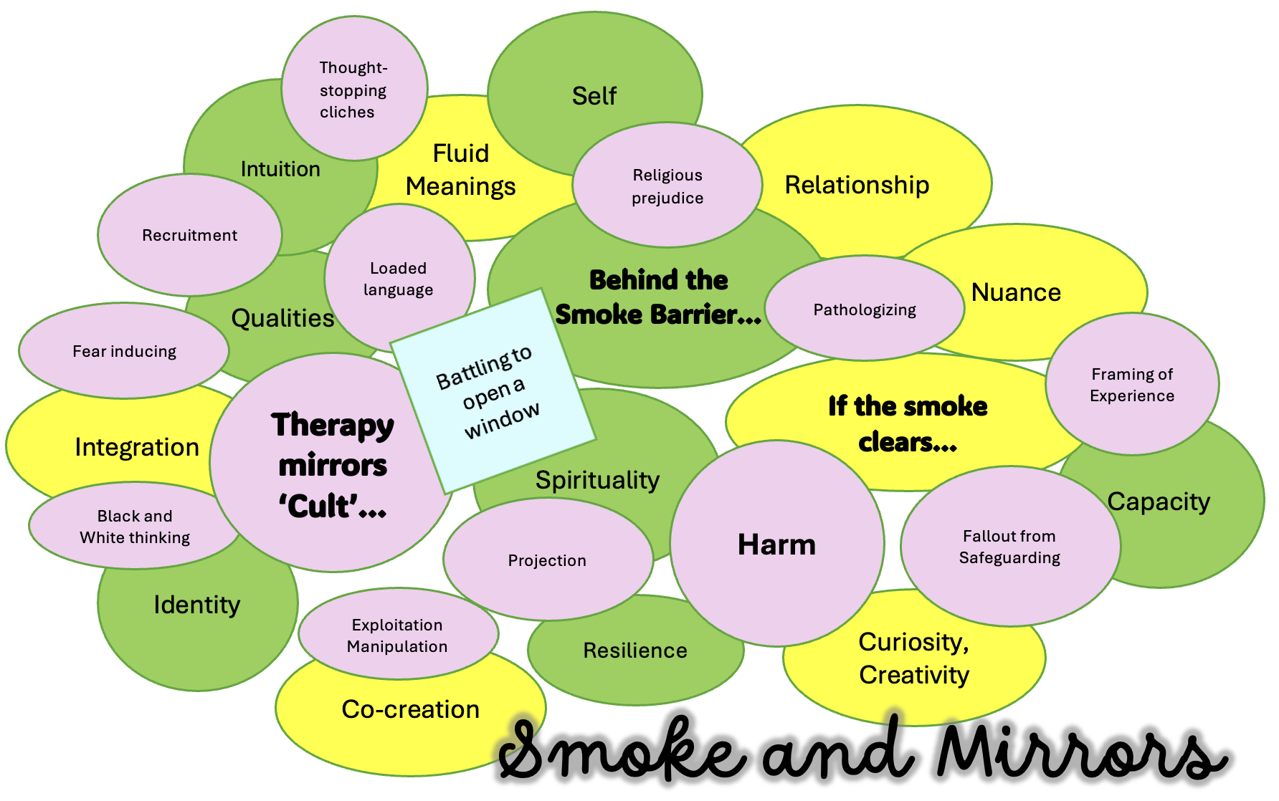
Figure 4.2: Particulate of Themes
To illustrate, the node of meaning at the point of ‘Projection’ was explored using the felt sense and the artwork in Figure 4.3 captured the experience and meaning intersecting with other themes and sub-themes. The following analysis draws on journal quotes from the table above.
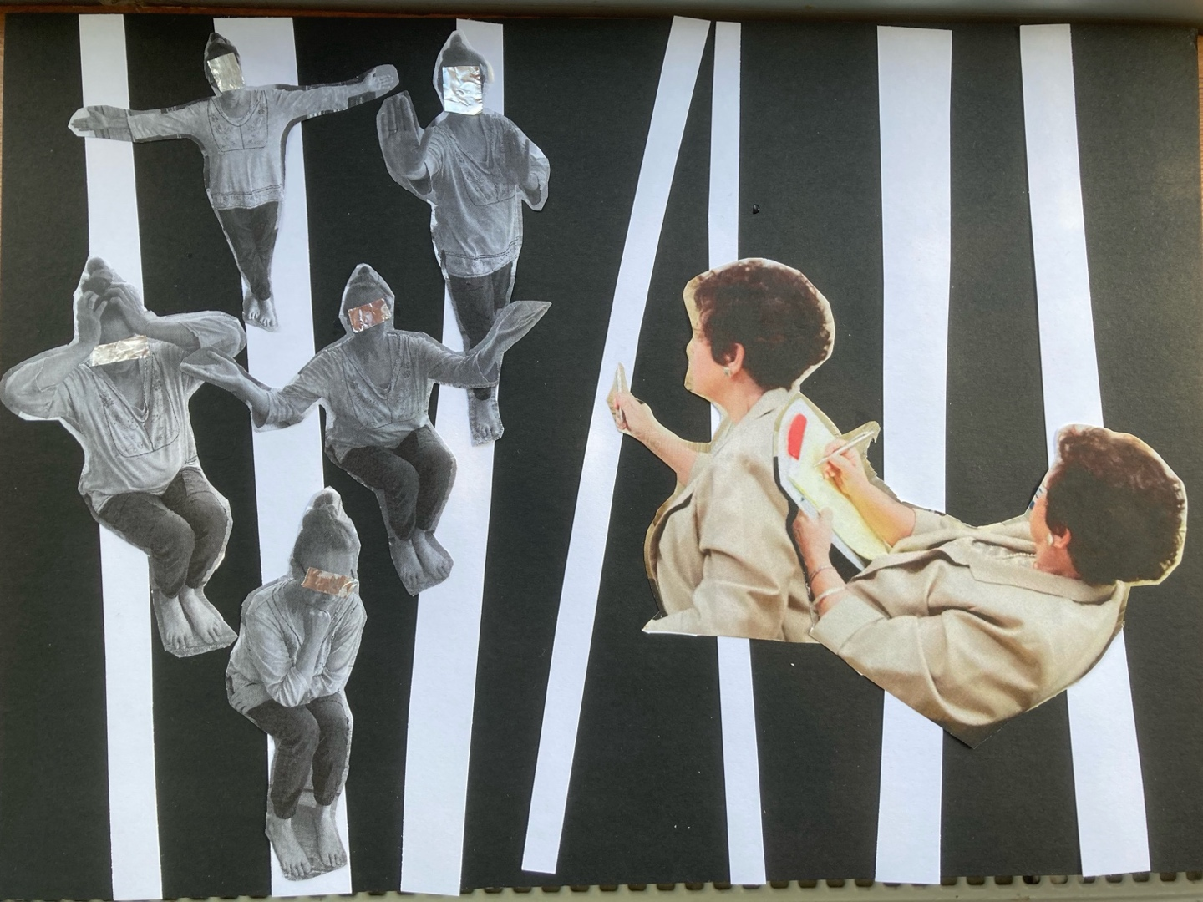
Figure 4.3: Projection
I am in shades of grey, signalling ‘Nuance’ . I have bare feet, representing my grounded-ness (‘Qualities’). The black and white backdrop symbolises a beast that dominates but is not fully visible because we are so close to it. This beast represents ‘Black and White Thinking’ in cult rhetoric. My postures demonstrate embodied feelings (‘Capacity’) of frustration, futility and closing off; trying to assertively (‘Capacity’) stop the projections from the therapist (‘Battling to Open a Window’); an exasperated ‘What more can I possibly show you?’ posture (‘Relationship’); and a sardonic, Jesus on the cross pose (‘Harm’ and ‘Religious Prejudice’) signifying feelings of resignation and crucifixion. The therapist is authoritatively holding a pen and interjecting to label my experiences (‘Pathologising’, ‘Loaded Language’ and ‘Thought-Stopping Clichés’). They have a hidden aspect, holding a clip board, containing their knowledge of cults and fitting my story into it, as well as a hidden activist agenda (‘Recruitment’) and bias. My face is covered with tinfoil, mirroring only the therapist, but also representing tinfoil mentality and the extremist element (‘Fear Inducing’) in cult rhetoric. My eyes are covered by it - a window to the soul which the therapist does not see (‘Relationship’ and ‘Spirituality’). The therapist has only an upper body, symbolising a lack of embodied resonance (‘Spirituality’ and ‘Capacity’) with me, and being in the head.
‘Harm’ node interacts with all the other themes and captures a holistically harmful experience. Bias, the prescriptive framework, and the pathologising tendency in cult rhetoric were experienced as deconstructing core parts of self, leading to the feeling of splitting: “it was all based on ego-centric, Western bollocks. My sense of self and beliefs don’t fit the model…I had to split myself to fit the narrative of having been in a cult”.
My spirituality is core to my sense of self, qualities and capacities. The split was caused by a confluence of influences, such as thought stopping clichés, loaded language, labelling of experience, therapist lack of cultural or spiritual sensitivity, creating the feeling of my faith being minimised, pathologised and deconstructed:
I encountered a genuine spiritual path. My faith was ignored. There was no curiosity about it or what it meant to me…I am being stripped of my faith…my faith was deconstructed…I felt like therapy demanded I give up my spirituality…exposing it as ‘pseudo’.

Further, extremist interpretations of my experiences led to a safeguarding concern and excessive, damaging interventions, including the leader’s arrest. The investigation felt like a prolonged strip search and entrenched division, closing potential future communication with multigenerational family members in the group. I felt misled by the therapist regarding coercive control since the structures in law did not support the safeguarding concern and I was drawn into a wider activist agenda.
I fought cult rhetoric, embodied in the therapist, at the node of ‘Battling to Open a Window’. The fight, combined with the feeling of splitting from core parts of myself, impacted my physical and mental health over time:
I had sleep problems, anxiety, and started drinking heavily. I had to do therapy to meet the requirements of my course, but it was harming me. I got overweight, liver problems, pre-diabetes. I stopped drinking and got better when I stopped therapy.

‘Relationship’ node invokes a more expansive perspective. For example, I appreciated that a relationship was co-created, but its quality was shaped by the way our attention and energy was focussed by cult rhetoric, creating fixed channels and restricting its fluidity. From any of the yellow-theme nodes, a meta-awareness and sense of valuing and non-judgement emerge: “all my experiences taught me about humanity”.
Similarly, standing at any of the green nodes creates meaning from a core, grounded sense of self rooted in spirituality, revealing an array of capacities, but which remained obscured, devalued, and distorted by cult rhetoric:
I was able to stand in my own power and set boundaries [with the group leader and the therapist]…The ability to focus inwardly, practice sincerity with self, embodied mindfulness, chair-work, dream-work, reflexivity, visualisation. I learned all that in Sufism. I was already adept at the things I encountered in therapy. But it was pathologized, interpreted as dissociation and the like. But I am very grounded.

A detailed explication of all nodes, which includes the spaces in between and shifting intersections, is curtailed by word count restriction. However, findings are discussed further in chapter five, and the creative synthesis captures my encounter with cult rhetoric in therapy as whole.

Creative Synthesis: Smoke and Mirrors (Meta)
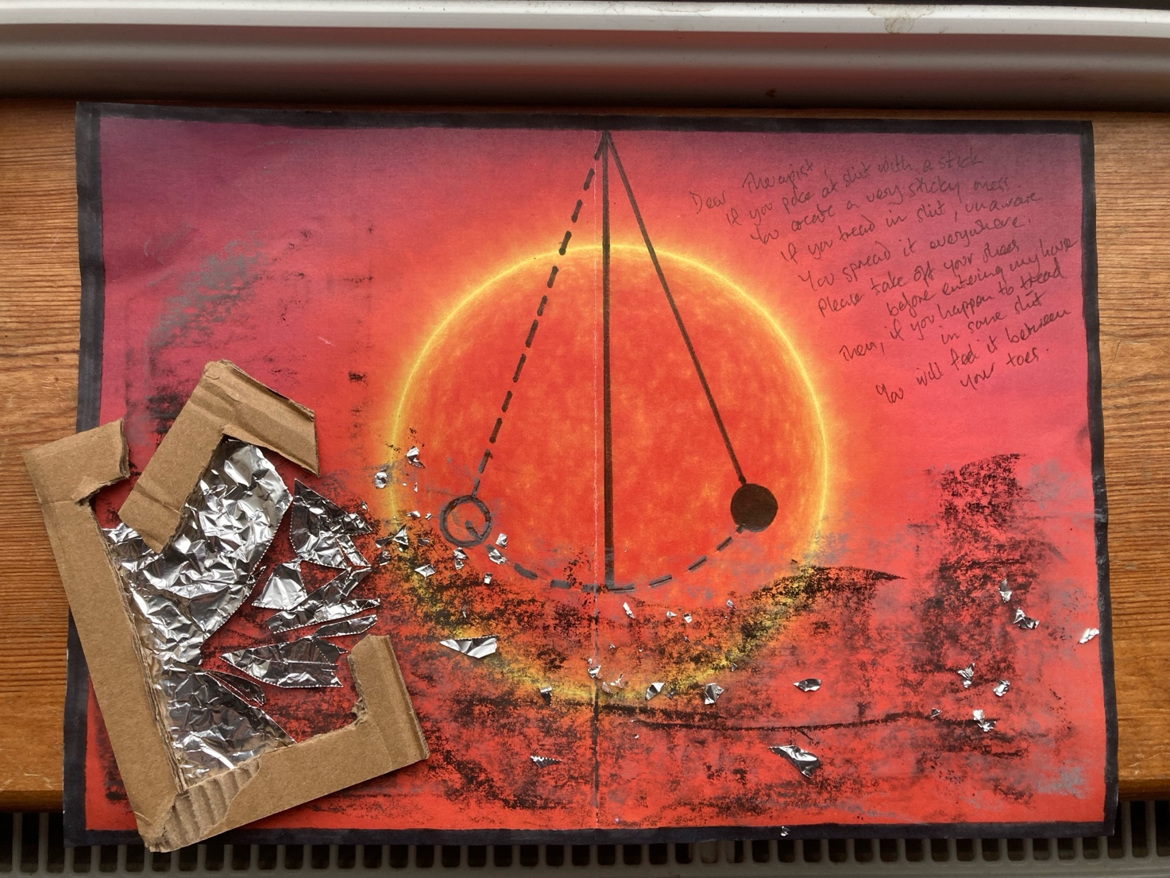
Figure 4.4: Smoke and Mirrors (Meta)

In ‘Smoke and Mirrors (Meta)’, tinfoil mentality - the extreme, paranoid theories around brainwashing and thought reform - is situated in a cardboard therapeutic frame. The frame also signifies the framing of my experience. The tinfoil is the distorted mirror, unable to reflect my experiences or sense of self accurately. The frame is insubstantial, inadequate and fake against the sun backdrop. As it breaks, the mirror shatters into shards across a wide area – my experience of harm. The smoke represents the pollution, and obfuscation of self and spirituality created by cult rhetoric. However, there is a sense that the smoke will disperse in the atmosphere. The shards are only tinfoil, not hard glass that can deeply wound, and will disperse on the wind, or burn in the sun. The cardboard frame will experience a similar end. The loose materials are not glued to the paper. These foreground elements may converge to temporarily obscure the sun, but cannot impact its core. The sun is what a Sufi feels, what I feel, in the Heart: unity; a burning; a spiritual organ of perception; the real Self, as real as the sun in the sky. Between the smoke and the sun is a pendulum, swinging between black and white. A liminal symbol, mediating between the sun and smoke, it represents both ‘black and white thinking’ in cult rhetoric and metamodern oscillation between binary opposites, which leads to integration. Aligned with cult rhetoric, it resembles a wrecking-ball. Aligned with integration, it oscillates like a precision-balanced metronome. The poem (Figures 4.4 and 4.5) encapsulates the transgressions and boundary issues in the therapeutic relationship and my sentiment toward these. This creative synthesis is testimony to the transformative HSSI process, through which I gained clarity and experienced deeper integration. During the process I initiated into another Sufi path. Cult hopping?
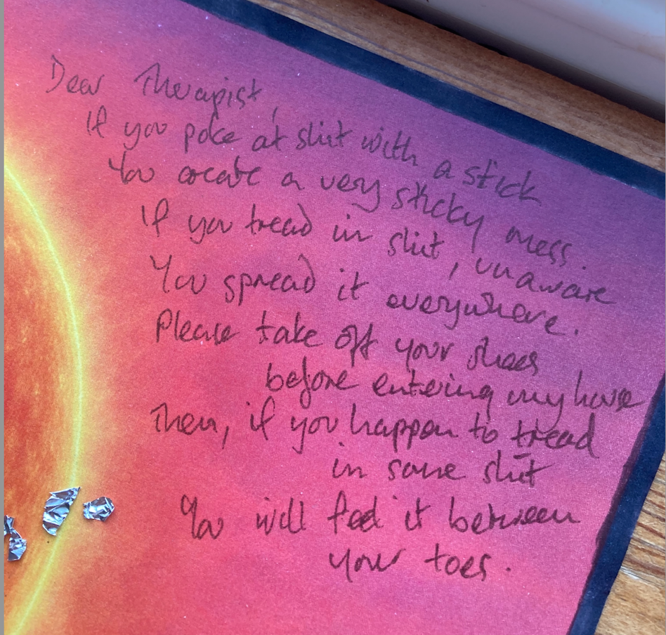
Figure 4.5: Detail: Poking at Shit
(Appendix 3: printed words)

Discussion and Conclusion

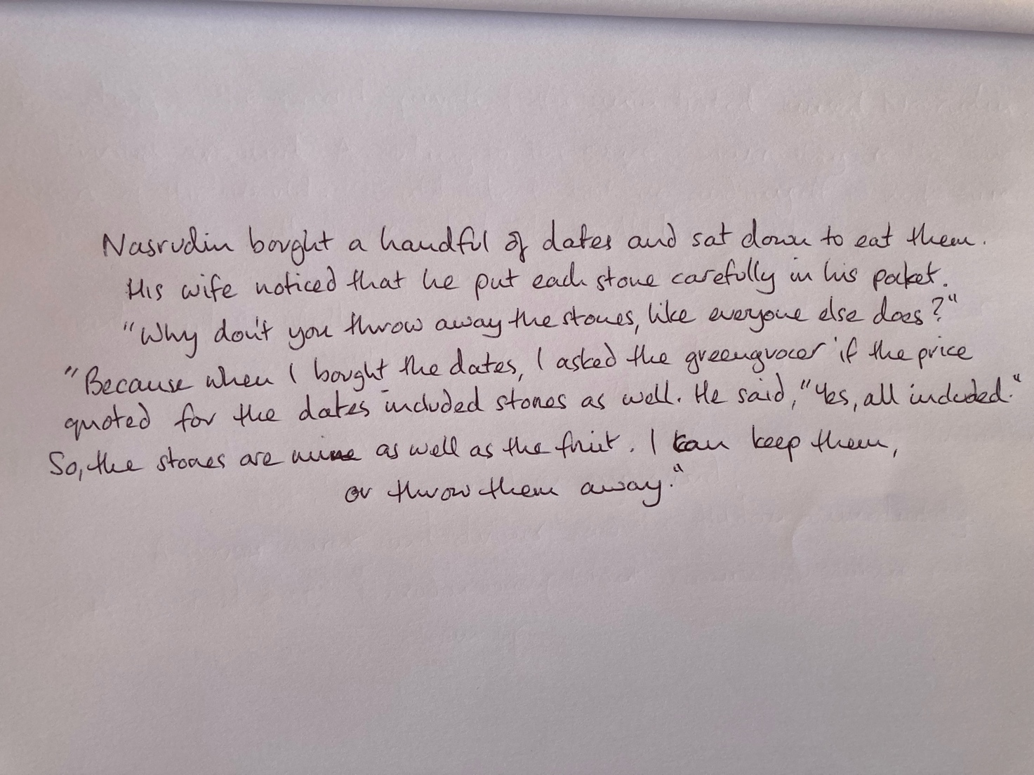

Figure 5.1: The Weight of the Stones
(Shah, 1993a, p.176)
(Appendix 9: printed words)

Discussion
Highly charged rhetoric that supports an activist agenda can lead to becoming like the thing being protested and rallied against (Nietzsche, 2002). My findings suggest that when cult rhetoric influences therapy, the dynamics mirror ‘cultic influence’ in many ways. The imbalance of power in the therapeutic relationship, subtle manipulation, ideology, loaded language, milieu influence, pathologising tendency, and polarising ‘black and white thinking’ coalesce in a similar way to the dynamics of coercion and control that anticult academics and therapists, such as Hassan (2020;2023;2025), Shaw (2014; 2019; 2023; 2025) and Jenkinson, (2016; 2019a; 2019b; 2023) strive to define. Where such therapeutic approaches include mindfulness, guided imagery, relaxation or meditation, these mirror Jenkinson’s (2019b) concept of confluential trance, said to be one of the main mechanisms of control and influence in cults by keeping members in an easily suggestible, merged state where they internalise ideology. Intensifying this process away from counterbalancing influences, retreats are said to significantly contribute to the creation of confluential trance in cults (Jenkinson, 2019). Where specialised cult-recovery group retreats are suggested, such as Jenkinson’s (2017) relational psychoeducational intensive, ‘Time Away for Post Cult Counselling’ (Hope Valley Counselling, 2026), the parallels with ‘cultic influence’ become even more apparent.
It is broadly asserted in anticult literature that cults offer a sense of belonging yet exploit members to serve the leader’s personal agendas, such as increasing wealth. Alignment with the wider anticult movement and organisations such as ICSA similarly offers a sense of belonging, and cult-recovery expertise can provide a lucrative income. My findings suggest that clients could be unethically pathologised, manipulated into dependency and exploited financially through professional structures presented as part of the therapeutic frame. Cult experts such as Jenkinson (2023) and Turner (2026) have established multifaceted careers founded upon cult rhetoric. Some experts charge upward of one-hundred and twenty pounds per hour for personal therapy. Additional, specialised retreats lasting several days are similarly expensive. Further income streams include specialised CPD training for counsellors and the wider health and social care sector, such as offered by Jenkinson’s ‘Hope Valley Counselling’ (2026), or media work, consultancy and exit support for those concerned about someone who is perceived as belonging to a cult, such as offered by Turner (2026).
These cult-like parallels undermine Berger’s (2025) assertion that survivor-clients unconsciously recreate and project their relationship dynamic with the cult leader onto the therapist, thereby defining the therapeutic relationship in terms of transference and countertransference. My findings in ‘Battling to Open a Window’ further suggest this is difficult for the client to challenge, and doing so can entrench a highly abusive and harmful dynamic. The imbalance of power, victim-perpetrator perspective, pathologising tendency and assumption that shame and trust issues have been created by the cult, can create a straitjacket for the client. My perception of therapist abuse of power in this regard concurs with Jones’ (2023) research which highlights how some therapists consciously and unconsciously abuse both self and client congruence, especially when challenged, throwing it back as “just your stuff” (Jones, 2023 p.283).
This dynamic echoes the shaming process said to stem from the traumatic narcissism of cult leaders, where they pathologically project all that is felt as ‘bad’ within themselves onto group members (Shaw, 2014; 2019; 2023; 2025) or the world outside the cult. The anticult recovery movement appears to have a significant blind spot here. For example, Levey and Dubrow-Marshall (2026) suggest that media representations create shame and stigma for survivors, causing them to compound an existing negative view of self, developed in the cult. Ignoring the media contribution of anticult therapists and academics, they suggest that survivors internalise these negative stereotypes and this hinders recovery. Demonstrating a strong sense of self, proportionate relationship with shame and the capacity to set boundaries, my findings contradict this. However, compounded by the milieu anticult ideology that is difficult to challenge, this was compromised over time through the process of therapy to the point that my sense of self, rooted in spirituality, felt as though it was ‘splitting’. Again, this mirrors the ‘splitting’, caused by cognitive dissonance, said to occur in cults (Stein, 2016). My findings concur with Broughton’s (2025) assessment that the therapeutic relationship is destroyed, and harm occurs where the counsellors’ concept of individual self conflicts with the client’s collective sense of self. The stubborn belief in the benign beneficence of therapy and anticult sentiment, which can only be upheld by sustained outward projection, is exemplified in O’Brian’s (2022) assertion that survivors avoid therapy because they have been indoctrinated against it and that core dysfunctional beliefs developed in the cult are responsible for mental illness.
In contrast, my findings show that Sufism cultivated my strong and resilient sense of self. There is an anatomy to the Sufi Way – a mystical experience that can be traced across the ages and is not confined to a particular path. At core, the Sufi feels God burning in the Heart. It is a non-physical place of unity - singular, yet plural. Sufi mystic Attar describes a valley of love where “Love is fire, mind is smoke” (Attar, 2017, p.104). Prendergast (2019) describes a fire in the heart, which is a portal to experiencing our true nature in communion with all of life. The plural, processual sense of self is carried on the current of the humanistic work of Carl Rogers’ (1961) principle of becoming, and Siegal’s (2022) concept of intraconnection where ‘me’ is replaced by ‘Mwe’. These concepts reach fruition in metamodernism, described as the age of self-actualisation (Storm, 2021), and characterised by the evolution of transcendence to a grounded form of immanence (Severan, 2022). Moreover, Sufi thought is often behind many of these shifts and even informs psychotherapy (Bozorgzadeh and Grasser, 2022). Cult rhetoric then, needs to catch up with the program. Further, the minimising and pathologising of my spiritual identity, flouts the ethical principles of cultural humility toward the client and responsibility of the therapist to bracket bias (BACP, 2025; Zaeske et al., 2024). My experience of Islamophobia and conflation with dangerous cult concurs with Thomas and Graham-Hyde’s (2024b) claim that this harmfully sweeps spirituality under a rug. Further, the conflation of dangerous cult and pathology that bolsters anticult activism can lead to safeguarding issues being distorted, with damaging consequences, as demonstrated by my findings.
At most then, my findings expose potential harms in cult recovery on a par with harms in LGBTQ conversion therapy (Jones et al., 2022), where the goal is focussed on “false and damaging beliefs [being] replaced with accurate, healthy beliefs” (O’Brian, 2022, npa). At least, my findings belie a core assumption that benign beneficence can be securely attributed to the cult-recovery therapeutic endeavour, and align with the idea that “healing is not just a process of deconstructing old identity and world view and constructing a new one, it is also the willingness to remain open to shifting and changing over the course of one’s life” (Anderson, 2023, pp.83-84). Enmeshed with all that, sits a capacity that does not disavow the darker faces of the human condition as integral to spirituality, resonating with Child and Howard’s (2023) perspective that rejects monopolar models of spirituality aligned with health and wellness.

Personal and Professional Implications
The personal, professional and counselling profession implications of this research somewhat overlap. This HSSI brought me clarity, integration and a deeper reconciliation with Sufism. Sufism is core to my sense of self and my humanistic counselling practice, which is intuitive, embodied and relational. My process and findings have strengthened my commitment to client-led creative process, cultural humility and respect for client autonomy and faith. I may modify some anticult constructs as a way of understanding mechanisms of control but will remember convey such constructs as models, not ultimate truths. It is important to explore these co-creatively whilst recognising their limitations. This allows for the client to step outside of pathology and victim-perpetrator dynamics, to explore nuance, fluid meanings and integration. Like Inform (2025), I aspire toward an ethos of respect that facilitates communication rather than division. I believe this would lead to better outcomes and reduce the potential for harm in therapy.
I stand behind Graham-Hyde’s (2021) call to end the application of the loaded term ‘cult’ to spiritual and religious groups and further advocate for cult rhetoric to be kept out of the therapeutic space, unless instigated by the client. I am conscious that my research may attract the labels ‘cult propaganda’ and ‘cult apologist’, in a similar vein to derogatory, populist political rhetoric. However, as Ryan (2026) points out concerning division between NRM and anticult academics, I am acutely aware of potential harms and mechanisms of coercion and control in groups, but I have a different research focus and therapeutic aim that centralises the individual in their intersectional reality. While this is personal, I suspect many people have similar experiences but are unmotivated to speak out in a hostile climate.
My research has drawn attention to a cluster of ethical concerns for the counselling profession concerning cult rhetoric, hidden activist agenda, bias and harm and highlighted significant blind-spots. These potentially negatively impact the individual client, whilst cult rhetoric exerts increasing influence in the counselling field, offering specialist training to counsellors and the wider health and social care sector. Like so called cults, therapy is currently an unregulated field. There is an opportune moment, as the field strives toward regulation through SCoPEd (BACP, 2022), to evaluate cult recovery methods and trainings and assess the influence of cult rhetoric in the field. However, since beginning this research, PCC has been renamed ‘Walking Free’ (Hope Valley Counselling, 2026). On the surface, this suggests a more nuanced, liberating approach, yet no core changes have been made, signifying a subtle obfuscation of the rhetoric and activist agenda, as well as an encroachment and widening of the application of cult rhetoric to spiritual abuse. Moreover, academic discourse is increasingly shaped through the establishment of the MSc in the Psychology of Coercive Control (Dubrow-Marshall and Dubrow-Marshall, 2017), which is closely aligned with University of Salford (2026) counselling training and ICSA. Such shifting sands suggest that the pervasive and distorting influence of cult rhetoric may not be so easily identified, mitigated or uprooted.
Against a broader cultural and political backdrop characterised by increasing polarisation, cult rhetoric in therapy might seem to be just another symptom. Yet even cult expert Kelly (2026) mourns the loss of perspective that is gained from interacting with ‘the other side’. Further, the World Psychiatric Association’s position statement asserts that faith should be respected as core to an individual’s sense of self and world view; when offering alternative interpretation of experience, the limitations of those interpretations should be clearly explained (Cook and Moreira-Almeida, 2021). However, harm in therapy is a large and heterogeneous area (Vybiral et al., 2024) that to date has not been confronted by the counselling field head on (Broughton, 2025). Perhaps the ‘smoke and mirrors’ of cult rhetoric will clear when the broader counselling field reflexively addresses its own blind spots in respect of harm.

Limitations
HSSI findings are considered not generalisable due to there being only one participant. As I fall into the category of first-generation survivors, the findings may not be applicable to second- and multi-generational survivors. The spiritual aspect of the research focussed only on Sufism. A broad scope of issues and themes emerged which could not be fully explored within the limitations of this paper and word count restriction necessitated the exclusion of some themes. For example, how AI, Google, and Facebook algorithms combined with cult rhetoric to influence my finding a specialist therapist.

Future Research and Development
This research has shed light on a broad array of ethical issues relating to bias and harm, the impact of cult rhetoric in counsellor, health and social care sector trainings and academia, and issues where cult rhetoric conflicts with self-concept, intersectionality and faith. All these provide foci for future research. Research exploring the process by which people come to identify as cult survivors, and how and why some reject that identity, may prove especially illuminating. Similarly, research that aims to identify the silent majority that leave ‘cults’, or explores resilience, strengths and integrity in this population, may balance current, pathologising anticult perspectives. With an emphasis on lived-experience, my research supports the assessment by Zaeske et al. (2024) that more research is needed concerning the process and outcome of therapy concerning CA, SA, Rit.A, and RA, and therapeutic approaches require development or modification so that clients can define their own experience and relationship with spirituality.
The transformational process evidenced through my HSSI, suggests that creativity may be healing for the survivor population. Research evidencing this is sparse. However, a pilot study using multimodal workshop ‘Arts for the Blues’ was trialled at an ICSA conference (Parsons et al., 2020; 2021). Parallelling my own experience, all participants easily entered a creative flow state through which they processed a pre-selected issue. This is a promising area that merits further investigation. My research paves the way for further development.

Conclusion
On completing the HSSI, I can now answer the research question. My encounter with cult rhetoric in therapy after leaving my Sufi group was experienced as harmful, having a temporary negative impact on my mental, physical and spiritual wellbeing. Cult rhetoric was found to influence therapy such that the therapy mirrored the dynamics of cultic influence it endeavoured to explain and deconstruct. The ideology, hidden activist agenda, polarising and pathologising tendency facilitated therapist abuse of power, obscured my core sense of self rooted in spirituality, and was a barrier to integration.

Exploring lived experience, this research has addressed a gap in literature evaluating therapeutic approaches to working with people who have experienced harm in spiritual and religious contexts. The critical literature review examined how cult rhetoric emerges within modern day ‘cult wars’ and demonstrated how this filters down to influence therapy. Raising a broad range of ethical issues, my contribution to knowledge includes a spotlight on the therapeutic frame as a potential vehicle for abuse and exploitation in these contexts. Contribution to wider discourse includes debate around terminology and classification, and the legitimacy of theories such as thought reform and brainwashing. The transformational HSSI process brought clarity concerning my experience of cult rhetoric in therapy and facilitated deeper integration and reconciliation with my spiritual path. This will impact my future professional practice; I aim to work with issues concerning spirituality, faith and harm. Attuned to nuance and humility, my commitment is to client-led, creative process. My research opens the door for the development of a creative approach where autonomy, strengths and resilience are foregrounded, faith and spirituality are integral to process, and clients create their own language and meanings to describe their experiences.
Cult rhetoric, fuelled by an activist agenda, is having a pervasive and distorting influence on therapeutic approaches, counsellor CPD trainings and awareness and trainings in the wider health and social care sector, with potentially harmful consequences. Unchecked, the implications for the counselling profession are deep rooted, and remedial or mitigating action is dependent upon embracing a structural, self-reflexive approach to harm under regulated auspices.

Epilogue

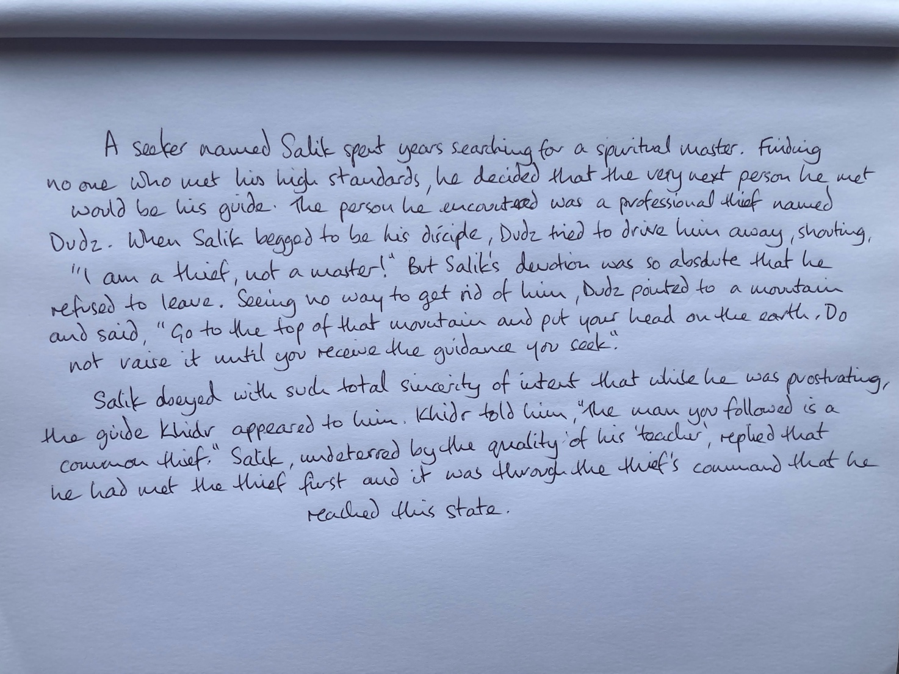

Figure 6.1: The People Who Attain
(Shah, 1993b, pp.181-182)
(Appendix 9: Printed words)

Word count: 16,499.

Reference list
Aebi-Mytton, L. (2021) ‘“That’s not me”: An exploration of first-generation, second-generation, and multigenerational adult leavers’, ICSA Today, 12(1), pp. 6-13.
Anderson, L. E. (2023) When Religion Hurts You: Healing from Religious Trauma and the Impact of High-Control Religion. Brazos Press.
Anderson, L. and Peck, B. (2025) Religious Trauma and the Nervous System Available at: https://religioustraumainstitute.heightsplatform.com/courses/what-is-religious-trauma (Accessed: 18 December 2025)
American Psychiatric Association [APA] (2013) Diagnostic and Statistical Manual of Mental Disorders: DSM-5. 5th edition. American Psychiatric Publishing Inc.
American Psychiatric Association [APA] (2023) Diagnostic and Statistical Manual of Mental Disorders: DSM-5-TR, 6th edition. American Psychiatric Publishing Inc.
American Psychiatric Association [APA] (2026) APA Concerned About Far-Reaching Consequences from Supreme Court Decision Regarding Therapy as ‘Free Speech’. Available at: https://www.apa.org/news/press/releases/2026/03/chiles-salazar-therapy-free-speech?fbclid=IwY2xjawQ66i1leHRuA2FlbQIxMABzcnRjBmFwcF9pZBAyMjIwMzkxNzg4MjAwODkyAAEe1HH27Es0m8zgmtRJz6GNLWaNs0JxLnswWUSYkuplJM1Bj7iItAaqHOlHBQs_aem_JGG2AsrMmM6Ee-jEZU51Ww
Archibald, S.D. (2024) A Heuristic Inquiry into Therapists' Lived Experience of Therapeutic Relationships. PhD Thesis. Saybrook University.
Asbury, M.E. `(2024) Seeing with the Heart. PhD Thesis. University of Erfurt.
Asimos, V. (2024) ‘Playing at religion: understanding contemporary spiritual experiences in popular culture’, in A. Thomas and E. Graham-Hyde (eds) Cult Rhetoric in the 21st Century: Deconstructing the Study of New Religious Movements. Bloomsbury, pp.178- 189.
Attar, F. (2017) The Conference of the Birds. Translated from the Persian by S. Wolpé. W. W. Norton and Company.
Baker, S.A., McLaughlin, E. and Rojek, C. (2024) Cults. Routledge.
Barker, E. (1984) The Making of a Moonie: Choice or Brainwashing? Blackwell.
Berger, K.H. (2025). Psychological Recovery from Religious Cult Defenses: A Feminist and Interpretive Hermeneutic Perspective. PhD Thesis. Pacifica Graduate Institute.
Bosorgzadeh, S. and Grasser, L. R. (2022) ‘The integration of the heart-centred paradigm of Sufi psychology in contemporary psychotherapy practice’, Psychotherapy, 59(3), pp. 405-414. Available at: https://doi.org/10.1037/pst0000414
Braun, V. and Clarke, V. (2021) Thematic Analysis: A Practical Guide. Sage.
British Association for Counselling and Psychotherapy [BACP](2022) SCoPEd Framework: January 2022 (amended 2025). Available at: https://www.bacp.co.uk/media/14435/scoped-framework-january-2022.pdf (Accessed: 14 April 2026)
British Association for Counselling and Psychotherapy [BACP](2025) Ethical Framework for the Counselling Professions. https://www.bacp.co.uk/media/23628/ethical-framework-for-the-counselling-professions-2025.pdf (Accessed 17 April 2026)
Broughton, E. (2025) ‘The big issue: the truth about harm in therapy’, Therapy Today (April) Available at: https://www.bacp.co.uk/bacp-journals/therapy-today/2025/articles-april/the-big-issue/#:~:text=Most%20harm%20in%20therapy%20is%20far%20less%20headline%2Dgrabbing%20than,Betraying%20trust
Buber, M. (1970) I and Thou (W. Kaufmann, Trans.). Simon and Schuster. (Original work published 1923)
Butcher, H.K. (2024) ‘Heuristic Research in Nursing Science’, Nursing Science Quarterly, 37(3) pp. 204-211.
Cardo, G. and Tudor, K. (2024). ‘A comparison between the concepts of Heuristic Enquiry and Tazkiyat-un-nafs’, European Journal for Qualitative Research in Psychotherapy, 14, pp. 75-90.
Cass, H. (2024) Independent Review of Gender Identity Services for Children and Young People: Final Report. Available at: https://cass.independent-review.uk/ (Accessed: 11 March 2026).
Challacombe, D.J. (2022) ‘Synergy between cults and terror groups: a systematic review of recruitment processes’, International Journal of Coercion Abuse and Manipulation, 3, pp.21-29. DOI: doi.org/10.54208/1000/0003/005
Childs, C. and Howard, C. (2023) ‘The yin-yang of spirituality: an introduction to the special issue’, Journal of Scientific Exploration: Anomalies and Frontier Science, 37(4), pp. 582-585
‘Chiles v. Salazar’ (2026) 607 U.S. ___ [Online]. Available at: Supreme Court of the United States (Accessed: 2 April 2026).
Chryssides, G. D. (2016) Jehovah’s Witnesses: Continuity and Change. Ashgate Publishing.
Chryssides, G. D. (2024) ‘A history of anticult rhetoric’, in, A. Thomas and E. Graham-Hyde (eds),Cult Rhetoric in the 21st Century: Deconstructing the Study of New Religious Movements. Bloomsbury, pp.40-58.
Cook, C.C.H and Moreira-Almeida, A. (2021) ‘Principles of integrating religion and spirituality in mental health care and the World Psychiatric Association’s position statement’, in A. Moreira-Almeida (Ed.) Spirituality and Mental Health Across Cultures. Oxford Medicine Online, pp.309-324. https://doi.org/10.1093/med/9780198846833.003.0019
Corvaglia, L. (2023) ‘Cults and persuasion: submission as preference shifting’, International Journal of coercion, Abuse and Manipulation, 8, pp.1-10. DOI: https://doi.org/10.54208/0008/001
Corvaglia, L. (2026) ‘The price of belief: rational choice, libertarian ideology, and cult advocacy’, International Journal of Coercion, Abuse and Manipulation, 9, pp.103-114. Doi: 10.54208/1000/0009/008

Crockford, S. (2024) ‘‘There is no QAnon’: cult accusations in contemporary American political and online discourse’, in A. Thomas and E. Graham-Hyde (eds) Cult Rhetoric in the 21st Century: Deconstructing the Study of New Religious Movements. Bloomsbury, pp.154-177.
Crowley, N. and Jenkinson, G. (2022) ‘Pathological spirituality’, in C.C.H. Cook and A. Powell (eds) Spirituality and Psychiatry, Cambridge University Press, pp.332–354. https://doi.org/10.1017/9781911623311.021
Damgaard (2021) Wounded Faith: Understanding and Healing from Spiritual Abuse. ICSA.
Decult (2025) Decult Voices - Beyond Belief. Available at: https://www.youtube.com/watch?v=NZMhsGHTn30 (Accessed: 17 December 2025)
Decult (2026) Voices or Courage: Pathways to Healing and Justice, Available at: https://decult.net/?zlinkid=0d0888c4-9105-46a0-b255-f3bc297c5351 (Accessed: 16 November 2025)
Dickson, W.R. (2022) ‘Sufism and Shari’a: contextualizing contemporary Sufi expressions’, Religions. 13 (449). https://doi.org/10.3390/rel13050449
Dille, A.M. (2023) Healing Spiritual Wounds: The Experience of Counselors Working with Religious Trauma Survivors. Master’s Thesis. Moody Theological Seminary.
Di Puppo, L. (2024a) ‘Between remembrance and forgetfulness: heart perception, oneness and the human-landscape relationship in a Bashkir Sufi circle’, Globalizations, pp.1-14. https://doi.org/10.1080/14747731.2024.2383012
Di Puppo, L. (2024b) ‘“What does the heart want?”: being seen, “heart ethnography,” and knowledge through surrender in a Bashkir Sufi circle in Russia’, HAU: Journal of Ethnographic Theory, 14(1), pp. 61–73. https://doi.org/10.1086/729989
Domestic Abuse Act (2021) England and Wales. The Stationary Office. Available at: https://www.legislation.gov.uk/ukpga/2021/17 (Accessed: 3 December 2025)
Domestic Abuse Intervention Program (2025), The Duluth Model. Available at: https://www.theduluthmodel.org/wheels/ (Accessed: 3 December 2025)
Dubrow-Marshall, R. and Dubrow-Marshall, L. J. (2017) MSc Psychology of Coercive Control Programme. University of Salford. Available at: www.salford.ac.uk/pgt-courses/psychology-of-coercive-control
Dubrow-Marshall, L. and Dubrow-`Marshall, R. (2019) ‘The psychological development and consequences of involvement with new religious movements: counselling issues for members, former members and families’, in S. Harvey, J.A. Beckford and S. Steidinger, New Religious Movements and Counselling. Routledge. https://doi.org/10.4324/9781315598086
Dubrow-Marshall, R. P. (2024)’ The recognition of cults’, in A. Thomas and E. Graham-Hyde (eds),Cult Rhetoric in the 21st Century: Deconstructing the Study of New Religious Movements. Bloomsbury. pp.96-113.
Eichel, S.K. (2022) ‘The theory that won’t go away: an updated review of the role hypnosis plays in mind control’, International Journal of Coercion, Abuse and Manipulatio,. 3, pp.31-36. DOI: doi.org/10.54208/1000/0003/001
Etherington, K. (2004). Heuristic research as a vehicle for personal and professional development, Counselling and psychotherapy research, 4(2), pp.48–63. Available at: https://doi.org/10.1080/14733140412331383973.
Equality and Human Rights Commission [EHRC] (2025) Code of Practice for Services, Public Functions and Associations: Updated Draft. Available at: https://www.equalityhumanrights.com/equality/equality-act-2010/codes-practice/code-practice-consultation-2025-changes-chapter-2 (Accessed: 11 March 2026)
Farrell, S.M. (2025) ‘Religious trauma: redefinition, attachment theory as a conceptual framework, and a path forward utilizing ecospirituality’, Journal of Religion and Spirituality in Social Work: Social Thought, 44(3), pp.264-277, DOI:10.1080/15426432.2025.2520516
‘Ferguson v Jonah’ (2015) New Jersey Superior Court No. L-5473-12 (N.J. Super. Ct. Law Div.) [Online]. Available at: NJ Courts (Accessed: 2 April 2026).
‘For Women Scotland Ltd v The Scottish Ministers’ (2025) UKSC 16. Available at: https://supremecourt.uk/cases/uksc-2024-0042 (Accessed: 11 March 2026)
Gendlin, E. T. (1981). Focusing. 2nd edition. Bantam.
Goldberg, L., Goldberg, W., Henry, R. And Langone, M. (2017) Cult Recovery: A Clinician’s Guide to Working with Former Members and Family. International Cultic Studies Association.
Graham-Hyde, E. (2021) ‘From bad to worse: the evolving nature of" cult" rhetoric in the wake of Covid-19 and QAnon’, Implicit religion, 24(2), pp.135-159. Available at: https://doi.org/10.1558/imre.0000
Graham-Hyde, E. (2023) From bad to worse: the evolving nature of “cult" rhetoric in the wake of Covid-19 and QAnon. Implicit religion, 24(2), pp.135-159. Available at: https://doi.org/10.1558/imre.0000
Greener, E. (2026) Reflective Journal. Unpublished.
Gregg, S. E. and Chryssides, G. D. (2017) ‘The silent majority: understanding apostate testimony beyond ‘insider/outsider’ binaries in the study of new religions’, in E.V. Gallagher (ed.) Visioning New and Minority Religions, pp.20-32. Routledge.
Harsey, S. and Freyd, J.J. (2020) ‘Deny, attack, and reverse victim and offender (DARVO): what is the influence on perceived perpetrator and victim credibility?’, Journal of Aggression, Maltreatment and Trauma, 29(8), pp.897-916.
Hassan, S.A. (2020) The BITE model of authoritarian control: undue influence, thought reform, brainwashing, mind control, trafficking and the law. PhD Thesis. Fielding Graduate University.
Hassan, S.A. (2023) ‘The bite model of authoritarian control’, Freedom of Mind Resource Centre. Available at: https://freedomofmind.com/wp-content/uploads/2023/08/BITE-model.pdf (Accessed: 13 March 2026)
Hassan, S.A. (2025) ‘Cult apologists and defenders with Dr Steven Hassan (Part 1)’, Cult Chat, Episode 73. Available at: https://www.youtube.com/watch?v=JuFCfXLpSas (Accessed: 17 December 2025)
Hassan, S. and Shah, M. J. (2019) ‘The anatomy of undue influence used by terrorist cults and traffickers to induce helplessness and trauma, so creating false identities’, Ethics, Medicine and Public Health, 8, pp.97–107.
Healy, D.P. (2017) The unique characteristics of postcult post traumatic stress disorder and suggested therapeutic approaches. International Journal of Cultic Studies. 8, 60-70.
Healy, D.P. (2026) ‘The unique characteristics of post-cult PTSD and suggested therapeutic approaches’, ICSA Today. Available at: https://internationalculticstudies.org/research-highlights/the-unique-characteristics-of-post-cult-ptsd-and-suggested-therapeutic-approaches/?fbclid=IwY2xjawQK7NlleHRuA2FlbQIxMABzcnRjBmFwcF9pZBAyMjIwMzkxNzg4MjAwODkyAAEevyfrfxO-I_GQYJMFrxuNk5W1cOMDqJVkHlZZMOyu0-NUe-_3kmxc0mKGw1Q_aem_Pe7yym8Hfp6o_EC5JDbYLQ (Accessed: 24 February 2026).
Herman, J. (1997). Trauma and Recovery. Basic Books.
Hesse, H. (2001) Siddartha. Translated from the German by G. Olesch, A. Dreher, A. Coulter, S. Langer and S Chaichenets. Available at: https://www.online-literature.com/hesse/siddhartha/12/ (Accessed: 14 November 2025).
Hilliard, A. (2025) ‘The psychology of cults’, Cult News 101. Available at: https://www.cultnews101.com/2025/10/the-psychology-of-cults.html?fbclid=IwY2xjawNK-qVleHRuA2FlbQIxMAABHhRzsDTiEQ6R7hSn-jZDty6QkhwCgrK9RUrqpxuwFQVFLWP0b_XGUbfnZyYE_aem_KpJrC6sQvQr85FZzqUlnWw (Accessed 19 November 2025)
Hope Valley Counselling (2026) Services. Available at: https://www.hopevalleycounselling.com/services (Accessed: 14 April 2026)
International Cultic Studies Association [ICSA] (2025a) Empowering minds, advancing research, supporting recovery. Available at: https://internationalculticstudies.org/ (Accessed: 14 December 2025)
International Cultic Studies Association [ICSA] (2025b) Pathways to expanding the scope of coercive control: understanding abusive dynamics and their impacts across interpersonal, institutional, and cultic contexts. Available at: https://internationalculticstudies.org/icsa-conference-2026/call-for-proposals-2026/?zlinkid=75247332-b873-46b6-af17-c59cdf6952af (Accessed: 15 December 2025)
International Journal of Coercion, Abuse and Manipulation [IJCAM] (2020 - present). Available at: https://library.internationalculticstudies.org/24n6hkd/ (Accessed: 20 November 2025)
Information Network Focus on Religious Movements [Inform] (2025) Inform General Policies. Available at: https://inform.ac/about-us-old/inform_policy/ (Accessed: 16 December 2025)
Inglis, S.H. (2021) Union and communion: a heuristic inquiry into the practice of presence and the experience of the holy. PhD Thesis. St Stephen’s College, Alberta.
Inside the Cult of the Jesus Army (2025) BBC iPlayer. Available at: https://www.bbc.co.uk/iplayer/episodes/m002fxr6/inside-the-cult-of-the-jesus-army (Accessed: 19 November 2025)
Introvigne, M. (2022) Brainwashing: Reality or Myth. Cambridge University Press.
Jenkinson, G. (2016) Freeing the Authentic Self: Phases of Recovery and Growth from an Abusive Cult Experience. PhD Thesis. University of Nottingham.
Jenkinson, G. (2017) ‘Relational psychoeducational intensive: time away for post cult counselling’, in R. Boyle (ed.) Cult Recovery: A Clinician’s Guide to Working with Former Members and Families. ICSA, pp.215-240.
Jenkinson, G. (2019a) ‘Out in the world: post-cult recovery’, Therapy Today, (March) pp. 23-26.
Jenkinson, G. (2019b) ‘Leaving psychologically - breaking the confluential trance’, International Journal of Cultic Studies, 10, pp. 72-80.
Jenkinson, G. (2023) Walking Free from the Trauma of Coercive, Cultic and Spiritual Abuse. Routledge.
Jenkinson, G. (2025a) Decult voices - beyond belief. Available at: https://www.youtube.com/watch?v=NZMhsGHTn30 (Accessed: 17 December 2025)
Jenkinson, G. (2025b) ‘”You’re sold a lie”: how do you spot a cult?’ BBC News, 2 August. Available at: https://www.bbc.co.uk/news/articles/cj4w95452eeo (Accessed: 5 April 2026)
Jones, C. (2023) ‘“That is just your stuff”: the potential use and abuse of congruence in counselling and psychotherapy practice and training’, Counselling and Psychotherapy Research, 23(2), pp. 283-287. DOI: 10.1002/capr.12620
Jones, T. W., Power, J., and Jones, T. M. (2022) ‘Religious trauma and moral injury from LGBTQA+ conversion practices’, Social Science and Medicine, 305, Article 115040. https://doi.org/10.1016/j.socscimed.2022.115040
Kawka, M. (2024) ‘A heuristic inquiry into the phenomenon of creating art from a spiritual viewpoint’, Journal for the Study of Spirituality, 14(2), pp. 124-142, DOI: 10.1080/20440243.2024.2375212
Kelly, J. (2025) ‘How do the pros get someone to leave a cult? Manipulate them into thinking it was their idea’, The Guardian, 19 November. Available at: https://www.theguardian.com/science/2025/nov/19/how-to-leave-a-cult-experts-intervention (Accessed: 21 November 2025)
Kelly, J. (2026) ‘Cult mediation with Patrick Ryan and Joe Kelly: can the field move beyond the ‘cult wars’ of the 1970s an 80s?’, Ecstatic Integration, 20 March. Available at: https://www.ecstaticintegration.org/p/cult-mediation-with-patrick-ryan?fbclid=IwY2xjawQqQb9leHRuA2FlbQIxMABzcnRjBmFwcF9pZBAyMjIwMzkxNzg4MjAwODkyAAEe9cU1nIIxxeEbibwsB1u7LEkg9FITLGQBc6Ws_fyNHN0tBbcwmbglTcTAIAI_aem_NwjbQ79OLNamQyYPP6437A (Accessed: 20 March 2026)
Kenny, G. (2012). ‘An introduction to Moustakas’s heuristic method’, Nurse Researcher, 19(3), pp. 6-11. DOI: 10.7748/nr2012.04.19.3.6.c9052
Kent, S.A. (2023) Interviewed by Arshy Mann for ‘CULTS #4 – The Cult Wars’, COMMONS, 8 November [Podcast]. Available at: https://www.canadaland.com/podcast/cults-4-the-cult-wars/ (Accessed: 19 April 2026)
Khan, H. I. (1990) ‘The unity of religious ideals’, The Sufi Message. Volume 9. Motilal Banarsidass Press.
Khan, Z. I. (2005) ‘The essence of Sufism’, The Power of Love. Omega Institute. Available at: https://wahiduddin.net/sufi/sufism.htm. Accessed 28th November 2025.
Khan, Z.I. (2022) Caravan of Souls: An Introduction to the Sufi Path of Hazrat Inayat Khan. Suluk Press.
Khan, Z. I. (2025) ‘In an Eastern Rose Garden’ [Webinar]. The Inayati Order. 25 October 2025.
Kilrea, K.A. and McCaslin, M.L. (2020) ‘Deep heuristics: an emergent methodology for transformative, actualizing, and potentiating relationships (Transformative Inquiry in Action)’, The Qualitative Report 11th Annual Conference, Fort Lauderdale, Florida, 16 January. Available at: https://nsuworks.nova.edu/tqrc/eleventh/day2/20/
Lacter, E.P. and Lehman, K. (2018) Guidelines to Differential Diagnosis between Schizophrenia and Ritual Abuse/Mind Control Traumatic Stress, Available at: http://endritualabuse.org/wp-content/uploads/2018/03/chapter4finalrevisions2008.pdf (Accessed: 19 April 2026)
Lalich, J. (1997) ‘Dominance and submission: the psychosexual exploitation of women in cults’, Cultic Studies Journal, 14(1), pp. 4–21.
Lalich, J. (2004) Bounded Choice: True Believers and Charismatic Cults. University of California Press.
Lalich, J. (2026) ‘I am proud to say that I was expert witness for the plaintiffs in this case’ [Facebook] 1st April. Available at: https://www.facebook.com/janja.lalich (Accessed: 2 April 2026)
Laycock, J.P. (2024) ‘A cult by any other name: is "High Demand Group" a useful category? (Perspectives Essay)’, Nova Religio, 28(1), pp. 90-104. https://dx.doi.org/10.1353/nvr.2024.a935565
Levey, D. and Dubrow-Marshall, R. (2026) ‘Cults and media stereotypes: does media coverage of current and former cult members hinder victims’ recovery? International Journal of Coercion, Abuse and Manipulation, 5, pp. 9-21. DOI: 10.54208/1000/0005/003
Lifton, R. J. (1961) Thought Reform and the Psychology of Totalism: A Study of ‘brainwashing’ in China. University of `North Carolina Press.
Mann, A. (2023) 'CULTS #4 – The Cult Wars', COMMONS, [Podcast]. 8 November. Available at: https://www.canadaland.com/podcast/cults-4-the-cult-wars/ (Accessed: 19 April 2026)
Maslow, A. H. (1956) ‘Self-actualizing people: a study of psychological health’, in C. Moustakas (ed.) The Self, pp. 160–194. Harper and Brothers.
Maslow, A. H. (1971). The Farther Reaches of Human Nature. Penguin.
Mihalache, G. (2019) ‘Heuristic inquiry: differentiated from descriptive phenomenology and aligned with transpersonal research methods’, The Humanistic Psychologist, 47(2), p.136.
Moustakas, C. (1961). Loneliness. Prentice-Hall.
Moustakas, C. (1990). Heuristic Research: Design, Methodology, and Applications. Sage Publications.
Najafi, H., Tudor, K. and Ings, W. (2025) ‘Resonances between heuristic inquiry and Persian illuminative thinking: a review of the evolution of heuristic inquiry’, in W. Ings and K. Tudor (eds.) Heuristic Enquiries: Research Across Disciplines and Professions. Routledge, pp. 11–26.
Nayar, P.K. (2025) ‘Posthumanism’, The Year's Work in Critical and Cultural Theory, p.mbaf014. Available at: https://doi.org/10.1093/ywcct/mbaf014
Newcombe, S., Harvey, S., Thomas, A., and Graham-Hyde, E. (eds.) (2013-2026) Religion at the Boundaries. Bloomsbury.
Newcombe, S. and Harvey, S. (2024) ‘Balancing pragmatism and precision: Inform’s approach to cult rhetoric’, in A. Thomas and E. Graham-Hyde (eds), Cult Rhetoric in the 21st Century: Deconstructing the Study of New Religious Movements. Bloomsbury, pp. 21-39.
Nietzsche, F. (2002) Beyond Good and Evil: Prelude to a Philosophy of the Future. Edited by R. Horstmann and J. Norman (Tr. J. Norman), Cambridge University Press.
O’Brian, D. (2022) ‘Pathways to healing: The importance of psychoeducation in the process of recovery and healing after leaving a cult’, ICSA Annual Conference. Available at: https://whova.com/web/icsaa_202207/
Ozertugrul, E. (2017) ‘Heuristic self-search inquiry into one experience of obsessive-compulsive disorder’, Journal of Humanistic Psychology, 57(3), pp. 215–242. Available at: https://journals.sagepub.com/doi/abs/10.1177/0022167815592503
Palmer, J. (2023) ‘Commons cults no. 4 – the cult wars’, Canadaland [Podcast], 8 November. Available at: https://www.canadaland.com/podcast/cults-4-the-cult-wars/ (Accessed: 21 November 2025)
Parsons, A., Kefalogianni, M., Dubrow_Marshall, L., Turner, R., Ingleton, H., Omylinska-Thurston, J., Thurston, S. and Krakow, V. (2020) ‘Reflections on offering a therapeutic creative arts intervention with cult survivors: a collective biography’, International Journal of Coercion, Abuse, and Manipulation, 1(1), pp. 1-14.
Parsons, A., Turner, R., Ingleton, H., Dubrow-Marshall, L., Kefalogianni, M., Omylinska-Thurston, J., Krakow, V. and Thurston, S. (2021) ‘Flowing towards freedom with multimodal creative therapy: the healing power of therapeutic arts for ex cult-members’, The Arts in Psychotherapy. 72(101743), pp. 1-9. https://doi.org/10.1016/j.aip.2020.101743
Patel, C. (2021) Conceptualizing the Cult Classification: The Structural Impacts of Mainstream Anti-Cult Ideology. Honors Program Theses. 133. https://scholarship.rollins.edu/honors/133
Polanyi, M. (1966) The Tacit Dimension. University of Chicago Press.
Polanyi, M. (1969). Knowing and Being. University of Chicago Press.
Prendergast, J. J. (2019) The Deep Heart: Our Portal to Presence. Sounds True.
Qur’an (2008) Translated by M.A.S. Abdel Haleem. Oxford University Press.
Richter, A. (2025) Decult voices - beyond belief. Available at: https://www.youtube.com/watch?v=NZMhsGHTn30 (Accessed: 17 December 2025)
Rogers, C.R. (1961). On Becoming a Person: A Therapist's View of Psychotherapy. Boston.
Ross, C. (2017) ‘Treatment strategies for programming and ritual abuse’, Journal of Trauma and Dissociation, 18(3), pp. 454-464, DOI: 10.1080/15299732.2017.1295427
Ryan, P. (2026) ‘Cult mediation with Patrick Ryan and Joe Kelly: Can the field move beyond the ‘cult wars’ of the 1970s an 80s?’ Ecstatic Integration. 20 March. Available at: https://www.ecstaticintegration.org/p/cult-mediation-with-patrick-ryan?fbclid=IwY2xjawQqQb9leHRuA2FlbQIxMABzcnRjBmFwcF9pZBAyMjIwMzkxNzg4MjAwODkyAAEe9cU1nIIxxeEbibwsB1u7LEkg9FITLGQBc6Ws_fyNHN0tBbcwmbglTcTAIAI_aem_NwjbQ79OLNamQyYPP6437A (Accessed: 20 March 2026)
Sage, (2019) Available at: https://uk.sagepub.com/sites/default/files/upm-binaries/93607_Chapter_1__What_is_Heuristic_Inquiry_Anyway.pdf . Sage Publications Inc.
Saunders, Kitzinger, J., and Kitzinger, C. (2015). ‘Anonymising interview data: challenges and compromise in practice’. Qualitative Research : QR, 15(5), pp. 616–632. https://doi.org/10.1177/1468794114550439.
Sela-Smith, S. (2001) Heuristic self-search inquiry: clarification of Moustakas' heuristic research. PhD Thesis, Saybrook University. ProQuest Dissertations Publishing.
Sela-Smith, S. (2002) ‘Heuristic research: a review and critique of Moustakas’s method’, Journal of Humanistic Psychology, 42(3), pp. 53-88.
Serious Crime Act (2015) England and Wales. The Stationary Office.
Severan, A. (2022) Metamodernism and the Return of Transcendence. Metamodern Spirituality Series, Vol 1, B. G. Dempsey (ed.) Palimpsest Press.
Shah, I. (1983) The Exploits of the Incomparable Mulla Nasrudin. Octagon Press Ltd.
Shah, I. (1993a) The Pleasantries of the Incredible Mulla Nasrudin. Penguin.
Shah, I. (1993b) Tales of the Dervishes: Teaching-stories of the Sufi Masters Over the Past Thousand Years. Penguin Arkana.
Shalchian, S.(2022) Clinician’s recommendations in treating victims and survivors of narcissistic abuse, PhD Thesis . Loma Linda University Electronic Theses.
Shaw, D. (2014) ‘The relational system of the traumatizing narcissist’, International Journal of Cultic Studies, 5, pp. 4–11.
Shaw, C. (2019) ‘Anxiety of hope in two new religious movements’, in S. Harvey, J. A. Beckford and S. Steidinger, New Religious Movements and Counselling. Routledge. https://doi.org/10.4324/9781315598086
Shaw, D. (2023) ‘The role of shame in cults: from recruitment to recovery, Psychoanalytic Dialogues, 33(6), pp. 779-795, DOI: 10.1080/10481885.2023.2263056
Shaw, D. (2025) ‘Understanding the traumatic narcissism theory and its clinical utility’, International Journal of Coercion, Abuse, and Manipulation, 8, pp. 81-92. DOI: 10.54208/1000/0008/006
Siegal, D.J. (2022) Intraconnected: MWe (Me+We) as the Integration of Self, Identity, and Belonging. Norton.
Silvia., A. (2024) ‘Criticism of the phenomenological approach (understanding the limits of subjectivity and objectivity in research)’, Journal of Sumatera Sociological Indicators, 3(1), pp. 238-243.
Sponholz, H.K., (2005). From the inside out: A theoretical study on cults from a depth psychological perspective, PhD Thesis. Pacifica Graduate Institute.
Stein, A. (2016) Terror, Love and Brainwashing: Attachment in Cults and Totalitarian Systems. Routledge.
Storm, J.A.J. (2021) Metamodernism: The Future of Theory. University of Chicago Press.
Sultan, N. (2019) Heuristic Inquiry: Researching Human Experience Holistically. Sage Publications.
Sultan, N. (2020) ‘Heuristic Inquiry: Bridging Humanistic Research and Counseling Practice’, The Journal of Humanistic Counseling, 59, pp.158-172. https://doi.org/10.1002/johc.12142
Sultan, N. (2024) ‘Heuristic inquiry as contemplative practice’, in B. Flannagan and C. Clough (eds) The Routledge Handbook of Research Methods in Spirituality and Contemplative Studies, Routledge, pp. 41-49.
Swindle, P.J., Cashwell, C. and Tangen, J.L. (2023) Counseling Survivors of Religious Abuse. Routledge. https://doi.org/10.4324/9781003029465
Thomas, A. and Graham-Hyde, E. (2021) ‘Seeking New Approaches to the Alternative: The Merging of New Religious Movements and the Study of Religion’, Rogue: Journal for Alternative Academia 1(1) Available at: https://www.researchgate.net/publication/348477945_Seeking_New_Approaches_to_the_Alternative_The_Merging_of_New_Religious_Movements_and_the_Study_of_Religion
Thomas, A. and Graham-Hyde, E. (2024a) ‘Cult rhetoric in the 21st Century: the disconnect between popular discourse and the ivory tower’, in A. Thomas and E. Graham-Hyde (eds), Cult Rhetoric in the 21st Century: Deconstructing the Study of New Religious Movements. Bloomsbury, pp. 3-20.
Thomas, A. and Graham-Hyde, E. (2024b) ‘The C word: why academics are concerned about the word ‘cult’’ The Impact of Social Science. The London School of Economics and Political Science. Available at: https://blogs.lse.ac.uk/impactofsocialsciences/2024/06/20/the-c-word-why-academics-are-concerned-about-the-word-cult/ (Accessed: 16 December 2025.
Tudor, K. (2023) ‘Critical heuristics in psychotherapy research: from ‘I-who-feels’ to ‘We-who-care—and act’, in K. Tudor and J. Wyatt (eds), Qualitative Research Approaches for Psychotherapy, Routledge, pp. 115-132.
Turner, R. (2026) To Think Again. Available at: https://www.tothinkagain.co.uk/ (Accessed: 14 April 2026)
University of Salford (2026) MSc/PgDip Counselling and Psychotherapy (Professional Training). Available at: https://www.salford.ac.uk/courses/postgraduate/counselling-and-psychotherapy-professional-training (Accessed: 14 April 2026)
Van der Kolk, B. (2015) The Body Keeps the Score: Brain, Mind and Body in the Healing of Trauma. Penguin.
Vybíral, Z., Ogles, B.M., Řiháček, T., Urbancová, B. and Gocieková, V. (2024) ‘Negative experiences in psychotherapy from clients’ perspective: a qualitative meta-analysis’, Psychotherapy Research, 34(3), pp. 279-292. DOI:10.1080/10503307.2023.2226813
Westbrook, D. A. (2024) ‘The light of the world: La Luz del Mundo, liminality and NRM studies’, in A. Thomas and E. Graham-Hyde (eds), Cult Rhetoric in the 21st Century: Deconstructing the Study of New Religious Movements. Bloomsbury, pp. 115-130.
Whitsett, D. and Rosow, N.P. (2026) ‘Global violence of women in cults: deliberate and structured mechanisms of control’, ICSA Today. Available at: https://internationalculticstudies.org/icsa-today/ (Accessed: 19 April 2026)
Wright, S.A. (2025) ‘‘Cult’ Rhetoric in the 21st Century: Deconstructing the Study of New Religious Movements’, Journal of Contemporary Religion, 40(2), pp. 367-370, DOI:10.1080/13537903.2025.2452079
Yadlin-Gadot, S., (2023) ‘On shame, love, mourning, and desire’, Psychoanalytic Dialogues, 33(6), pp. 803-810. DOI: 10.1080/10481885.2023.2263057
Yin, R. K. (2014). ‘Case study research design and methods (5th edition)’, Canadian Journal of Program Evaluation, 30(1), pp. 108–110. Available at: https://doi.org/10.3138/cjpe.30.1.108
Zaeske, L. M., Dye, A. R., Spadoni, S., Strothkamp, R., Kane, M. L., Ridgway, K., Dugan, A. J., Patterson, T. P., McEathron, S. R., and Cole, B. P. (2024) ‘Addressing harm from adverse religious/spiritual experiences in psychotherapy: A scoping review’, Practice Innovations, 9(1), pp. 1–18. https://doi.org/10.1037/pri0000237
Zhao, R. Y. (2022) Internal family systems therapy with victims of religious trauma: efficacy in treating trauma symptoms and impact on the desire to engage with spirituality [Poster presentation]. 20th Annual SPFC Research Conference, Seattle, WA. Available at: https://digitalcommons.spu.edu/spfc_research_conference/spfc_conf_2022/spfc_conf_2022_events/31/

Appendix 1: Desire

Nasrudin had a buffalo whose horns were very wide apart. He had often thought that if he could mount between them, it would be just like sitting on a throne. One day the animal sat down near him, and he simply had to sit between the horns. He could not resist the temptation. The buffalo almost immediately stood up and tossed him. His wife, finding him lying on the ground stunned, began to cry.
“Weep not!” said the Mulla, as he came around. “I have had my suffering, but at least I have also attained my desire.”

From The Pleasantries of the Incredible Mulla Nasrudin (Shah, 1993a, p.115)

Appendix 2: I Believe You are Right

The Mulla was made a magistrate. During his first case the plaintiff argued so persuasively that he exclaimed, “I believe you are right!”
The clerk of the Court begged him to restrain himself, for the defendant had not been heard yet.
Nasrudin was so carried away by the eloquence of the defendant that he cried out as soon as the man had finished his evidence, “I believe you are right!”
The clerk of the Court could not allow this.
“Your honour, they cannot both be right.”
“I believe you are right!” said Nasrudin.

From The Pleasantries of the Incredible Mulla Nasrudin (Shah, 1993a, p.67)

Appendix 3: The Scholar and the Boatman

A scholar was being ferried across a fast-flowing river by Nasrudin.
“Have you ever studied grammar?” asked the scholar.
“No,” said Nasrudin.
“Then you have wasted half your life.”
A few minutes later Nasrudin turned to his passenger.
“Have you ever learned to swim?”
“No.”
“Then your whole life is wasted—we are sinking!”

From The Exploits of the Incomparable Mulla Nasrudin (Shah, 1983, p.27)

Appendix 4: Journal Excerpt (highlighted themes)

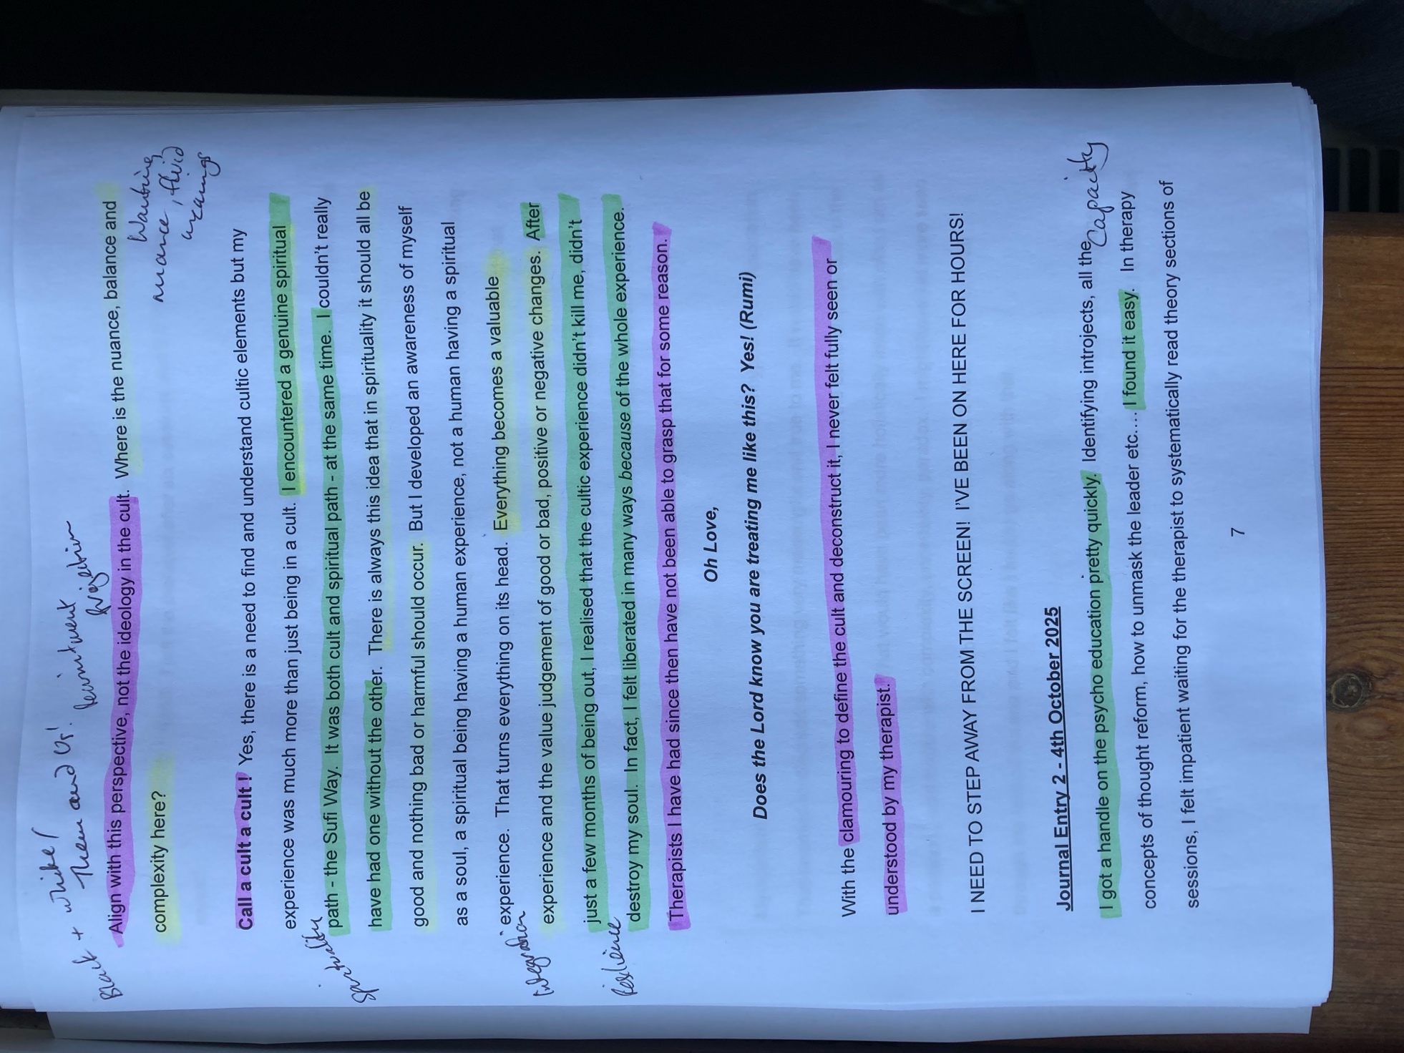

Appendix 5: Process of Refining Themes
Example of refining themes process:
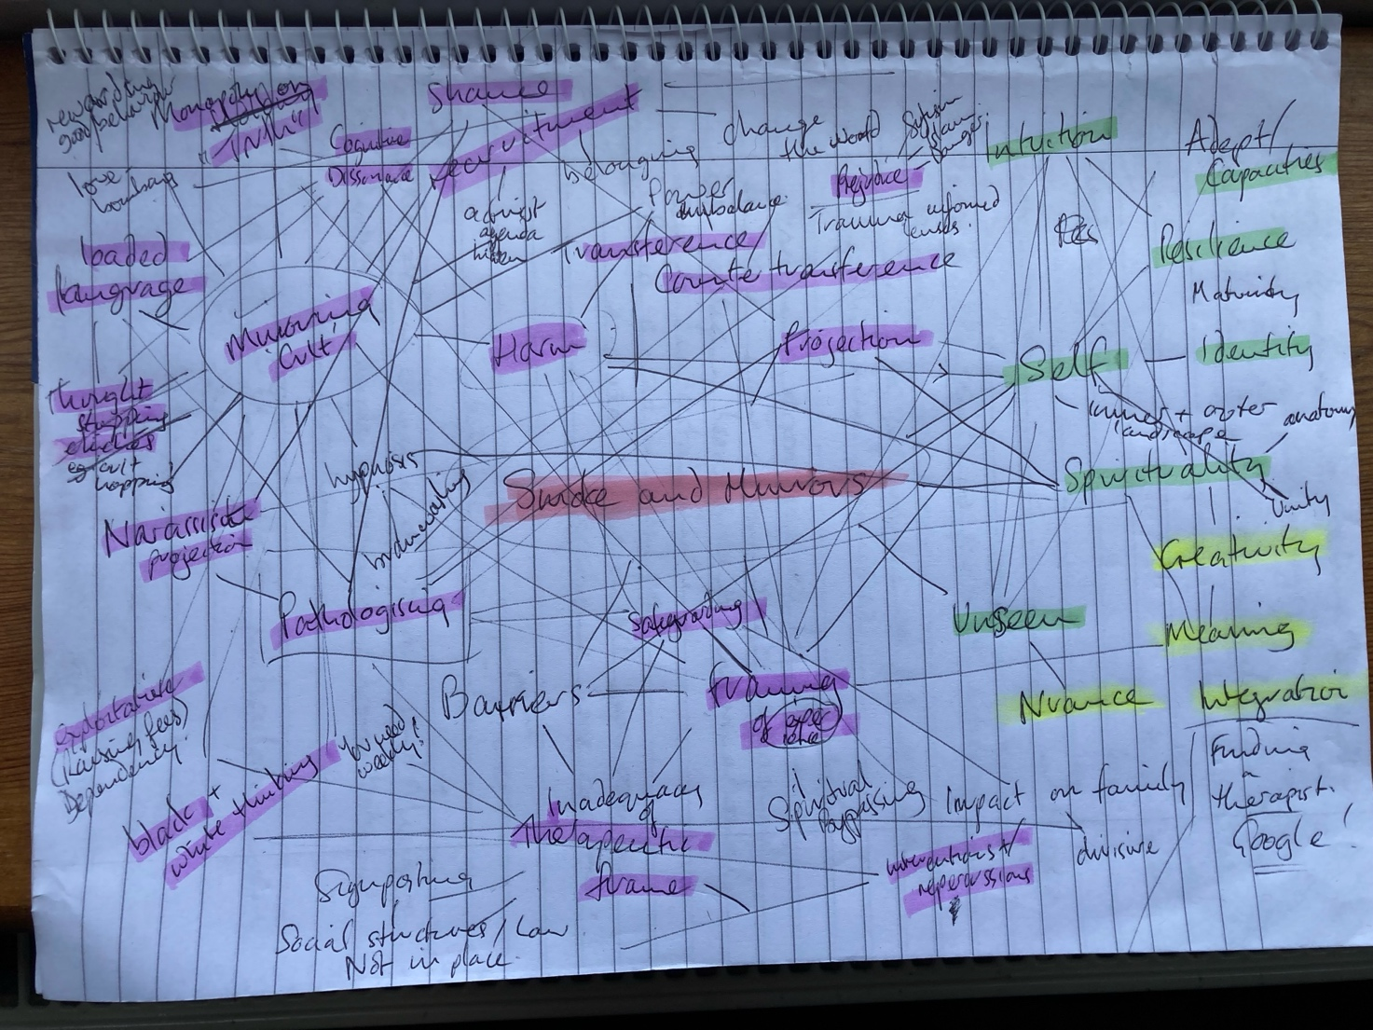

Appendix 6: The Test

‘According to the general opinion of the uninitiated,’ mused Nasrudin, […] ‘dervishes are mad. According to the sages, however, they are the true masters of the world. I would like to test one, and myself, to make sure.’
Then he saw a tall figure, robed like an Akldan dervish – reputed to be exceptionally enlightened men – coming towards him.
‘Friend,’ said the Mulla, ‘I want to perform an experiment, to test your powers of psychic penetration, and also my sanity.’
‘Proceed,’ said the Akldan.
Nasrudin made a sudden sweeping motion with his arm, then clenched his fist. ‘What have I in my hand?’
‘A horse, chariot and driver,’ said the Akldan immediately.
‘That’s no real test,’ – Nasrudin was petulant – ‘because you saw me pick them up.’

From The Pleasantries of the Incredible Mulla Nasrudin (Shah, 1993a, p.79)

Appendix 7: Poking at Shit (Printed words)

Dear Therapist,
If you poke at shit with a stick
You make a very sticky mess.
If you tread in shit, unaware,
You spread it everywhere.
Please take off your shoes before entering my house.
Then, if you happen to tread in some shit,
You will feel it between your toes.

Appendix 8: The Weight of the Stones

Nasrudin bought a handful of dates and sat down to eat them. His wife noticed that he put each stone carefully in his pocket.
‘Why don’t you throw away the stones, like everyone else does?’
‘Because when I bought the dates, I asked the greengrocer if the price quoted for the dates included stones as well. He said: ‘”Yes, all included.” So, the stones are mine as well as the fruit. I can keep them or throw them away.’

The Pleasantries of the Incredible Mulla Nasrudin (Shah, 1993a, p.176)

Appendix 9: The People who Attain

A seeker named Salik spent years searching for a spiritual master. Finding no one who met his high standards, he decided that the very next person he met would be his guide. The person he encountered was a professional thief named Dudz. When Salik begged to be his disciple, Dudz tried to drive him away. Shouting, “I am a thief, not a master!” But Salik’s devotion was so absolute that he refused to leave. Seeing no way to get rid of him, Dudz pointed to a mountain and said, “Go to the top of that mountain and put your head on the earth. Do not raise it until you receive the guidance you seek.”

Salik obeyed with such total sincerity of intent that while he was prostrating, the guide Khidr appeared to him. Khidr told him, “The man you followed is a common thief.” Salik, undeterred by the quality of his ‘teacher’ replied that he had met the thief first and it was through the thief’s command that he reached this state.

From Tales of the Dervishes: Teaching-stories of the Sufi Masters Over the Past Thousand Years (Shah, 1993b, pp.181-182)

Khidr is the archetype ‘green man’ that manifests to teach a sincere seeker wisdom which is often beyond religious forms of morality.

