Contemporary Developments in Employment Relations

Name: Agnieszka Grabowska-Phillips

CIPD Membership Number: 48812683

Date: 19/03/18

Word count (approx.: 3000 words)

I declare that this assignment is my own work and that any information obtained from books and other sources have been appropriately referenced.

Signed......................................................... Date...............................................

Contents

Introduction 3
Conflict overview 3
The external factors affecting conflict 3
Indeterminacy of the employment relationship 4
Pluralism vs unitarism 4
Additional factors in conflict 4
Contracts of employment 5
UK and EU employment relations law 5
Changes in law affecting the conflict 6
The role of trade unions in a conflict 7
The employee voice 7
Union vs non-union representation 8
Employee voice and organisation performance 8
The types of conflict 9
The contemporary trends in conflict resolution 10
The skills needed for effective grievance and dispute handling procedures 11
Third party intervention in collective disputes 11
References 13

Introduction

“Employee relations has replaced industrial relations as the term for defining the relationship between employers and employees” (CIPD, 2017b). This paper aims to explore the nature and context of employment relations. The industrial action taken by junior doctors in 2016 has been used as an example to explain employment relations legislation, illustrate contemporary developments in employee involvement and participation, and to highlight different forms of conflict behaviour and dispute resolution.

Conflict overview

The plans of new contracts for junior doctors in England were drafted in 2012 (BBC, 2016). The employers (NHS) and the trade union (BMA) both agreed that the old contracts needed to be modernised, as the old banding system was outdated, unfair and operated with unintentional consequences (NHS, 2015). Yet, the union have later objected to the proposed changes. New contracts involved changing shift pattern, overtime remuneration and linking pay increases to the progression system based on the set training stages rather than time of service (BBC, 2016). Negotiations between the BMA, NHS and the government began in October 2013 and after a number of strikes, a revised contract was agreed in May 2016 (Independent, 2016a).

The external factors affecting conflict

PESTLE analysis can be used to identify specific external factors that affect the employment relationship (Morrison, 2017). In the case of the industrial action taken by junior doctors in 2016, political, economic and social factors seem the most obvious:
A political challenge to the status quo often leads to a clash of policies pursued by the government and the unions (Wrigley, 2015). The Conservative Party Manifesto 2015 committed to increase the range of NHS services that are available seven days a week (Mughal & Mughal, 2016). The junior doctors responded with the argument that they already work weekends, providing the majority of the medical staffing on Saturdays and Sundays (BBC, 2016).
Economic causes have historically been the most common cause of industrial disputes (Hirsh, 2018). About one percent of junior doctors who do lots of extra hours and qualify for premium payments that were to be scrapped would lose out. In addition, pay rises linked to training progression would mean slower pay increase to some doctors. Finally, new doctors would be worse off than the ones who started their careers under the old arrangements (BBC, 2016).
Another common cause of strike is the desire to get improvements of an unfair policy (Maurice, et al., 1986). The plan to change junior doctor’s work pattern was driven by the research that found that patients are more likely to die if they are admitted on a weekend. The findings questioned the way services were organised at weekends. The doctors disagreed, claiming that patients admitted at weekends tend to be sicker, and the conflict intensified (BBC, 2016).

Indeterminacy of the employment relationship

Some elements of an employee’s contract are set, for instance, wages or terms and conditions. However, the employment relationship is by definition indeterminate, and much of a job’s details are largely left to be decided by a manager (Sisson, 2008). The psychological contract plays a critical role in fulfilling the unwritten conditions. It consists of the mutual expectations, beliefs and obligations as perceived by the employer and the employee (CIPD, 2017b). The employees’ perception of interests is critical. The more they believe the interests are shared, the more they are willing to work diligently for an employer (Cunningham, 2015). In contrast, breaking the psychological contract can have a disastrous impact not only on employees’ engagement and commitment, but also on their job satisfaction and well-being, often leading to conflict (CIPD, 2017b).
During the junior doctors’ strike, NHS and the government have been repeatedly accused of breaching the psychological contract with staff. Something that is once broken, may be impossible to reverse. It made the task of getting employees support to change even more difficult (Edwards, 2016).

Pluralism vs unitarism

To understand why conflict has occurred, it is important to understand the nature of the employment relationship. In the unitary approach, all members are similar and share the same interest; the employer and employee cooperate in harmony to achieve a common goal. In contrast, the pluralist approach recognises that different interests within sub-groups can cause conflict, and therefore focuses on compromising and collective bargaining (Fox, 1966). The third type of employment relationship is partnership between trade unions and employers, often seen as a modern alternative to pluralism and unitarism. In it, the unions act together with the employer to introduce agreed change (Michael, 1999).
In the nineties, partnership relations have become a main issue in industrial relations policy in Britain (Bacon & Samuel, 2009). At that time, with examples of no union recognition, a single union deal and pay deals unilaterally determined by management, NHS showed an essentially pluralist pattern (Corby, 1992). In the years that followed, the Department of Health started gradually introducing policies aiming to move from a controlling model towards a more diplomatic approach (Mason, et al., 2004). In spite of that, during the 2016 dispute, both sides showed little evidence of good partnership, continuously accusing each other of putting patients at risk and unwillingness to cooperate (Independent, 2016b).

Additional factors in conflict

In addition to conspicuous factors mentioned earlier, the breakdown in relationships can often appear due to more subtle, underlying issues:
Failing culture
Around the time the new contracts were proposed, the NHS staff were voicing their anger against being overworked (working longer hours), and undervalued (covering more patients without additional remuneration). They were experiencing burnout and the situation was getting worse, often described by the media as reaching crisis point (Carpenter, 2015).

Safety issues
During the consultations, junior doctors expressed worry about not getting enough rest to perform their job properly. The BMA claimed that frequently changing working patterns would lead to fatigue, inevitably making patients less safe. The union argued that some of the administrative changes included in new contracts would also result in removing important safeguards (Hitchens, 2016).

Contracts of employment

To avoid uncertainty or dispute about the terms of employment, the good practice is for them to be clearly set out and given to the new employee before or when they start the job (CIPD, 2017a). A contract does not have to be in writing to be legally valid, but it is better if it is (ACAS, 2018a).
Full-time, part-time, honorary and so called ‘zero hours contracts’ are being used across the NHS. The part-time contracts were introduced to improve recruitment and retention of consultants to promote a healthy work-life balance and encourage flexible working (BMA, 2018a). In contrary, junior doctors’ contracts are very rigid, full-time contracts (BMA, 2016). They benefit the planning and management purposes, but hinder employee engagement. The modelling was undertaken to consider impact and implications of allowing more flexible working (Wilkinson, 2016) and the issue remains high on BMA’s agenda (BMA, 2018d).
Honorary contracts are used for the doctors who work in an academic institution but remain clinically active. They allow them to undertake paid work and access appropriate expenses, but do not provide a salary or regular employment (BMA, 2016). ‘Zero hours contracts’ are not contracts in legal terms, but the agreements between two parties with no minimum contracted hours set (CIPD, 2017c). In 2013, almost 70,000 of NHS staff were employed using such contracts (NursingTimes, 2013).

UK and EU employment relations law

The fundamental sources of primary legislation in the UK are Acts of Parliament that set out the key principles of the law. The secondary sources i.e. regulations and orders are issued by ministers and contain a lot more detailed legislation. Judge-made laws, otherwise known as ‘case law’ or 'common law', are established by previous court rulings, judicial decisions and administrative legal findings (CIPD, 2016).
The main sources of EU law are directives, treaties and regulations. Directives set out general principles which member states are then obliged to adopt into national law. Treaties are negotiated by the governments of all EU member states and ratified by their national parliaments. Regulations have a direct effect and come into effect on a set date (CIPD, 2018).
UK and EU employment relations laws (Fig.1) cover health & safety, business transfers, occupational pensions and others (ACAS, 2018b). Detailed information on employment relations policy can be sourced from the authoritative website Gov.UK (GOV.UK, 2018a) and through ACAS (GOV.UK, 2018b).
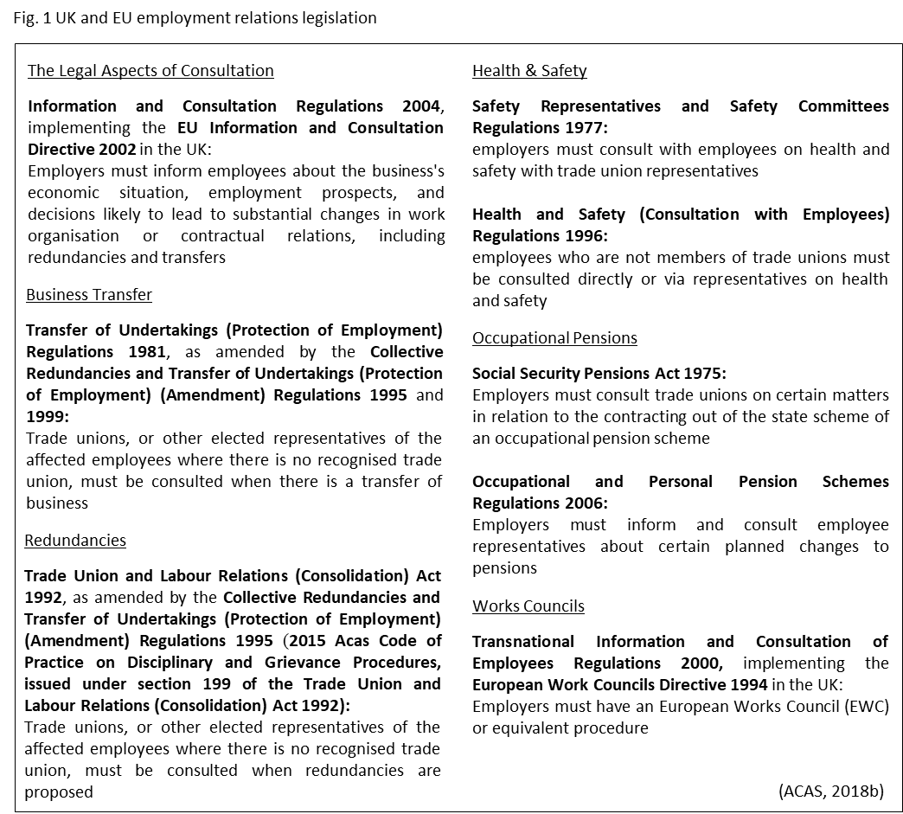

Changes in law affecting the conflict

Imposing a new contract requires the employer to serve employees with a contractual notice period, terminate the current contract and re-hire them on a new contract with the proposed changes in it. Because of the recent changes to the employment law, this might lead to a claim for unfair dismissal and, depending on the facts, there may be issues of indirect sex discrimination for female employees (Amunwa, 2016).
Section 98(4) of the Employment Rights Act 1996 specified the conditions in which a dismissal can take place. The employer must now show there is a good business reason for the change of terms and conditions, and that reasonable and fair procedures has been followed. In the junior doctors’ example, the government had to justify the changes, and did so on the basis that it intended to introduce a seven days a week NHS service to improve patient care. The evidence was also given, that a fair procedure was followed and the employees’ circumstances were fully considered before any decision was taken (Amunwa, 2016).
Section 19 of the Equality Act 2010 implemented the concept of indirect discrimination. When an employer tries to impose changes to working hours and shift patterns, the outcomes may indirectly discriminate against women due to child-care responsibilities. The employer must now have a valid defence on the basis that the requirement is justified (Amunwa, 2016). The junior doctors argued that proposed contracts discriminate against women (McCartney, 2016), but the government’s assessment showed that while the new contract would impact disproportionately on women, this impact was justified (Amunwa, 2016).

The role of trade unions in a conflict

The BMA is formally recognised for collective bargaining purposes both nationwide and locally (Fig.2) (GOV.UK, 2018e). Officially recognised by government and the Doctors and Dentists Review Body, it represents the views of GPs in the health service and NHS doctors in the hospital and public health and community services (BMA, 2018b).

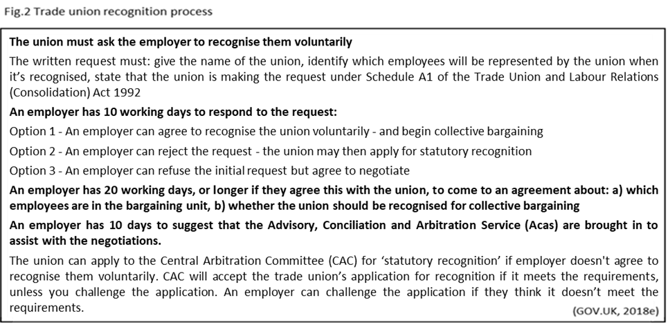

For an industrial action to be lawful there must be a trade dispute, a properly-conducted industrial action ballot and a written notice of industrial action sent to the employer (GOV.UK, 2018c). Taking part in industrial action that breaks the regulations could result in dismissal (GOV.UK, 2018d), and therefore, one of the main objectives of a trade union is to protect employees’ positions and ensure compliance with industrial relations legislation (BMA, 2018b). During the junior doctors’ dispute, strike action has been called by a trade union, and it complied with all the balloting and notification rules (Walters, 2016).

The employee voice

Employee voice can be defined as “informed employees who can contribute and are listened to” (ACAS, 2018c). It can be applied in many ways: Employee involvement is a management style where individuals are involved directly in all aspects of the decision-making process and encouraged to take ownership of the project (de la Morreaux, 2018). Participation is a group approach where employees are encouraged to form a team of representatives (forum) through which they can participate in decision-making and make improvement suggestions (de la Morreaux, 2018). Partnership refers to collaboration between employers and employees, where mutuality is a central concept. Usually it takes the form of formal agreement between employer and a trade union representing employees (Reilly, 2001).
The last ten years saw the partnership approach being slowly, but gradually introduced into the NHS. Yet, it was not until the months leading to the junior doctors’ dispute, when faced with the evidence linking engagement to employee wellbeing, patient satisfaction and clinical outcomes, the organisation recognised it as vital to high quality care, and focused in particular, on the need for a strong employee voice throughout the trust (Dromey, 2014). The new contracts, included a requirement for junior doctor forums to be set up (BMA, 2018c).

Union vs non-union representation

A systematic imbalance of power between employers and employees, gives the former an unfair advantage over the latter (Hogbin, 2006). Trade unions redressed this imbalance by engaging in collective bargaining and organising united action to protect workers’ rights (McDonald, 2018). Yet, the employment laws and regulations decreased the need for collective bargaining (Bianca, 2018) and in the UK around half of employee representatives are currently non-union (ACAS, 2014). Their role tends to be much more restricted and limited mainly to consultation.
There are four main areas that non-union representative can cover: ongoing consultation, issue specific consultation, employee safety and individual grievance or disciplinary matters (ACAS, 2014). The Trade Union and Labour Relations (Consolidation) Act 1992 protects union members and representatives from being victimised or dismissed for work relating to their trade union role and exercising their right to time off for trade union duties. This protection does not extend to the non-union representatives (UNISON, 2017).
The main disadvantages of union membership are the fees and less collaborative work environment; the unionised workers often experience less of a sense of partnership and trust with their supervisors (Keller, 2016). What’s more, the members of an overall bargaining unit in which the majority rules, give away their autonomy (Hunter, 1999b). Even though union membership gives employees a legal right to influence the union’s agenda by participating in its internal governance, the loss of individuality is inevitable (Hunter, 1999a). To make the process more democratic, in 2017, a tougher ballot threshold of at least fifty percent turnout of eligible union members was introduced (GOV.UK, 2017).
During the junior doctors’ dispute there were numerous instances of disagreement amongst the union members. In September 2016, BMA was forced to call off a planned five-day strike, when junior doctors who were worried about the impact it would have on patients revolted against it (Campbell, 2016a).

Employee voice and organisation performance

The employee voice is the main way employees can influence matters that affect them at work, contributing toward innovation, productivity and business improvement. (CIPD, 2017d). It was found to have a big impact on levels of employee engagement, ultimately leading to higher productivity (Rees, et al., 2013). When employees can freely express their concerns, organisations see increased retention and stronger performance (Detert & Burris, 2016).
Within the NHS, many organisational performance outcomes are linked directly to employee engagement e.g. better patient experience, fewer medical errors, stronger financial management, higher staff morale, less absenteeism, improved staff experience and productivity. A strong employee voice leads to better engagement and then translates directly into improved performance (Fig.3).
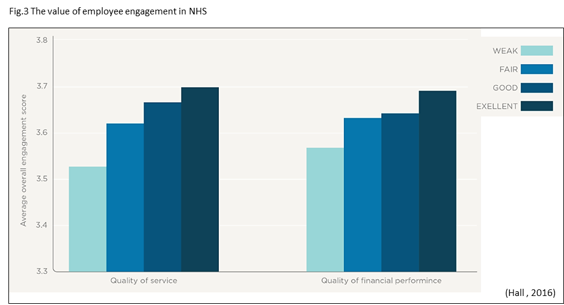
The feeling of powerlessness and ‘not having a voice’ by junior doctors could well be one of the triggers for the 2016 dispute over contracts (Hall , 2016).

The types of conflict

Conflict can be defined as disagreement between two or more parties who perceive that they have incompatible concerns (Bloisi, 2007). In contrast, misbehaviour is a behaviour that is unacceptable to management and may significantly disrupt its functioning of an organisation. It is voluntary, committed by choice and can be harmful to a person, the work group, or the organisation (Tek Yew & Gregory, 2011).
According to the pluralist perception, conflict is a natural factor which supports transformational change (Furnham, 2005). However, there is a great deal of cost linked to workplace conflict (ACAS/CIPD, 2013) (Fig.4).
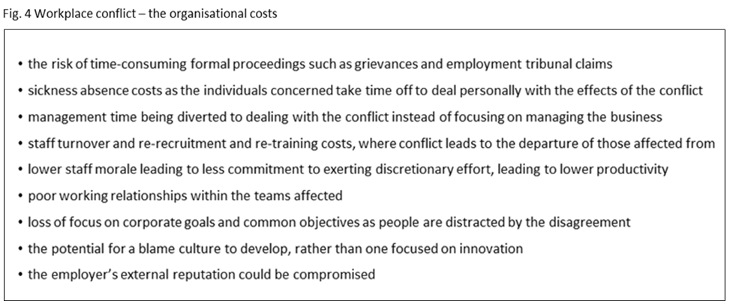

Collective bargaining can be defined as a process of negotiation between the unions and employers (ILO, 2015). Any form of industrial action (Fig.5), that is not authorised or endorsed by a trade union is unofficial and participating employees do not have statutory protection from unfair dismissal. In addition, some professions, for instance prison officers, are banned from taking industrial action and in their case, striking is always illegal. For the industrial action to be authorised i.e. official, the union must organise a legal ballot giving employers at least two weeks’ notice. The employer must be informed of the result of the ballot as soon as possible (CIPD, 2017e). The employees who are engaged in the official industrial action may still be in breach of contract, and the employer can legitimately withhold all or part of their pay. As a result, industrial action may affect their continuity of employment and the right to redundancy pay (Walters, 2016).
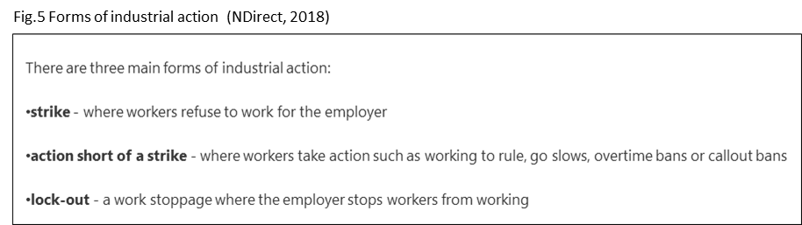
(NDirect, 2018)
None of the hospitals in England reported any patient safety incidents or occurrences of misbehaviour during the junior doctors’ dispute. Yet, withdrawal of care in emergency areas threatened the bond of trust between doctors and patients (Campbell & Johnson, 2016). The strike was described as reckless, unethical and breaching the Hippocratic injunction to do no harm (Campbell, 2016b).

The contemporary trends in conflict resolution

It can be argued that employment protection laws decreased the power of employers to hold employees to contractual commitments, which in turn eroded the value of employment relationships (Hogbin, 2006). At the individual level, the overall trend in conflict resolution is that employers are making increased use of mediation, and other forms of alternative dispute as opposed to court hearings (CIPD, 2015). In the case of employees, an increased preference for alternative dispute resolution methods can also be observed, with advocates viewing them as a more speedy and cost-effective alternative to court proceedings (Purcell, 2010).
Developments in employment law have also greatly contributed to the weakening of the collective bargaining powers and the amount of industrial action has significantly reduced in the last 30 years (Fig.6) (ONS, 2016). Data on changes in bargaining coverage rates for 48 countries shows that the bargaining coverage is continuously decreasing. In the United Kingdom bargaining coverage is currently at the medium-low level, as the collective bargaining is still prevalent in some sectors, especially in the health services (ILO, 2015).
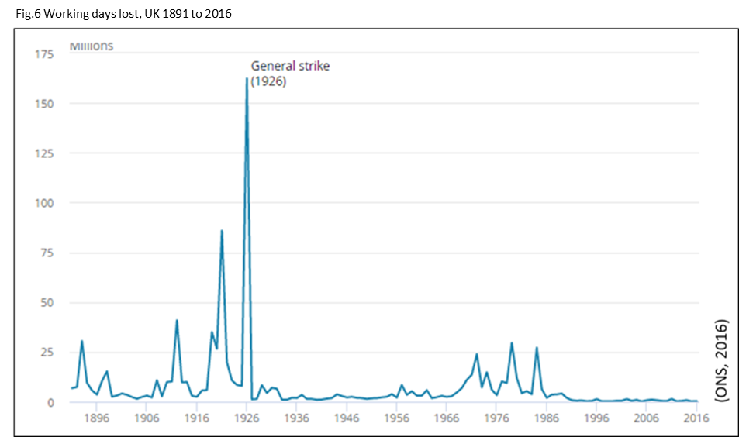

The skills needed for effective grievance and dispute handling procedures

“Conflict management refers to techniques and ideas designed to reduce the negative effects of conflict and enhance the positive outcomes for all parties involved” (HRZone, 2017). The biggest mistake often made by HR personnel is dealing with conflict through formal procedures, grievance and employment tribunals and not properly addressing the low-level conflicts often lurking in the side-lines (Simms, 2017). In fact, the ability to identify conflict in the workplace and knowing how to quickly and effectively resolve the underlying issues, in a positive way, is a paramount skill for a HR professional.
There are five steps to conflict resolution: ‘set the scene’, ‘gather information’, ‘agree to the problem’, ‘brainstorm possible solutions’ and ‘negotiate a solution’ (Bisk, 2017). Active listening skills are essential, as listening increases the chances of understanding and helps to enhance the relationship among participants. Good communication is the key to conflict resolution and respectful listening is the best way to achieve it (Sutton, 2013). When negotiating a solution, the best outcome is the so called ‘win-win’ situation, with both parties achieving a satisfying outcome (Johns & Perkins, 2016). Negotiation skills are therefore also extremely useful, as they allow to reach agreements with less complications and stress (Gillen, 2008).

Third party intervention in collective disputes

There are three forms of third party intervention: conciliation, mediation and arbitration (ACAS, 2015a).
Mediation is an out-of-court dispute resolution method where a neutral, third party helps in achieving a negotiated solution (Huczynski & Buchanan, 2007). It can be used at any stage in the conflict, but it is especially effective at the initial phase of disagreement, before conflict escalates (ACAS/CIPD, 2013).
An alternative to mediation is a conciliation. It aims to bring the parties together to clarify the issues and reach a settlement. Just like in mediation proceedings, the ultimate decision to agree on the settlement remains with the parties. However, while a mediator, will in most cases and as a matter of principle, refrain from making a settlement proposal, the conciliator is expected to provide it (DRH, 2018). Conciliation is the gateway to arbitration and is carried out by Acas staff, as opposed to arbitration that is carried by external experts on a panel drawn up by ACAS (ACAS, 2015a).
Arbitration is a method where a neutral party has the authority to make a decision which is binding on the parties in conflict (Huczynski & Buchanan, 2007). It is used to settle individual disputes as well as for collective employment related disputes (ACAS, 2018d). The decision is binding as a matter of law and has the same effect as a court judgment (ACAS, 2018e).
In the case of junior doctor’s dispute, BMA and the government has agreed to use the conciliation service at ACAS (BBC, 2015), ultimately leading to resolving the conflict (Cooper, 2016). ACAS stated that “the talks have been held in a constructive manner and cooperative spirit between the parties, that will allow an improvement in industrial relations" (ACAS, 2015b).

References

ACAS/CIPD, 2013. Mediation: An approach to resolving workplace issues. [Online]
Available at: http://m.acas.org.uk/media/pdf/n/n/Mediation-an-approach-to-resolving-workplace-issues.pdf
[Accessed 17 03 2018].
ACAS, 2014. Non-Union Representation in the Workplace. [Online]
Available at: http://m.acas.org.uk/media/pdf/9/o/Non-union-representation-in-the-workplace-advisory-booklet.pdf
[Accessed 09 03 2018].
ACAS, 2015a. Arbitration in collective disputes: A useful tool. [Online]
Available at: http://m.acas.org.uk/media/pdf/q/e/Arbitration-in-collective-disputes-a-useful-tool-in-the-toolbox.pdf
[Accessed 17 03 2018].
ACAS, 2015b. Acas statement and agreement on junior doctors' talks. [Online]
Available at: http://www.acas.org.uk/index.aspx?articleid=5558
[Accessed 17 03 2018].
ACAS, 2018a. Contracts of employment. [Online]
Available at: http://www.acas.org.uk/index.aspx?articleid=1577
[Accessed 03 03 2018].
ACAS, 2018b. Consultation. [Online]
Available at: http://www.acas.org.uk/index.aspx?articleid=675
[Accessed 03 03 2018].
ACAS, 2018c. The seven levers of workplace productivity. [Online]
Available at: http://www.acas.org.uk/index.aspx?articleid=5461
[Accessed 07 03 2018].
ACAS, 2018d. Arbitration. [Online]
Available at: http://www.acas.org.uk/index.aspx?articleid=1711
[Accessed 7 03 2018].
ACAS, 2018e. The Acas Arbitration Scheme for the resolution of flexible working disputes (England and Wales). [Online]
Available at: http://www.acas.org.uk/media/pdf/r/c/Acas-Arbitration-scheme-flexible-working-disputes-England-and-Wales.pdf
[Accessed 17 03 2018].
Amunwa, B., 2016. What does the junior doctors’ strike tell us about UK employment law?. [Online]
Available at: https://lawmostly.com/2016/04/08/what-does-the-junior-doctors-strike-tell-us-about-uk-employment-law/
[Accessed 04 03 2018].
Bacon, N. & Samuel, P., 2009. Partnership agreement adoption and survival in the British private and public sectors. Employment and Society, 23(2), pp. 231-248.
BBC, 2015. Junior doctor dispute to go to talks at Acas. [Online]
Available at: http://www.bbc.co.uk/news/health-34915820
[Accessed 17 03 2018].
BBC, 2016. Junior doctors' row: The dispute explained. [Online]
Available at: http://www.bbc.co.uk/news/health-34775980
[Accessed 28 02 2018].
Bianca, A., 2018. Factors Affecting Industrial Relations. [Online]
Available at: https://yourbusiness.azcentral.com/factors-affecting-industrial-relations-1407.html
[Accessed 28 02 2018].
Bisk, 2017. Effective Conflict Resolution Techniques. [Online]
Available at: https://essentialsofbusiness.ufexec.ufl.edu/resources/human-resources/the-conflict-resolution-process/#.WgY1fGi0OUm
[Accessed 11 11 2017].
Bloisi, W., 2007. An Introduction to Human Resource Management. 1 ed. London: McGraw-Hill Education.
BMA, 2016. Junior doctors' handbook on the 2016 contract. [Online]
Available at: https://webcache.googleusercontent.com/search?q=cache:Q7IeF_3gKo8J:https://www.bma.org.uk/-/media/files/pdfs/employment%2520advice/contracts/junior%2520doctor%2520contract/junior-doctors-handbook-2016-tcs-sept2016-amended.pdf%3Fla%3Den+&cd=1&hl=en&ct=clnk
[Accessed 03 03 2018].
BMA, 2018a. Part-time and flexible working. [Online]
Available at: https://www.bma.org.uk/advice/employment/contracts/consultant-contracts/part-time-and-flexible-working
[Accessed 03 03 2018].
BMA, 2018b. BMA as a trade union: Strength in numbers. [Online]
Available at: https://www.bma.org.uk/about-us/bma-as-a-trade-union
[Accessed 04 03 2018].
BMA, 2018c. Junior doctor forums. [Online]
Available at: https://www.bma.org.uk/advice/employment/contracts/junior-doctor-contract/junior-doctors-forums
[Accessed 07 03 2018].
BMA, 2018d. Committee overview. [Online]
Available at: https://www.bma.org.uk/collective-voice/committees/junior-doctors-committee/committee-overview
[Accessed 07 03 2018].
Campbell, D., 2016a. BMA calls off September junior doctors' strike after 'scores' of protests. [Online]
Available at: https://www.theguardian.com/society/2016/sep/05/bma-calls-off-september-junior-doctors-strike-after-scores-of-protests
[Accessed 08 03 2018].
Campbell, D., 2016b. All-out junior doctors’ strike unethical and reckless, says NHS chief. [Online]
Available at: https://www.theguardian.com/society/2016/apr/09/doctors-strike-nhs-chief-england
[Accessed 17 03 2017].
Campbell, D. & Johnson, S., 2016. Almost 80% of junior doctors took part in all-out strike, NHS says. [Online]
Available at: https://www.theguardian.com/society/2016/apr/26/80-percent-junior-doctors-took-part-in-all-out-strike
[Accessed 17 03 2018].
Carpenter, N., 2015. Not Fair, Not Safe: 6 Reasons Junior Doctors Are Preparing to Strike. [Online]
Available at: http://novaramedia.com/2015/10/12/not-fair-not-safe-6-reasons-junior-doctors-are-preparing-to-strike/
[Accessed 01 03 2018].
CIPD, 2015. Conflict management: a shift in direction?, London: CIPD.
CIPD, 2016. How UK employment law is made. [Online]
Available at: https://www.cipd.co.uk/knowledge/fundamentals/emp-law/about/uk-emp-law-made
[Accessed 03 03 2018].
CIPD, 2017a. Contracts of employment. [Online]
Available at: https://www.cipd.co.uk/knowledge/fundamentals/emp-law/terms-conditions/contracts-factsheet#6020
[Accessed 03 03 2018].
CIPD, 2017b. Employee relations: an introduction. [Online]
Available at: https://www.cipd.co.uk/knowledge/fundamentals/relations/employees/factsheet
[Accessed 28 02 2018].
CIPD, 2017c. Zero-hours contracts. [Online]
Available at: https://www.cipd.co.uk/knowledge/fundamentals/emp-law/terms-conditions/zero-hours-factsheet
[Accessed 03 03 2018].
CIPD, 2017d. Employee voice. [Online]
Available at: https://www.cipd.co.uk/knowledge/fundamentals/relations/communication/voice-factsheet
[Accessed 07 03 2018].
CIPD, 2017e. Trade union recognition and industrial action Q&As. [Online]
Available at: https://www.cipd.co.uk/knowledge/fundamentals/relations/employees/trade-unions-questions
[Accessed 17 03 2017e].
CIPD, 2018. Employment law: EU and Brexit. [Online]
Available at: https://www.cipd.co.uk/knowledge/fundamentals/emp-law/about/eu-impact
[Accessed 03 03 2018].
Cooper, C., 2016. Junior doctors' contract dispute resolved after Government and BMA reach deal. [Online]
Available at: http://www.independent.co.uk/news/uk/politics/junior-doctors-contract-deal-nhs-bma-jeremy-hunt-a7036376.html
[Accessed 17 03 2018].
Corby, S., 1992. Industrial Relations Developments in NHS Trusts. Employee Relations, 14(6), pp. 33-44.
Cunningham, P., 2015. Demystifying the Psychological Contract. [Online]
Available at: https://rapidbi.com/demystifying-the-psychological-contract/
[Accessed 16 03 2018].
de la Morreaux, A., 2018. The Difference Between Employee Participation & Employee Involvement. [Online]
Available at: http://smallbusiness.chron.com/difference-between-employee-participation-employee-involvement-13013.html
[Accessed 07 03 2018].
Detert, J. & Burris, E., 2016. Can Your Employees Really Speak Freely?. [Online]
Available at: https://hbr.org/2016/01/can-your-employees-really-speak-freely
[Accessed 10 03 2018].
DRH, 2018. Conciliation. [Online]
Available at: http://www.dispute-resolution-hamburg.com/conciliation/what-is-conciliation/
[Accessed 17 03 2018].
Dromey, J., 2014. Meeting the Challenge: Successful Employee Engagement in the NHS, London: IPA.
Edwards, N., 2016. The NHS workforce crisis may be irreversible. [Online]
Available at: http://blogs.bmj.com/bmj/2016/06/14/nigel-edwards-the-nhs-workforce-crisis-may-be-irreversible/
[Accessed 01 03 2018].
Eklund, A., 2010. Managing Conflict. [Online]
Available at: http://www.andyeklund.com/managing-conflict/
[Accessed 10 11 2017].
Fox, A., 1966. Managerial Ideology And Labour Relations. British Journal of Industrial Relations, 4(1-3), pp. 366-378.
Furnham, A., 2005. The Psychology of Behaviour at Work. 2 ed. Hove: Psychology Press.
Gillen, T., 2008. Negotiating, Influencing and Perduading. 2 ed. London: CIPD.
GOV.UK, 2017. Trade Union Act measures come into force to protect people from undemocratic industrial action. [Online]
Available at: https://www.gov.uk/government/news/trade-union-act-measures-come-into-force-to-protect-people-from-undemocratic-industrial-action
[Accessed 17 03 2017].
GOV.UK, 2018a. Trade unions and workers rights. [Online]
Available at: https://www.gov.uk/browse/employing-people/trade-unions
[Accessed 03 03 2018].
GOV.UK, 2018b. Advisory, Conciliation and Arbitration Service (Acas). [Online]
Available at: https://www.gov.uk/acas
[Accessed 03 03 2018].
GOV.UK, 2018c. If your business faces industrial action. [Online]
Available at: https://www.gov.uk/if-your-business-faces-industrial-action/lawful-industrial-action
[Accessed 04 03 2018].
GOV.UK, 2018d. Taking part in industrial action and strikes. [Online]
Available at: https://www.gov.uk/industrial-action-strikes/your-employment-rights-during-industrial-action
[Accessed 05 03 2018].
GOV.UK, 2018e. Employers: recognise a trade union. [Online]
Available at: https://www.gov.uk/trade-union-recognition-employers
[Accessed 07 03 2018].
Hall , B., 2016. Employee Engagement in NHS Healthcare. [Online]
Available at: https://www.interact-intranet.com/blog/employee-engagement-in-nhs-healthcare/
[Accessed 10 03 2018].
Hirsh, L., 2018. What Are the Causes of Conflict in Industrial Relations?. [Online]
Available at: http://smallbusiness.chron.com/causes-conflict-industrial-relations-59203.html
[Accessed 01 03 2018].
Hitchens, D., 2016. Briefing: what’s behind the junior doctors’ strike?. [Online]
Available at: https://blogs.spectator.co.uk/2016/01/briefing-whats-behind-the-junior-doctors-strike/
[Accessed 01 03 2018].
Hogbin, G., 2006. Power in employment relationships: Is there an imbalance?. 1 ed. Wellington: New Zealand Business Roundtable.
Horowitz, R., 2013. 9 Ways to Influence Without Authority. [Online]
Available at: https://www.hrvoice.org/9-ways-to-influence-without-authority/
[Accessed 12 11 2017].
HRZone, 2017. What is Conflict Management?. [Online]
Available at: https://www.hrzone.com/hr-glossary/what-is-conflict-management
[Accessed 11 11 2017].
Huczynski, A. & Buchanan, D., 2007. Organizational Behaviour. Harlow: Financial Times/ Prentice Hall.
Hunter, P., 1999b. Disadvantages of Union Representation. [Online]
Available at: https://www.mackinac.org/2313
[Accessed 04 03 2018].
Hunter, R., 1999a. Advantages of Union Representation. [Online]
Available at: https://www.mackinac.org/2312
[Accessed 08 03 2018].
ILO, 2015. Trends in collective bargainning coverage: Stability, erosion or decline?, Geneva: International Labour Office.
Independent, 2016a. Junior doctors' contract: A timeline of the dispute between the BMA and Jeremy Hunt. [Online]
Available at: http://www.independent.co.uk/news/uk/home-news/junior-doctors-strike-contract-dispute-timelines-bma-jeremy-hunt-nhs-a7001061.html
[Accessed 28 02 2018].
Independent, 2016b. Junior Doctors' Strike. [Online]
Available at: http://www.independent.co.uk/life-style/health-and-families/health-news/junior-doctors-strike-bma-and-government-accuse-each-other-of-putting-patients-at-risk-as-walkout-a6805141.html
[Accessed 01 03 2018].
Johns, T. & Perkins, G., 2016. Developing professional practice. In: S. Taylor & C. Woodhams, eds. Studying Human Resource Management. London: CIPD, pp. 67-88.
Keller, L., 2016. The Pros and Cons of Joining a Labor Union. [Online]
Available at: http://www.foxbusiness.com/features/the-pros-and-cons-of-joining-a-labor-union
[Accessed 09 03 2018].
Kilman, R. H. & Thomas, K. W., 1977. Developing a forced-choice measure of conflict-handling behaviour: the'Mode' instrument. Educational and Psychological Measurement, Volume 37, pp. 309-325.
Mason, B., Heaton, N. & Morgan, J., 2004. Social partnership strategies in two health service trusts. Personnel Review, 33(6), pp. 648-664.
Maurice, M., Sellier, F. & Silvestre, J., 1986. The Social Fundations of Industrial Power. 1 ed. London: The MIT Press.
McCartney, M., 2016. Margaret McCartney: A sexist contract for junior doctors. [Online]
Available at: http://www.bmj.com/content/353/bmj.i1943
[Accessed 08 03 2018].
McDonald, L., 2018. The Advantages of Unions to Employees. [Online]
Available at: http://smallbusiness.chron.com/advantages-unions-employees-24936.html
[Accessed 04 03 2018].
Michael, T., 1999. Assessing the significance of partnership agreements. [Online]
Available at: https://www.eurofound.europa.eu/observatories/eurwork/articles/assessing-the-significance-of-partnership-agreements
[Accessed 28 02 2018].
Morrison, M., 2017. Internal and external factors that impact the employment relationship. [Online]
Available at: https://rapidbi.com/internal-and-external-factors-that-impact-the-employment-relationship/
[Accessed 28 02 2018].
Mughal, Z. & Mughal, F., 2016. The junior doctor contract in the National Health Service. Journal of Family Medicine and Primary Care, 5(2), pp. 225-227.
NDirect, 2018. Industrial action. [Online]
Available at: https://www.nidirect.gov.uk/articles/industrial-action
[Accessed 19 03 2018].
NHS, 2015. Junior doctors’ contract offer - what it means for you. [Online]
Available at: http://www.nhsemployers.org/~/media/Employers/Documents/Need%20to%20know/JD%20A4%20booklet%20FINAL%20amends%2027%20Nov.pdf#page=9
[Accessed 28 02 2018].
NursingTimes, 2013. NHS using increasing number of 'zero hour' contracts. [Online]
Available at: https://www.nursingtimes.net/roles/nurse-managers/nhs-using-increasing-number-of-zero-hour-contracts/5061074.article
[Accessed 03 03 2018].
ONS, 2016. Labour disputes in the UK: 2016. [Online]
Available at: https://www.ons.gov.uk/employmentandlabourmarket/peopleinwork/workplacedisputesandworkingconditions/articles/labourdisputes/latest
[Accessed 19 03 2018].
Purcell, J., 2010. UK: Individual disputes at the workplace – alternative disputes resolution. [Online]
Available at: https://www.eurofound.europa.eu/observatories/eurwork/comparative-information/national-contributions/united-kingdom/uk-individual-disputes-at-the-workplace-alternative-disputes-resolution
[Accessed 17 03 2018].
Rees, C., Alfes, K. & Gatenby, M., 2013. Employee voice and engagement: connections and consequences. The International Journal of Human Resource Management, 14 02, 24(14), pp. 2780-2798.
Reilly, P., 2001. Partnership under pressure: How do I survive?, Brighton: Institute for Employment Studies.
Simms, J., 2017. There's more than one way to solve a dispute: Resolving workplace differences is a fine art - and many businesses have been getting it dramatically wrong.. People Management, Volume 4, pp. 32-35.
Sisson, K., 2008. Putting the record straight: Industrial relations and the employment relationship. 1 ed. Coventry: Warwick Business School.
Sutton, C., 2013. Clear Communication Reduces Conflict: Listening?. [Online]
Available at: https://www.hrvoice.org/clear-communication-reduces-conflict-listening/
[Accessed 16 03 2018].
Tek Yew, L. & Gregory, G., 2011. Organisational misbehaviour: Should management intervene?. [Online]
Available at: http://www.theborneopost.com/2011/07/26/organisational-misbehaviour-should-management-intervene/
[Accessed 17 03 2018].
UNISON, 2017. Victimisation on union grounds. [Online]
Available at: https://www.unison.org.uk/content/uploads/2017/04/trade-union-victimisation-april.pdf
[Accessed 09 03 2018].
Walters, K., 2016. Strike on the NHS. [Online]
Available at: https://www.michelmores.com/news-views/news/strike-nhs
[Accessed 04 03 2018].
Wilkinson, D., 2016. A more ‘flexible’ approach for Junior Doctors. [Online]
Available at: https://heeoe.hee.nhs.uk/sites/default/files/6._flexible_working_update_-_david_wilkinson.pdf
[Accessed 03 03 2018].
Woodruff, J., 2018. Advantages & Disadvantages of Unions for Employers. [Online]
Available at: https://bizfluent.com/info-12140728-advantages-disadvantages-unions-employers.html
[Accessed 09 03 2018].
Wrigley, C., 2015. Labour, Labour Movements, Trade Unions and Strikes (Great Britain and Ireland). [Online]
Available at: https://encyclopedia.1914-1918-online.net/article/labour_labour_movements_trade_unions_and_strikes_great_britain_and_ireland
[Accessed 01 03 2018].

